**Object Oriented Programming   
& Data Structures**

**Programming Assignment Instruction**

**To Teaching Assistants: Please check that the information at the top bar is correct.**

**You must use the assignment template to implement your programs**.

**You do not receive any score points if you do not use the template.**

In this assignment, you are going to implement some classes which are integrated in a large system. You can see the files in the folder **00_StudentWork**. These classes are:

* GALAXY_SYSTEM
* MONTE_CARLO_SYSTEM
* SIMPLE_FILE_EDITOR
* SIMPLE_PAINTER
* SORTING_VISUALIZATION

Please read the instructions for implementing these classes. **Write your programs in Visual Studio 2019 on the .NET platform. The compiler version must be v142.**

Open the project: SOGLFramework.sln. **We will rebuild your program in the Release mode and check your program.**

**How to run the program? You can find the executable file SelfMotivatedSystem.exe**

**in ./bin/Release**

**To run the program**: 1) go the folder ./bin/release/. 2) Then execute SelfMotivatedSystem.exe.

**Do not press F5 to run the program. We do not set the file directories in the project. Go to the folder and click** SelfMotivatedSystem.exe to run it.

**The demo program may have bugs.** These bugs are useful for you to understand that if we do not do a good job to check our programs thoroughly, all these bugs cannot be fixed. However, as you can see, you can still run the programs without a severe runtime error. **Thus, please follow the instructions. If the instructions are not clear to you, send us an email to clarify the issues. Could you find any bugs in the demo program? Do you know how to fix the bugs?**

**Submission**:

1. Change the folder name to ID_Name, where ID is your student ID and Name is your name. Zip and then upload the entire folder of the project (must contain source code) to E3 platform before the deadline.
2. You must demonstrate your work to our TAs in the lab session.
3. If you cannot demonstrate your program to our TAs, your score is zero.

**Penalties**

1. Late submission: 40% penalty each day.
2. Cheating: you will be received a score of zero. For example, borrowing your source code to others or/and copying others’ source code.
3. **You can add new functions but you must not add new files. Deduct 50pt if you add new files.**

**Requirement Specification**

All the calculations should be done in double precision in **Monte Carlo Simulation**.

**Basic tasks.**

Use double to define a variable which is a floating point number. All the calculations should be done in double precision. Don’t use float. Show the value of a floating point number up to 8 decimal digits.

1. **Basic tasks.**
2. **Write your name in the header file mySystemApp.h**
3. **Set the macro STUDENT_INFO in mySystem.h correctly. So that the top bar of the window shows the subsystem name, your name and student ID.**
4. Press ‘s’ or ‘S’ to show your student information: **date**, student ID, name, and email address. Implement void MY_SYSTEM_APP::showStudentInfo_2022( ) const.

**Items I, II, and III must be done. If one of the items is not finished properly, your score is zero.**

**Key usages**

F1: perform subsystem: **Monte Carlo Simulation**

F2: perform subsystem: **Galaxy Simulation**

F3: perform subsystem: **Painter**

F4: perform subsystem: **File to read a bitmap from a file**

F5: perform subsystem: **Visualization of bubble sort**

i, I: display the information about a subsystem. Show key usages of the subsystem

s, S: show the student information on the console window

**Exercise at your free time: Project properties**

**NOTE: Do not modify the assignment template when you do this exercise. You should create a dummy project for the exercise.**

Please look for some information about project properties, including C/C++ general, Linker general, and Linker include. Learn about additional dependencies, additional library directories, and so on. **Do you know when you can use F5 and F7?**

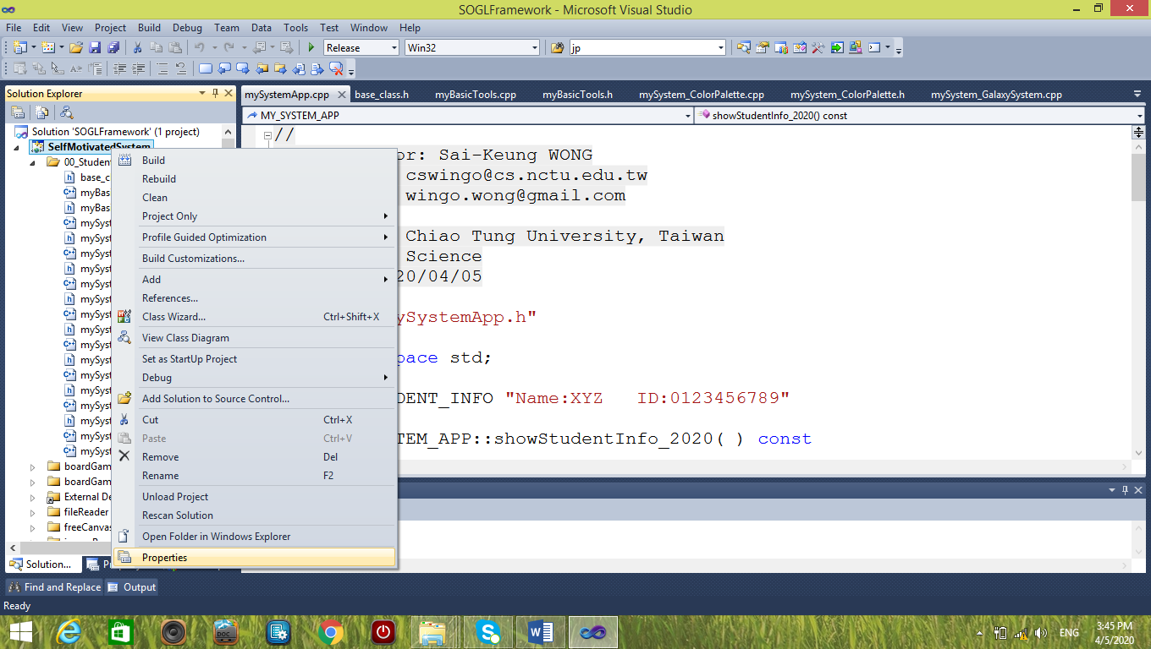

Select Properties to show the properties of the project

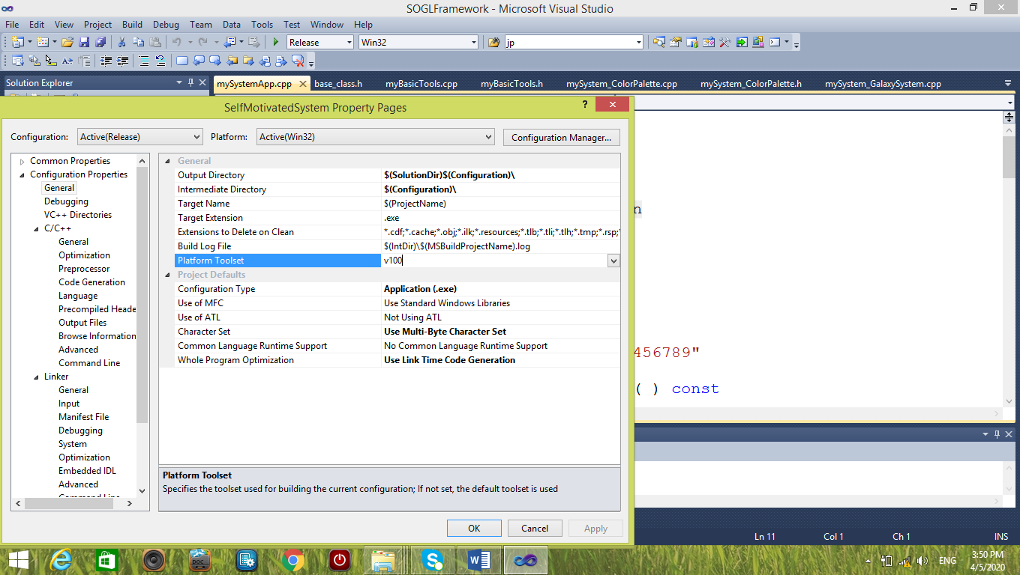

You can change the Platform toolset here. Please use the required toolset.

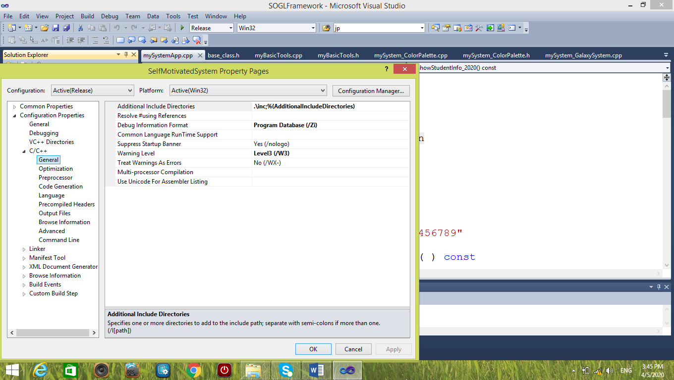

You can set the directories. Always use relative file paths.

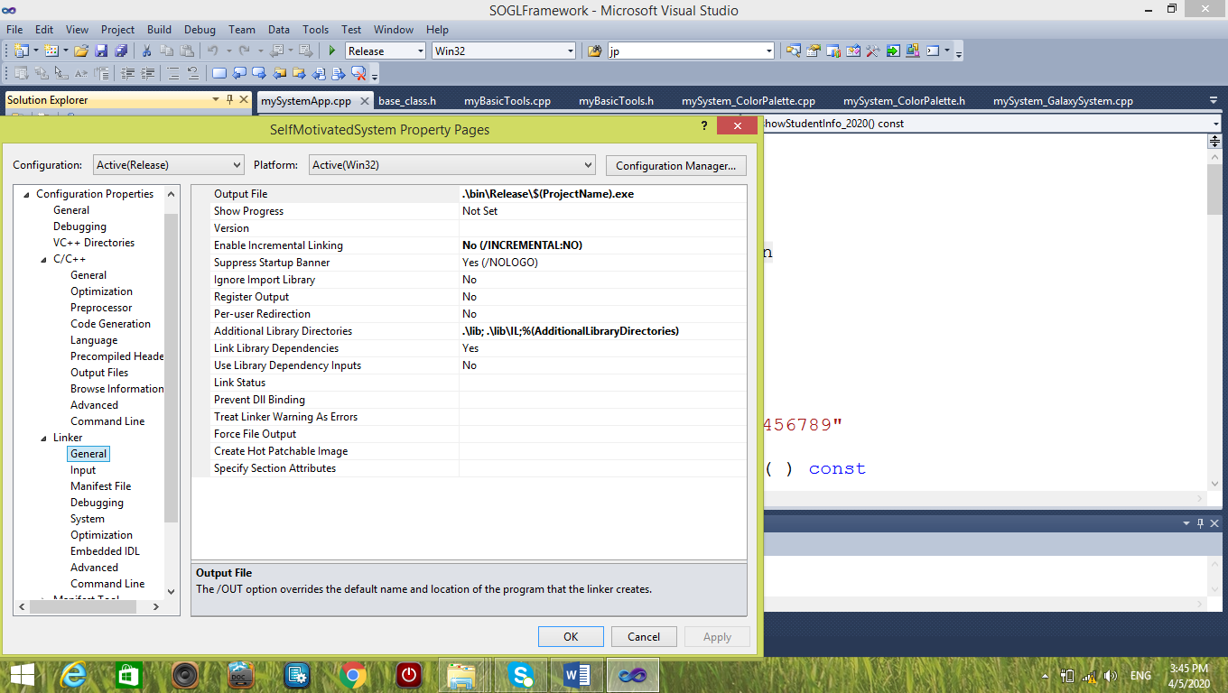

You can set libraries, such as dlls. Set the file paths correctly. Please read information on your own.