|  |
| --- |
| TRACK Team Project Operation and User Manual |
| Distributed Database Query Engine Service (DDQES) |
| Frederic Colin [2012400565] Henry Loharja [2012280102] Ng Yi Ying [2012280098] |

Table of Content

List of Tables 1

List of Figures 1

Introduction 2

Application Development Environment 2

Hardware Configuration 2

Software Configurations 3

Installation and Configuration 3

Required Hardware 3

Required Software 3

Optional Software 4

Optional Configuration 4

Setup Application 4

Setup Database System 5

Configuration of MySQL 5

Configuration of SQLite 5

Configuration of PostgreSQL 5

Launching Application 6

Basic Operations of Distributed Database Query Engine System (DDQES) 6

Potential Steps 7

Help 8

Tomcat Installation 8

Launching Application 8

Support Contacts 8

# List of Tables

Table 1 Hardware Configurations 2

Table 2 Required Hardware Configurations 3

Table 3 Required Software Configurations 4

# List of Figures

Figure 1 Print Screen of Distributed Database Query Engine System (DDQES) page 6

Figure 2 Basic Operations of Distributed Database Query Engine Service (DDQES) 6

# Introduction

Distributed Database Query Engine Service (DDQES) is a project system which is assigned to promote a better and deep insight on the knowledge of distributed database system through a hands-on software design and implementation experiment. In term of scope, the project system is covering a distributed system environment which involved four distributed sites and four database engines. In short, the entire distributed environment is designed to be capable of handling distributed query processing that involved distributed query requests, query analysis for decomposition and localization. With the concern of data communication cost, query optimization is within the considerations of the project scope for effective database retrievals and optimized returned result set. In addition, to ease crossed platforms data communication; DDQES is developed with the functionality of being published as a web service to support remote service call from all available sites for further processing, which is described with Web Service Description Language (WSDL). The entire project is handled by a group of three team members (with TRACK as the team name), namely Frederic Colin, Henry Loharja and Ng Yi Ying as the team leader. In this documentation, it will be covering the details of application development environment, instruction of installations, configuration and basic idea of the query engine operation. In the following section, the application development environment will be listed.

# Application Development Environment

There are three developers for the Distributed Database Query Engine System (DDQES) who are assigned with different parts of implementations, including web user interface, query decomposition, query tree optimization, optimized strategy plan generation, execution and result integration. Hence, there are 3 different development hardware configurations and having the application being tested to ensure the interoperability.

## Hardware Configuration

|  |  |  |  |
| --- | --- | --- | --- |
|  | **Operating System** | **Processor** | **RAM** |
| **Configuration 1** | Windows 7 Home Premium 64 bit | i7-2630QM@2.00GHz | 4GB |
| **Configuration 2** |  |  |  |
| **Configuration 3** |  |  |  |

Table 1 Hardware Configurations

## Software Configurations

All three developers are using the same Integrated Development Environment (IDE) to code all the application features; which is Eclipse Juno (4.2) – Eclipse IDE for Java EE Developer. Apart from the IDE, Apache Tomcat 7.0 is installed in the system to support the execution of Java servlets and renders the written Java Server Page (JSP) coding.

# Installation and Configuration

To run Distributed Database Query Engine Service (DDQES) on personal computer, there are several installations and configurations need to be in place. The following are the required hardware and software installations specifications:

## Required Hardware

To ensure a smooth user experience for running Distributed Database Query Engine Server (DDQES), the following hardware specification is the preferred configuration:

|  |  |
| --- | --- |
| **Hardware Element** | **Specifications** |
| Operating System | Windows XP, Windows Vista, Windows 7, Linux, MacOS X, Solaris |
| RAM | 1GB or higher |
| Hardisk Memory | 200MB |
| Processor | Dual-core Pentium 1.5 GHz or higher |

Table 2 Required Hardware Configurations

## Required Software

|  |  |
| --- | --- |
| **Software Element** | **Specifications** |
| Java Environment | JRE 1.7  Java 2 Standard Edition (J2SE) SDK 1.3 or later  Download: <http://java.sun.com/j2se/> |
| Apache Tomcat | Tomcat 7.0  Download: <http://tomcat.apache.org/download-70.cgi> |
| MySQL |  |
| PostgreSQL |  |
| Web Browser | Any browser:  Mozilla Firefox (any version), Internet Explorer (any version), Google Chrome, Opera and Safari |

Table 3 Required Software Configurations

Apart from installing the required software, there are additional configuration is needed to ensure Distributed Database Query Engine (DDQES) can be run normally. For instance, class path of the JDK need to be configured in system environment variable as JAVA_HOME variable needs to be pointed to the location of the java run time environment to support the Tomcat. Otherwise, the Tomcat server may not able to run. The additional help for Tomcat installation can be found in Section Help.

## Optional Software

It is not necessary to install the default Integrated Development Environment (IDE) which was being used during development phase. However, for any further debugging and learning purpose, Eclipse Juno (4.2) – Eclipse IDE for Java EE Developer is the suggested software. It is downloaded from the following link: <http://www.eclipse.org/downloads/>

## Optional Configuration

For debugging purpose, it will be more convenient to configure Apache Tomcat in Eclipse IDE. The configuration can be done by following the step-by-step instruction in the link:

<http://theopentutorials.com/tutorials/java-ee/how-to-configure-apache-tomcat-in-eclipse-ide/>

## Setup Application

After all installation and configurations are done, a final setup for Distributed Database Query Engine System (DDQES) application is required to run it. By browsing the folder where this document is being stored, there is a folder with the name of “DDQES_Complete” should be copied to Tomcat 7.0 web directory which usually can be found at:

C:\Program Files\Apache Software Foundation\Tomcat 7.0\webapps

Special Note: Since DDQES is running in a distributed system environment, it requires four physical personal computers with the same installation requirements and configurations. Otherwise, a single personal computer would need to open 4 different ports to simulate the same distributed scenario.

## Setup Database System

Apart from a highly distributed environment, Distributed Database Query Engine System (DDQES) are using three heterogeneous database systems, which are namely MySQL, SQLite and PostgreSQL. Therefore, it is necessary to setup the entire database to support the DDQES operations.

### Configuration of MySQL

Fred may need to add in how to turn on the necessary port or maybe just install WAMP server. But, if you specified of using WAMP, then you may need to add the installation over the Require Software section.

### Configuration of SQLite

Under DDQES_Complete folder, there is a file called “TRACK_Hibernate.db”, it should be placed under the folder of:

C:\Program Files\Apache Software Foundation\Tomcat 7.0\webapps

### Configuration of PostgreSQL

Henry you may need to write how to configure and start the database and add in necessary software installation in Require Software section. I have not much idea of how it work.

## Launching Application

Next, start Tomcat 7.0 server. Now, by entering:

<http://locahost:8080/DDQES_Complete/launcher.jsp> into the web browser URL box should be able to see the following page:



Figure 1 Print Screen of Distributed Database Query Engine System (DDQES) page

If the above page can be shown, it means the performed installations are in place. Now, the application can be used.

## Basic Operations of Distributed Database Query Engine System (DDQES)

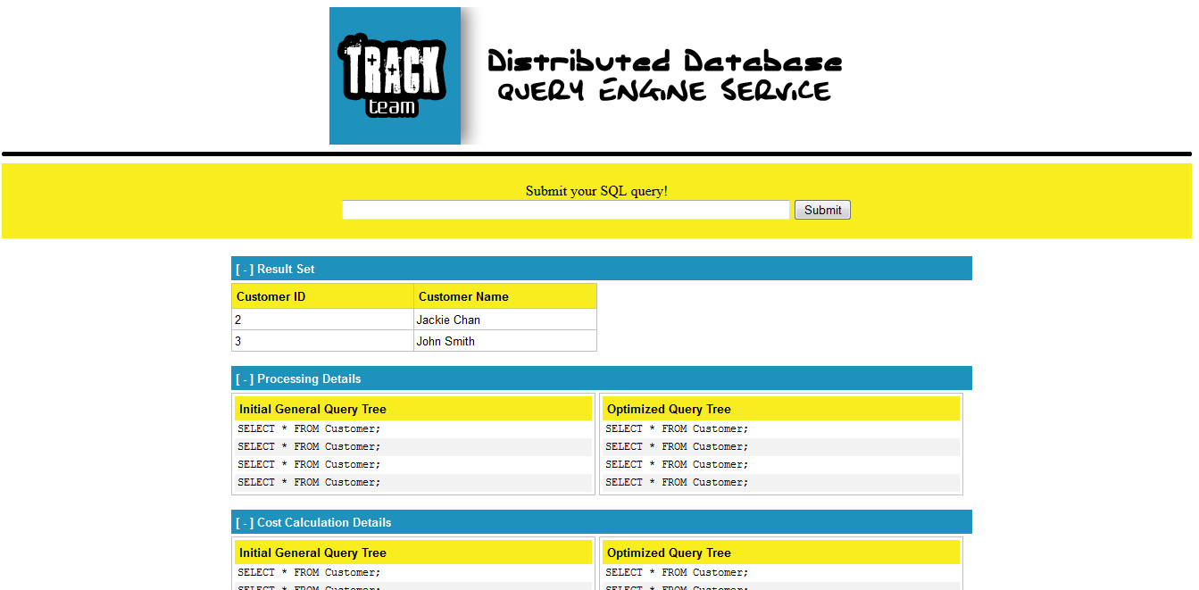

1

2

3

4

5

6

7

8

9

10

Figure 2 Basic Operations of Distributed Database Query Engine Service (DDQES)

Based on the above figure, the functionalities are labeled with individual number and its corresponding explanation can found as follow:

1. Reload the current page
2. Enter SQL query, such as “SELECT * FROM customer”
3. Submit SQL query by sending request to backend system for further executions
4. Error message. For the case where the user is entering an invalid SQL query, an error message will be shown up with red in font. An example of invalid SQL is “SELECT * FROM people” as there is no such table named people in the database.
5. Clickable hide/show result set bar. By default, labeled element 6 will be shown. By clicking on this bar, the entire section of element 6 will be hidden. For the case where element 6 is already being hidden, another click will show the content again.
6. The result set of the entered SQL query
7. Clickable hide/show processing details bar. By default, labeled element 8 will be shown. By clicking on this bar, the entire section of element 8 will be hidden. For the case where element 8 is already being hidden, another click will show the content.
8. Processing details which having the default initial general query tree on the left while the optimized query tree on the right.
9. Clickable hide/show cost calculation details bar. By default, labeled element 10 will be shown. By clicking on this bar, the entire section of element 10 will be hidden. For the case where element 10 is already being hidden, another click will show the content again.
10. Cost calculation details which having the communication cost of the default initial general query tree on the left while having the communication cost of the default optimized query tree on the right.

## Potential Steps

User may refer to the following potential steps to operate Distributed Database Query Engine System (DDQES):

Step 1: Enter SQL query into the text box (labeled as 2 in Figure 2)

Step 2: Click on “Submit” button (labeled as 3 in Figure 2)

Step 3: View results (labeled as 6, 8 and 10 in Figure 2)

For the case if there are error message highlighted with red font appear in label 4 area after step 2, please modify the entered SQL statement.

## Help

### Tomcat Installation

For any encountered problem trying to install Tomcat, detail Tomcat Setup can be found here for both Windows and UNIX:

<http://tomcat.apache.org/tomcat-7.0-doc/setup.html#Windows>

<http://www.roseindia.net/quickguide/tomcat/tomcatdownloadinstall.shtml>

<http://tomcat.apache.org/tomcat-4.1-doc/RUNNING.txt>

It is highly recommended where Windows user can use the default Windows installation. The following is Tomcat Wiki which additional information can be obtained regarding starting and features of Tomcat: <http://wiki.apache.org/tomcat/>

### Launching Application

After entering <http://localhost:8080/DDQES_Complete/launcher.jsp> into the browser URL box, if the following issue was encountered it may be due to:

* Error 404: Tomcat installation is in place, provided the application folder may be misplaced. Please ensure the application folder (DDQES_Complete) is being placed under C:\Program Files\Apache Software Foundation\Tomcat 7.0\webapps
* Unable to connect: It may be due to Tomcat installation is not completed and/or Tomcat server is not started. Please check the Tomcat connection and try again.

## Support Contacts

**Frontend Web Interface**

Ng Yi Ying: [yiying.ng@gmail.com](mailto:yiying.ng@gmail.com)

**Backend Operations**

Frederic Colin: [fredericcolin.fc@gmail.com](mailto:fredericcolin.fc@gmail.com)

Henry Loharja: [henry7.asakura@gmail.com](mailto:henry7.asakura@gmail.com)