-This program is coded by C on Visual Studio.

-The program is in the Debug folder: Graduate coding puzzle.exe

-The source code is inside the Graduate coding puzzle folder: Graduate coding puzzple.c

-Users should enter the PLACE command first. Otherwise, the program is not able to continue.

-The program will show the warring message if the robot is out of bound, and it will discard the command

-user could enter the PLACE command anytime to put the robot in the new location.

**Test cases:**

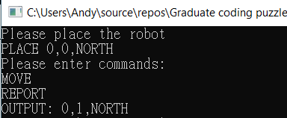

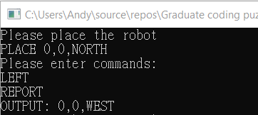

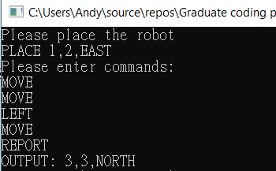

For out of bound:

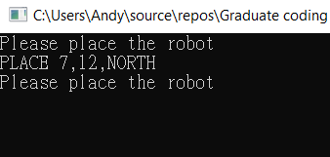

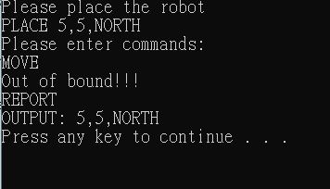

The robot could be put on new location anytime:

