**<https://yibelta.github.io/yibeepogithub.io/index.html>**

[**https://yibelta.github.io/yibeepogithub.io/yiba.html**](https://yibelta.github.io/yibeepogithub.io/yiba.html)

**E-portfolio Reflection Assignment**

In this module I have learnt, understand and practices on different concepts like about scientific Investigation and ethics, developing research questions, review the literature review, research proposal, developing research methods, developing in analyzing qualitative data and research writing. With these all process I got knowledge and experiences on the subject matter also, I develop extra skill on how to process and interpret research data using different statistical tools. Here below I would like to reflect or share my all activities and journey in this module.

In my collaborative learning discussion 1, I posted Malcious Contribution to content screens about the U.S children internet protection Act (CIPA) and blocker plus software is computerized cyberspace value screen to benefit the institution conform through CIPA this in line with principle 2.3 which include: develop your profession knowledge, skill and competence.

In summary part I posted about the responsibility embraces: Indorsing vital civil rights and caring separately person’s right to sovereignty. Crucial goal of calculating specialists is to diminish undesirable significances of calculation, as well as fears to well-being, security, individual safety, and confidentiality.

In the case of my collaborative learning discussion 2 I raised on the accuracy of information on Whizzz cereal research outcome. Based on the research outcome it is principled for him to advocate examining accurate figures in a method that provisions two or extra diverse assumptions with revision of methodology and possible scientific justification the subsequent lessons might also reverse or might display condensed or robust outcome extent than the previous unities (Grindrod, P. & Moreno, J,2018).

In addition to my point my classmates: Jan Kufner, Freya Basey and Samuel Tselapedi reflected their comments on my initial post respectively. Jan Kufner said publishing the complete result herself, when Whizz is only publishing favorable results is a very good route to follow. There is however a more powerful alternative: As per Legal framework for European statistics Article 2 statistical principles (1c) the statistics must also be distributed in an impartial way. Freya Basey said Whilst I agree with both Yibeltal and Jan on a moral level regarding Abi circumventing Whizzz to publish full results, due consideration should be given to the recourse that Abi may face. For example, a confidentiality agreement is likely to form part of Abi’s contract with Whizzz (Bott, 2014).

And Samuel Tselapedi said the integrity and credibility of the research findings may be questionable since the decision to explore other correlation methods was taken after realizing that the researched product has no nutritional value as hypothesized.

And finally, I summarized my post in the following manner: principled conclusions are founded on three core methods: responsibility, civil rights and area-founded. So, misrepresentation of the results in a research report, manipulation of data analyses, and falsification of data represent research misconduct. In the rights-based method, the constitutional rights of the human being are expected to remain significant (Rosnow and Rosenthal, 2011).

I have submitted my research review outline and assignment on “The Impact of Modern Technology on Student Learning Experiences in Higher Education” and I reviewed different literature and I concluded that IT could have positive impact on teaching and learning process in higher education if we utilized properly. In research proposal development part, I have submitted research proposal outline on “Use of Information Systems to Transform the Health care Sector in Addis Ababa, Ethiopia: A Case of All Public Hospitals” and I received constructive input from my respected tutor Dr Steph Paladini as per the given comments I have prepared with considering the following parts like significance of study, research problem, research questions, objective, key literature, methodology, ethical consideration and work plan then submitted the audio recorded document.

In statistics exercises I have completed all throughout this module, including those from the mandatory worksheets in Units 8 and 9 and interpreted the statistics exercises out puts and my findings.

For instance, Exe 8.4G I have completed test t two-tailed test to check whether the population mean impurity differs between the two filtration agents.

The resulting output is presented below. Not all this output is relevant, so it need not all be discussed. The attained related trials t = -3.26394 through 11 degrees of freedom. The related two-tailed p-value is p = 0.007546, therefore the detected t is substantial at the 0.05 scale. The sample mean numbers of items sold for Container Agent 1 and Agent 2 remained, separately 8.25 and 8.68. The statistics consequently found important indication which the fundamental mean figure of containers sold was greater for Agent 2 8.68, by an estimated 8.25-8.68 = -0.43333 items per store. The outcomes advocate that Agent 2 would be selected.

For instance, Exe 8.6C I have completed f-Test two-sample for variances and t-test: two-sample presumptuous identical adjustments in order to check whether the population mean income of Males exceeds to income Female. incomes variances of variables are, individually 233.129 and 190.175. The detected F test indicator is F = 1.22586 through 59 and 59 related grades of independence, considering a two tailed p-value of p = 0.436492. The detected F proportion is therefore not substantial. The figures are steady through the hypothesis that the population variances underlying the income under the two variables (Male and Female) do not differ, and we therefore proceed to use identical discrepancies arrangement of the unconnected examples t test.

Since we wish to test if the population mean income difference between male and female, a two-tailed t test is appropriate here. The attained autonomous samples t = 3.2679 with 118 degrees of independence. The related two-tailed p-value is p = 0.00071, so the detected t is substantial at the 1% level (two-tailed). The sample mean income for sexes M and F were, respectively, 52.91 and 44.23. The figures consequently establish robust sign that the original income difference is superior for sex M, by projected 52.91 – 44.23 = 8.68, The results strongly suggest that income Male exceeds than Female income. I have attached all necessary documents in my E-portfolio page so that you can see it detail.

Sample Screen Shoots



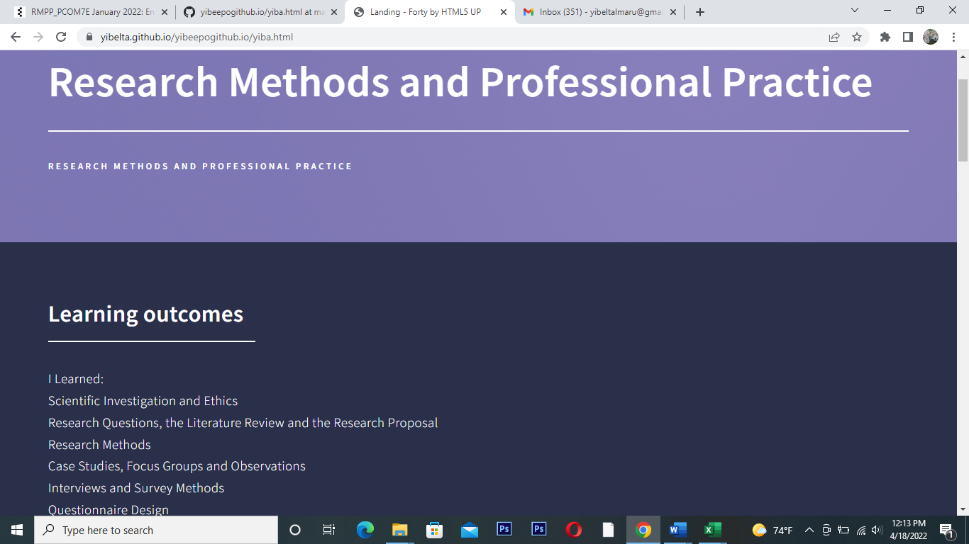

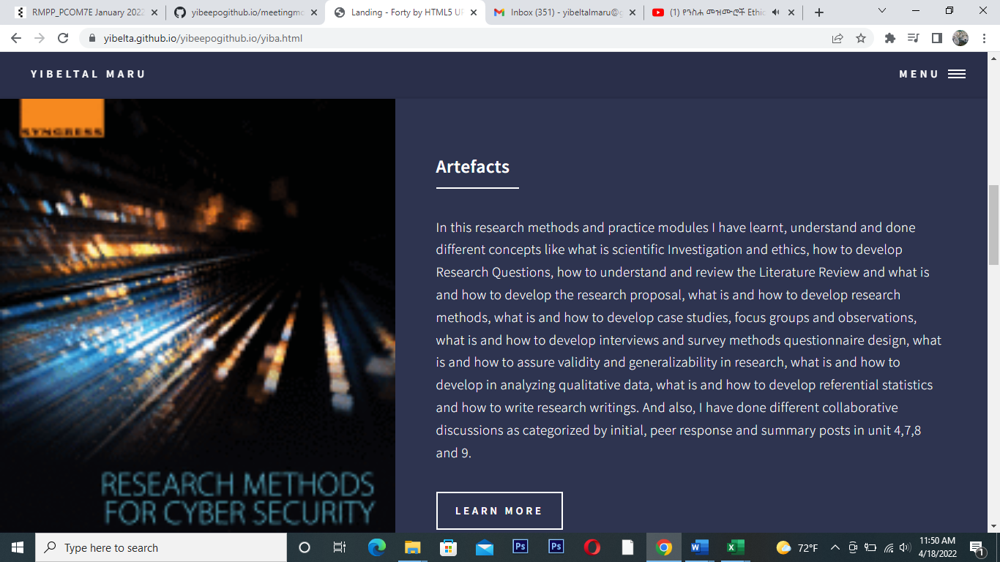

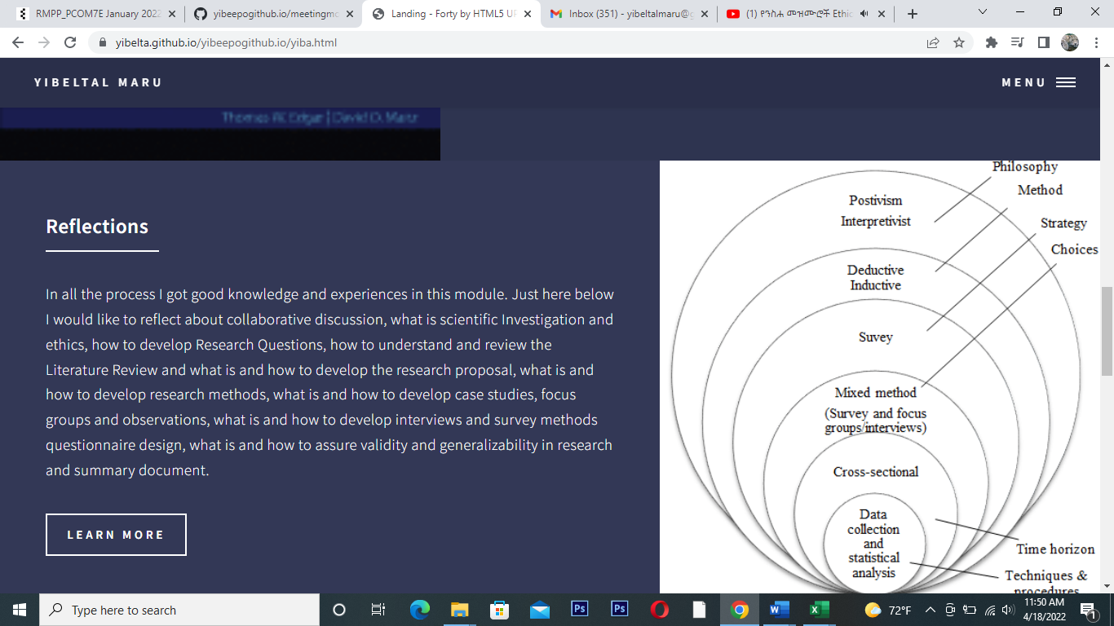



**References**

ACM (2018) ACM Code of Ethics and Professional Conduct. Available from: <https://www.acm.org/code-of-ethics#h-2.3-know-and-respect-existing-rules-pertaining-to-professional-work> [Accessed 10 February 2022].

Bott, F. (2014) Professional Issues in Information Technology. 2nd ed. London: BCS.

Grindrod, P. And Moreno, J.,.(2018) Code of conduct. Available at: [http://www.code-of-ethics.org/code-of-conduct](http://www.code-of-ethics.org/code-of-conduct/) [Accessed on March 2022].

Rosnow, R. L. and Rosenthal, R. (2011) Ethical principles in data analysis: An overview’, *Handbook of Ethics in Quantitative Methodology*, pp. 37–58. doi: 10.4324/9780203840023.ch3.