1.
variable | x | y | z | c
Machine number | 0xffff8000 | 0x020a | 0x0000fffa | 0x40
variable | a | b | u | v
Machine number | 0xbf8ccccd | 0x4025000000000000 | 0x4e932c06 | 0x41d26580b4800000

The result of GDB:
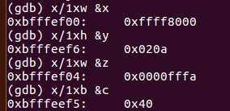

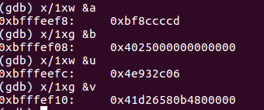

The result of running C program:

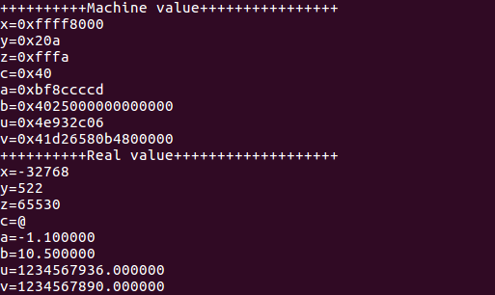
While the result of both is the same .

2.
I.
The address of a(&a) | The address of b(&b) | The address of x(&x) | The address of y(&y)
0xbfffef24 | 0xbfffef28 | 0xbfffef18 | 0xbfffef1c

Steps | x | y | *x | *y
Before 1st step | 0xbfffef24 | 0xbfffef28 | 1 | 2
After 1st step | 0xbfffef24 | 0xbfffef28 | 1 | 3
After 2nd step | 0xbfffef24 | 0xbfffef28 | 2 | 3
After 3rd step | 0xbfffef24 | 0xbfffef28 | 2 | 1

ii.
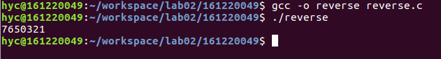
Reason of error: Becaude the number ‘4’ is in the middle, when we run xor_swap(&a[3],&a[3]), a[3] is always the same as a[3]. So
when head = tail = (len-1)/2, x and y share the same memory, which makes x=y=0 after doing “*x = *x ^ *y”

The changed version:
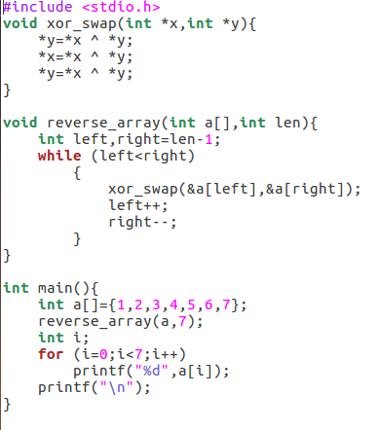

3.
 | Output: True/False | Reason
Sentence 1 | True | Int is 4 bytes,double is 8 bytes, when changing from double to int, it only cuts the partion part, and has nothing to do with integer part.
Sentence 2 | False | Int is 4 bytes,float is 4 bytes,too.(int)xf will be -2147483648 instead of 2147483647.
Sentence 3 | False | After cutting some bits, p1 and p2 will both become 3.141593 and they share the same value.
Sentence 4 | True | Because of precision problem, f-f will become 0, so result1==1.0, and it is the same as d.
Sentence 5 | False | Because of precision problem, (d+f)=f, so result2 will become 0 instead of 1.0.

4.
1)
 | Machine number(hex) | Value(dec) |  | Machine number(hex) | Value(dec)
x | 0x66 | 102 | y | 0x39 | 57
~x | 0x99 | -103 | !x | 0x00 | 0
x&y | 0x20 | 32 | x&&y | 0x01 | 1
x|y | 0x7f | 127 | x||y | 0x01 | 1
 | Machine number(hex) | Value(dec) | OF | SF | CF | AF
x1 | 0xb0 | -80 | 0 | 0 | 0 | 0
y1 | 0x8c | -116 | 0 | 0 | 0 | 0
x1+y1 | 0x3c | -196 | 0 | 0 | 0 | 0
x1-y1 | 0x24 | 36 | 0 | 0 | 0 | 1
y1-x1 | 0xdc | -36 | 0 | 1 | 1 | 0
x2 | 0xb0 | 176 | 0 | 1 | 1 | 0
y2 | 0x8c | 140 | 0 | 1 | 1 | 0
x2+y2 | 0x3c | 316 | 0 | 0 | 0 | 0
x2-y2 | 0x24 | 36 | 0 | 0 | 0 | 1
y2-x2 | 0xdc | -36 | 0 | 1 | 1 | 0

The reasons of the change of eflags:
- SF is set as MSB. Because y1-x1, y2-x2 is negative and x2+y2 is positive, and SF changes only when performing operations.
- CF is a flag indicating carrying-bit or borrowing-bit. When we do y1-x1 or y2-x2, we should borrow bits, so the CF changes.
- AF is auxiliary carrying flag. When we do x1-y1 or x2-y2,a carry happens to bit 3rd

