**DAVICOM Semiconductor, Inc.**

Web API 規格書

Web API格式使用說明

***YiCheng-Liao***

***Micron_WebAPI規格書_N01_zh_TW***

***February 8, 2023***

History

|  |  |  |  |  |
| --- | --- | --- | --- | --- |
| **版本** | **頁數** | **說明** | **修改者** | **備註** |
| N01 |  | 初搞 | YiCheng | 2023-02-06 |
|  |  |  |  |  |
|  |  |  |  |  |
|  |  |  |  |  |
|  |  |  |  |  |
|  |  |  |  |  |
|  |  |  |  |  |

目 錄

History ii

一、 資料庫定義 4

1. ERP關聯資料表 4

二、 使用者資料表 5

1. 建立使用者資料 5

2. 查詢使用者 6

3. 查詢使用者ID 7

4. 更新使用者 8

5. 刪除使用者 9

三、 品號資料表 10

# 資料庫定義

## ERP關聯資料表

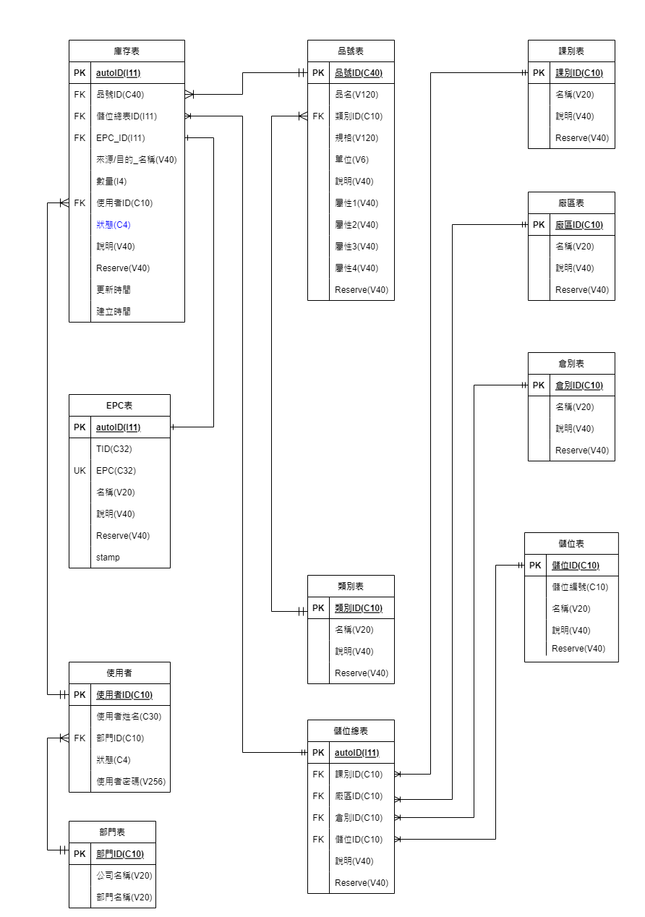

原始檔案: 美光流程資料庫V1.5.drawioo

# 名稱定義表

|  |  |
| --- | --- |
| Request | |
|  |  |
| Response "service": 0=sys, 1=web, 2=database, 3=other …. ,server處理回應代號  "code": 依server系統訊息碼回應  "msg": 文字簡要說明  "data":[json data], 以 JSON詳細資料列表 | |
|  | |
|  | |
|  | |

# 使用者資料表

|  |  |
| --- | --- |
| 建立使用者資料 | |
| 功能說明 | **使用者資料建立** |
| url: <http://127.0.0.1:3000/catalog/users>  Method: POST | |
| Body:  {  "users_id": "user007",  "name": "user0012",  "deptid": "dept001",  "state": "0",  "password": "123456"  } | |
| res.status(200); //http status  Response data:  {  "service": 1,  "code": 200,  "msg": "Flds_user creat successfully users_id: user007",  "data": []  ERROR:  res.status(200);  Response data:  {  "service": 2,  "code": 1062,  "msg": "ER_DUP_ENTRY",  "data": [{"msg":"Duplicate entry 'user005' for key 'PRIMARY'"}]  } | |
|  | |

|  |  |
| --- | --- |
| 查詢使用者 | |
| 功能說明 | **查詢所有使用者** |
| |  | | --- | | url: <http://127.0.0.1:3000/catalog/users>  Method: GET | | Body:  無 | |  |   Response: 多筆JSON資料  {  "code": 200,  "msg": "flds_user findAll successfully....",  "data": [    {  "users_id": "user001",  "name": "user0012",  "deptid": "dept001",  "state": "",  "password": "123456",  "timestamp": "2023-01-03T06:23:22.000Z"  },    {  "users_id": "user002",  "name": "user0012",  "deptid": "dept001",  "state": "",  "password": "123456",  "timestamp": "2023-01-03T06:26:59.000Z"  },  ],  } | |
|  | |

|  |  |
| --- | --- |
| 查詢使用者ID | |
| 功能說明 | **以ID查詢使用者** |
| url: [http://127.0.0.1:3000/catalog/users/user001](http://127.0.0.1:3000/catalog/users/user001%20)  Method: GET  req.params = user001 | |
| Body:  無 | |
| res.status(200);  Response:有資料  {  "code": 200,  "msg": "Flds_user findOne: user001 successfully.",  "data": [    {  "users_id": "user001",  "name": "user0012",  "deptid": "dept001",  "state": "",  "password": "123456",  "timestamp": "2023-01-03T06:23:22.000Z"  }  ],  }  res.status(200);  Response:無資料  {  "code": 204,  "msg": "Not found users_id: user006"  } | |
|  | |

|  |  |
| --- | --- |
| 更新使用者 | |
| 功能說明 | **以ID更新使用者資料** |
| url: [http://127.0.0.1:3000/catalog/users/user001](http://127.0.0.1:3000/catalog/users/user001%20)  Method: PUT  req.params = user001 | |
| Body:  {  "users_id": "user001",  "name": "user0012",  "deptid": "dept001",  "state": "0",  "password": "rrrrrr"  } | |
| res.status(200);  Response:有資料  {  "code": 200,  "msg": "Flds_user updateById successfully.",  "data": [    {  "users_id": "user001",  "name": "user0012",  "deptid": "dept001",  "state": "0",  "password": "rrrrrr"  }  ],  }  res.status(500);  Response:無資料  {  "code": 500,  "msg": "Not found uid: user006"  } | |
|  | |

|  |  |
| --- | --- |
| 刪除使用者 | |
| 功能說明 | **以ID更新使用者資料** |
| url: [http://127.0.0.1:3000/catalog/users/user001](http://127.0.0.1:3000/catalog/users/user001%20)  Method: DELETE | |
| Body:  無 | |
| res.status(200);  Response:有資料  {  "code": 200,  "msg": "deleteOne successfully users_id: user001"  }  res.status(500);  Response:無資料  {  "code": 400,  "msg": "Not found users_id: user006"  } | |
|  | |

# 品號資料表