Home page.

The colour I was assigned was #EFA94A. I have chosen to use this colour as the background of the navigation bar as this is a persistent element that heavily influences the user’s brand recognition. Every foreground element has the same rounded edges to create a sense of unity between unrelated elements.

For buttons, I have chosen to use shades of a complementary blue for the principle of emphasis, specifically on the sign-up button through high contrast against the orange background. The sign-up button is the only button to use a deeper shade of blue as this is the primary call to action, placing further emphasis on it. Every button is blue to invoke the similarity principle, so that the user can immediately understand that everything that is blue should be clickable.

Input fields are all grey as apart from the one on the navigation bar, they are on a white background. As with the buttons, this invokes the similarity principle. These follow the consistency and standards heuristic as it is still commonly accepted that a darker area on a light background represents a text field.

I have chosen to place the logo on the top left as this is the position that the flow of the website begins, it balances out the placement of the sign-in and sign-up buttons through symmetry by taking up the same space on the opposite side.

All text is coloured to strongly contrast the background it is on to maximise readability.

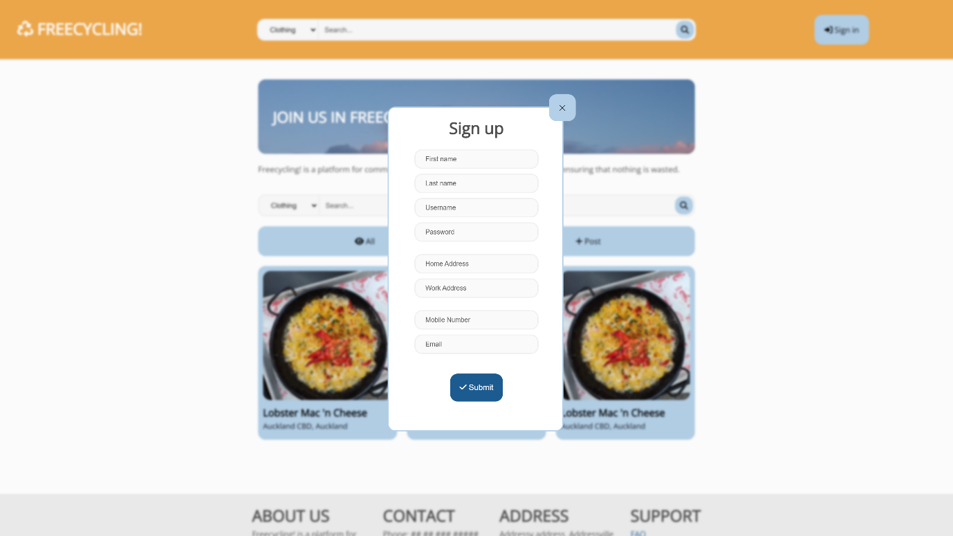

Sign-up form modal.

The modal follows the same colour scheme as the home page for the sake of unity. It is placed in the centre of the screen and the rest of the site is darkened and blurred. This de-emphasises the content behind the modal, emphasising the modal itself.

To close the modal, the user can click on the X on the top right of the modal or click anywhere outside the modal. While redundant, this contributes to the user control and freedom heuristic as the user may not notice the X button on the top right of the modal and may try to continue interacting with the home page.

Every field in the form is identical in size and alignment. The principle of similarity and common fate shows that the information that should be placed in these fields is related. Each category of the form is grouped by the proximity principle, helping the user put into perspective what the form is asking for i.e. personal information, location information, and contact information.

Footer.

At the bottom of the page, the footer is grey. This shows that it is lower in hierarchy than the page’s main contents and indicates to the user that it is less important. This is part of Aesthetic and minimal design as the information in it isn’t needed as often, and therefore, it is “hidden” at the bottom. Common fate and proximity are used to group the text.

The footer works with the navigation bar and the whitespace around the main content to emphasise the content as the figure and everything else as the ground.

The links are blue, too, but they are in a different style than the buttons, as they should lead to support pages, which are different from the rest of the site. They are parts of help and documentation.

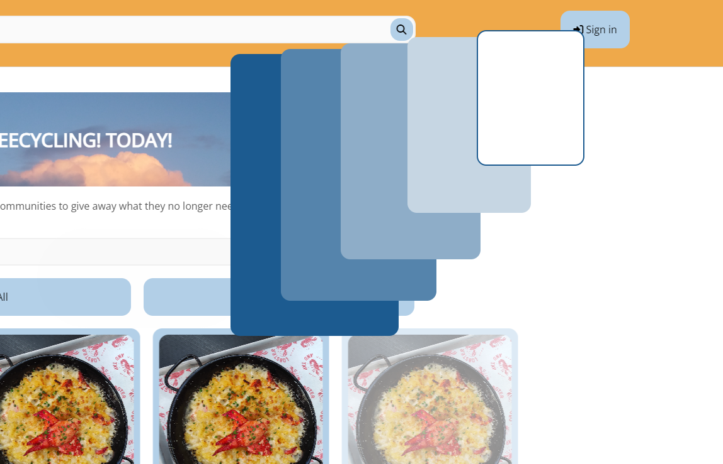

Animation upon opening sign-up form modal.

An animation plays Upon clicking the sign-up button, transitioning the button into the modal. This creates a sense of continuity between pressing the button and the form, ensuring to the user that this is intended behaviour rather than an abrupt change.



Buttons. The right one is hovered over, while the left one is not.

Each button has at least one image or icon on it. This clarifies to English readers what the button does, and non-English readers can more confidently navigate the site as the icons are universal through match between the system and the real world.

All the buttons become a deeper shade of blue when hovered. This is a part of visibility of system status as it is immediate feedback indicating that clicking will do something, without requiring the user to click to confirm it.

Another aspect of this is the pointer. While I can’t screenshot it, the cursor changes to a pointed finger when hovering over clickables like buttons and links, and it changes to a caret cursor over text fields to indicate that text can be inputted.

Category selector next to search bar.

There is the option to search for specific categories next to the search bars. This option is in the form of a dropdown for the recognition rather than recall heuristic as it is much faster to select an option from a list rather than type something out and risk it being an invalid input.

Navigation bar sticks to the top while scrolling down.

As you scroll down, the navigation bar sticks to the top of the page. Not only does this always keep the orange branding present, but it also contributes to user control and freedom, as it is always possible to access it from any part of the site, no matter how far down the user has scrolled.

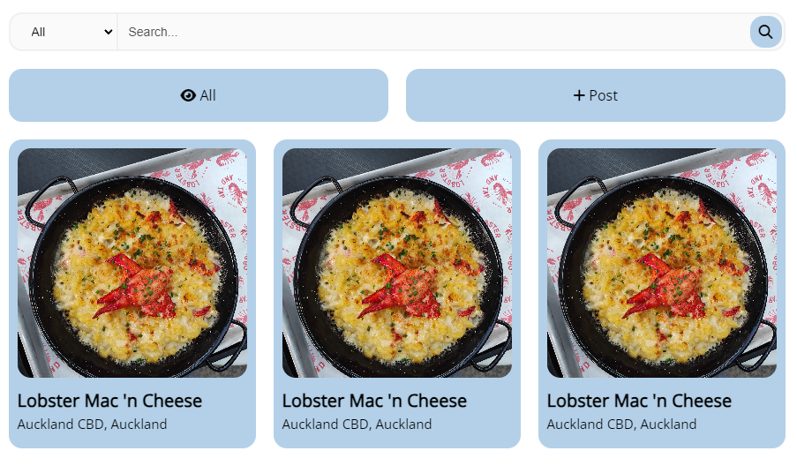

Content elements.

These elements have identical spacing between them, using proximity and closure to group these together. This is done as they are all element related to interacting with listings on the site. Free lobster mac ‘n cheese is a placeholder, but these previews would show real listings, and by grouping them with the search bar and buttons, the user understands that by interacting with those elements, they will be in some way interacting with the contents of the previews.

The previews continuously cycle through to emulate the feeling of window shopping or scanning through a store shelf, as this is a match between the system and the real world, using the user’s prior experience to inform them of what the purpose of the site is.