Presentation:

为什么用scroll

1interactivity up down

2continuity

<https://pudding.cool/process/responsive-scrollytelling/>

先完成折线图

再确定keypoints 和 段落的位置

再添加其他表格

框架

模仿<https://smashdelta.com/smartcities>

The rise and fall of bitcoin (大logo)

底部折线图？

**1intro**

The price of bitcoin rose and fell in the last two years. From less than $1000 in early 2017 to almost $20,000 of late 2017 before an epic plunge that lose 82% of the value, it has all the hallmarks of a bubble -- speculative buying, fear of missing out, a sudden frenzy of interest from the general public.

Follow the time line, lets dive into the largest daily changes in price from the beginning of 2017 through the end of November 2018 and specific events coinciding with them.

**2 Paragraph x 8**

From January to April, the price rose steadily from $965 to $1316. On May 21, BTC surpassed $2000 for the first time, and from there, continued to quickly gain traction at price.

On August 1, the Bitcoin network split in an event now known as the [**Bitcoin Cash hard fork**](https://coolwallet.io/what-is-bitcoin-cash/). Although many were expecting this to lead to a crash in BTC’s price, following the split, it fell slightly from $2874 to $2719. It quickly recovered, reaching a new ALT of $3000 on August 6, and surpassing $4000 by mid-August. At the start of September, it was $4710, but its bull runs briefly impeded by the announcement of China’s ICO crackdown on September 4, which resulted in a dip from $4531 to $4308.

From October to the end of the year, it was a case of one ATH replacing another. At the end of October, $6000 was reached for the first time, with $7000 following in early November. On November 20, a new ALT of $8000 was reached, demonstrating a quick recovery from a crash of $5760 just days before.

The rest of the year would go down in history as Bitcoin’s biggest bull run. What caused the bull run is attributed to a number of factors, including greater media attention, an increase in public interest fueled by a fear of missing out (FOMO), greater institutional interest, and the introduction of BTC futures trading. At the start of December, $10,699 was hit, and then the price continued to increase by thousands every couple of days – until it hit its all-time high to date of $19,429 on December 17.

The high was not sustained, however, with the price dipping in the following days, going back down to $13,311 on December 24, a correction that essentially shaved billions of dollars off BTC’s market capitalization. Ironically, the decline is considered by many, including the Federal Reserve Bank of San Francisco, to have been a consequence of the [**launch of Bitcoin futures trading**](https://cointelegraph.com/news/federal-reserve-bitcoin-futures-launch-led-to-december-2017-price-decline). The year was finished on $13,313.

**3So, what’s next?**

Looking back at bitcoins price fluctuation in the last two years, stomach-churning tumbles of 40%, one thing for sure is that the once most popular crypto currency is a **extremely volatile asset**, and **highly sensitive to external factors** like government regulation or cybersecurity. We expect a long way to go before it can function as a reliable medium of exchange.

4 key points

Tooltip：

Price：$xxx

Time :

Text:

1Japan and Russia make bitcoin legal currency-April 12

<https://www.cnbc.com/2017/04/12/bitcoin-price-rises-japan-russia-regulation.html>

Bitcoin splits into Bitcoin and Bitcoin Cash – Aug 5

Price dipped in response to China's bitcoin ICO and exchange crackdown-Sep 12

<https://www.cnbc.com/2017/09/04/chinese-icos-china-bans-fundraising-through-initial-coin-offerings-report-says.html>

Price rose 5% in 24 hours, to reach a new all-time high -December 17

<http://fortune.com/2017/12/17/bitcoin-record-high-short-of-20000/>

Price lost one third of its value in 24 hours, dropping below $14,000- Dec 22

<https://money.cnn.com/2017/12/22/investing/bitcoin-plunges-below-14k/index.html>

“[**Black Tuesday**](https://cointelegraph.com/news/twitter-reacts-to-black-tuesday)”: Regulatory uncertainty in China and Korea-Jan 16

<https://cointelegraph.com/news/twitter-reacts-to-black-tuesday>

January 8, 2018

CoinMarketCap drops South Korea prices from cryptocurrency rates and regulator inspects cryptocurrency bank accounts. - January 8, 2018Bitcoin value: $16831.09     Bitcoin value 10 days later: $10685.16     View Event #79 on ChartCoinMarketCap removed prices from South Korean exchanges from its calculations of cryptocurrency rates without any warning, resulting in a steep drop in all prices.

Additionally, Korea’s financial authorities on Jan. 8 launched an investigation into cryptocurrency-related services provided by local banks amid criticism that recent government measures are having little impact on cooling the markets. Sources: https://www.reuters.com/article/uk-global-bitcoin/bitcoin-slides-as-website-drops-south-korea-prices-from-virtual-currency-rates-idUSKBN1EX1DB

Read more: [100% Complete Bitcoin Price History Graph + Related Events up to 2019 | 99Bitcoins](https://99bitcoins.com/price-chart-history/)

|  |  |  |
| --- | --- | --- |
| 5 February 2018 | $6,200 ecrease | Price dropped by 50% in 16 days, falling below $7,000.[[163]](https://en.wikipedia.org/wiki/History_of_bitcoin" \l "cite_note-163) |

The table below summarizes the seven largest daily price changes of Bitcoin in terms of absolute value during the period in question. Each coincides with a new event or piece of information that investors may have found important.

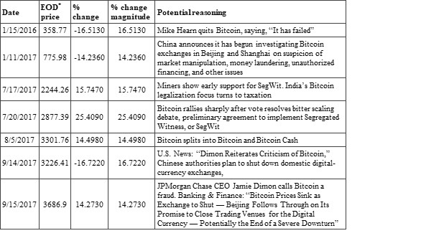

The largest daily increase in Bitcoin’s price during the period occurred on July 20, 2017 (25.4 percent), when an agreement appeared to be reached regarding the scaling of Bitcoin’s blockchain-based payment system. The largest daily price decrease occurred on September 14, 2017, when the Chinese government announced plans to shut down domestic cryptocurrency exchanges.