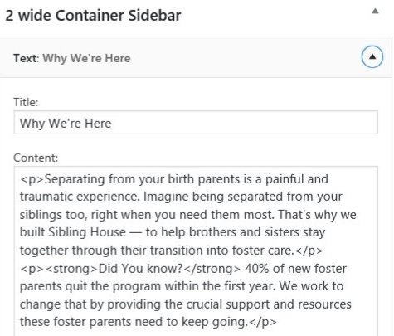

<p>Separating from your birth parents is a painful and traumatic experience. Imagine being separated from your siblings too, right when you need them most. That's why we built Sibling House — to help brothers and sisters stay together through their transition into foster care.</p>

<p><strong>Did You know?</strong> 40% of new foster parents quit the program within the first year. We work to change that by providing the crucial support and resources these foster parents need to keep going.</p>

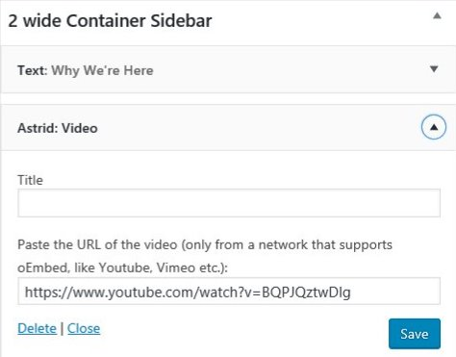

https://www.youtube.com/watch?v=BQPJQztwDlg

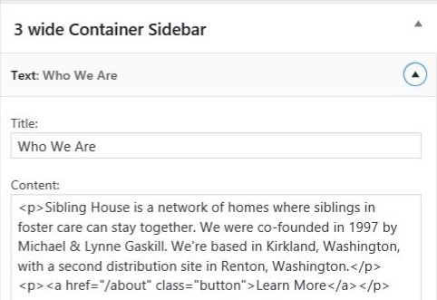

<p>Sibling House is a network of homes where siblings in foster care can stay together. We were co-founded in 1997 by Michael & Lynne Gaskill. We're based in Kirkland, Washington, with a second distribution site in Renton, Washington.</p>

<p><a href="/about" class="button">Learn More</a></p>

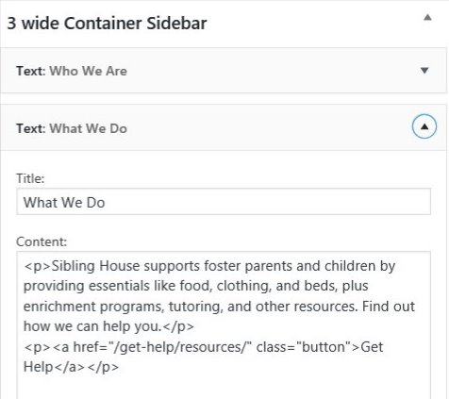

<p>Sibling House supports foster parents and children by providing essentials like food, clothing, and beds, plus enrichment programs, tutoring, and other resources. Find out how we can help you.</p>

<p><a href="/get-help/resources/" class="button">Get Help</a></p>

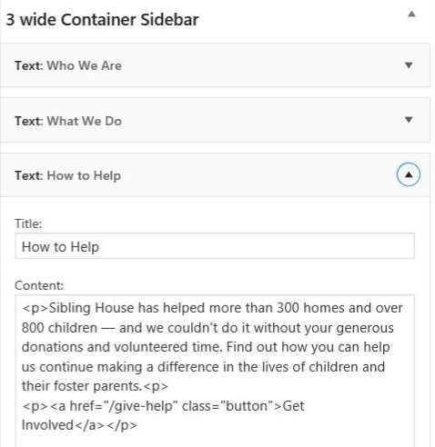

<p>Sibling House has helped more than 300 homes and over 800 children — and we couldn't do it without your generous donations and volunteered time. Find out how you can help us continue making a difference in the lives of children and their foster parents.<p>

<p><a href="/give-help" class="button">Get Involved</a></p>

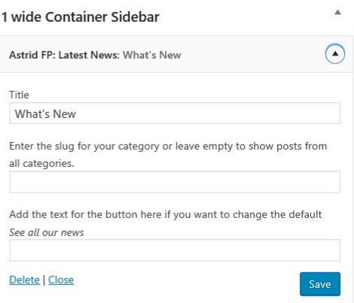

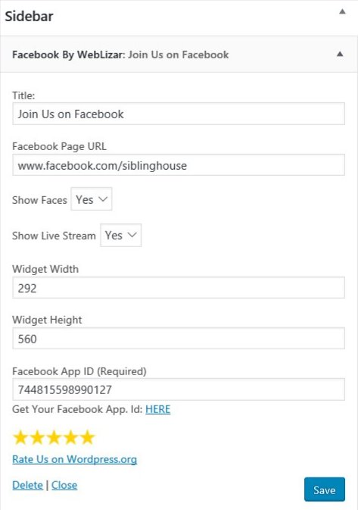

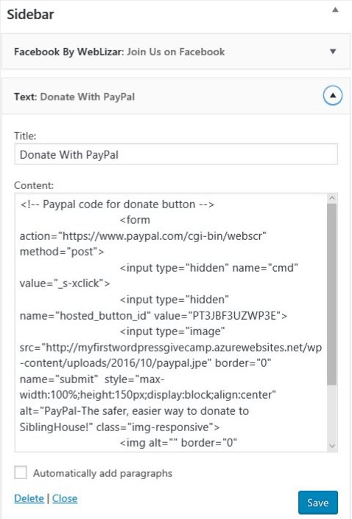

<!-- Paypal code for donate button -->

<form action="https://www.paypal.com/cgi-bin/webscr" method="post">

<input type="hidden" name="cmd" value="_s-xclick">

<input type="hidden" name="hosted_button_id" value="PT3JBF3UZWP3E">

<input type="image" src="http://myfirstwordpressgivecamp.azurewebsites.net/wp-content/uploads/2016/10/paypal.jpe" border="0" name="submit" style="max-width:100%;height:150px;display:block;align:center" alt="PayPal-The safer, easier way to donate to SiblingHouse!" class="img-responsive">

<img alt="" border="0" src="https://www.paypal.com/en_US/i/scr/pixel.gif" width="1" height="1" >

</form>

<!-- end paypal code for donate button -->

