**Report of Manual Strategy**

Course: CS 7646 ML4T

Name: Yichao Zhang

GT User ID: yzhang3414

1. **Technical Indicators**

**Here we use 3 indicators: Price/SMA , Bollinger Band Position, Momentum**

**The prices have been normalized to 1**

* **Price / SMA (Simple Moving Average)**

Here, SMA (Simple Moving Average) is the average of prices in the recent 10 days. It is much smoother than the prices, which means less chaos.

However, SMA is not comparable. Different stocks have very different SMA, just like prices.

Here we use price/SMA as our indicator. This value of price/SMA is close to 1, no matter for what stock. So it is comparable. When the price is much lower/higher than SMA, that indicates a buy/sell signal.

Below is the Prices, SMA and Price/SMA in 2008 and 2009.

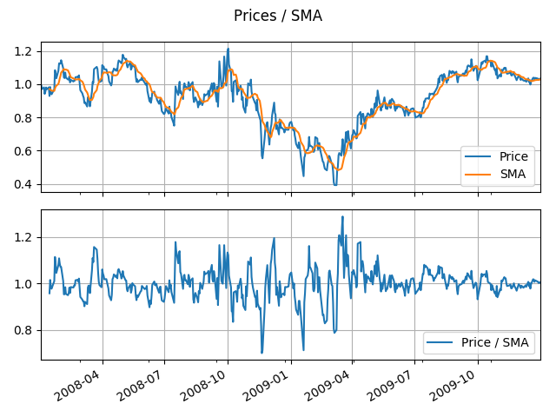

* **Bollinger Band Position**

Bollinger Band is another useful tool for prediction. The top/bottom band value equals SMA +/- 2*STD, where STD is the standard deviation of simple moving prices.

BBP(Bollinger Band Position) is:

(price - bottom band value) / (top band value - bottom band value)

The top/ bottom band values are much smoother than the prices, and have less chaos.

BBP is typically between 0-1. When the BBP is much lower/higher than 0.5, that indicates a buy/sell signal.

Below is the Prices, top band, bottom band, and BBP in 2008 and 2009.

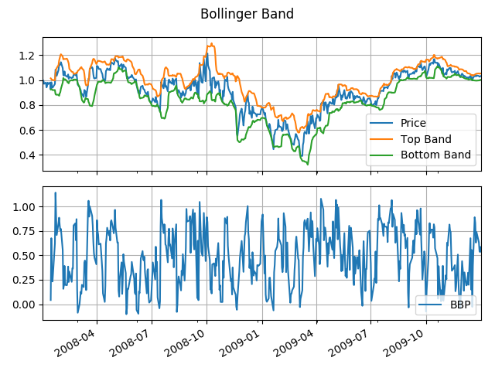

* **Momentum**

Here, Momentum equals price / price of 3 days ago – 1. It indicates the speed of price changing. It is typically close to 0.

When the momentum is very positively/ negatively large, that means the price is moving up/ down very fast, so that we should not sell / buy at this point.

Below is the Prices, and Momentum in 2008 and 2009.

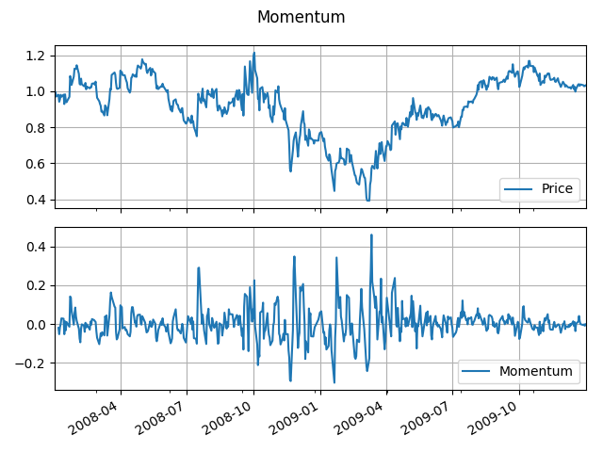

1. **Theoretically Optimal Strategy**

**Theoretically Optimal Strategy** is that we long/short as much as we can when tomorrow price is higher or lower than today. If the price won’t change, we do nothing. We limit the holding shares in 3 positions: 1000, 0, -1000. So when our action exceeds the limit, we stop at the limit.

**Benchmark** is that we buy 1000 shares, and hold it to the end.

Here Commission = $0 and Impact = 0.

The details of 2008-2009 has been shown below.

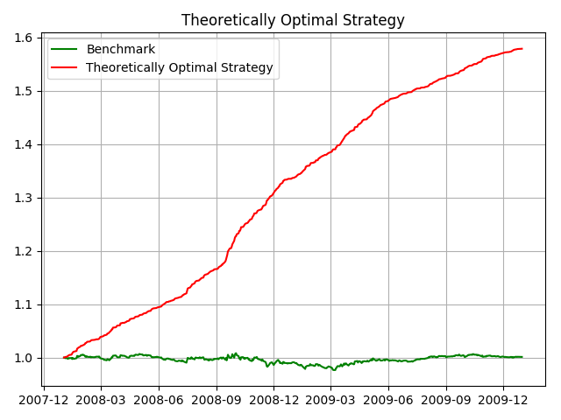

Theoretically Optimal Strategy

cum_ret: 0.57861000000000007

avg_daily_ret: 0.00090666668174388702

std_daily_ret: 0.00091135883655471528

Benchmark

cum_ret: 0.0012300000000000644

avg_daily_ret: 3.7364779836330479e-06

std_daily_ret: 0.0016126823215239833

1. **Manual Strategy**

**Manual Strategy** is that:

If price/SMA < 0.98 and BBP < 0.02 and Momentum > -0.3, we long as much as we can;

If price/SMA > 1.02 and BBP > 0.98 and Momentum < 0.3, we short as much as we can;

Otherwise, we do nothing.

We limit the holding shares in 3 positions: 1000, 0, -1000. So when our action exceeds the limit, we stop at the limit.

Here Commission = $9.95 and Impact = 0.005

The details of 2008-2009 has been shown below.

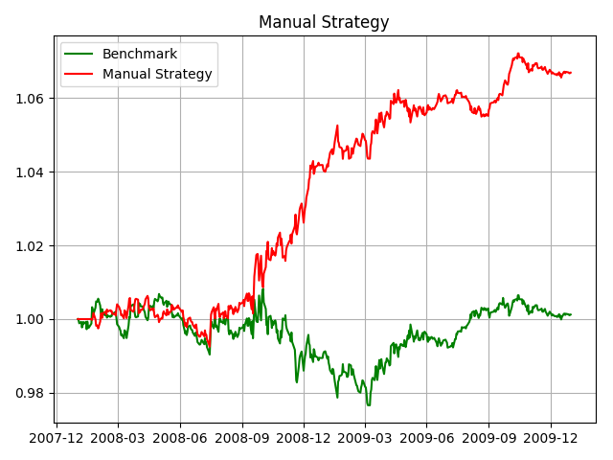

Munual Strategy in sample

cum_ret: 0.066874600000000006

avg_daily_ret: 0.00012959819667794791

std_daily_ret: 0.0015187132543848145

Benchmark, in sample

cum_ret: 0.0012300000000000644

avg_daily_ret: 3.7364779836330479e-06

std_daily_ret: 0.0016126823215239833

The performance is good, we get about 6.7% cum_return. Much better than the benchmark, which is about 0 cum_return.

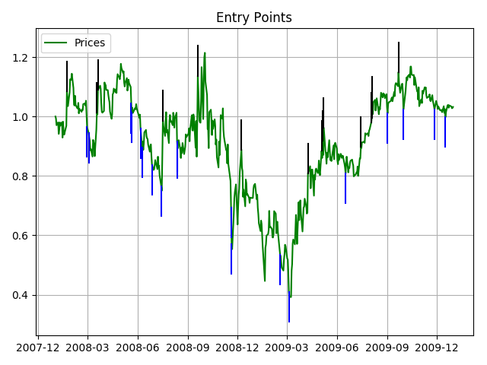

1. **Comparative Analysis**

The details of 2010-2011 has been shown below.

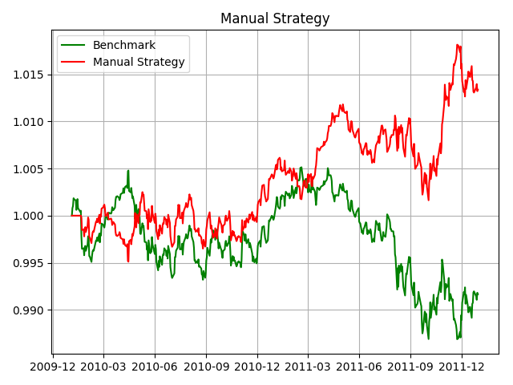

Munual Strategy out sample

cum_ret: 0.013370250000000139

avg_daily_ret: 2.6706241957101183e-05

std_daily_ret: 0.00077668194676794723

Benchmark, out sample

cum_ret: - 0.0083400000000000141

avg_daily_ret: -1.6320225884111369e-05

std_daily_ret: 0.00081278761801517802

Here the performance is not as good as in sample data, we get only 1.3% cum_return. But our performance is still better than the benchmark, which has negative cum_return

Compare with in sample result, we find out performance decreases, because the market goes down in 2010-2011. Although we are better than the benchmark, we cannot beat the market too much.

