**Report of Martingale**

Course: CS 7646 ML4T

Name: Yichao Zhang

GT User ID: yzhang3414

1. **In Experiment 1, estimate the probability of winning $80 within 1000 sequential bets. Explain your reasoning.**

The probability is about 100%.

Figure 1,2,3 show that all the episodes win $80 before 300 spins, we can see that both mean and median hit $80 and standard deviation decreased to 0.

This is because we have unlimited bank rolls, no matter how many times we lose, we can win a spin after each losing list, and increase $1 after each win. Sooner or later, we will win 80 times and get $80 after enough spins.

1. **In Experiment 1, what is the estimated expected value of our winnings after 1000 sequential bets? Explain your reasoning. Go here to learn about expected value:** [**https://en.wikipedia.org/wiki/Expected_value**](https://en.wikipedia.org/wiki/Expected_value)

$80.

In this experiment, the expected value is the mean value. As shown in figure 2, after enough sequential bets (here < 300), the mean value converges to $80.

1. **In Experiment 1, does the standard deviation reach a maximum value then stabilize as the number of sequential bets increases? Explain why it does (or does not).**

No.

As shown in figure 2, after enough sequential bets (here < 300), both mean value + standard deviation and mean value - standard deviation converge to mean value $80. So that standard deviation converges to $0.

1. **In Experiment 2, estimate the probability of winning $80 within 1000 sequential bets. Explain your reasoning.**

The probability is about 66.9%.

According to the simulation results, we count the number where episode winning = $80, and get 669. Then divide by the total episodes 1000.

1. **In Experiment 2, what is the estimated expected value of our winnings after 1000 sequential bets? Explain your reasoning.**

The expected value (mean value) is about $-31 after 1000 bets.

As shown in Figure 4, the mean value almost levels about $-28 after 300 bets, and according to the whole simulation results, it levels about $-31 after 1000 bets.

1. **In Experiment 2, does the standard deviation reach a maximum value then stabilize as the number of sequential bets increases? Explain why it does (or does not).**

Yes.

The standard deviation converges to the maximum value, about $158.

As shown in Figure 5, the median converges to $80, and median – standard deviation leaves away from median as the bets increase, and levels at about $-78 after enough bets. So the standard deviation converges to the maximum value, about $158.

1. **Include figures 1 through 5.**

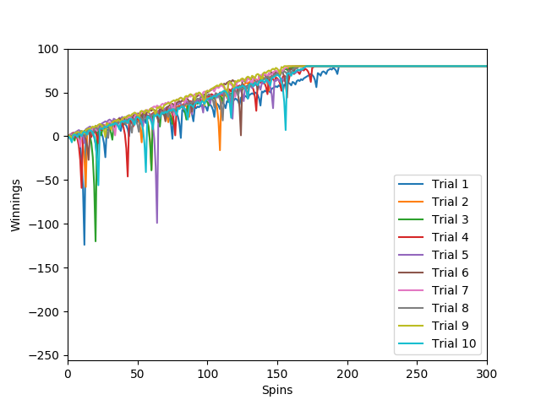

Figure 1: Winnings of each Spin, where episodes = 10, unlimited bank rolls

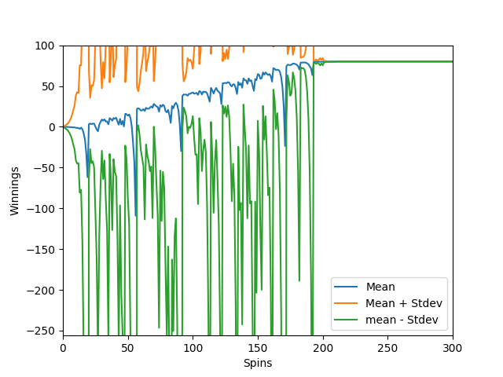

Figure 2: Mean values with Standard Deviations for Winnings of each Spin,

where episodes = 1000, unlimited bank rolls

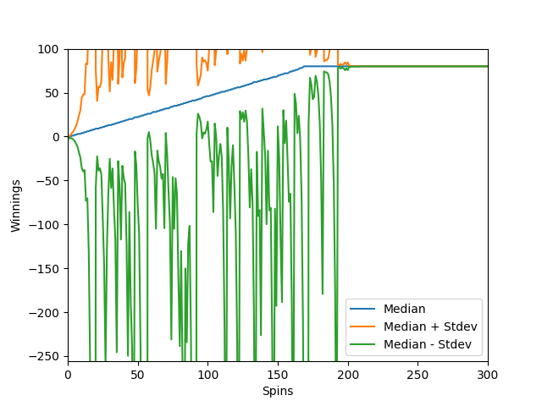

Figure 3: Median values with Standard Deviations for Winnings of each Spin,

where episodes = 1000, unlimited bank rolls

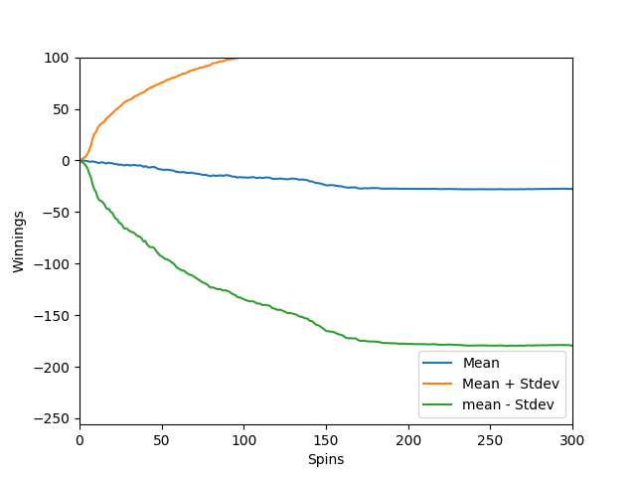

Figure 4: Mean values with Standard Deviations for Winnings of each Spin,

where episodes = 1000, bank rolls = $256

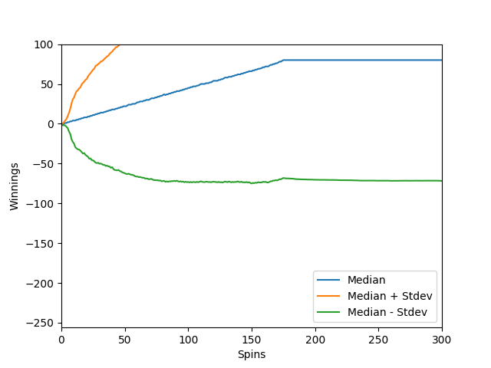

Figure 5: Median values with Standard Deviations for Winnings of each Spin,

where episodes = 1000, bank rolls = $256