**Report of Optimize Something**

Course: CS 7646 ML4T

Name: Yichao Zhang

GT User ID: yzhang3414

1. **Includes a chart comparing the optimal portfolio with SPY using the following parameters:**

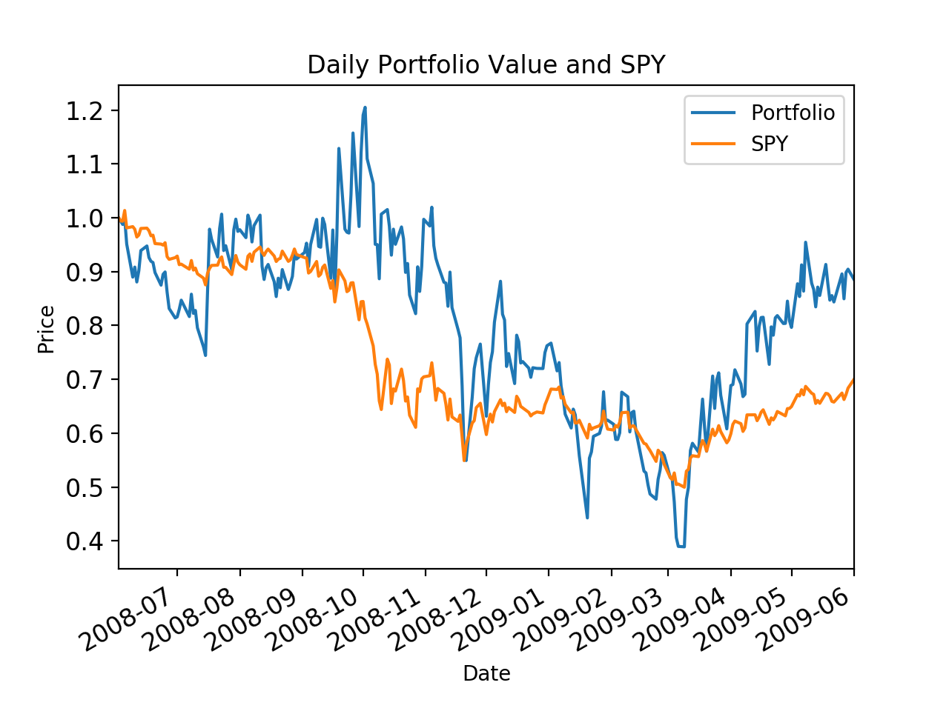

Figure 1: Comparing the optimal portfolio with SPY

Daily Portfolio Details

Start Date: 2008-06-01 00:00:00

End Date: 2009-06-01 00:00:00

Symbols: ['IBM', 'X', 'GLD', 'JPM']

Allocations: [ 0.00000000e+00 6.93889390e-16 0.00000000e+00 1.00000000e+00]

Sharpe Ratio: 0.423952549074

Volatility (stdev of daily returns): 0.0687736588046

Average Daily Return: 0.0018367037394

Cumulative Return: -0.114809081527