Problem 1

E_CV plot
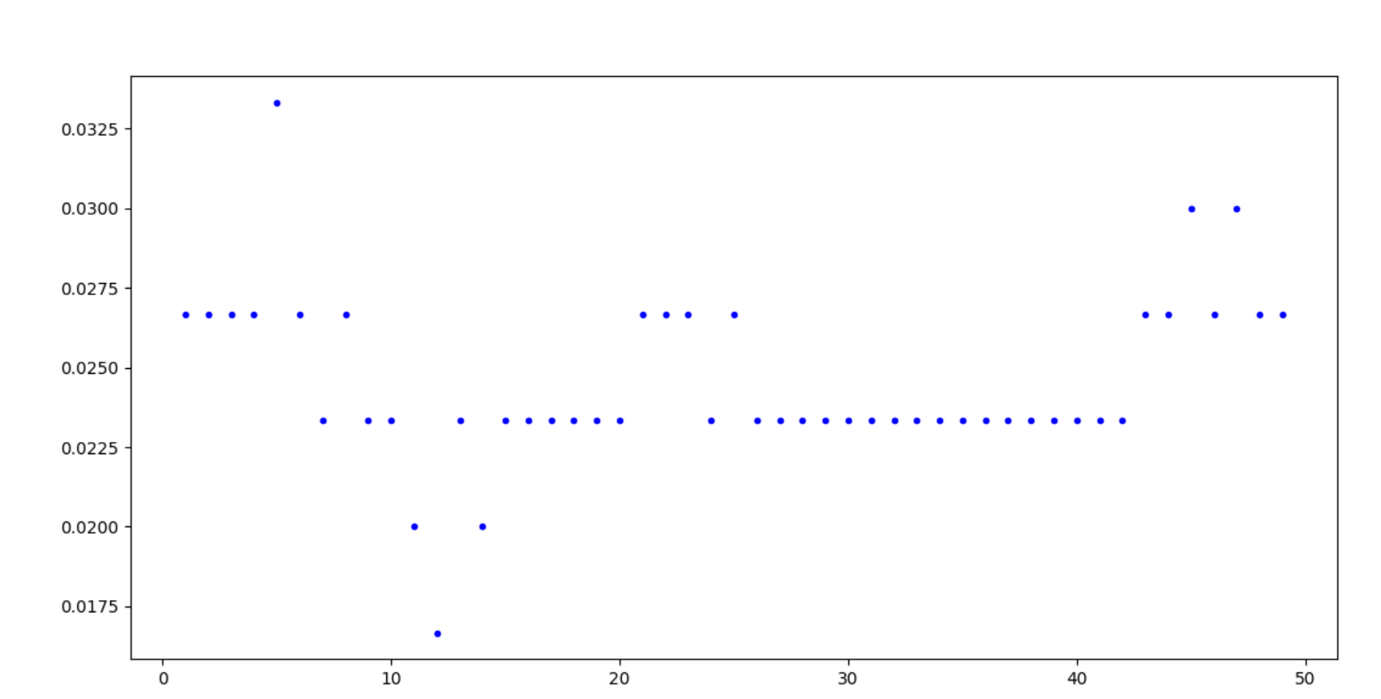
Decision Boundary
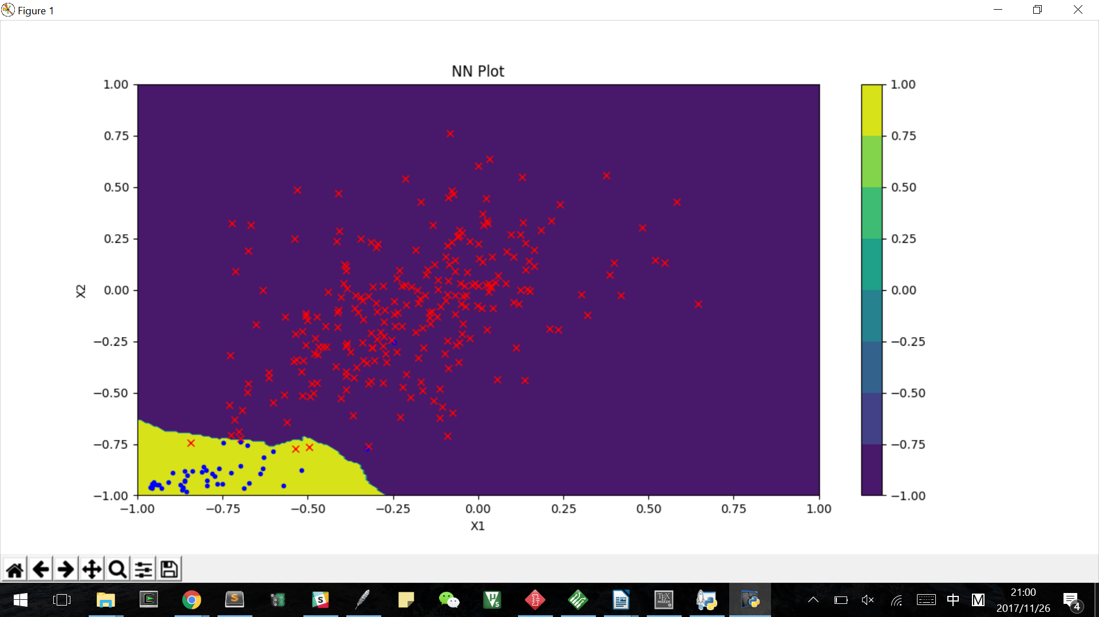

Problem 2

E_CV plot
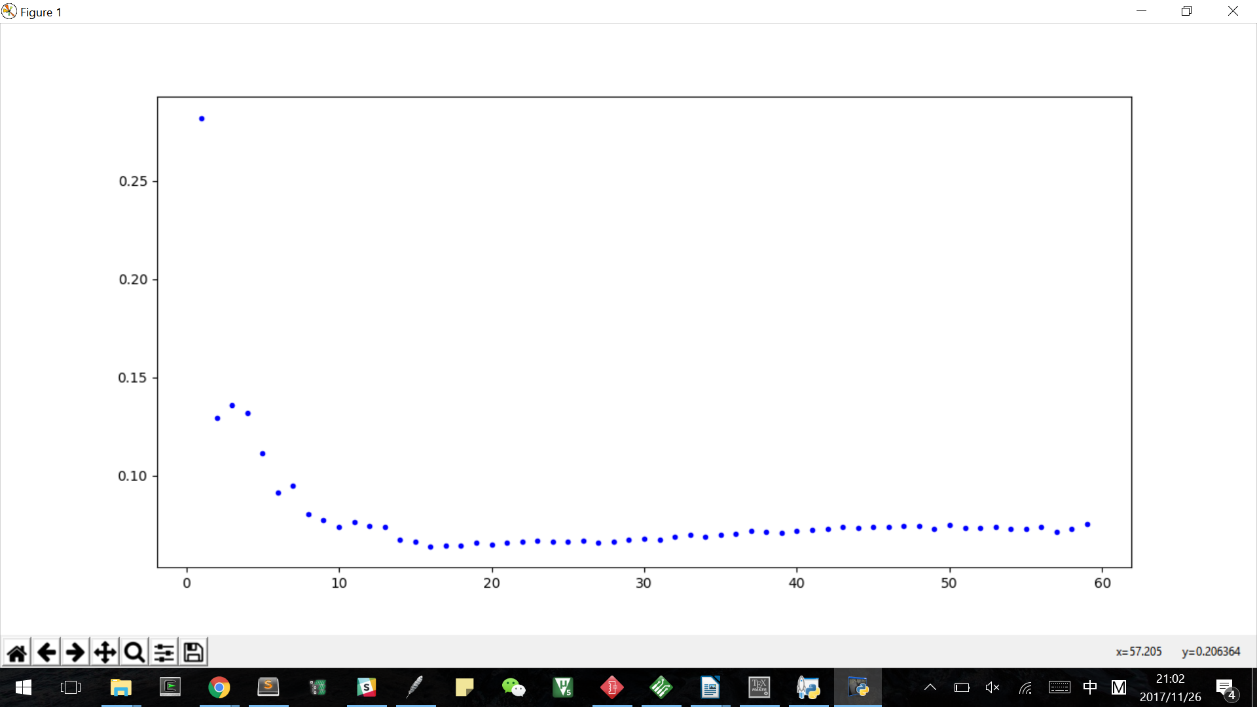
Decision Boundary
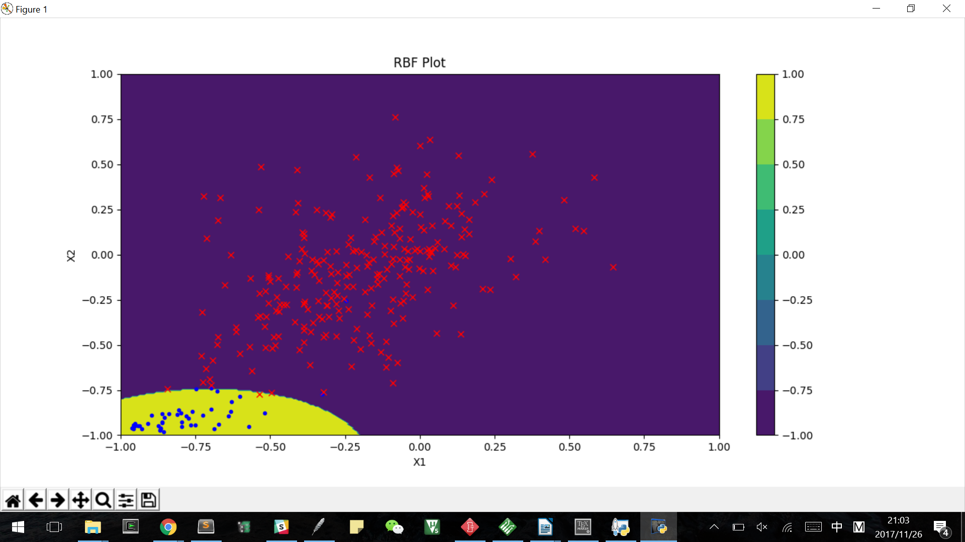

Linear Model
train
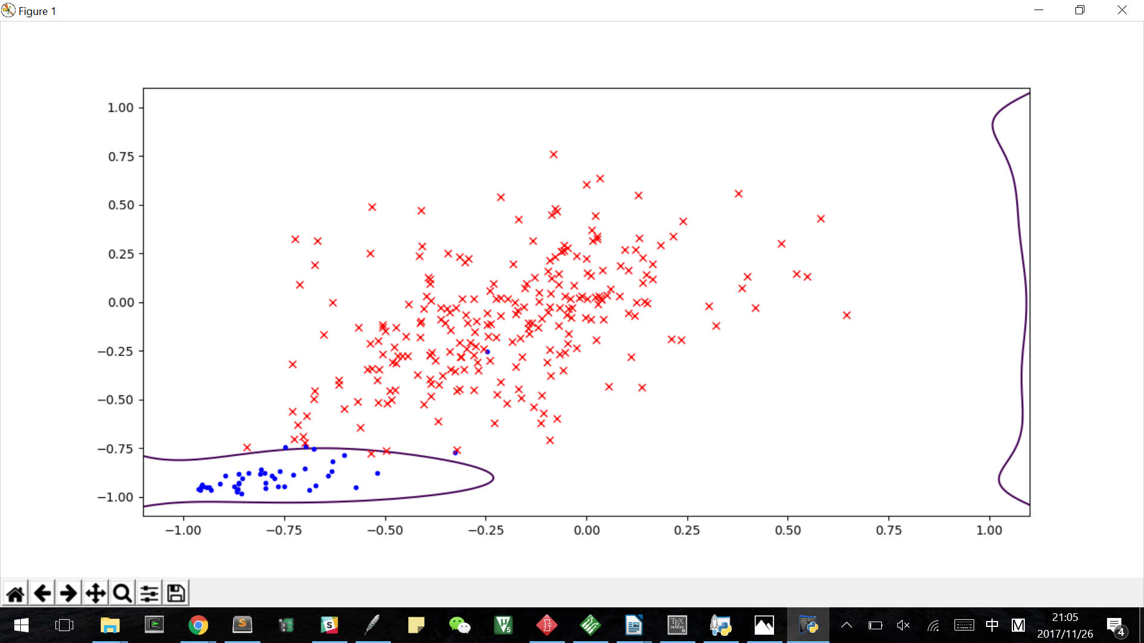
test
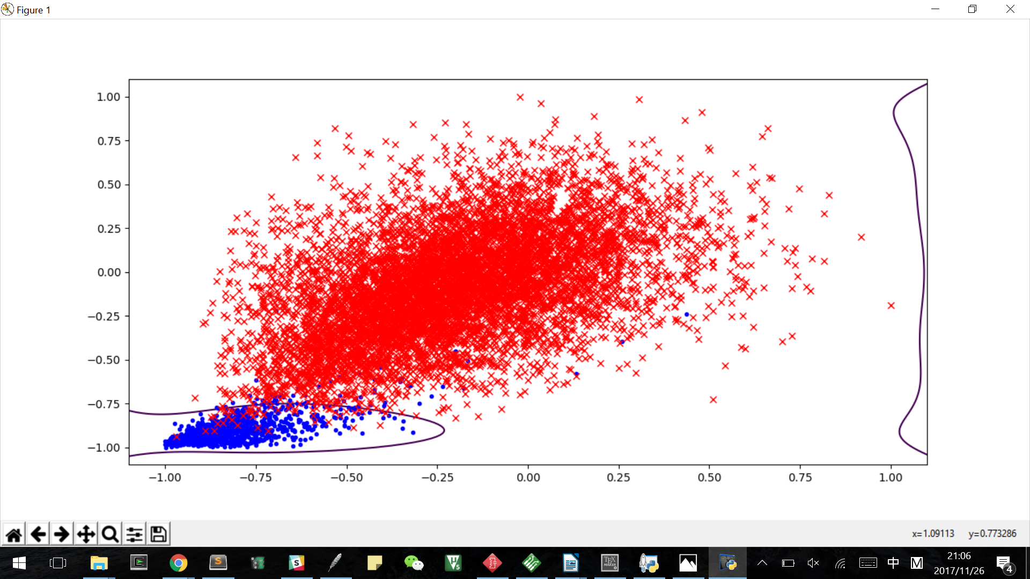

Data Selection==========================
Extracting Data...
Extract data from: ZipDigits.train
Extract data from: ZipDigits.test
9298 data points
Selecting Data...
Data selection Done
KNN=======================
Selecting K...
best k and cv: 12 0.0166666666667
e_test: 0.0137808401867
Drawing Contour...
--- 140.220000029 seconds ---
RBF=========================
Selecting K...
RBF learn with 16 centers
best k and cv: 16 0.0639422156696
etest: 0.012891753723
--- 7.31200003624 seconds ---
Linear Model==================================
Drawing Contour...
lambda: 1.99 E_CV: 0.0583217769809 E_test: 0.0134474327628

