MODEL: reg = 0.0
E_CV: 0.0809970940527 E_test: 0.0172260502334
================================================
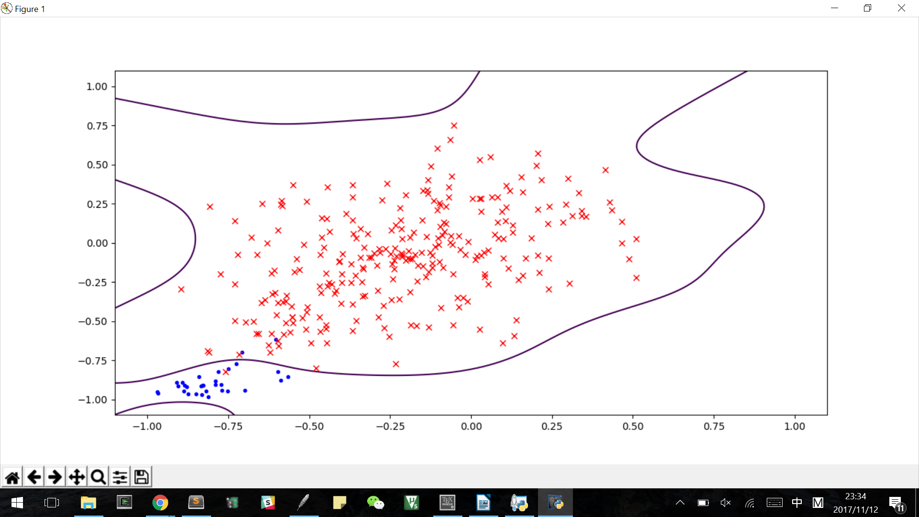

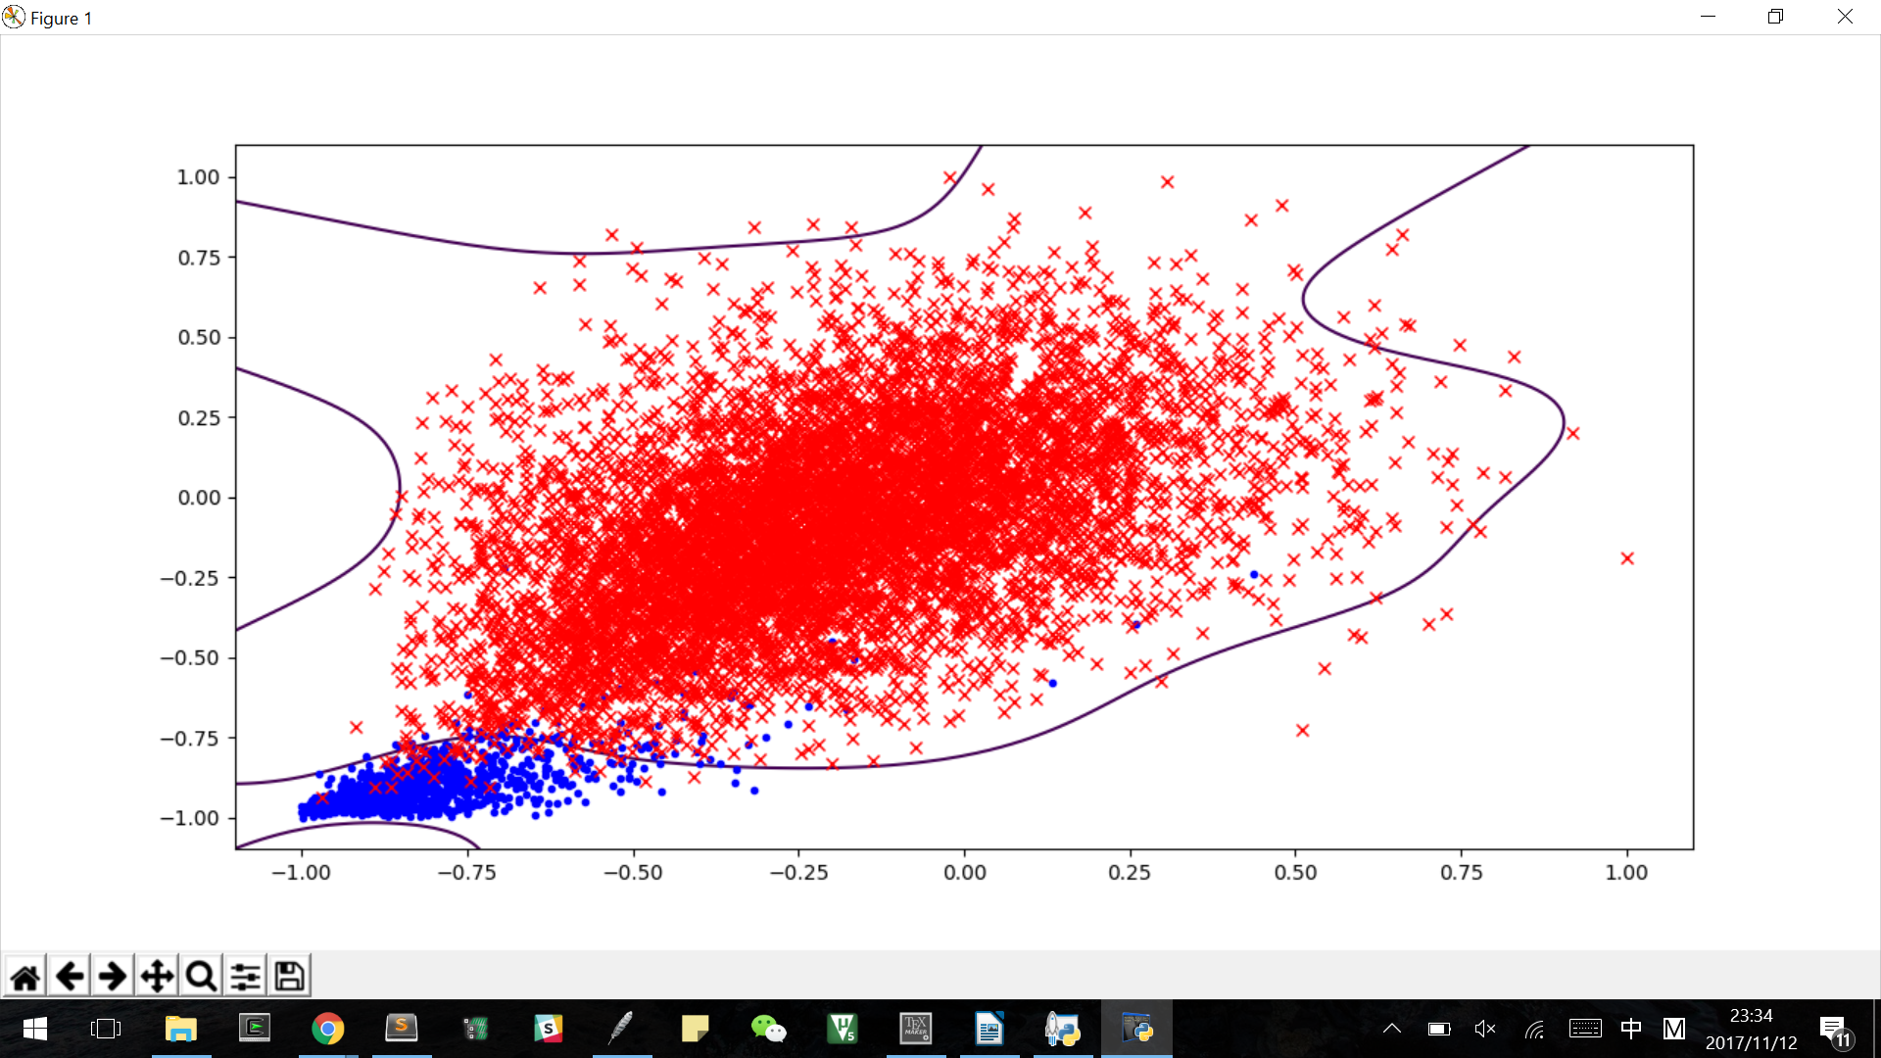

MODEL: reg = 2.0
E_CV: 0.0504480684725 E_test: 0.0148921982663
================================================
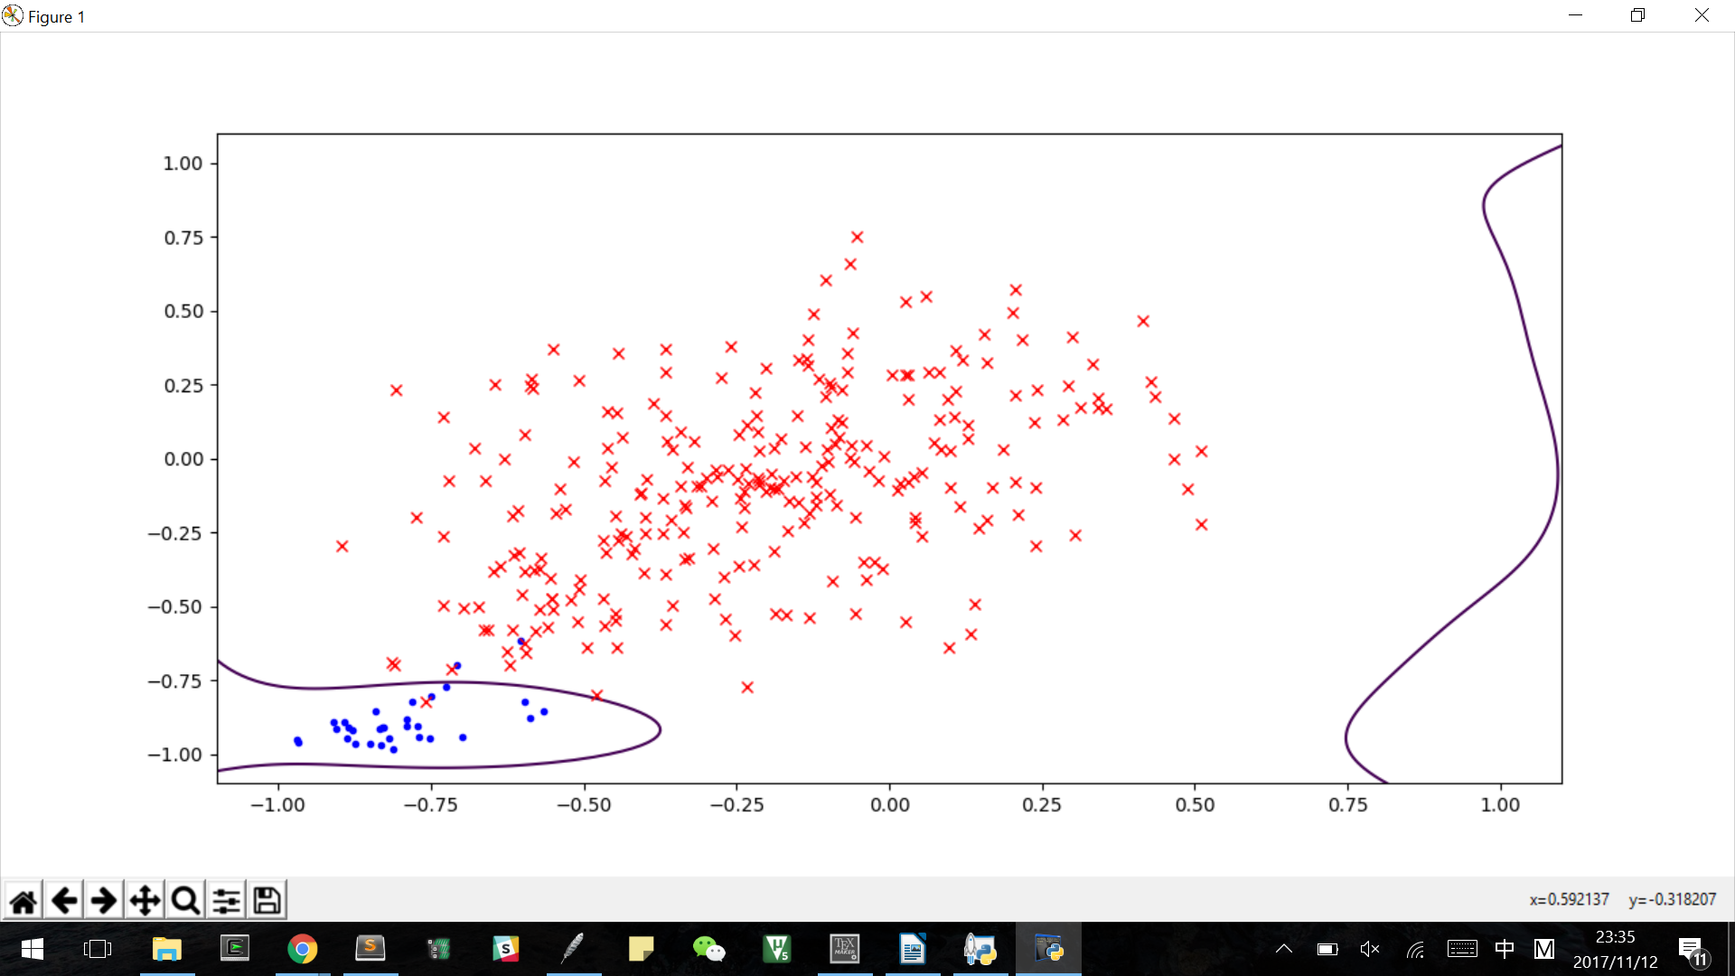

testing data
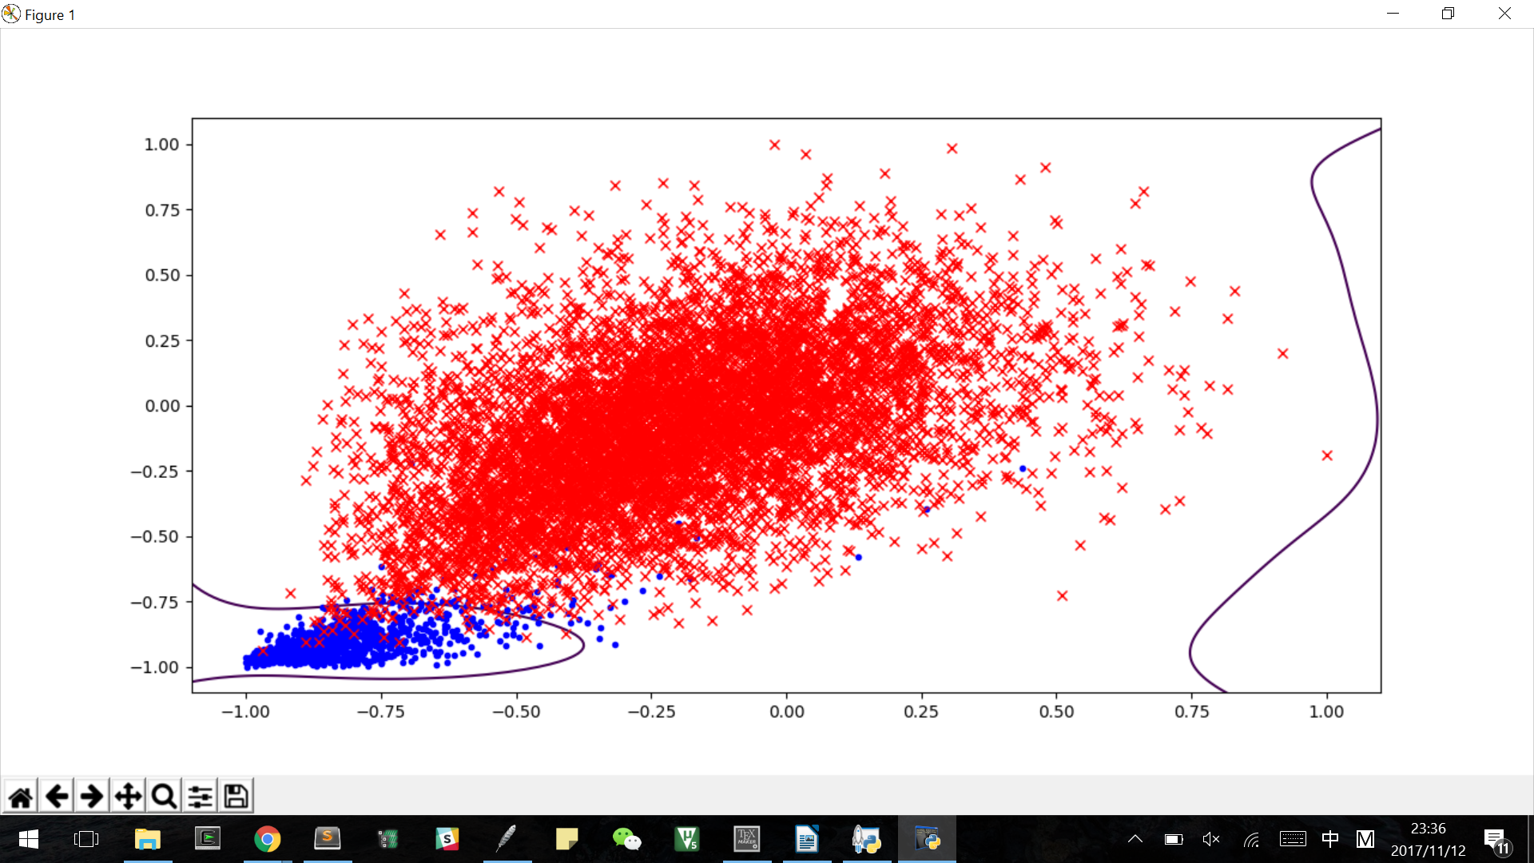

ecv vs etest
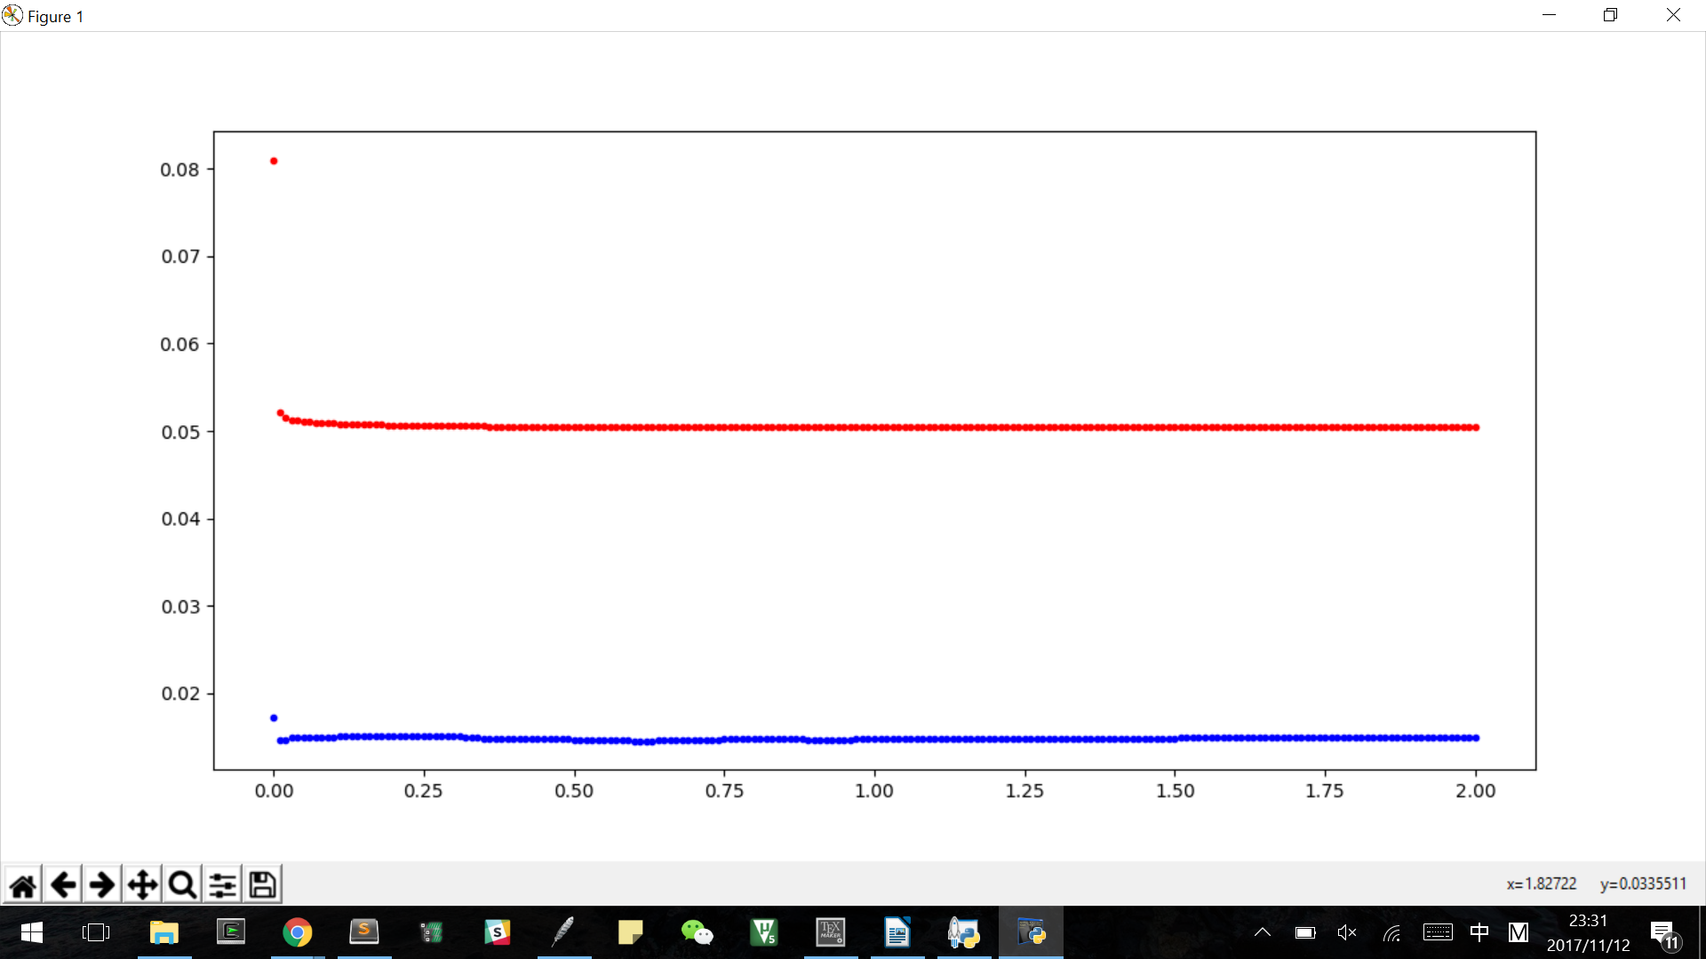

lambda star: 1.17 E_CV: 0.0503865112933 E_test: 0.0147810624583
