Exercises
1.8 v <= 0.1 means we get 9 green balls out of ten sample balls. The probability of getting a green ball from the pool is 0.1, so the probability of getting 9 green balls is (0.1)⁹ = 10⁻⁹

1.9
u=0.9, v<=0.1, |v-u|>=0.8
P[|v-u|>=0.8]<=2e^{-2*0.8*10} = 2.25e-7
QUESTION: Oirginal equation has |v-u|>e, can I use >= in this calculation? (Ask TA)

1.10
(a) u=0.5 for all three coins
(b)
c_1

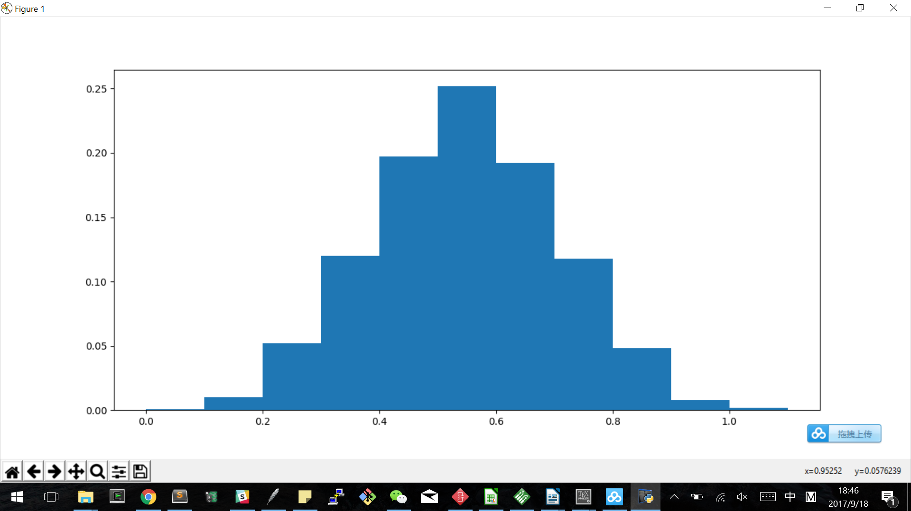

c_rand
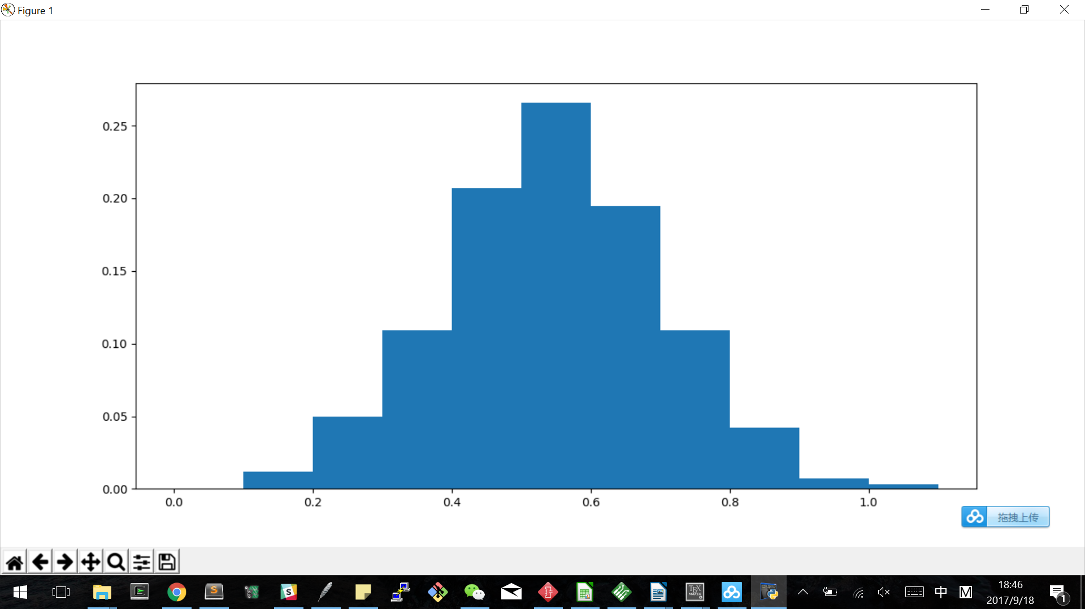

c_min

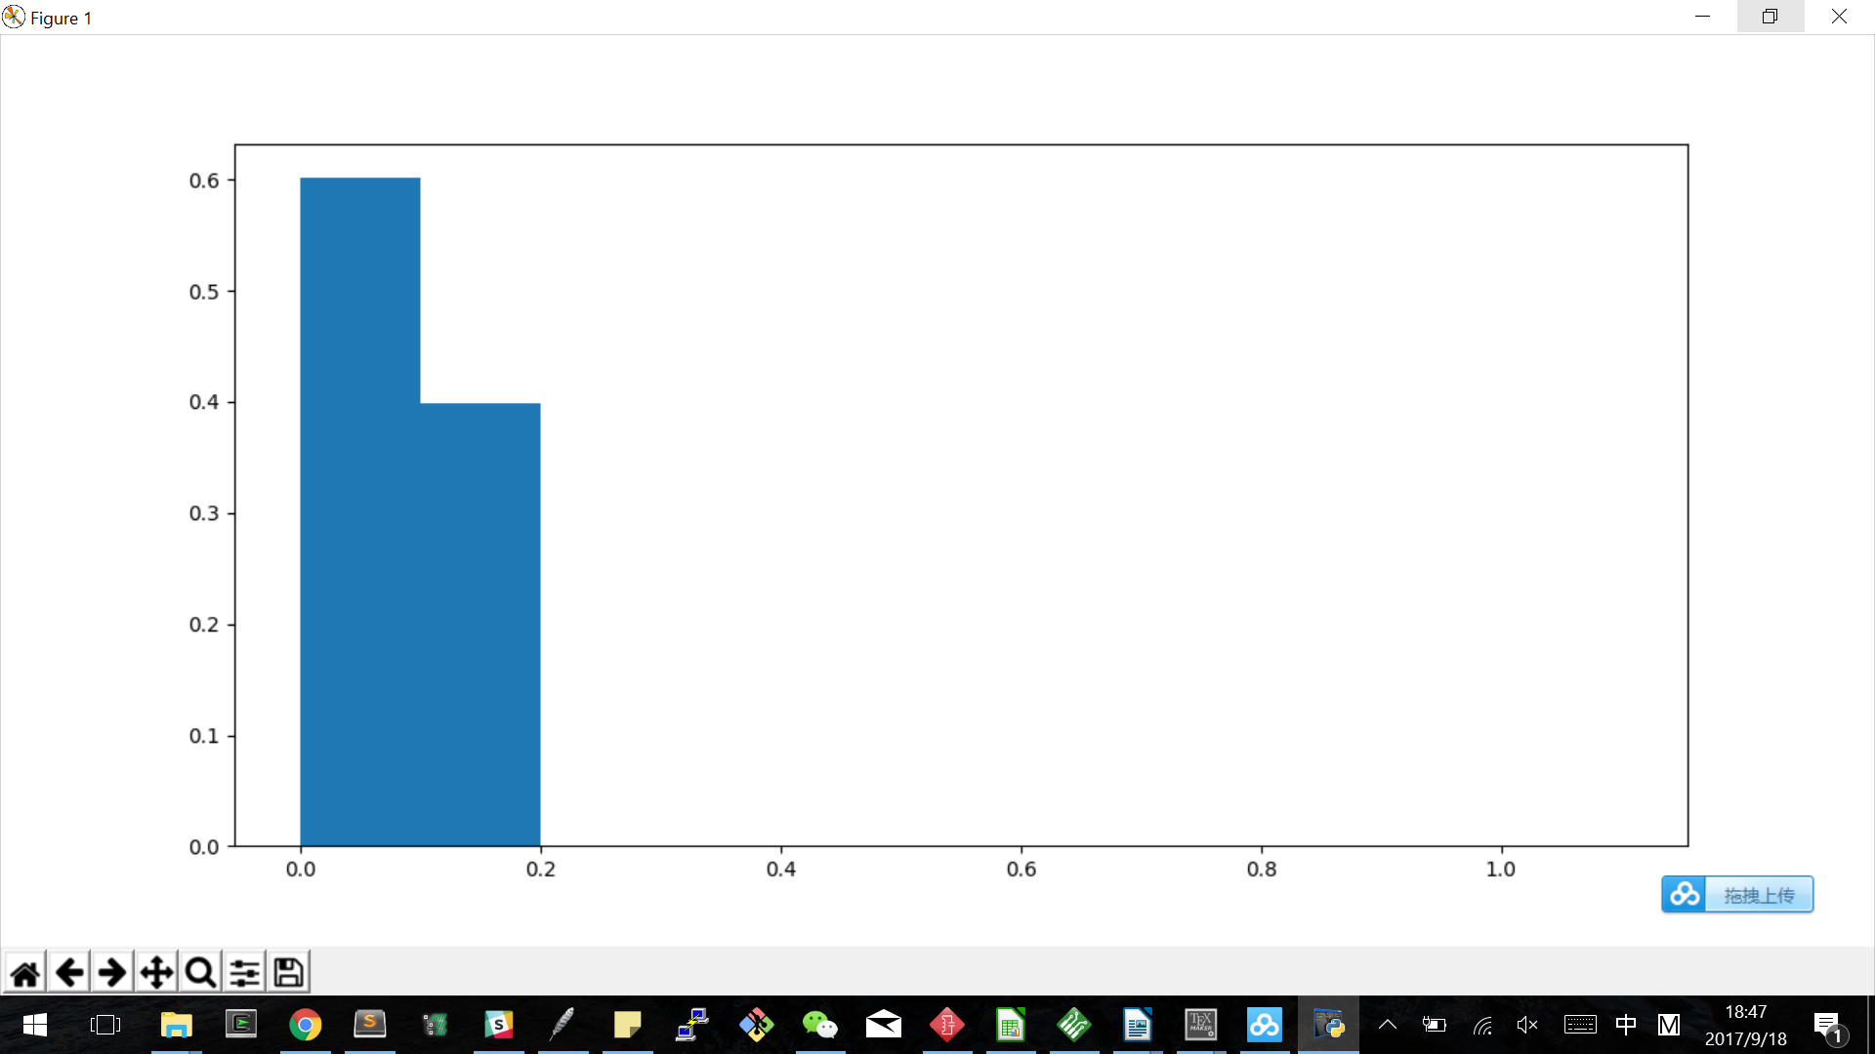
c)
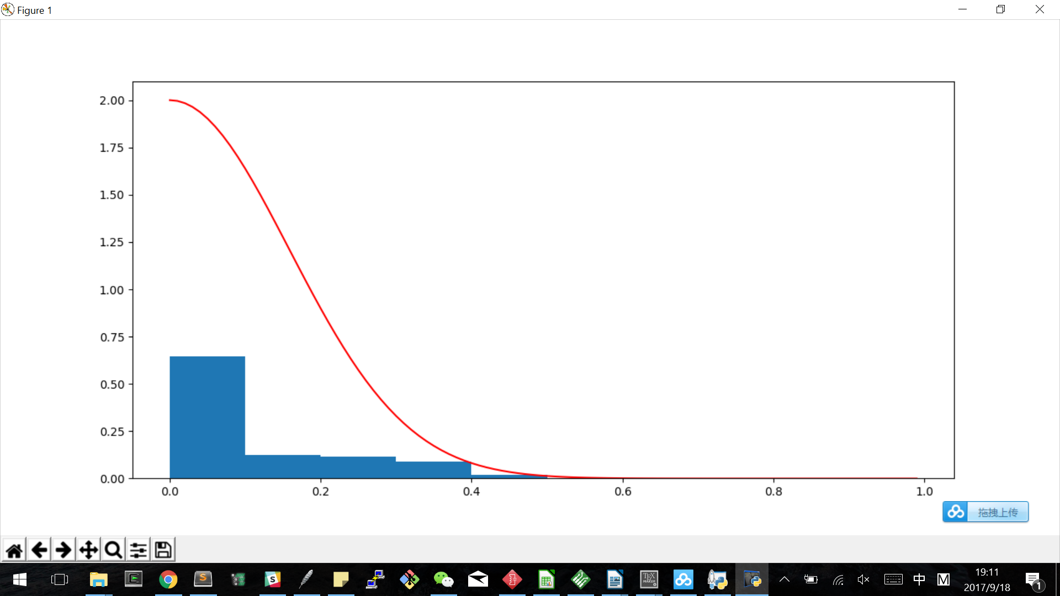
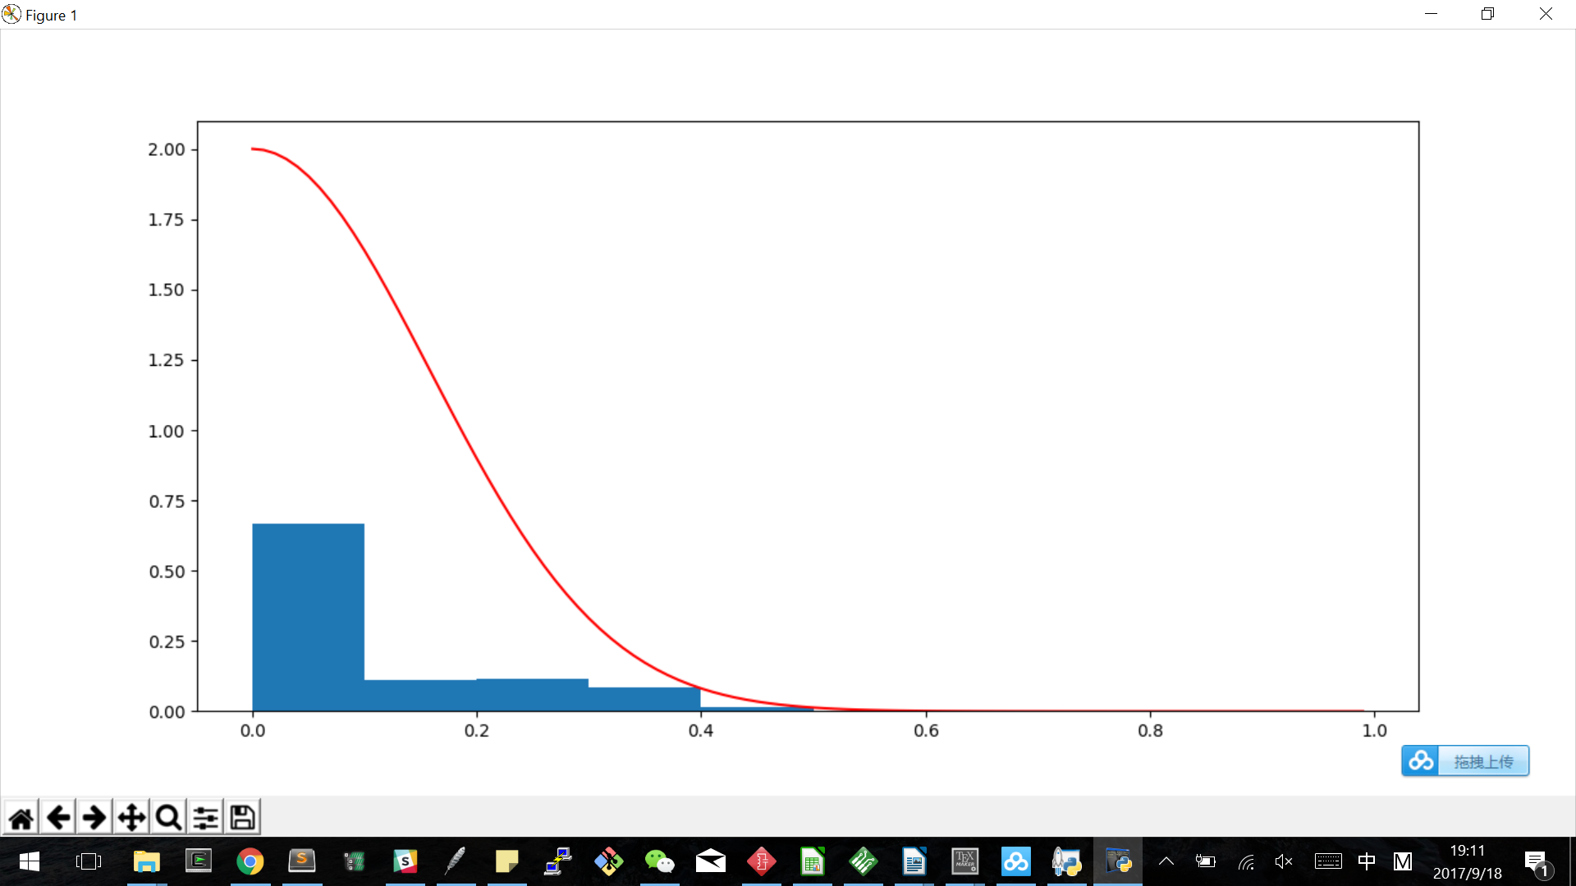
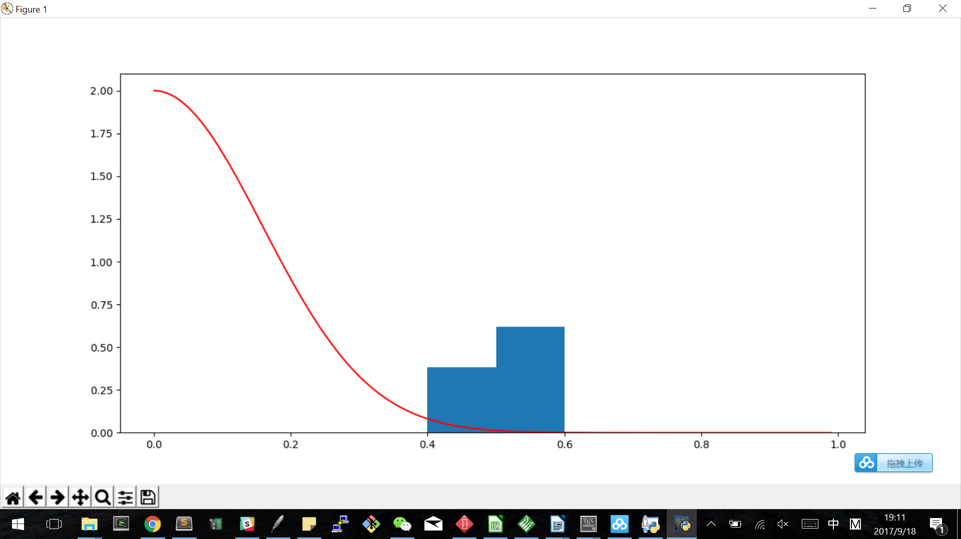

d) The first flipped coin and the random selected coin obeys Hoeffding bound; the min coin doesn’t.
The first flipped coin and the random selected coin are hypotheses that are fixed before data set generation, so they follow the rule. The minimum coin is a hypothesis that changes during data set generation; each time a coin has a smaller fraction of heads than current minimum value would result in an update in hypothesis.

e)Relate to bin problem
We have 1000 bins, each bin contains infinite red and green balls; there are same number of green balls and red balls. We try to estimate the red/total ratio, which is 0.5. (u=0.5)
We take out 10 balls out of each bin and look at red ball ratio. Our first hypothesis is the sample ratio from bin no.1, and the second hypothesis is the sample ratio from a random bin. In both of these cases the hypothesis is fixed before we begin to pick balls out of bins, and therefore they are protected by Hoeffding Bound. The third hypothesis is different; it CHANGES after data generation. This hypothesis takes the bin with least red ball sample, and therefore can be switched from bin A to bin B after data point generation in bin A. This switching violates prerequisite of Hoeffding Bound, and therefore is not protected.

WE HAVE BIAS TOWARD SOME TYPES OF SAMPLE RESULTS, THEREFORE VIOLATING THE RULE.

1.11
a) No.
b) Yes.
c) NEED QUESTION CLARIFICATION
S will agree most with D, which is always +1, while C will deliberately choose -1. If p=0.9, S will produce better result than C 90% of the time. So the answer is 0.9

d) p<0.5

1.12: (c) is what I can promise. I cannot guarantee g’s performance, I cannot find a g that is likely to produce good performance, but I can check if the g I picked is likely to produce good performance.

Problems
1.3 PLA Proof
a)Since w* separates the data, all the data are correctly classified by w*. In this case all of y_{n}(w*^{T}x_{n})<0. So ρ > 0.
b)
w(t) = w(t-1)+y(t-1)x(t-1)

w^{T}(t)w* = (w(t-1)+y(t-1)x(t-1))^{T}w*
= w^{T}(t-1)w*+y(t-1)x^{T}(t-1)w*
= w^{T}(t-1)w*+y(t-1)w*^{T}x(t-1)

since ρ is the minimum of y_{n}w*^{T}x_{n}, we have y(t-1)w*^{T}x(t-1)>= ρ , so we have:
w^{T}(t)w*>=w^{T}(t-1)w*+ρ

Induction proof of w^{T}w* >= tρ:

Base case: iteration zero has w(0)w* = 0 since w(0)=0, and tρ = 0 since t = 0. So we have w(0)w*=tρ

Induction step: With iteration N being correct, we prove that iteration N+1 is correct.
For iteration N (t=N), we have

w(N)w*>=Nρ
We have proved w^{T}(t)w*>=w^{T}(t-1)w*+ρ, by substituting in N we have
w^{T}(N+1)w*>=w^{T}(N)w*+ρ
Combine this equation with w(N)w*>=Nρ we have
w^{T}(N+1)w*>=(N+1)ρ
c)

w(t) = w(t-1)+x(t-1)y(t-1)
w(t)² = w^{T}(t)w(t) = w^{T}(t)w(t-1)+w^{T}(t)x(t-1)y(t-1)

w^{T}(t-1)x(t-1)y(t-1)<=0

w^{T}(t-1)w(t) = w(t-1)² + w^{T}(t-1)x(t-1)y(t-1)

w(t-1)² >= w^{T}(t-1)w(t)

1.7b
