KRAS suppression in pancreatic cancer cells
RNA SEQ PROGRESS REPORT
Yichuan Lin | University of Ottawa, Faculty of Science | 2026-10-01

1 Overview
This report reanalyses data from the study by Klomp and colleagues.¹ Gene counting is complete for 17 runs from eight pancreatic cancer cell lines. The dataset contains eight control runs and nine KRAS siRNA runs. Correcting duplicate inputs resolved the KRAS M1 counting failure. The current matrix contains 28,395 gene rows, with all runs retained for review.²

2 Work completed
The original quality review covered 34 FASTQ files with FastQC and MultiQC. HISAT2 2.2.3 aligned paired reads to human hg38 using unstranded settings, without trimming or a read limit. featureCounts 2.1.1 used the built-in hg38 annotation, counted pairs as fragments and excluded chimeric fragments.²
Full-file checks showed that the original M1 R1 and decompressed R2 contained identical reads. Replacement files from ENA run SRR24828469 matched the expected checksums.³ All 45,292,678 paired identifiers matched in order, and the uploaded Galaxy copies passed the file checks.²
After reanalysis, M1 assigned counts rose from 509 to 37,657,740, and concordant unique alignment rose from 0.0030% to 85.54%. Overall alignment stayed near 96.5%, which shows why this metric alone did not reveal the error. M1 now detects 18,871 genes and correlates with its Pa01C control at r = 0.9944.²
All 454,320 values in the other 16 count columns remained unchanged. Their assignment rates range from 65.61% to 76.45%, compared with 68.94% for corrected M1. The appendix presents the count distributions, correlations and principal component analysis (PCA). M3 separates in both treatment conditions, so this pattern alone does not justify excluding it.²
R code rebuilds the raw count matrix and sample annotations. Python code generates the plots from log2(CPM + 1), where CPM means counts per million. Exported counts remain unnormalized integers. The earlier FastQC reports describe the original files, not a new quality assessment of the replacement M1 pair.²

3 Next steps
First, establish whether the two P5 KRAS runs are technical repeats, biological repeats or alternative experiments. Their accessions are SRR24828471 and SRR24828472. This distinction determines the final analysis inputs. Next, compare treatments while accounting for cell-line identity, using raw integer counts. Report effect sizes and adjusted P values before interpreting gene or pathway changes.

4 Summary
The M1 input error is corrected, and the updated count matrix retains all 17 runs. The quality plots support proceeding to statistical analysis but do not establish KRAS knockdown efficiency or treatment effects. The next priority is to resolve the P5 repeat relationship, then test the treatment effect while accounting for cell line.

Appendix A Count distributions
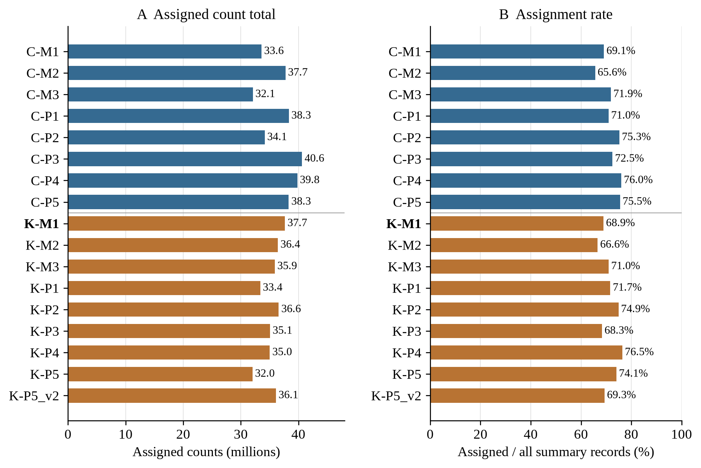
Figure A1 Assigned counts and assignment rates
Assigned count totals and assignment rates. C denotes control and K denotes KRAS siRNA. Codes identify cell lines throughout the appendix. The rate uses all featureCounts summary records as its denominator.²
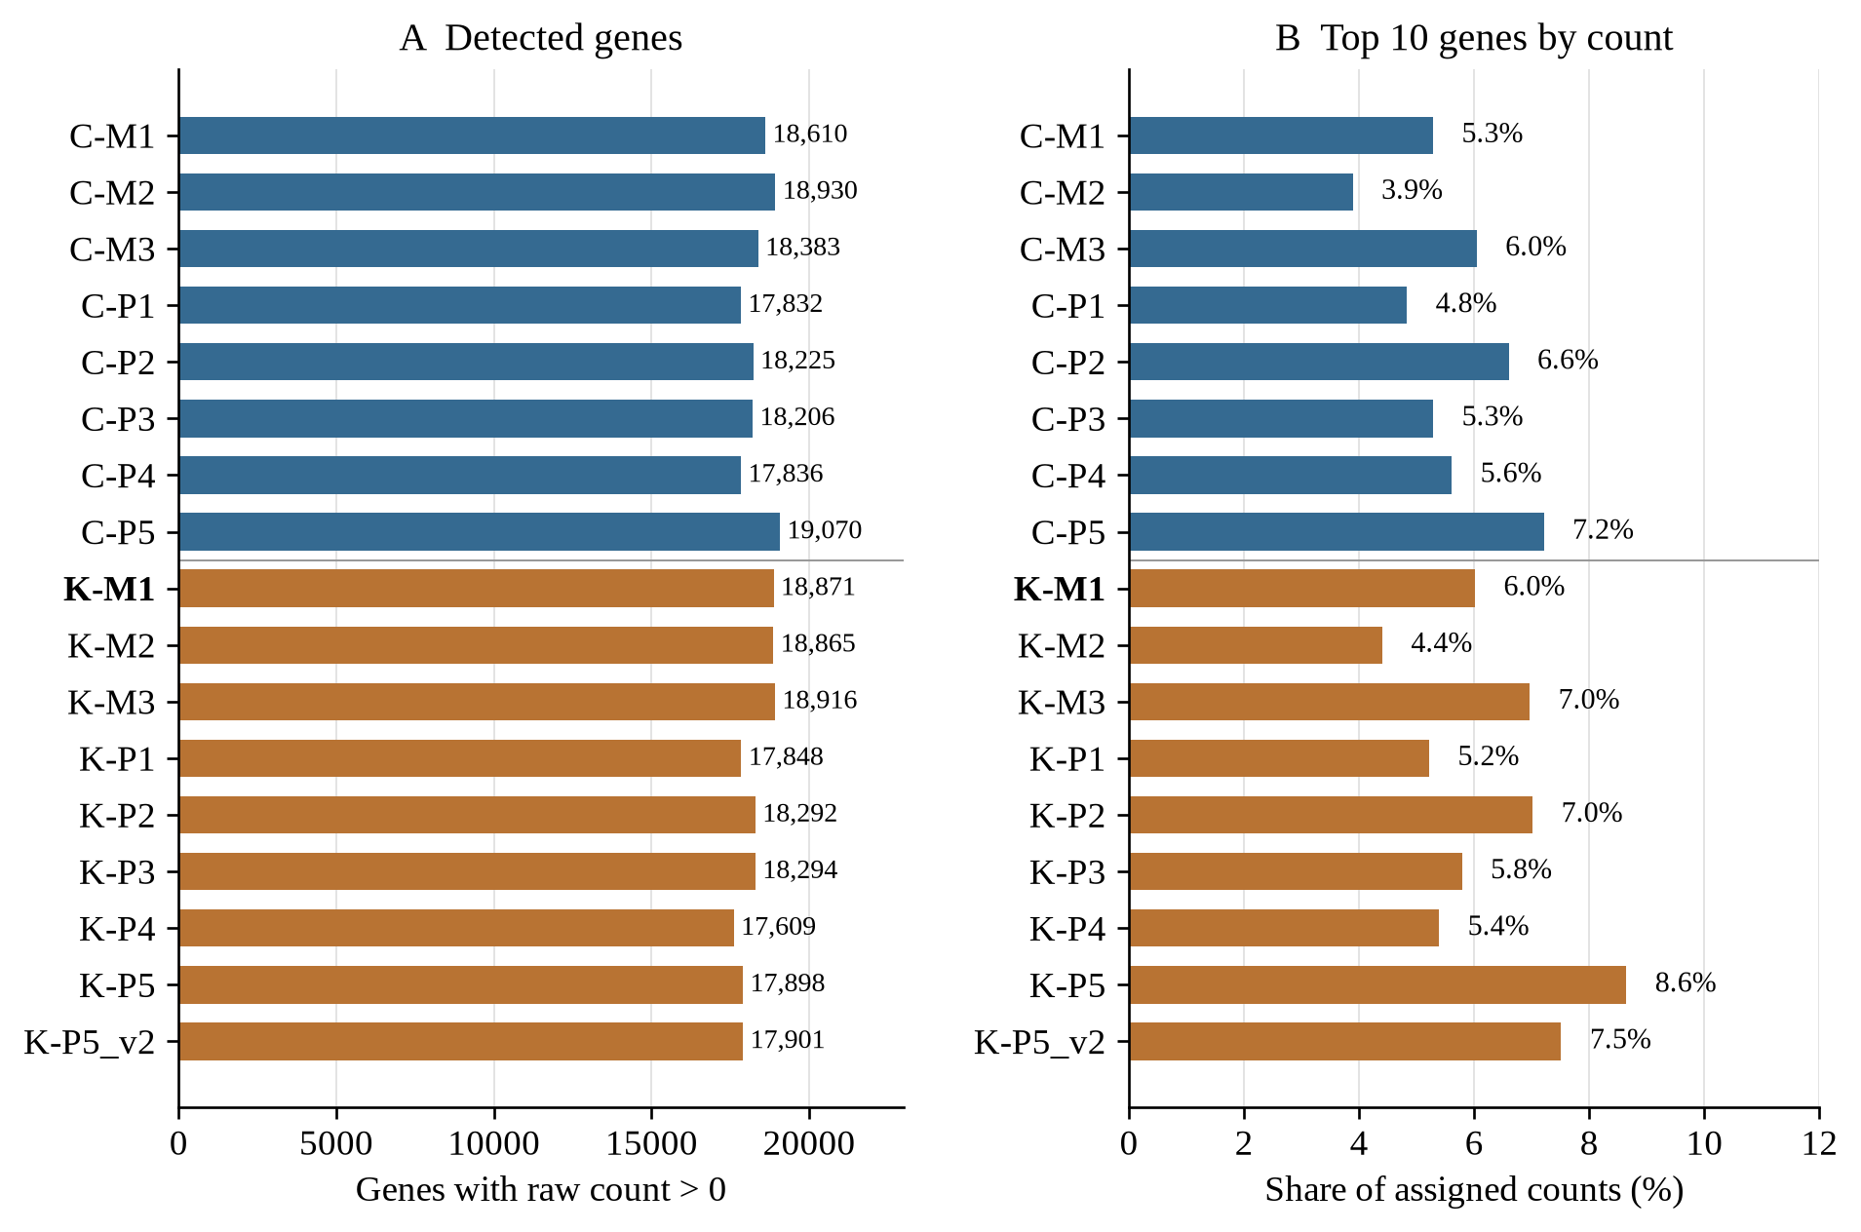
Figure A2 Detected genes and abundant transcripts
Genes with raw counts above zero and the share of assigned counts from the ten most abundant genes. Corrected K-M1 detects 18,871 genes. Its ten most abundant genes contribute 6.01% of assigned counts.²

Appendix B Sample correlations
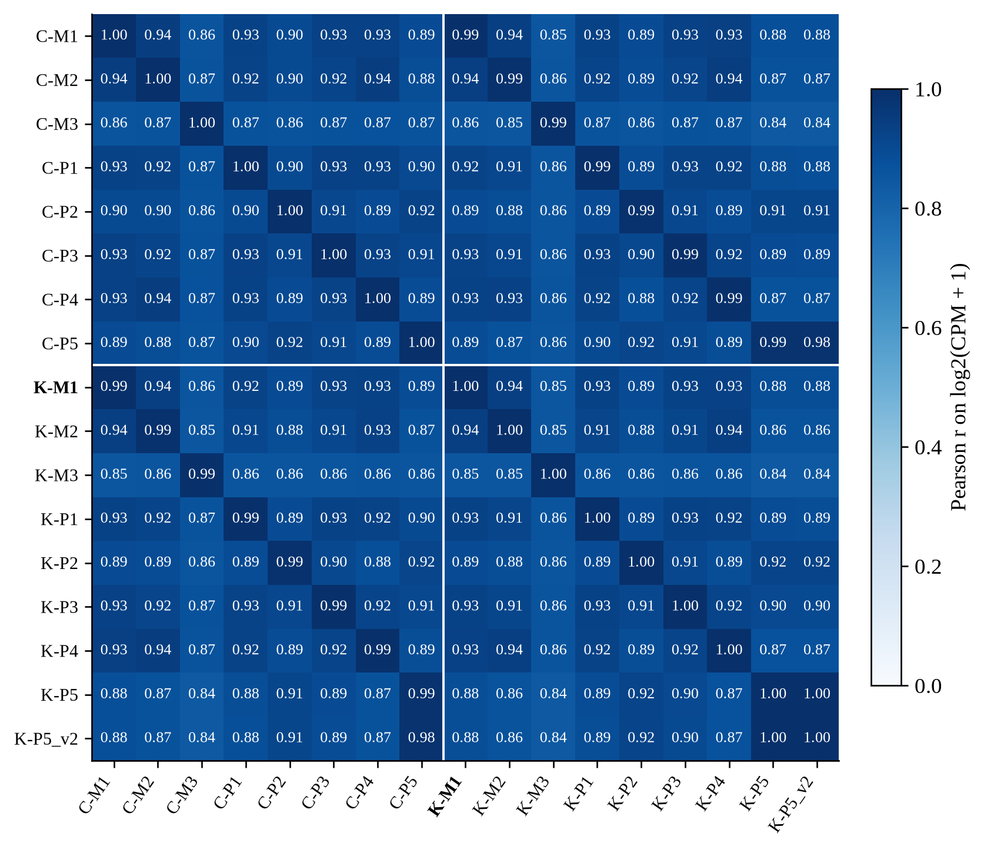
Figure B1 Correlations between samples
Pearson correlations of log2(CPM + 1) across genes detected in at least one run. Values are rounded to two decimal places. A displayed 1.00 does not establish identical samples.²
Corrected K-M1 has its highest correlation with C-M1 (r = 0.9944). Matched control and treatment profiles are similar within cell lines. This similarity does not rule out gene-specific treatment effects.

Appendix C PCA and M1 comparison
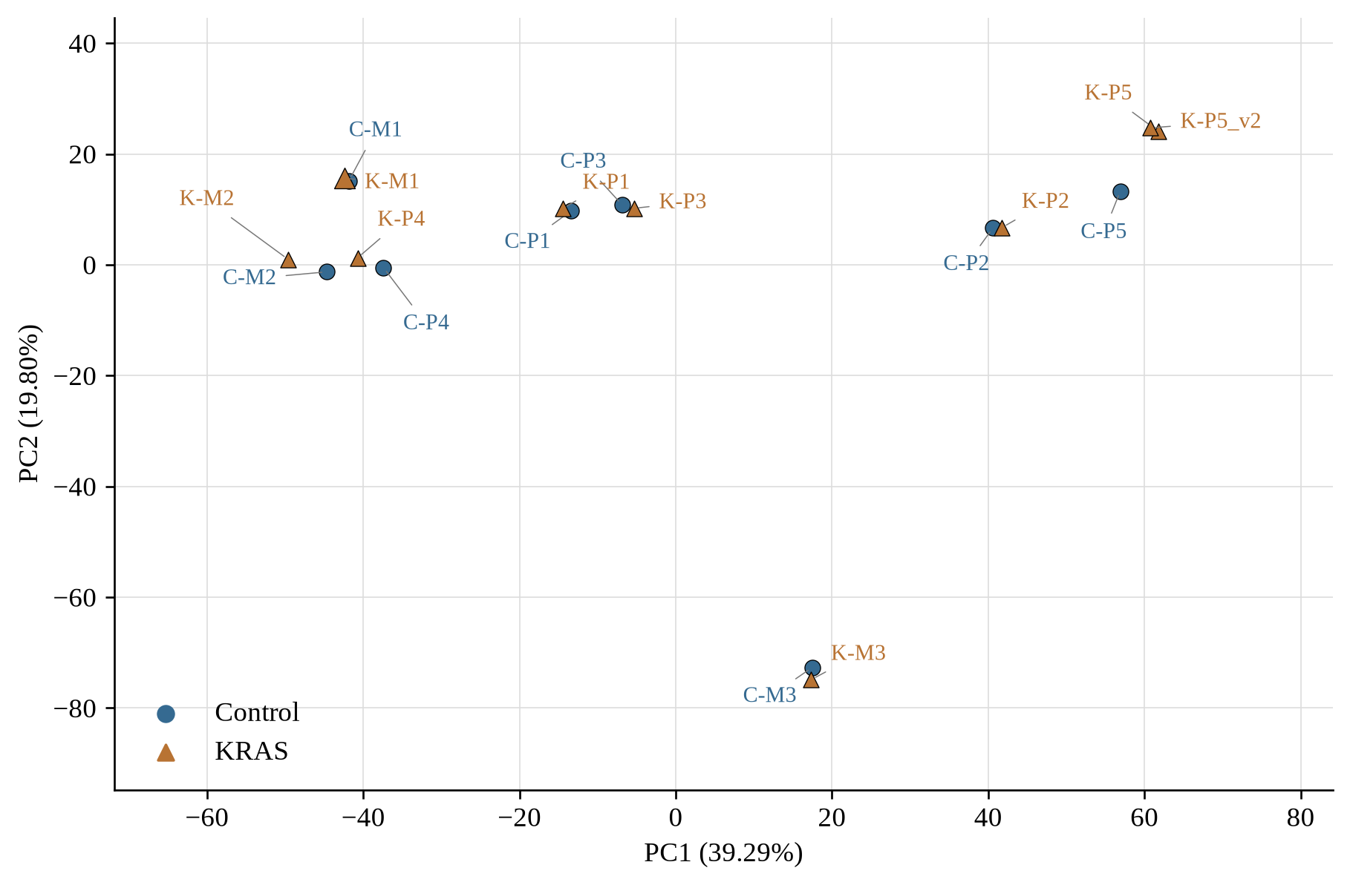
Figure C1 Sample positions in the PCA
PCA uses the 500 genes with the highest log2(CPM + 1) variance, centered by gene without scaling. PC1 and PC2 explain 39.29% and 19.80% of the variance. Both M3 runs separate on PC2.²
M1 result | Assigned counts | Assigned rate | Detected genes | Chimera rate
Original | 509 | 0.00079% | 167 | 96.68%
Corrected | 37,657,740 | 68.94% | 18,871 | 0.42%
Table C1 M1 before and after input correction
Assigned and chimera rates use all featureCounts summary records. Detected genes have raw counts above zero.²

References
- Klomp JA, Klomp JE, Stalnecker CA, Bryant KL, Edwards AC, Drizyte-Miller K, et al. Defining the KRAS- and ERK-dependent transcriptome in KRAS-mutant cancers. Science. 2024 Jun 7;384(6700):eadk0775. doi:10.1126/science.adk0775.
- Lin Y. PDAC KRAS RNA-seq: analysis for 2026-10-01 [Internet]. GitHub; 2026 [cited 2026 Oct 1]. Available from: https://github.com/yichuanlin07/pdac-kras-rnaseq/tree/462867100fa1628d716cb7722a574da5f90577df/analysis/2026-10-01
- European Bioinformatics Institute. European Nucleotide Archive: SRR24828469 [Internet]. [cited 2026 Oct 1]. Available from: https://www.ebi.ac.uk/ena/browser/view/SRR24828469
Review: ____________________ Date: ____________________

