KRAS suppression in pancreatic cancer cells
WEEK6 PROGRESS REPORT
Yichuan Lin

1 Overview
Cell-cycle gene sets, led by E2F targets and the G2M checkpoint, were enriched among genes with lower expression after KRAS small interfering RNA (siRNA) treatment in eight pancreatic cancer cell lines from Klomp and colleagues. The primary CAMERA gene-set test returned a minimum adjusted P value (q) of 0.354.^{⁠1,2}

2 Work completed
The corrected count matrix contains 28,395 gene rows and matches all 17 source count tables. KRAS M1 has 37,657,740 assigned counts. The two MiaPaca-2 KRAS libraries were summed before filtering, giving 16 observations across eight paired cell lines.^{⁠2}
Hallmark and Reactome gene sets from the Molecular Signatures Database (MSigDB) 2026.2.Hs were matched to the count matrix by Entrez gene identifier.^{⁠3} After trimmed mean of M-values (TMM) normalization, limma-trend models were fitted to log counts per million calculated with a prior count of two.^{⁠4,5} The model was ~cell_line + condition, with Control as the reference. Filtering retained 17,819 genes with at least 10 counts in two observations. CAMERA compared each gene set with the remaining measured genes using its estimated residual gene correlation.^{⁠6}
The primary analysis tested 50 Hallmark and 1,122 Reactome sets containing 15-500 measured genes. Benjamini-Hochberg correction covered all 1,172 tests together. The minimum global q was 0.354, with zero sets at q < 0.05. Fixing the correlation at 0.01 yielded 272 sets at q < 0.05. Appendix C gives the correlation and degrees-of-freedom settings.^{⁠2}
The earlier DESeq2/edgeR joint list contains 2,020 genes: 745 decreases and 1,275 increases, with matching directions between methods. Over-representation analysis (ORA) used a background of 15,055 genes with adjusted P values in both methods. Across 2,266 tests, 46 set-direction combinations met q < 0.05: nine Hallmark and 37 Reactome. E2F targets and the G2M checkpoint had the strongest Hallmark enrichment among decreases.^{⁠2}
Sensitivity analyses comprised eight paired cell-line omissions and two single-library P5 models. The selected E2F, G2M and MYC sets retained their downward competitive direction across all 11 models. ORA of the 1,515-gene stability list also retained E2F and G2M enrichment.^{⁠2}

3 Summary
E2F targets and the G2M checkpoint show the strongest Hallmark enrichment among downregulated genes in the joint list.

Appendix A Samples and analysis design
Table A1 Run accessions for the paired cell lines
Cell line | Control siRNA | KRAS siRNA
HPAC | SRR24828480 | SRR24828481
MiaPaca-2 | SRR24828470 | SRR24828471; SRR24828472
PANC-1 | SRR24828473 | SRR24828474
Pa01C | SRR24828468 | SRR24828469
Pa02C | SRR24828466 | SRR24828467
Pa04C | SRR24828479 | SRR24828465
Pa14C | SRR24828477 | SRR24828478
Pa16C | SRR24828475 | SRR24828476
The MiaPaca-2 treatment observation combines the raw integer counts from SRR24828471 and SRR24828472, giving 68,124,190 assigned counts. Local P5 is SRR24828471 (public alias MP2_K2v2); local P5_v2 is SRR24828472 (MP2_K2).^{⁠2}
Table A2 Model sizes and retained genes
Analysis | Observations | Cell lines | Retained genes | Residual df
Full pooled model | 16 | 8 | 17,819 | 7
Eight omission models | 14 each | 7 each | 17,288-17,749 | 6 each
P5 SRR24828471 only | 16 | 8 | 17,705 | 7
P5 SRR24828472 only | 16 | 8 | 17,734 | 7
Each omission removes both conditions of one cell line and repeats filtering, TMM normalization and limma-trend fitting. Residual df denotes residual degrees of freedom. The maximum effective library-size ratio across models is 2.21. The models estimate a common treatment effect after adjusting for cell line.^{⁠2}
MSigDB 2026.2.Hs supplies 50 Hallmark and 1,867 Reactome sets; the Reactome snapshot uses release 97. Set size is measured after intersection with each analysis universe. Entrez identifiers determine gene matching and test eligibility, and gene symbols provide display labels.^{⁠3}

Appendix B Enrichment of selected genes
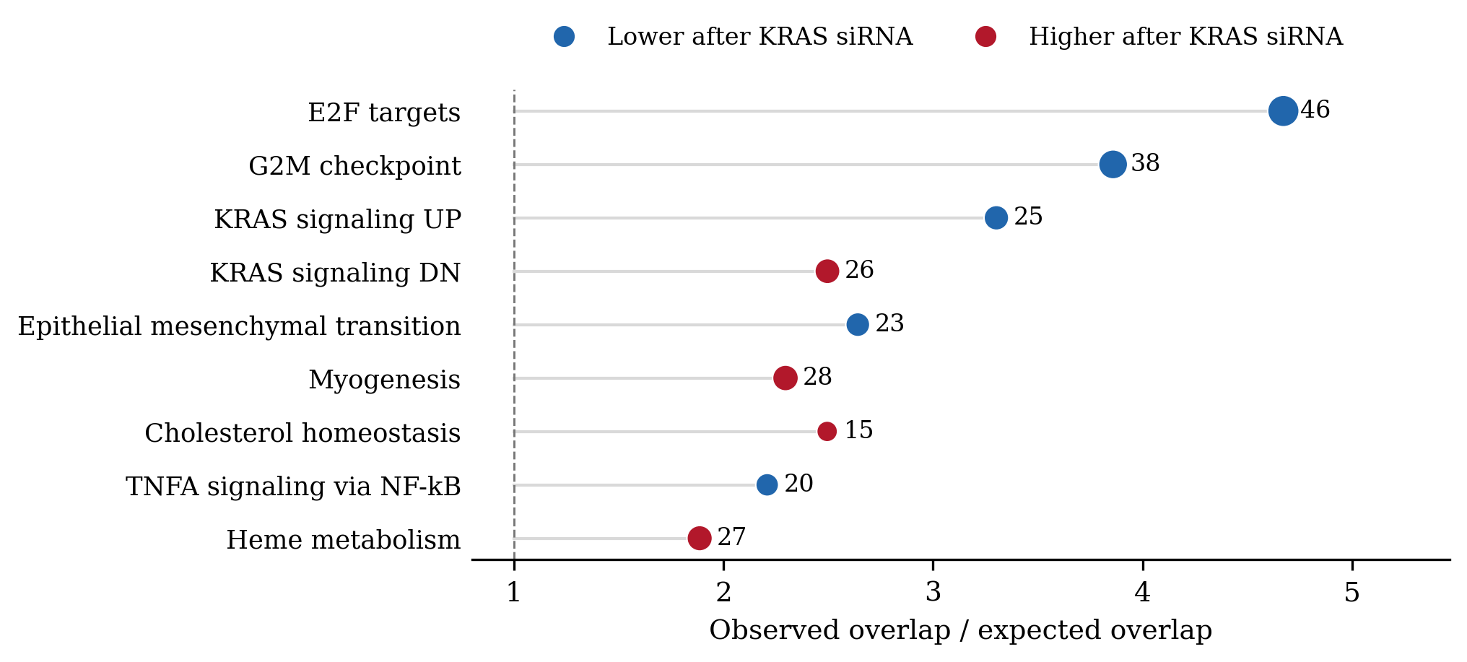
Figure B1 Hallmark sets enriched in the joint gene list
The plot shows all nine Hallmark set-direction tests with global q < 0.05. Joint selection requires adjusted P < 0.05 and absolute log2 fold change > 0.5 in both gene-level methods; DESeq2 uses its unshrunk model effect. Dot size and adjacent numbers show the selected genes overlapping each set. Blue indicates decreases and red indicates increases after KRAS siRNA. The dashed line marks the expected overlap. ORA uses a hypergeometric test with a 15,055-gene background and jointly adjusts both directions and both collections.^{⁠2}
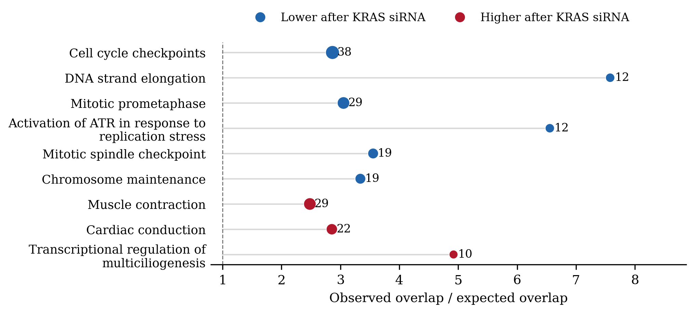
Figure B2 Selected Reactome overlaps
The plot shows the six lowest-q downward and three lowest-q upward Reactome tests from the 37 significant set-direction combinations. Several Reactome terms share member genes.^{⁠2}

Appendix C Gene correlation and test assumptions
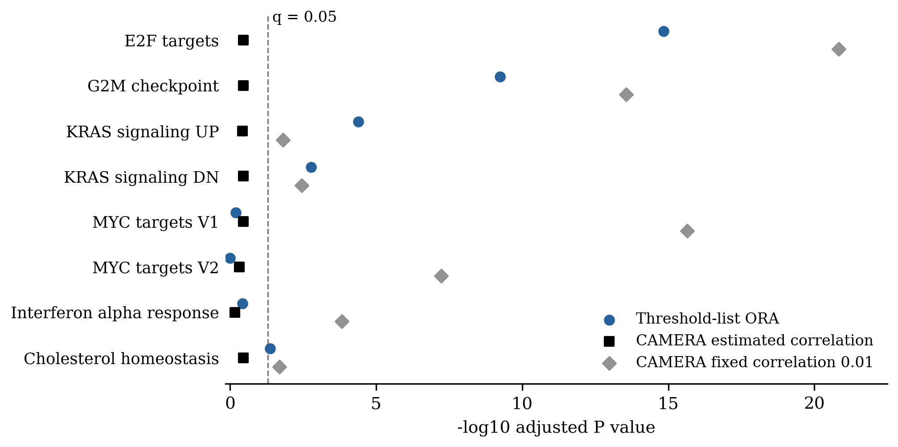
Figure C1 Comparison of enrichment tests
Eight selected Hallmark sets are compared using ORA in the primary CAMERA direction, CAMERA with estimated correlation, and CAMERA with correlation fixed at 0.01. Points to the right of the dashed line meet q < 0.05 in their respective test families. ORA uses a 15,055-gene background; CAMERA uses the 17,819 retained genes.^{⁠2}
Table C1 Correlation estimates and adjusted P values
Gene set | Estimated correlation | ORA q | CAMERA q | Fixed 0.01 q
E2F targets | 0.260 | 1.4e-15 | 0.355 | 1.5e-21
G2M checkpoint | 0.153 | 5.7e-10 | 0.354 | 2.7e-14
KRAS signaling UP | 0.023 | 4.1e-05 | 0.373 | 0.015
KRAS signaling DN | 0.016 | 0.002 | 0.354 | 0.004
MYC targets V1 | 0.164 | 0.628 | 0.354 | 2.3e-16
Interferon alpha | 0.416 | 0.379 | 0.695 | 0.00015
Primary CAMERA estimates residual correlation within each set, sets a minimum variance inflation factor of one, and uses seven residual degrees of freedom in the full model. The fixed-correlation sensitivity uses correlation 0.01 and 17,817 test degrees of freedom in the installed implementation.^{⁠2,6}
Correcting the 50 Hallmark tests separately gave a minimum q of 0.368.^{⁠2}

Appendix D Sensitivity and biological context
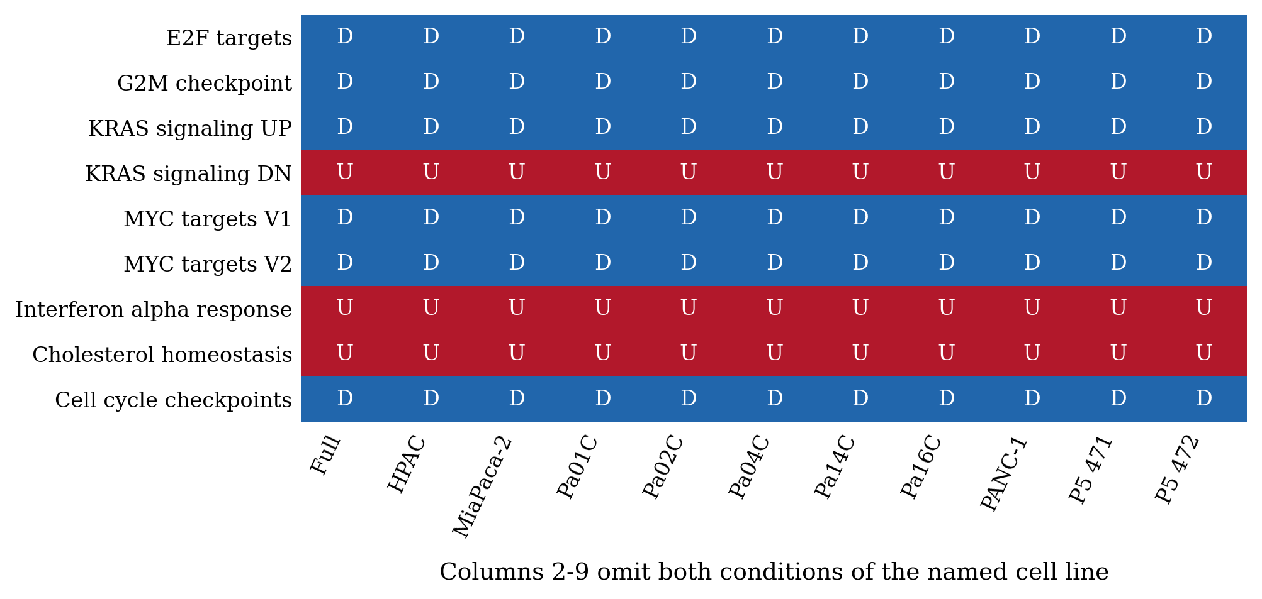
Figure D1 Competitive direction across eleven models
D and U indicate downward and upward CAMERA directions relative to the other measured genes. Column 1 is the full pooled model; columns 2-9 each omit the named cell line; the last two columns retain SRR24828471 or SRR24828472 alone for P5 KRAS. All nine displayed sets are available in every model. Across the 11 primary fits, zero sets met global q < 0.05.^{⁠2}
Table D1 ORA using the descriptive stability list
Gene set and direction | Full-list overlap | Full-list q | Stable-list overlap | Stable-list q
E2F targets down | 46 | 1.4e-15 | 35 | 8.7e-12
G2M checkpoint down | 38 | 5.7e-10 | 29 | 1.3e-07
KRAS signaling UP down | 25 | 4.1e-05 | 20 | 0.0002
KRAS signaling DN up | 26 | 0.002 | 16 | 0.190
The stability list contains 538 decreases and 977 increases. Inclusion requires joint selection in the full fit, finite effects with the same direction in all eight omissions, and selection by both differential-expression methods in at least seven omission rounds. ORA uses the same 15,055-gene background. Repeating ORA with all 17,819 retained genes as the background also retains E2F and G2M enrichment.^{⁠2}
The cell-cycle enrichment is consistent with the published study's findings on KRAS-ERK regulation of proliferation.^{⁠1} The Hallmark names KRAS signaling UP and KRAS signaling DN identify the reference signatures; their observed directions here are down and up, respectively.^{⁠2}
Pathway analyses used R 4.5.2, edgeR 4.8.2 and limma 3.66.0. ORA used the existing DESeq2 and edgeR result tables.^{⁠2}

References
1. Klomp JA, Klomp JE, Stalnecker CA, Bryant KL, Edwards AC, Drizyte-Miller K, et al. Defining the KRAS- and ERK-dependent transcriptome in KRAS-mutant cancers. Science. 2024 Jun 7;384(6700):eadk0775. doi:10.1126/science.adk0775.
2. Lin Y. PDAC KRAS RNA-seq Week 6 pathway analysis [dataset]. 2026 Oct 30. Input source revision 7e3fe15664597474008b63753dd9e4b20efec04a. Analysis archive: Week6_2026-10-30 (sources/input_validation.json; results/).
3. Molecular Signatures Database. Human Hallmark and Reactome gene sets, version 2026.2.Hs [Internet]. 2026 Oct [cited 2026 Oct 30]. Available from: https://data.broadinstitute.org/gsea-msigdb/msigdb/release/2026.2.Hs/ . Release notes: https://docs.gsea-msigdb.org/MSigDB/Release_Notes/MSigDB_2026.2.Hs/ .
4. Robinson MD, Oshlack A. A scaling normalization method for differential expression analysis of RNA-seq data. Genome Biol. 2010 Mar 2;11(3):R25. doi:10.1186/gb-2010-11-3-r25.
5. Ritchie ME, Phipson B, Wu D, Hu Y, Law CW, Shi W, et al. limma powers differential expression analyses for RNA-sequencing and microarray studies. Nucleic Acids Res. 2015 Apr 20;43(7):e47. doi:10.1093/nar/gkv007.
6. Wu D, Smyth GK. Camera: a competitive gene set test accounting for inter-gene correlation. Nucleic Acids Res. 2012 Sep;40(17):e133. doi:10.1093/nar/gks461.
Review: ____________________ Date: ____________________

