ELEC7023 Assignment 3-2 — Object Detection
Item | Content
Course | Edge computing device programming for AI projects
Student | Yao Yichuan
Task | Detect objects in two images, compare confidence thresholds 0.3 and 0.7
Device | Jetson (jetson-inference detectNet)
Code | assin3_detection.py
Model | ssd-mobilenet-v2

GitHub Repository
https://github.com/yichuanyao/7023B-Assignment-Three

1. Method
Test images (from COCO detection/segmentation benchmark):
Image | Content | Source
images/image1.jpeg | Two cats + remotes on a sofa (COCO 000000039769) | COCO val2017
images/image2.jpeg | Kitchen scene with person & many objects (COCO 000000397133) | COCO val2017
- Load ssd-mobilenet-v2 with jetson_inference.detectNet.
- Change camera input to image input (jetson_utils.loadImage).
- Run detection on Image 1 and Image 2.
- Repeat with threshold 0.3 (< 0.5) and 0.7 (> 0.5).
- For each detection, record:
ClassID, Confidence, Left, Top, Right, Bottom, Width, Height, Area, Center.
- Save annotated images under results/.

Run command (on Jetson)
cd ~/jetson-inference/examples
python3 assin3_detection.py --image1 images/image1.jpeg --image2 images/image2.jpeg --thresholds 0.3 0.7 --outdir results

2. Detected Images

Image 1 @ threshold 0.3 (5 detections)
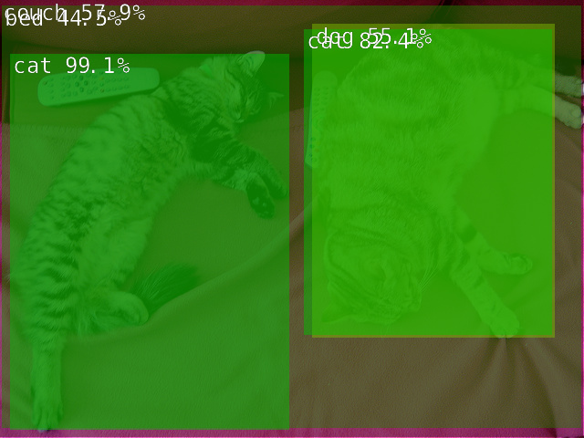
Image 1 threshold 0.3

Image 1 @ threshold 0.7 (2 detections)
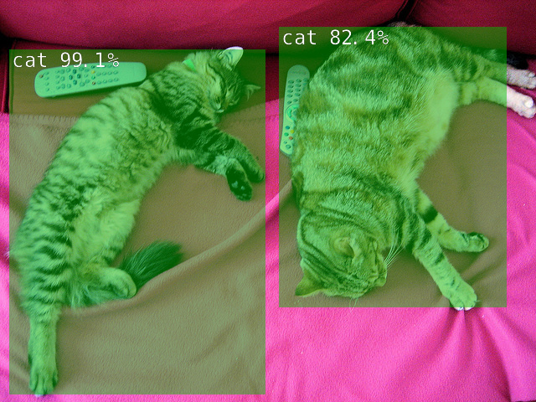
Image 1 threshold 0.7

Image 2 @ threshold 0.3 (4 detections)
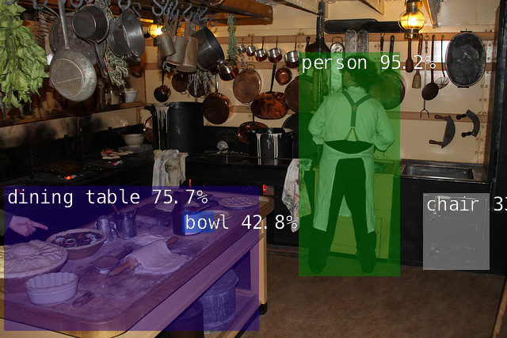
Image 2 threshold 0.3

Image 2 @ threshold 0.7 (2 detections)
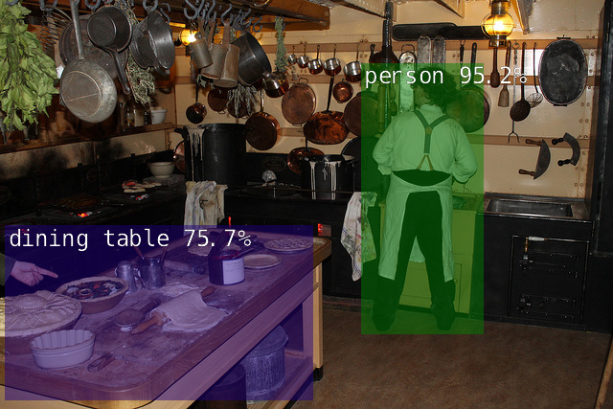
Image 2 threshold 0.7

3. Detection Results

Image 1 @ threshold 0.3 (5 objects)
-- Detection #1
-- ClassID: 63
-- Class: couch
-- Confidence: 0.57861328125
-- Left: 0.0
-- Top: 0.0
-- Right: 639.0
-- Bottom: 479.0
-- Width: 639.0
-- Height: 479.0
-- Area: 306081.0
-- Center: (319.5, 239.5)
-- Detection #2
-- ClassID: 65
-- Class: bed
-- Confidence: 0.444580078125
-- Left: 2.65625
-- Top: 6.5625
-- Right: 638.125
-- Bottom: 470.15625
-- Width: 635.46875
-- Height: 463.59375
-- Area: 294599.34375
-- Center: (320.390625, 238.359375)
-- Detection #3
-- ClassID: 17
-- Class: cat
-- Confidence: 0.99072265625
-- Left: 11.484375
-- Top: 59.296875
-- Right: 318.125
-- Bottom: 471.328125
-- Width: 306.640625
-- Height: 412.03125
-- Area: 126345.5234375
-- Center: (164.8046875, 265.3125)
-- Detection #4
-- ClassID: 18
-- Class: dog
-- Confidence: 0.55078125
-- Left: 342.5
-- Top: 26.71875
-- Right: 609.375
-- Bottom: 371.25
-- Width: 266.875
-- Height: 344.53125
-- Area: 91946.78125
-- Center: (475.9375, 198.984375)
-- Detection #5
-- ClassID: 17
-- Class: cat
-- Confidence: 0.82421875
-- Left: 333.125
-- Top: 32.9296875
-- Right: 605.625
-- Bottom: 367.96875
-- Width: 272.5
-- Height: 335.0390625
-- Area: 91298.140625
-- Center: (469.375, 200.44921875)

Image 2 @ threshold 0.3 (4 objects)
-- Detection #1
-- ClassID: 67
-- Class: dining table
-- Confidence: 0.7568359375
-- Left: 5.3125
-- Top: 235.39208984375
-- Right: 328.125
-- Bottom: 418.86865234375
-- Width: 322.8125
-- Height: 183.4765625
-- Area: 59228.52734375
-- Center: (166.71875, 327.13037109375)
-- Detection #2
-- ClassID: 1
-- Class: person
-- Confidence: 0.9521484375
-- Left: 377.8125
-- Top: 66.51025390625
-- Right: 505.9375
-- Bottom: 349.64794921875
-- Width: 128.125
-- Height: 283.1376953125
-- Area: 36277.015625
-- Center: (441.875, 208.0791015625)
-- Detection #3
-- ClassID: 62
-- Class: chair
-- Confidence: 0.338134765625
-- Left: 534.6875
-- Top: 244.14892578125
-- Right: 619.0625
-- Bottom: 341.30810546875
-- Width: 84.375
-- Height: 97.1591796875
-- Area: 8197.8056640625
-- Center: (576.875, 292.728515625)
-- Detection #4
-- ClassID: 51
-- Class: bowl
-- Confidence: 0.427734375
-- Left: 230.0
-- Top: 267.50048828125
-- Right: 270.0
-- Bottom: 295.43896484375
-- Width: 40.0
-- Height: 27.9384765625
-- Area: 1117.5390625
-- Center: (250.0, 281.4697265625)

Image 1 @ threshold 0.7 (2 objects)
-- Detection #1
-- ClassID: 17
-- Class: cat
-- Confidence: 0.99072265625
-- Left: 11.484375
-- Top: 59.296875
-- Right: 318.125
-- Bottom: 471.328125
-- Width: 306.640625
-- Height: 412.03125
-- Area: 126345.5234375
-- Center: (164.8046875, 265.3125)
-- Detection #2
-- ClassID: 17
-- Class: cat
-- Confidence: 0.82421875
-- Left: 333.125
-- Top: 32.9296875
-- Right: 605.625
-- Bottom: 367.96875
-- Width: 272.5
-- Height: 335.0390625
-- Area: 91298.140625
-- Center: (469.375, 200.44921875)

Image 2 @ threshold 0.7 (2 objects)
-- Detection #1
-- ClassID: 67
-- Class: dining table
-- Confidence: 0.7568359375
-- Left: 5.3125
-- Top: 235.39208984375
-- Right: 328.125
-- Bottom: 418.86865234375
-- Width: 322.8125
-- Height: 183.4765625
-- Area: 59228.52734375
-- Center: (166.71875, 327.13037109375)
-- Detection #2
-- ClassID: 1
-- Class: person
-- Confidence: 0.9521484375
-- Left: 377.8125
-- Top: 66.51025390625
-- Right: 505.9375
-- Bottom: 349.64794921875
-- Width: 128.125
-- Height: 283.1376953125
-- Area: 36277.015625
-- Center: (441.875, 208.0791015625)

Field meanings (Lecture 4)
Field | Meaning
ClassID | Predicted object category ID
Confidence | How certain the model is
Left / Top | Top-left corner of the box
Right / Bottom | Bottom-right corner of the box
Width / Height | Box size
Area | Width × Height
Center | Midpoint of the box

4. Threshold Comparison Table
Image | Confidence threshold | Number of detected objects | Missed or incorrect detections
Image 1 | 0.3 | 5 | Incorrect: bed (sofa misclassified), dog (right cat misclassified as dog). Missed: two remotes
Image 1 | 0.7 | 2 | Incorrect low-confidence boxes removed. Still missed: two remotes
Image 2 | 0.3 | 4 | Weak extras: chair (0.34), bowl (0.43). Missed many kitchen items (pots/pans/utensils)
Image 2 | 0.7 | 2 | chair and bowl filtered out. Still missed many small kitchen objects

5. Report Questions

Q1. How did the results change when you increased the threshold?
When the threshold increased from 0.3 to 0.7, the number of detections decreased:
- Image 1: 5 → 2
- Image 2: 4 → 2
Only high-confidence boxes remained (both cats on Image 1; person + dining table on Image 2). Low-confidence / uncertain predictions were removed, so the output looked cleaner, but some true or borderline objects disappeared.

Q2. Were any objects detected at the lower threshold but not at the higher threshold? Why?
Yes.
- Image 1 lost: couch (0.58), bed (0.44), dog (0.55)
- Image 2 lost: chair (0.34), bowl (0.43)
These scores are between 0.3 and 0.7, so they pass the low threshold but fail the high threshold. The network still proposes those boxes; confidence filtering discards them when the cutoff is stricter.

Q3. Which threshold would you choose for your application scenario? Explain your choice.
Chosen scenario: home / kitchen object detection on an edge device (person, cat, bowl, furniture — COCO-style classes).
Chosen threshold: 0.7
Reason: at 0.3, Image 1 produced clear mistakes (bed, dog), and Image 2 added weak boxes. At 0.7, the remaining detections (cat, cat, person, dining table) are more reliable. For an edge demo where false alarms are more confusing than missing a few small objects, 0.7 is the better choice.

6. Submission Checklist
- assin3_detection.py uploaded to GitHub
- GitHub link written in this report
- Detected / annotated images included
- Detection field outputs included
- Comparison table filled
- Three questions answered
- Export this file to PDF or DOC and upload to Moodle

