CliffBoxPushing: learning and robustness
AI6101 · YourName · YourMatriculationNumber
1. Q-learning and the mandatory experiment
The fixed 6×14 world uses state (agent row, column, box row, column), four actions, 7,056 Cartesian states and 28,224 Q entries. The original reward is −1−Manhattan(A,B)−Manhattan(B,G), with −1000 for a cliff and +1000 at the goal. Cliff, goal or 100 steps ends the episode. The original environment is unchanged.
Update: Q(s,a) ← Q(s,a)+α[r+γ(1−d)max_{b}Q(s′,b)−Q(s,a)], with α=0.1, γ=0.99, ε=0.1 and zero terminal bootstrap. Train 30,000 episodes per noise level {0,0.1,0.2}, seeds {7,17,27}. Noise replaces the intended action uniformly with one of the other three; update the intended action. Evaluate 300 episodes per policy/test noise with ε=0: 8,100 episodes. Success means box at goal.
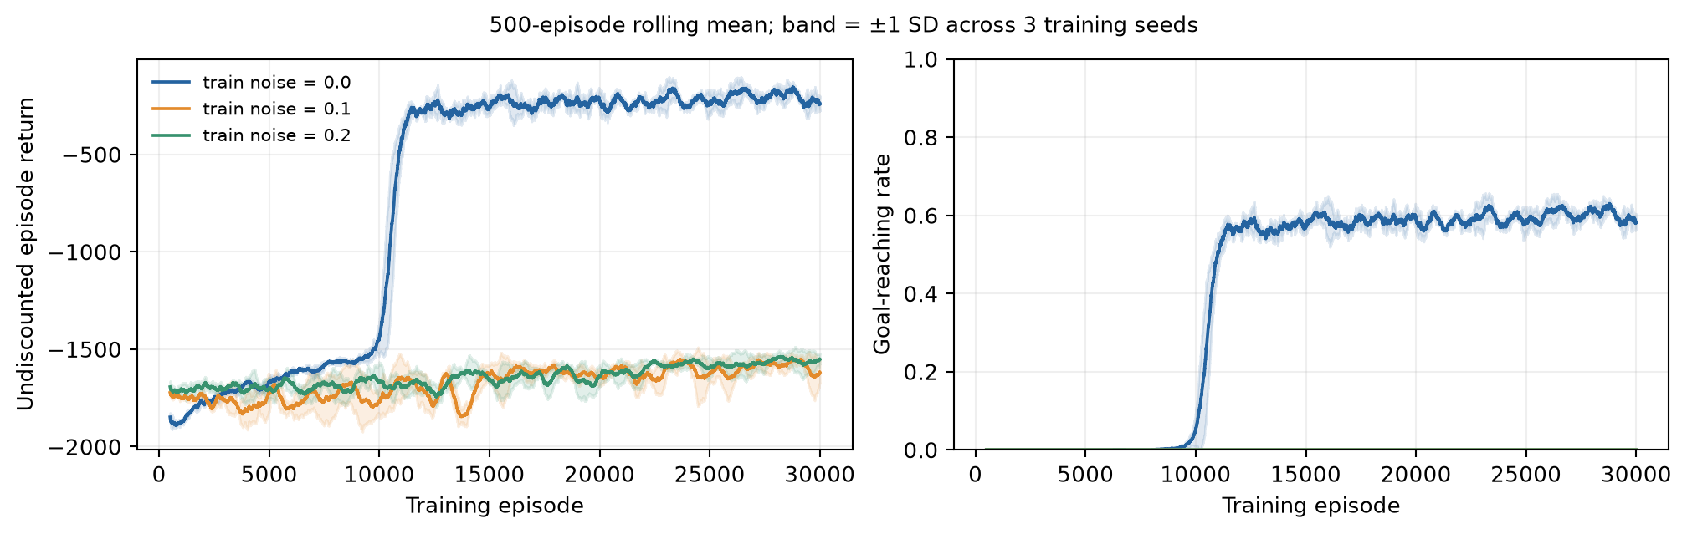
Figure 1. Original-reward training: 500-episode rolling means, bands ±1 sample SD across seeds. Clean greedy success is 100%; random actions achieve 0% in 1,000 episodes. The seed-7 learned clean route takes 39 steps, return 577. Training retains ε exploration.
2. Cross-noise generalization and final policy
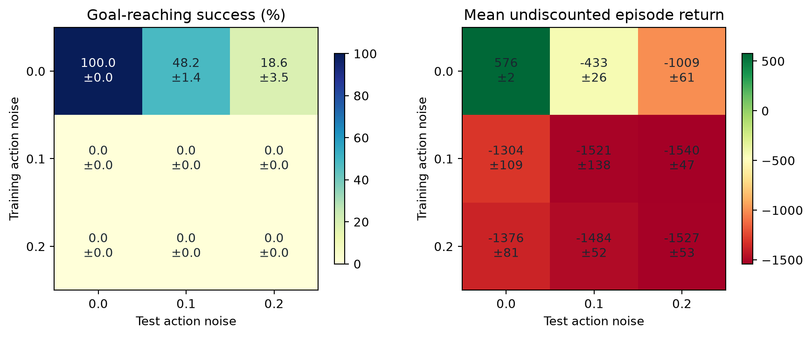
Figure 2. Rows=train noise, columns=test noise; mean ± SD across three seeds (900 episodes/cell). Clean-trained success drops to 48.2% and 18.6% at test noise 0.1/0.2. Both noisy-training settings have zero goal visits in 90,000 training episodes each and zero evaluation successes. Their clean tests all time out: noise training did not improve robustness within this budget.
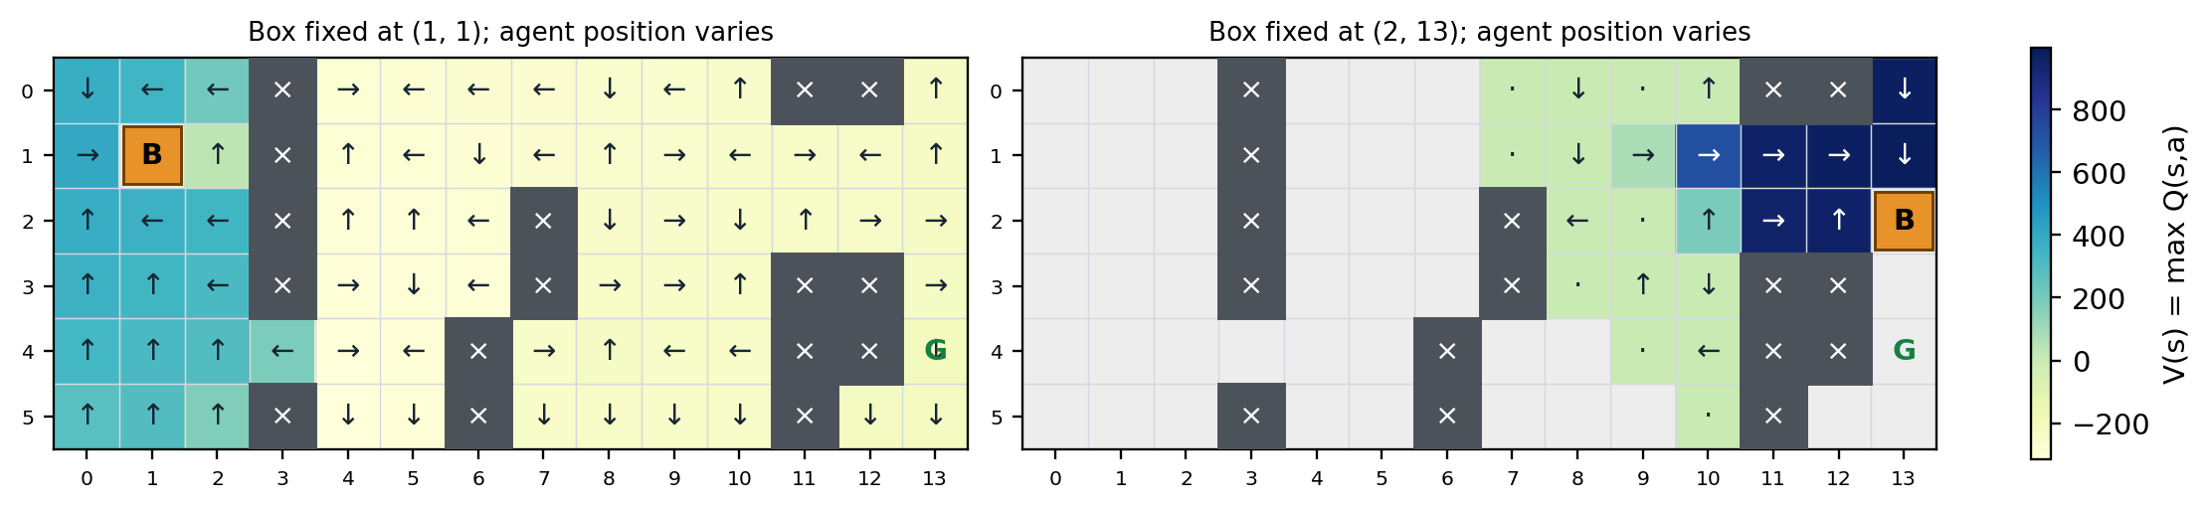
Figure 3. Clean-trained seed-7 V(s)=max_{a}Q(s,a), with greedy arrows conditioned on both positions. Gray=unvisited, dot=tie, B=box, G=goal. The notebook includes four slices and the complete joint-state table. Untried actions may retain optimistic zeros.
Exploration and pure sparse-reward bonuses
AI6101 · YourName · YourMatriculationNumber
3. Bonus 1: exploration comparison
Original rewards and primitive actions, no action noise; identical α, γ, 30,000-episode budget and three seeds. Reuse the mandatory clean ε-greedy runs. UCB tries unvisited actions first, then maximizes Q(s,a)+20√[ln(N(s)+1)/N(s,a)]. The bonus affects selection only. The greedy baseline trains with ε=0; every learned policy is evaluated without exploration for 300 episodes/seed.
Training method | First goal episode: seeds 7 / 17 / 27 | Eval success | Mean return
ε-greedy (ε=0.1) | 9131 / 8038 / 6285 | 100.0% | 575.7
UCB (c=20) | 5106 / 5294 / 5031 | 100.0% | 577.0
Greedy (ε=0) | 5127 / 4701 / 4735 | 100.0% | 577.0

UCB discovers a goal earlier than ε-greedy (median 5,106 vs 8,038 episodes), but greedy is earlier still (4,735). Negative step rewards make untried zero Q-values optimistic, and random ties provide exploration even with ε=0. All reach 100% final clean success; these results do not establish a universal UCB advantage.
4. Bonus 2: only goal reward, hierarchical Q-learning
Reward is exactly 1000 at the original goal, otherwise 0, including cliffs and timeout. No dense pretraining, intermediate reward or demonstration is used. Hand-designed options use local BFS to position the agent safely, then make one safe push. This map/safety prior does not plan the full box route or use goal distance. The high-level push choice is learned. Every primitive action executes the original step() and counts toward 100; dead ends continue safely until the original timeout.
For an option lasting k steps, the target is Σ_{i=0}^{k−1} γ^{i}r_{i} +(1−d)γ^{k}max_{o}Q(s′,o). The replay method performs 10 backward passes over actual successful trajectories. All four ablations train 5,000 episodes/seed and evaluate 300 episodes/seed; random options remain random in evaluation.
Sparse training method | First goal: seeds 7 / 17 / 27 | Eval success | Mean steps
Primitive ε-greedy | none / none / none | 0.0% | 20.4
Random safe options | 570 / 1386 / 626 | 0.0% | 100.0
Option Q, no replay | 1155 / 3454 / 2394 | 0.0% | 100.0
Option Q + replay ×10 | 1155 / 3454 / 2394 | 100.0% | 42.3

Only the replay learner reaches 100% final success (900/900; sparse return 1000). No-replay learns the same first goals but fails final tests: replay improves propagation, not first discovery. Equal episode caps do not imply equal interactions or compute; the notebook records both, including extra replay updates.
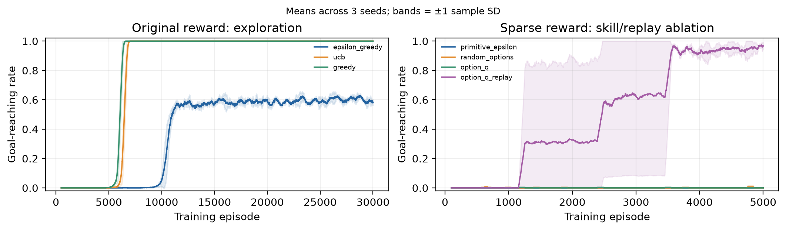
Figure 4. Goal-reaching training rates: exploration comparison (500-episode window) and sparse ablations (100-episode window); mean ± SD across three seeds.
Scope. Three seeds limit precision. Constant α/ε and the four-coordinate state (without time remaining) do not prove convergence or optimality. Sparse skills supply substantial map knowledge; the ablations explicitly isolate their contribution. References: Watkins & Dayan (1992), Q-learning; Auer et al. (2002), Finite-time Analysis of the Multiarmed Bandit Problem; Sutton, Precup & Singh (1999), Between MDPs and semi-MDPs; supplied AI6101 brief/environment.

