Correlations between gender and research topics at three major archaeology conferences

Yichun Chen1,✉, and Ben Marwick2

17 July, 2020

Text of abstract

1 University of One Place  
2 University of Another Place

✉ Correspondence: [Yichun Chen <[yichun33@uw.edu](mailto:yichun33@uw.edu)>](mailto:yichun33@uw.edu)

# Abstract

Disproportionate representation of genders has long existed in many academic fields. Rising interest in gender equality in society generally has resulted in greater scrutiny on gender inequality in academic communities. Analysis of authorship of peer-reviewed publications shows that archaeology is similar to other academic fields in having long been dominated by men. We ask if gender disproportionality is evident in the choice of topics that archaeologists present on at major conferences, particularly the Society of American Archaeology (SAA), the European Association of Archaeologists (EAA) and the Computer Applications and Quantitative Methods in Archaeology (CAA) meetings. Does the gender of the participants in these archaeological conferences correlate with the topics of their presentations? We analysed presenters’ names in the published programs of these three archaeology conferences to infer gender. We then used machine learning to identify topics from presentation titles. We found that there are some associations between gender and topics. An awareness of these correlations between research topics and gender is important to ensure equitable participation in archaeology, and unbiased access to training opportunities for students. We expect these findings to be useful for instructors who prioritize gender equality in student and early career research activities.

# Introduction

Gender under-representation and inequality has long existed in science, from under-representation of women and minority genders in school text books to academic publications (Hamilton et al., 2006; Tushingham et al., 2017). Women are often under-represented for several reasons, including stereotyping that unfairly underestimates individuals’ abilities, which often leads to lack of support for women in academic fields (Xu, 2008). In this paper we explore the relationship between gender and research topics to determine if women and men tend to focus more on certain topics than others.

We used a computational method to identify topics from the titles of presentations delivered at meetings of the Society of American Archaeology (SAA, 2016-2019), the European Association of Archaeologists (EAA, 2018) and the Computer Applications and Quantitative Methods in Archaeology (CAA, 2017). We analysed the covariance of topics and genders of presenters to explore how gender ratios vary between these conferences and by topics.

# Background

According to the American Anthropological Association’s (AAA) *AnthroGuide*, there is a growing number of women participating in anthropology’s graduate programs. For example, in the 2012-2013 school year, women consists of 64% of graduate students in anthropology programs and 65% of students that completed an anthropology doctoral degrees are women, whereas in 1972 32% of PhD are granted to women and 59% in 1995 (Bardolph, 2014). Although women slightly outnumber men in anthropology graduate programs, previous work has shown substantial gender imbalances in publication practices in archaeology where men greatly outnumber women, especially as first authors in peer reviewed journal articles (Bardolph, 2014). One of the first studies of this imbalance is Bardolph (2014), who looked at 7,381 members of the Society of American Archaeology and found 53% men and 47% women. She also looked at 1,601 articles published during 1990-2013 in five high-visibility archaeology journals and found a range of proportions of women to men authors of 0.32-0.73, with three of the five journals having a proportion of <0.5.

Rodrı́guez-Álvarez and Lozano (2018) studied gender balance among 309 authors of 299 publications produced during 1978-2016 by the Atapuerca Project, a large archaeo-palaeontological project in Burgos, Spain. They ‘manually defined’ the gender of each author, and found 13 articles authored exclusively by women, 34.8% of papers have women as first-authors, and overall, 35.9% of all authors are women (Rodrı́guez-Álvarez and Lozano, 2018). Over time, they observed a trend of increasing numbers of papers that include women as authors, numbers of paper lead by women as the first author, and increases in the ratio of female to male authors in group-authored papers. They did not make any observations about relationships between gender and topics.

Another similar imbalance can be seen in terms of the authorship of articles or papers written. For example, for the authorship of the first authors of 1,104 articles published in the *Journal of Field Archaeology* during 1974–2018, 72% of them are men (Heath-Stout, 2020). Heath-Stout (2020) investigates the possibility that the gender gap in authorship is due to due to sexism in the peer review process. Out of 830 instances of peer review for where both the reviewer’s gender and the first author’s gender could be determined, neither the first author’s gender, the reviewer’s gender, nor the combination of the two had a significant effect on the reviewer’s recommendation.

Fulkerson and Tushingham (2019) collected data on author’s gender and occupational affiliation in peer reviewed journals (*American Antiquity* (AQ), *Advances in Archaeological Practice* (AAP), *Journal of California and Great Basin Anthropology* (JCGBA), and *California Archaeology* (CA)) and some non-peer-reviewed venues (the *SAA Archaeological Record* (SAA Record) and the SCA *Proceedings*). Among the 5,010 authors of 2,445 articles in their sample, 27.1% of first/single authors of peer-reviewed journal articles are women, and 72.9% are men. The gender gap is less pronounced in the non-peer-reviewed venues with women accounting for 40.8% of lead authors in 517 articles.

Bardolph (2018) examined data from 2007 to 2017 about the membership in the Society of California Archaeology (SCA) conference, and the lead-authors of JCGBA and CA. Bardolph (2018) noted that women’s conference presentation rates are consistent with their membership rates in SCA, and that it was not until 2017 when women’s participation rates finally exceeded men’s. Although women are more actively participating in SCA, this is not the case for lead-authorship of JCGBA and CA (Bardolph, 2018). Throughout the majority of time in the period studied, lead-authorship of JCGBA articles is highly skewed towards men with only 34% women. A greater difference between men and women lead-authorship can be seen in CA, in 2009 there was no women lead-authors at all, and overall only 23% of the published papers of CA have women as lead-authors (Bardolph, 2018).

When looking at gender ratios among the membership in Society for California Archaeology from 1967 to 2016, Tushingham et al. (2017) report a trend of women increasingly maintaining their society membership they remain underrepresented in peer-reviewed journals. Tushingham et al. (2017) examined authorship gender trends in 1,599 papers in three journals, *Journal of California and Great Basin Anthropology/Journal of California Archaeology* (JCGBA/JCA), *California Archaeology* (CA) and a non-peer reviewed *Proceedings* of the Society for California Archaeology (PSCA). In a total of 2,617 authors, 844 (32.3%) were women, 1,762 (67.3%) were men, and 11 (0.4%) were gender unknown/ambiguous (Tushingham et al., 2017). They found significant increases in the proportion of female lead authors over time in JCGBA/JCA and PSCA, but not in CA, perhaps because of the shorter publishing period for this journal (Tushingham et al., 2017). This similar trend of a gender gap in archaeology can also be seen in women’s pay (VanDerwarker et al., 2018). In the University of California, Santa Barbara Gender Equity Project,(**???**) report an imbalance in pay rates, for example, women make a greater proportion of people paid less $60,000 and men outnumber women in salary brackets greater than $60,000. (**???**).

Studies of authorship where that gender is inferred from the author’s first name are common, but can give wrong results for non-English, androgynous, and uncommon names. Heath-Stout (n.d.) avoided these limitations by conducting a survey that directly asked archaeologists for their self-identifications of gender, race/ethnicity and sexual orientation. In her intersectional study, Heath-Stout (n.d.) a higher number of women publishing in archaeology than shown in previous studies, even in the studies of the same publications that she studied. Heath-Stout (n.d.) explains this as a result of change over time, with her study including more recent publications than others, and concludes that most journals is slowly reaching gender parity.

In an article by Sinclair (2016), he has compared the relative standings between men and women researchers in terms of number of citations made by other authors in the field of archaeology. Among the list of 50 most cited authors, only 6 of them (12%) are women, meaning that recognition in terms of citation are still mostly given to men, similar theme can be seen even if we increase to top 250 authors, with 19% being women (Sinclair, 2016). One possible reason could be that men and women simply have preferences over different topics and this is one reason why we want to examine if there’s some correlation between gender and topics of presentation.

We have extended the study of ratios of authorships in the field of archaeology by specifically focusing on the gender imbalance that occurs in the topics that the authors present in major archaeological conferences.

# Methods

We requested from conference organisers spreadsheets files of the publicly available program information for three major archaeology meetings held in 2018: the Society of American Archaeology (SAA, 2016-2019), the European Association of Archaeologists (EAA, 2018) and the Computer Applications and Quantitative Methods in Archaeology (CAA, 2017).

We estimated the gender of the first-named speaker for each presentation using the R programming language and the gender package (Blevins and Mullen, 2015; Lincoln, n.d.; Mihaljević et al., 2019). We inferred the gender of personal names by looking each name up in the US Social Security Administration (SSA) baby name data, and calculating the overall probability that a given name was male or female (Mihaljević et al., 2019). If the proportion of people in the SSA data with a certain given name are recorded as female is 0.5 or higher, we predicted the gender of the presenter with this name as female. For example, in the SSA dataset the the name “Lynne” returns 0.006 as proportion of individuals with this name who are recorded as male, and 0.994 as the proportion female, thus we inferred that people in our conference data who are called Lynne are women.

This method of inferring gender has the advantage of speed, transparency and reproducibility, but also some substantial limitations that are important to be upfront about. We are only able to infer binary male/female genders and assign the first names into these two categories. This has the unfortunate result of excluding or mis-identifying other genders from the results, excluding them from our analysis. We considered it impractical and invasive to write to each first-named presented to request their gender information. A further limitation of our approach is that it sometimes fails to classify non-English names at all, as the SSA data consists mostly of English names. This means that people with non-English names are underrepresented in our results. It is important to note that the inferences of gender presented here are not self-identified by the presenters, but are computed probabilistically. Better quality and more representative data would result if presenters self-identified their gender to conference organisers, but currently these data are not available. We encourage conference organizers to collect gender data directly from participants to improve the representation of minority genders in future studies. Our hope is that this work, despite its many limitations, will stimulate the collection of more reliable, justifiable, and useful data by conference organisers.

We identified the topic of each presentation by generating a structural topic model for all the presentations in each of the three conferences. Topic modeling is a machine learning method to automatically find related groups of words that resemble traditional ‘themes’ or ‘topics’ in a collection of documents. Topic models are ‘unsupervised’ methods because they infer rather than assume the content of the topics in a collection of documents, and they have been used across a variety of fields (Chang et al., 2009). This approach uses latent Dirichlet allocation to allow every word to be present in every topic, but with different weightings, such that the most heavily weighted 5-10 words of a topic often capture the essence of the topic as a coherent and familiar concept. When generating topic models, we have to first decide on the number of topics that the method will identify in our texts.

We have used the built in algorithm of the stm package based off of Lee and Mimno (2014) to find the number of topics (Mimno and Lee, 2014). This method finds the number of topic by choosing anchor words and using statistical probability so that for each assumed topic a specific anchor word will only appear once, after this the algorithm will reconstruct the word co-occurance pattern for the non-anchor words to create a convex combination of the co-occurance patterns of those anchor words. After creating the convex the algorithm will then choose the farthest point from our subspace until the given number of anchors have been found. It is important to note that this method will not alway result in the same number of suggested topics, as it is based off of probability and dependent on the quality of the anchor words chosen. The topic modeling algorithm then assigns all words in every document into our set number of topics, and assigns each word a probability based on its per-topic-per-word probability, and each document (i.e. conference presentation title) is assigned a distribution of topics with different weights. To visualise the topic model output we use the 10 words with the highest weighting within each topic as keywords to represent each topic. In generating the topic model we excluded words that are common in English generally or in archaeology and so have little semantic value, for example, ‘the’, ‘a’, ‘el’, ‘al’, ‘archaeology’, etc.

A structural topic model (STM) allows us to include, alongside the typical topic modeling process, other document-level metadata to analyse covariance between topics and metadata (Roberts et al., 2019). Covariates of interest can be included into the prior distributions for document-topic proportions and topic-word distributions using a standard regression model (Roberts et al., 2014). This means that we can examine the relationship between the topics and document-level variables of interest. In our case, we computed the relationship between the inferred the gender of the first-named presenter for each presentation, and the distribution of topics in each presentation. When we observed the topics for each presentation, we generated a regression where the topic is the outcome variable, and gender is the explanatory variable. This regression gives us insights into whether gender caused archaeologists to spend a larger portion of their presentation on a particular topic.

# Results

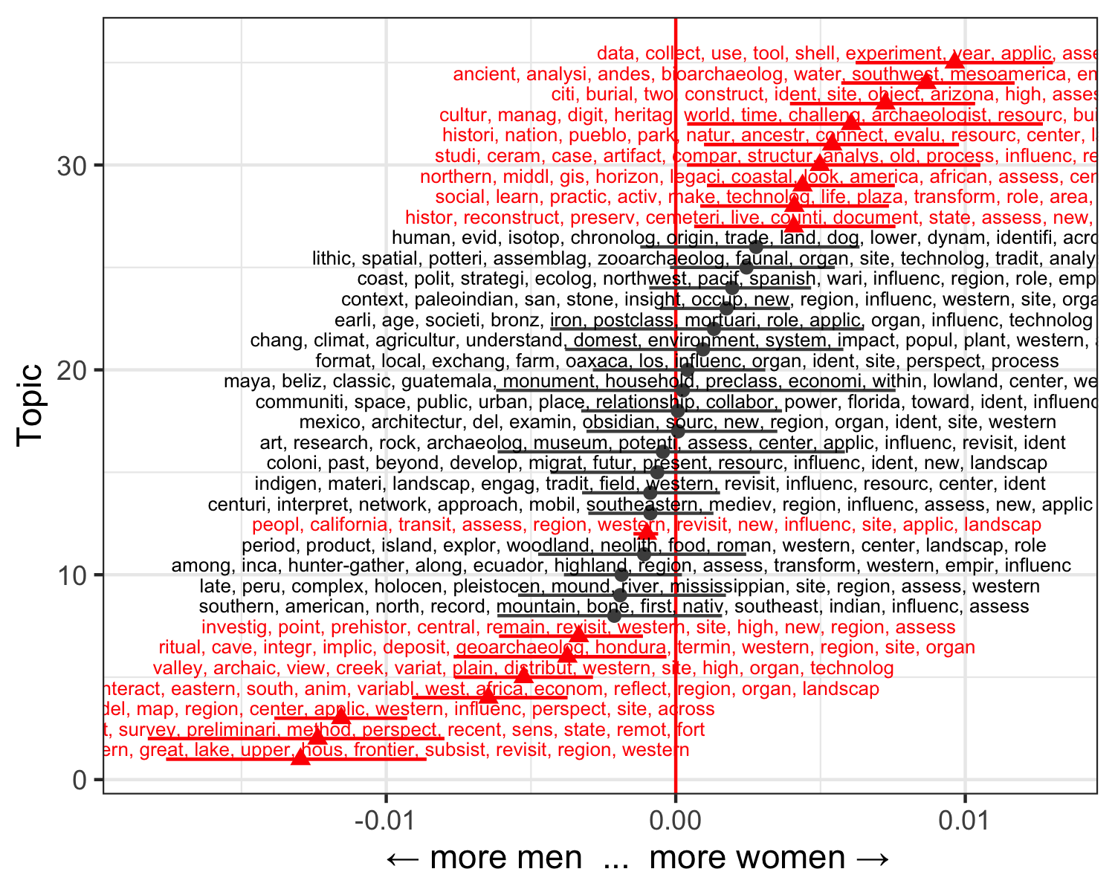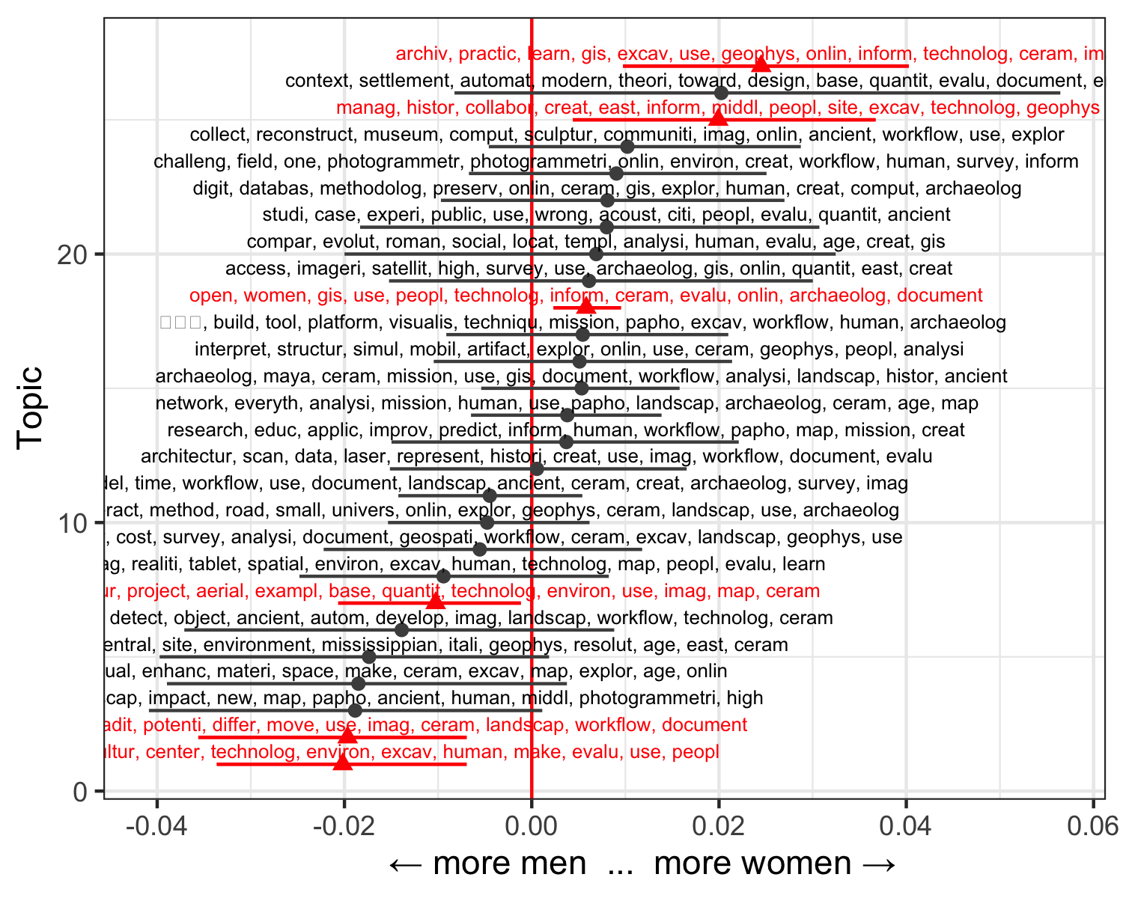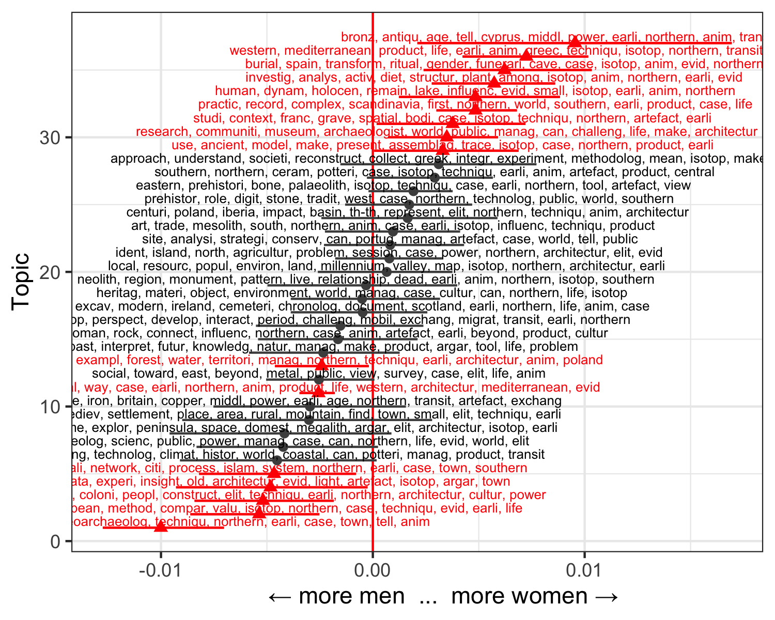

Overall we see similar women-to-men ratios for the SAA (1.1) and EAA (1.2), but much lower for the CAA (0.6). Even before we look into the gender preferences for specific topics within each conference, we already have a hint that computational topics may be less preferred by women than by men.

In the SAA data we found a total of 2,930 presentations. Of these we could identify the first-named authors of 2608 (89%) presentations as either men (n=1246) or women (n=1362). In the SAA presentations we identified the optimum number of topics as 35, with 17 of these showing non-random co-variance with the gender of the first-named presenter. Eight of these topics were associated with men, and nine topics associated with women. One of the main difference that we can see between the topics of the genders are the locations that the presenters are interested in. Topics associated more with women include bioarchaeology, cemeteries, burials, shells, and ceramics. Topics associated more with men include survey and landscape archaeology, geoarchaeology, rituals, and regional studies. Women are more likely to work on locations such as Mesoamerica, Arizona and national parks, while men are more likely to present on topics about the Great Lakes, and Honduras.

For the EAA data we have 2,928 presentations, and 2237 (76%) where the first author could be classified as either a man (n=1016) or woman (n=1221). For EAA we generated a total of 37 topics, with 16 of these showing non-random co-variance with the gender of the first-named presenter. Seven of these topics were associated with men, and nine topics associated with women. Although topics significantly associated with men and women both include the word “Mediterranean”, women seem to be focusing more on the western Mediterranean while men seems to be focusing on the northern Mediterranean. Topics associated more with women include burials, graves, museums, animals, diet, and ritual. Topics associated more with men include geoarchaeology, architecture, and towns.

For the CAA meeting we have 358 presentations, and 318 (89%) first-named authors could be classified as either men (n=194) or women (n=124). For CAA we generated a total of 27 topics, with 6 of these showing non-random co-variance with the gender of the first-named presenter. Three of these topics were associated with men, and three topics associated with women. Topics associated more with women include archives, GIS, geophysics, collaboration, and teaching. Topics associated more with men include environmental and landscape archaeology.

# Discussion

Our results show correlations between the gender of the first-named presenter and the topics in their conference presentation. Although each of the three meetings have distinctive sets of topics, we can identify some common themes in the topics that correlate with

Although the gender gap in academia has been shrinking in recent years, there remain substantial differences, which often result in underrepresentation of women in many fields and career stages, as well as disadvantages such as lower salaries and less access to high-prestige employment (Caprile et al., 2012). Even research into these gender biases suffers a bias, with Cislak et al. (2018) finding that articles on gender bias and race bias are funded less often and published in journals with a lower Impact Factor than articles on comparable instances of social discrimination.

Compare topics between the three confs

how to use these results… implicit bias in assigment topics…

# Conclusion

# Acknowledgements

# References

Bardolph, D.N., 2018. Controlling the narrative: A comparative examination of gendered publishing trends in the sca and beyond. California Archaeology 10, 159–186.

Bardolph, D.N., 2014. A critical evaluation of recent gendered publishing trends in american archaeology. American Antiquity 79, 522–540.

Blevins, C., Mullen, L., 2015. Jane, john... Leslie? A historical method for algorithmic gender prediction. DHQ: Digital Humanities Quarterly 9.

Caprile, M., Addis, E., Castaño, C., Klinge, I., Larios, M., Meulders, D., Müller, J., O’Dorchao, S., Palasik, M., Plasman, R., others, 2012. Meta-analysis of gender and science research. Synthesis report. Luxembourg: Publications Office of the European Union. doi: https://doi. org/10.2777/75176.

Chang, J., Gerrish, S., Wang, C., Boyd-Graber, J.L., Blei, D.M., 2009. Reading tea leaves: How humans interpret topic models, in: Advances in Neural Information Processing Systems. pp. 288–296.

Cislak, A., Formanowicz, M., Saguy, T., 2018. Bias against research on gender bias. Scientometrics 115, 189–200. <https://doi.org/10.1007/s11192-018-2667-0>

Fulkerson, T.J., Tushingham, S., 2019. Who dominates the discourses of the past? Gender, occupational affiliation, and multivocality in north american archaeology publishing. American Antiquity 84, 379–399.

Hamilton, M.C., Anderson, D., Broaddus, M., Young, K., 2006. Gender stereotyping and under-representation of female characters in 200 popular children’s picture books: A twenty-first century update. Sex Roles 55, 757–765.

Heath-Stout, L.E., n.d. Who writes about archaeology? An intersectional study of authorship in archaeological journals. American Antiquity 1–20.

Heath-Stout, L.E., 2020. Guest editorial introduction: Gender, equity, and the peer review process at the journal of field archaeology.

Lincoln, M., n.d. Gender: Predict gender from names using historical data. R package version 0.5. 2., 2018.

Mihaljević, H., Tullney, M., Santamarı́a, L., Steinfeldt, C., 2019. Reflections on gender analyses of bibliographic corpora. Frontiers in Big Data 2, 29.

Mimno, D., Lee, M., 2014. Low-dimensional embeddings for interpretable anchor-based topic inference, in: Proceedings of the 2014 Conference on Empirical Methods in Natural Language Processing (Emnlp). pp. 1319–1328.

Roberts, M.E., Stewart, B.M., Tingley, D., Lucas, C., Leder-Luis, J., Gadarian, S.K., Albertson, B., Rand, D.G., 2014. Structural topic models for open-ended survey responses. American Journal of Political Science 58, 1064–1082.

Roberts, M., Stewart, B., Tingley, D., Benoit, K., Stewart, M.B., Rcpp, L., Imports matrixStats, R., KernSmooth, N., 2019. Package “stm”.

Rodrı́guez-Álvarez, X.-P., Lozano, S., 2018. Gender balance in the scientific production of the atapuerca archaeological and palaeontological research project. Journal of Anthropological Sciences 96, 1–8.

Sinclair, A., 2016. The intellectual base of archaeological research 2004–2013: A visualisation and analysis of its disciplinary links, networks of authors and conceptual language. Internet Archaeology 42.

Tushingham, S., Fulkerson, T., Hill, K., 2017. The peer review gap: A longitudinal case study of gendered publishing and occupational patterns in a female-rich discipline, western north america (1974–2016). PloS one 12.

VanDerwarker, A.M., Brown, K.M., Gonzalez, T., Radde, H., 2018. The ucsb gender equity project: Taking stock of mentorship, equity, and harassment in california archaeology through qualitative survey data. California Archaeology 10, 131–158.

Xu, Y.J., 2008. Gender disparity in stem disciplines: A study of faculty attrition and turnover intentions. Research in higher education 49, 607–624.

### Colophon

This report was generated on 2020-07-17 18:15:39 using the following computational environment and dependencies:

#> ─ Session info ───────────────────────────────────────────────────────────────  
#> setting value   
#> version R version 4.0.2 (2020-06-22)  
#> os macOS Catalina 10.15.5   
#> system x86_64, darwin17.0   
#> ui X11   
#> language (EN)   
#> collate en_US.UTF-8   
#> ctype en_US.UTF-8   
#> tz America/Los_Angeles   
#> date 2020-07-17   
#>   
#> ─ Packages ───────────────────────────────────────────────────────────────────  
#> package * version date lib source   
#> assertthat 0.2.1 2019-03-21 [1] CRAN (R 4.0.0)  
#> backports 1.1.8 2020-06-17 [1] CRAN (R 4.0.0)  
#> blob 1.2.1 2020-01-20 [1] CRAN (R 4.0.0)  
#> bookdown 0.20 2020-06-23 [1] CRAN (R 4.0.0)  
#> broom 0.7.0 2020-07-09 [1] CRAN (R 4.0.2)  
#> callr 3.4.3 2020-03-28 [1] CRAN (R 4.0.0)  
#> cellranger 1.1.0 2016-07-27 [1] CRAN (R 4.0.0)  
#> cli 2.0.2 2020-02-28 [1] CRAN (R 4.0.0)  
#> colorspace 1.4-1 2019-03-18 [1] CRAN (R 4.0.0)  
#> crayon 1.3.4 2017-09-16 [1] CRAN (R 4.0.0)  
#> data.table 1.12.8 2019-12-09 [1] CRAN (R 4.0.0)  
#> DBI 1.1.0 2019-12-15 [1] CRAN (R 4.0.0)  
#> dbplyr 1.4.4 2020-05-27 [1] CRAN (R 4.0.0)  
#> desc 1.2.0 2018-05-01 [1] CRAN (R 4.0.0)  
#> devtools 2.3.0 2020-04-10 [1] CRAN (R 4.0.1)  
#> digest 0.6.25 2020-02-23 [1] CRAN (R 4.0.0)  
#> dplyr * 1.0.0 2020-05-29 [1] CRAN (R 4.0.0)  
#> ellipsis 0.3.1 2020-05-15 [1] CRAN (R 4.0.0)  
#> evaluate 0.14 2019-05-28 [1] CRAN (R 4.0.0)  
#> fansi 0.4.1 2020-01-08 [1] CRAN (R 4.0.0)  
#> farver 2.0.3 2020-01-16 [1] CRAN (R 4.0.0)  
#> forcats * 0.5.0 2020-03-01 [1] CRAN (R 4.0.0)  
#> fs 1.4.2 2020-06-30 [1] CRAN (R 4.0.1)  
#> gender * 0.5.4 2020-05-15 [1] CRAN (R 4.0.0)  
#> genderdata 0.5.0 2020-05-09 [1] local   
#> generics 0.0.2 2018-11-29 [1] CRAN (R 4.0.0)  
#> ggplot2 * 3.3.2 2020-06-19 [1] CRAN (R 4.0.0)  
#> glue 1.4.1 2020-05-13 [1] CRAN (R 4.0.0)  
#> gtable 0.3.0 2019-03-25 [1] CRAN (R 4.0.0)  
#> haven 2.3.1 2020-06-01 [1] CRAN (R 4.0.0)  
#> here * 0.1 2017-05-28 [1] CRAN (R 4.0.0)  
#> hms 0.5.3 2020-01-08 [1] CRAN (R 4.0.0)  
#> htmltools 0.5.0 2020-06-16 [1] CRAN (R 4.0.0)  
#> httr 1.4.1 2019-08-05 [1] CRAN (R 4.0.0)  
#> jsonlite 1.7.0 2020-06-25 [1] CRAN (R 4.0.0)  
#> knitr 1.29 2020-06-23 [1] CRAN (R 4.0.0)  
#> labeling 0.3 2014-08-23 [1] CRAN (R 4.0.0)  
#> lattice 0.20-41 2020-04-02 [1] CRAN (R 4.0.2)  
#> lifecycle 0.2.0 2020-03-06 [1] CRAN (R 4.0.0)  
#> lubridate 1.7.9 2020-06-08 [1] CRAN (R 4.0.1)  
#> magrittr 1.5 2014-11-22 [1] CRAN (R 4.0.0)  
#> Matrix 1.2-18 2019-11-27 [1] CRAN (R 4.0.2)  
#> memoise 1.1.0 2017-04-21 [1] CRAN (R 4.0.0)  
#> modelr 0.1.8 2020-05-19 [1] CRAN (R 4.0.0)  
#> munsell 0.5.0 2018-06-12 [1] CRAN (R 4.0.0)  
#> pillar 1.4.6 2020-07-10 [1] CRAN (R 4.0.0)  
#> pkgbuild 1.1.0 2020-07-13 [1] CRAN (R 4.0.0)  
#> pkgconfig 2.0.3 2019-09-22 [1] CRAN (R 4.0.0)  
#> pkgload 1.1.0 2020-05-29 [1] CRAN (R 4.0.0)  
#> prettyunits 1.1.1 2020-01-24 [1] CRAN (R 4.0.0)  
#> processx 3.4.3 2020-07-05 [1] CRAN (R 4.0.1)  
#> ps 1.3.3 2020-05-08 [1] CRAN (R 4.0.0)  
#> purrr * 0.3.4 2020-04-17 [1] CRAN (R 4.0.0)  
#> R6 2.4.1 2019-11-12 [1] CRAN (R 4.0.0)  
#> Rcpp 1.0.5 2020-07-06 [1] CRAN (R 4.0.2)  
#> readr * 1.3.1 2018-12-21 [1] CRAN (R 4.0.0)  
#> readxl 1.3.1 2019-03-13 [1] CRAN (R 4.0.0)  
#> remotes 2.1.1 2020-02-15 [1] CRAN (R 4.0.0)  
#> reprex 0.3.0 2019-05-16 [1] CRAN (R 4.0.0)  
#> rlang 0.4.7 2020-07-09 [1] CRAN (R 4.0.0)  
#> rmarkdown 2.3 2020-06-18 [1] CRAN (R 4.0.0)  
#> rprojroot 1.3-2 2018-01-03 [1] CRAN (R 4.0.0)  
#> rstudioapi 0.11 2020-02-07 [1] CRAN (R 4.0.0)  
#> rvest 0.3.5 2019-11-08 [1] CRAN (R 4.0.0)  
#> scales 1.1.1 2020-05-11 [1] CRAN (R 4.0.0)  
#> sessioninfo 1.1.1 2018-11-05 [1] CRAN (R 4.0.0)  
#> stm 1.3.5 2019-12-17 [1] CRAN (R 4.0.0)  
#> stringi 1.4.6 2020-02-17 [1] CRAN (R 4.0.0)  
#> stringr * 1.4.0 2019-02-10 [1] CRAN (R 4.0.0)  
#> testthat 2.3.2 2020-03-02 [1] CRAN (R 4.0.0)  
#> tibble * 3.0.3 2020-07-10 [1] CRAN (R 4.0.0)  
#> tidyr * 1.1.0 2020-05-20 [1] CRAN (R 4.0.0)  
#> tidyselect 1.1.0 2020-05-11 [1] CRAN (R 4.0.0)  
#> tidyverse * 1.3.0 2019-11-21 [1] CRAN (R 4.0.0)  
#> usethis 1.6.1 2020-04-29 [1] CRAN (R 4.0.0)  
#> vctrs 0.3.1 2020-06-05 [1] CRAN (R 4.0.0)  
#> withr 2.2.0 2020-04-20 [1] CRAN (R 4.0.0)  
#> xfun 0.15 2020-06-21 [1] CRAN (R 4.0.0)  
#> xml2 1.3.2 2020-04-23 [1] CRAN (R 4.0.0)  
#> yaml 2.2.1 2020-02-01 [1] CRAN (R 4.0.0)  
#>   
#> [1] /Library/Frameworks/R.framework/Versions/4.0/Resources/library

The current Git commit details are: u

#> Local: master /Users/bmarwick/Desktop/archyconfgender  
#> Remote: master @ origin (https://github.com/yichun33/archyconfgender)  
#> Head: [8424bca] 2020-07-10: resolve merge conflict