Computer Vision HW1 B07902127 資工二 羅義鈞

Part 1

1. 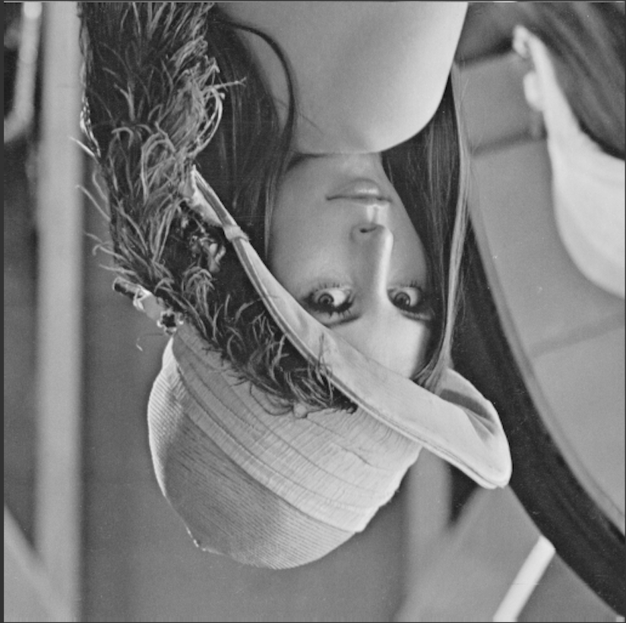 upside-down lena.bmp  
   Done by creating an empty 3D numpy array, and copying image from the bottom to the top using for loop.
2. 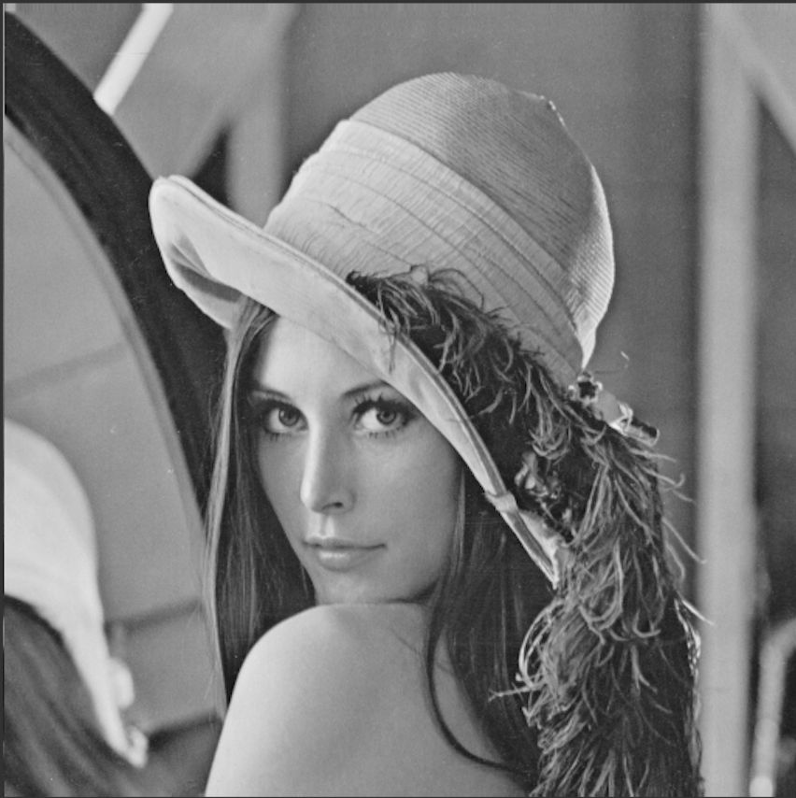 right-side-left lena.bmp  
   Done by creating an empty 3D numpy array, and copying image from the right to the left using for loop.
3. diagonally flip lena.bmp

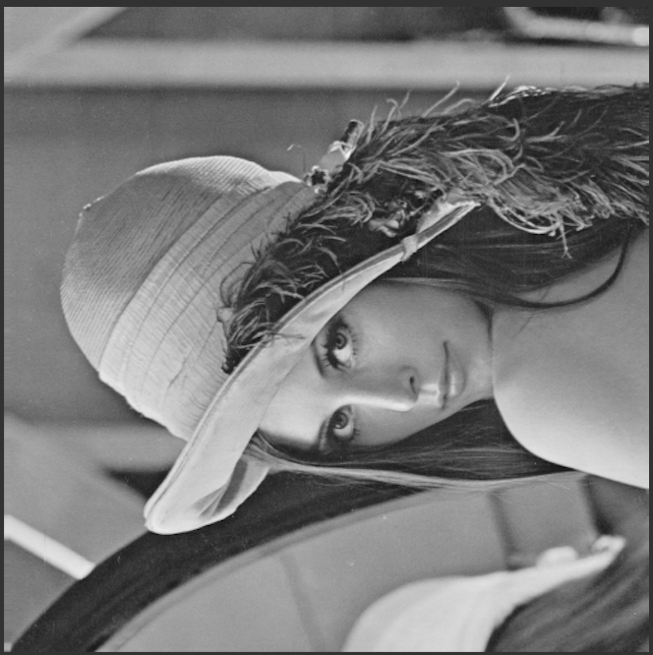Done by creating an empty 3D numpy array, exchange the x, y of image and copy to the array using double for loop.

Part 2

By using photoshop:

1. rotate lena.bmp 45 degrees clockwise

影像 🡪 影像調整 🡪 任意 🡪 45度

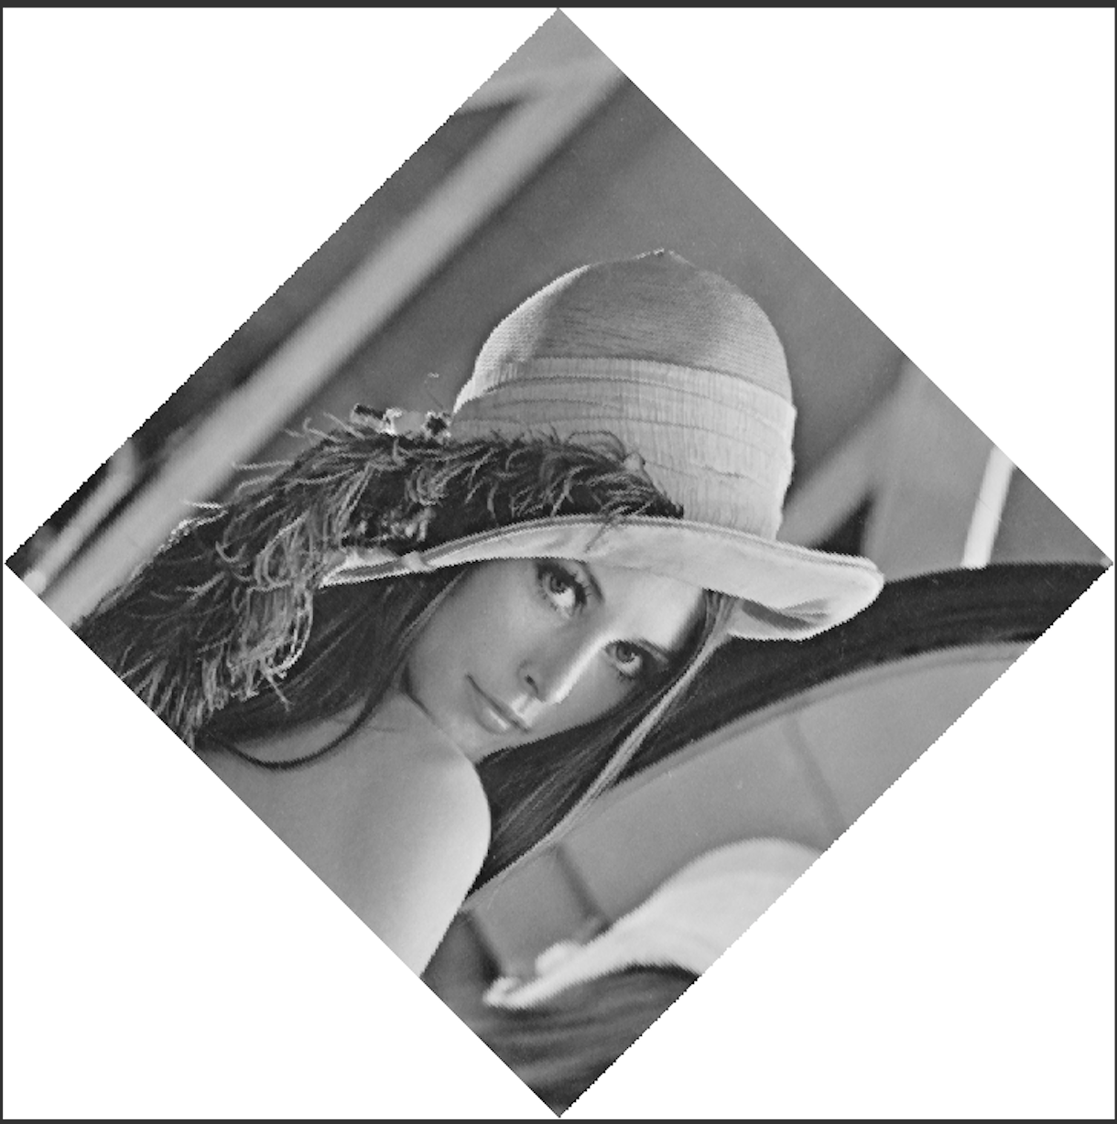

1. shrink lena.bmp in half

影像 🡪 影像尺寸 🡪 長寬改為256 x 256



1. Binarize lena.bmp at 128 to get a binary image

影像 🡪 調整 🡪 臨界值 🡪 修改為128

