Hocam data setini eğer siz daha düzgün ayırabilirseniz bu modele yükleyip deneme yapabilirsiniz.

Ben elimden geldiğince ayırdım.

Model predictionu modelin hiç görmediği imagelere yaptırıp elde ettim.

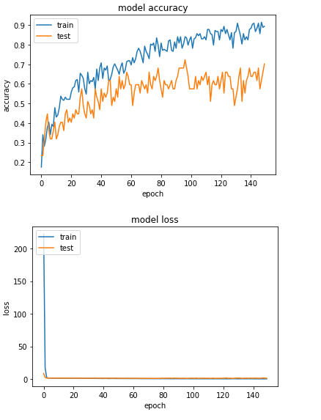

Özet olarak:

Karanlığı gayet iyi buluyor.

Uygun , Overexposed ve yansimali fotograflarda da güzel çalışıyor.

Bulanik fotografıda kafasına göre bulduğunu söyleyebilirim :D

Modelin hiç görmediği imagelere göre Çıkan sonuçlar

OVEREXPOSED KLASÖRÜ(Kendim overexposed diyordum bunlara)

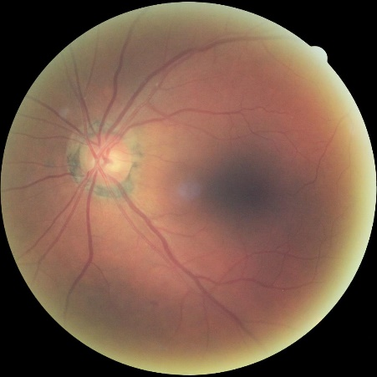

This image most likely belongs to yansimali with a 22.18 percent confidence.

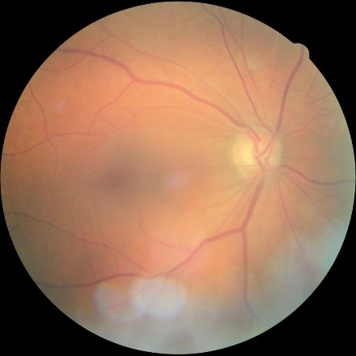

T This image most likely belongs to overexpo with a 30.78 percent confidence.

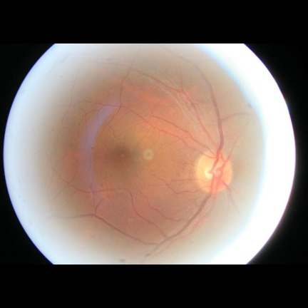

This image most likely belongs to overexpo with a 40.43 percent confidence.

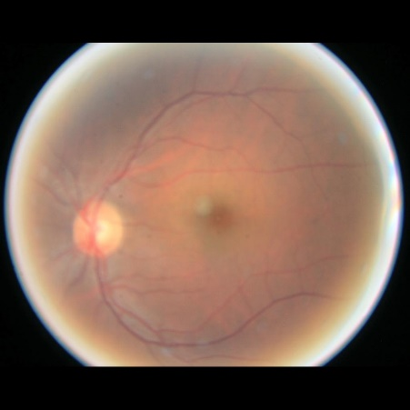

This image most likely belongs to yansimali with a 22.83 percent confidence.

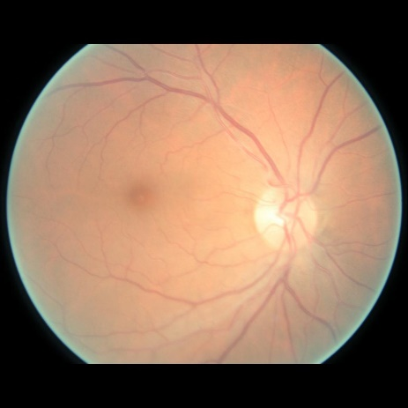

This image most likely belongs to overexpo with a 33.62 percent confidence.

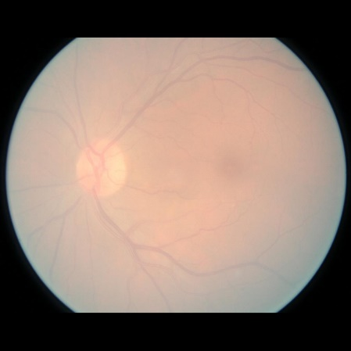

This image most likely belongs to overexpo with a 36.58 percent confidence.

Karanlik klasöründen 5 tane fotograf.

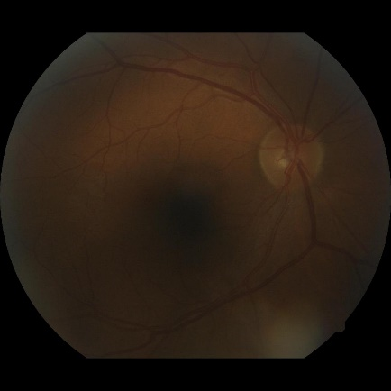

This image most likely belongs to karanlik with a 39.88 percent confidence.

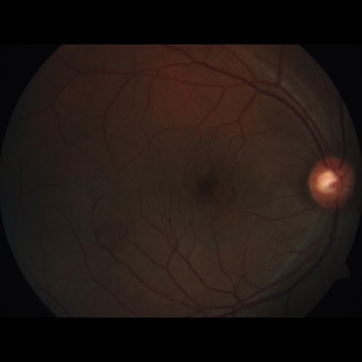

This image most likely belongs to karanlik with a 40.23 percent confidence.

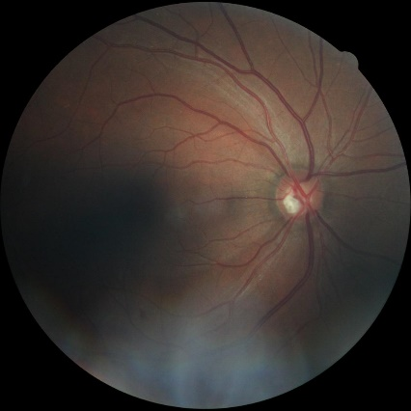

This image most likely belongs to karanlik with a 39.24 percent confidence.

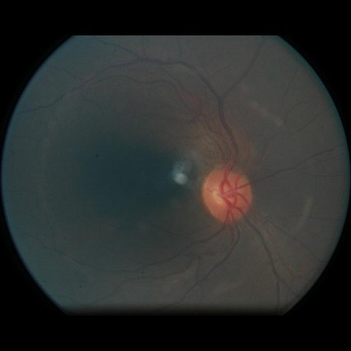

This image most likely belongs to karanlik with a 40.46 percent confidence.

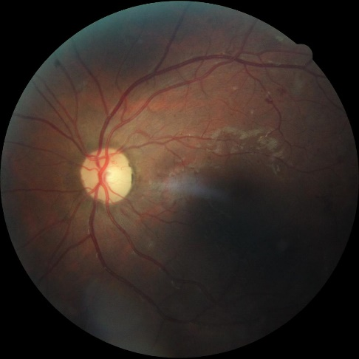

This image most likely belongs to karanlik with a 39.95 percent confidence.

Yansimali Klasörü

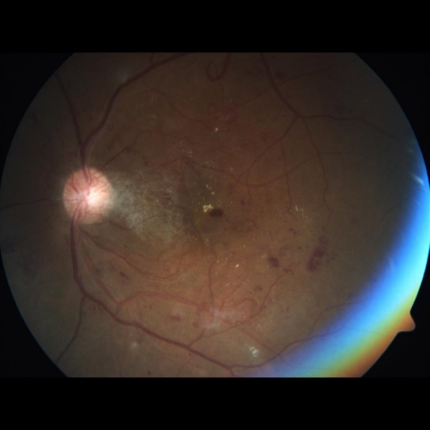

This image most likely belongs to karanlik with a 40.46 percent confidence.

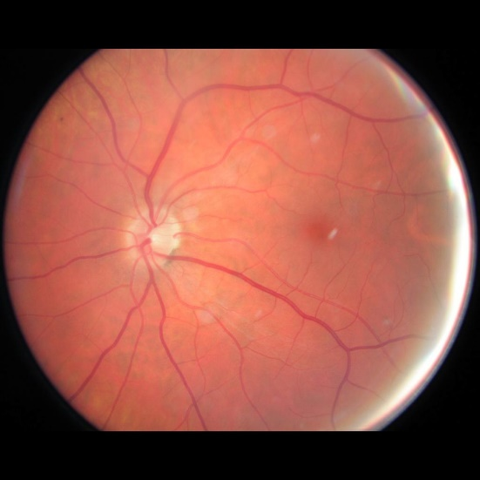

This image most likely belongs to yansimali with a 40.18 percent confidence.

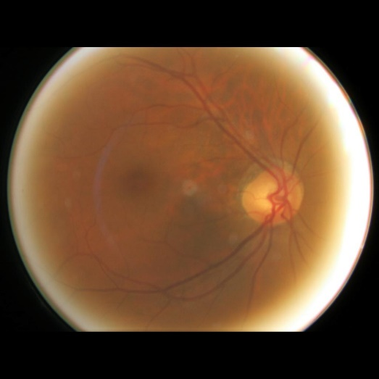

This image most likely belongs to yansimali with a 28.58 percent confidence.

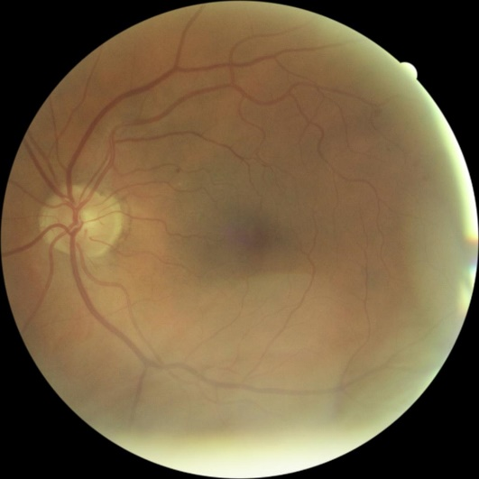

This image most likely belongs to yansimali with a 25.18 percent confidence.

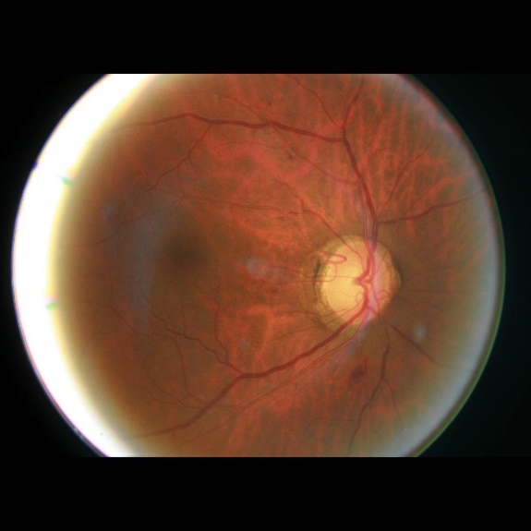

This image most likely belongs to yansimali with a 40.40 percent confidence.

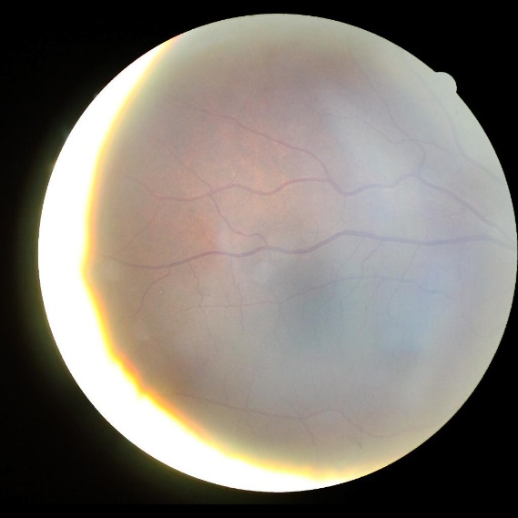

This image most likely belongs to yansimali with a 40.03 percent confidence.

Uygun klasörü (hepsi uygun değil ama deneme yaptıgım klasörün içinde bu imageler vardı 😊)

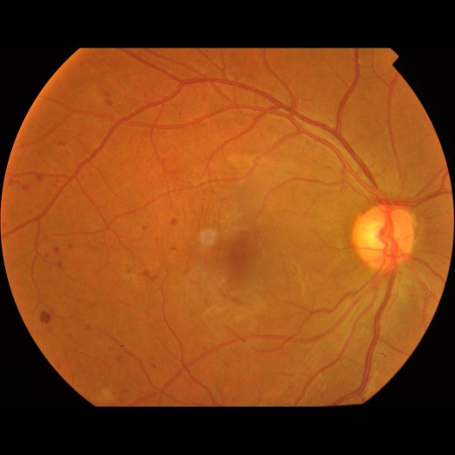

This image most likely belongs to bulanik with a 40.46 percent confidence.

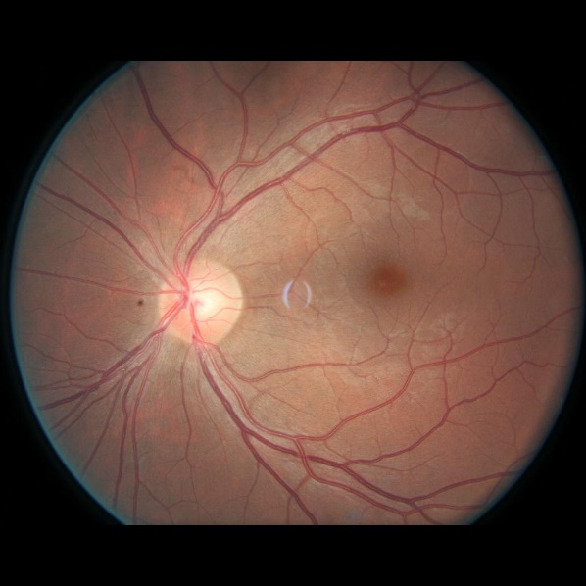

This image most likely belongs to uygun with a 22.51 percent confidence.

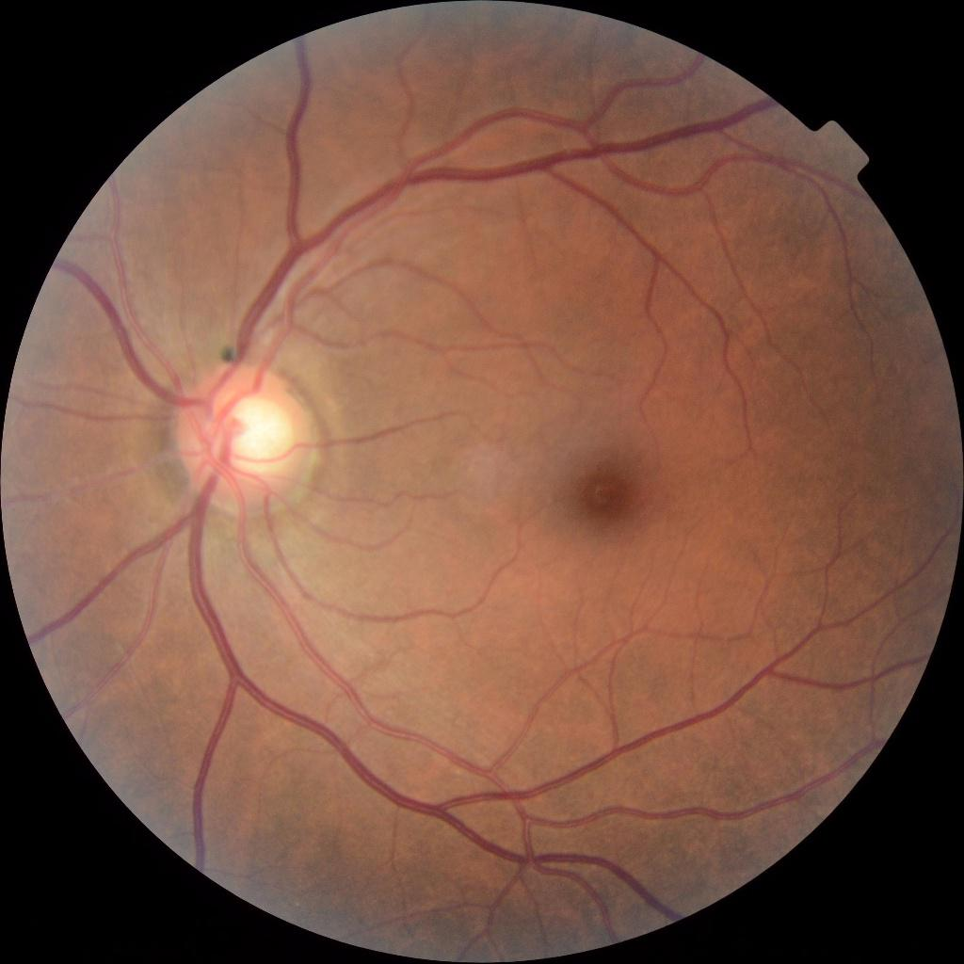

his image most likely belongs to uygun with a 26.59 percent confidence.

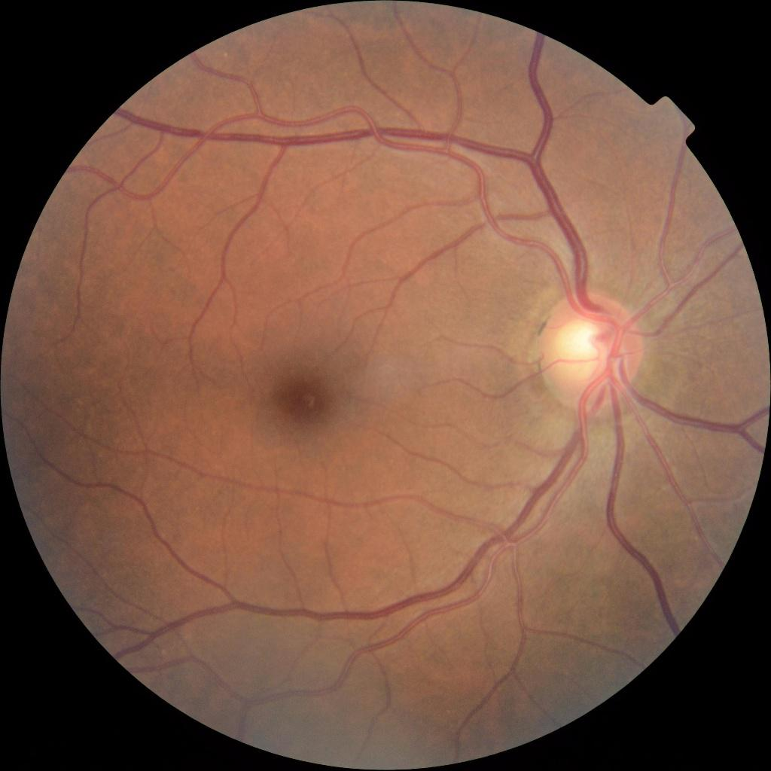

This image most likely belongs to uygun with a 30.39 percent confidence.

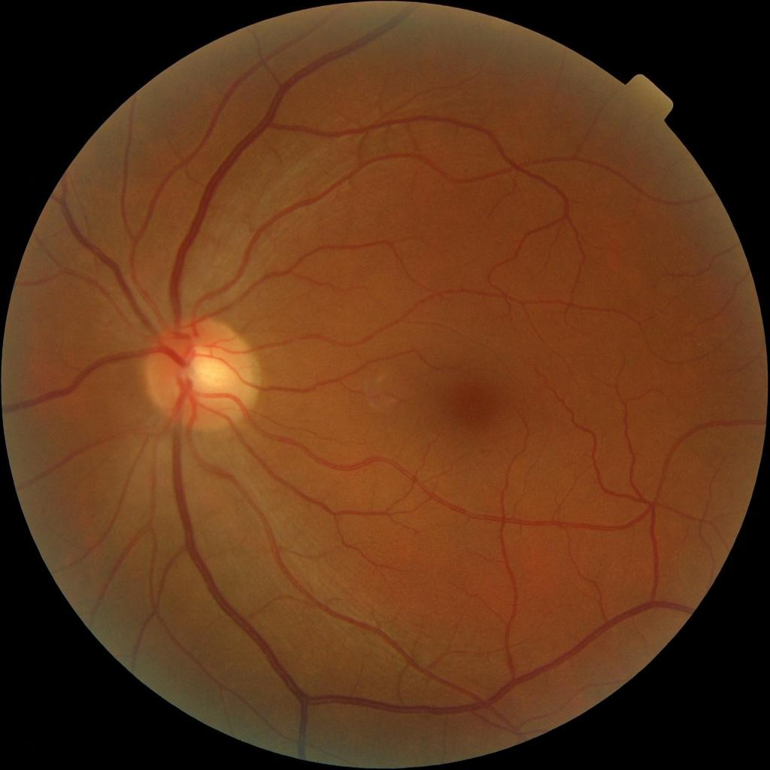

This image most likely belongs to bulanik with a 33.14 percent confidence.

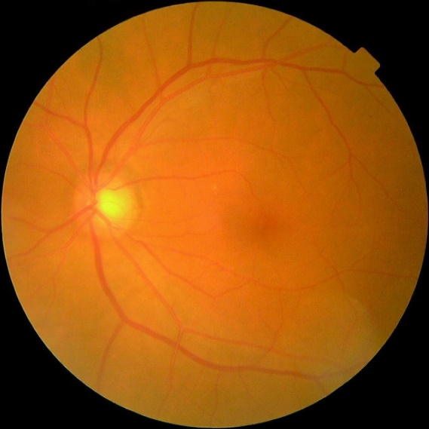

This image most likely belongs to bulanik with a 40.45 percent confidence.

Bulanik klasörü

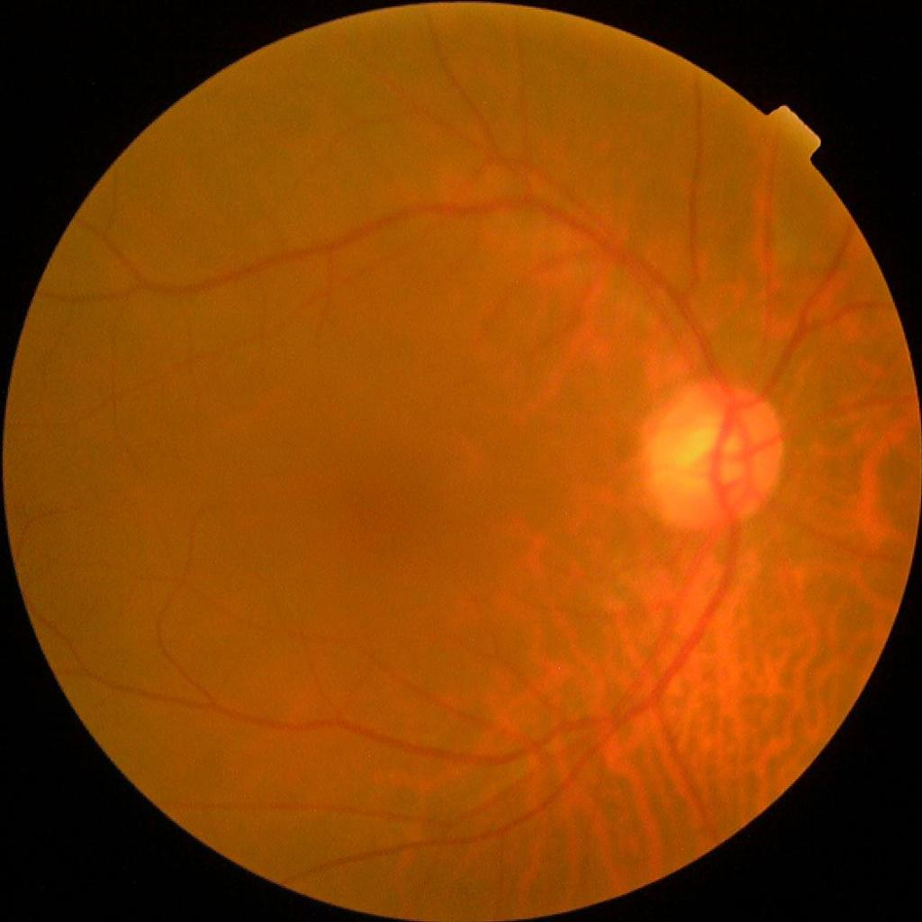

This image most likely belongs to bulanik with a 40.44 percent confidence.

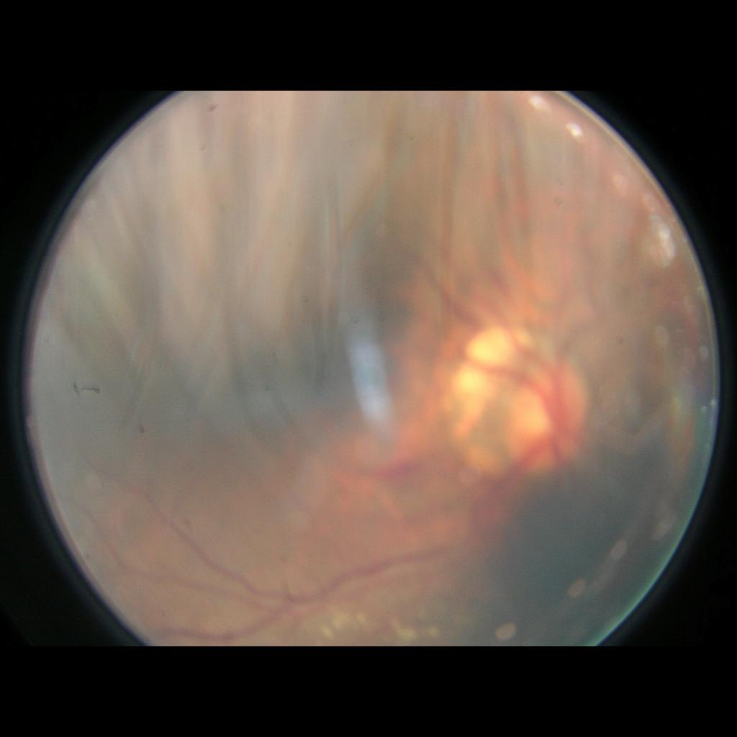

This image most likely belongs to yansimali with a 25.47 percent confidence.

,

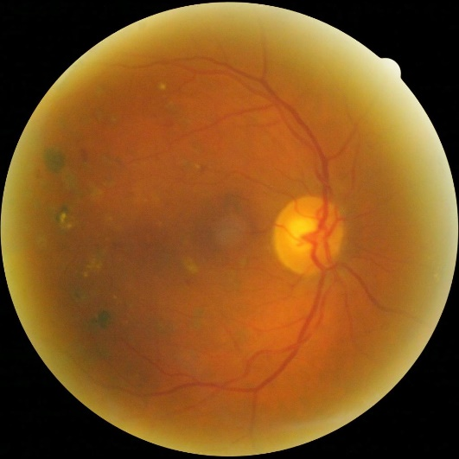

This image most likely belongs to overexpo with a 28.70 percent confidence.

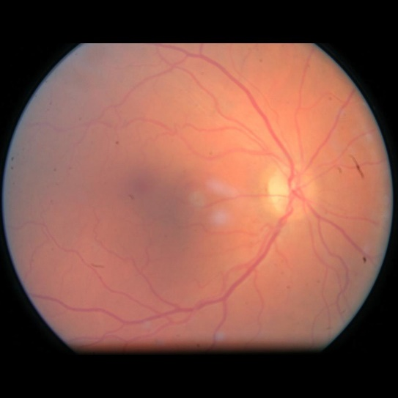

This image most likely belongs to overexpo with a 33.65 percent confidence.

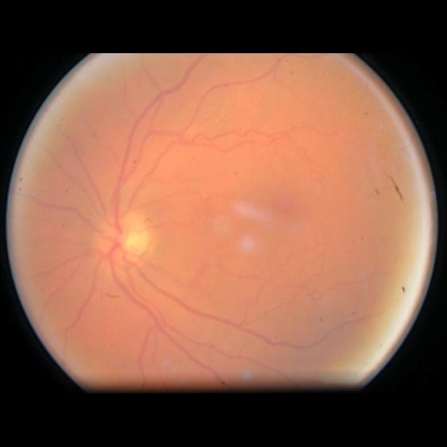

This image most likely belongs to yansimali with a 40.17 percent confidence.