Paleomagnetic and Geochemical Investigation of the Bolaven Plateau Volcanic Field: Testing the Australasian Impact Crater Hypothesis, Southern Laos
Nicolas Anderson^{1,*}, Paolo Sanchez¹, Kerry Sieh², and Joseph L. Kirschvink¹
¹Division of Geological and Planetary Sciences, California Institute of Technology, Pasadena, CA 91125, USA
²Earth Observatory of Singapore, Nanyang Technological University, Singapore 639798
Corresponding author: nanderson@caltech.edu
The source crater for the Australasian tektite strewn field, formed by a large bolide impact at approximately 790 ka, has remained elusive for over a century despite extensive searches across Southeast Asia. Recent geological, geochemical, and geophysical evidence suggests that this impact crater lies buried beneath the basaltic lavas of the Bolaven Plateau volcanic field in southern Laos. To test this hypothesis, we conducted the first detailed paleomagnetic and magnetostratigraphic study of the Bolaven volcanic field, analyzing approximately 80 drill core and block samples from 16 localities across southern Laos. Our investigation included vibrating sample magnetometer (VSM) analysis, thermal and alternating field demagnetization, conglomerate tests on proposed ejecta deposits, and polarity determinations of proposed in-situ basalt flows. We complemented the magnetic work with SEM/EDS mineral identification of the basalts and with new major- and trace-element analyses of Australasian tektites (electron microprobe and LA-ICP-MS) and of the candidate Bolaven source rocks, evaluated with a reversible-jump Markov-chain Monte-Carlo source-unmixing model. Our results reveal that weathered basalt surfaces show consistently lower coercivity (mean Hc = 13.9 mT vs. 17.0 mT) but higher mass-normalized remanent (Mr = 93 vs. 68 μAm²/g) and saturation magnetization (Ms = 405 vs. 230 μAm²/g) compared to fresh cores, indicating maghemite – derived from primary titanomagnetite identified by SEM/EDS – as the dominant magnetic carrier in weathering rinds. Watson conglomerate tests on six boulder localities show that two (NWF-C, NWF-B) carry demonstrably random, pre-depositional clast magnetizations, while two others (PKS-G, PKS-F) fail with clustered directions and are better read as weathered in-situ flows, and the remaining two (PKQ-A, PKS-H) are statistically indeterminate at the available sample sizes; all verdicts are robust to re-expressing unresolved specimens as remagnetization circles. A passing test means the clasts carry random, pre-depositional remanences and were not remagnetized in place; this is consistent with ballistic ejecta, but on its own it does not distinguish impact debris from fluvially reworked or mass-wasted basalt. Magnetic polarities agree with the ⁴⁰Ar/³⁹Ar ages at only three of the dated in-situ flows (NWF-A, PKS-B, WBE-A); several of the others are reversed where the Brunhes chron predicts normal polarity, or are directionally disturbed, indicating that either the eruption ages or the in-situ status of these flows need revision. One previously interpreted in-situ flow (PKS-H) resolves into two stratigraphically separate horizons: a directionally discordant upper horizon (HA) whose two internally tight cores diverge by 64°, inconsistent with a single in-situ cooling unit, and a coherent lower unit (HB); all of its cores carry reversed virtual geomagnetic poles that sit 34–46° from the reversed axial dipole, permitting – though not proving – a record of the transitional late-Matuyama field immediately preceding the 773 ka reversal. Taken together, the magnetic data provide a secondary test of the Bolaven impact hypothesis that is largely non-confirmatory. The basalts are high-fidelity magnetic recorders, yet they carry no shock-related high-coercivity phases, most dated flows disagree with their ⁴⁰Ar/³⁹Ar polarities, and the tektite-bearing diamicton (“catastro-loess”) that caps the sequence – whose own origin is disputed, having been read both as impact debris and as ordinary wind-blown loess – is too magnetically incoherent to sample. A parallel geochemical test points the same way. A reversible-jump Bayesian unmixing of 82 quality-screened electron-microprobe analyses of four tektites shows that they are melts of a quartz-rich sand and a fine-grained aluminous sediment, consistent with earlier work. A basaltic contribution of about 5 % is permitted (no more than ~10 % in any model variant); it is required only when no unconstrained component is allowed, and trace-element ratios independently cap it at ~10–20 %. Neither the Khorat Group sediments nor the lateritic regolith now exposed on the Bolaven Plateau can be the parent as sampled: they are too leached of Ca and Na, and the trace-element budget does not close with them. Iridium is below the ~4 ppb LA-ICP-MS detection limit, too high to test the trace (≤ 0.005 %) chondritic component inferred from Os isotopes, and an apparent Pd signal is an analytical (YO⁺) interference. Neither the magnetism nor the geochemistry therefore corroborates the impact interpretation or detects an impact-specific signature. The paleomagnetism shows the volcanic stratigraphy and its radiometric framework to be more complex than previously assumed. The geochemistry is consistent with a sediment-dominated Indochinese source but is not diagnostic of the Bolaven location.
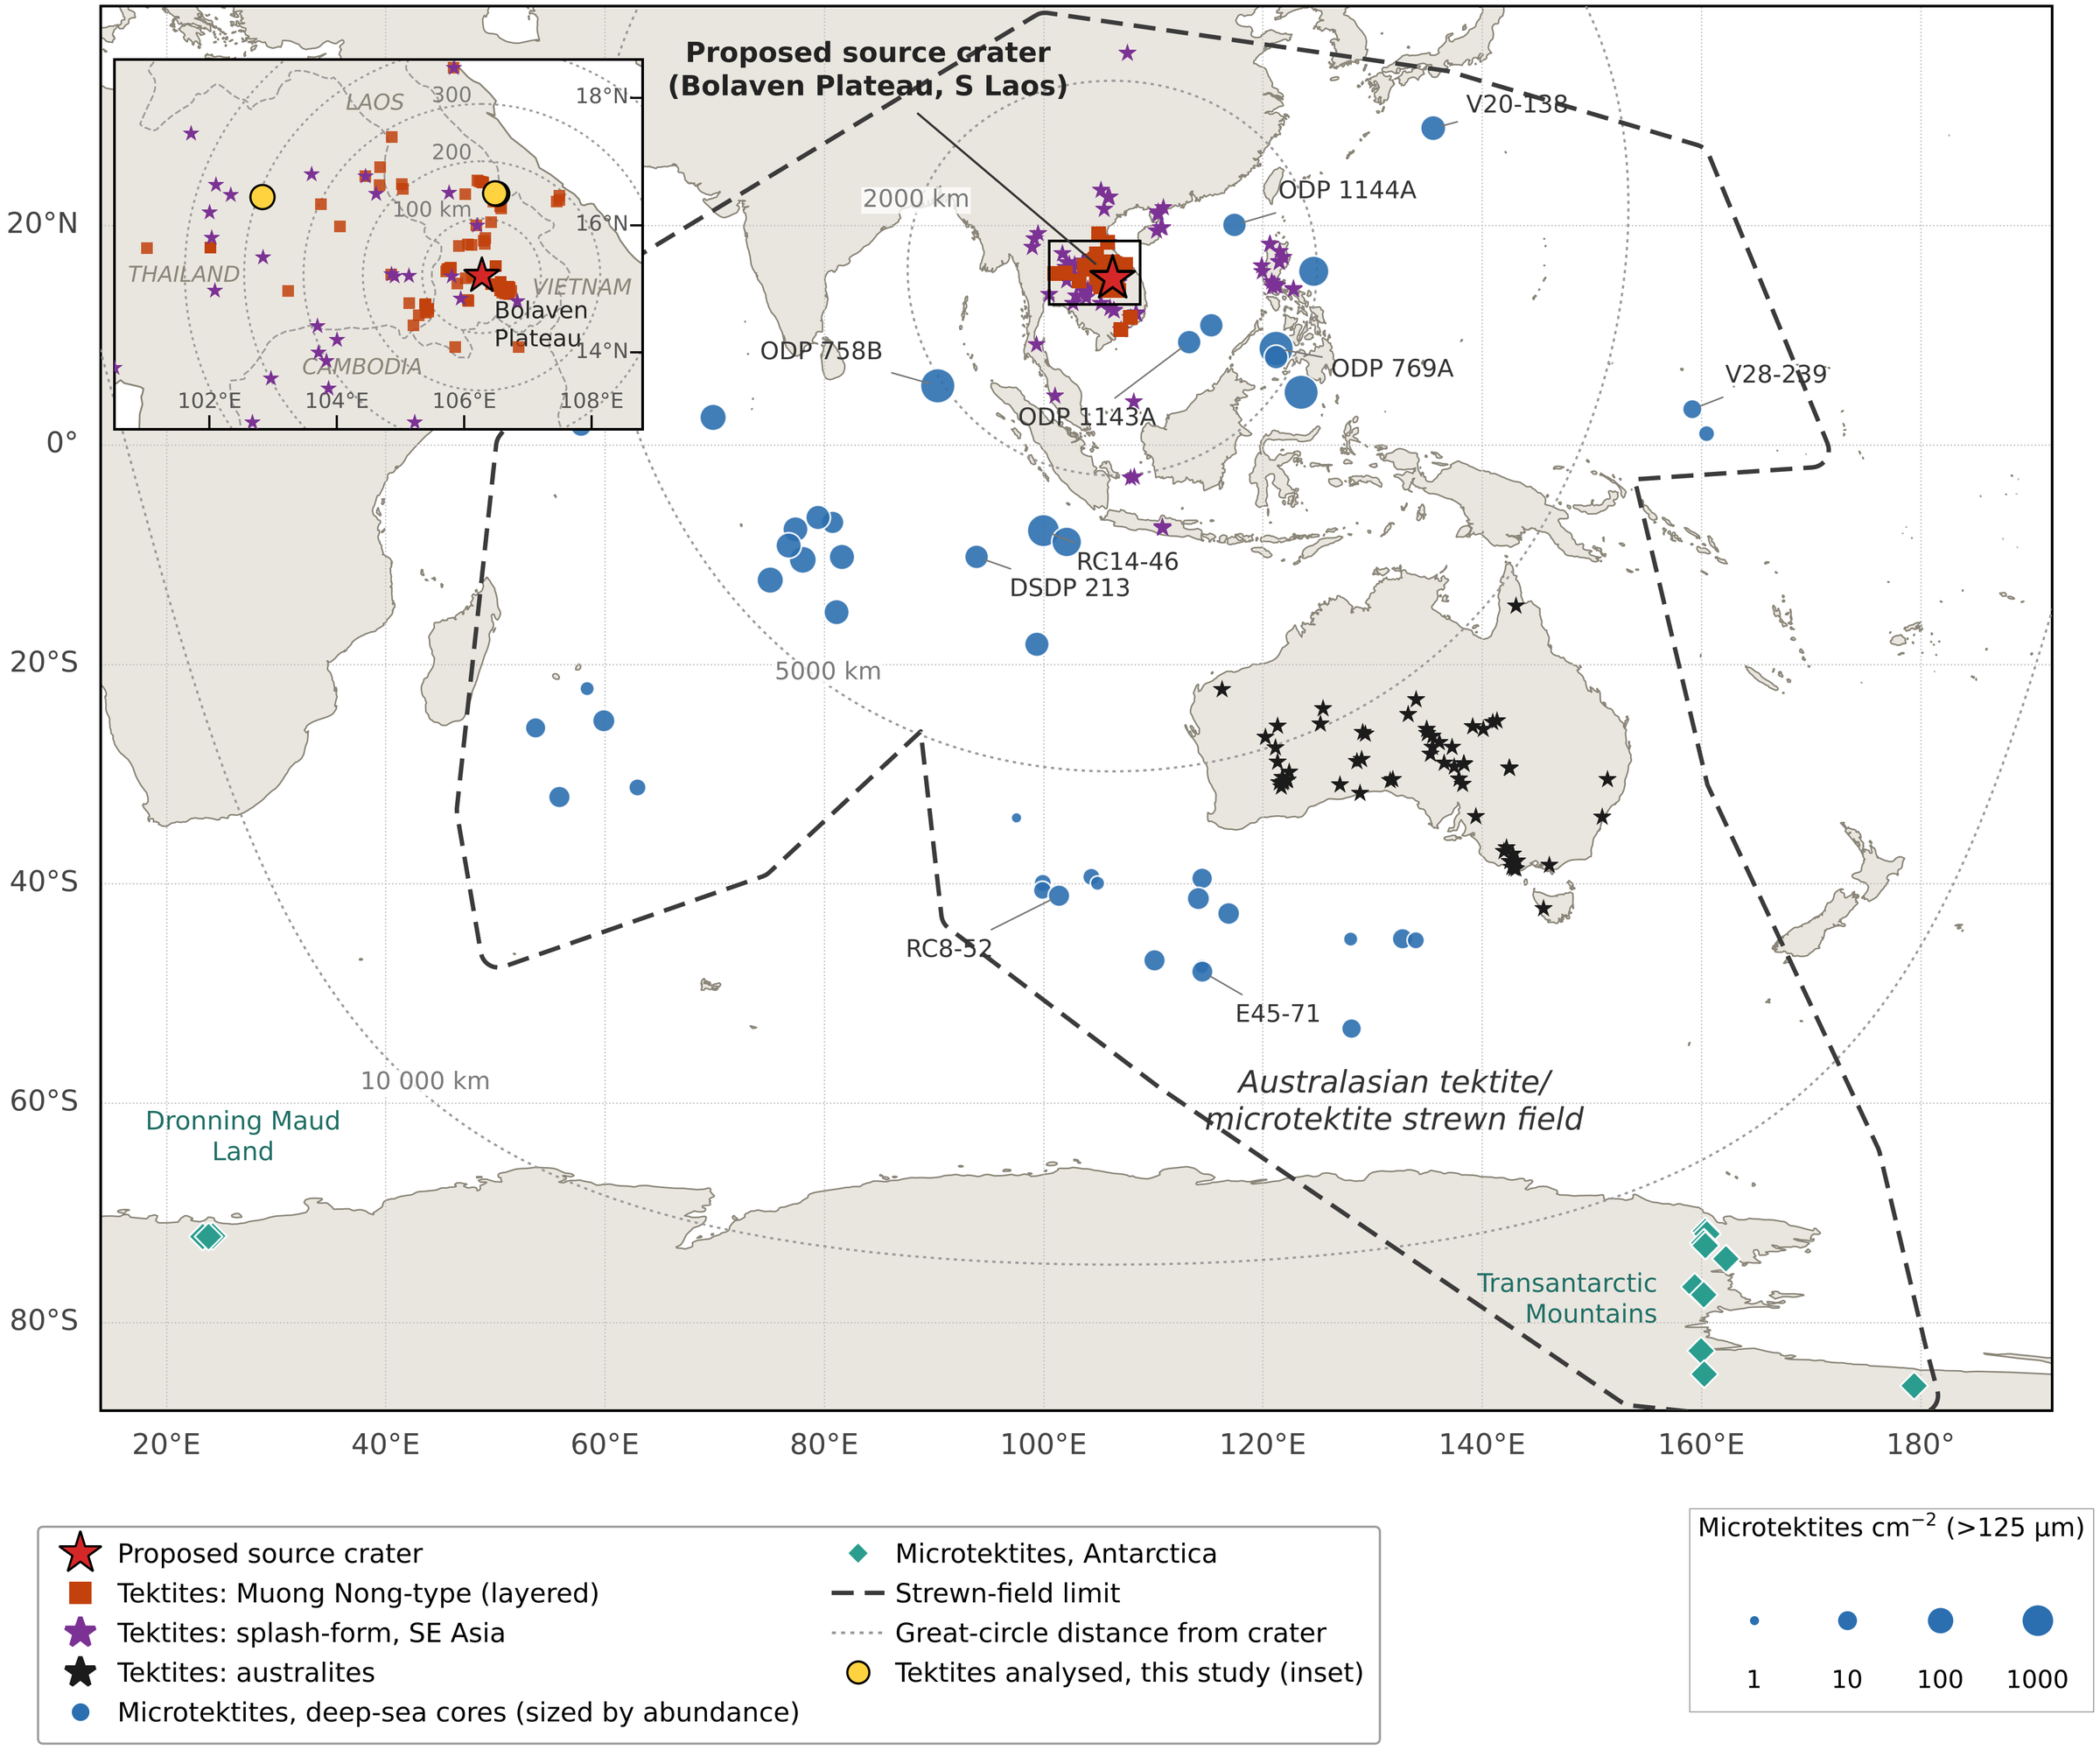
Figure 1. Distribution of the Australasian tektite/microtektite strewn field (redrawn and updated after Folco et al., 2010, fig. 1). Red star: proposed source crater beneath the Bolaven Plateau, southern Laos (15.20°N, 106.27°E; Sieh et al., 2020). Tektites are shown by type: Muong Nong-type (layered) tektites (orange squares), splash-form tektites from SE Asia — indochinites, philippinites, javanites, billitonites and S China finds (purple stars) — and australites (black stars). Deep-sea microtektite cores (blue circles) are scaled by microtektite abundance (>125 µm per cm²; Glass, 1994; Folco et al., 2010); Antarctic microtektite sites (green diamonds) are from the Transantarctic Mountains (Folco et al., 2009, 2010, 2016; Brase et al., 2021; Chernonozhkin et al., 2021) and Dronning Maud Land (Soens et al., 2021). Dashed line: strewn-field limit; dotted lines: great-circle distance from the proposed crater. Inset: tektite localities in southern Laos and neighbouring Thailand, Vietnam and Cambodia, with the tektites analysed in this study (yellow circles); rings at 100 km intervals from the crater. Tektite localities are compiled from published geochemical datasets (Lacroix, 1935; Baker, 1956; Barnes, 1962, 1964; Taylor, 1962; Cassidy et al., 1969; Chapman & Scheiber, 1969; Chapman, 1971; Chalmers et al., 1976; Blum et al., 1992; Koeberl, 1992; Fiske et al., 1996; Son & Koeberl, 2005; Amare & Koeberl, 2006; Mizera et al., 2016; Žák et al., 2019; Tada et al., 2020) and Sieh et al. (2020, Dataset S1).

Introduction
The Australasian tektite strewn field represents one of the most extensive impact ejecta deposits on Earth, covering approximately 20% of the Earth’s eastern hemisphere from Indochina to East Antarctica (Glass & Pizzuto, 1994; Fig. 1). These glassy impact spherules, formed by a bolide impact at 790 ± 3 ka (Schwarz et al., 2016; Jourdan et al., 2019), provide compelling evidence for a major impact event during the late Pleistocene. Despite nearly a century of searching, the source crater for these tektites has remained one of the most enduring mysteries in impact geology.
The northwest-trending increase in both abundance and size of tektite specimens points to an impact site in eastern central Indochina (Fig. 1; Glass & Pizzuto, 1994; Ford, 1988). Geochemical analysis of the tektites indicates target rocks consisting primarily of quartz-rich coarse siltstone to fine sandstone, with evidence for a mafic component (Koeberl, 1992; Wasson, 1991). The high silica content, relict mineral grains, and elevated concentrations of elements such as Mg, Ni, Co, and Cr suggest mixing of siliciclastic sediments with basaltic materials (Amare & Koeberl, 2006; Goderis et al., 2017).
Recently, Sieh et al. (2020) presented compelling evidence that the Australasian impact crater lies buried beneath the Bolaven Plateau volcanic field in southern Laos. Their hypothesis is supported by five lines of evidence: (1) tektite geochemistry consistent with mixing of local sandstone and basaltic materials, (2) pre- and post-impact basaltic flows for the right age that could bury the crater, (3) a negative gravity anomaly of appropriate dimensions within the volcanic field, (4) proximal ejecta deposits with shocked quartz, and (5) the capping massive silty deposit, which contains microscopic tektite spherules termed “catastro-loess” or Bolaven diamicton.
The timing of the Australasian impact at 790 ka is particularly significant as it barely predates the Brunhes-Matuyama (BM) polarity reversal at 773 ± 3 ka (Singer et al., 2019). This proximity to a major geomagnetic field reversal provides an opportunity to investigate potential relationships between large impacts and geomagnetic field behavior. Previous studies have suggested that major impacts might influence geodynamo processes (Muller & Morris, 1986), though this remains controversial.
Paleomagnetic analysis offers powerful tools for testing the Bolaven impact hypothesis. Magnetostratigraphic polarity determinations provide an independent check on the ⁴⁰Ar/³⁹Ar chronology and constrain the timing of volcanic activity relative to the impact, while analysis of remanent magnetization in ejecta deposits can reveal shock-related magnetic signatures. Furthermore, the temporal proximity to the BM reversal allows investigation of magnetic field behavior during this critical period.
Here we present the first comprehensive paleomagnetic and magnetostratigraphic study of the Bolaven Plateau volcanic field, combined with advanced geochemical modeling, to test the Australasian impact crater hypothesis and investigate associated magnetic field changes.

Geological Context

Regional Geology
The Bolaven Plateau rises approximately 1 km above the surrounding Khorat Plateau in southern Laos, east of the Mekong River (Fig. 2; Sieh et al., 2020). It is underlain by nearly flat-lying Mesozoic quartz sandstones and mudstones of Jurassic age, part of the regionally extensive Khorat Group, which crop out almost continuously around the plateau’s cliffy perimeter. These fine-grained siliciclastic rocks comprise a sequence at least 500 m thick. The lower part of the exposed section is dominated by approximately 250 m of friable, reddish mudstones and siltstones, overlain by an uppermost 200–250 m of massive to cross-bedded fluvial sandstones. Above the sandstones lies an erosional unconformity, upon which the Cenozoic basalts of the Bolaven volcanic field were emplaced; it is this basaltic cover that buries the underlying bedrock and any structure incised into it. The combination of a thick, quartz- and clay-rich sedimentary substrate beneath a basaltic cap is central to the impact hypothesis, because both lithologies are candidate source materials for the chemical composition of Australasian tektites (Sieh et al., 2020).
At the regional scale, the Khorat Plateau represents the largest contiguous expanse of fine-grained, siliciclastic Mesozoic sedimentary rocks in mainland Southeast Asia, covering approximately 155,000 km² across the Khorat Basin of Thailand and Laos. Its uniform, flat-lying stratigraphy provides a laterally consistent target lithology, so that impact melts or ejecta derived from anywhere across the region would be expected to share a broadly similar bulk composition.
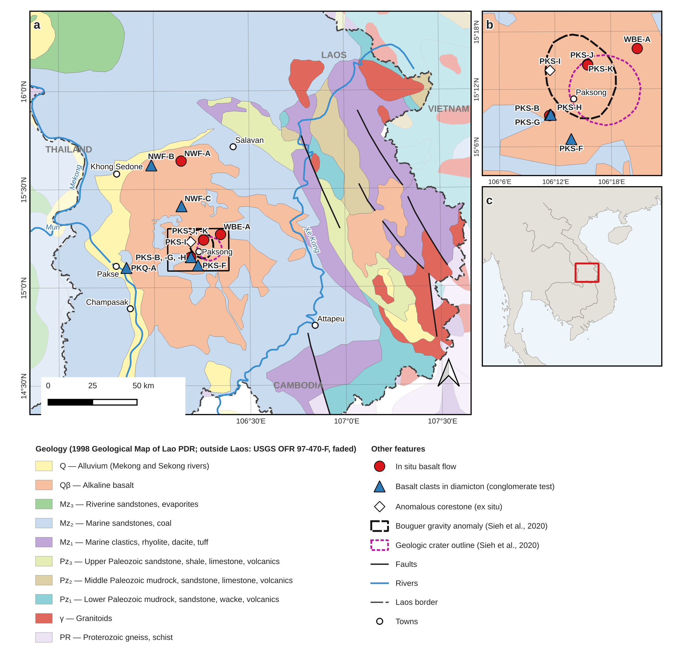
Figure 2. (a) Geologic map of southern Laos and the Bolaven Plateau showing the paleomagnetic sites of this study: in situ basalt flows (red circles), basalt clasts in diamicton sampled for conglomerate tests (blue triangles), and the anomalous corestone locality PKS-I (white diamond). Geology within Laos from the 1998 Geological Map of Lao PDR (digitised for this study); geology of neighbouring Thailand, Cambodia and Vietnam (faded) generalised from the USGS Geology of Southeast Asia (Steinshouer et al., 1999, OFR 97-470-F, after UNESCO/CGMW, 1990) and reclassified to the Lao map units. Dashed black outline: Bouguer gravity anomaly; dotted magenta outline: geologic crater outline of the proposed source crater (Sieh et al., 2020). Box shows the area of (b). (b) Enlargement of the central Bolaven Plateau sites; PKS-B, -G and -H lie within ~200 m of one another. (c) Location of (a) in mainland Southeast Asia.

Sedimentology and Stratigraphy
The stratigraphy relevant to the impact hypothesis comprises three superposed elements: the Mesozoic siliciclastic target succession, its deeply weathered Cenozoic cover, and the candidate impact deposits themselves (Fig. 3). The target is the Khorat Group, a Jurassic–Cretaceous sequence of continental red beds deposited in fluvial and floodplain to shallow-lacustrine environments across a broad intracratonic basin (Bunopas et al., 1998; Sieh et al., 2020). Around the Bolaven Plateau it is exposed as nearly flat-lying, laterally continuous strata at least 500 m thick, in which two sedimentological end members dominate: an upper 200–250 m of massive to cross-bedded, quartz-rich fluvial sandstone, and a lower 250 m of friable reddish mudstone and siltstone recording overbank and floodplain deposition. These two lithologies – a mature quartz arenite and an illite/kaolinite-rich mudrock – are the compositional poles from which any Bolaven-sourced tektite must be built, and their laterally uniform, blanket geometry means that ejecta or melt derived from anywhere across the Khorat Basin would inherit a broadly similar bulk composition (Sieh et al., 2020).
Overlying the Mesozoic bedrock across an erosional unconformity is the Cenozoic weathering and volcanic cover. Prolonged tropical weathering of both the sandstone–mudstone substrate and the overlying basalts has produced thick lateritic and bauxitic saprolite profiles – mined economically on the plateau – in which primary silicates are broken down to kaolinite, gibbsite, and residual Fe–Ti oxides (Sanematsu et al., 2011). This weathering mantle is important sedimentologically because it, rather than fresh rock, is the immediate parent material at the surface: the saprolites are strongly leached in mobile elements (alkalis and alkaline earths) yet enriched in meteoric ¹⁰Be, a combination that bears directly on both the major-element and cosmogenic-isotope budgets attributed to the tektite source (Sieh et al., 2020).
The candidate impact deposits are stratigraphically the youngest element. Sieh et al. (2024) described an unsorted, matrix-supported polymict breccia exposed 10–20 km southeast of the proposed crater centre, containing decimetre- to metre-scale angular clasts of Khorat sandstone and mudstone set in a finer clastic matrix. They interpreted it as proximal ballistic ejecta on the basis of several features atypical of ordinary fluvial or mass-flow deposits: local inversion of the normal stratigraphic order, “jigsaw-puzzle” fitting of adjacent clasts indicating in-place fragmentation with little transport-related rounding, and, most diagnostically, quartz grains carrying planar deformation features. Comparable diamictons occur elsewhere on and around the plateau and have long been linked – together with the regional “catastro-loess” and microtektite-bearing horizons – to the Australasian event (Bunopas et al., 1998).
The sedimentological interpretation of these deposits is, however, actively contested, and it is this dispute that motivates an independent test. Mizera (2022) argued that the Bolaven candidate fails on several grounds and that the clastic deposits invoked as ejecta are equally consistent with terrestrial mass-wasting, colluvial, or reworked-weathering origins, so that neither their texture nor the presence of deformed quartz uniquely requires an impact; on geochemical and crater-scaling grounds they – and Whymark (2021) – favour source regions far from Laos. Because the diagnostic sedimentary and shock criteria are themselves disputed, the stratigraphy alone cannot presently confirm or refute the crater. Paleomagnetism offers a test that does not depend on the interpretation of these deposits: in-situ post-impact flows and any genuine ejecta should carry the magnetostratigraphic, shock-remanence, or reheating signatures predicted if the crater lies beneath the Bolaven field, and it is these that the remainder of this paper examines.
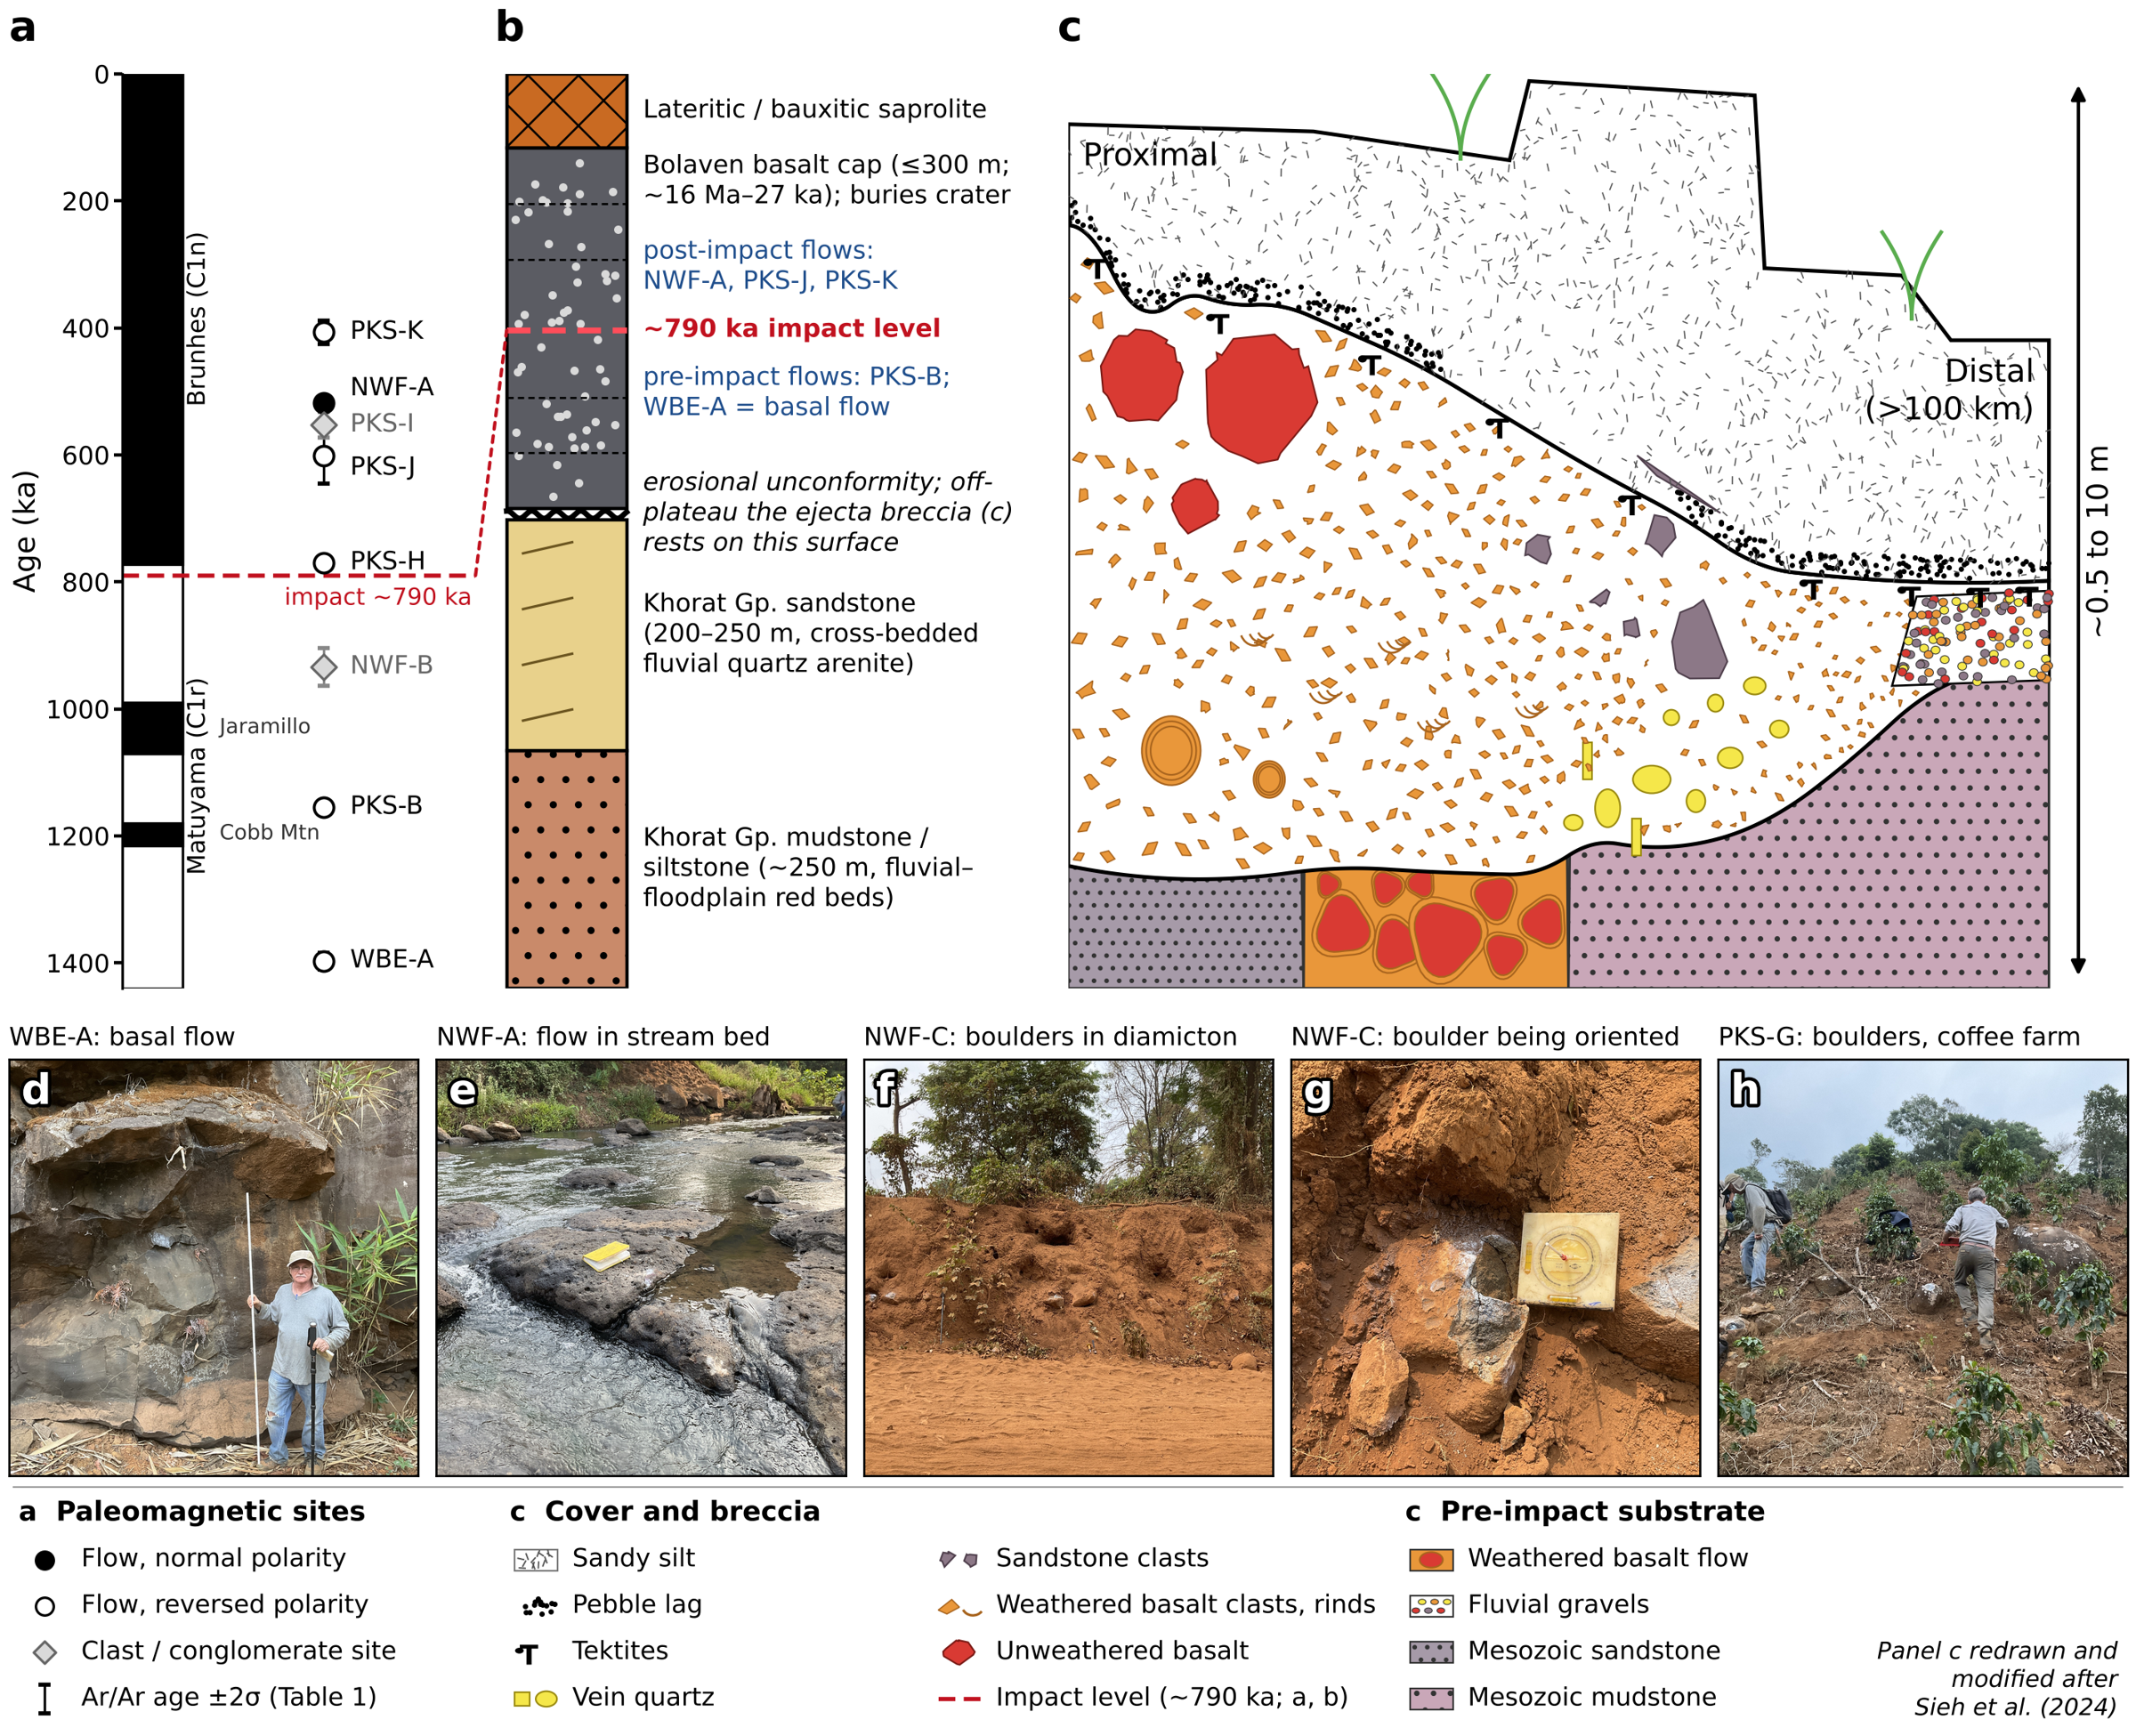
Figure 3. Stratigraphic framework of the Bolaven impact test. (a) Paleomagnetic sites of this study plotted at their ⁴⁰Ar/³⁹Ar ages (±2σ; Table 1) against the geomagnetic polarity time scale (GPTS 2020; Ogg, 2020). Filled and open circles are in situ flows of normal and reversed measured polarity; the record begins at WBE-A, the lowest basalt flow. Grey diamonds are clast/conglomerate sites (PKS-I, NWF-B), whose remanence does not record the field at the dated eruption. Red dashed line: the Australasian impact at ~790 ka, just before the Matuyama–Brunhes reversal. (b) Schematic composite stratigraphy of the impact target and its cover (thicknesses not to scale): Khorat Group fluvial–floodplain mudstone/siltstone and cross-bedded quartz sandstone, an erosional unconformity, and the Bolaven basalt cap (≤300 m; ~16 Ma–27 ka) weathered at the top to lateritic/bauxitic saprolite. The ~790 ka impact level separates pre-impact flows (PKS-B and the basal flow WBE-A) from post-impact flows (NWF-A, PKS-J, PKS-K) that bury the crater; off the plateau the ejecta breccia rests on the pre-impact surface. (c) Composite sketch of the proximal-to-distal ejecta breccia and overlying sandy silt (vertical extent ~0.5–10 m), redrawn and modified after Sieh et al. (2024). The breccia rests on pre-impact substrate (Mesozoic sandstone and mudstone, weathered basalt flows, fluvial gravels), fines upward and with distance from the proposed crater, carries unweathered basalt and sandstone boulders near its top proximally and vein-quartz clasts near its base distally, and has tektites at and just below its upper contact beneath a pebble lag and the sandy silt; no single exposure shows all of these features. (d–h) Field photographs from the March 2024 sampling campaign: (d) WBE-A, the basal in situ flow (person for scale); (e) NWF-A, an in situ flow exposed in a stream bed (notebook for scale); (f) NWF-C, basalt boulders in the red diamicton; (g) an NWF-C boulder with the orientation plate in place before sampling; (h) PKS-G, basalt boulders on a coffee-farm hillslope.

Bolaven Volcanic Field
A basaltic volcanic field covering approximately 5,000 km² caps the Mesozoic rocks and extends down the flanks of the plateau (Sieh et al., 2020). The volcanic field has a calculated volume of approximately 910 km³, with basalt thickness reaching up to 300 m in the summit region. This extent and thickness are sufficient to completely obscure an impact crater up to 15 km in diameter with a rim rising several hundred meters above the bedrock surface.
The Bolaven volcanic field represents a typical intraplate basaltic field, characterized by scattered, low-eruption-volume scoria cones and flows reflecting the rise of individual batches of magma (Valentine & Hirano, 2010). The field lacks the long-lived, localized composite volcanoes that would indicate the presence of a large crustal magma reservoir, making the existence of a buried caldera unlikely.
Previous ⁴⁰Ar/³⁹Ar dating has revealed that volcanic activity spanned from approximately 16 Ma to 27 ka, with eruptions occurring both before and after the 790 ka impact (Sieh et al., 2020; Sanematsu et al., 2011). The temporal distribution of dated flows shows that most exposed lavas in the summit region are younger than the impact age, supporting the burial hypothesis. Additionally, the sedimentary sequences and the basaltic component provides an ideal target lithology matching the geochemical composition inferred from Australasian tektites (Blum et al., 1992; Koeberl, 1992; Sieh et al., 2020).

Evidence for Impact
Sieh et al. (2020) presented multiple lines of evidence supporting the presence of a buried impact crater beneath the Bolaven volcanic field:
Geochemical evidence: Principal component analysis of Australasian tektites indicates that >90% of observed chemical variation can be explained by mixing of Mesozoic bedrock with Bolaven basalts and their weathered derivatives. The high ¹⁰Be concentrations in tektites are consistent with incorporation of meteoric ¹⁰Be from weathered basaltic saprolites.
Geochronological constraints: ⁴⁰Ar/³⁹Ar dating reveals that all flows directly above the proposed crater center are younger than 790 ka, while pre-impact flows exist on the periphery of the field. This distribution supports complete burial of the impact site by post-impact volcanism.
Geophysical anomaly: A negative Bouguer gravity anomaly of approximately 6 mGal in the summit region corresponds to the expected signature of a buried crater filled with low-density impact breccia.
Proximal ejecta: A unique outcrop 10-20 km southeast of the proposed crater center exposes a sequence of brecciated sandstone and mudstone with features consistent with impact ejecta, including stratigraphic inversion, jigsaw-puzzle fitting of clasts, and shocked quartz grains with planar deformation features (Sieh et al., 2024).
Figure 2 places these observations, and our sampling, on the regional geology. The negative Bouguer anomaly and the crater outline proposed by Sieh et al. (2020) lie beneath the summit of the plateau, where every dated flow is younger than the impact, whereas the brecciated ejecta crop out off the plateau margin to the southeast, and the tektite-bearing diamicton (“catastro-loess”) blankets the plateau and its flanks. In their composite section (Fig. 3c), the proximal breccia carries unweathered boulders of basalt and sandstone near its top. If these basalt boulders are ejecta, they were excavated from pre-impact flows, were cold when they landed, and should retain the remanence of their parent flows in random orientations; if they are corestones weathered in place, or rock remagnetized after deposition, their directions should cluster. We therefore sampled two kinds of site (Fig. 2): dated flows on and around the plateau (NWF-A, NWF-B, PKS-B, PKS-H, PKS-J, PKS-K and WBE-A, together with the PKS-I corestone), which test the ⁴⁰Ar/³⁹Ar chronology magnetostratigraphically, and basalt boulders in the diamicton at four localities (NWF-C, PKQ-A, PKS-F and PKS-G), on which conglomerate tests distinguish transported clasts from rock that was weathered or remagnetized in place.

Paleomagnetic Context
The timing of the Australasian impact at 790 ka places it within a period of significant geomagnetic field variability leading up to the Brunhes-Matuyama reversal. Singer et al. (2019) documented field weakening beginning around 795 ka, followed by unstable polarity and intensity behavior around 785 ka, culminating in the final reversal to normal polarity at 773 ka. This temporal framework provides an important context for interpreting paleomagnetic results from the Bolaven field. Recent global field models reinforce and extend this picture: Mahgoub et al. (2023, 2024) resolve a 21–32 kyr reversal process beginning at ~800–795 ka and completing at ~773–768 ka, with the axial dipole collapsing below ~5 ZAm² and precursory episodes of transitional field behavior before the main directional change, while new ¹⁰Be records from the Chinese Loess Plateau independently anchor the boundary at 773 ± 3 ka (Tang et al., 2025). On this chronology the ~790 ka impact falls within, not merely before, an extended interval of weak and unstable field.
Impact-related magnetization can result from several processes, including shock remanent magnetization (SRM) acquired during the brief period of impact-induced shock compression, and thermoremanent magnetization (TRM) from impact-generated melts (Tikoo et al., 2015). These signatures, combined with detailed magnetostratigraphy, can provide crucial tests of the impact hypothesis.
The Bolaven candidate is, however, contested. Critiques on geochemical grounds – that the proposed sandstone–basalt source mixture cannot reproduce tektite composition or its cosmogenic ¹⁰Be inventory (Ma & others, 2004) – together with objections to the small size of the putative crater and to the ambiguity of the proposed proximal ejecta (Sieh et al., 2024), have been raised by Mizera (2022) and Whymark (2021), who instead favour alternative source locations (beneath the Alashan Desert of northwestern China, and a submarine structure in the Gulf of Tonkin, respectively). Paleomagnetism offers an independent line of test that is largely absent from this debate. The impact melt itself records the field at the time of impact: Gattacceca et al. (2022) showed that Muong Nong layered tektites carry a thermoremanent magnetization acquired during cooling below 585°C on pseudo-single-domain magnetite. In-situ flows and any genuine ejecta should likewise carry diagnostic magnetostratigraphic, shock, or reheating signatures if the crater lies here. We therefore apply rock- and paleomagnetic methods to the Bolaven basalts to test the candidate location directly.

Methods

Sample Collection and Preparation
Field work was conducted in southern Laos during November 2023, following approval from the Laotian Ministry of Energy and Mines. We collected approximately 80 oriented drill core and block samples from 16 localities across the Bolaven Plateau volcanic field, focusing on basaltic flows and interpreted ejecta deposits. Sample sites included 12 localities of interpreted in-situ basalt flows for magnetostratigraphic analysis and 4 localities of proposed proximal ejecta deposits for conglomerate testing.
Samples were collected using a portable diamond-tipped drill with water cooling to minimize heating during extraction. Six sites were collected as whole rock block samples after drill battery failure. Core orientations were measured using Brunton compass and sun compass when possible, with corrections applied for local magnetic declination. GPS coordinates and elevation were recorded for each site.
Block samples were reoriented to their original in-situ positions in the laboratory, and 2.5 cm diameter cores were extracted using a diamond-tipped drill. Sample azimuths were preferentially determined using sun compass orientations collected in the field. All cores were cut and prepared into 1.5 cm tall cylindrical specimens for magnetic analysis. In-situ tektites found within the diamicton were also oriented and collected to examine potential magnetic phenomena captured during cooling. Sites, sample types, orientation methods and specimen numbers are listed in Table S1.

Laboratory Procedures
Laboratory analyses were conducted at two institutions. Rock magnetic characterization was performed at the University of Tokyo, while all paleomagnetic analyses were conducted at the Caltech Paleomagnetism Laboratory using established protocols (Biasi et al., 2021). Standard paleomagnetic specimens (2.5 cm diameter, 2.2 cm height) were prepared from drill cores using a diamond saw with water cooling.
Natural remanent magnetization (NRM) was measured using a 2G Enterprises three-axis superconducting rock magnetometer housed in a magnetically shielded room at Caltech. Progressive alternating field (AF) demagnetization was performed in 2.5-20 mT steps up to 100 mT using a 2G AF demagnetizer. Selected samples underwent progressive thermal demagnetization in 50-100°C steps up to 680°C using an ASC thermal demagnetizer in a magnetically shielded furnace.
Magnetic susceptibility was measured using a Kappabridge KLY-3 susceptibility meter to monitor potential alteration during heating. Isothermal remanent magnetization (IRM) acquisition curves and coercivity spectra were obtained using pulse magnetizers and AF demagnetizers at Caltech.

Paleomagnetic Analysis
Natural remanent magnetization (NRM) was measured for all samples using a 2G Enterprises three-axis superconducting quantum interference device (SQUID) rock magnetometer housed in a magnetically shielded room. Progressive thermal demagnetization was performed following standard stepwise procedures (Thellier & Thellier, 1959) from ambient temperature to 580°C (Curie temperatures of magnetite) in 30°C steps using an ASC thermal demagnetizer in a magnetically shielded furnace.
Alternating field (AF) demagnetization was applied to selected samples in 2.5-20 mT steps up to 100 mT using a 2G AF demagnetizer. This nondestructive technique was particularly useful for removing weak coercivity secondary overprints such as viscous remanent magnetization (VRM) and lightning-induced magnetization.
Component analysis was performed using principal component analysis (PCA) following the method of Kirschvink (1980). Characteristic remanent magnetization (ChRM) directions were calculated from linear trajectory segments with maximum angular deviation (MAD) ≤ 15°; free-line fits were additionally required to trend toward the origin (deviation angle, dANG ≤ 15°). Because fine-grained maghemite breaks down on heating, thermal demagnetization of most specimens could not usefully proceed beyond ~450–510 °C, and a minority of specimens never isolate a stable endpoint below that ceiling; the demagnetization arcs of such specimens were fit as best-fit planes (remagnetization circles) and combined with the line fits using the method of McFadden and McElhinny (1988). Vector component diagrams and equal-area projections were analyzed using the PmagPy software package.
Conglomerate tests were systematically applied to assess whether clasts within the diamicton deposits acquired their magnetization before or after deposition. Specimens were first averaged to their parent boulder (clast), and the boulder-mean directions were tested for randomness with the Watson (1956) test, which compares the resultant vector length R of N unit vectors with the critical value Ro₉₅ expected for a random population of N directions (estimated here by Monte Carlo simulation with 10⁶ draws, reproducing Watson’s tabulated values). If R < Ro₉₅ the null hypothesis of randomness cannot be rejected and the test is passed, indicating stable magnetization acquired before deposition; R > Ro₉₅ indicates systematic clustering, as expected for an in-situ flow or post-depositional remagnetization. All verdicts were double-checked with boulder means recomputed by the combined lines-and-planes method. This technique is critical for distinguishing transported clasts from weathered in-situ flows.

Rock Magnetic Characterization
Comprehensive rock magnetic experiments were conducted using a Princeton Measurements Corporation vibrating sample magnetometer (VSM) to determine coercivity (Hc), remanent magnetization (Mr), saturation magnetization (Ms), and magnetic domain states. The VSM operates using Faraday’s Law of electromagnetic induction, where samples are vibrated in a strong magnetic field, inducing alternating voltage in pickup coils proportional to sample magnetization.
Hysteresis loops were measured to determine coercivity of remanence (Hcr) and calculate domain state ratios. The squareness ratio (Mr/Ms) and Hcr/Hc ratios were used to classify magnetic grain size and domain states following established criteria. Weathered lateritic basalt surface chips were systematically compared to relatively unaltered deeper core sections to assess how surficial weathering influences magnetic properties and infer mineralogical transformations with depth.
Low-temperature magnetic measurements were performed using a Quantum Design Magnetic Property Measurement System (MPMS) to identify magnetic transitions and assess the presence of magnetite, titanomagnetite, and other magnetic phases.

Microscopy and Shock Analysis
Petrographic analysis was conducted using standard transmitted light microscopy to characterize rock textures and identify magnetic mineral phases. Scanning electron microscopy (SEM) was employed to examine potential planar deformation features (PDFs) in quartz grains from ejecta samples.
Microstructural analysis focused on identifying shock-related features including undulose extinction in plagioclase, irregular fractures in olivine, and systematic planar fractures in quartz. Crystallographic orientations of planar fractures were measured using universal stage techniques to assess consistency with shock-induced PDFs.

Geochemical Analysis
Major elements of Australasian tektites were measured by electron probe microanalysis (EPMA; 153 spot analyses on seven tektites: MNG24_A3_1–3, MNG24_B1, MNG24_C2 and MG24_B1 from three localities near Muong Nong, Savannakhet Province, Laos (~16.5°N, 106.5°E), and KK24_T1 from Khon Kaen, northeastern Thailand) [instrument, accelerating voltage, beam current, beam diameter and standards to be supplied by P. Sanchez]. Because tektite glass is essentially anhydrous, analyses with oxide totals below 97 wt% were rejected as compromised by vesicles, alteration or polishing relief, following the screening criterion of Carter et al. (2025). This retains 82 analyses on four tektites (MNG24_A3_1, n = 30; MNG24_B1, n = 17; MG24_B1, n = 5; KK24_T1, n = 30). Every analysis of MNG24_A3_2 (totals 33–86 wt%), MNG24_A3_3 (61–97 wt%) and MNG24_C2 (66–94 wt%) was rejected, as were four marginal analyses (96.3–96.9 wt%) of MNG24_B1 and MG24_B1. Accepted analyses were recomputed anhydrous with total Fe as FeO; the analysed tektites and screening results are listed in Table S2. Trace elements were measured by laser-ablation ICP-MS on two tektites from sample MNG24_A3 (MNG24_A3_1 and MNG24_A3_2; five ablation sites each, five replicate analyses per site) using EPMA SiO2 as the internal standard [instrument, calibration and secondary reference materials to be supplied]. Three MNG24_A3_2 sites had been standardised to SiO2 values (27–37 wt%) taken from rejected EPMA points; because Al/Si, which is independent of the internal standard, is identical in the two tektites, all MNG24_A3_2 analyses were re-standardised to the accepted MNG24_A3_1 mean (75.0 wt% SiO2). Relative to EPMA on the same tektite, LA-ICP-MS returns Al2O3, MgO and TiO2 30, 7 and 8 % high and MnO 38 % low, and most trace-element concentrations lie 3–38 % above the median of published Indochinite and Muong Nong analyses (Cr is 18 % below it; Ni is twice it, though within the published range) (Fig. S1a). Absolute LA-ICP-MS concentrations are therefore treated as accurate to no better than ±30 %, and interpretation relies on inter-element ratios (Th/Sc, Eu/Eu*, rare-earth pattern shape) that are insensitive to the internal standard and to most calibration offsets. Candidate target lithologies sampled in this study – Khorat Group sandstone (n = 10) and mudstone (n = 3), lateritic saprolite developed on basalt (n = 4), the tektite-hosting diamicton or “catastro-loess” (n = 9) and Bolaven basalt (n = 2) – were analysed for major elements by X-ray fluorescence and for trace elements by ICP-MS on pressed-powder pellets. They were combined with the regional compilation of Sieh et al. (2020), which includes analyses from Sanematsu et al. (2011) and Saminpanya et al. (2014) among other sources: Bolaven basalt (n = 252 after removing 62 analyses with LOI > 3 wt% or totals outside 98.5–101.5 wt%), Khorat Group sandstone (49) and mudstone (5), laterite and saprolite on basalt (47), sedimentary laterite and bauxite (37), Bolaven loess (13; grouped here with the diamicton) and felsic metatuff (8; dacitic–rhyolitic, Na2O 2.6–5.7 and K2O 3.0–5.5 wt%, major elements only). Three further samples labelled metatuff in the compilation were excluded: two are altered mafic rocks (SiO2 43–57 wt%, LOI 8–9 wt%) and one is Na-leached (Na2O 0.01 wt%). The field context of the metatuff (unit, and whether it lies beneath the Khorat Group) is not documented in the compilation. Values reported below detection were set to half the detection limit. The basalts were divided at the alkaline–subalkaline boundary of Macdonald & Katsura (1964) into tholeiitic basalt and basaltic andesite (n = 229) and alkali basalt and basanite (n = 25, including both basalts analysed here), because the two suites differ several-fold in incompatible-element contents (median Th 1.6 versus 7.0 µg/g; Th/Sc 0.07 versus 0.46). Published Indochinite and Muong Nong-type tektite analyses (n = 262; e.g. Koeberl, 1992; Amare & Koeberl, 2006) provide the regional reference.
Tektite source lithologies were inferred with the reversible-jump Bayesian unmixing model of Carter et al. (2025), re-implemented here (code archived with the data). Each EPMA analysis is modelled as a mixture, Y = C·M, of K components whose compositions (C) and per-analysis mixing weights (M) are unknown; K itself is a free parameter (Gallagher et al., 2009). Following Carter et al. (2025), each component is drawn from a dictionary of lithology types, each type is assigned a truncated-normal prior on every oxide, the prior on K is Poisson with mean 10 (truncated at 30), the mixing weights of each analysis carry a Dirichlet prior, and the likelihood is Gaussian on centred-log-ratio-transformed data and model. The dictionary comprises the eight regional lithology types listed above (prior medians and robust standard deviations (1.4826 × MAD) from our analyses and the regional compilation of Sieh et al. (2020), with standard deviations of at least 15 % of the median, or 25 % for types with fewer than five analyses), an unweathered post-Archean shale (PAAS; Taylor & McLennan, 1985; ±20 %) to represent fine-grained sediment not affected by tropical weathering, and an unconstrained “random” component. Nine oxides were used (SiO2, TiO2, Al2O3, FeOt, MnO, MgO, CaO, Na2O, K2O); Cl, SO3 and Cr2O3 are at or below detection. Where Carter et al. (2025) used a uniform 0.5 % relative uncertainty, we combined per-oxide EPMA accuracy (1–5 %, 20 % for MnO) in quadrature with a 5 % mixing-model error, because tektite melting does not conserve every oxide exactly. Posterior sampling used Metropolis–Hastings with within-model moves (composition, weights, component-type swap) and between-model moves (birth, death, split and merge), step sizes adapted to an acceptance rate of 0.234 during burn-in. As in Carter et al. (2025), twelve chains were started from random states with K drawn uniformly from 2–30 and run for 6 × 10⁴ iterations, the first half being discarded as burn-in. Once a chain has converged, between-model moves are almost never accepted, because adding or removing a component perturbs the fit to all 82 analyses at once; the posterior on K and on component identity is therefore represented by the spread among chains. Chains whose median log-likelihood lay more than 50 units below that of the best chain (i.e. trapped in a much poorer mode) would have been excluded; none were. Uncertainties combine within- and between-chain variance (Carter et al., 2025). Sensitivity runs (four chains each, 3 × 10⁴ iterations) excluded the random component, excluded Na2O and K2O, and restricted the dictionary to the regional lithologies (no PAAS or random component). Trace elements were not inverted. Instead, the bulk posterior mixtures were combined with the median trace-element contents of each lithology to predict Th/Sc and Eu/Eu*, which were then compared with the LA-ICP-MS data.

Results

Rock Magnetic Properties
Vibrating sample magnetometer (VSM) and Magnetic Property Measurement System (MPMS) analyses of 16 volcanic basalt specimens from the University of Tokyo reveal site-specific weathering effects on magnetic properties. The dataset includes samples from five paleomagnetic sites, with systematic comparison of weathered lateritic surfaces versus fresh interior cores.
Site NWF-C (Ejecta site): This diamicton basalt boulder ( 400 kyr age) exhibits the most pronounced weathering signature. Fresh interior samples display higher coercivity (21.1 mT) and squareness ratio (Mr/Ms = 0.327) compared to lateritic weathered surfaces (average Hc = 16.6 mT, Mr/Ms = 0.264). The large weathered sample shows elevated saturation magnetization (214.1 μAm²) compared to the fresh equivalent (77.95 μAm²), indicating concentration of magnetic minerals during lateritization. MPMS analysis of sample NWF-C-P8 provides additional constraints on magnetic mineralogy (Fig. 4d). Zero-field-cooled (ZFC) and field-cooled (FC) magnetization curves (5–300 K) show typical ferrimagnetic behavior without clear magnetic transitions. The absence of a distinct Verwey transition ( 120 K) suggests either oxidized magnetite (maghemite) or very fine-grained magnetic particles, consistent with tropical weathering processes. IRM acquisition curves demonstrate near-saturation by 1 T (7.9 × 10⁻³ emu at 3 T), confirming the dominance of low-coercivity phases. The elevated magnetization at low temperatures (ZFC: 3.05 × 10⁻² emu at 5 K vs. 7.2 × 10⁻³ emu at 300 K) and significant ZFC-FC divergence indicate a distribution of magnetic grain sizes, including superparamagnetic particles that become blocked at low temperatures.
Site PKS-B (In-situ flow, 1155 ± 2 ka): This older in-situ basalt flow shows variable weathering effects. Fresh samples exhibit coercivity ranging 16.8–22.4 mT with high squareness ratios (Mr/Ms = 0.348), while the single lateritic weathered sample shows intermediate coercivity (17.3 mT) and reduced squareness ratio (0.265). The relatively modest weathering signature may reflect the flow’s greater age and more advanced weathering profile development.
Site PKQ-A (Ejecta site): This site demonstrates the most consistent weathering pattern across multiple sample pairs. Fresh interior samples consistently show higher coercivity (10.6–15.7 mT) and squareness ratios (0.206–0.268) compared to lateritic weathered equivalents (Hc = 8.4–10.6 mT, Mr/Ms = 0.160–0.186). All weathered samples from this site exhibit lateritic alteration, indicating uniform weathering intensity.
Additional sites (PKS-I, PKS-HB): Site PKS-I follows the expected pattern with fresh samples (26.2 mT) exceeding weathered coercivity (22.2 mT). However, site PKS-HB shows anomalous behavior with weathered samples (14.7 mT) displaying higher coercivity than fresh equivalents (10.7 mT), possibly reflecting different primary mineralogy or incomplete weathering.
Magnetic domain states: Calculated squareness ratios indicate predominantly pseudo-single-domain (PSD) behavior across all samples (Mr/Ms = 0.160–0.348). Fresh samples consistently exhibit higher ratios, suggesting that lateritic weathering promotes larger effective domain states through maghemitization of primary magnetite. The preservation of PSD characteristics in both weathered and fresh samples indicates that tropical weathering has not completely destroyed paleomagnetically useful magnetic carriers. The MPMS results support this interpretation, showing that maghemitization has occurred while preserving the magnetic signal carriers. Representative hysteresis loops (Fig. 4a,b) are narrow and magnetite-like, closing by 300 mT with no high-coercivity contribution. On a Day plot (Mr/Ms vs. Hcr/Hc) all specimens cluster within the pseudo-single-domain field (Fig. 4c; Table S3), and every one of the seven paired fresh–weathered cores shows the same sense of change: weathering lowers the squareness ratio (mean Mr/Ms = 0.29 fresh vs. 0.23 weathered) and drives samples toward more multidomain-like behavior. This weathering signal is systematic and internal to individual cores, whereas no comparable trend is resolvable with eruption age among the dated in-situ flows (553 ka, 770 ka, and 1155 ka), indicating that surficial weathering, rather than age, is the primary control on the rock-magnetic properties. Independent alternating-field rock-magnetic experiments on pilot specimens corroborate a fine, low-coercivity magnetite carrier: isothermal remanent magnetization acquisition saturates by 200–300 mT, natural-remanence median destructive fields are 10–20 mT, and ARM/SIRM ratios (0.13–0.29) are consistent with the pseudo-single-domain grain sizes inferred from the hysteresis data.
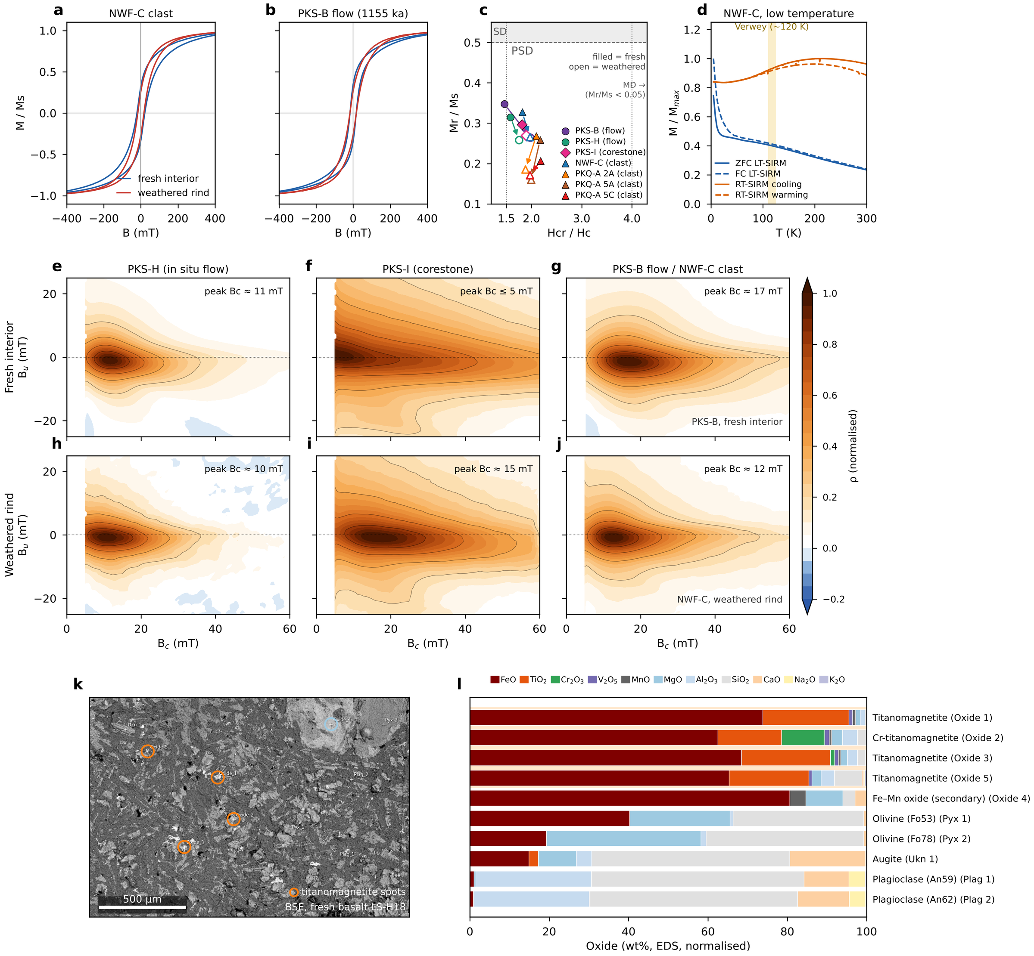
Figure 4. Rock magnetism of Bolaven basalts. (a, b) Hysteresis loops (high-field paramagnetic slope removed, normalised to Ms) of paired fresh-interior (blue) and weathered-rind (red) chips from the ejecta clast NWF-C and the in situ flow PKS-B (1155 ka). Loops close by ~300 mT and are narrow and steep through the origin, indicating a low-coercivity, magnetite-family assemblage with no hematite-like contribution; the weathered rinds have lower squareness. (c) Day plot (Day et al., 1977; Dunlop, 2002) of seven fresh (filled) → weathered (open) pairs from in situ flows (circles), the PKS-I corestone (diamond) and diamicton clasts (triangles). All specimens lie in the pseudo-single-domain field, and every pair shifts in the same sense: weathering lowers Mr/Ms (mean 0.29 fresh vs 0.23 weathered) toward more multidomain-like behaviour, independent of site type or eruption age. (d) Low-temperature (MPMS) remanence of NWF-C: zero-field-cooled and field-cooled low-temperature SIRM on warming (blue) and room-temperature SIRM on cooling and warming (orange), each normalised to its maximum. No Verwey transition is resolved near 120 K (shaded), consistent with oxidation of primary magnetite toward maghemite; the steep rise below ~30 K reflects ultrafine, near-superparamagnetic grains. (e–j) FORC diagrams (local-polynomial fit, smoothing factor 5; 10 for the finer-step PKS-B measurement) of fresh interiors (e–g) and weathered rinds (h–j). All show a central ridge along Bu = 0 with limited vertical spread (weakly interacting PSD/SD-like magnetite) and no high-coercivity or strongly interacting component. Ridge coercivities (≈10–17 mT) match bulk Hc; the fresh PKS-I interior is the exception, with a broad, low-coercivity distribution peaking at ≤5 mT (MD-like) compared with ~15 mT in its weathered rind. White strip at low Bc: region excluded where the smoothing window extends beyond the measured data. (k) Back-scattered-electron image of fresh basalt LS-H18 (Area 1) with the ten EDS spots; orange rings mark the titanomagnetite grains (the pale grain at upper right hosts the secondary Fe–Mn oxide). (l) EDS compositions of all ten spots (wt%, normalised to 100 %, all Fe as FeO). The four titanomagnetite grains (one Cr-rich) consist of 79–96 wt% FeO + TiO₂ and are the only Fe–Ti oxides, identifying titanomagnetite as the primary remanence carrier; the silicates (olivine Fo53–78, augite, labradorite An59–62) and a secondary Fe–Mn oxide make up the rest of the assemblage. No shock, high-pressure or metallic phases were found.
Implications for paleomagnetic analysis: The systematic coercivity reduction and domain state changes associated with lateritic weathering emphasize the importance of analyzing fresh interior portions of volcanic samples. However, the retention of stable PSD carriers in weathered zones suggests that surface samples may still preserve reliable paleomagnetic directions, albeit with altered magnetic properties. Site-specific variations in weathering intensity require careful assessment of magnetic stability on a sample-by-sample basis. The absence of clear low-temperature magnetic transitions in the MPMS data further confirms that weathering has promoted oxidation of primary magnetite to maghemite, which may enhance the stability of natural remanent magnetization through chemical remanent magnetization (CRM) acquisition.
The thermal demagnetization behavior of our basalt samples indicates a significant loss of remanence by approximately 450°C, even when heating is conducted in a nitrogen atmosphere. This observation suggests that the magnetic signal is dominated by maghemite (γ-Fe₂O₃) formed during weathering, which is known to be thermally unstable at relatively low temperatures. Numerous studies have shown that fine-grained or poorly crystalline maghemite, particularly of pedogenic or weathering origin, can irreversibly transform to hematite (α-Fe₂O₃) or become structurally disordered at temperatures as low as 230–400°C, even in the absence of oxygen (Dunlop & Özdemir, 1997; Özdemir & Banerjee, 1984; Velzen et al., 1993). This transformation is often accompanied by a pronounced drop in magnetic susceptibility and remanence, and is not solely dependent on external oxidation conditions. The observed low-temperature demagnetization in our samples is therefore consistent with the known thermal instability of fine-grained maghemite, which transforms to weakly magnetic hematite or loses its ferrimagnetic order at temperatures well below the Curie temperature of stoichiometric maghemite ( 600–670°C).
FORC Analysis: First-order reversal curve diagrams for representative fresh and weathered basalts are dominated by a well-defined central ridge along Bu = 0 that peaks at low coercivity (Bc ≈ 11–17 mT) with limited vertical (Bu) spread – the signature of weakly-interacting pseudo-single-domain to single-domain-like magnetite. These ridge coercivities agree with the bulk hysteresis coercivities and the AF median destructive fields measured on the same cores. The distributions contain no high-coercivity phases and no strong interaction fields. Because each core was measured in a single weathering state, the FORC diagrams do not by themselves resolve a fresh-versus-weathered coercivity contrast; that contrast is instead captured by the paired-core Day plot. Critically, the absence of anomalous high-coercivity phases or distinctive interaction signatures provides no evidence for shock-related magnetic phases, and – together with the systematic fresh-to-weathered gradients documented above – supports in-situ tropical alteration rather than an impact origin for the magnetic-property variations.
Mineral identification (SEM/EDS). Scanning-electron-microscope imaging with energy-dispersive spectroscopy directly identifies the magnetic carrier. In fresh basalt (specimen LS-H18), the opaque Fe–Ti oxide grains are titanomagnetite (FeO 63–74 wt%, TiO₂ 16–22 wt%), with minor vanadium and manganese and, in one grain, 11 wt% Cr₂O₃ (Fig. 4k,l; Table S4). The silicate framework is ordinary intraplate-basalt mineralogy – labradorite (An_{60–63}) and an Fe–Mg silicate (pyroxene/olivine) – with no exotic, high-pressure, or metallic (e.g. Ni-rich) phases. Primary titanomagnetite of this composition oxidizes to titanomaghemite during tropical weathering, which reconciles the mineralogy with the maghemite inferred from the absent Verwey transition and the low-temperature ( 450°C) unblocking, and confirms that the carrier is an ordinary igneous oxide rather than a shock- or impact-generated phase.
Summary: Comprehensive rock magnetic analyses including VSM, MPMS, FORC, and SEM/EDS measurements reveal systematic weathering-induced transformations of magnetic minerals in Laotian volcanic basalts. Fresh basalt interiors consistently preserve higher coercivities (10.6–26.2 mT), elevated squareness ratios (Mr/Ms = 0.206–0.348), and focused FORC distributions characteristic of pseudo-single-domain magnetite. In contrast, lateritic weathered surfaces exhibit reduced coercivities (8.4–22.2 mT), lower squareness ratios (0.160–0.265), and dispersed FORC patterns with enhanced magnetostatic interactions, indicating progressive maghemitization. Low-temperature MPMS measurements confirm the absence of the Verwey transition, supporting widespread oxidation of primary magnetite, and SEM/EDS identifies that primary oxide as titanomagnetite (which oxidizes to titanomaghemite on weathering). The systematic magnetic gradients from fresh bottoms to weathered tops, combined with the absence of shock-related signatures, indicate that the magnetic property variations record in-situ tropical weathering rather than shock or impact heating. These variations are therefore a weathering signal and carry no positive information about the proposed impact. Despite significant maghemitization, all samples retain pseudo-single-domain carriers capable of preserving paleomagnetic signals, though fresh interior samples are strongly preferred for paleomagnetic analysis. Site-specific variations in weathering intensity (most pronounced at ejecta site NWF-C, intermediate at in-situ flows) likely reflect differences in exposure age, porosity, and local drainage conditions rather than primary emplacement mechanisms. IRM acquisition, AF demagnetization of the NRM, ARM/SIRM ratios and AF coercivity spectra are shown in Figs S2 and S3.

Geochemistry: Testing the Bolaven Source Hypothesis
The impact hypothesis makes a testable geochemical prediction: if the Australasian tektites are melts of the Bolaven target column, their composition should be reproducible as a mixture of the local Mesozoic (Khorat Group) sediments and Bolaven basalts (Sieh et al., 2020) – a claim contested on geochemical grounds (Mizera, 2022). Previous work on Indochinite and Muong Nong-type tektites established that their parent was a fine-grained, quartz-rich sediment with a Jurassic-age crustal Sr–Nd signature and a near-surface ¹⁰Be inventory, possibly with a minor mafic contribution (Blum et al., 1992; Koeberl, 1992; Ma et al., 2004; Amare & Koeberl, 2006). We ask what our new data add to this, restricting claims to what the data can support: (i) which analyses are reliable, (ii) which of the regional lithologies a Bayesian unmixing model requires, (iii) whether trace-element ratios agree, and (iv) whether a projectile signature is resolvable.
Data quality. Only 82 of the 153 EPMA analyses, on four tektites, have oxide totals of at least 97 wt% (Fig. 5a). The rejected analyses (totals 33–97 wt%, including every analysis of MNG24_A3_2, MNG24_A3_3 and MNG24_C2) are not interpreted. The accepted analyses lie within the field of published Indochinite and Muong Nong tektites on every Harker diagram (Fig. 5b–h); tektite means span 70.8–80.6 wt% SiO2, with CaO 1.0–2.4, Na2O 1.2–1.6 and K2O 2.4–2.8 wt% (anhydrous), the most siliceous being KK24_T1 from Thailand. The LA-ICP-MS data come from only two tektites from one sample (MNG24_A3), and their absolute concentrations carry a calibration offset of up to ~30 % (Methods; Fig. S1a); they characterise two specimens, not the strewn field. Their inter-element ratios nonetheless reproduce the regional tektite signature: Th/Sc = 1.14 and 1.20, Eu/Eu* = 0.69 and 0.66 and La/Th = 2.8 and 2.5, against literature medians of 1.33, 0.62 and 2.8.
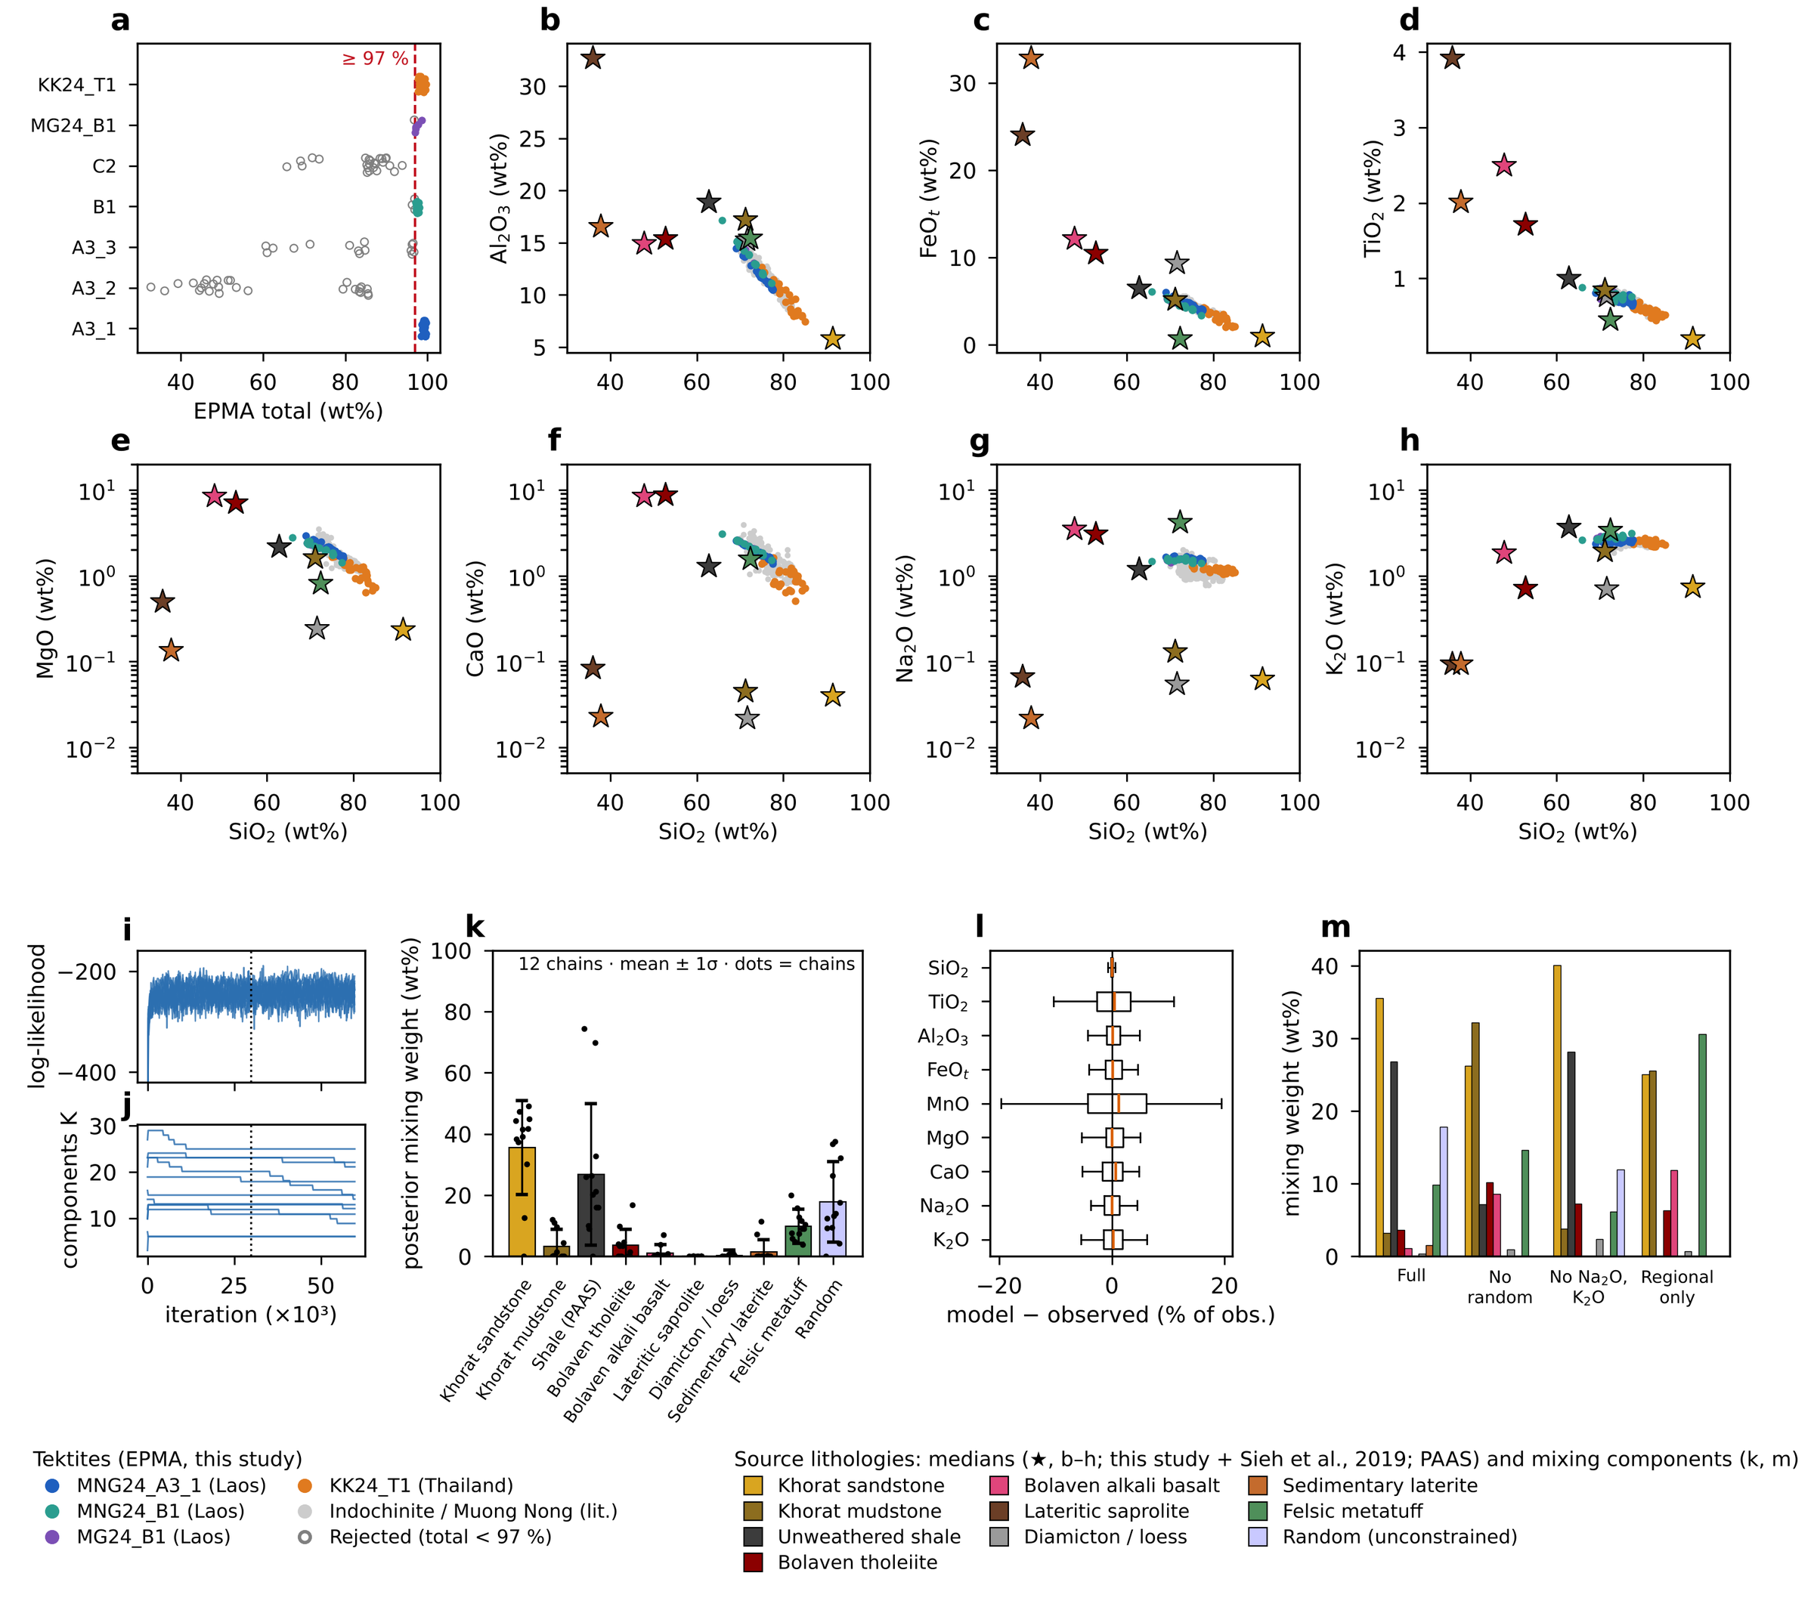
Figure 5. Major-element composition of Laos and Thailand tektites and reversible-jump MCMC unmixing of their source (after Carter et al., 2025). (a) EPMA analytical totals per tektite; analyses below 97 wt% (open grey) are rejected, leaving 82 accepted analyses on four tektites. (b–h) Anhydrous Harker diagrams of the accepted analyses (MgO, CaO, Na₂O and K₂O on log scales, to show how strongly the regional sediments and regolith are leached), compared with published Indochinite and Muong Nong tektites (grey; n = 262) and with the median compositions of the candidate source lithologies (stars): this study and the compilation of Sieh et al. (2020), with the Bolaven basalts divided into tholeiite and alkali basalt and the metatuff restricted to felsic samples, and unweathered post-Archean shale (PAAS; Taylor & McLennan, 1985). (i) Log-likelihood and (j) number of components K for the 12 chains of the full model (6 × 10⁴ iterations; dotted line = end of burn-in); all chains fit equally well with very different K. (k) Posterior mixing weights by lithology type (mean ± 1σ, combining within- and between-chain variance; dots are chain means). (l) Posterior-predictive residuals (model − observed, % of observed) for each oxide. (m) Mean mixing weights in the full model and the three sensitivity runs: no random component; Na₂O and K₂O excluded; and regional lithologies only (no PAAS or random component). The weights of all runs are listed in Table S5.
Bayesian unmixing. All twelve chains reproduce the 82 accepted analyses equally well (median log-likelihoods -265 to -220; interquartile per-analysis residuals within ±3 % for every oxide except MnO; Fig. 5l), but they do so with between 6 and 25 components, so the number of components is not constrained by the data (Fig. 5i,j). What is reproducible among chains is the type of material required (Fig. 5k). (1) The deeply weathered lithologies that now cover the plateau – lateritic saprolite on basalt, sedimentary laterite and bauxite, and the tektite-hosting diamicton or “loess” – are not required (combined weight 1.9 %, present in at most 17 % of posterior samples). (2) A quartz-rich sand classified as Khorat sandstone (29 ± 17 %) is required in 91 % of samples. (3) The remainder must be a fine-grained aluminous component carrying ~1.5–2 wt% each of CaO and Na2O. No sampled Khorat sediment supplies this, because all are intensely leached (median CaO ≤ 0.04 and Na2O ≤ 0.15 wt%; Fig. 5f,g), so the model assigns it to the unweathered-shale (37 ± 25 %) and felsic metatuff (15 ± 8 %) types, whose posterior compositions move toward the tektite composition itself. These two types should be read as proxies for unleached, Na–K-bearing fine-grained material, not as identified source rocks: PAAS is a global average, and the field context of the regional metatuff is not documented. (4) A Ca–Mg-rich component is permitted but not uniquely identified: Bolaven basalt contributes 5 ± 4 % (tholeiite 3.7 %, alkali basalt 1.1 %; present in 64 % of samples) – in this run the alkali basalts, despite their higher K2O and Na2O, are scarcely used – and an unconstrained “random” component of intermediate composition takes 11 ± 10 %, which itself indicates that the dictionary does not contain an adequate parent. The basalt and random components trade off: without the random component, basalt rises to about 10 % and becomes required. Otherwise the sensitivity runs give the same picture (without the random component: basalt rises to ~10 % and becomes required; with Na2O and K2O excluded: sandstone 40 %, unweathered shale plus metatuff 34 %, basalt ≤7 %, weathered regolith 2.4 %; with only the regional lithologies (no PAAS or random component): sandstone 25 %, unweathered shale plus metatuff 31 %, basalt ~10 %, weathered regolith 0.7 %; Fig. 5m; Table S5). Restricted to the regional lithologies, the model substitutes felsic metatuff (31 ± 13 %), the only sampled regional rock that is not leached of Na and K. Lateritic saprolite is never used. The unmixing therefore supports a sediment-dominated parent, in agreement with earlier work, but shows that the tektites cannot be melts of the Khorat sediments and regolith as they are exposed today. A less-weathered equivalent – fresh Khorat mudstone at depth, or the unweathered sediment that preceded the Pleistocene laterite – would be required, and no such material has yet been analysed. [Sensitivity-run values and posterior-sample frequencies to be re-checked against figures/rjMCMC_summary.json before submission.]
Trace elements. On the chondrite-normalised REE diagram the two tektites match the published Indochinite pattern: light-REE-enriched with a negative Eu anomaly, at concentrations within or slightly above (≤ 20 %) the literature range (Fig. S1b). In the calibration-insensitive ratios (Fig. S1c) they fall among the regional sediments and unweathered shale (Th/Sc 0.8–2.0, Eu/Eu* 0.58–0.70) and away from the Bolaven basalts (Eu/Eu* ≈ 1.0–1.1; Th/Sc ≈ 0.07 for the tholeiites and 0.46 for the alkali basalts) and basaltic saprolite. Mixed with even the most Th-rich regional sediment (Khorat sandstone, Th/Sc ≈ 2.0), about 10 % tholeiite or 20 % alkali basalt lowers Th/Sc to the tektite value (≈ 1.2), and ~20 % alkali basalt raises Eu/Eu* above the tektite range, so the trace ratios allow at most ~10–20 % basalt-derived material, depending on the suite. The felsic metatuff has no trace-element analyses and is omitted from the following prediction. The bulk posterior mixtures predict Eu/Eu* = 0.59–0.71 (90 % range), consistent with the tektites, and Th/Sc = 0.73–1.42, which brackets the observed values but is mostly lower (median 0.95). They also under-predict absolute Zr and Th (predicted 151 and 9 µg/g, against literature medians of 299 and 14.5 µg/g), because the regional sandstones are poor in zircon (median Zr ≈ 110 µg/g). The trace-element budget therefore does not close with the existing endmember data, mirroring the major-element result: the parent sediment was less weathered, and probably richer in heavy minerals, than the Khorat rocks sampled at the surface.
Platinum-group elements. In 34 of the 50 LA-ICP-MS analyses both ¹⁹¹Ir and ¹⁹³Ir are zero, and the non-zero values (0.3–4.4 ppb) do not agree between the two isotopes (Fig. S4b). Ir is therefore below detection, with an upper limit of about 4 ppb (~1 % of CI chondrite). The reported Pd (0.02–0.38 µg/g; median 0.18 µg/g) cannot be real. It would be ~350 times the upper-crustal abundance (0.52 ppb; Rudnick & Gao, 2003) and ~30 % of CI chondrite (McDonough & Sun, 1995), while Ir (< 1 % CI) and Ru (≈ 0.3 ppb) are at or below crustal levels – a Pd/Ir and Pd/Ru fractionation unlike any terrestrial or meteoritic reservoir. Instead, the site-mean Pd/Y ratio is nearly constant (0.006–0.012; Fig. S4a). On ¹⁰⁵Pd, the usual analysis mass, this corresponds to an ⁸⁹Y¹⁶O⁺/⁸⁹Y⁺ production rate of 0.13–0.26 %, a typical value for LA-ICP-MS, so the reported Pd is most plausibly a yttrium-oxide interference. The isotope monitored was not recorded and should be confirmed. Pd is not interpreted further. Laser ablation cannot test for a projectile at the level expected here: the non-radiogenic Os of Laotian Muong Nong and splash-form tektites indicates at most ~0.005 % of a chondritic component (Ackerman et al., 2019), which would add ~0.02 ppb Ir – two orders of magnitude below our detection limit. Ni, Co and Cr in MNG24_A3_1 (78, 18 and 62 µg/g) lie within the published Indochinite ranges (10th–90th percentiles: Ni 21–181, Co 11–25, Cr 58–184 µg/g). Because the Bolaven basalt and its laterites are themselves rich in these elements (median Ni 160 and 210 µg/g), the siderophile elements do not discriminate between a projectile and a mafic or lateritic target contribution. Cu (10–14 µg/g) and Zn (48–52 µg/g) are lower than in average upper crust (28 and 67 µg/g), as is commonly reported for tektites, but given the calibration uncertainty and the unknown composition of the true parent we draw no inference from them.
Summary. Within the limits of the data – four tektites with reliable major elements and two with trace elements – the geochemistry establishes four points, each consistent with the regional literature. First, the tektites are sediment-dominated melts of a quartz-rich sand plus a fine-grained aluminous sediment. Second, that parent was much less weathered than any Khorat sediment or regolith now exposed on the Bolaven Plateau, which cannot supply the tektites’ Ca and Na. Third, a basaltic contribution of about 5 % is permitted (no more than ~10 % in any model variant); it is required only when the model is denied an unconstrained component, and the trace-element ratios cap it at ~10 % (tholeiite) to ~20 % (alkali basalt). Fourth, LA-ICP-MS cannot detect a projectile component at the ≤ 0.005 % level indicated by Os isotopes. None of these results discriminates the Bolaven location from any other Indochinese source with a similar sedimentary cover; a decisive test would need analyses of unweathered Khorat sediment from depth and isotopic (Sr–Nd, ¹⁰Be) comparison with the tektites.

Thermal Demagnetization Results
In the study area, basalt flows can often be heavily desiccated or poorly exposed due to vegetation cover, which makes the determination of whether a flow is in-situ or ex-situ particularly challenging. Determining the polarity of a dated basalt flow and comparing it with known geomagnetic polarity intervals provides a useful test to assess if a flow is in-situ or has been remagnetized, depending on how well it agrees with the known geocentric axial dipole field at the time of its formation.
Six localities of interpreted in-situ basalt flows with pre-existing ⁴⁰Ar/³⁹Ar dates produced by Sieh et al. (2020) – NWF-A, PKS-B, PKS-I, PKS-J, PKS-K and WBE-A – together with the two-horizon locality PKS-H, were analyzed for polarity determination against the wes2020 geomagnetic polarity timescale model. An updated ⁴⁰Ar/³⁹Ar age of 1155 ± 2 ka for the PKS-B flow (sample PKS24-BA-1; K. Sieh, written communication, 2026) supersedes the preliminary 906 ± 12 ka assignment used in earlier drafts and places that flow in the C1r.2r reversed subchron, between the Jaramillo and Cobb Mountain normal subchrons.
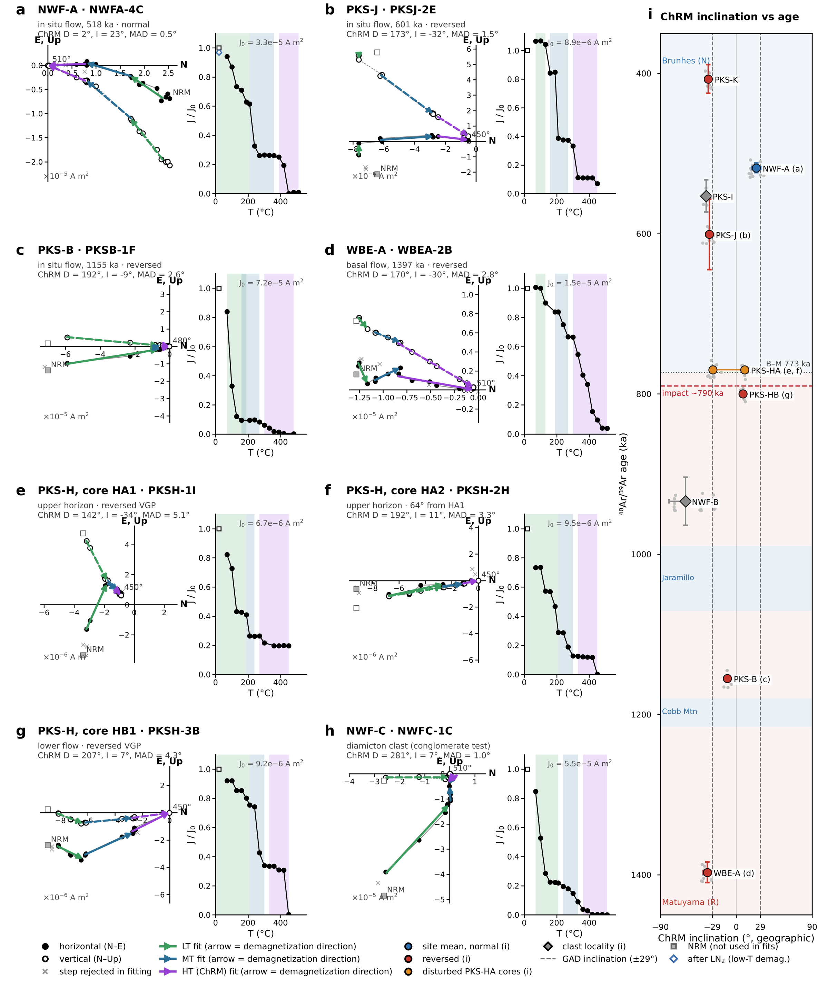
Figure 6. Representative thermal demagnetization of Bolaven basalts in geographic coordinates. For each specimen, left: orthogonal-vector (Zijderveld) diagram with the horizontal-plane projection (N vs E; filled symbols) and vertical-plane projection (N vs Up; open symbols); right: remanence intensity normalised to the NRM (J/J₀) against demagnetization temperature. Least-squares line fits (principal component analysis; Kirschvink, 1980) to the low-temperature (LT, ~70–190 °C, green), mid-temperature (MT, ~210–300 °C, blue) and high-temperature (HT, ~330–510 °C, purple) components are drawn as arrows pointing in the direction of demagnetization; the HT component, which trends to the origin, is taken as the characteristic remanent magnetization (ChRM). Shaded bands on the intensity plots mark the temperature range of each fitted component. Specimen ChRM directions and maximum angular deviations (MAD) are listed above each panel. (a) NWF-A, normal-polarity in situ flow (518 ka); (b) PKS-J, a well-defined reversed direction at a site dated to the Brunhes (601 ka); (c) PKS-B (1155 ka) and (d) WBE-A (1397 ka, the basal flow), reversed in situ flows; (e, f) cores HA1 and HA2 from the upper horizon at PKS-H, 64° apart; (g) core HB1 from the lower PKS-H flow; (h) an NWF-C diamicton clast. (i) Site-mean ChRM inclination (geographic) against ⁴⁰Ar/³⁹Ar age (Table 1), with polarity intervals of the GPTS (blue normal, red reversed; Brunhes–Matuyama boundary dotted at 773 ka) and the ~790 ka impact (red dashed). Large symbols are core-level site means (Table 2), coloured by VGP polarity (blue normal, red reversed; orange the two discordant PKS-HA cores; grey diamonds the clast localities PKS-I and NWF-B); grey dots are individual specimen ChRMs, horizontal bars ±1σ of the specimen inclinations and vertical bars the 2σ age uncertainty. Dashed vertical lines mark the geocentric axial dipole inclination (±29°) at the site latitude. Letters in brackets link sites to panels a–h. Reversed flows dated to the Brunhes (PKS-K, PKS-J) are the polarity mismatches of Table 1. Most specimens lose the bulk of their remanence by ~450 °C and reach the origin by 480–510 °C, consistent with a fine-grained (titano)maghemite carrier (Fig. 4).
Representative demagnetization behavior is summarized in Figure 6 (representative demagnetization). In-situ flows (e.g. NWF-A, WBE-A; Fig. 6a,d) yield single-component characteristic remanent magnetizations (ChRM) that decay approximately univectorially toward the origin after removal of a small low-stability overprint, permitting well-defined Fisher means. The disturbed PKS-HA horizon behaves quite differently: its two cores carry directions 64° apart within the same stratigraphic level – and although both poles are reversed by VGP latitude, such discordance means the horizon cannot record a single cooling event (Fig. 6e,f). The underlying PKS-HB flow (Fig. 6g) is, by contrast, univectorial and reversed. Ejecta clasts (Fig. 6h) each carry an internally coherent ChRM, but these directions differ randomly from clast to clast, which is the basis for the conglomerate tests below. In all cases the bulk of the remanence unblocks by 450°C, consistent with the fine-grained maghemite carrier inferred from the rock-magnetic data. Orthogonal-vector diagrams of all 364 specimens are given in Figs S5–S16.
All site means reported in this section follow a specimen → sample (oriented core) → site Fisher-averaging scheme, so that each site’s precision (k, α95) reflects the number of independent oriented cores rather than the raw specimen count; the definitive sample-to-site statistics and VGP-based polarities are compiled in Table 2 (sample-to-site statistics). Polarity is assigned from the sign of the VGP latitude rather than from the sign of inclination, which matters for shallow or anomalously-declined directions. Individual specimen-level Fisher parameters quoted in the descriptive text below are retained for continuity but are superseded by Table 2 (sample-to-site statistics) where they differ. Site ages, polarities and statistics are listed in Tables 1 and 2.
Sites with confirmed polarity matches:
NWF-A/NWF24-A (518 ± 6 ka, C1n chron): This site represents rocks in a stream below a bridge, supposed to be in situ flow. Normal (N) polarity was measured, consistent with the Brunhes normal chron expected at this age. The site shows shallow north declination and moderately positive inclination, and thermal demagnetization reveals consistent behavior with a well-defined ChRM that decays univectorially to the origin (Fig. 6a). Site mean over five oriented blocks: dec = 11.8°, inc = +23.7°, k = 43, α95 = 11.8° (specimen level: k = 92, α95 = 4.0°, n = 15); VGP latitude +78.1°. The measured polarity matches expectations, providing a reliable magnetostratigraphic anchor point. The directions cluster near the present-day field, indicating stable magnetization preserved since formation.
PKS-B/PKS24-B (1155 ± 2 ka, C1r.2r subchron): This site represents in situ basal “shockwave breccia” basalt at the bottom of a dam excavation site; the updated ⁴⁰Ar/³⁹Ar age of 1155 ± 2 ka (PKS24-BA-1) places it in the reversed subchron between the Jaramillo and Cobb Mountain normal subchrons. Reversed (R) polarity was measured, consistent with that age. The single oriented block (seven specimens) displays southerly declination and shallow negative inclination (dec = 190.6°, inc = −10.6°; specimen-level k = 270, α95 = 3.7°; VGP latitude −75.6°), near the reversed axial dipole, suggesting primary thermoremanent magnetization. The agreement with expected polarity validates this as a reliable in-situ flow marker within the Matuyama chron.
WBE-A/WBE24-A (1397 ± 13 ka, C1r.3r chron): This site represents in situ massive basalt flow used as a basalt stratigraphic control and displays the best outcrop exposure. Reversed (R) polarity was measured, consistent with the Matuyama reversed chron expected at 1397 ka. The two oriented blocks yield internally tight, mutually consistent directions ~10° apart; site mean dec = 168.1°, inc = −34.5°, k = 82, α95 = 28.0° (N = 2 cores; VGP latitude −78.0°). Thermal demagnetization indicates stable magnetization with progressive unblocking to approximately 450 °C, after which significant intensity loss occurs due to maghemite transformation (Fig. 6d). This site provides a critical older stratigraphic constraint for the volcanic sequence, confirming that reversed polarity flows pre-date the proposed impact event.
Sites with polarity mismatches (assigned ages likely wrong):
PKS-K/PKS24-K (407 ± 18 ka, C1n chron): This site represents polarity of in situ basalt flow from a nearby scoria cone adjacent to site PKS-J. Reversed (R) polarity was measured despite the site falling within the Brunhes normal chron. The two oriented cores are internally tight but mutually discordant: core 1 lies near the reversed axial dipole (dec = 174.9°, inc = −29.4°) while core 2 is pulled ~35° toward the southwest (dec = 216.3°, inc = −33.5°), most simply by an incompletely removed low-temperature overprint. The site mean (dec = 195.1°, inc = −33.2°, k = 10.6, N = 2; VGP latitude −75.3°) is therefore poorly constrained in declination but unambiguously reversed. The polarity mismatch indicates this flow is significantly older than the assigned age, potentially dating to the Matuyama reversed chron (>773 ka); the well-defined reversed directions argue against wholesale remagnetization and instead point to an erroneous radiometric age. Resampling and redating of this flow is planned.
PKS-J/PKS24-J (601 ± 44 ka, C1n chron): This site represents polarity from a supposed in situ basalt flow, potentially with pahoehoe lobes and columnar jointing. Reversed (R) polarity was measured when normal polarity was expected from the assigned Brunhes age. The three oriented cores agree closely: site mean dec = 174.9°, inc = −31.9°, k = 244, α95 = 7.9° (VGP latitude −84.7°), within a few degrees of the reversed axial dipole (Fig. 6b). The consistent reversed polarity indicates this flow likely dates to the Matuyama chron rather than the Brunhes; it may represent an older flow trapped as an island (kipuka) within the 601 ka flow field. Thermal demagnetization shows behavior consistent with maghemite, with significant intensity loss beginning around 400–450 °C. This flow is also slated for redating.
Anomalous corestone locality:
PKS-I/PKS24-I or PKS15-I (553 ± 20 ka, C1n chron): This questionably in situ corestone along the roadside yields a tightly clustered but anomalous direction up and to the NE (dec = 47.9°, inc = −35.6°; k = 330, α95 = 4.2° over five specimens), ~49° from any axial-dipole direction, with a VGP latitude of +31.3° that is neither clearly normal nor reversed. The high precision rules out random noise, and the NRM intensity does not suggest a lightning strike; the direction is best explained by post-magnetization rotation of a displaced block. We therefore treat this locality as an ex-situ clast (“Displaced clast” in Table 1) that cannot test its assigned 553 ka age.
Complex polarity site:
PKS-H/PKS24-HA+HB (~770 ka datum, near the C1n/C1r.1r (Brunhes–Matuyama) boundary): This locality samples two basalt horizons at different stratigraphic levels and is best treated as two distinct units. The upper horizon (HA; cores HA1 + HA2), taken as the ~770.5 ± 9.3 ka datum and interpreted by Sieh et al. (2020) as an in-situ flow at the Brunhes–Matuyama boundary, yields two internally tight cores (HA1: dec = 141.2°, inc = −28.0°, k = 96; HA2: dec = 194.5°, inc = +9.8°, k = 157) whose means nevertheless diverge by 64°. Because a cooling lava records a single direction, the horizon cannot be an intact in-situ cooling unit, and its combined Fisher mean (dec = 164.9°, inc = −13.5°, k = 6.1, 19 specimens) is not a meaningful field reading. Notably, when polarity is assigned from VGP latitude rather than inclination sign, both HA cores are reversed (VGP latitudes −53° and −65°): HA2’s positive inclination is offset by its SSW declination, which drives its pole into the southern hemisphere. The lower horizon (HB; core HB1), a set of concentric-laterite basalt boulders 5.5 m below and 12 m west of HA, is tightly grouped (dec = 209.6°, inc = +7.9°, k = 549, α95 = 3.3° over five specimens) and demagnetizes univectorially to the origin (Fig. 6g); its VGP latitude of −55° likewise makes it reversed despite its positive inclination. All three cores therefore carry reversed VGPs, but all sit 34–46° from the reversed axial dipole, and the HA2 and HB1 directions are only 15° apart. Two readings are possible and cannot be separated with one core per boulder: the units record the anomalous, transitional field of the late Matuyama immediately preceding the reversal – consistent with global models that place the ~790 ka impact within an extended (~800–770 ka) interval of weak, unstable field (Mahgoub et al., 2024) – or they share a common post-emplacement rotation. A Watson test on the three core means is formally random (R = 2.50 < Ro₉₅ = 2.62) but has essentially no statistical power at N = 3. Either way, HA’s internal discordance means an in-situ Brunhes–Matuyama boundary cannot be confirmed at this locality; redating of these boulders is planned.
These polarity determinations provide critical magnetostratigraphic constraints for the volcanic sequence. Three dated flows (NWF-A, PKS-B – under its updated 1155 ± 2 ka age – and WBE-A) show agreement between measured and expected polarity, anchoring the framework (Fig. 6i). Two sites (PKS-K, PKS-J) show clear polarity mismatches indicating likely incorrect age assignments, and both are slated for resampling and redating. PKS-I behaves as a rotated clast. Site PKS-H, previously interpreted as an in-situ flow straddling the Brunhes–Matuyama boundary, resolves into a directionally discordant upper horizon (HA) that cannot be a single cooling unit and a coherent lower unit (HB); all of its cores carry reversed VGPs that sit well off the reversed dipole, permitting – but not proving – a record of the transitional late-Matuyama field. An in-situ Brunhes–Matuyama boundary cannot be confirmed there.
Table 1. Comparison of ⁴⁰Ar/³⁹Ar ages (Sieh et al., 2020; PKS-B and PKS-H updated, K. Sieh, written communication, 2026) with measured paleomagnetic polarity for the dated Bolaven sites, in order of age. Expected chron and polarity are those spanned by the age ± 2σ on the GPTS 2020 (Ogg, 2020; Brunhes–Matuyama boundary 773 ka; Jaramillo 990–1071 ka; Cobb Mountain 1180–1215 ka). Measured polarity is assigned from the latitude of the site-mean virtual geomagnetic pole (VGP; Table 2), not from the sign of inclination. Coordinates are means of the 2024 GPS waypoints (WGS84). Shaded rows are polarity mismatches.
[tab:age_polarity_summary]
Site | Sample (Sieh et al.) | Lat (°N) | Lon (°E) | Setting | ⁴⁰Ar/³⁹Ar age (ka ± 2σ) | Expected chron (GPTS 2020) | Exp. polarity | VGP lat (°) | Measured polarity | Age–polarity agreement
PKS-K | PKS24-K | 15.242 | 106.258 | In-situ flow | 407 ± 18 | C1n | N | −75.3 | R | Mismatch
NWF-A | NWF24-A | 15.645 | 106.143 | In-situ flow | 518 ± 6 | C1n | N | +78.1 | N | Match
PKS-I | PKS24-I / PKS15-I | 15.233 | 106.191 | Corestone (ex situ) | 553 ± 20 | C1n | N | +31.3 | Indet.ᵃ | Displaced clast
PKS-J | PKS24-J | 15.243 | 106.258 | In-situ flow | 601 ± 44 | C1n | N | −84.7 | R | Mismatch
PKS-HA | PKS24-HA | 15.156 | 106.192 | Upper horizon | 770.5 ± 9.3 | C1n / C1r.1rᵇ | N or R | −52.6 / −65.3 | R, R (64° apart)ᶜ | Discordant
PKS-HB | PKS24-HB | 15.156 | 106.192 | Lower flow, 5.5 m below HA | > 770.5ᵈ | C1n / C1r.1rᵇ | N or R | −55.0 | R | Consistent if > 773 ka
NWF-B | NWF24-B | 15.624 | 105.986 | Blocks (transported) | 934 ± 30 | C1r.1r | R | +0.2 | Indet.ᵃ | Random clasts (Fig. 7o)
PKS-B | PKS24-BA-1 | 15.154 | 106.190 | In-situ flow | 1155 ± 2ᵉ | C1r.2r | R | −75.6 | R | Match
WBE-A | WBE24-A | 15.270 | 106.347 | Basal flow | 1397 ± 13 | C1r.3r | R | −78.0 | R | Match
ᵃ VGP latitude between −45° and +45° (PKS-I) or a random clast population (NWF-B, Watson test, Fig. 7o): polarity not assigned.
ᵇ The 770.5 ± 9.3 ka age (761–780 ka) spans the Brunhes–Matuyama boundary at 773 ka and the ~800–770 ka reversal-transition interval.
ᶜ Core-level VGP latitudes of the two PKS-HA cores (HA1 / HA2), both reversed; the cores are internally tight but 64° apart (Table 2).
ᵈ PKS-HB is not independently dated; it underlies the dated HA horizon by 5.5 m and is therefore older than 770.5 ka.
ᵉ Updated age for sample PKS24-BA-1 (K. Sieh, written communication, 2026); previously reported as ~1.0 Ma.
Table 2. Sample-to-site paleomagnetic statistics for the dated Bolaven localities, computed by specimen → sample (oriented core or block) → site Fisher (1953) averaging of the high-temperature (HT, ChRM) component in geographic coordinates (no tilt correction; flows are sub-horizontal). Specimen fits are from the pmagpy re-fits (fitquest; deposited in MagIC) and are accepted where MAD ≤ 15°; n spec gives accepted/measured specimens. α95 and k are core-level statistics; for single-core sites (*) they are specimen-level. Indented italic rows give individual core means where the cores of a site disagree or are few. VGPs are computed at each site's GPS coordinates (Table 1). Polarity is from VGP latitude. Dashes denote statistics that are undefined (single core) or meaningless (α95 ≥ 90°). Shaded rows are polarity mismatches.
[tab:site_stats]
Site / core | Age (ka ± 2σ) | N cores (n spec acc./meas.) | Dec (°) | Inc (°) | α95 (°) | k | VGP lat (°) | VGP lon (°E) | Polarity (VGP) | Expected (GPTS) | Result
PKS-K | 407 ± 18 | 2 (9/9) | 195.1 | −33.2 | 86.6 | 10.6 | −75.3 | 2.9 | R | N | Mismatch
PKSK-1 |  | 1 (3) | 174.9 | −29.4 | 8.3 | 222.6 | −85.0
PKSK-2 |  | 1 (6) | 216.3 | −33.5 | 2.7 | 605.4 | −55.2
NWF-A | 518 ± 6 | 5 (15/15) | 11.8 | +23.7 | 11.8 | 42.9 | +78.1 | 210.5 | N | N | Match
PKS-I | 553 ± 20 | 1 (5/5) | 47.9 | −35.6 | 4.2* | 330.4* | +31.3 | 231.3 | Indet. | N | Clast
PKS-J | 601 ± 44 | 3 (12/12) | 174.9 | −31.9 | 7.9 | 244.2 | −84.7 | 219.8 | R | N | Mismatch
PKS-HA | 770.5 ± 9.3 | 2 (19/19) | 169.4 | −10.1 | – | 3.3 | −75.5 | 153.3 | R | N/R | Discordant
HA1 |  | 1 (11) | 141.2 | −28.0 | 4.7 | 96.4 | −52.6
HA2 |  | 1 (8) | 194.5 | +9.8 | 4.4 | 157.3 | −65.3
PKS-HB | > 770.5 | 1 (5/5) | 209.6 | +7.9 | 3.3* | 549.1* | −55.0 | 46.9 | R | N/R | Coherent
NWF-B | 934 ± 30 | 3 (20/20) | 75.6 | −60.2 | 84.8 | 3.2 | +0.2 | 239.1 | Indet. | R | Random (congl.)
NWFB-1 |  | 1 (7) | 120.5 | −41.5 | 2.8 | 466.3 | −33.8
NWFB-2 |  | 1 (6) | 17.8 | −26.3 | 0.9 | 6061.9 | +55.7
NWFB-3 |  | 1 (7) | 128.4 | −73.2 | 2.2 | 785.2 | −32.7
PKS-B | 1155 ± 2 | 1 (7/7) | 190.6 | −10.6 | 3.7* | 269.8* | −75.6 | 58.3 | R | R | Match
WBE-A | 1397 ± 13 | 2 (11/11) | 168.1 | −34.5 | 28.0 | 81.7 | −78.0 | 216.1 | R | R | Match
WBEA-1 |  | 1 (8) | 163.0 | −39.4 | 2.0 | 779.6 | −72.4
WBEA-2 |  | 1 (3) | 172.6 | −29.5 | 3.4 | 1285.1 | −82.9
Sites in order of age. PKS-H is reported as its two stratigraphic horizons (HA upper, dated; HB 5.5 m below). PKS-I and NWF-B are included for completeness: PKS-I is an ex-situ corestone and NWF-B a random clast population (conglomerate test, Fig. 7o).
The site-mean characteristic remanent magnetization (ChRM) directions for all interpreted in-situ flows are summarised on a single equal-area projection in Figure 7a.
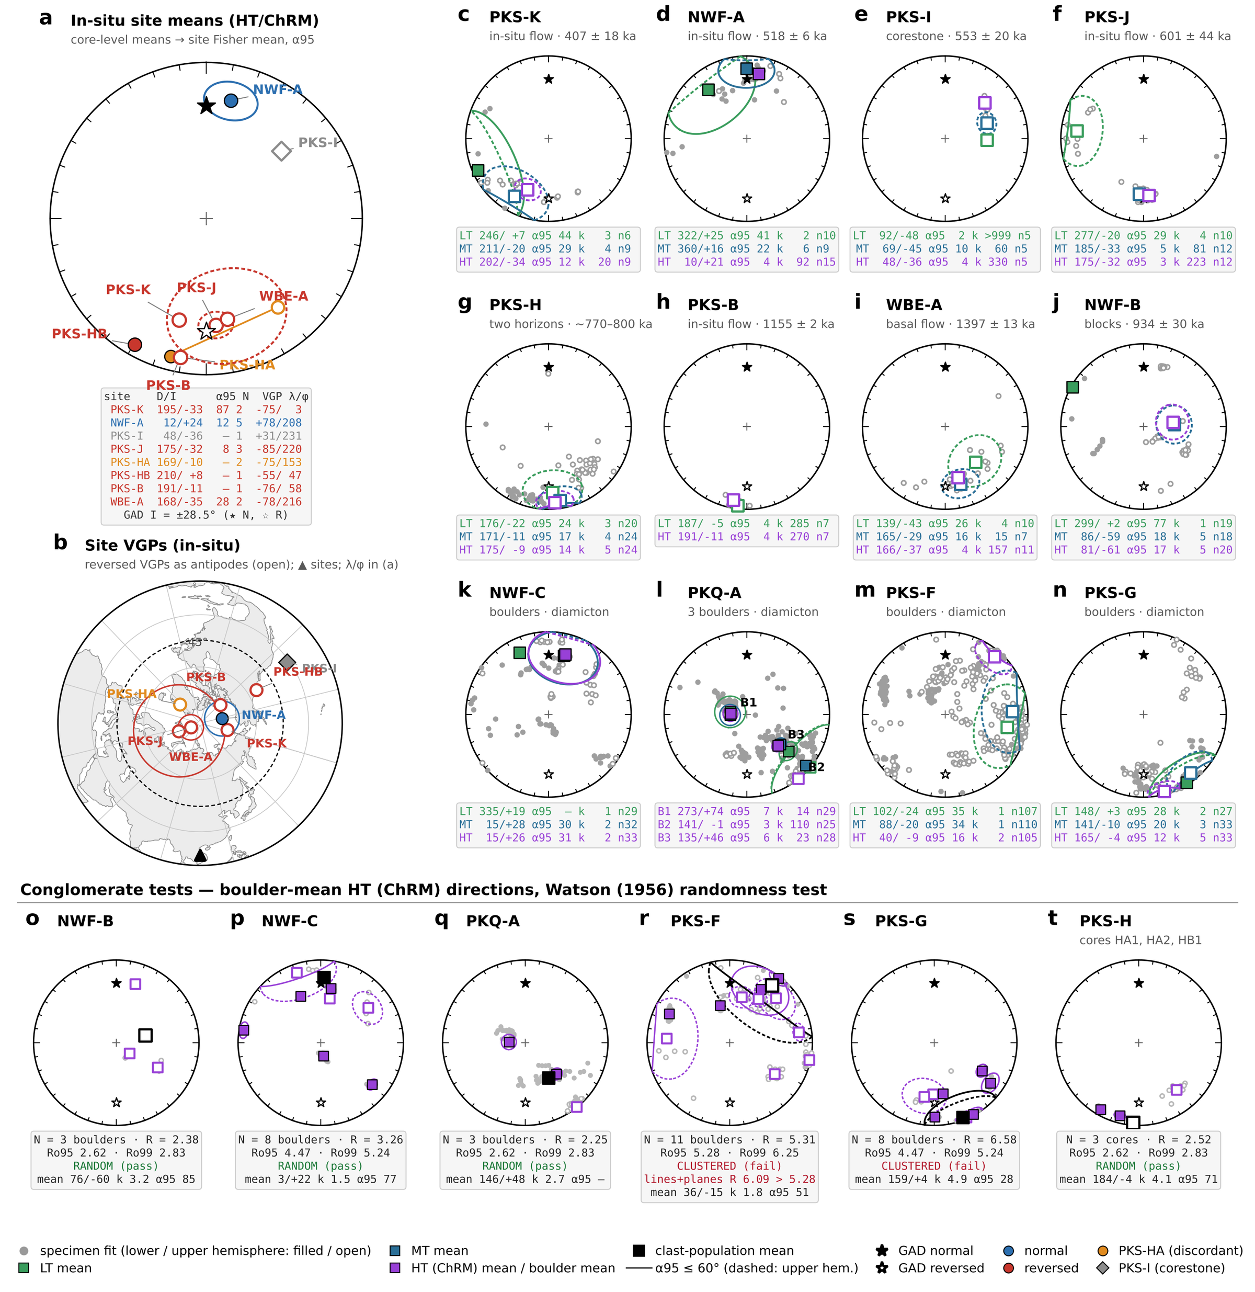
Figure 7. Equal-area projections of the component directions from all twelve Bolaven sites. Filled symbols are on the lower hemisphere and open symbols on the upper. Stars mark the geocentric axial dipole (GAD) direction at the site latitude (I = ±28.5°; filled = normal, open = reversed). (a) Site-mean ChRM (HT) directions for the in-situ flows, computed specimen → core → site (Fisher, 1953) with α95. Colours give VGP polarity: blue normal, red reversed. Orange marks the two discordant PKS-HA cores, which are plotted individually and joined. The grey diamond is the PKS-I corestone. The inset table lists each site's declination/inclination, α95, number of cores N and VGP latitude/longitude. (b) Site VGPs on a north-polar equal-area map. Reversed VGPs are plotted as their antipodes (open symbols), and A95 is drawn where α95 ≤ 60°. The dashed circle at 45° latitude separates stable-polarity from transitional VGPs. The triangle marks the sampling area. Only specimen fits with MAD ≤ 15° are used throughout. (c–n) Every site, in order of ⁴⁰Ar/³⁹Ar age and then the diamicton localities. Grey symbols are all specimen component fits. Squares are the specimen-level Fisher means of the low-temperature (LT, green), mid-temperature (MT, blue) and high-temperature (HT = ChRM, purple) components, each with its α95. Colours match Fig. 6 and the fitquest fitting interface. Each stats box gives D/I, α95, k and n for each component. PKQ-A is treated as a conglomerate of three field boulders (B1 = cores 0–4, B2 = cores 5–6, B3 = cores 7–9), so panel l shows boulder means rather than a site mean, and its stats box lists the HT mean of each boulder. (o–t) Conglomerate tests on the six boulder and diamicton localities. Purple squares are boulder-mean HT directions, each with its α95. Grey symbols are the specimens. The black square is the mean of the clast population. Randomness was tested with the Watson (1956) resultant-length test. Critical values Ro95 and Ro99 come from 2 × 10⁵ Monte-Carlo draws of N random unit vectors. R < Ro95 means the population is random (the test passes: the clasts carry pre-depositional remanences). R ≥ Ro95 means it is clustered (the test fails). PKQ-A was tested on its three field boulders. For PKS-F, the McFadden & McElhinny (1988) lines-and-planes result, with unresolved specimens treated as remagnetization circles, is also given. PKS-H was tested on its three cores (HA1, HA2, HB1); with N = 3 the test has little power. α95 circles larger than 60° are reported in the stats boxes but not drawn.

Conglomerate Test Results
Six diamicton or boulder localities – the four originally targeted for conglomerate testing (NWF-C, PKQ-A, PKS-F, PKS-G) plus NWF-B and the two-horizon locality PKS-H, whose boulder populations the polarity analysis showed to warrant the same treatment – were subjected to conglomerate tests using the Watson (1956) test of randomness to distinguish transported clasts from weathered in-situ volcanic material. The Watson test compares the resultant vector (R) of the N boulder-mean directions with Ro, the minimum resultant length expected from a random population of N directions at a given confidence level (95% or 99%; estimated here by Monte Carlo simulation, which reproduces Watson’s tabulated values). If R < Ro₉₅, the null hypothesis of randomness cannot be rejected at the 95% confidence level and the test is passed, indicating a random distribution consistent with transported clasts. If R > Ro₉₅, the null hypothesis is rejected and the test fails, indicating systematic clustering inconsistent with random emplacement.
Specimens were averaged to their parent boulders before testing, and all verdicts were double-checked by recomputing boulder means with the combined lines-and-planes method of McFadden and McElhinny (1988), in which specimens that fail to isolate a stable endpoint below the ~450–510 °C maghemite ceiling contribute their demagnetization arcs as remagnetization circles rather than being discarded; the two treatments agree at every locality. Passing populations are characterized by low precision parameters (k ≈ 1–3) and large confidence intervals, with R well below N. The boulder-mean directions and test outcomes are shown in Figure 7o–t; Table 3 (conglomerate tests). The PKS-F comparison is shown in Fig. S17.
Table 3. Conglomerate tests on the six boulder and diamicton localities (Fig. 7o–t). Specimen HT (ChRM) directions with MAD ≤ 15° were averaged to their parent boulder, block or core, and the unit means were tested for randomness with the Watson (1956) resultant-length test. Ro95 and Ro99 are the critical resultant lengths for N random unit vectors from 2 × 10⁵ Monte-Carlo draws. R < Ro95: the clast directions are random and the clasts were magnetized before deposition (test passes). R ≥ Ro95: they are clustered (test fails). Clast mean = Fisher mean of the unit means. The lines-and-planes column repeats the test with unresolved specimens treated as remagnetization circles (McFadden & McElhinny, 1988). PKQ-A is tested on its three field boulders (cores 0–4, 5–6 and 7–9). Tests with N = 3 (NWF-B, PKQ-A, PKS-H) have little power. Shaded rows fail.
Locality | Units tested | N (n spec) | R | Ro95 | Ro99 | Clast mean D/I (°) | k | α95 (°) | R (lines + planes) | Verdict
NWF-B | Blocks (3) | 3 (20) | 2.38 | 2.62 | 2.83 | 76/−60 | 3.2 | 85 | 2.38 | Random
NWF-C | Boulders (8) | 8 (33) | 3.26 | 4.47 | 5.24 | 3/+22 | 1.5 | 77 | 3.26 | Random
PKQ-A | Field boulders (3; 10 cores) | 3 (82) | 2.25 | 2.62 | 2.83 | 146/+48 | 2.7 | – | 2.25 | Random
PKS-F | Boulders (11) | 11 (105) | 5.31 | 5.28 | 6.25 | 36/−15 | 1.8 | 51 | 6.09 | Clustered
PKS-G | Boulders (8) | 8 (33) | 6.58 | 4.47 | 5.24 | 159/+4 | 4.9 | 28 | 6.58 | Clustered
PKS-H | Cores HA1, HA2, HB1 | 3 (24) | 2.52 | 2.62 | 2.83 | 184/−4 | 4.1 | 71 | 2.50 | Random
Localities passing the conglomerate test (RANDOM):
NWF-C/NWF24-C (800–1397 ka suspected age, 8 block samples): This site represents a conglomerate test of ejecta boulders in diamicton. Watson randomness statistics give N = 8 boulders, R = 3.26, Ro₉₅ = 4.48, Ro₉₉ = 5.26, with R < Ro₉₅: the population passes, as the null hypothesis of randomness cannot be rejected at the 95% confidence level. The site yields random declinations and inclinations with very low precision (k = 1.6) and high dispersion (α95 ≈ 77°), exactly as expected for transported clasts. Individual boulder means are widely scattered across the equal-area projection, with both upper- and lower-hemisphere directions and both polarities, indicating that the basalt clasts retained diverse pre-depositional magnetizations. The site mean (dec = 2.8°, inc = +22.0°) is not geologically meaningful given the random distribution. The lines-and-planes recomputation returns an identical verdict.
NWF-B/NWF24-B (934 ± 30 ka, 3 block samples): Originally sampled as an in-situ flow in a stream bed, this locality’s three cores are each internally tight but mutually discordant (120.5°/−41.5°, 17.8°/−26.3°, 128.4°/−73.2°), and the site-level mean is meaningless (k = 3.2). Treated instead as a three-boulder conglomerate test, the population is random (R = 2.38 < Ro₉₅ = 2.62): the boulders carry stable pre-depositional magnetizations and were transported, consistent with the field setting – a stream bed demarcating flows of different ages – and with re-examination of the outcrop photographs. Although the test has limited power at N = 3, the qualitative conclusion that these are transported boulders rather than an in-situ flow is secure, and the locality’s 934 ka date cannot be used as an in-situ polarity anchor.
Scale-dependent locality – PKQ-A/PKQ24-A (800–1397 ka suspected age, 10 oriented cores from 3 field boulders, double diamicton outside Pakse): The verdict at this locality depends on the grouping scale, and we therefore do not count it as a statistical pass. Tested at the level of the ten individually oriented cores, the directions are strongly clustered (R = 7.27 > Ro₉₅ = 5.03): cores 0–4 share a steep west-up direction (combined mean dec = 272.5°, inc = +73.8°, k = 14), while cores 5–9 share SE shallow-to-moderate directions (141.2°/−0.9°, k = 110; 135.3°/+45.7°, k = 23). Grouped as the three boulders recognized in the field (cores 0–4, 5–6, 7–9), the three boulder means are formally random (R = 2.25 < Ro₉₅ = 2.62), but at N = 3 the Watson test has essentially no power. What the locality does demonstrate is three internally coherent but mutually discordant magnetization units – qualitatively consistent with transported boulders – while the shared directions among cores within each group warn that parts of the deposit may share a post-depositional overprint or a common rotation. We treat PKQ-A as qualitatively consistent with transport but statistically unproven.
Localities failing the conglomerate test (NOT RANDOM):
PKS-F/PKS24-F or BPO15-A (800–1397 ka suspected age, 11 boulders including the separately oriented core PKSF-1.): This site represents a conglomerate test of boulders in coffee-farm diamicton, and in earlier fitting rounds it appeared to pass. With the final component fits the test fails under every quality-controlled treatment: screened line fits give R = 5.31 > Ro₉₅ = 5.28 (N = 11) and R = 5.13 > 5.03 when PKSF-1. is merged with boulder 1 (N = 10), and the lines-and-planes recomputation – in which the PKSF-3 and PKSF-4 specimens that never isolate a stable endpoint below the ~450–510 °C ceiling contribute remagnetization circles instead of unreliable lines – strengthens the failure (R = 6.09 > 5.28 at N = 11; R = 5.92 > 5.03 at N = 10). The failure is driven by seven of the eleven boulders sharing a NE-shallow direction (group mean dec ≈ 36°, inc ≈ −7°, k = 3.8); the circle-constrained boulders 3 and 4 converge toward the same cluster. This shared direction lies ~130° from the reversed field in which the impact occurred and ~50° from the present field, so it is neither an impact-age thermal overprint nor a modern viscous overprint. It is best explained either as a secondary component that the maghemite-limited demagnetization could not fully remove, or as in-place corestones of a single flow with an anomalous (possibly transitional-field) direction – notably, the cluster lies only ~30° from the anomalous PKS-I corestone. In either case the clast directions are not demonstrably random, and PKS-F cannot be counted as evidence for transported clasts.
PKS-G/PKS24-HF (800–1397 ka suspected age, 8 block samples): This site represents a conglomerate test of boulders in coffee-farm diamicton. Watson statistics give N = 8, R = 6.58, Ro₉₅ = 4.48, Ro₉₉ = 5.26, with R > Ro₉₉: the null hypothesis of randomness is rejected at both the 95% and 99% confidence levels and the population fails the test. Site statistics: dec = 159.2°, inc = +4.1°, α95 = 27.8°, k = 4.9. Most boulder means cluster in the SE quadrant with shallow inclinations, inconsistent with random emplacement. This failure suggests the locality represents an in-situ flow that weathered in place into separated corestones, each slightly tilted but recording a common primary magnetization; alternatively it could be ejecta remagnetized after deposition, though the moderate clustering argues more strongly for in-situ weathering of a coherent, pre-reversal (reversed-polarity) flow. Redating of one of these boulders is planned to test this interpretation.
Implications for ejecta distribution:
Of the six boulder localities tested, only NWF-C (N = 8) and NWF-B (N = 3) yield demonstrably random, pre-depositional clast magnetizations; PKS-G and PKS-F fail with clustered directions; PKQ-A fails at the core level and is random only at the powerless three-boulder grouping; and PKS-H is random at N = 3, likewise without statistical power. The random directions at NWF-C and NWF-B establish that those clasts were deposited as solid fragments carrying diverse pre-existing magnetizations rather than acquiring a common magnetization in place. This is a necessary condition for ballistic ejecta, but it is not unique to it: fluvial transport or mass-wasting of older weathered basalt would randomize clast orientations in the same way, and an alluvial/fluvial origin for the Bolaven diamicton has been argued on sedimentological grounds (Mizera, 2022). The test therefore rules out in-situ formation at these localities without, on its own, establishing a ballistic (impact) origin. The failures are equally instructive: PKS-G, and probably PKS-F, most simply represent in-situ flows that weathered into corestone fields, demonstrating that boulder trains in this deeply weathered terrain cannot be assigned to the diamicton by field appearance alone, and that careful conglomerate testing is essential before any boulder deposit is counted as ejecta.
The suspected age range of 800-1397 ka for the diamicton clasts reflects sampling of the older volcanic stratigraphy, consistent with excavation of basalt flows from depth during crater formation at approximately 790 ka. This age distribution is consistent with impact excavation of earlier flows, though reworking of the same stratigraphy by surface processes would produce a similar age spread. The diverse polarities within the diamicton (both normal and reversed) show that the clasts sample flows erupted during multiple polarity intervals; this fits an impact that excavated a stratigraphic sequence, but reworking of a similarly time-spanning set of flows would mix polarities in the same way, so the polarity diversity by itself does not establish a ballistic origin.

Detailed Site-by-Site Paleomagnetic Results
To provide comprehensive documentation of our findings, we present detailed paleomagnetic results for each analyzed site, including both in-situ flow sites and ejecta localities. These detailed descriptions support the polarity confirmations and conglomerate test interpretations presented above.

In Situ Flow Sites
NWF-A/NWF24-A (Age: 518 ± 6 ka, 5 block samples): This site comprises rocks in a stream below a bridge, supposed to be in situ flow. Normal polarity is consistent with the Brunhes normal chron expected at 518 ka. Thermal demagnetization shows well-defined behavior with shallow north declination (11.8°) and moderately positive inclination (+23.7°). Orthogonal vector plots reveal progressive unblocking with clean trajectories toward the origin. Fisher mean statistics: dec = 11.8°, inc = +23.7°, k = 43, α95 = 11.8° over five oriented blocks (specimen level: k = 92, α95 = 4.0°, n = 15). The site is near present-day field direction, supporting stable thermoremanent magnetization preservation since formation.
NWF-B/NWF24-B (Age: 934 ± 30 ka, 3 block samples): Originally supposed to be in situ flow; thermal demagnetization reveals three internally tight but mutually discordant core directions (120.5°/−41.5°, 17.8°/−26.3°, 128.4°/−73.2°), a meaningless site mean (k = 3.2, α95 = 85°), and a Watson-random boulder population (R = 2.38 < Ro₉₅ = 2.62). The locality is reinterpreted as transported boulders – consistent with its stream-bed setting – and is treated with the conglomerate tests rather than as an in-situ polarity site.
PKS-B/PKS24-B (Age: 1155 ± 2 ka, 1 block sample): This site represents in situ basal "shockwave breccia" basalt at the bottom of a dam excavation site. Reversed polarity is consistent with the C1r.2r reversed subchron expected at the updated 1155 ± 2 ka age (PKS24-BA-1). Thermal demagnetization shows excellent behavior with progressive unblocking through 580°C. The orthogonal vector plot displays southerly declination (190.6°) and shallow negative inclination (−10.6°), near axial dipole configuration. M/M0 vs. Temperature plot shows characteristic decay with most intensity lost by 450°C, consistent with maghemite as the dominant carrier. Equal-area projection and Zijderveld diagrams confirm well-grouped reversed polarity directions. Fisher statistics: dec = 190.6°, inc = −10.6°, k = 270, α95 = 3.7°, n = 7 specimens. This site provides a robust reversed polarity marker within the Matuyama chron.
PKS-H/PKS24-HA+HB (Age: ~770 ka datum, upper horizon; HB 5.5 m below): See the polarity section for the full treatment. Core means: HA1 141.2°/−28.0° (k = 96, 11 specimens), HA2 194.5°/+9.8° (k = 157, 8 specimens), HB1 209.6°/+7.9° (k = 549, 5 specimens). HA1–HA2 diverge by 64° within one horizon, precluding an intact cooling unit; all three VGP latitudes are southern (−53°, −65°, −55°) and 34–46° from the reversed dipole, with HA2–HB1 only 15° apart – permitting a transitional late-Matuyama field record or a shared rotation. An in-situ Brunhes–Matuyama boundary cannot be confirmed here.
PKS-I/PKS24-I/PKS15-I (Age: 553 ± 20 ka, 1 core sample): This questionably in situ corestone along roadside is likely a lone clast. Thermal demagnetization reveals a weird direction up and to the NE (dec = 47.9°, inc = −35.6°), well away from expected Brunhes directions. The orthogonal vector plot shows relatively stable trajectories but the final direction is anomalous. M/M0 vs. Temperature behavior shows gradual decay. Fisher statistics: dec = 47.9°, inc = −35.6°, α95 = 4.2, k = 330, n_lines = 5, n_planes = 0. Equal-area projection shows tight clustering of an aberrant direction. The intensity doesn’t suggest lightning strike, but the unusual direction and isolated occurrence strongly suggest this represents a transported clast rather than in-situ flow. Further thermal demagnetization to higher temperatures is warranted.
PKS-J/PKS24-J (Age: 601 ± 44 ka, 3 core samples): This site represents polarity from supposed in situ basalt flow, potentially with pahoehoe lobes and columnar jointing. Reversed polarity is inconsistent with the assigned Brunhes age; the assigned age is likely wrong. Thermal demagnetization shows well-defined trajectories with steep declination (175.6°) and shallow negative inclination (-32.5°). The orthogonal vector plots reveal two distinct core behaviors: blue cores show consistent steep reversed directions, while red and green cores initially show scattered directions before converging to the reversed polarity at higher temperatures. Fisher statistics: dec = 174.9°, inc = −31.9°, α95 = 7.9, k = 244 (core level, N = 3), n = 12 specimens. The well-defined reversed polarity suggests this flow is actually from the Matuyama chron (>773 ka), possibly representing an older flow trapped as an island (kipuka) that was incorrectly assigned a younger age.
PKS-K/PKS24-K (Age: 407 ± 18 ka, 2 core samples): This site represents polarity of in situ basalt flow from a nearby scoria cone, adjacent to PKS-J. Reversed polarity conflicts with the expected normal Brunhes polarity; the assigned age is likely wrong. Thermal demagnetization shows moderately well-grouped reversed directions (dec = 195.1°, inc = −33.2°). The orthogonal vector plots display relatively clean trajectories though some scatter occurs. M/M0 vs. Temperature shows progressive loss of magnetization, with most intensity lost by 400°C consistent with maghemite. Fisher statistics: dec = 195.1°, inc = −33.2°, α95 = 86.6, k = 10.6 (core level, N = 2; the two cores are 35° apart), n = 9 specimens. The reversed polarity argues against remagnetization and instead points to an incorrect radiometric age, with the true age likely >773 ka in the Matuyama. May need a little more demagnetization for confidence.
WBE-A/WBE24-A (Age: 1397 ka, 2 block samples): This site represents in situ massive basalt flow to be used as basalt stratigraphic control, displaying the best outcrop exposure. Reversed polarity is consistent with the Matuyama reversed chron expected at 1397 ka, assuming age is correct. Thermal demagnetization shows excellent progressive unblocking with well-defined reversed directions (dec = 168.1°, inc = −34.5°). The orthogonal vector plots reveal clean trajectories from two cores (blue and red) that converge to nearly identical reversed directions. M/M0 vs. Temperature displays characteristic decay with intensity loss beginning around 200°C and most magnetization lost by 450°C. Equal-area projection shows tight clustering of directions. Fisher statistics: dec = 168.1°, inc = −34.5°, α95 = 28.0, k = 82 (core level, N = 2), n = 11 specimens. This site provides the most reliable older stratigraphic constraint for the volcanic sequence with excellent agreement between measured reversed polarity and expected polarity at 1397 ka.

Ejecta/Diamicton Sites - Conglomerate Tests
NWF-C/NWF24-C (Age: 800–1397 ka suspected, 8 block samples): PASSES the conglomerate test with excellent random scatter: R = 3.26 < Ro₉₅ = 4.48 (N = 8). Boulder means span all quadrants and both hemispheres: NWFC-1 279.2°/+6.3°, NWFC-2 11.3°/−44.7°, NWFC-3 336.4°/+38.7°, NWFC-4 341.1°/−11.4°, NWFC-5 129.1°/+20.9°, NWFC-6 53.4°/−29.6°, NWFC-7 10.7°/+33.6°, NWFC-8 169.5°/+76.8°. Site statistics (k = 1.6, α95 ≈ 77°) meet the passing criteria exactly; the random distribution confirms these clasts retained diverse pre-depositional magnetizations.
PKQ-A/PKQ24-A (Age: 800–1397 ka suspected, 10 oriented cores from 3 field boulders): Scale-dependent result – see the conglomerate section. Core-level test fails (R = 7.27 > Ro₉₅ = 5.03, N = 10); three-field-boulder test is random (R = 2.25 < 2.62, N = 3) but powerless. Group means: cores 0–4 at 272.5°/+73.8° (k = 14), cores 5–6 at 141.2°/−0.9° (k = 110), cores 7–9 at 135.3°/+45.7° (k = 23). Treated as qualitatively consistent with transported boulders but statistically unproven.
PKS-F/PKS24-F or BPO15-A (Age: 800–1397 ka suspected, 11 boulders): FAILS the conglomerate test under every quality-controlled treatment (screened lines: R = 5.31 > Ro₉₅ = 5.28 at N = 11; lines-and-planes: R = 6.09 > 5.28; ten-boulder variants likewise). Boulder means: PKSF-0 295.7°/+19.8°, PKSF-1 124.7°/−34.3°, PKSF-1. 102.0°/−2.2°, PKSF-2 30.3°/+25.9°, PKSF-3 330.4°/−10.3° (circle-constrained), PKSF-4 57.6°/−21.7° (circle-constrained), PKSF-5 345.7°/+51.5°, PKSF-6 34.9°/+0.7°, PKSF-7 33.0°/−36.7°, PKSF-8 81.2°/−16.6°, PKSF-9 14.5°/−42.3°. Seven boulders share a NE-shallow cluster (mean ≈ 36°/−7°, k = 3.8), ~130° from the reversal-era field and ~50° from the present field; interpreted as incomplete removal of a secondary component at the ~450–510 °C ceiling and/or in-place corestones of a single anomalously-directed flow.
PKS-G/PKS24-HF (Age: 800–1397 ka suspected, 8 block samples): FAILS the conglomerate test at both confidence levels (R = 6.58 > Ro₉₉ = 5.26, N = 8). Boulder means cluster in the SE quadrant with shallow inclinations: PKSG-1 179.6°/+11.5°, PKSG-2 181.5°/−38.1°, PKSG-3 156.6°/−2.1°, PKSG-4 190.6°/−34.1°, PKSG-5 120.4°/+33.6°, PKSG-6 151.4°/+1.4°, PKSG-7 170.3°/+37.8°, PKSG-8 125.8°/+17.2°. The systematic clustering indicates an in-situ, reversed-polarity flow weathered in place into separated corestones; a boulder from this locality is to be redated to test the pre-reversal-flow interpretation.
These comprehensive site descriptions provide the full paleomagnetic context supporting our interpretations of in-situ flows versus ejecta deposits, polarity determinations, and magnetostratigraphic constraints on the Bolaven Plateau volcanic sequence and impact event.

Discussion

Magnetic Mineralogy and Weathering Effects
The systematic differences between weathered and fresh basalt samples provide insights into tropical weathering processes affecting paleomagnetic carriers. The transformation of magnetite to maghemite during lateritic weathering creates magnetic phases with lower coercivity but higher magnetic moments, consistent with observations from other tropical volcanic terrains (Ananthapadmanabha et al., 2014) and with the Bolaven basalts themselves, whose laterite profiles are dominated by secondary Fe oxides and oxyhydroxides (Sanematsu et al., 2011).
The preservation of pseudo-single-domain behavior in most samples suggests that weathering has not completely destroyed the primary magnetic signal, though the mixed domain states indicate some degree of maghemitization. This finding is crucial for paleomagnetic reliability, as PSD grains are generally considered reliable carriers of ancient magnetic fields.
The identification of maghemite as the dominant magnetic carrier in weathered surfaces has implications for paleointensity studies, as maghemite can carry stable remanent magnetization but may complicate absolute intensity determinations due to its different magnetic properties compared to magnetite.

Impact Crater Hypothesis Testing
Our results are best read as a secondary, and largely non-confirmatory, magnetic test of the Bolaven impact hypothesis. The basalts are high-fidelity recorders – stable, single-component ChRMs carried by pseudo-single-domain grains – so this was a fair test, and the lack of any positive impact signature is not simply a consequence of poor material. The conglomerate tests isolate two diamicton localities (NWF-C and NWF-B) whose clasts carry random, pre-depositional remanences, which excludes in-situ formation for those sites. But randomly-oriented clasts are equally the expected product of fluvial or mass-wasting reworking of older basalt, so the conglomerate result is consistent with an ejecta origin without being diagnostic of one: magnetism cannot, by itself, separate ballistic emplacement from ordinary sedimentary transport. The other boulder localities cut the other way: PKS-G and PKS-F fail the test with clustered directions and are most simply in-situ flows weathered into corestone fields, and PKQ-A fails at the core level – so most of the boulder populations sampled as candidate ejecta are not demonstrably transported at all.
The finding that PKS-H, previously interpreted as an in-situ flow spanning the Brunhes–Matuyama boundary, instead comprises a directionally discordant upper horizon (HA; two internally tight cores 64° apart, both with reversed, far-sided VGPs) and a coherent, reversed lower unit (HB) highlights the difficulty of field identification in highly weathered tropical environments. HA’s internal discordance precludes a single in-situ cooling unit – pointing to block rotation within a weathered flow or to reworking/ejecta emplacement – so an in-situ Brunhes–Matuyama boundary cannot be confirmed there, and the extent of disturbed or transported material may be larger than previously recognized. At the same time, the convergence of the HA2 and HB1 directions (15° apart) at 34–46° from the reversed dipole leaves open the attractive possibility that these units record the anomalous transitional field of the latest Matuyama; redating of the PKS-H boulders, now planned, would test it.
The magnetostratigraphy does not straightforwardly corroborate the ⁴⁰Ar/³⁹Ar chronology established by Sieh et al. (2020). Only three of the dated in-situ flows (NWF-A, PKS-B – under its updated 1155 ± 2 ka age – and WBE-A) carry the polarity expected at their assigned ages. Others are discordant: PKS-J and PKS-K are reversed where their Brunhes-age assignments predict normal polarity, PKS-H is directionally disturbed, and NWF-B and PKS-I are incoherent or single-clast. Rather than validating the age framework, the paleomagnetic data indicate that several of these units are either mis-dated or are not the in-situ flows they were mapped as – a complication that must be resolved before the volcanic stratigraphy can be tied confidently to the timing of the proposed impact.
Consistent with the magnetic data, our preliminary petrographic and geochemical screening has not identified independent impact indicators in the sampled basalts: no shocked mineral grains (e.g. planar deformation features) have been identified, and iridium in the tektites is below the ~4 ppb detection limit of our LA-ICP-MS analyses, too high to test the trace chondritic component inferred from Os isotopes (Ackerman et al., 2019). Had the sampled basalts lain close enough to the impact to be shocked, one would expect diagnostic high-pressure mineral phases and planar microstructures alongside characteristic magnetic effects – shock remanent magnetization, pressure demagnetization, and shifts in the remanence carriers (Louzada et al., 2008; Pittarello et al., 2020). None of these is observed: the FORC and hysteresis data show only weakly-interacting pseudo-single-domain magnetite of low coercivity, and the characteristic remanences are ordinary thermoremanent directions. Even the tektite-spherule-bearing diamicton (“catastro-loess”) that caps the sequence is ambiguous: its emplacement has been attributed both to impact-generated fires and airfall debris (Bunopas et al., 1998; Bunopas et al., 1999; Haines et al., 2004) and to ordinary wind-blown (loess) or fluvial deposition (Mizera, 2022), and in any case the unit is too poorly consolidated and magnetically incoherent to yield a meaningful paleomagnetic result. The material most likely to bear directly on the impact is thus either contested in origin or unmeasurable by these methods. We therefore regard the present magnetic dataset as neither confirming nor refuting the buried-crater hypothesis: it constrains the weathering and magnetic-recording behaviour of the basalts and flags problems in the existing geochronology, but it does not add an independent, impact-specific line of support.

Implications for Impact Processes
If the diamicton clasts are impact ejecta, their random, pre-depositional directions indicate that the fragments retained magnetizations acquired before deposition and were not strongly reheated – that is, they would represent near-surface material transported without extensive shock heating. The same absence of heating is, however, expected for clasts moved by surface processes, so this observation constrains the thermal history of the clasts but not the transport mechanism.
This thermal constraint can be sharpened using the impact age. The Australasian event at 790 ka fell within the reversed Matuyama chron, shortly before the Brunhes–Matuyama boundary at 773 ka (Singer et al., 2019). Any clast melted or heated above its Curie temperature by the impact and then cooled in place would therefore have acquired a coherent, reversed thermoremanent magnetization – exactly as the Muong Nong tektites did, which retain a thermoremanent magnetization carried by pseudo-single-domain magnetite acquired on cooling at the time of impact (Gattacceca et al., 2022) – and a suite of such clasts would fail the conglomerate test with a common reversed direction. The diamicton sites instead pass the test, retaining diverse pre-existing polarities, which shows the clasts were emplaced cold and never thermally reset. Paleomagnetism thus rejects a hot, impact-melt or strongly-reheated origin for these clasts, even though it cannot separate cold ballistic ejecta from ordinary sedimentary reworking. This is one of the few impact-specific inferences the magnetic data allow, and it is a negative one.
The same reasoning applies to the pre-impact in-situ flows, and it bears most directly on the oldest units at the base of the proposed structure. Because the impact fell within the reversed Matuyama chron, an impact-induced thermal or shock reset would imprint a reversed overprint – but PKS-B (1155 ka) and WBE-A (1397 ka) erupted during the Matuyama and are already reversed, so their polarity alone cannot distinguish a primary thermoremanence from a 790 ka reset. The character of the remanence breaks this degeneracy: a reset at 790 ka would record the weak, unstable, transitional field of the reversal onset (Singer et al., 2019), not a stable reversed dipole. WBE-A – the oldest unit, and the one exposed at the base of the candidate structure, where shock and heating should be greatest – instead carries a tightly grouped (k = 544), stable reversed direction (inc = −33°, close to the reversed axial-dipole value at this latitude) with an ordinary thermoremanent character and no shock-magnetic phases, indicating a primary 1397 ka magnetization that was not thermally reset. PKS-B, despite its field designation as “shockwave breccia” (Sieh et al., 2024), likewise shows no shock-magnetic signature and a reversed direction consistent with its 1155 ka primary age. NWF-B is directionally incoherent rather than coherently overprinted, favouring disturbance or transport over in-situ impact reheating. At the very locations where an impact overprint should be strongest – the basal, oldest flows – none is resolved, which reinforces the non-confirmatory result.
The presence of both normal and reversed polarity clasts within individual diamicton sites reflects sampling of volcanic flows spanning multiple polarity intervals, consistent with excavation – or reworking – of a stratigraphic sequence of older basalts. This is compatible with the proposed incorporation of local basaltic material into the Australasian tektites (Sieh et al., 2020), which our unmixing permits as a minor (about 5 %, at most ~10–20 %) but not uniquely required component, and it does not by itself require an impact origin for the diamicton.

Brunhes-Matuyama Transition Context
The timing relationships revealed by our magnetostratigraphy place the impact within the broader context of the Brunhes–Matuyama (B–M) polarity transition, one of the best-documented reversals in the geologic record. High-resolution volcanic and sedimentary sequences place the directional midpoint at ~773 ka, preceded by a prolonged interval of low field intensity and unstable, transitional directions from ~795 ka onward (Singer et al., 2019; Suganuma et al., 2015; Biasi et al., 2021). Recent global field models sharpen this picture considerably: Mahgoub et al. (2023, 2024) resolve a 21–32 kyr reversal process spanning roughly 800–770 ka, with the main global directional change near 778 ka, the axial dipole collapsing below ~5 ZAm² at the reversal minimum, and robust precursory episodes of transitional field behavior. Independently, new ¹⁰Be records from the Chinese Loess Plateau anchor the boundary at 773 ± 3 ka within MIS 19c and attribute older apparent positions of the boundary in loess to post-depositional displacement of the magnetic signal rather than to an older reversal (Tang et al., 2025). On this chronology the ~790 ka Australasian impact falls within the transitional window itself, not merely close to it. Our reversed, far-sided directions at PKS-H (both horizons) would be consistent with eruption during this late-Matuyama transitional interval, and a coherent in-situ section spanning the B–M boundary at that locality would be valuable; in practice the internal discordance of the upper horizon prevents PKS-H from providing that record, and none of our sites resolves the transition in situ. While our dataset does not provide evidence for impact-triggered geomagnetic changes, the coincidence of the impact with the reversal’s transitional interval warrants continued investigation of potential relationships between large impacts and geodynamo processes.

Conclusions
Our paleomagnetic investigation of the Bolaven Plateau volcanic field was designed as an independent magnetic test of the hypothesis that this region hosts the long-sought Australasian impact crater. The test is largely non-confirmatory: the basalts record magnetization well, but the magnetic data neither carry impact-specific signatures nor reproduce the expected magnetostratigraphy. Key findings include:
Conglomerate tests: Of six boulder localities tested, two (NWF-C and the re-classified NWF-B) pass the Watson randomness test, showing their clasts carry random, pre-depositional magnetizations rather than a common in-situ direction; PKS-G and PKS-F fail with clustered directions and are better read as weathered in-situ flows, and PKQ-A fails at the core level. A passing test rules out in-situ formation but – because fluvial or mass-wasting reworking would randomize clasts in the same way – is consistent with, not diagnostic of, a ballistic ejecta origin. All verdicts are robust to re-expressing unresolved specimens as remagnetization circles (McFadden & McElhinny, 1988).
Magnetostratigraphic framework: Magnetic polarities match the published ⁴⁰Ar/³⁹Ar ages at only three in-situ flows (NWF-A, PKS-B – under its updated 1155 ± 2 ka age – and WBE-A); several others are reversed where normal polarity is expected, or are directionally disturbed, so the magnetostratigraphy points to problems in the age assignments or in the in-situ status of these flows rather than validating them. The resolution of one previously misinterpreted “flow” (PKS-H) into a directionally discordant upper horizon (HA; two tight cores 64° apart, both with reversed, far-sided VGPs) and a coherent reversed lower unit (HB) demonstrates the value of specimen-to-sample-to-site averaging and VGP-based polarity assignment in highly weathered tropical environments.
Weathering characterization: Systematic rock magnetic analysis reveals that tropical weathering transforms magnetite to maghemite in surface layers while preserving paleomagnetically useful pseudo-single-domain carriers in sample interiors. This finding has important implications for future paleomagnetic studies in tropical volcanic terrains.
No shock signature: Neither the rock-magnetic data (no high-coercivity or strongly-interacting phases) nor preliminary petrographic and geochemical screening (no shocked grains; tektite Ir below the ~4 ppb LA-ICP-MS detection limit) reveal an impact-shock signature in the sampled basalts, and the tektite-bearing diamicton cap – whose origin (impact debris versus wind-blown loess) is itself disputed – is magnetically incoherent and could not be measured.
In sum, paleomagnetism provides a rigorous but non-confirmatory check on the Bolaven impact hypothesis: the basalts are reliable recorders, yet they yield no impact-specific magnetic signature and a magnetostratigraphy that conflicts with the existing ⁴⁰Ar/³⁹Ar framework rather than reinforcing it. These results neither establish nor exclude the buried crater; they identify the volcanic stratigraphy and its dating as the problems to resolve next, and they indicate that any decisive magnetic or geochemical test will have to target the tektite-bearing diamicton itself rather than the surrounding flows. More broadly, they show both the value and the limits of rock-magnetic methods for evaluating heavily weathered, candidate impact terrains.

Acknowledgments
This research was supported by the Eugene and Carolyn Shoemaker Impact Cratering Award (August 2023) and additional funding from the California Institute of Technology. We thank the Department of Geology and Mines of the Lao People’s Democratic Republic for permission to conduct fieldwork and sample collection in November 2023. We acknowledge the guidance and collaboration of Joe Kirschvink and Paul Asimow at Caltech, Kerry Sieh at Nanyang Technical University, and Brad Singer at University of Wisconsin-Madison. Field assistance was provided by local collaborators in southern Laos. Laboratory analyses were facilitated by the staff of the Caltech Paleomagnetism Laboratory, Mineral Spectroscopy Lab, and GPS Division Analytical Facility. We thank the reviewers for their constructive comments that improved this manuscript.

References
Ö. Özdemir, S. K. Banerjee (1984). High temperature stability of maghemite. Physics of the Earth and Planetary Interiors, 36, 87–104.
Ackerman, L., Zak, K., Magna, T. (2019). The quest for an extraterrestrial component in Muong Nong-type and splash-form Australasian tektites from Laos using highly siderophile elements and Re-Os isotope systematics. Geochimica et Cosmochimica Acta, 252, 179–205.
Amare, K., Koeberl, C. (2006). Variation of chemical composition in Australasian tektites from different localities in Vietnam. Meteoritics & Planetary Science, 41, 107–123.
Ananthapadmanabha, A. L., Shankar, R., Sandeep, K. (2014). Rock magnetic properties of lateritic soil profiles from southern India: Evidence for pedogenic processes. Journal of Applied Geophysics, 111, 203–210.
Biasi, J., Kirschvink, J. L., Fu, R. R. (2021). Characterizing the Geomagnetic Field at High Southern Latitudes: Evidence From the Antarctic Peninsula. Journal of Geophysical Research: Solid Earth, 126, e2021JB023273.
Blum, J. D., Papanastassiou, D. A., Koeberl, C., Wasserburg, G. J. (1992). Neodymium and strontium isotopic study of Australasian tektites–New constraints on the provenance and age of target materials. Geochimica et Cosmochimica Acta, 56, 483–492.
Bunopas, S., Wasson, J. T., Vella, P., Fontaine, H., Hada, S., Burrett, C., Khositanont, S. (1998). The early extraterrestrial collision with a whole comet in the Australasian tektite field, apparent evidences and discoveries from Thailand and East Asia. Ninth Regional Congress on Geology, Mineral and Energy Resources of Southeast Asia, 17–19.
Bunopas, S., Bunopas, S., Wasson, J. T. (1999). Early Quaternary global terrestrial impact of a whole comet in the Australasian tektite field, newest apparent evidences discovery from Thailand and East Asia. Bulletin of the Geological Society of Malaysia, 43, 555–575.
Carter, J., Sanchez, P., Fuentes, A. J., Renne, P. R., Burns, D. H., Bermúdez, H. D. (2025). Inferences of source lithologies for Chicxulub microtektites using a Bayesian approach. Geochemistry, Geophysics, Geosystems, 26, e2024GC011924. https://doi.org/10.1029/2024GC011924
D. J. Dunlop, Ö. Özdemir (1997). Rock Magnetism: Fundamentals and Frontiers. Cambridge University Press.
Folco, L., Perchiazzi, N., D’Orazio, M., Frezzotti, M. L., Glass, B. P., Rochette, P. (2010). Shocked quartz and other mineral inclusions in Australasian microtektites. Geology, 38, 211–214.
Folco, L., Glass, B. P., D’Orazio, M. (2018). Australasian microtektites: Impactor identification using Cr, Co and Ni ratios. Geochimica et Cosmochimica Acta, 222, 550–568.
Ford, R. J. (1988). An empirical-model for the Australasian tektite field. Australian Journal of Earth Sciences, 35, 483–490.
Gallagher, K., Charvin, K., Nielsen, S., Sambridge, M., Stephenson, J. (2009). Markov chain Monte Carlo (MCMC) sampling methods to determine optimal models, model resolution and model choice for Earth Science problems. Marine and Petroleum Geology, 26, 525–535.
Gattacceca, Jérôme, Rochette, Pierre, Quesnel, Yoann, Singsoupho, Sounthone (2022). Revisiting the paleomagnetism of Muong Nong layered tektites: Implications for their formation process. Meteoritics & Planetary Science, 57, 558–571.
Glass, B. P., Pizzuto, J. E. (1994). Geographic variation in Australasian microtektite concentrations: Implications concerning the location and size of the source crater. Journal of Geophysical Research, 99, 19075–19081.
Goderis, S., Tagle, R., Fritz, J., Bartoschewitz, R., Artemieva, N. (2017). On the nature of the Ni-rich component in splash-form Australasian tektites. Geochimica et Cosmochimica Acta, 217, 28–50.
Haines, P. W., Howard, K. T., Ali, J. R., Burrett, C. F., Bunopas, S. (2004). Flood deposits penecontemporaneous with 0.8 Ma tektite fall in NE Thailand: impact-induced environmental effects?. Earth and Planetary Science Letters, 225, 19–28.
Jourdan, F., Nomade, S., Wingate, M. T. D., Eroglu, E., Deino, A. (2019). Ultraprecise age and formation temperature of the Australasian tektites constrained by ⁴⁰Ar/³⁹Ar analyses. Meteoritics & Planetary Science, 54, 2573–2591.
Kirschvink, J. L. (1980). The least-squares line and plane and the analysis of palaeomagnetic data. Geophysical Journal International, 62, 699–718.
Koeberl, C. (1992). Geochemistry and origin of Muong Nong-type tektites. Geochimica et Cosmochimica Acta, 56, 1033–1064.
Louzada, K. L., Weiss, B. P., Maloof, A. C., Stewart, S. T., Swanson-Hysell, N. L., Soule, S. A. (2008). Paleomagnetism of Lonar impact crater, India. Earth and Planetary Science Letters, 275, 308–319.
Ma, P., others (2004). Beryllium-10 in Australasian tektites: Constraints on the location of the source crater. Geochimica et Cosmochimica Acta, 68, 3883–3896.
Macdonald, G. A., Katsura, T. (1964). Chemical composition of Hawaiian lavas. Journal of Petrology, 5, 82–133.
Mahgoub, A. N., Korte, M., Panovska, S. (2023). Characteristics of the Matuyama–Brunhes magnetic field reversal based on a global data compilation. Journal of Geophysical Research: Solid Earth, 128, e2022JB025286. https://doi.org/10.1029/2022JB025286
Mahgoub, A. N., Korte, M., Panovska, S., Schanner, M. (2024). Robustness of characteristics of the Matuyama–Brunhes geomagnetic field reversal found in global models. Frontiers in Earth Science, 12, 1443095.
McDonough, W. F., Sun, S.-S. (1995). The composition of the Earth. Chemical Geology, 120, 223–253.
McFadden, P. L., McElhinny, M. W. (1988). The combined analysis of remagnetization circles and direct observations in palaeomagnetism. Earth and Planetary Science Letters, 87, 161–172.
Mahgoub, A. N., Korte, M., Panovska, S. (2023). Characteristics of the Matuyama–Brunhes magnetic field reversal based on a global data compilation. Journal of Geophysical Research: Solid Earth, 128, e2022JB025286. https://doi.org/10.1029/2022JB025286
Mahgoub, A. N., Korte, M., Panovska, S. (2023). Characteristics of the Matuyama–Brunhes magnetic field reversal based on a global data compilation. Journal of Geophysical Research: Solid Earth, 128, e2022JB025286. https://doi.org/10.1029/2022JB025286
Mizera, Jiří (2022). Quest for the Australasian impact crater: Failings of the candidate location at the Bolaven Plateau, Southern Laos. Meteoritics & Planetary Science, 57, 1973–1986.
Muller, R. A., Morris, D. E. (1986). Geomagnetic reversals from impacts on the Earth. Geophysical Research Letters, 13, 1177–1180.
Pittarello, L., Daly, L., Pickersgill, A. E., Ferrière, L., Lee, M. R. (2020). Shock metamorphism in plagioclase and selective amorphization. Meteoritics & Planetary Science, 55, 1103–1115.
Rudnick, R. L., Gao, S. (2003). Composition of the continental crust. In: Treatise on Geochemistry, vol. 3, pp. 1–64. Elsevier.
Saminpanya, S., Duangkrayom, J., Jintasakul, P., Hanta, R. (2014). Petrography, mineralogy and geochemistry of Cretaceous sediment samples from western Khorat Plateau, Thailand, and considerations on their provenance. Journal of Asian Earth Sciences, 83, 13–34.
Sanematsu, K., Moriyama, T., Laochou, S., Watanabe, Y. (2011). Laterization of basalts and sandstone associated with the enrichment of Al, Ga and Sc in the Bolaven Plateau, southern Laos. Bulletin of the Geological Survey of Japan, 62, 105–129.
Schwarz, W. H., Trieloff, M., Bollinger, K., Gantert, N., Fernandes, V. A., Meyer, H.-P., Povenmire, H., Jessberger, E. K., Guglielmino, M., Koeberl, C. (2016). Coeval ages of Australasian, Central American and Western Canadian tektites reveal multiple impacts 790 ka ago. Geochimica et Cosmochimica Acta, 178, 307–319.
Sieh, K., Herrin, J., Jicha, B., Schonwalder Angel, D., Moore, J. D. P., Banerjee, P., Wiwegwin, W., Sihavong, V., Singer, B., Chualaowanich, T., Charusiri, P. (2020). Australasian impact crater buried under the Bolaven volcanic field, Southern Laos. Proceedings of the National Academy of Sciences, 117, 1346–1353.
Sieh, K., Schonwalder Angel, D., Herrin, J., Jicha, B., Singer, B., Sihavong, V., Wiwegwin, W., Wong, N., Quah, J. Y. (2024). Proximal ejecta of the Bolaven extraterrestrial impact, southern Laos. Proceedings of the National Academy of Sciences, 121, e2400122121. https://doi.org/10.1073/pnas.2400122121
Singer, B. S., Jicha, B. R., Mochizuki, N., Coe, R. S. (2019). Synchronizing volcanic, sedimentary, and ice core records of Earth’s last magnetic polarity reversal. Science Advances, 5, eaaw4621.
Suganuma, Y., Okada, M., Horie, K., Kaiden, H., Takehara, M., Senda, R., Kimura, J.-I., Kawamura, K., Kazaoka, O., Head, M. J. (2015). Age of Matuyama–Brunhes boundary constrained by U–Pb zircon dating of a widespread tephra. Geology, 43, 491–494.
Sun, S. S., McDonough, W. F. (1989). Chemical and isotopic systematics of oceanic basalts: implications for mantle composition and processes. Geological Society, London, Special Publications, 42, 313–345.
Taylor, S. R., McLennan, S. M. (1985). The Continental Crust: Its Composition and Evolution. Blackwell Scientific.
Tang, L., Zhou, W., Wang, X., Xian, F., Kong, X., Du, Y., Zhou, J., Zhao, G., Fu, Y., Chen, N. (2025). ¹⁰Be records of the Matuyama–Brunhes polarity reversal in the northeastern Chinese Loess Plateau. Quaternary Science Reviews, 353, 109212. https://doi.org/10.1016/j.quascirev.2025.109212
Watson, G. S. (1956). A test for randomness of directions. Monthly Notices of the Royal Astronomical Society, Geophysical Supplement, 7, 160–161.
Thellier, E., Thellier, O. (1959). Sur l’intensité du champ magnétique terrestre dans le passé historique et géologique. Annales de Géophysique, 15, 285–376.
Tikoo, S. M., Weiss, B. P., Buz, J., Lima, E. A., Maloof, A. C., Saavedra, M. J., Swanson-Hysell, N. L. (2015). Magnetic fidelity of lunar samples and implications for an ancient core dynamo. Earth and Planetary Science Letters, 337, 93–103.
Valentine, G., Hirano, N. (2010). Mechanisms of low-flux intraplate volcanic fields–Basin and Range (North America) and northwest Pacific Ocean. Geology, 38, 55–58.
A. J. van Velzen, K. P. Kodama, S. K. Banerjee, D. J. Dunlop (1993). Low-temperature behavior of multidomain magnetite and maghemite in magnetization and Mössbauer studies. Geophysical Research Letters, 20, 671–674.
Wasson, J. T. (1991). Layered tektites: A multiple impact origin for the Australasian tektites. Earth and Planetary Science Letters, 102, 95–109.
Whymark, Aubrey (2021). A review of evidence for a Gulf of Tonkin location for the Australasian tektite source crater. Thai Geoscience Journal, 2, 1–29.
Zijderveld, J. D. A. (2013). A.C. demagnetization of rocks: analysis of results. Developments in Solid Earth Geophysics, 3, 254–286.

Supplementary figures
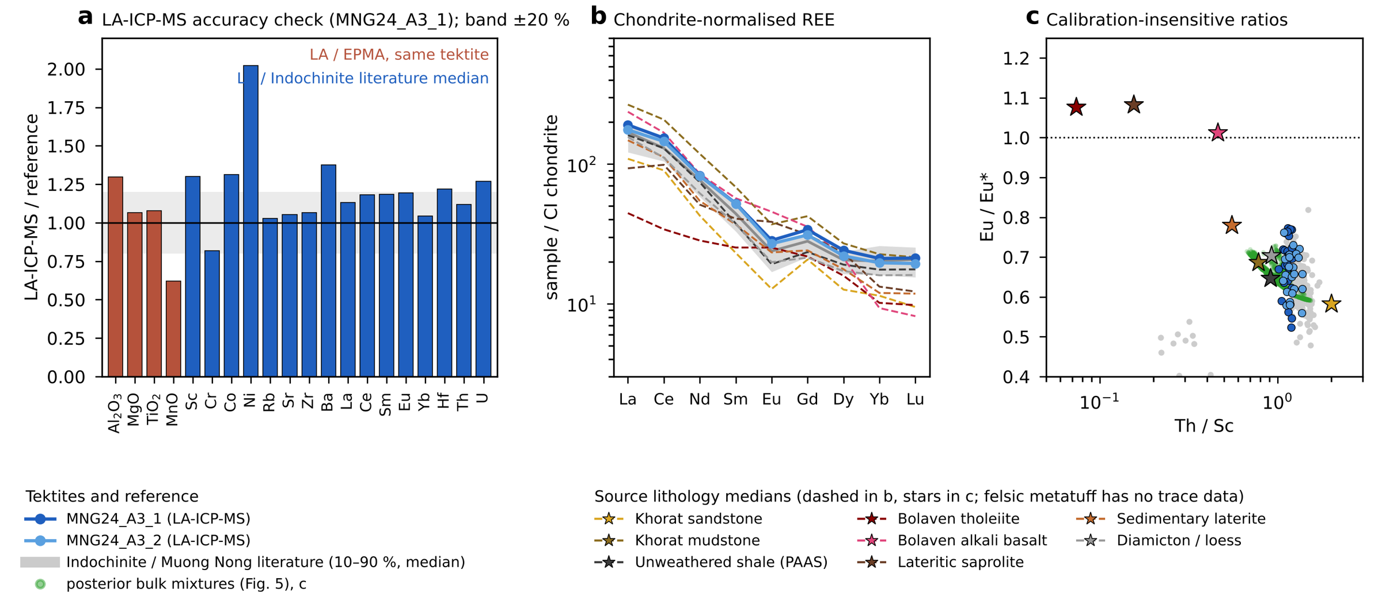
Figure S1. Trace elements of tektites MNG24_A3_1 and MNG24_A3_2 (LA-ICP-MS). (a) Accuracy check. Red bars: LA-ICP-MS/EPMA on the same tektite for four major elements. Blue bars: LA-ICP-MS relative to the median of published Indochinite and Muong Nong analyses. The shaded band is ±20 %. (b) CI-chondrite-normalised REE (Sun & McDonough, 1989) compared with the literature 10–90 % range and with source lithology medians. (c) Th/Sc versus Eu/Eu*, which are insensitive to the internal standard and to dilution, for the tektites, the literature (Eu* from Sm and Tb), source lithologies (stars; the felsic metatuff has no trace-element data) and the bulk posterior mixtures of Fig. 5 (green; metatuff omitted).
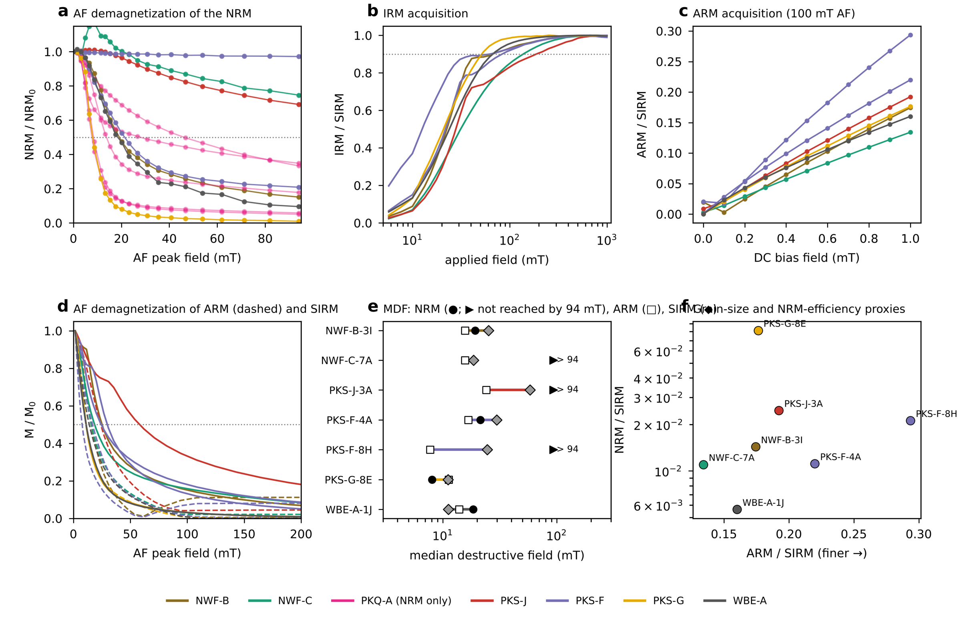
Figure S2. Additional rock magnetism from the 2G RAPID sequences (Code/figS: make_figS_rockmag.py). Colours are sites. (a) AF demagnetization of the NRM to 94 mT (PKQ-A specimens, pale, were measured for the NRM only). (b) IRM acquisition to 1 T, normalised to the SIRM; most of the IRM is acquired by ~100–200 mT, as expected for (titano)magnetite-family carriers. (c) ARM acquisition in a 100 mT AF with a 0–1 mT DC bias, normalised to the SIRM. (d) AF demagnetization of the ARM (dashed) and the SIRM (solid). (e) Median destructive fields (MDF) of NRM, ARM and SIRM; arrows mark NRMs that retain more than half their intensity at 94 mT (AF-hard). (f) ARM/SIRM (a grain-size proxy; higher = finer) against NRM/SIRM. NWF-A-2E is omitted: its moments after the NRM step are at holder-noise level. Where a specimen was run more than once, the NRM is taken from the first run and the laboratory remanences from the last, complete run. NWF-B-3I, NWF-C-7A, PKS-G-8E and WBE-A-1J show the measurement rotation described in Fig. S3; their intensity-based parameters are shown, but their AF directions are not used.
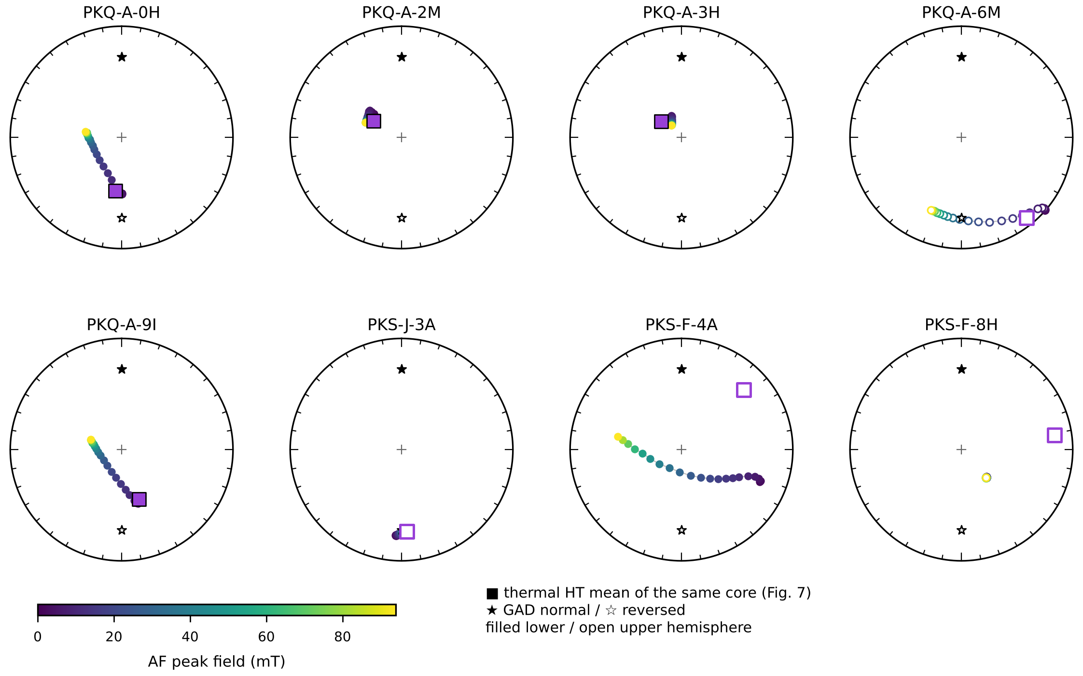
Figure S3. AF demagnetization paths of the NRM in geographic coordinates (rotated with the corrected sample orientations), coloured by AF peak field (0–94 mT); filled = lower, open = upper hemisphere. Purple squares are thermal HT (ChRM) means of the same core (Fig. 7) where available; stars are the GAD directions. Only specimens with coherent AF paths are shown: PKQ-A-0H, -2M, -3H and -9I converge on the thermal HT direction, PKQ-A-6M, PKS-J-3A and PKS-F-4A decay along smooth paths, and PKS-F-8H is AF-stable. Four further specimens measured on the sample changer in 2025–26 (NWF-B-3I, NWF-C-7A, PKS-G-8E, WBE-A-1J) are omitted: their directions jump along small circles at near-constant inclination from step to step, a rotational artefact of the measurement rather than a demagnetization path, so their AF directions carry no information. Their thermal results (Fig. 7; Figs. S5–S16) are unaffected.
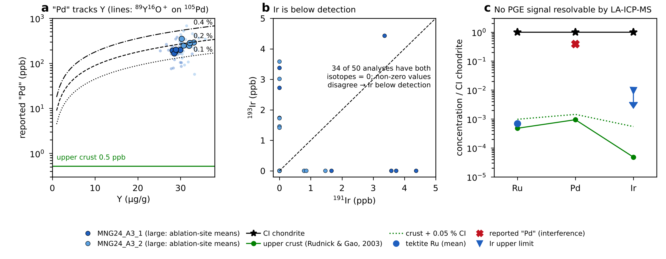
Figure S4. Platinum-group elements by LA-ICP-MS. (a) Reported “Pd” against Y. Small symbols are individual analyses; large symbols are ablation-site means. Lines show the apparent ¹⁰⁵Pd produced by ⁸⁹Y¹⁶O⁺ at oxide production rates of 0.1–0.4 %. (b) ¹⁹¹Ir against ¹⁹³Ir: most analyses are zero and the non-zero values do not agree between isotopes, so Ir is below detection. (c) CI-normalised Ru, Pd and Ir compared with CI chondrite, upper continental crust (Rudnick & Gao, 2003) and crust plus 0.05 % CI. Detecting a projectile component at the ≤ 0.005 % level inferred from Os isotopes (Ackerman et al., 2019) is beyond LA-ICP-MS.
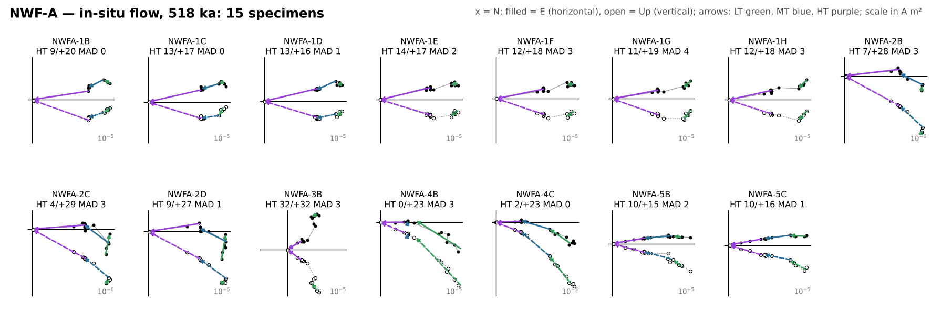
Figure S5. Orthogonal-vector (Zijderveld) diagrams of every thermally demagnetized specimen from NWF-A (in-situ flow, 518 ka), in geographic coordinates. x = north; filled symbols = horizontal plane (east), open = vertical plane (up); scale in A m². Arrows are the LT (green), MT (blue) and HT (purple) least-squares fits from the fitquest re-fits, drawn in the direction of demagnetization. Each label gives the HT direction (declination/inclination) and MAD; red labels mark HT fits with MAD > 15°, which are excluded from all site, boulder and conglomerate statistics.
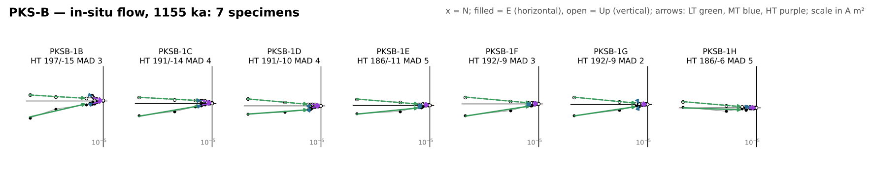
Figure S6. Orthogonal-vector (Zijderveld) diagrams of every thermally demagnetized specimen from PKS-B (in-situ flow, 1155 ka), in geographic coordinates. x = north; filled symbols = horizontal plane (east), open = vertical plane (up); scale in A m². Arrows are the LT (green), MT (blue) and HT (purple) least-squares fits from the fitquest re-fits, drawn in the direction of demagnetization. Each label gives the HT direction (declination/inclination) and MAD; red labels mark HT fits with MAD > 15°, which are excluded from all site, boulder and conglomerate statistics.
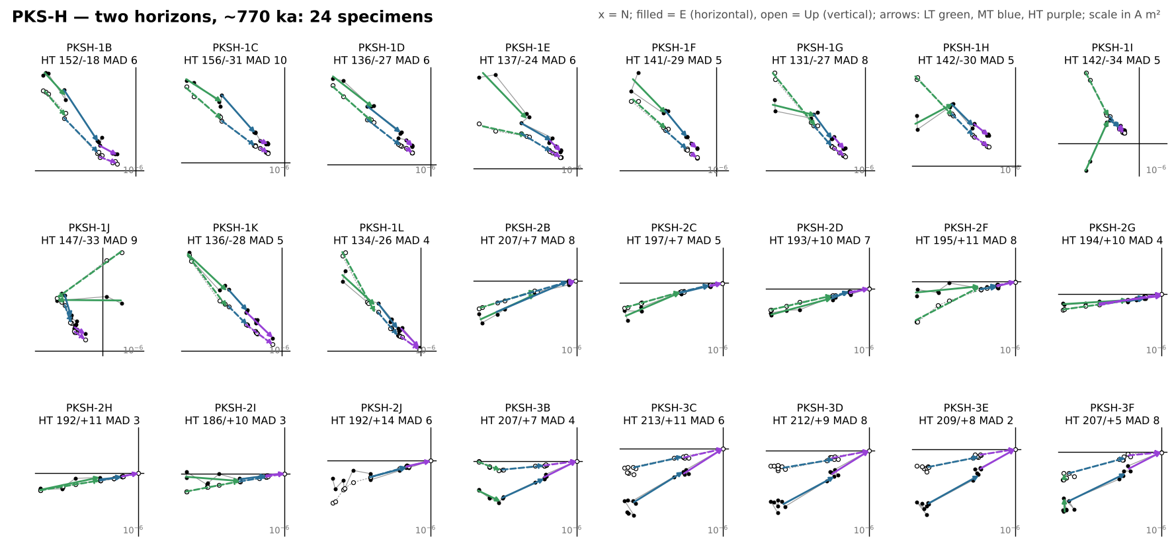
Figure S7. Orthogonal-vector (Zijderveld) diagrams of every thermally demagnetized specimen from PKS-H (upper horizon HA, cores 1–2; lower flow HB, core 3), in geographic coordinates. x = north; filled symbols = horizontal plane (east), open = vertical plane (up); scale in A m². Arrows are the LT (green), MT (blue) and HT (purple) least-squares fits from the fitquest re-fits, drawn in the direction of demagnetization. Each label gives the HT direction (declination/inclination) and MAD; red labels mark HT fits with MAD > 15°, which are excluded from all site, boulder and conglomerate statistics.
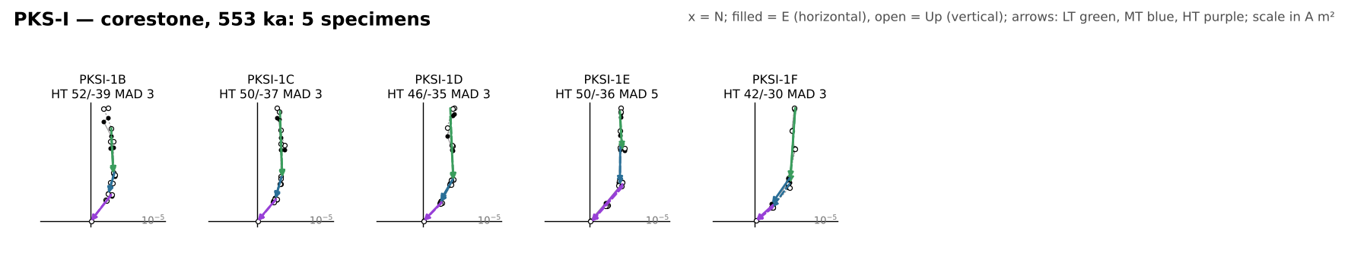
Figure S8. Orthogonal-vector (Zijderveld) diagrams of every thermally demagnetized specimen from PKS-I (corestone, 553 ka), in geographic coordinates. x = north; filled symbols = horizontal plane (east), open = vertical plane (up); scale in A m². Arrows are the LT (green), MT (blue) and HT (purple) least-squares fits from the fitquest re-fits, drawn in the direction of demagnetization. Each label gives the HT direction (declination/inclination) and MAD; red labels mark HT fits with MAD > 15°, which are excluded from all site, boulder and conglomerate statistics.
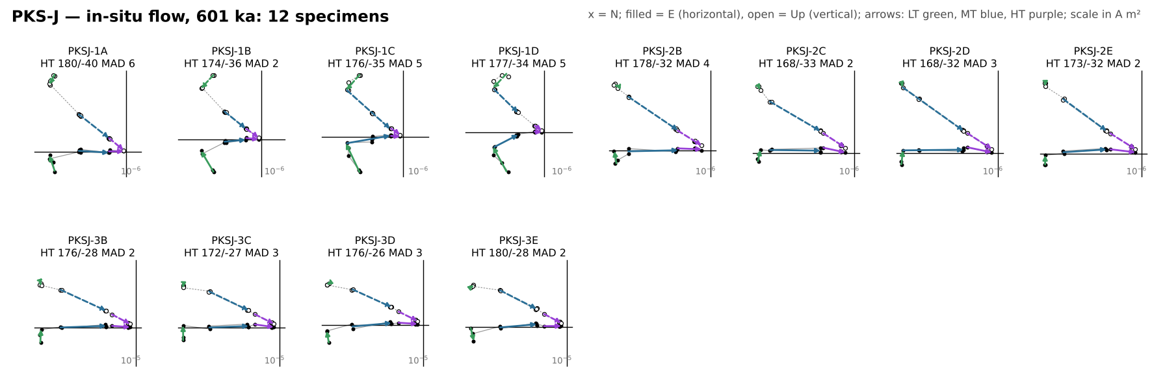
Figure S9. Orthogonal-vector (Zijderveld) diagrams of every thermally demagnetized specimen from PKS-J (in-situ flow, 601 ka), in geographic coordinates. x = north; filled symbols = horizontal plane (east), open = vertical plane (up); scale in A m². Arrows are the LT (green), MT (blue) and HT (purple) least-squares fits from the fitquest re-fits, drawn in the direction of demagnetization. Each label gives the HT direction (declination/inclination) and MAD; red labels mark HT fits with MAD > 15°, which are excluded from all site, boulder and conglomerate statistics.
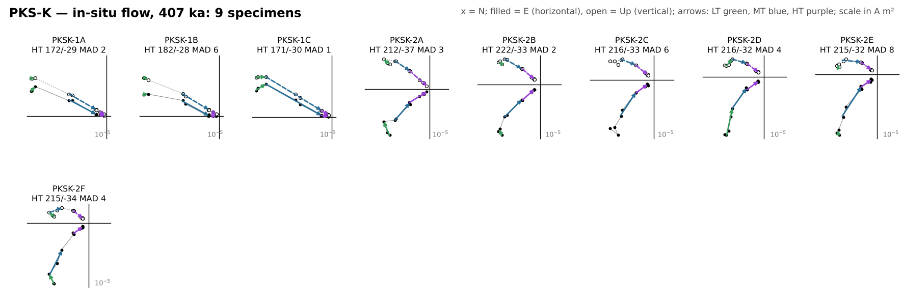
Figure S10. Orthogonal-vector (Zijderveld) diagrams of every thermally demagnetized specimen from PKS-K (in-situ flow, 407 ka), in geographic coordinates. x = north; filled symbols = horizontal plane (east), open = vertical plane (up); scale in A m². Arrows are the LT (green), MT (blue) and HT (purple) least-squares fits from the fitquest re-fits, drawn in the direction of demagnetization. Each label gives the HT direction (declination/inclination) and MAD; red labels mark HT fits with MAD > 15°, which are excluded from all site, boulder and conglomerate statistics.
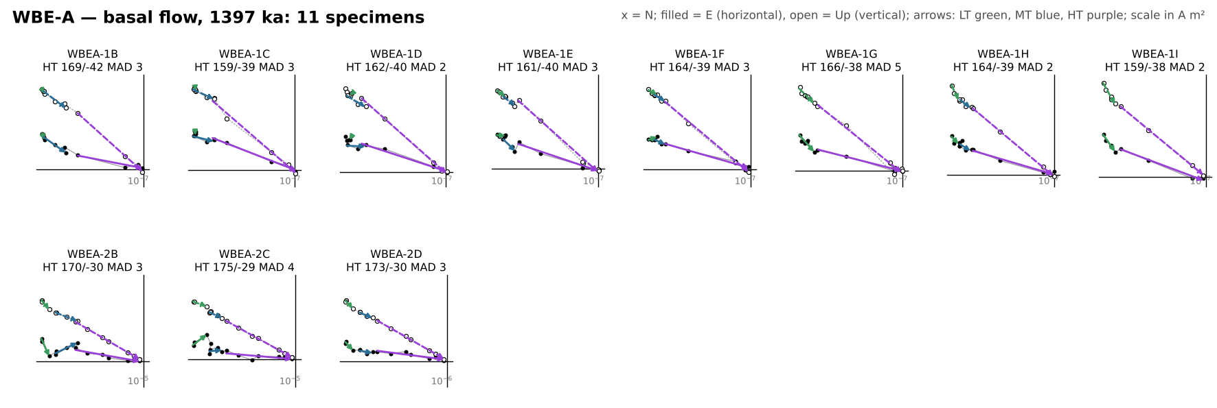
Figure S11. Orthogonal-vector (Zijderveld) diagrams of every thermally demagnetized specimen from WBE-A (basal flow, 1397 ka), in geographic coordinates. x = north; filled symbols = horizontal plane (east), open = vertical plane (up); scale in A m². Arrows are the LT (green), MT (blue) and HT (purple) least-squares fits from the fitquest re-fits, drawn in the direction of demagnetization. Each label gives the HT direction (declination/inclination) and MAD; red labels mark HT fits with MAD > 15°, which are excluded from all site, boulder and conglomerate statistics.
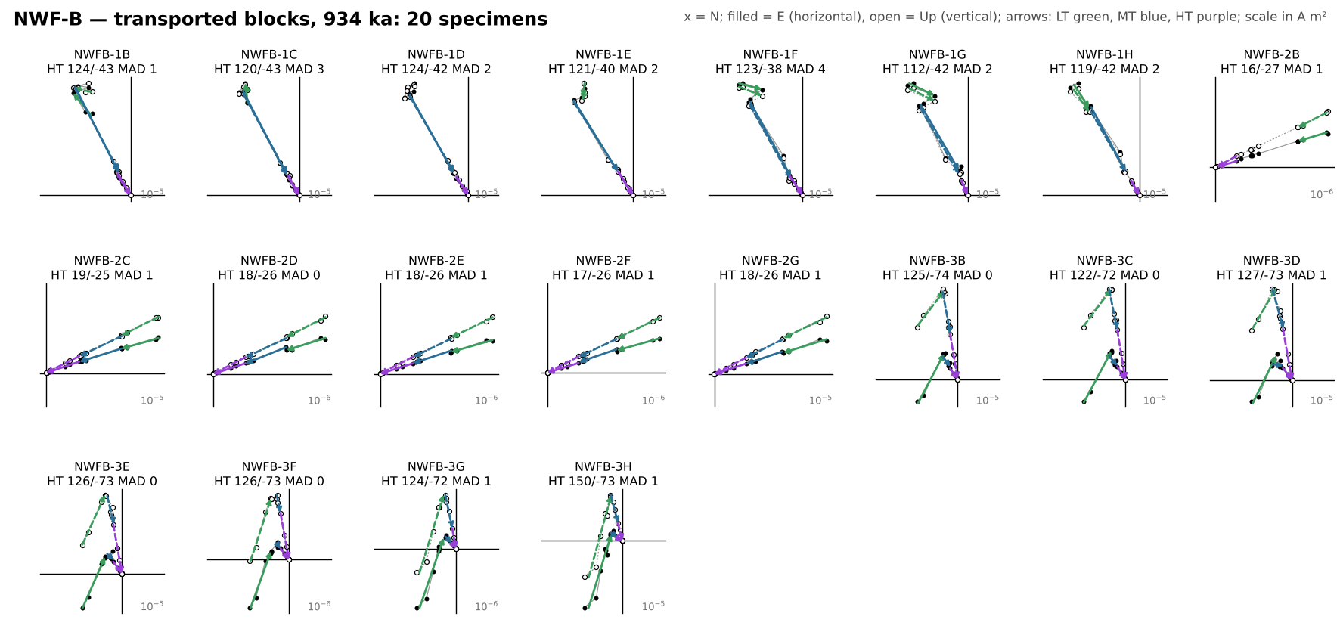
Figure S12. Orthogonal-vector (Zijderveld) diagrams of every thermally demagnetized specimen from NWF-B (transported blocks), in geographic coordinates. x = north; filled symbols = horizontal plane (east), open = vertical plane (up); scale in A m². Arrows are the LT (green), MT (blue) and HT (purple) least-squares fits from the fitquest re-fits, drawn in the direction of demagnetization. Each label gives the HT direction (declination/inclination) and MAD; red labels mark HT fits with MAD > 15°, which are excluded from all site, boulder and conglomerate statistics.
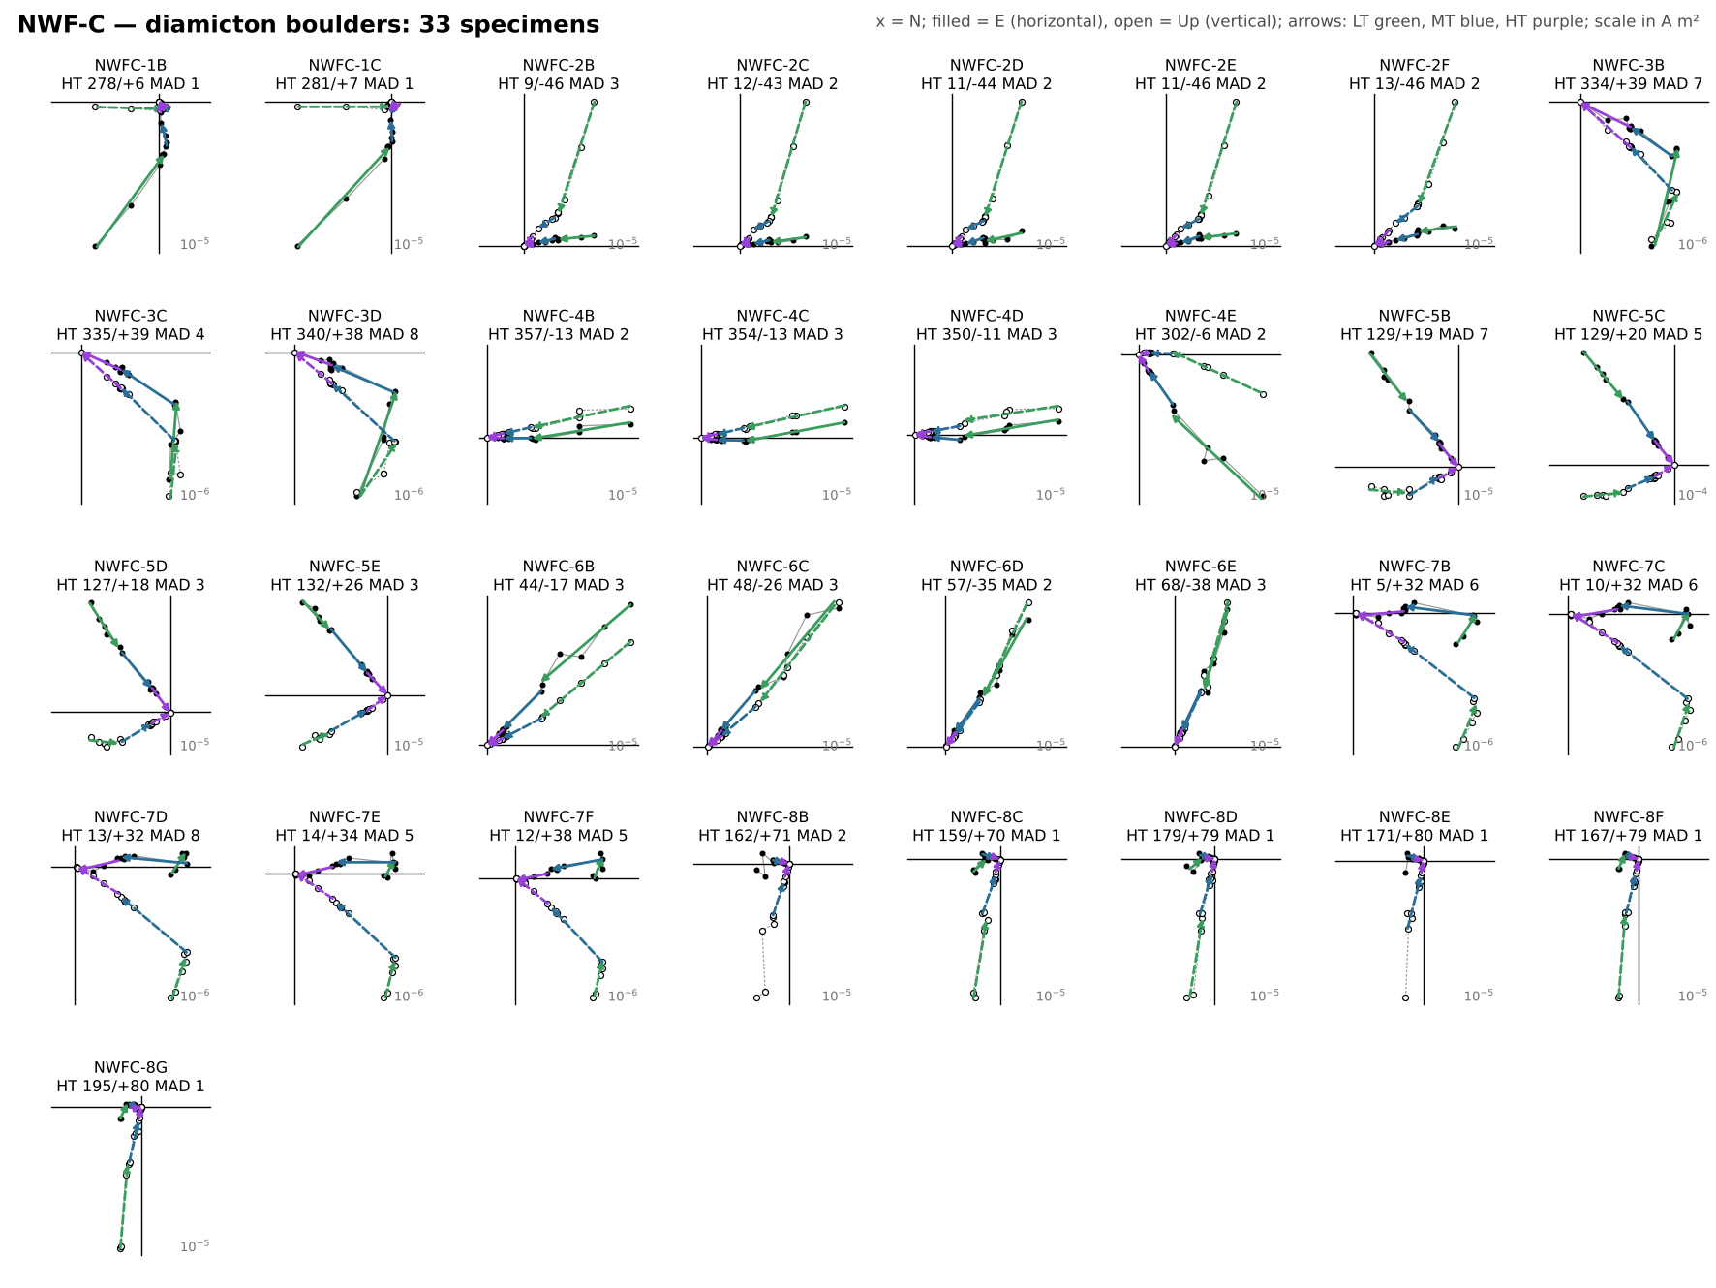
Figure S13. Orthogonal-vector (Zijderveld) diagrams of every thermally demagnetized specimen from NWF-C (diamicton boulders), in geographic coordinates. x = north; filled symbols = horizontal plane (east), open = vertical plane (up); scale in A m². Arrows are the LT (green), MT (blue) and HT (purple) least-squares fits from the fitquest re-fits, drawn in the direction of demagnetization. Each label gives the HT direction (declination/inclination) and MAD; red labels mark HT fits with MAD > 15°, which are excluded from all site, boulder and conglomerate statistics.
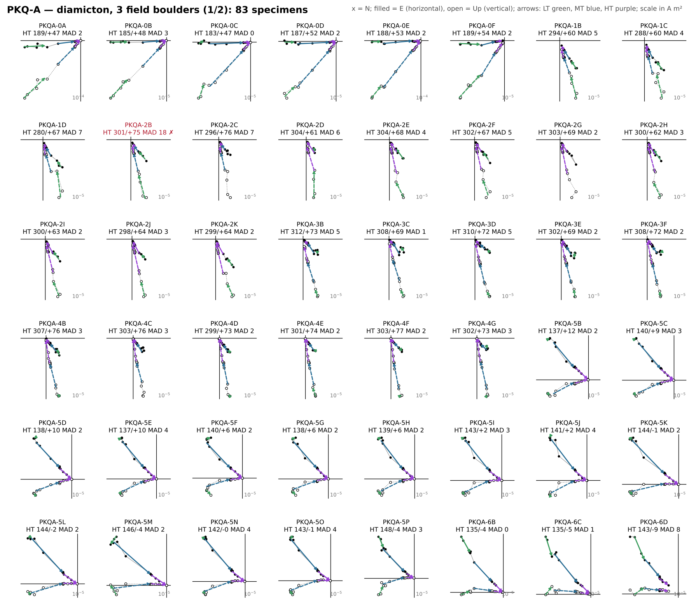
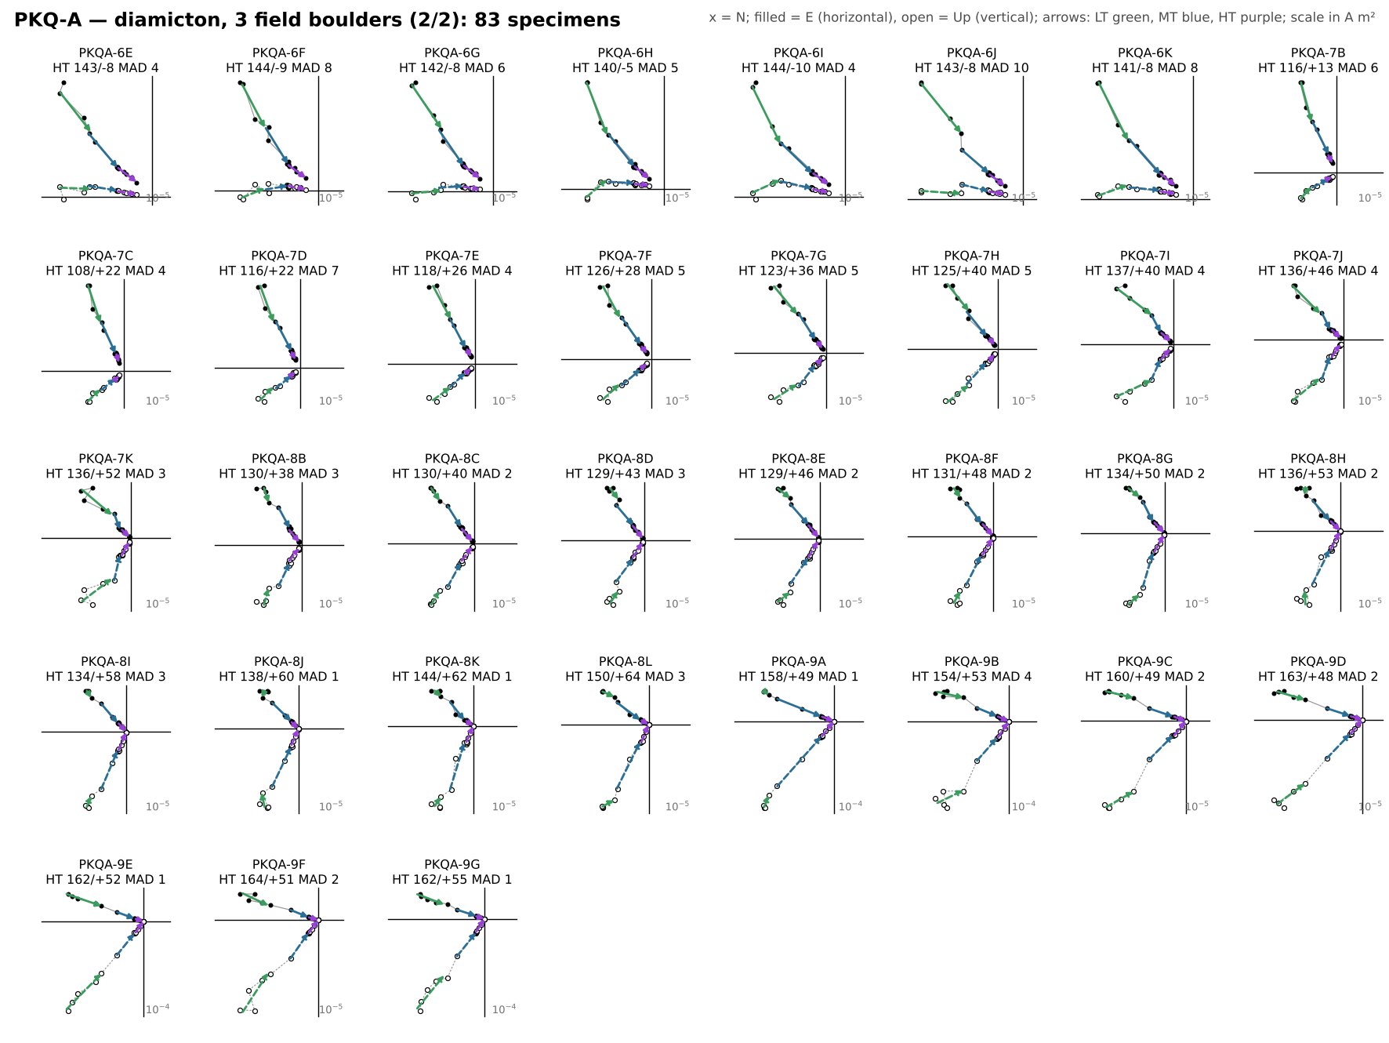
Figure S14. Orthogonal-vector (Zijderveld) diagrams of every thermally demagnetized specimen from PKQ-A (diamicton; field boulders B1 = cores 0–4, B2 = 5–6, B3 = 7–9), in geographic coordinates (2 parts). x = north; filled symbols = horizontal plane (east), open = vertical plane (up); scale in A m². Arrows are the LT (green), MT (blue) and HT (purple) least-squares fits from the fitquest re-fits, drawn in the direction of demagnetization. Each label gives the HT direction (declination/inclination) and MAD; red labels mark HT fits with MAD > 15°, which are excluded from all site, boulder and conglomerate statistics.
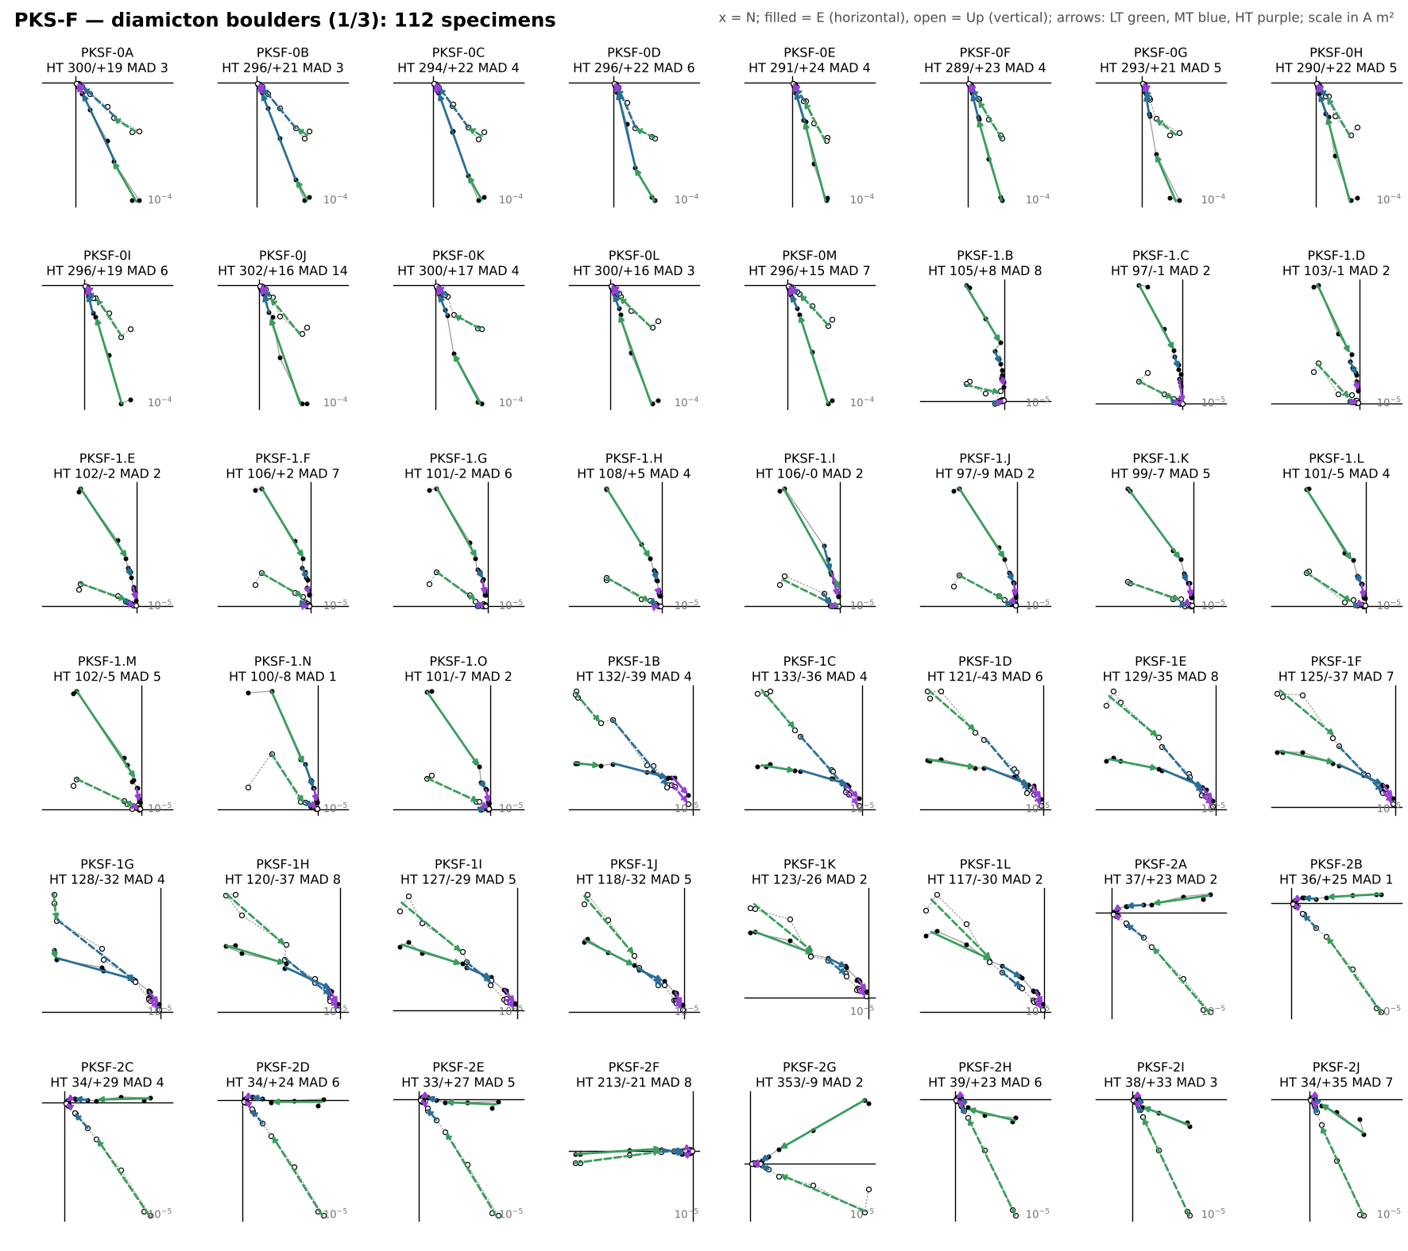
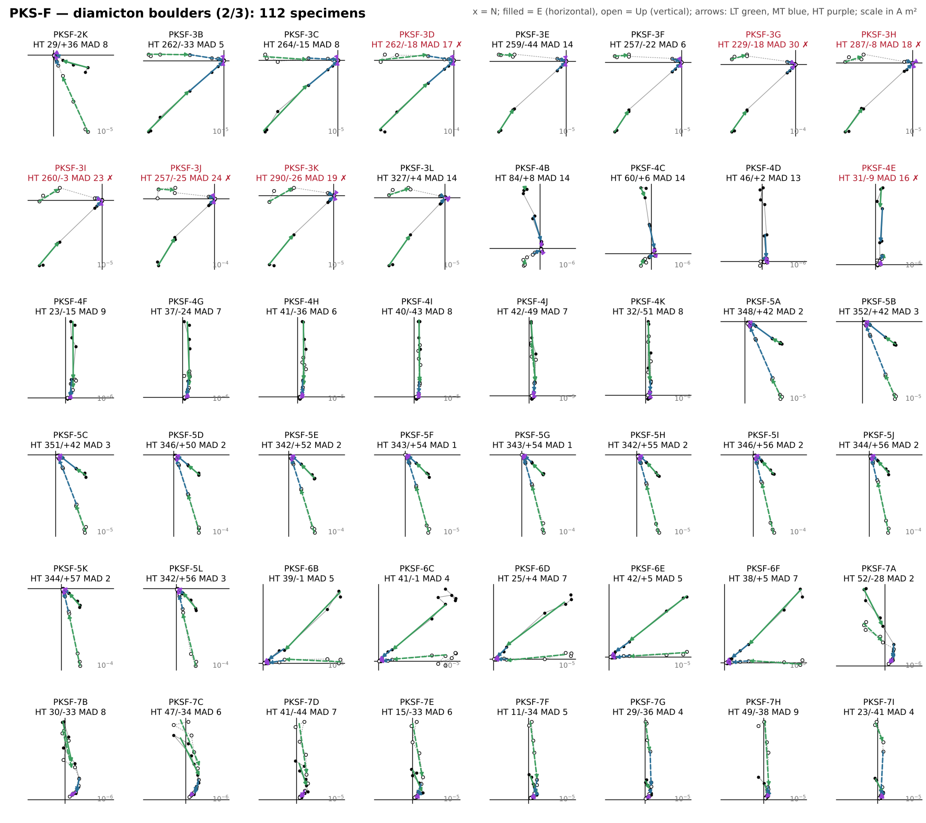
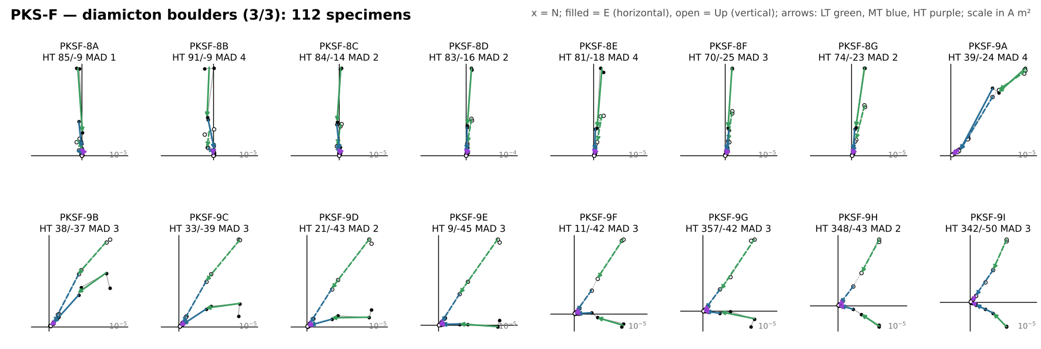
Figure S15. Orthogonal-vector (Zijderveld) diagrams of every thermally demagnetized specimen from PKS-F (diamicton boulders), in geographic coordinates (3 parts). x = north; filled symbols = horizontal plane (east), open = vertical plane (up); scale in A m². Arrows are the LT (green), MT (blue) and HT (purple) least-squares fits from the fitquest re-fits, drawn in the direction of demagnetization. Each label gives the HT direction (declination/inclination) and MAD; red labels mark HT fits with MAD > 15°, which are excluded from all site, boulder and conglomerate statistics.
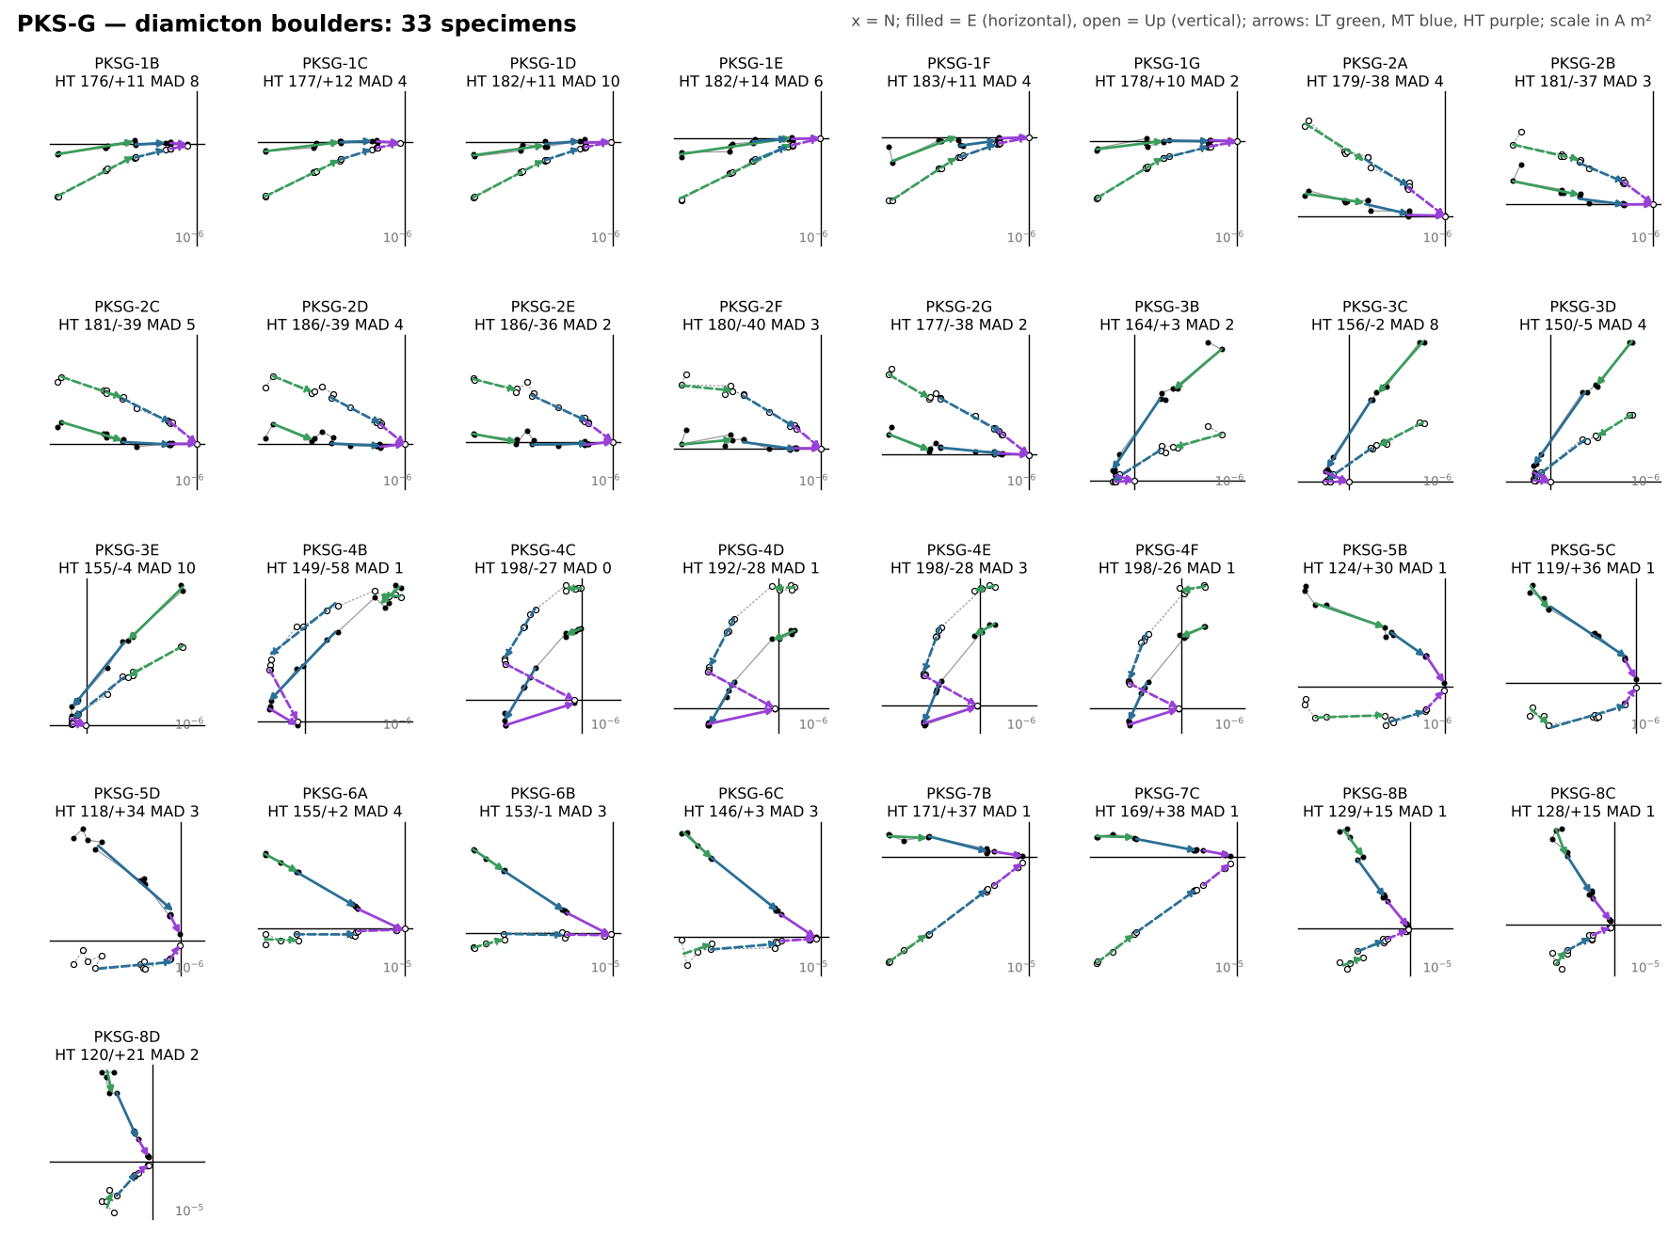
Figure S16. Orthogonal-vector (Zijderveld) diagrams of every thermally demagnetized specimen from PKS-G (diamicton boulders), in geographic coordinates. x = north; filled symbols = horizontal plane (east), open = vertical plane (up); scale in A m². Arrows are the LT (green), MT (blue) and HT (purple) least-squares fits from the fitquest re-fits, drawn in the direction of demagnetization. Each label gives the HT direction (declination/inclination) and MAD; red labels mark HT fits with MAD > 15°, which are excluded from all site, boulder and conglomerate statistics.
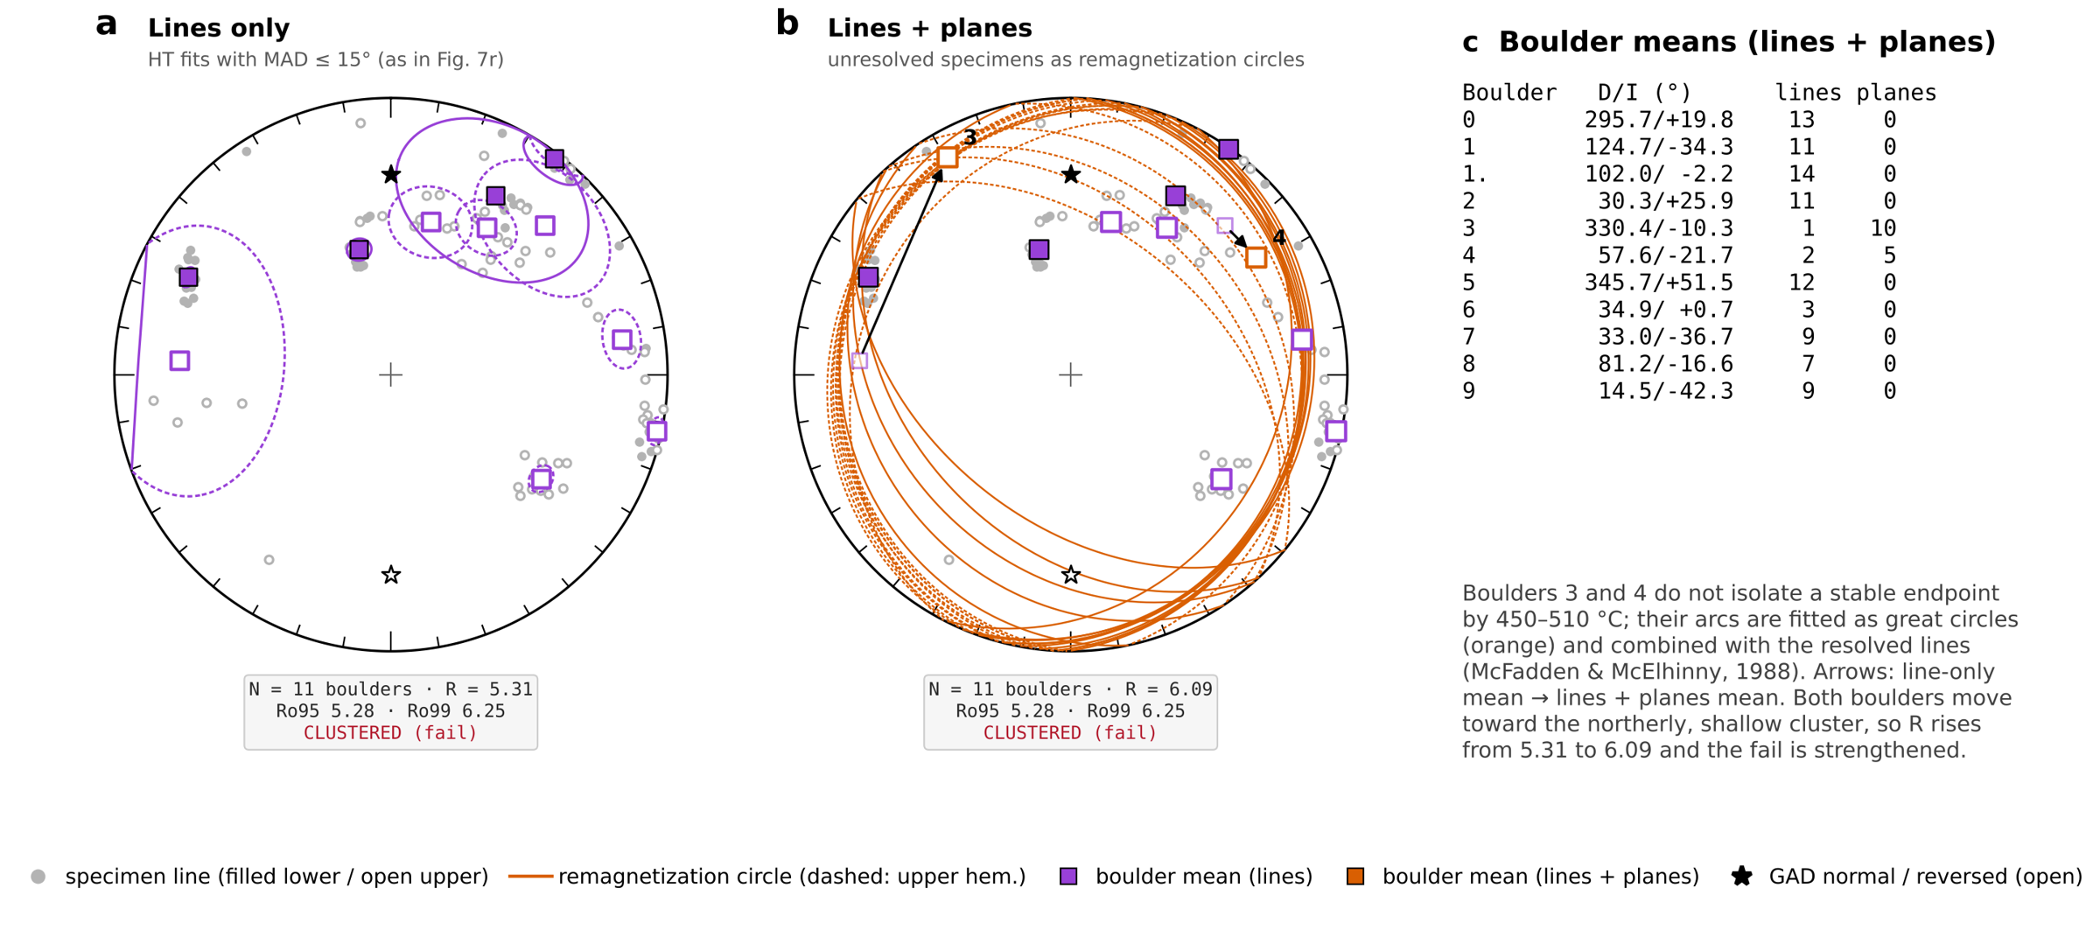
Figure S17. PKS-F conglomerate test with lines only and with lines plus planes (McFadden & McElhinny, 1988; mcfadden_gc_check.py). (a) Boulder-mean HT directions from HT fits with MAD ≤ 15° (as in Fig. 7r): R = 5.31 against Ro95 = 5.28. (b) Specimens that do not isolate a stable endpoint by 450–510 °C, mostly in boulders 3 and 4, are re-expressed as remagnetization circles (orange; poles rotated to geographic with each specimen's own component fits) and combined with the resolved lines. Arrows run from the line-only to the lines-plus-planes boulder means; both move toward the northerly, shallow cluster, R rises to 6.09 and the population is clustered under either treatment. (c) Lines-plus-planes boulder means.

Supplementary tables
Table S1. Paleomagnetic sample inventory. Coordinates are means of the 2024 GPS waypoints (WGS84). Orientation from the sample-header files: sun compass, or magnetic compass corrected to IGRF declination. Specimens: thermally demagnetized specimens with fitted components; HT accepted: specimens whose HT (ChRM) fit has MAD ≤ 15°; component fits: all LT, MT and HT fits.
Site | Lat (°N) | Lon (°E) | Setting | Sample type | Orientation | Cores / blocks | Specimens | HT accepted (MAD ≤ 15°) | Component fits
NWF-A | 15.6446 | 106.1427 | In-situ flow | Block | Sun | 5 | 15 | 15 | 40
NWF-B | 15.6236 | 105.9859 | Blocks (transported) | Block | Magnetic (IGRF-corr.) | 3 | 20 | 20 | 58
NWF-C | 15.4148 | 106.1433 | Diamicton boulders | Block | Sun | 8 | 33 | 33 | 97
PKQ-A | 15.1020 | 105.8536 | Diamicton boulders | Core | Sun (cores 0, 3 magnetic) | 10 | 83 | 82 | 238
PKS-B | 15.1543 | 106.1897 | In-situ flow | Block | Sun | 1 | 7 | 7 | 21
PKS-F | 15.1131 | 106.2282 | Diamicton boulders | Core | Sun | 11 | 112 | 105 | 334
PKS-G | 15.1558 | 106.1903 | Diamicton boulders | Block | Magnetic (IGRF-corr.) | 8 | 33 | 33 | 98
PKS-H | 15.1557 | 106.1918 | Two horizons (HA, HB) | Core | Sun | 3 | 24 | 24 | 68
PKS-I | 15.2328 | 106.1908 | Corestone | Core | Sun | 1 | 5 | 5 | 15
PKS-J | 15.2431 | 106.2581 | In-situ flow | Core | Magnetic (IGRF-corr.) | 3 | 12 | 12 | 36
PKS-K | 15.2419 | 106.2585 | In-situ flow | Core | Magnetic (IGRF-corr.) | 2 | 9 | 9 | 26
WBE-A | 15.2700 | 106.3472 | Basal flow | Block | Magnetic (IGRF-corr.) | 2 | 11 | 11 | 31

Table S2. Tektites analysed in this study. EPMA spots with oxide totals below 97 wt% are rejected (shaded: no accepted analyses). LA-ICP-MS: five ablation sites with five replicates each.
Tektite | Locality | EPMA spots | Accepted (≥ 97 wt%) | Total range (wt%) | LA-ICP-MS
KK24_T1 | Khon Kaen, NE Thailand | 30 | 30 | 97.7–99.7 | —
MG24_B1 | Muong Nong area, Savannakhet, Laos | 6 | 5 | 96.8–98.6 | —
MNG24_A3_1 | Muong Nong area, Savannakhet, Laos | 30 | 30 | 98.4–99.7 | yes (5 sites × 5)
MNG24_A3_2 | Muong Nong area, Savannakhet, Laos | 27 | 0 | 32.7–85.6 | yes (5 sites × 5)
MNG24_A3_3 | Muong Nong area, Savannakhet, Laos | 15 | 0 | 60.7–96.7 | —
MNG24_B1 | Muong Nong area, Savannakhet, Laos | 20 | 17 | 96.3–98.0 | —
MNG24_C2 | Muong Nong area, Savannakhet, Laos | 25 | 0 | 65.8–93.9 | —

Table S3. Hysteresis parameters of the seven fresh-interior / weathered-rind chip pairs plotted in Fig. 4c (MicroMag VSM; Hc and Mr/Ms from the slope-corrected loops, Hcr from backfield remanence). Shaded rows are weathered chips. PKS24-I and PKS24-HB were filed as PKQ24-… in the instrument files.
Site | Setting | Sample | Chip | Mass (g) | Hc (mT) | Hcr (mT) | Mr (µA m²) | Ms (µA m²) | Mr/Ms | Hcr/Hc
PKS-B | In-situ flow | PKS24-BA-P1 | fresh | 0.299 | 16.8 | 24.5 | 33.6 | 96.7 | 0.348 | 1.46
 |  |  | weathered | 0.164 | 17.3 | 34.2 | 8.6 | 32.5 | 0.265 | 1.98
PKS-H (HB) | In-situ flow | PKS24-HB-P1 | fresh | 0.423 | 14.7 | 23.3 | 30.7 | 97.5 | 0.315 | 1.58
 |  |  | weathered | 0.023 | 10.7 | 18.7 | 2.1 | 8.3 | 0.258 | 1.75
PKS-I | Corestone | PKS24-I-P1 | fresh | 1.307 | 26.2 | 47.5 | 90.4 | 304.5 | 0.297 | 1.81
 |  |  | weathered | 0.108 | 22.2 | 42.1 | 23.3 | 86.5 | 0.270 | 1.90
NWF-C | Diamicton clast | NWF24-C-P8 | fresh | 0.307 | 21.1 | 38.3 | 25.5 | 78.0 | 0.327 | 1.82
 |  |  | weathered | 0.300 | 16.6 | 32.6 | 28.8 | 108.3 | 0.266 | 1.97
PKQ-A (2A) | Diamicton clast | PKQ24-A-P2A | fresh | 0.637 | 15.7 | 33.0 | 34.2 | 127.4 | 0.268 | 2.10
 |  |  | weathered | 0.359 | 10.6 | 19.9 | 32.2 | 173.4 | 0.186 | 1.88
PKQ-A (5A) | Diamicton clast | PKQ24-A-P5A | fresh | 0.790 | 13.9 | 30.3 | 34.1 | 132.0 | 0.258 | 2.17
 |  |  | weathered | 0.286 | 8.4 | 16.8 | 19.2 | 120.0 | 0.160 | 1.99
PKQ-A (5C) | Diamicton clast | PKQ24-A-P5C | fresh | 0.668 | 10.6 | 23.2 | 27.4 | 133.0 | 0.206 | 2.18
 |  |  | weathered | 0.245 | 8.7 | 17.1 | 15.6 | 90.8 | 0.171 | 1.97

Table S4 lists the complete set of ten quantitative energy-dispersive X-ray (EDS) point analyses obtained from a fresh Bolaven basalt (specimen LS-H18, Area 1), extending the three oxide analyses shown in the main text (Fig. 4k,l). The analyses span every major phase identified in back-scattered-electron imaging: five Fe–Ti oxide grains (four titanomagnetite, one of them chromian, plus one secondary Fe–Mn oxide), two plagioclase (labradorite, An_{59–62}), two olivine grains spanning Fo_{53–78}, and one augite. No exotic, high-pressure, shock-diagnostic, or metallic (Ni-rich) phase was encountered – the assemblage is that of an ordinary, weathered intraplate basalt rather than an impact-shocked or impactor-contaminated lithology, corroborating the rock-magnetic and geochemical results in the main text.
Table S4. Complete EDS analyses of Bolaven basalt specimen LS-H18 (Area 1), acquired on an Oxford Instruments EDS system. All values in wt%, normalized to 100%; all iron reported as FeO. “–” denotes an oxide below detection. Anorthite (An) and forsterite (Fo) contents are computed from cation proportions. Analyses 1, 4 and 5 are the three oxide grains shown in Fig. 4k,l. The assemblage – titanomagnetite (one Cr-rich), a secondary Fe–Mn oxide, labradorite, olivine, and augite – is ordinary intraplate-basalt mineralogy with no high-pressure, shock, or metallic phases.
[tab:sem_eds]
# | Phase | SiO2 | TiO2 | Al2O3 | Cr2O3 | V2O5 | FeO | MnO | MgO | CaO | Na2O | K2O
1 | Titanomagnetite | 0.42 | 21.74 | 1.18 | – | 0.89 | 73.80 | 0.82 | 1.15 | – | – | –
2 | Plagioclase (An59) | 53.60 | – | 29.13 | – | – | 1.07 | – | 0.45 | 11.27 | 4.14 | 0.34
3 | Olivine (Fo53) | 32.99 | – | 0.77 | – | – | 40.26 | – | 25.30 | 0.68 | – | –
4 | Cr-titanomagnetite | 2.30 | 16.03 | 3.80 | 10.83 | 1.16 | 62.55 | 0.61 | 2.72 | – | – | –
5 | Titanomagnetite | 2.02 | 22.41 | 2.56 | 1.07 | 0.91 | 68.48 | 0.60 | 1.68 | 0.26 | – | –
6 | Plagioclase (An62) | 52.53 | – | 29.22 | – | – | 0.90 | – | – | 12.95 | 4.12 | 0.28
7 | Olivine (Fo78) | 39.73 | – | 1.32 | – | – | 19.37 | – | 38.88 | 0.70 | – | –
8 | Fe–Mn oxide (secondary) | 3.02 | – | – | – | – | 80.66 | 4.05 | 9.31 | 2.97 | – | –
9 | Augite (clinopyroxene) | 49.93 | 2.37 | 3.87 | – | – | 14.92 | – | 9.55 | 19.11 | – | 0.26
10 | Titanomagnetite | 7.00 | 20.15 | 3.37 | – | 0.73 | 65.33 | – | 2.28 | 0.39 | 0.28 | 0.48
Table S5. Posterior mixing weights (wt%, mean ± 1σ combining within- and between-chain variance) of each lithology type in the reversible-jump MCMC unmixing of the 82 accepted EPMA analyses (Fig. 5k, m). The number in parentheses is the percentage of posterior samples in which the type is present. Full model: 12 chains × 6 × 10⁴ iterations; sensitivity runs: 4 chains × 3 × 10⁴ iterations. "Excluded" marks types removed from the dictionary in that run.
Lithology type | Full model (12 chains) | No random (4) | Na₂O, K₂O excluded (4) | Regional only (4)
Khorat sandstone | 35.6 ± 15.4 (91) | 26.2 ± 13.3 (99) | 40.1 ± 11.9 (100) | 25.0 ± 11.2 (99)
Khorat mudstone | 3.3 ± 5.6 (37) | 32.2 ± 20.8 (100) | 3.8 ± 4.6 (48) | 25.5 ± 12.0 (100)
Unweathered shale (PAAS) | 26.8 ± 23.1 (91) | 7.2 ± 8.5 (50) | 28.2 ± 15.8 (100) | excluded
Felsic metatuff | 9.9 ± 5.7 (91) | 14.7 ± 11.1 (75) | 6.2 ± 6.3 (65) | 30.6 ± 12.9 (100)
Bolaven tholeiite | 3.7 ± 5.2 (53) | 10.2 ± 5.1 (100) | 7.3 ± 9.5 (50) | 6.3 ± 5.5 (71)
Bolaven alkali basalt | 1.1 ± 2.7 (19) | 8.6 ± 9.7 (75) | 0.0 ± 0.2 (1) | 11.9 ± 6.3 (86)
All basalt (sum) | 4.8 ± 5.4 (64) | 18.8 ± 9.4 (100) | 7.3 ± 9.5 (50) | 18.2 ± 2.3 (100)
Lateritic saprolite | 0.0 ± 0.0 (0) | 0.0 ± 0.0 (0) | 0.0 ± 0.0 (0) | 0.0 ± 0.0 (0)
Sedimentary laterite / bauxite | 1.6 ± 3.8 (17) | 0.0 ± 0.0 (0) | 0.0 ± 0.0 (0) | 0.0 ± 0.0 (0)
Diamicton / loess | 0.4 ± 1.6 (6) | 1.0 ± 3.0 (14) | 2.4 ± 3.5 (40) | 0.7 ± 2.1 (12)
Random (unconstrained) | 17.8 ± 13.2 (86) | excluded | 12.0 ± 8.7 (75) | excluded

