Paleomagnetic and Geochemical Investigation of the Bolaven Plateau Volcanic Field: Testing the Australasian Impact Crater Hypothesis, Southern Laos
Nicolas Anderson¹·*, Paolo Sanchez¹, Kerry Sieh², and Joseph L. Kirschvink¹ ¹Division of Geological and Planetary Sciences, California Institute of Technology, Pasadena, CA 91125, USA ²Earth Observatory of Singapore, Nanyang Technological University, Singapore 639798 *Corresponding author: nanderson@caltech.edu
The source crater of the Australasian tektite strewn field is proposed to lie buried beneath the Bolaven Plateau volcanic field in southern Laos. We present the first paleomagnetic test of this hypothesis, together with new tektite and target-rock geochemistry, using ~80 oriented samples from 12 basalt localities. Rock-magnetic and SEM/EDS data show primary titanomagnetite partially oxidized to maghemite by lateritic weathering yet retaining stable pseudo-single-domain remanence; no shock-related magnetic phases are present. Watson conglomerate tests show that boulders at two diamicton localities carry random, pre-depositional magnetizations – consistent with, but not diagnostic of, ballistic ejecta – while two others fail as weathered in-situ flows and two are statistically indeterminate. Magnetic polarities match ⁴⁰Ar/³⁹Ar ages at only three of six dated flows; two reversed flows with Brunhes ages require redating, and the flow thought to span the Brunhes–Matuyama boundary is internally discordant, so no in-situ reversal record is confirmed. Reversible-jump Bayesian unmixing of 82 quality-screened tektite analyses requires a sediment-dominated parent less weathered than any exposed Khorat Group rock, permits at most ~10–20% basalt, and cannot discriminate Bolaven from other Indochinese sources. The hypothesis survives both tests but gains no independent support; the volcanic chronology needs revision first.

Introduction
The Australasian tektite strewn field is the largest known on Earth, covering ~20% of the eastern hemisphere from Indochina to Antarctica (Glass, 1994; Folco et al., 2010) (Fig. 1). The glassy impact melts that define it formed at 788 ± 3 ka (Jourdan et al., 2019; Schwarz et al., 2016), yet after a century of searching their source crater remains unidentified. Tektite abundances, sizes and geochemistry point to an impact site in central Indochina onto quartz-rich siliciclastic sediments with a minor mafic component (Koeberl, 1992; Blum et al., 1992; Amare & Koeberl, 2006; Goderis et al., 2017).
Sieh et al. (2020) proposed that the crater lies buried beneath the Bolaven Plateau volcanic field in southern Laos (Fig. 2), citing tektite chemistry consistent with mixing of local sandstone and basalt, pre- and post-impact lava flows able to bury a crater, a negative Bouguer gravity anomaly of appropriate size, proximal breccias with shocked quartz (Sieh et al., 2024), and a capping tektite-bearing diamicton. The hypothesis is contested: Mizera (2022) argues on geochemical and sedimentological grounds that the Bolaven candidate fails, and that the diamicton is ordinary loess and alluvium. The debate has so far lacked an independent physical test.
Paleomagnetism offers one. Magnetic polarities of dated flows test the ⁴⁰Ar/³⁹Ar framework that underpins the burial argument; conglomerate tests on diamicton boulders establish whether they were magnetized before or after deposition; rock magnetism can reveal shock-related phases; and the impact’s timing – within the extended (~800–770 ka) transitional interval of the Brunhes–Matuyama (B–M) reversal (Singer et al., 2019; Mahgoub et al., 2024) – makes any in-situ record of the reversal at Bolaven doubly valuable. Here we present the first paleomagnetic and magnetostratigraphic study of the Bolaven volcanic field, with new rock-magnetic, SEM/EDS and tektite geochemical data, as an independent test of the impact hypothesis.
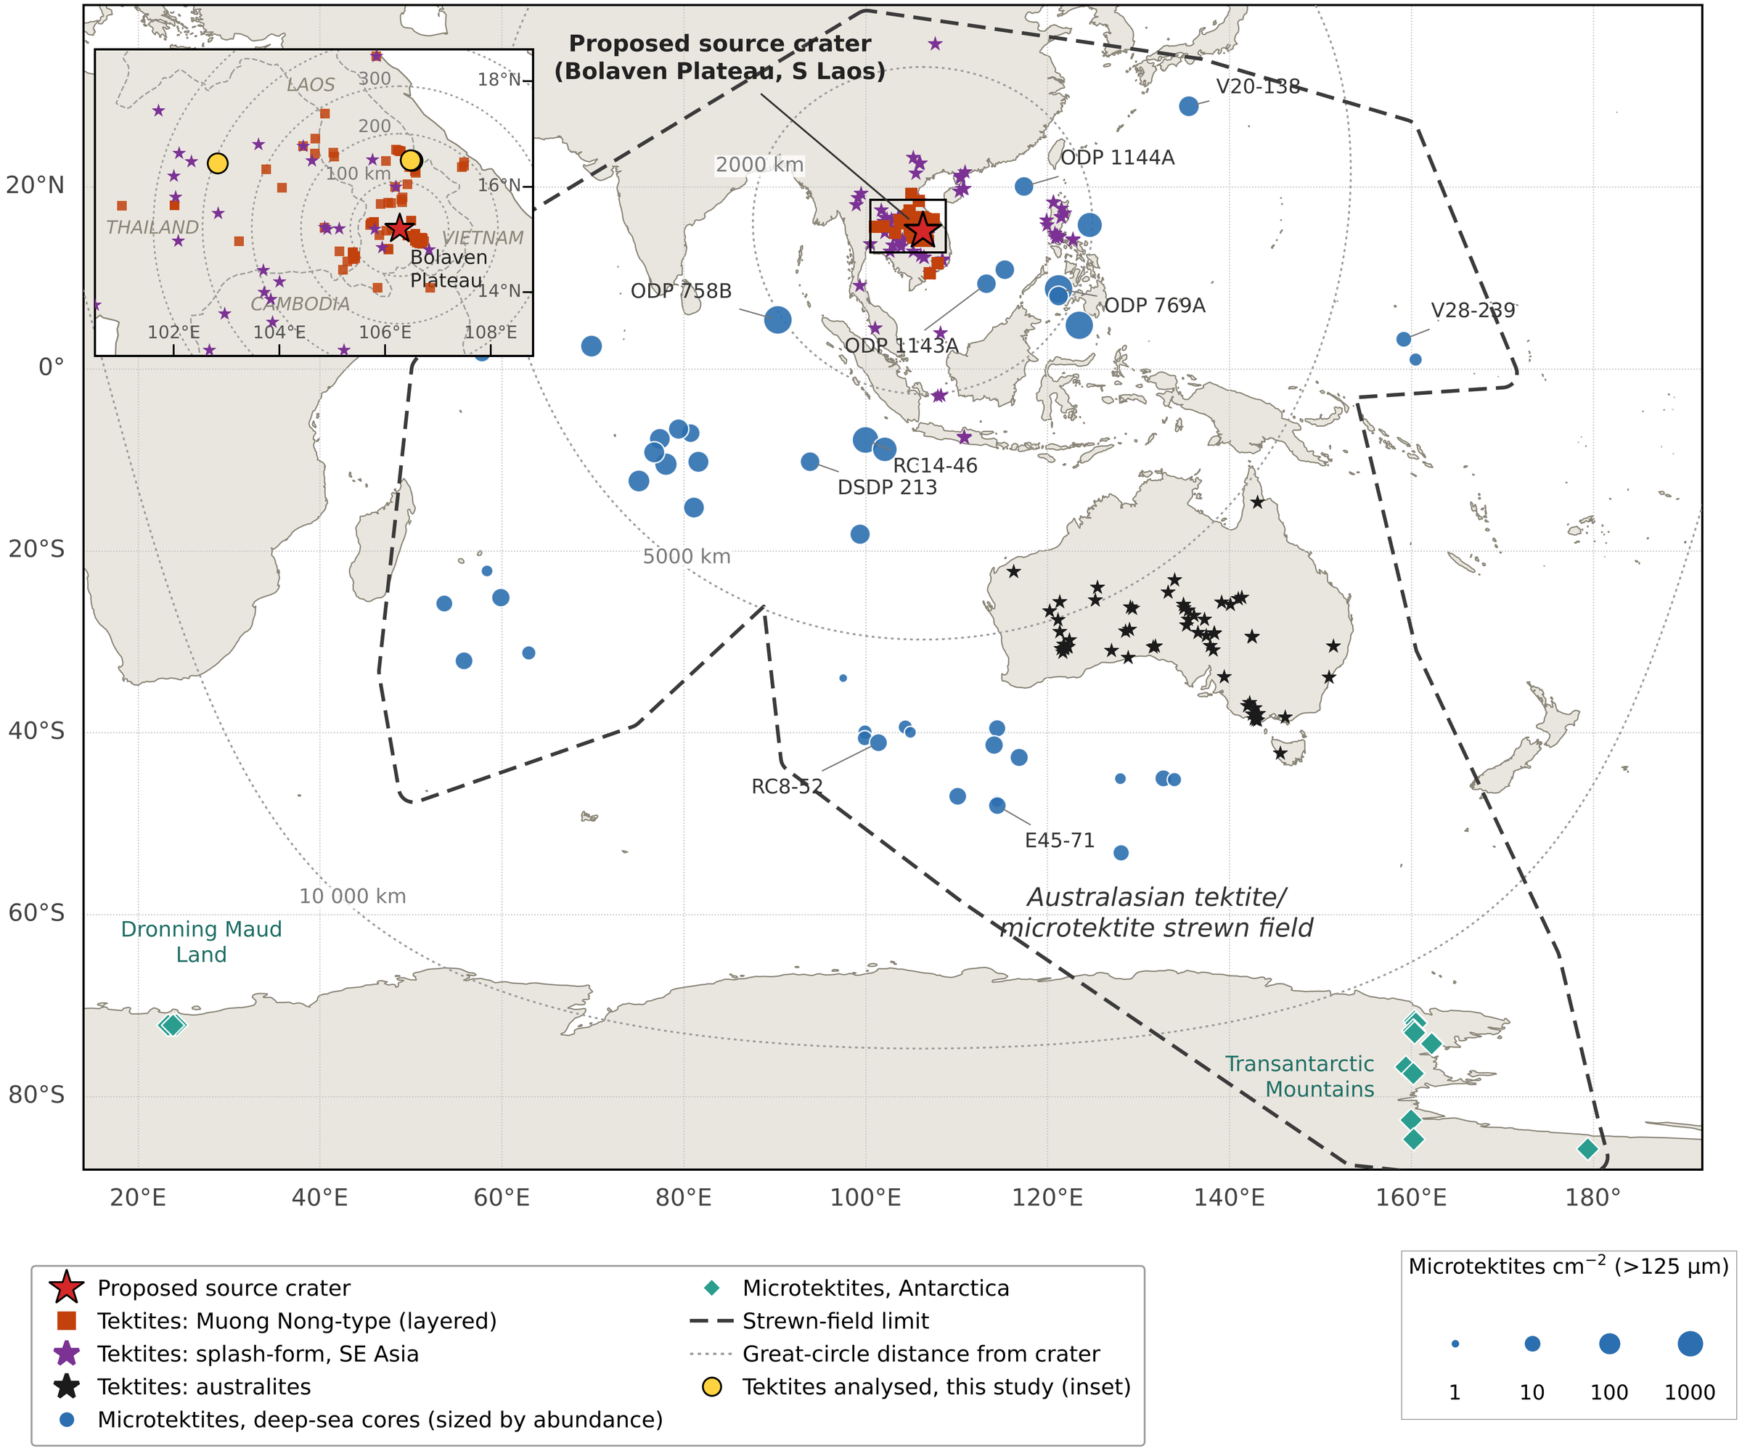
Figure 1. Distribution of the Australasian tektite/microtektite strewn field (redrawn and updated after Folco et al., 2010, fig. 1). Red star: proposed source crater beneath the Bolaven Plateau, southern Laos (15.20°N, 106.27°E; Sieh et al., 2020). Tektites are shown by type: Muong Nong-type (layered) tektites (orange squares), splash-form tektites from SE Asia — indochinites, philippinites, javanites, billitonites and S China finds (purple stars) — and australites (black stars). Deep-sea microtektite cores (blue circles) are scaled by microtektite abundance (>125 µm per cm²; Glass, 1994; Folco et al., 2010); Antarctic microtektite sites (green diamonds) are from the Transantarctic Mountains (Folco et al., 2009, 2010, 2016; Brase et al., 2021; Chernonozhkin et al., 2021) and Dronning Maud Land (Soens et al., 2021). Dashed line: strewn-field limit; dotted lines: great-circle distance from the proposed crater. Inset: tektite localities in southern Laos and neighbouring Thailand, Vietnam and Cambodia, with the tektites analysed in this study (yellow circles); rings at 100 km intervals from the crater. Tektite localities are compiled from published geochemical datasets (Lacroix, 1935; Baker, 1956; Barnes, 1962, 1964; Taylor, 1962; Cassidy et al., 1969; Chapman & Scheiber, 1969; Chapman, 1971; Chalmers et al., 1976; Blum et al., 1992; Koeberl, 1992; Fiske et al., 1996; Son & Koeberl, 2005; Amare & Koeberl, 2006; Mizera et al., 2016; Žák et al., 2019; Tada et al., 2020) and Sieh et al. (2020, Dataset S1).
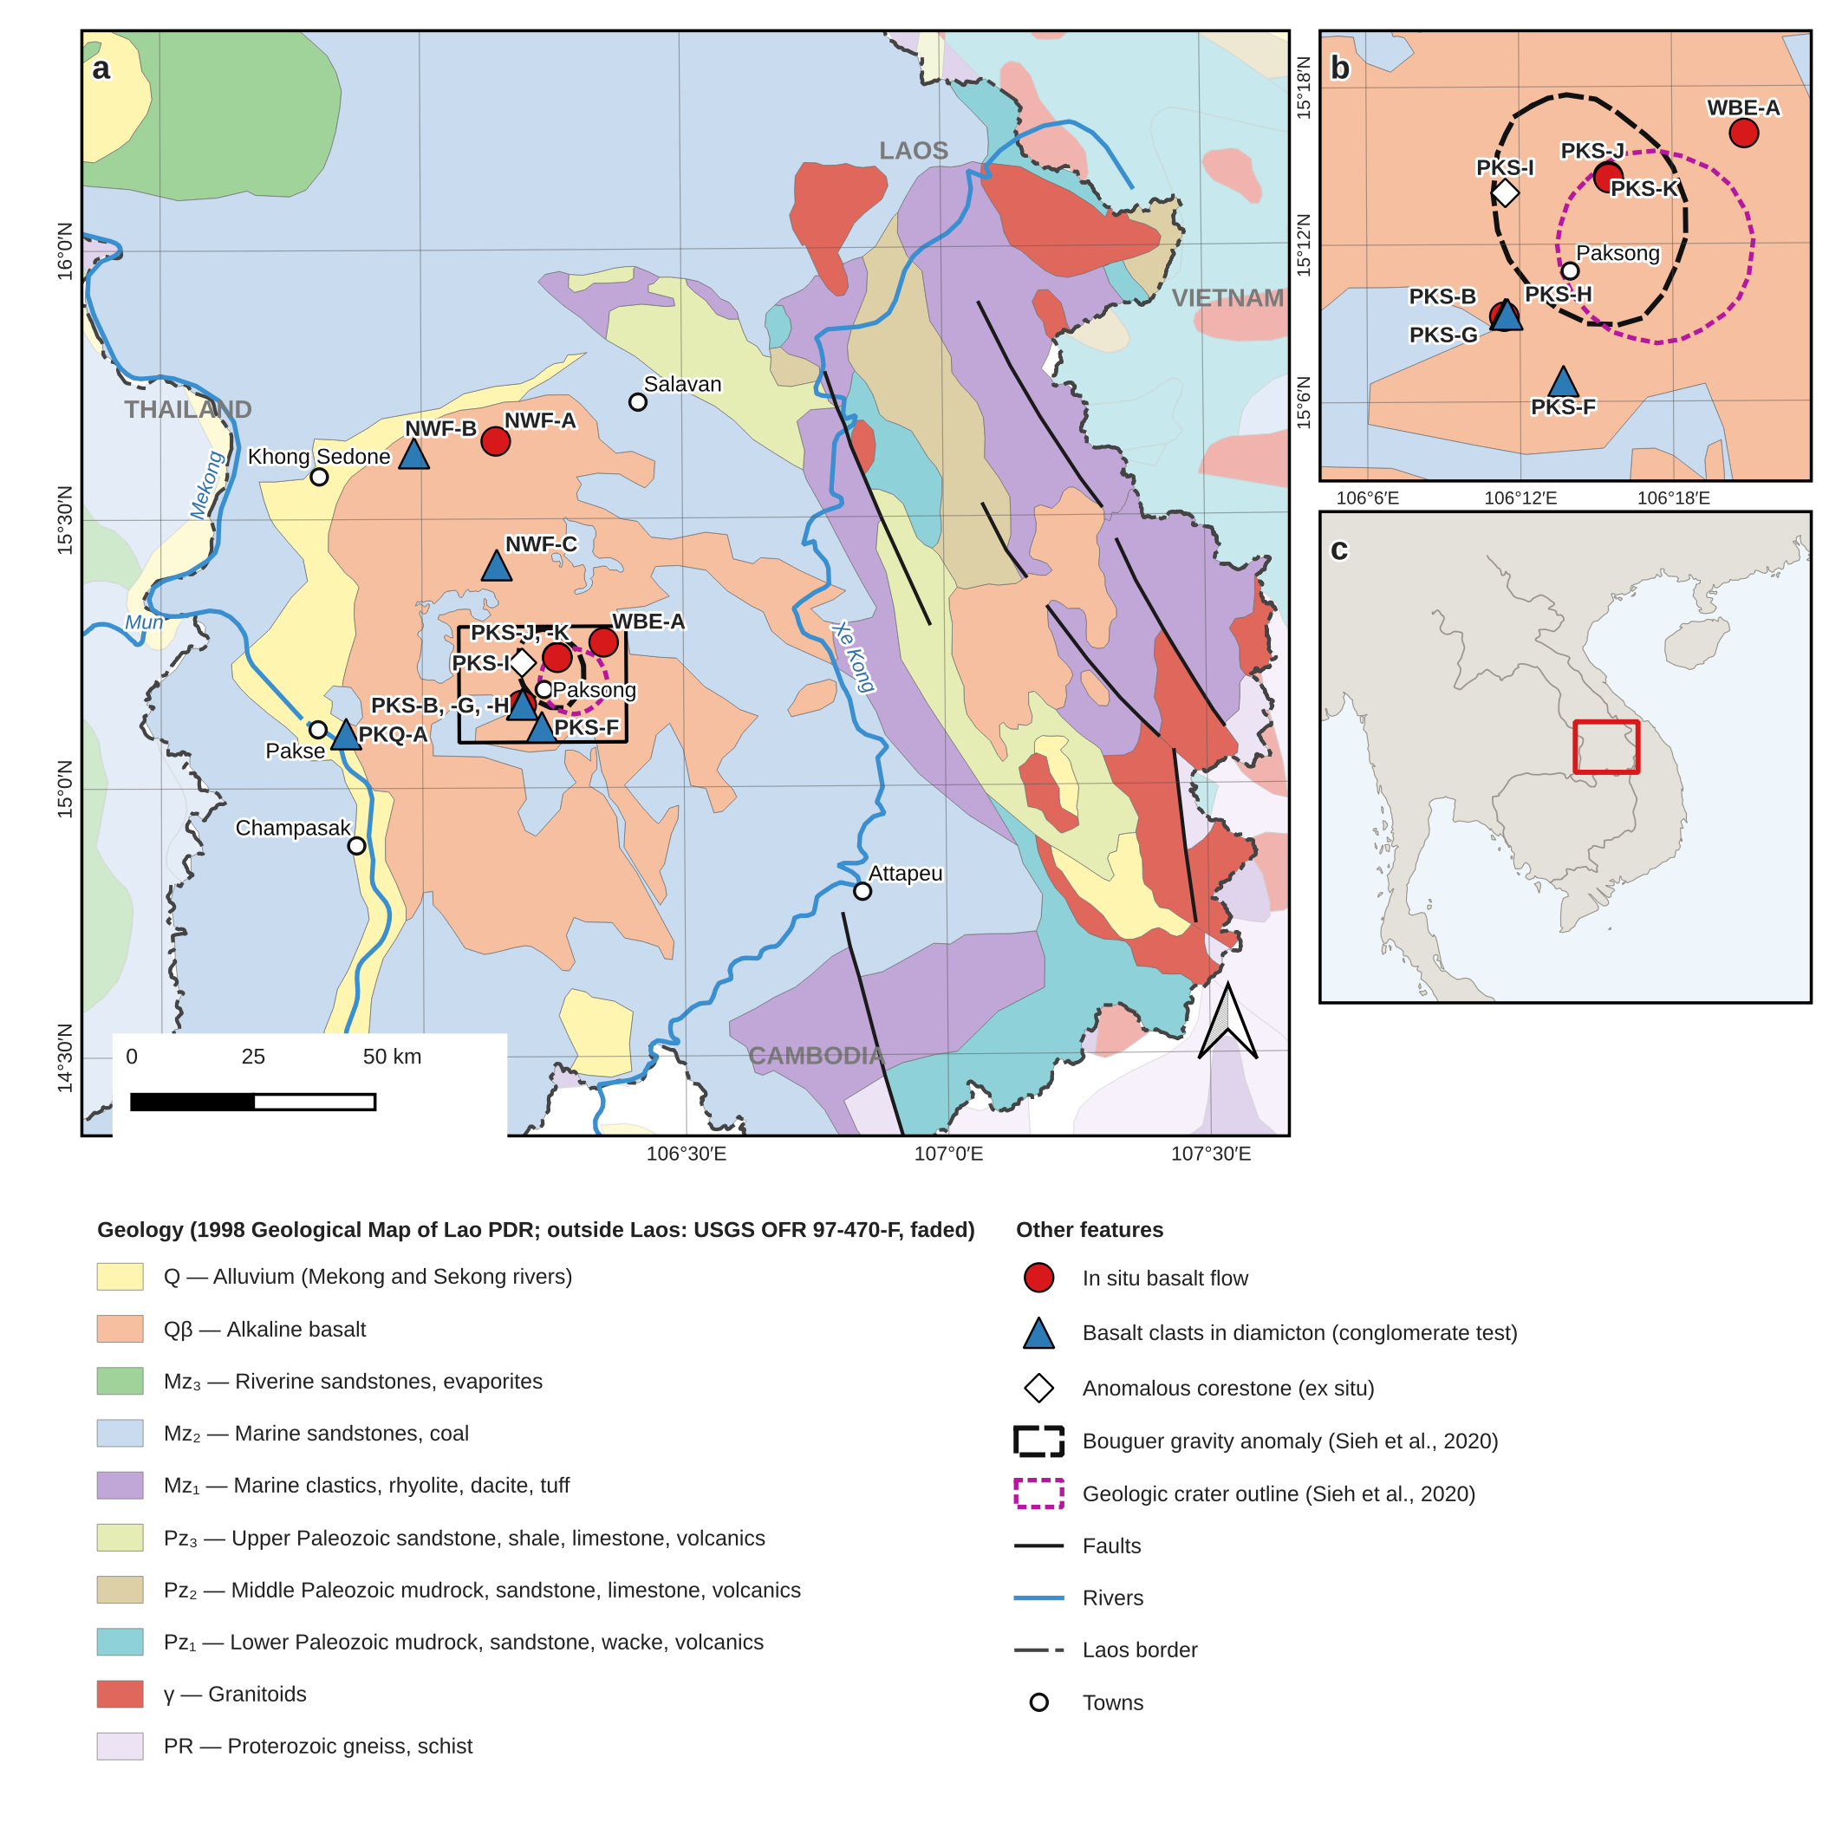
Figure 2. (a) Geologic map of southern Laos and the Bolaven Plateau showing the paleomagnetic sites of this study: in situ basalt flows (red circles), basalt clasts in diamicton sampled for conglomerate tests (blue triangles), and the anomalous corestone locality PKS-I (white diamond). Geology within Laos from the 1998 Geological Map of Lao PDR (digitised for this study); geology of neighbouring Thailand, Cambodia and Vietnam (faded) generalised from the USGS Geology of Southeast Asia (Steinshouer et al., 1999, OFR 97-470-F, after UNESCO/CGMW, 1990) and reclassified to the Lao map units. Dashed black outline: Bouguer gravity anomaly; dotted magenta outline: geologic crater outline of the proposed source crater (Sieh et al., 2020). Box shows the area of (b). (b) Enlargement of the central Bolaven Plateau sites; PKS-B, -G and -H lie within ~200 m of one another. (c) Location of (a) in mainland Southeast Asia.

Geological Setting
The Bolaven Plateau rises ~1 km above the surrounding lowlands of southern Laos, east of the Mekong River (Fig. 2). It is underlain by nearly flat-lying Jurassic–Cretaceous Khorat Group red beds, at least 500 m thick: an upper 200–250 m of massive to cross-bedded quartz-rich fluvial sandstone over ~250 m of friable mudstone and siltstone (Fig. 3b). These two lithologies – a mature quartz arenite and an illite/kaolinite-rich mudrock – are the compositional poles from which any Bolaven-sourced tektite must be built, and their laterally uniform blanket geometry means ejecta or melt from anywhere in the Khorat Basin would inherit a similar bulk composition (Sieh et al., 2020). Prolonged tropical weathering has converted the exposed Mesozoic and basaltic surfaces alike to laterite, bauxite and saprolite, strongly leached of Ca, Na and other mobile elements (Sanematsu et al., 2011).
A basaltic volcanic field of ~5,000 km² and ~910 km³ caps the plateau, reaching 300 m thickness in the summit region – sufficient to hide a crater up to 15 km in diameter. ⁴⁰Ar/³⁹Ar ages span ~16 Ma to 27 ka, with eruptions before and after the 790 ka impact; flows directly above the proposed crater centre are all younger than 790 ka, supporting burial (Sieh et al., 2020). The field is a typical intraplate assemblage of scattered scoria cones and fissure-fed flows with no large central volcano, making a buried caldera unlikely (Valentine & Gregg, 2008).
The candidate impact deposits are the youngest element: an unsorted, matrix-supported polymict breccia exposed 10–20 km southeast of the proposed centre, with stratigraphic inversion, jigsaw-fit clasts and quartz grains carrying planar deformation features, overlain by a massive sandy silt ("catastro-loess") containing tektite fragments (Sieh et al., 2024) (Fig. 3c). Mizera (2022) interprets the same deposits as fluvial and aeolian. The boulder-bearing diamicton that hosts our conglomerate-test sites belongs to this contested unit.
The impact at ~790 ka barely predates the B–M reversal, whose directional midpoint is at 773 ± 3 ka but whose full process – dipole collapse below ~5 ZAm², precursory transitional episodes, completion at ~773–768 ka – spans roughly 800–770 ka (Singer et al., 2019; Mahgoub et al., 2023, 2024); new ¹⁰Be records independently anchor the boundary at 773 ± 3 ka (Tang et al., 2025). The impact therefore fell within the reversal’s transitional interval, so pre-impact flows should be reversed, immediately post-impact flows could record transitional directions, and any impact-reset magnetization would have recorded a weak, unstable field.
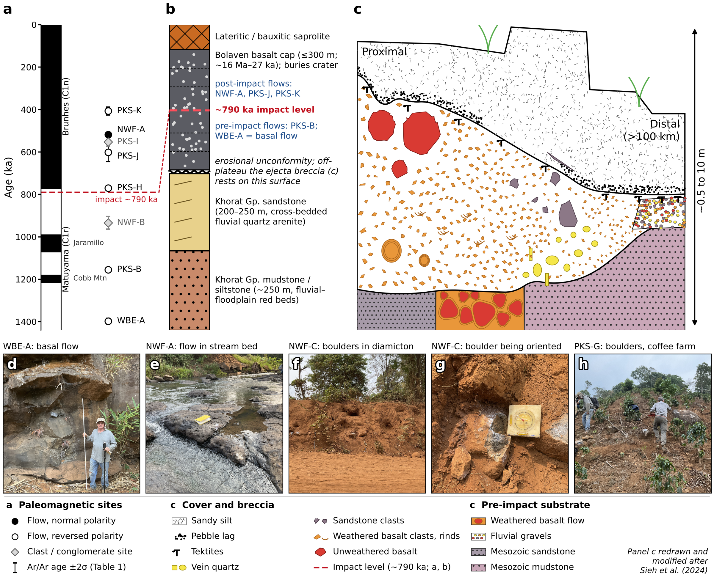
Figure 3. Stratigraphic framework of the Bolaven impact test. (a) Paleomagnetic sites of this study plotted at their ⁴⁰Ar/³⁹Ar ages (±2σ; Table 1) against the geomagnetic polarity time scale (GPTS 2020; Ogg, 2020). Filled and open circles are in situ flows of normal and reversed measured polarity; the record begins at WBE-A, the lowest basalt flow. Grey diamonds are clast/conglomerate sites (PKS-I, NWF-B), whose remanence does not record the field at the dated eruption. Red dashed line: the Australasian impact at ~790 ka, just before the Matuyama–Brunhes reversal. (b) Schematic composite stratigraphy of the impact target and its cover (thicknesses not to scale): Khorat Group fluvial–floodplain mudstone/siltstone and cross-bedded quartz sandstone, an erosional unconformity, and the Bolaven basalt cap (≤300 m; ~16 Ma–27 ka) weathered at the top to lateritic/bauxitic saprolite. The ~790 ka impact level separates pre-impact flows (PKS-B and the basal flow WBE-A) from post-impact flows (NWF-A, PKS-J, PKS-K) that bury the crater; off the plateau the ejecta breccia rests on the pre-impact surface. (c) Composite sketch of the proximal-to-distal ejecta breccia and overlying sandy silt (vertical extent ~0.5–10 m), redrawn and modified after Sieh et al. (2024). The breccia rests on pre-impact substrate (Mesozoic sandstone and mudstone, weathered basalt flows, fluvial gravels), fines upward and with distance from the proposed crater, carries unweathered basalt and sandstone boulders near its top proximally and vein-quartz clasts near its base distally, and has tektites at and just below its upper contact beneath a pebble lag and the sandy silt; no single exposure shows all of these features. (d–h) Field photographs from the March 2024 sampling campaign: (d) WBE-A, the basal in situ flow (person for scale); (e) NWF-A, an in situ flow exposed in a stream bed (notebook for scale); (f) NWF-C, basalt boulders in the red diamicton; (g) an NWF-C boulder with the orientation plate in place before sampling; (h) PKS-G, basalt boulders on a coffee-farm hillslope.

Methods

Sampling and laboratory procedures
We collected 64 oriented drill cores and block samples (364 specimens) from 12 basalt localities across the Bolaven Plateau in March 2024 (Fig. 2; Tables 1, S1): six interpreted in-situ flows for magnetostratigraphy and six boulder populations in diamicton for conglomerate testing. Orientations used sun compass where possible, with magnetic-declination corrections otherwise. Block samples were re-oriented in the laboratory and cored; all specimens were measured on a 2G Enterprises three-axis SQUID magnetometer in the magnetically shielded room at Caltech. Specimens underwent progressive thermal demagnetization, typically in 30°C steps, with alternating-field demagnetization of pilot specimens; full protocols are given in Supporting Information Text S2.

Paleomagnetic analysis
Characteristic remanent magnetizations (ChRM) were fit by principal component analysis (Kirschvink, 1980) with MAD ≤ 15°; free-line fits were additionally required to trend toward the origin (deviation angle ≤ 15°). Because fine-grained maghemite breaks down on heating, demagnetization could not usefully proceed beyond ~450–510 °C, and specimens that failed to isolate a stable endpoint below that ceiling were fit as remagnetization circles and combined with the lines by the method of McFadden & McElhinny (1988). Site statistics follow a specimen → oriented core → site Fisher hierarchy, and polarity is assigned from virtual geomagnetic pole (VGP) latitude rather than inclination sign, which matters for the shallow, anomalously declined directions encountered here. Conglomerate tests use the Watson (1956) randomness test on boulder-mean directions, with critical values from Monte Carlo simulation (10⁶ draws), and every verdict was double-checked with lines-plus-circles boulder means (Text S2). All analyses used PmagPy; fits and data are archived in the MagIC database (see Data Availability).

Rock magnetism and electron microscopy
Hysteresis loops, back-field curves and first-order reversal curves (FORCs) were measured on paired fresh-interior and weathered-rind chips with a Princeton Measurements vibrating sample magnetometer at the University of Tokyo, and low-temperature remanence cycling on a Quantum Design MPMS (Fig. 4). Opaque phases in a fresh basalt were identified by SEM with energy-dispersive spectroscopy (Fig. 4k,l; Table S4). Petrographic screening for shock features used transmitted-light microscopy and SEM.

Tektite and target-rock geochemistry
Major elements of seven Australasian tektites from Laos and Thailand were measured by EPMA (153 spots); analyses with oxide totals below 97 wt% were rejected as compromised, following Carter et al. (2025), leaving 82 analyses on four tektites. Trace elements were measured by LA-ICP-MS on two tektites; absolute concentrations are accurate to no better than ±30%, so interpretation relies on calibration-insensitive ratios (Th/Sc, Eu/Eu*, rare-earth pattern shape). Candidate target rocks (Khorat sandstone and mudstone, basalt, saprolite, diamicton) were analysed by XRF and ICP-MS and combined with the regional compilation of Sieh et al. (2020), screened and divided into tholeiitic and alkaline basalt suites (Macdonald & Katsura, 1964). Tektite source lithologies were inferred with a re-implementation of the reversible-jump Bayesian unmixing model of Carter et al. (2025); instrument details, priors and sensitivity runs are given in Text S2 and S4.

Results

Rock magnetism and magnetic mineralogy
Paired fresh–weathered measurements show a single coherent story (Fig. 4): the carrier is fine-grained, low-coercivity titanomagnetite (SEM/EDS: FeO 63–74 wt%, TiO₂ 16–22 wt%; Fig. 4k,l; Table S4) progressively oxidized to (titano)maghemite in lateritic rinds. Hysteresis loops close by ~300 mT with no high-coercivity phase; all specimens plot in the pseudo-single-domain (PSD) field of the Day plot, and every one of seven fresh→weathered pairs shifts the same way, weathering lowering the squareness ratio (mean Mᵣ/Mₛ 0.29 → 0.23) independent of site type or eruption age (553–1155 ka). Low-temperature remanence of the most weathered clast shows no Verwey transition, confirming oxidation of primary magnetite. FORC diagrams show a weakly-interacting central ridge at 10–17 mT in both states; the anomalous corestone PKS-I is the exception, with a multidomain-like fresh interior (≤5 mT) and a ~15 mT weathered rind. Thermal demagnetization loses most remanence by ~450 °C even under nitrogen, consistent with fine-grained maghemite inversion (Dunlop & Özdemir, 1997); this sets the demagnetization ceiling used throughout. Critically, no shock-related phases – anomalous coercivities, strong interactions, or exotic oxide compositions – are present in any sample. Weathering, not impact processing, controls the magnetic mineralogy; per-site details are given in Text S3.
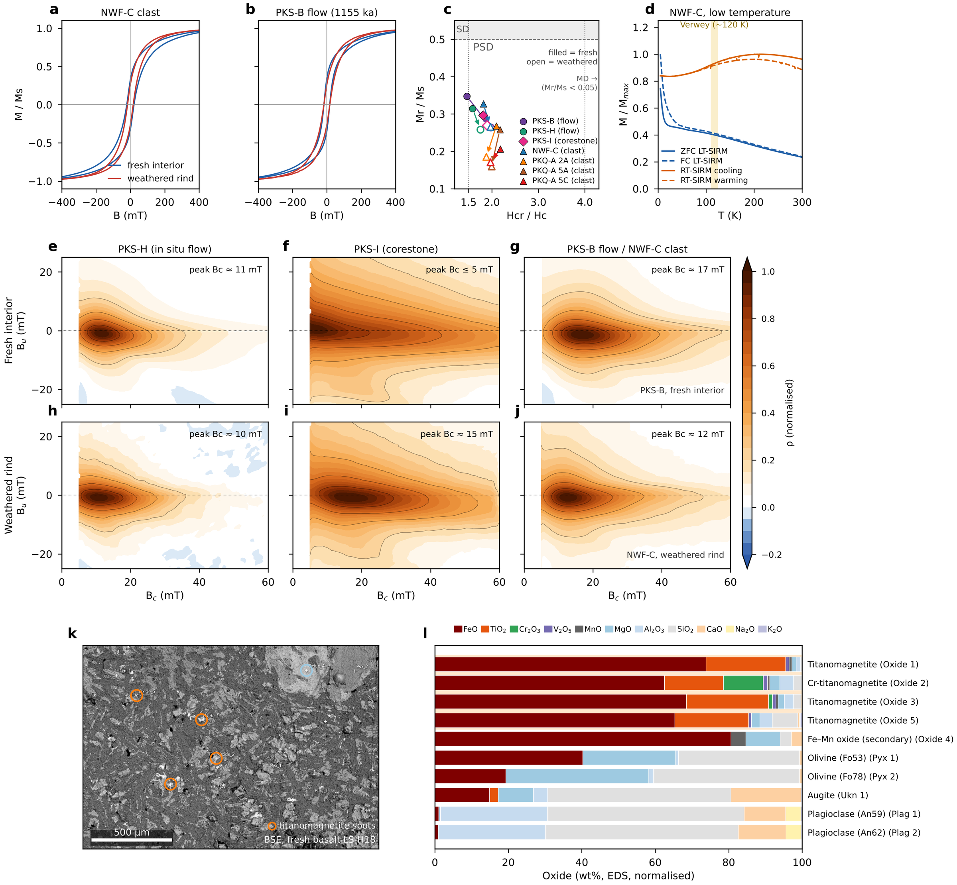
Figure 4. Rock magnetism of Bolaven basalts. (a, b) Hysteresis loops (high-field paramagnetic slope removed, normalised to Ms) of paired fresh-interior (blue) and weathered-rind (red) chips from the ejecta clast NWF-C and the in situ flow PKS-B (1155 ka). Loops close by ~300 mT and are narrow and steep through the origin, indicating a low-coercivity, magnetite-family assemblage with no hematite-like contribution; the weathered rinds have lower squareness. (c) Day plot (Day et al., 1977; Dunlop, 2002) of seven fresh (filled) → weathered (open) pairs from in situ flows (circles), the PKS-I corestone (diamond) and diamicton clasts (triangles). All specimens lie in the pseudo-single-domain field, and every pair shifts in the same sense: weathering lowers Mr/Ms (mean 0.29 fresh vs 0.23 weathered) toward more multidomain-like behaviour, independent of site type or eruption age. (d) Low-temperature (MPMS) remanence of NWF-C: zero-field-cooled and field-cooled low-temperature SIRM on warming (blue) and room-temperature SIRM on cooling and warming (orange), each normalised to its maximum. No Verwey transition is resolved near 120 K (shaded), consistent with oxidation of primary magnetite toward maghemite; the steep rise below ~30 K reflects ultrafine, near-superparamagnetic grains. (e–j) FORC diagrams (local-polynomial fit, smoothing factor 5; 10 for the finer-step PKS-B measurement) of fresh interiors (e–g) and weathered rinds (h–j). All show a central ridge along Bu = 0 with limited vertical spread (weakly interacting PSD/SD-like magnetite) and no high-coercivity or strongly interacting component. Ridge coercivities (≈10–17 mT) match bulk Hc; the fresh PKS-I interior is the exception, with a broad, low-coercivity distribution peaking at ≤5 mT (MD-like) compared with ~15 mT in its weathered rind. White strip at low Bc: region excluded where the smoothing window extends beyond the measured data. (k) Back-scattered-electron image of fresh basalt LS-H18 (Area 1) with the ten EDS spots; orange rings mark the titanomagnetite grains (the pale grain at upper right hosts the secondary Fe–Mn oxide). (l) EDS compositions of all ten spots (wt%, normalised to 100 %, all Fe as FeO). The four titanomagnetite grains (one Cr-rich) consist of 79–96 wt% FeO + TiO₂ and are the only Fe–Ti oxides, identifying titanomagnetite as the primary remanence carrier; the silicates (olivine Fo53–78, augite, labradorite An59–62) and a secondary Fe–Mn oxide make up the rest of the assemblage. No shock, high-pressure or metallic phases were found.

Tektite geochemistry
Only 82 of 153 EPMA analyses, on four tektites, have oxide totals ≥ 97 wt% (Fig. 5a); the accepted analyses lie within the published Indochinite field on every Harker diagram, and the two tektites with LA-ICP-MS data reproduce the regional trace-element signature (Th/Sc = 1.14 and 1.20, Eu/Eu* = 0.69 and 0.66). Reversible-jump unmixing of the accepted analyses (Fig. 5i–m) constrains the type of parent material even though the number of components is unconstrained: a quartz-rich sand classified as Khorat sandstone (36 ± 15%) is required; the deeply weathered lithologies that now cover the plateau (saprolite, laterite, the diamicton itself) are not used; and the balance must be a fine-grained aluminous sediment carrying ~1.5–2 wt% each of CaO and Na₂O – which no sampled Khorat rock supplies, because all are intensely leached (median CaO ≤ 0.04 wt%). The model assigns that component to unweathered-shale (27 ± 23%) and metatuff (10 ± 6%) proxies for unleached fine-grained material, i.e., the tektite parent was much less weathered than anything now exposed.
Basalt is permitted but not demanded: 4.8 ± 5.4% in the main run – with an unconstrained "random" component taking 18 ± 13%, itself a sign that the dictionary lacks an adequate parent – rising to 19 ± 9% and becoming required only when the model is denied that component. Trace-element ratios cap the basaltic contribution independently – ~10% tholeiite or ~20% alkali basalt brings Th/Sc down to the tektite value, and more alkali basalt pushes Eu/Eu* out of range – while absolute Zr and Th are under-predicted by the posterior mixtures, mirroring the major-element result that the sampled endmembers are inadequate. Iridium is below the ~4 ppb detection limit, two orders of magnitude above the ≤0.005% chondritic component indicated by Os isotopes (Ackerman et al., 2019), and the apparent Pd signal is an ⁸⁹Y¹⁶O⁺ interference (Fig. S4), so no projectile test is possible with these data. The mild Ni–Cr–Co enrichment of the tektites is matched by weathered basalt and carries no meteoritic fingerprint. None of these results discriminates the Bolaven location from any other Indochinese source with similar sedimentary cover; details, data-quality figures and sensitivity runs are given in Fig. 5m, Fig. S1 and Table S5.
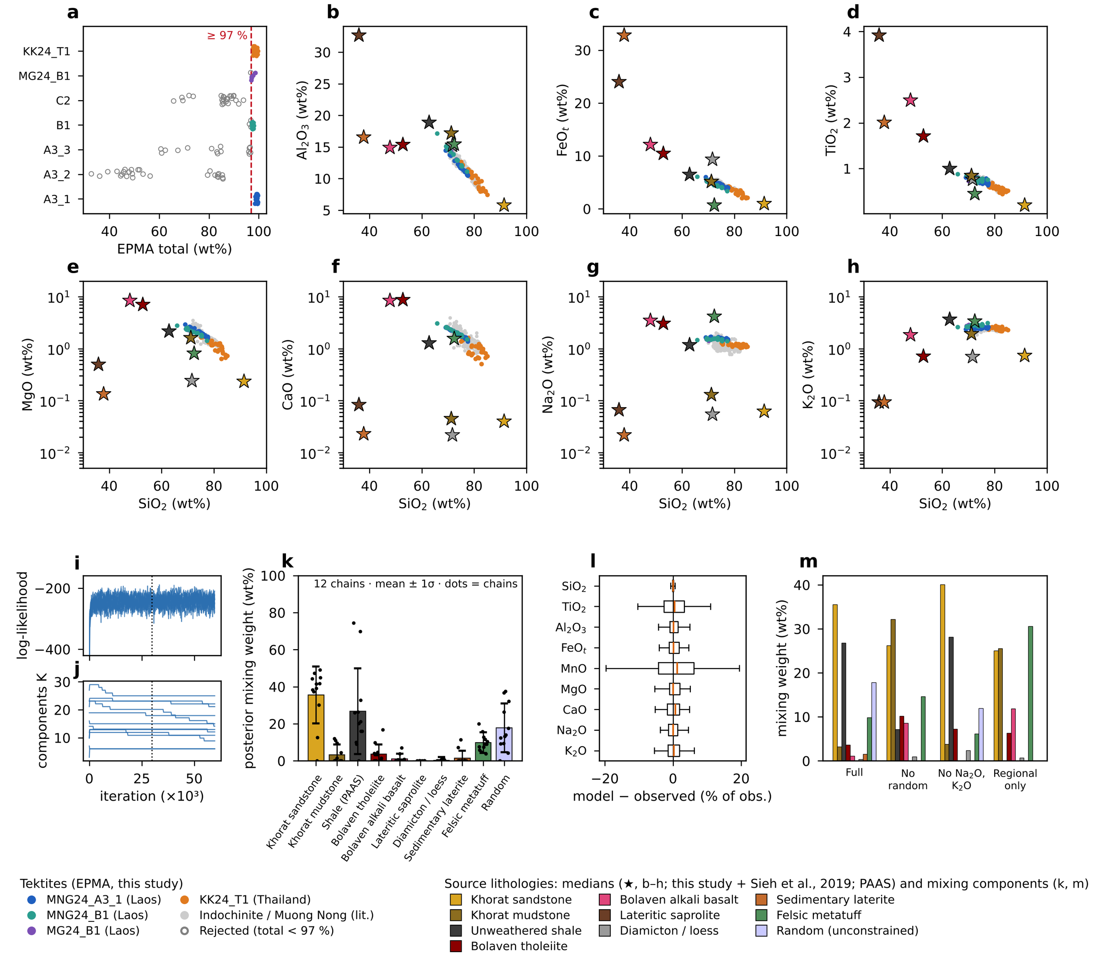
Figure 5. Major-element composition of Laos and Thailand tektites and reversible-jump MCMC unmixing of their source (after Carter et al., 2025). (a) EPMA analytical totals per tektite; analyses below 97 wt% (open grey) are rejected, leaving 82 accepted analyses on four tektites. (b–h) Anhydrous Harker diagrams of the accepted analyses (MgO, CaO, Na₂O and K₂O on log scales, to show how strongly the regional sediments and regolith are leached), compared with published Indochinite and Muong Nong tektites (grey; n = 262) and with the median compositions of the candidate source lithologies (stars): this study and the compilation of Sieh et al. (2020), with the Bolaven basalts divided into tholeiite and alkali basalt and the metatuff restricted to felsic samples, and unweathered post-Archean shale (PAAS; Taylor & McLennan, 1985). (i) Log-likelihood and (j) number of components K for the 12 chains of the full model (6 × 10⁴ iterations; dotted line = end of burn-in); all chains fit equally well with very different K. (k) Posterior mixing weights by lithology type (mean ± 1σ, combining within- and between-chain variance; dots are chain means). (l) Posterior-predictive residuals (model − observed, % of observed) for each oxide. (m) Mean mixing weights in the full model and the three sensitivity runs: no random component; Na₂O and K₂O excluded; and regional lithologies only (no PAAS or random component). The weights of all runs are listed in Table S5.

Polarity of dated flows and magnetostratigraphy
Six localities of interpreted in-situ flows with ⁴⁰Ar/³⁹Ar ages (Sieh et al., 2020), plus the two-horizon locality PKS-H, were tested against the geomagnetic polarity timescale (Fig. 3a; Tables 1, 2). An updated age of 1155 ± 2 ka for the PKS-B flow (sample PKS24-BA-1; K. Sieh, written communication, 2026) supersedes the preliminary 906 ± 12 ka assignment and places that flow in the C1r.2r reversed subchron.
Three flows match expectation. NWF-A (518 ± 6 ka) is normal (five cores: dec = 11.8°, inc = +23.7°, k = 43, VGP +78°), consistent with its Brunhes age (Fig. 6a). PKS-B (1155 ka) and WBE-A (1397 ± 13 ka) are reversed with near-dipole directions (190.6°/−10.6° and 168.1°/−34.5°; VGPs −76° and −78°), consistent with their Matuyama ages (Fig. 6c,d) and anchoring the pre-impact stratigraphy.
Two flows contradict their ages. PKS-J (601 ± 44 ka) and PKS-K (407 ± 18 ka) both carry well-defined reversed magnetizations (174.9°/−31.9°, k = 244; 195.1°/−33.2°) despite Brunhes-age assignments that predict normal polarity (Fig. 6b). The tight, near-dipole reversed directions argue against remagnetization; the flows are most simply older than 773 ka – kipukas of older lava within younger fields, or mis-assigned dates – and both are being resampled for redating. PKS-I (553 ± 20 ka) is a lone roadside corestone with a tightly clustered direction (47.9°/−35.6°, k = 330) ~49° from any dipole direction and a VGP latitude of +31°: a rotated, displaced block that cannot test its assigned age.
PKS-H, interpreted by Sieh et al. (2020) as an in-situ flow at the B–M boundary (770.5 ± 9.3 ka), resolves into two units. The upper horizon (HA) yields two internally tight cores (k = 96 and 157) whose means diverge by 64° (Fig. 6e,f): it cannot be an intact cooling unit. The lower boulder horizon (HB) is coherent (209.6°/+7.9°, k = 549) and demagnetizes univectorially (Fig. 6g). Assigned by VGP latitude, all three cores are reversed (−53°, −65°, −55°) – HA2’s positive inclination is offset by its SSW declination – yet all sit 34–46° from the reversed dipole, and HA2 and HB1 lie within 15° of each other. The units either record the anomalous transitional field of the latest Matuyama, consistent with the impact falling inside the reversal’s transitional window (Mahgoub et al., 2024), or share a common post-emplacement rotation; one core per boulder cannot separate these. Either way, HA’s internal discordance means no in-situ B–M boundary is confirmed at this locality; the boulders are being redated.
In sum, the magnetostratigraphy anchors the framework at three flows but contradicts it at two, reclassifies one site as a clast and one as disturbed (Figs. 6i, 7a,b). The ⁴⁰Ar/³⁹Ar chronology that underpins the burial argument is therefore more complex than previously assumed, and its revision is prerequisite to tying the volcanic stratigraphy to the impact.
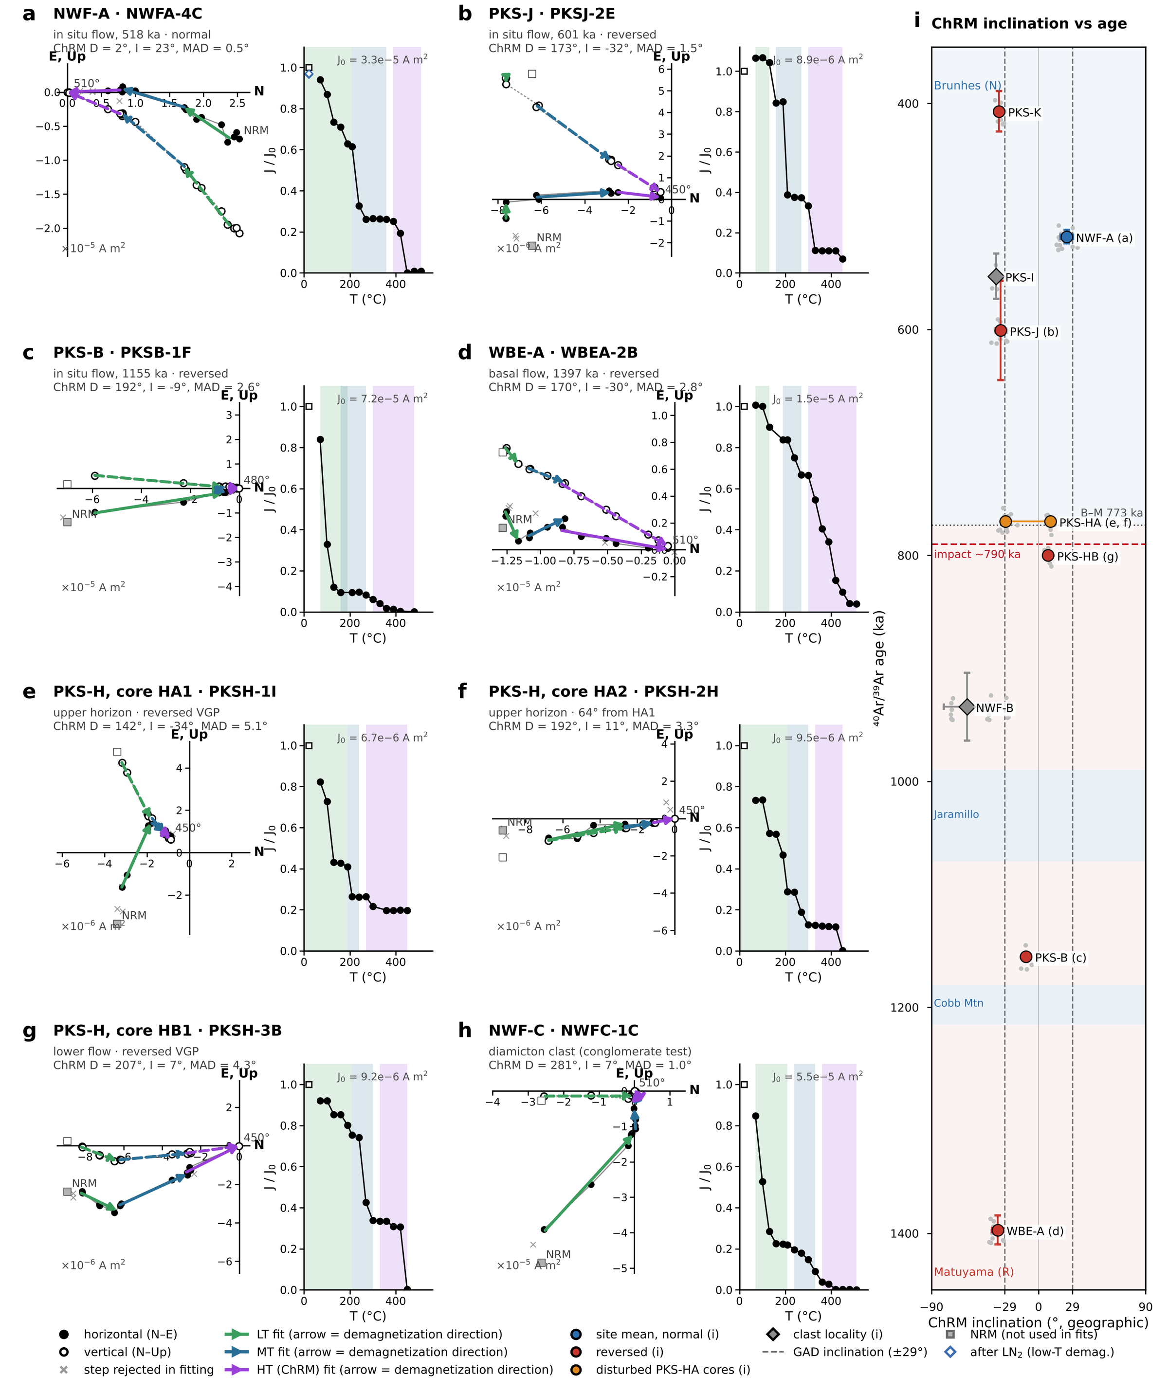
Figure 6. Representative thermal demagnetization of Bolaven basalts in geographic coordinates. For each specimen, left: orthogonal-vector (Zijderveld) diagram with the horizontal-plane projection (N vs E; filled symbols) and vertical-plane projection (N vs Up; open symbols); right: remanence intensity normalised to the NRM (J/J₀) against demagnetization temperature. Least-squares line fits (principal component analysis; Kirschvink, 1980) to the low-temperature (LT, ~70–190 °C, green), mid-temperature (MT, ~210–300 °C, blue) and high-temperature (HT, ~330–510 °C, purple) components are drawn as arrows pointing in the direction of demagnetization; the HT component, which trends to the origin, is taken as the characteristic remanent magnetization (ChRM). Shaded bands on the intensity plots mark the temperature range of each fitted component. Specimen ChRM directions and maximum angular deviations (MAD) are listed above each panel. (a) NWF-A, normal-polarity in situ flow (518 ka); (b) PKS-J, a well-defined reversed direction at a site dated to the Brunhes (601 ka); (c) PKS-B (1155 ka) and (d) WBE-A (1397 ka, the basal flow), reversed in situ flows; (e, f) cores HA1 and HA2 from the upper horizon at PKS-H, 64° apart; (g) core HB1 from the lower PKS-H flow; (h) an NWF-C diamicton clast. (i) Site-mean ChRM inclination (geographic) against ⁴⁰Ar/³⁹Ar age (Table 1), with polarity intervals of the GPTS (blue normal, red reversed; Brunhes–Matuyama boundary dotted at 773 ka) and the ~790 ka impact (red dashed). Large symbols are core-level site means (Table 2), coloured by VGP polarity (blue normal, red reversed; orange the two discordant PKS-HA cores; grey diamonds the clast localities PKS-I and NWF-B); grey dots are individual specimen ChRMs, horizontal bars ±1σ of the specimen inclinations and vertical bars the 2σ age uncertainty. Dashed vertical lines mark the geocentric axial dipole inclination (±29°) at the site latitude. Letters in brackets link sites to panels a–h. Reversed flows dated to the Brunhes (PKS-K, PKS-J) are the polarity mismatches of Table 1. Most specimens lose the bulk of their remanence by ~450 °C and reach the origin by 480–510 °C, consistent with a fine-grained (titano)maghemite carrier (Fig. 4).
Table 1. Comparison of ⁴⁰Ar/³⁹Ar ages (Sieh et al., 2020; PKS-B and PKS-H updated, K. Sieh, written communication, 2026) with measured paleomagnetic polarity for the dated Bolaven sites, in order of age. Expected chron and polarity are those spanned by the age ± 2σ on the GPTS 2020 (Ogg, 2020; Brunhes–Matuyama boundary 773 ka; Jaramillo 990–1071 ka; Cobb Mountain 1180–1215 ka). Measured polarity is assigned from the latitude of the site-mean virtual geomagnetic pole (VGP; Table 2), not from the sign of inclination. Coordinates are means of the 2024 GPS waypoints (WGS84). Shaded rows are polarity mismatches.
Site | Sample (Sieh et al.) | Lat (°N) | Lon (°E) | Setting | ⁴⁰Ar/³⁹Ar age (ka ± 2σ) | Expected chron (GPTS 2020) | Exp. polarity | VGP lat (°) | Measured polarity | Age–polarity agreement
PKS-K | PKS24-K | 15.242 | 106.258 | In-situ flow | 407 ± 18 | C1n | N | −75.3 | R | Mismatch
NWF-A | NWF24-A | 15.645 | 106.143 | In-situ flow | 518 ± 6 | C1n | N | +78.1 | N | Match
PKS-I | PKS24-I / PKS15-I | 15.233 | 106.191 | Corestone (ex situ) | 553 ± 20 | C1n | N | +31.3 | Indet.ᵃ | Displaced clast
PKS-J | PKS24-J | 15.243 | 106.258 | In-situ flow | 601 ± 44 | C1n | N | −84.7 | R | Mismatch
PKS-HA | PKS24-HA | 15.156 | 106.192 | Upper horizon | 770.5 ± 9.3 | C1n / C1r.1rᵇ | N or R | −52.6 / −65.3 | R, R (64° apart)ᶜ | Discordant
PKS-HB | PKS24-HB | 15.156 | 106.192 | Lower flow, 5.5 m below HA | > 770.5ᵈ | C1n / C1r.1rᵇ | N or R | −55.0 | R | Consistent if > 773 ka
NWF-B | NWF24-B | 15.624 | 105.986 | Blocks (transported) | 934 ± 30 | C1r.1r | R | +0.2 | Indet.ᵃ | Random clasts (Fig. 7o)
PKS-B | PKS24-BA-1 | 15.154 | 106.190 | In-situ flow | 1155 ± 2ᵉ | C1r.2r | R | −75.6 | R | Match
WBE-A | WBE24-A | 15.270 | 106.347 | Basal flow | 1397 ± 13 | C1r.3r | R | −78.0 | R | Match

Table 2. Sample-to-site paleomagnetic statistics for the dated Bolaven localities, computed by specimen → sample (oriented core or block) → site Fisher (1953) averaging of the high-temperature (HT, ChRM) component in geographic coordinates (no tilt correction; flows are sub-horizontal). Specimen fits are from the pmagpy re-fits (fitquest; deposited in MagIC) and are accepted where MAD ≤ 15°; n spec gives accepted/measured specimens. α95 and k are core-level statistics; for single-core sites (*) they are specimen-level. Indented italic rows give individual core means where the cores of a site disagree or are few. VGPs are computed at each site's GPS coordinates (Table 1). Polarity is from VGP latitude. Dashes denote statistics that are undefined (single core) or meaningless (α95 ≥ 90°). Shaded rows are polarity mismatches.
Site / core | Age (ka ± 2σ) | N cores (n spec acc./meas.) | Dec (°) | Inc (°) | α95 (°) | k | VGP lat (°) | VGP lon (°E) | Polarity (VGP) | Expected (GPTS) | Result
PKS-K | 407 ± 18 | 2 (9/9) | 195.1 | −33.2 | 86.6 | 10.6 | −75.3 | 2.9 | R | N | Mismatch
PKSK-1 |  | 1 (3) | 174.9 | −29.4 | 8.3 | 222.6 | −85.0
PKSK-2 |  | 1 (6) | 216.3 | −33.5 | 2.7 | 605.4 | −55.2
NWF-A | 518 ± 6 | 5 (15/15) | 11.8 | +23.7 | 11.8 | 42.9 | +78.1 | 210.5 | N | N | Match
PKS-I | 553 ± 20 | 1 (5/5) | 47.9 | −35.6 | 4.2* | 330.4* | +31.3 | 231.3 | Indet. | N | Clast
PKS-J | 601 ± 44 | 3 (12/12) | 174.9 | −31.9 | 7.9 | 244.2 | −84.7 | 219.8 | R | N | Mismatch
PKS-HA | 770.5 ± 9.3 | 2 (19/19) | 169.4 | −10.1 | – | 3.3 | −75.5 | 153.3 | R | N/R | Discordant
HA1 |  | 1 (11) | 141.2 | −28.0 | 4.7 | 96.4 | −52.6
HA2 |  | 1 (8) | 194.5 | +9.8 | 4.4 | 157.3 | −65.3
PKS-HB | > 770.5 | 1 (5/5) | 209.6 | +7.9 | 3.3* | 549.1* | −55.0 | 46.9 | R | N/R | Coherent
NWF-B | 934 ± 30 | 3 (20/20) | 75.6 | −60.2 | 84.8 | 3.2 | +0.2 | 239.1 | Indet. | R | Random (congl.)
NWFB-1 |  | 1 (7) | 120.5 | −41.5 | 2.8 | 466.3 | −33.8
NWFB-2 |  | 1 (6) | 17.8 | −26.3 | 0.9 | 6061.9 | +55.7
NWFB-3 |  | 1 (7) | 128.4 | −73.2 | 2.2 | 785.2 | −32.7
PKS-B | 1155 ± 2 | 1 (7/7) | 190.6 | −10.6 | 3.7* | 269.8* | −75.6 | 58.3 | R | R | Match
WBE-A | 1397 ± 13 | 2 (11/11) | 168.1 | −34.5 | 28.0 | 81.7 | −78.0 | 216.1 | R | R | Match
WBEA-1 |  | 1 (8) | 163.0 | −39.4 | 2.0 | 779.6 | −72.4
WBEA-2 |  | 1 (3) | 172.6 | −29.5 | 3.4 | 1285.1 | −82.9

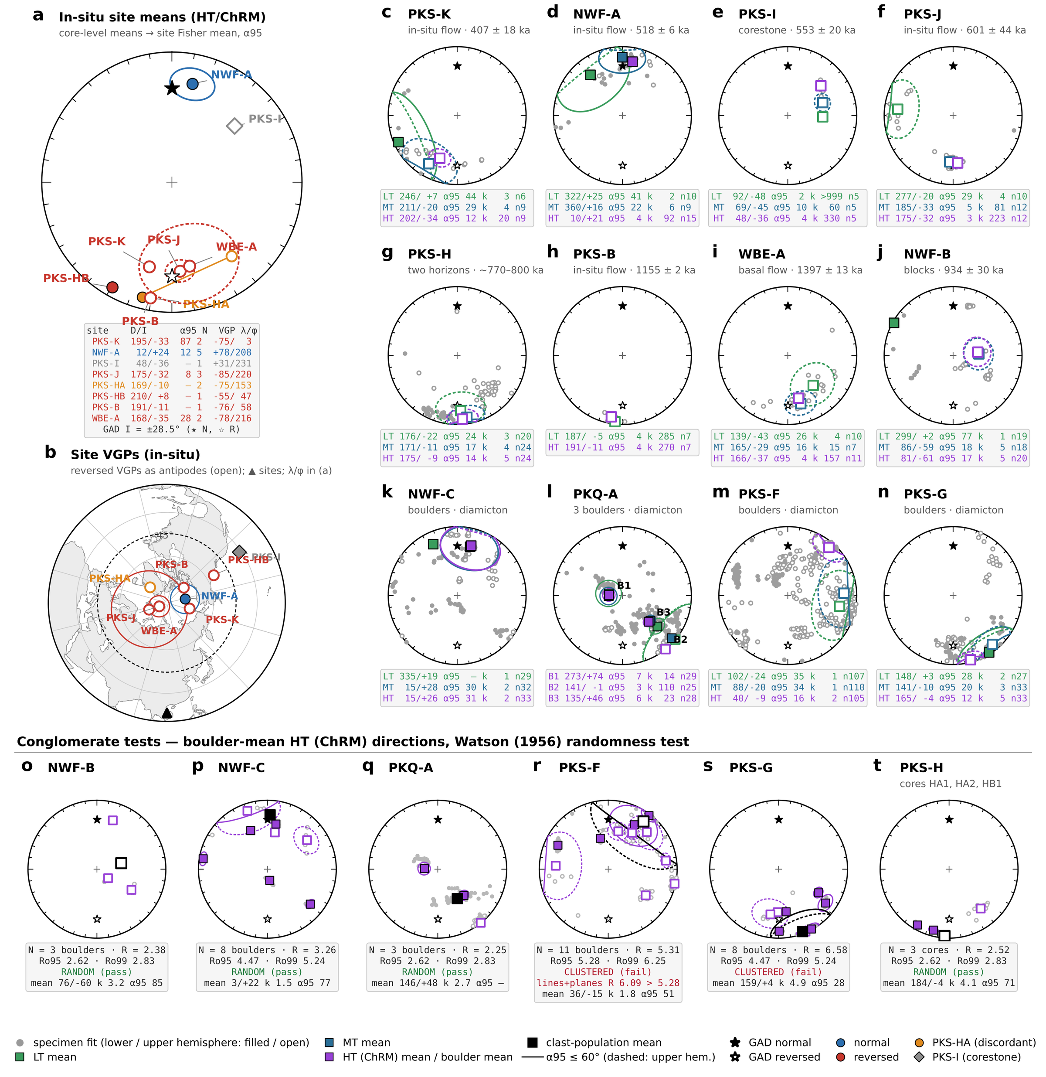
Figure 7. Equal-area projections of the component directions from all twelve Bolaven sites. Filled symbols are on the lower hemisphere and open symbols on the upper. Stars mark the geocentric axial dipole (GAD) direction at the site latitude (I = ±28.5°; filled = normal, open = reversed). (a) Site-mean ChRM (HT) directions for the in-situ flows, computed specimen → core → site (Fisher, 1953) with α95. Colours give VGP polarity: blue normal, red reversed. Orange marks the two discordant PKS-HA cores, which are plotted individually and joined. The grey diamond is the PKS-I corestone. The inset table lists each site's declination/inclination, α95, number of cores N and VGP latitude/longitude. (b) Site VGPs on a north-polar equal-area map. Reversed VGPs are plotted as their antipodes (open symbols), and A95 is drawn where α95 ≤ 60°. The dashed circle at 45° latitude separates stable-polarity from transitional VGPs. The triangle marks the sampling area. Only specimen fits with MAD ≤ 15° are used throughout. (c–n) Every site, in order of ⁴⁰Ar/³⁹Ar age and then the diamicton localities. Grey symbols are all specimen component fits. Squares are the specimen-level Fisher means of the low-temperature (LT, green), mid-temperature (MT, blue) and high-temperature (HT = ChRM, purple) components, each with its α95. Colours match Fig. 6 and the fitquest fitting interface. Each stats box gives D/I, α95, k and n for each component. PKQ-A is treated as a conglomerate of three field boulders (B1 = cores 0–4, B2 = cores 5–6, B3 = cores 7–9), so panel l shows boulder means rather than a site mean, and its stats box lists the HT mean of each boulder. (o–t) Conglomerate tests on the six boulder and diamicton localities. Purple squares are boulder-mean HT directions, each with its α95. Grey symbols are the specimens. The black square is the mean of the clast population. Randomness was tested with the Watson (1956) resultant-length test. Critical values Ro95 and Ro99 come from 2 × 10⁵ Monte-Carlo draws of N random unit vectors. R < Ro95 means the population is random (the test passes: the clasts carry pre-depositional remanences). R ≥ Ro95 means it is clustered (the test fails). PKQ-A was tested on its three field boulders. For PKS-F, the McFadden & McElhinny (1988) lines-and-planes result, with unresolved specimens treated as remagnetization circles, is also given. PKS-H was tested on its three cores (HA1, HA2, HB1); with N = 3 the test has little power. α95 circles larger than 60° are reported in the stats boxes but not drawn.

Conglomerate tests of the diamicton boulders
Six boulder populations were tested with the Watson (1956) randomness test on boulder-mean directions (Fig. 7o–t, Table 3; critical values Ro by Monte Carlo). Random, pre-depositional magnetizations indicate transported clasts; clustering indicates an in-situ flow weathered into corestones or post-depositional remagnetization. All verdicts are unchanged when unresolved specimens contribute remagnetization circles instead of lines (McFadden & McElhinny, 1988).
Two localities pass. NWF-C (eight boulders) is unambiguously random (R = 3.26 < Ro₉₅ = 4.48), with boulder means spanning all quadrants and both polarities. NWF-B (three boulders), originally sampled as an in-situ flow, has internally tight but mutually discordant cores and passes as a conglomerate (R = 2.38 < 2.62): transported boulders, consistent with its stream-bed setting, whose 934 ka date therefore cannot anchor polarity.
Two localities fail. PKS-G (eight boulders) clusters strongly (R = 6.58 > Ro₉₉ = 5.26) around a shallow southeasterly reversed direction: an in-situ, pre-reversal flow weathered into separated corestones, not ejecta; a boulder has been collected for redating to test this. PKS-F (eleven boulders) appeared to pass in early fitting rounds but fails under every quality-controlled treatment (screened lines R = 5.31 > 5.28; lines-plus-circles R = 6.09 > 5.28; Fig. S17): seven boulders share a NE-shallow direction ~130° from the reversal-era field and ~50° from the present field – neither an impact-age nor a modern overprint, but either a secondary component unremovable below the maghemite ceiling or in-place corestones of an anomalously directed flow (only ~30° from PKS-I).
Two are indeterminate. PKQ-A fails at the ten-core level (R = 7.27 > 5.03) – the cores group into three internally coherent, mutually discordant boulders – and is random only at the powerless three-boulder grouping (R = 2.25 < 2.62); it is qualitatively consistent with transport but statistically unproven. PKS-H’s three cores are likewise formally random (R = 2.50 < 2.62) without power at N = 3.
The passes at NWF-C and NWF-B rule out in-situ formation there, a necessary condition for ballistic ejecta – but fluvial or mass-wasting reworking randomizes clasts equally well (Mizera, 2022), so the test cannot by itself establish an impact origin. The failures are equally instructive: boulder trains in this deeply weathered terrain cannot be assigned to the diamicton by field appearance alone. Per-boulder statistics are tabulated in Text S3.
Table 3. Conglomerate tests on the six boulder and diamicton localities (Fig. 7o–t). Specimen HT (ChRM) directions with MAD ≤ 15° were averaged to their parent boulder, block or core, and the unit means were tested for randomness with the Watson (1956) resultant-length test. Ro95 and Ro99 are the critical resultant lengths for N random unit vectors from 2 × 10⁵ Monte-Carlo draws. R < Ro95: the clast directions are random and the clasts were magnetized before deposition (test passes). R ≥ Ro95: they are clustered (test fails). Clast mean = Fisher mean of the unit means. The lines-and-planes column repeats the test with unresolved specimens treated as remagnetization circles (McFadden & McElhinny, 1988). PKQ-A is tested on its three field boulders (cores 0–4, 5–6 and 7–9). Tests with N = 3 (NWF-B, PKQ-A, PKS-H) have little power. Shaded rows fail.
Locality | Units tested | N (n spec) | R | Ro95 | Ro99 | Clast mean D/I (°) | k | α95 (°) | R (lines + planes) | Verdict
NWF-B | Blocks (3) | 3 (20) | 2.38 | 2.62 | 2.83 | 76/−60 | 3.2 | 85 | 2.38 | Random
NWF-C | Boulders (8) | 8 (33) | 3.26 | 4.47 | 5.24 | 3/+22 | 1.5 | 77 | 3.26 | Random
PKQ-A | Field boulders (3; 10 cores) | 3 (82) | 2.25 | 2.62 | 2.83 | 146/+48 | 2.7 | – | 2.25 | Random
PKS-F | Boulders (11) | 11 (105) | 5.31 | 5.28 | 6.25 | 36/−15 | 1.8 | 51 | 6.09 | Clustered
PKS-G | Boulders (8) | 8 (33) | 6.58 | 4.47 | 5.24 | 159/+4 | 4.9 | 28 | 6.58 | Clustered
PKS-H | Cores HA1, HA2, HB1 | 3 (24) | 2.52 | 2.62 | 2.83 | 184/−4 | 4.1 | 71 | 2.50 | Random

Discussion

A fair but non-confirmatory test
Our results are best read as a secondary, and largely non-confirmatory, test of the Bolaven impact hypothesis. The basalts are high-fidelity recorders – stable, single-component ChRMs carried by PSD grains – so the lack of any positive impact signature is not a consequence of poor material. The conglomerate tests isolate two diamicton localities whose clasts were magnetized before deposition, which excludes in-situ formation there but cannot separate ballistic emplacement from ordinary sedimentary transport; the other four boulder populations are not demonstrably transported at all, and two are most simply weathered in-situ flows. The resolution of PKS-H into a disturbed upper horizon and a coherent reversed lower unit shows both the difficulty of field identification in deeply weathered terrain and the value of VGP-based polarity assignment; its far-sided reversed directions permit – but do not prove – a record of the transitional late-Matuyama field in which the impact occurred.
The magnetostratigraphy does not corroborate the published ⁴⁰Ar/³⁹Ar chronology. Only NWF-A, PKS-B (at its revised 1155 ka age) and WBE-A carry the expected polarity; PKS-J and PKS-K are reversed where Brunhes ages predict normal; NWF-B and PKS-I are not in-situ flows at all. Rather than validating the age framework, the paleomagnetism indicates that several units are mis-dated or misidentified – a complication that must be resolved before the volcanic stratigraphy can date the burial of the proposed crater. Redating of PKS-J, PKS-K, the PKS-G corestones and the PKS-H boulders is underway.

No impact-imposed magnetization
The impact fell in the reversed, transitional latest Matuyama, so any clast heated above its Curie temperature at 790 ka would have acquired a common reversed-to-transitional thermoremanence – as the Muong Nong tektites did (Gattacceca et al., 2022) – and a suite of such clasts would fail the conglomerate test with a shared reversed direction. Instead the passing diamicton sites retain diverse polarities including normal: the clasts were emplaced cold and never thermally reset. The same logic applies to the pre-impact flows, where any impact reset would have recorded the weak transitional field rather than a stable dipole direction: WBE-A, the oldest and stratigraphically lowest flow, where shock and heating should be greatest, carries a tight, dipole-consistent primary remanence, as does PKS-B despite its field designation as "shockwave breccia." At the locations where an impact overprint should be strongest, none is resolved. Paleomagnetism thus rejects hot emplacement or impact reheating for every unit sampled – a real, if negative, constraint: if these diamicton boulders are ejecta, they travelled and landed cold.

Implications for the Bolaven hypothesis
The geochemistry points the same way as the magnetism. The tektite parent was a quartz-rich sand plus a fine-grained, unleached aluminous sediment with ~5–20% basalt permitted and ~10–20% as the upper bound – consistent with a Khorat-type target anywhere in Indochina, and specifically inconsistent with the deeply weathered rocks now exposed on the plateau. A decisive geochemical test would require unweathered Khorat sediment from depth and isotopic (Sr–Nd, ¹⁰Be) comparison; a decisive magnetic test would have to target the tektite-bearing diamicton itself, which is too magnetically incoherent to measure by standard methods. Neither our magnetism nor our geochemistry refutes the Bolaven hypothesis – burial by post-impact flows survives both – but after this first independent test the hypothesis rests where it did: on the gravity anomaly, the proximal breccia, and a volcanic chronology that our data show needs revision. While our dataset provides no evidence for impact-triggered geomagnetic change, the coincidence of the impact with the B–M transitional interval warrants continued attention as candidate sections are dated.

Conclusions
1. Bolaven basalts carry stable PSD titanomagnetite/maghemite remanence despite intense lateritic weathering, and none of 364 specimens shows shock-related magnetic phases.
2. Watson conglomerate tests show boulders at NWF-C and NWF-B were magnetized before deposition (transport required, impact not); PKS-G and PKS-F fail as weathered in-situ flows; PKQ-A and PKS-H are statistically indeterminate. Boulder fields in this terrain cannot be assigned to the ejecta-bearing diamicton by field appearance alone.
3. Magnetic polarity matches the ⁴⁰Ar/³⁹Ar ages at only three of six dated flows; PKS-J and PKS-K require redating, and no in-situ Brunhes–Matuyama boundary is confirmed. The chronology underpinning the burial argument needs revision.
4. The tektite parent was a sediment-dominated, little-weathered Khorat-type target; basalt is permitted at ~5–20% and capped by trace-element ratios at ~10–20%. No projectile signature is detectable at available limits. Nothing in either dataset discriminates Bolaven from other Indochinese candidates.
The Bolaven impact hypothesis survives this first paleomagnetic test uncontradicted but unconfirmed. The way forward is concrete: redate the discordant flows, sample unweathered Khorat sediment at depth, and develop methods capable of interrogating the diamicton itself.

Acknowledgments
This research was supported by the Eugene and Carolyn Shoemaker Impact Cratering Award (August 2023) and additional funding from the California Institute of Technology. We thank the Department of Geology and Mines of the Lao People’s Democratic Republic for permission to conduct fieldwork and sample collection in March 2024. We acknowledge the guidance and collaboration of Joe Kirschvink and Paul Asimow at Caltech, Kerry Sieh at Nanyang Technical University, and Brad Singer at University of Wisconsin-Madison. Field assistance was provided by local collaborators in southern Laos. Laboratory analyses were facilitated by the staff of the Caltech Paleomagnetism Laboratory, Mineral Spectroscopy Lab, and GPS Division Analytical Facility.

Data Availability
All paleomagnetic measurements and component fits are archived in the MagIC database [DOI to be inserted]. Geochemical data, the reversible-jump unmixing code and all figure-generation scripts are available at https://github.com/yicolas/2024_Laos_Australasian_Impactor [Zenodo DOI on acceptance].

References
Ö. Özdemir, S. K. Banerjee (1984). High temperature stability of maghemite. Physics of the Earth and Planetary Interiors, 36, 87–104.
Ackerman, L., Zak, K., Magna, T. (2019). The quest for an extraterrestrial component in Muong Nong-type and splash-form Australasian tektites from Laos using highly siderophile elements and Re-Os isotope systematics. Geochimica et Cosmochimica Acta, 252, 179–205.
Amare, K., Koeberl, C. (2006). Variation of chemical composition in Australasian tektites from different localities in Vietnam. Meteoritics & Planetary Science, 41, 107–123.
Ananthapadmanabha, A. L., Shankar, R., Sandeep, K. (2014). Rock magnetic properties of lateritic soil profiles from southern India: Evidence for pedogenic processes. Journal of Applied Geophysics, 111, 203–210.
Biasi, J., Kirschvink, J. L., Fu, R. R. (2021). Characterizing the Geomagnetic Field at High Southern Latitudes: Evidence From the Antarctic Peninsula. Journal of Geophysical Research: Solid Earth, 126, e2021JB023273.
Blum, J. D., Papanastassiou, D. A., Koeberl, C., Wasserburg, G. J. (1992). Neodymium and strontium isotopic study of Australasian tektites–New constraints on the provenance and age of target materials. Geochimica et Cosmochimica Acta, 56, 483–492.
Bunopas, S., Wasson, J. T., Vella, P., Fontaine, H., Hada, S., Burrett, C., Khositanont, S. (1998). The early extraterrestrial collision with a whole comet in the Australasian tektite field, apparent evidences and discoveries from Thailand and East Asia. Ninth Regional Congress on Geology, Mineral and Energy Resources of Southeast Asia, 17–19.
Bunopas, S., Bunopas, S., Wasson, J. T. (1999). Early Quaternary global terrestrial impact of a whole comet in the Australasian tektite field, newest apparent evidences discovery from Thailand and East Asia. Bulletin of the Geological Society of Malaysia, 43, 555–575.
Carter, J., Sanchez, P., Fuentes, A. J., Renne, P. R., Burns, D. H., Bermúdez, H. D. (2025). Inferences of source lithologies for Chicxulub microtektites using a Bayesian approach. Geochemistry, Geophysics, Geosystems, 26, e2024GC011924. https://doi.org/10.1029/2024GC011924
D. J. Dunlop, Ö. Özdemir (1997). Rock Magnetism: Fundamentals and Frontiers. Cambridge University Press.
Folco, L., Perchiazzi, N., D’Orazio, M., Frezzotti, M. L., Glass, B. P., Rochette, P. (2010). Shocked quartz and other mineral inclusions in Australasian microtektites. Geology, 38, 211–214.
Folco, L., Glass, B. P., D’Orazio, M. (2018). Australasian microtektites: Impactor identification using Cr, Co and Ni ratios. Geochimica et Cosmochimica Acta, 222, 550–568.
Ford, R. J. (1988). An empirical-model for the Australasian tektite field. Australian Journal of Earth Sciences, 35, 483–490.
Gallagher, K., Charvin, K., Nielsen, S., Sambridge, M., Stephenson, J. (2009). Markov chain Monte Carlo (MCMC) sampling methods to determine optimal models, model resolution and model choice for Earth Science problems. Marine and Petroleum Geology, 26, 525–535.
Gattacceca, Jérôme, Rochette, Pierre, Quesnel, Yoann, Singsoupho, Sounthone (2022). Revisiting the paleomagnetism of Muong Nong layered tektites: Implications for their formation process. Meteoritics & Planetary Science, 57, 558–571.
Glass, B. P., Pizzuto, J. E. (1994). Geographic variation in Australasian microtektite concentrations: Implications concerning the location and size of the source crater. Journal of Geophysical Research, 99, 19075–19081.
Goderis, S., Tagle, R., Fritz, J., Bartoschewitz, R., Artemieva, N. (2017). On the nature of the Ni-rich component in splash-form Australasian tektites. Geochimica et Cosmochimica Acta, 217, 28–50.
Haines, P. W., Howard, K. T., Ali, J. R., Burrett, C. F., Bunopas, S. (2004). Flood deposits penecontemporaneous with 0.8 Ma tektite fall in NE Thailand: impact-induced environmental effects?. Earth and Planetary Science Letters, 225, 19–28.
Jourdan, F., Nomade, S., Wingate, M. T. D., Eroglu, E., Deino, A. (2019). Ultraprecise age and formation temperature of the Australasian tektites constrained by ⁴⁰Ar/³⁹Ar analyses. Meteoritics & Planetary Science, 54, 2573–2591.
Kirschvink, J. L. (1980). The least-squares line and plane and the analysis of palaeomagnetic data. Geophysical Journal International, 62, 699–718.
Koeberl, C. (1992). Geochemistry and origin of Muong Nong-type tektites. Geochimica et Cosmochimica Acta, 56, 1033–1064.
Louzada, K. L., Weiss, B. P., Maloof, A. C., Stewart, S. T., Swanson-Hysell, N. L., Soule, S. A. (2008). Paleomagnetism of Lonar impact crater, India. Earth and Planetary Science Letters, 275, 308–319.
Ma, P., others (2004). Beryllium-10 in Australasian tektites: Constraints on the location of the source crater. Geochimica et Cosmochimica Acta, 68, 3883–3896.
Macdonald, G. A., Katsura, T. (1964). Chemical composition of Hawaiian lavas. Journal of Petrology, 5, 82–133.
Mahgoub, A. N., Korte, M., Panovska, S. (2023). Characteristics of the Matuyama–Brunhes magnetic field reversal based on a global data compilation. Journal of Geophysical Research: Solid Earth, 128, e2022JB025286. https://doi.org/10.1029/2022JB025286
Mahgoub, A. N., Korte, M., Panovska, S., Schanner, M. (2024). Robustness of characteristics of the Matuyama–Brunhes geomagnetic field reversal found in global models. Frontiers in Earth Science, 12, 1443095.
McDonough, W. F., Sun, S.-S. (1995). The composition of the Earth. Chemical Geology, 120, 223–253.
McFadden, P. L., McElhinny, M. W. (1988). The combined analysis of remagnetization circles and direct observations in palaeomagnetism. Earth and Planetary Science Letters, 87, 161–172.
Mahgoub, A. N., Korte, M., Panovska, S. (2023). Characteristics of the Matuyama–Brunhes magnetic field reversal based on a global data compilation. Journal of Geophysical Research: Solid Earth, 128, e2022JB025286. https://doi.org/10.1029/2022JB025286
Mahgoub, A. N., Korte, M., Panovska, S. (2023). Characteristics of the Matuyama–Brunhes magnetic field reversal based on a global data compilation. Journal of Geophysical Research: Solid Earth, 128, e2022JB025286. https://doi.org/10.1029/2022JB025286
Mizera, Jiří (2022). Quest for the Australasian impact crater: Failings of the candidate location at the Bolaven Plateau, Southern Laos. Meteoritics & Planetary Science, 57, 1973–1986.
Muller, R. A., Morris, D. E. (1986). Geomagnetic reversals from impacts on the Earth. Geophysical Research Letters, 13, 1177–1180.
Pittarello, L., Daly, L., Pickersgill, A. E., Ferrière, L., Lee, M. R. (2020). Shock metamorphism in plagioclase and selective amorphization. Meteoritics & Planetary Science, 55, 1103–1115.
Rudnick, R. L., Gao, S. (2003). Composition of the continental crust. In: Treatise on Geochemistry, vol. 3, pp. 1–64. Elsevier.
Saminpanya, S., Duangkrayom, J., Jintasakul, P., Hanta, R. (2014). Petrography, mineralogy and geochemistry of Cretaceous sediment samples from western Khorat Plateau, Thailand, and considerations on their provenance. Journal of Asian Earth Sciences, 83, 13–34.
Sanematsu, K., Moriyama, T., Laochou, S., Watanabe, Y. (2011). Laterization of basalts and sandstone associated with the enrichment of Al, Ga and Sc in the Bolaven Plateau, southern Laos. Bulletin of the Geological Survey of Japan, 62, 105–129.
Schwarz, W. H., Trieloff, M., Bollinger, K., Gantert, N., Fernandes, V. A., Meyer, H.-P., Povenmire, H., Jessberger, E. K., Guglielmino, M., Koeberl, C. (2016). Coeval ages of Australasian, Central American and Western Canadian tektites reveal multiple impacts 790 ka ago. Geochimica et Cosmochimica Acta, 178, 307–319.
Sieh, K., Herrin, J., Jicha, B., Schonwalder Angel, D., Moore, J. D. P., Banerjee, P., Wiwegwin, W., Sihavong, V., Singer, B., Chualaowanich, T., Charusiri, P. (2020). Australasian impact crater buried under the Bolaven volcanic field, Southern Laos. Proceedings of the National Academy of Sciences, 117, 1346–1353.
Sieh, K., Schonwalder Angel, D., Herrin, J., Jicha, B., Singer, B., Sihavong, V., Wiwegwin, W., Wong, N., Quah, J. Y. (2024). Proximal ejecta of the Bolaven extraterrestrial impact, southern Laos. Proceedings of the National Academy of Sciences, 121, e2400122121. https://doi.org/10.1073/pnas.2400122121
Singer, B. S., Jicha, B. R., Mochizuki, N., Coe, R. S. (2019). Synchronizing volcanic, sedimentary, and ice core records of Earth’s last magnetic polarity reversal. Science Advances, 5, eaaw4621.
Suganuma, Y., Okada, M., Horie, K., Kaiden, H., Takehara, M., Senda, R., Kimura, J.-I., Kawamura, K., Kazaoka, O., Head, M. J. (2015). Age of Matuyama–Brunhes boundary constrained by U–Pb zircon dating of a widespread tephra. Geology, 43, 491–494.
Sun, S. S., McDonough, W. F. (1989). Chemical and isotopic systematics of oceanic basalts: implications for mantle composition and processes. Geological Society, London, Special Publications, 42, 313–345.
Taylor, S. R., McLennan, S. M. (1985). The Continental Crust: Its Composition and Evolution. Blackwell Scientific.
Tang, L., Zhou, W., Wang, X., Xian, F., Kong, X., Du, Y., Zhou, J., Zhao, G., Fu, Y., Chen, N. (2025). ¹⁰Be records of the Matuyama–Brunhes polarity reversal in the northeastern Chinese Loess Plateau. Quaternary Science Reviews, 353, 109212. https://doi.org/10.1016/j.quascirev.2025.109212
Watson, G. S. (1956). A test for randomness of directions. Monthly Notices of the Royal Astronomical Society, Geophysical Supplement, 7, 160–161.
Thellier, E., Thellier, O. (1959). Sur l’intensité du champ magnétique terrestre dans le passé historique et géologique. Annales de Géophysique, 15, 285–376.
Tikoo, S. M., Weiss, B. P., Buz, J., Lima, E. A., Maloof, A. C., Saavedra, M. J., Swanson-Hysell, N. L. (2015). Magnetic fidelity of lunar samples and implications for an ancient core dynamo. Earth and Planetary Science Letters, 337, 93–103.
Valentine, G., Hirano, N. (2010). Mechanisms of low-flux intraplate volcanic fields–Basin and Range (North America) and northwest Pacific Ocean. Geology, 38, 55–58.
A. J. van Velzen, K. P. Kodama, S. K. Banerjee, D. J. Dunlop (1993). Low-temperature behavior of multidomain magnetite and maghemite in magnetization and Mössbauer studies. Geophysical Research Letters, 20, 671–674.
Wasson, J. T. (1991). Layered tektites: A multiple impact origin for the Australasian tektites. Earth and Planetary Science Letters, 102, 95–109.
Whymark, Aubrey (2021). A review of evidence for a Gulf of Tonkin location for the Australasian tektite source crater. Thai Geoscience Journal, 2, 1–29.
Zijderveld, J. D. A. (2013). A.C. demagnetization of rocks: analysis of results. Developments in Solid Earth Geophysics, 3, 254–286.

