Supporting Information for “Paleomagnetic and Geochemical Investigation of the Bolaven Plateau Volcanic Field: Testing the Australasian Impact Crater Hypothesis, Southern Laos”
Nicolas Anderson, Paolo Sanchez, Kerry Sieh, and Joseph L. Kirschvink
Contents: Text S1, sedimentology and stratigraphy of the target succession; Text S2, supplementary methods; Text S3, site-by-site paleomagnetic documentation; Figures S1–S16; Tables S1–S5.

Text S1. Sedimentology and stratigraphy of the target succession
The stratigraphy relevant to the impact hypothesis comprises three superposed elements: the Mesozoic siliciclastic target succession, its deeply weathered Cenozoic cover, and the candidate impact deposits themselves (Fig. 3). The target is the Khorat Group, a Jurassic–Cretaceous sequence of continental red beds deposited in fluvial and floodplain to shallow-lacustrine environments across a broad intracratonic basin (Bunopas et al., 1998; Sieh et al., 2019). Around the Bolaven Plateau it is exposed as nearly flat-lying, laterally continuous strata at least 500 m thick, in which two sedimentological end members dominate: an upper 200–250 m of massive to cross-bedded, quartz-rich fluvial sandstone, and a lower 250 m of friable reddish mudstone and siltstone recording overbank and floodplain deposition. These two lithologies – a mature quartz arenite and an illite/kaolinite-rich mudrock – are the compositional poles from which any Bolaven-sourced tektite must be built, and their laterally uniform, blanket geometry means that ejecta or melt derived from anywhere across the Khorat Basin would inherit a broadly similar bulk composition (Sieh et al., 2019).
Overlying the Mesozoic bedrock across an erosional unconformity is the Cenozoic weathering and volcanic cover. Prolonged tropical weathering of both the sandstone–mudstone substrate and the overlying basalts has produced thick lateritic and bauxitic saprolite profiles – mined economically on the plateau – in which primary silicates are broken down to kaolinite, gibbsite, and residual Fe–Ti oxides (Sanematsu et al., 2011). This weathering mantle is important sedimentologically because it, rather than fresh rock, is the immediate parent material at the surface: the saprolites are strongly leached in mobile elements (alkalis and alkaline earths) yet enriched in meteoric ¹⁰Be, a combination that bears directly on both the major-element and cosmogenic-isotope budgets attributed to the tektite source (Sieh et al., 2019).
The candidate impact deposits are stratigraphically the youngest element. Sieh et al. (2023) described an unsorted, matrix-supported polymict breccia exposed 10–20 km southeast of the proposed crater centre, containing decimetre- to metre-scale angular clasts of Khorat sandstone and mudstone set in a finer clastic matrix. They interpreted it as proximal ballistic ejecta on the basis of several features atypical of ordinary fluvial or mass-flow deposits: local inversion of the normal stratigraphic order, “jigsaw-puzzle” fitting of adjacent clasts indicating in-place fragmentation with little transport-related rounding, and, most diagnostically, quartz grains carrying planar deformation features. Comparable diamictons occur elsewhere on and around the plateau and have long been linked – together with the regional “catastro-loess” and microtektite-bearing horizons – to the Australasian event (Bunopas et al., 1998).
The sedimentological interpretation of these deposits is, however, actively contested, and it is this dispute that motivates an independent test. Mizera (2022) argued that the Bolaven candidate fails on several grounds and that the clastic deposits invoked as ejecta are equally consistent with terrestrial mass-wasting, colluvial, or reworked-weathering origins, so that neither their texture nor the presence of deformed quartz uniquely requires an impact; on geochemical and crater-scaling grounds they – and Whymark (2021) – favour source regions far from Laos. Because the diagnostic sedimentary and shock criteria are themselves disputed, the stratigraphy alone cannot presently confirm or refute the crater. Paleomagnetism offers a test that does not depend on the interpretation of these deposits: in-situ post-impact flows and any genuine ejecta should carry the magnetostratigraphic, shock-remanence, or reheating signatures predicted if the crater lies beneath the Bolaven field, and it is these that the remainder of this paper examines.

Text S2. Supplementary methods

Sample Collection and Preparation
Field work was conducted in southern Laos during November 2023, following approval from the Laotian Ministry of Energy and Mines. We collected approximately 80 oriented drill core and block samples from 16 localities across the Bolaven Plateau volcanic field, focusing on basaltic flows and interpreted ejecta deposits. Sample sites included 12 localities of interpreted in-situ basalt flows for magnetostratigraphic analysis and 4 localities of proposed proximal ejecta deposits for conglomerate testing.
Samples were collected using a portable diamond-tipped drill with water cooling to minimize heating during extraction. Six sites were collected as whole rock block samples after drill battery failure. Core orientations were measured using Brunton compass and sun compass when possible, with corrections applied for local magnetic declination. GPS coordinates and elevation were recorded for each site.
Block samples were reoriented to their original in-situ positions in the laboratory, and 2.5 cm diameter cores were extracted using a diamond-tipped drill. Sample azimuths were preferentially determined using sun compass orientations collected in the field. All cores were cut and prepared into 1.5 cm tall cylindrical specimens for magnetic analysis. In-situ tektites found within the diamicton were also oriented and collected to examine potential magnetic phenomena captured during cooling. Sites, sample types, orientation methods and specimen numbers are listed in Table S1.

Laboratory Procedures
Laboratory analyses were conducted at two institutions. Rock magnetic characterization was performed at the University of Tokyo, while all paleomagnetic analyses were conducted at the Caltech Paleomagnetism Laboratory using established protocols (Biasi et al., 2021). Standard paleomagnetic specimens (2.5 cm diameter, 2.2 cm height) were prepared from drill cores using a diamond saw with water cooling.
Natural remanent magnetization (NRM) was measured using a 2G Enterprises three-axis superconducting rock magnetometer housed in a magnetically shielded room at Caltech. Progressive alternating field (AF) demagnetization was performed in 2.5-20 mT steps up to 100 mT using a 2G AF demagnetizer. Selected samples underwent progressive thermal demagnetization in 50-100°C steps up to 680°C using an ASC thermal demagnetizer in a magnetically shielded furnace.
Magnetic susceptibility was measured using a Kappabridge KLY-3 susceptibility meter to monitor potential alteration during heating. Isothermal remanent magnetization (IRM) acquisition curves and coercivity spectra were obtained using pulse magnetizers and AF demagnetizers at Caltech.

Paleomagnetic Analysis
Natural remanent magnetization (NRM) was measured for all samples using a 2G Enterprises three-axis superconducting quantum interference device (SQUID) rock magnetometer housed in a magnetically shielded room. Progressive thermal demagnetization was performed following standard stepwise procedures (Thellier & Thellier, 1959) from ambient temperature to 580°C (Curie temperatures of magnetite) in 30°C steps using an ASC thermal demagnetizer in a magnetically shielded furnace.
Alternating field (AF) demagnetization was applied to selected samples in 2.5-20 mT steps up to 100 mT using a 2G AF demagnetizer. This nondestructive technique was particularly useful for removing weak coercivity secondary overprints such as viscous remanent magnetization (VRM) and lightning-induced magnetization.
Component analysis was performed using principal component analysis (PCA) following the method of Kirschvink (1980). Characteristic remanent magnetization (ChRM) directions were calculated from linear trajectory segments with maximum angular deviation (MAD) ≤ 15°; free-line fits were additionally required to trend toward the origin (deviation angle, dANG ≤ 15°). Because fine-grained maghemite breaks down on heating, thermal demagnetization of most specimens could not usefully proceed beyond ~450–510 °C, and a minority of specimens never isolate a stable endpoint below that ceiling; the demagnetization arcs of such specimens were fit as best-fit planes (remagnetization circles) and combined with the line fits using the method of McFadden and McElhinny (1988). Vector component diagrams and equal-area projections were analyzed using the PmagPy software package.
Conglomerate tests were systematically applied to assess whether clasts within the diamicton deposits acquired their magnetization before or after deposition. Specimens were first averaged to their parent boulder (clast), and the boulder-mean directions were tested for randomness with the Watson (1956) test, which compares the resultant vector length R of N unit vectors with the critical value Ro₉₅ expected for a random population of N directions (estimated here by Monte Carlo simulation with 10⁶ draws, reproducing Watson’s tabulated values). If R < Ro₉₅ the null hypothesis of randomness cannot be rejected and the test is passed, indicating stable magnetization acquired before deposition; R > Ro₉₅ indicates systematic clustering, as expected for an in-situ flow or post-depositional remagnetization. All verdicts were double-checked with boulder means recomputed by the combined lines-and-planes method. This technique is critical for distinguishing transported clasts from weathered in-situ flows.

Rock Magnetic Characterization
Comprehensive rock magnetic experiments were conducted using a Princeton Measurements Corporation vibrating sample magnetometer (VSM) to determine coercivity (Hc), remanent magnetization (Mr), saturation magnetization (Ms), and magnetic domain states. The VSM operates using Faraday’s Law of electromagnetic induction, where samples are vibrated in a strong magnetic field, inducing alternating voltage in pickup coils proportional to sample magnetization.
Hysteresis loops were measured to determine coercivity of remanence (Hcr) and calculate domain state ratios. The squareness ratio (Mr/Ms) and Hcr/Hc ratios were used to classify magnetic grain size and domain states following established criteria. Weathered lateritic basalt surface chips were systematically compared to relatively unaltered deeper core sections to assess how surficial weathering influences magnetic properties and infer mineralogical transformations with depth.
Low-temperature magnetic measurements were performed using a Quantum Design Magnetic Property Measurement System (MPMS) to identify magnetic transitions and assess the presence of magnetite, titanomagnetite, and other magnetic phases.

Microscopy and Shock Analysis
Petrographic analysis was conducted using standard transmitted light microscopy to characterize rock textures and identify magnetic mineral phases. Scanning electron microscopy (SEM) was employed to examine potential planar deformation features (PDFs) in quartz grains from ejecta samples.
Microstructural analysis focused on identifying shock-related features including undulose extinction in plagioclase, irregular fractures in olivine, and systematic planar fractures in quartz. Crystallographic orientations of planar fractures were measured using universal stage techniques to assess consistency with shock-induced PDFs.

Geochemical Analysis
Major elements of Australasian tektites were measured by electron probe microanalysis (EPMA; 153 spot analyses on seven tektites: MNG24_A3_1–3, MNG24_B1, MNG24_C2 and MG24_B1 from three localities near Muong Nong, Savannakhet Province, Laos (~16.5°N, 106.5°E), and KK24_T1 from Khon Kaen, northeastern Thailand) [instrument, accelerating voltage, beam current, beam diameter and standards to be supplied by P. Sanchez]. Because tektite glass is essentially anhydrous, analyses with oxide totals below 97 wt% were rejected as compromised by vesicles, alteration or polishing relief, following the screening criterion of Carter et al. (2025). This retains 82 analyses on four tektites (MNG24_A3_1, n = 30; MNG24_B1, n = 17; MG24_B1, n = 5; KK24_T1, n = 30). Every analysis of MNG24_A3_2 (totals 33–86 wt%), MNG24_A3_3 (61–97 wt%) and MNG24_C2 (66–94 wt%) was rejected, as were four marginal analyses (96.3–96.9 wt%) of MNG24_B1 and MG24_B1. Accepted analyses were recomputed anhydrous with total Fe as FeO; the analysed tektites and screening results are listed in Table S2. Trace elements were measured by laser-ablation ICP-MS on two tektites from sample MNG24_A3 (MNG24_A3_1 and MNG24_A3_2; five ablation sites each, five replicate analyses per site) using EPMA SiO2 as the internal standard [instrument, calibration and secondary reference materials to be supplied]. Three MNG24_A3_2 sites had been standardised to SiO2 values (27–37 wt%) taken from rejected EPMA points; because Al/Si, which is independent of the internal standard, is identical in the two tektites, all MNG24_A3_2 analyses were re-standardised to the accepted MNG24_A3_1 mean (75.0 wt% SiO2). Relative to EPMA on the same tektite, LA-ICP-MS returns Al2O3, MgO and TiO2 30, 7 and 8 % high and MnO 38 % low, and most trace-element concentrations lie 3–38 % above the median of published Indochinite and Muong Nong analyses (Cr is 18 % below it; Ni is twice it, though within the published range) (Fig. S1a). Absolute LA-ICP-MS concentrations are therefore treated as accurate to no better than ±30 %, and interpretation relies on inter-element ratios (Th/Sc, Eu/Eu*, rare-earth pattern shape) that are insensitive to the internal standard and to most calibration offsets. Candidate target lithologies sampled in this study – Khorat Group sandstone (n = 10) and mudstone (n = 3), lateritic saprolite developed on basalt (n = 4), the tektite-hosting diamicton or “catastro-loess” (n = 9) and Bolaven basalt (n = 2) – were analysed for major elements by X-ray fluorescence and for trace elements by ICP-MS on pressed-powder pellets. They were combined with the regional compilation of Sieh et al. (2019), which includes analyses from Sanematsu et al. (2011) and Saminpanya et al. (2014) among other sources: Bolaven basalt (n = 252 after removing 62 analyses with LOI > 3 wt% or totals outside 98.5–101.5 wt%), Khorat Group sandstone (49) and mudstone (5), laterite and saprolite on basalt (47), sedimentary laterite and bauxite (37), Bolaven loess (13; grouped here with the diamicton) and felsic metatuff (8; dacitic–rhyolitic, Na2O 2.6–5.7 and K2O 3.0–5.5 wt%, major elements only). Three further samples labelled metatuff in the compilation were excluded: two are altered mafic rocks (SiO2 43–57 wt%, LOI 8–9 wt%) and one is Na-leached (Na2O 0.01 wt%). The field context of the metatuff (unit, and whether it lies beneath the Khorat Group) is not documented in the compilation. Values reported below detection were set to half the detection limit. The basalts were divided at the alkaline–subalkaline boundary of Macdonald & Katsura (1964) into tholeiitic basalt and basaltic andesite (n = 229) and alkali basalt and basanite (n = 25, including both basalts analysed here), because the two suites differ several-fold in incompatible-element contents (median Th 1.6 versus 7.0 µg/g; Th/Sc 0.07 versus 0.46). Published Indochinite and Muong Nong-type tektite analyses (n = 262; e.g. Koeberl, 1992; Amare & Koeberl, 2006) provide the regional reference.
Tektite source lithologies were inferred with the reversible-jump Bayesian unmixing model of Carter et al. (2025), re-implemented here (code archived with the data). Each EPMA analysis is modelled as a mixture, Y = C·M, of K components whose compositions (C) and per-analysis mixing weights (M) are unknown; K itself is a free parameter (Gallagher et al., 2009). Following Carter et al. (2025), each component is drawn from a dictionary of lithology types, each type is assigned a truncated-normal prior on every oxide, the prior on K is Poisson with mean 10 (truncated at 30), the mixing weights of each analysis carry a Dirichlet prior, and the likelihood is Gaussian on centred-log-ratio-transformed data and model. The dictionary comprises the eight regional lithology types listed above (prior medians and robust standard deviations (1.4826 × MAD) from our analyses and the regional compilation of Sieh et al. (2019), with standard deviations of at least 15 % of the median, or 25 % for types with fewer than five analyses), an unweathered post-Archean shale (PAAS; Taylor & McLennan, 1985; ±20 %) to represent fine-grained sediment not affected by tropical weathering, and an unconstrained “random” component. Nine oxides were used (SiO2, TiO2, Al2O3, FeOt, MnO, MgO, CaO, Na2O, K2O); Cl, SO3 and Cr2O3 are at or below detection. Where Carter et al. (2025) used a uniform 0.5 % relative uncertainty, we combined per-oxide EPMA accuracy (1–5 %, 20 % for MnO) in quadrature with a 5 % mixing-model error, because tektite melting does not conserve every oxide exactly. Posterior sampling used Metropolis–Hastings with within-model moves (composition, weights, component-type swap) and between-model moves (birth, death, split and merge), step sizes adapted to an acceptance rate of 0.234 during burn-in. As in Carter et al. (2025), twelve chains were started from random states with K drawn uniformly from 2–30 and run for 6 × 10⁴ iterations, the first half being discarded as burn-in. Once a chain has converged, between-model moves are almost never accepted, because adding or removing a component perturbs the fit to all 82 analyses at once; the posterior on K and on component identity is therefore represented by the spread among chains. Chains whose median log-likelihood lay more than 50 units below that of the best chain (i.e. trapped in a much poorer mode) would have been excluded; none were. Uncertainties combine within- and between-chain variance (Carter et al., 2025). Sensitivity runs (four chains each, 3 × 10⁴ iterations) excluded the random component, excluded Na2O and K2O, and restricted the dictionary to the regional lithologies (no PAAS or random component). Trace elements were not inverted. Instead, the bulk posterior mixtures were combined with the median trace-element contents of each lithology to predict Th/Sc and Eu/Eu*, which were then compared with the LA-ICP-MS data.

Text S3. Site-by-site paleomagnetic documentation

Polarity localities: full demagnetization results
Sites with confirmed polarity matches:
NWF-A/NWF24-A (518 ± 6 ka, C1n chron): This site represents rocks in a stream below a bridge, supposed to be in situ flow. Normal (N) polarity was measured, consistent with the Brunhes normal chron expected at this age. The site shows shallow north declination and moderately positive inclination, and thermal demagnetization reveals consistent behavior with a well-defined ChRM that decays univectorially to the origin (Fig. 6a). Site mean over five oriented blocks: dec = 11.8°, inc = +23.7°, k = 43, α95 = 11.8° (specimen level: k = 92, α95 = 4.0°, n = 15); VGP latitude +78.1°. The measured polarity matches expectations, providing a reliable magnetostratigraphic anchor point. The directions cluster near the present-day field, indicating stable magnetization preserved since formation.
PKS-B/PKS24-B (1155 ± 2 ka, C1r.2r subchron): This site represents in situ basal “shockwave breccia” basalt at the bottom of a dam excavation site; the updated ⁴⁰Ar/³⁹Ar age of 1155 ± 2 ka (PKS24-BA-1) places it in the reversed subchron between the Jaramillo and Cobb Mountain normal subchrons. Reversed (R) polarity was measured, consistent with that age. The single oriented block (seven specimens) displays southerly declination and shallow negative inclination (dec = 190.6°, inc = −10.6°; specimen-level k = 270, α95 = 3.7°; VGP latitude −75.6°), near the reversed axial dipole, suggesting primary thermoremanent magnetization. The agreement with expected polarity validates this as a reliable in-situ flow marker within the Matuyama chron.
WBE-A/WBE24-A (1397 ± 13 ka, C1r.3r chron): This site represents in situ massive basalt flow used as a basalt stratigraphic control and displays the best outcrop exposure. Reversed (R) polarity was measured, consistent with the Matuyama reversed chron expected at 1397 ka. The two oriented blocks yield internally tight, mutually consistent directions ~10° apart; site mean dec = 168.1°, inc = −34.5°, k = 82, α95 = 28.0° (N = 2 cores; VGP latitude −78.0°). Thermal demagnetization indicates stable magnetization with progressive unblocking to approximately 450 °C, after which significant intensity loss occurs due to maghemite transformation (Fig. 6d). This site provides a critical older stratigraphic constraint for the volcanic sequence, confirming that reversed polarity flows pre-date the proposed impact event.
Sites with polarity mismatches (assigned ages likely wrong):
PKS-K/PKS24-K (407 ± 18 ka, C1n chron): This site represents polarity of in situ basalt flow from a nearby scoria cone adjacent to site PKS-J. Reversed (R) polarity was measured despite the site falling within the Brunhes normal chron. The two oriented cores are internally tight but mutually discordant: core 1 lies near the reversed axial dipole (dec = 174.9°, inc = −29.4°) while core 2 is pulled ~35° toward the southwest (dec = 216.3°, inc = −33.5°), most simply by an incompletely removed low-temperature overprint. The site mean (dec = 195.1°, inc = −33.2°, k = 10.6, N = 2; VGP latitude −75.3°) is therefore poorly constrained in declination but unambiguously reversed. The polarity mismatch indicates this flow is significantly older than the assigned age, potentially dating to the Matuyama reversed chron (>773 ka); the well-defined reversed directions argue against wholesale remagnetization and instead point to an erroneous radiometric age. Resampling and redating of this flow is planned.
PKS-J/PKS24-J (601 ± 44 ka, C1n chron): This site represents polarity from a supposed in situ basalt flow, potentially with pahoehoe lobes and columnar jointing. Reversed (R) polarity was measured when normal polarity was expected from the assigned Brunhes age. The three oriented cores agree closely: site mean dec = 174.9°, inc = −31.9°, k = 244, α95 = 7.9° (VGP latitude −84.7°), within a few degrees of the reversed axial dipole (Fig. 6b). The consistent reversed polarity indicates this flow likely dates to the Matuyama chron rather than the Brunhes; it may represent an older flow trapped as an island (kipuka) within the 601 ka flow field. Thermal demagnetization shows behavior consistent with maghemite, with significant intensity loss beginning around 400–450 °C. This flow is also slated for redating.
Anomalous corestone locality:
PKS-I/PKS24-I or PKS15-I (553 ± 20 ka, C1n chron): This questionably in situ corestone along the roadside yields a tightly clustered but anomalous direction up and to the NE (dec = 47.9°, inc = −35.6°; k = 330, α95 = 4.2° over five specimens), ~49° from any axial-dipole direction, with a VGP latitude of +31.3° that is neither clearly normal nor reversed. The high precision rules out random noise, and the NRM intensity does not suggest a lightning strike; the direction is best explained by post-magnetization rotation of a displaced block. We therefore treat this locality as an ex-situ clast (“Displaced clast” in Table 1) that cannot test its assigned 553 ka age.
Complex polarity site:
PKS-H/PKS24-HA+HB (~770 ka datum, near the C1n/C1r.1r (Brunhes–Matuyama) boundary): This locality samples two basalt horizons at different stratigraphic levels and is best treated as two distinct units. The upper horizon (HA; cores HA1 + HA2), taken as the ~770.5 ± 9.3 ka datum and interpreted by Sieh et al. (2019) as an in-situ flow at the Brunhes–Matuyama boundary, yields two internally tight cores (HA1: dec = 141.2°, inc = −28.0°, k = 96; HA2: dec = 194.5°, inc = +9.8°, k = 157) whose means nevertheless diverge by 64°. Because a cooling lava records a single direction, the horizon cannot be an intact in-situ cooling unit, and its combined Fisher mean (dec = 164.9°, inc = −13.5°, k = 6.1, 19 specimens) is not a meaningful field reading. Notably, when polarity is assigned from VGP latitude rather than inclination sign, both HA cores are reversed (VGP latitudes −53° and −65°): HA2’s positive inclination is offset by its SSW declination, which drives its pole into the southern hemisphere. The lower horizon (HB; core HB1), a set of concentric-laterite basalt boulders 5.5 m below and 12 m west of HA, is tightly grouped (dec = 209.6°, inc = +7.9°, k = 549, α95 = 3.3° over five specimens) and demagnetizes univectorially to the origin (Fig. 6g); its VGP latitude of −55° likewise makes it reversed despite its positive inclination. All three cores therefore carry reversed VGPs, but all sit 34–46° from the reversed axial dipole, and the HA2 and HB1 directions are only 15° apart. Two readings are possible and cannot be separated with one core per boulder: the units record the anomalous, transitional field of the late Matuyama immediately preceding the reversal – consistent with global models that place the ~790 ka impact within an extended (~800–770 ka) interval of weak, unstable field (Mahgoub et al., 2024) – or they share a common post-emplacement rotation. A Watson test on the three core means is formally random (R = 2.50 < Ro₉₅ = 2.62) but has essentially no statistical power at N = 3. Either way, HA’s internal discordance means an in-situ Brunhes–Matuyama boundary cannot be confirmed at this locality; redating of these boulders is planned.
These polarity determinations provide critical magnetostratigraphic constraints for the volcanic sequence. Three dated flows (NWF-A, PKS-B – under its updated 1155 ± 2 ka age – and WBE-A) show agreement between measured and expected polarity, anchoring the framework (Fig. 6i). Two sites (PKS-K, PKS-J) show clear polarity mismatches indicating likely incorrect age assignments, and both are slated for resampling and redating. PKS-I behaves as a rotated clast. Site PKS-H, previously interpreted as an in-situ flow straddling the Brunhes–Matuyama boundary, resolves into a directionally discordant upper horizon (HA) that cannot be a single cooling unit and a coherent lower unit (HB); all of its cores carry reversed VGPs that sit well off the reversed dipole, permitting – but not proving – a record of the transitional late-Matuyama field. An in-situ Brunhes–Matuyama boundary cannot be confirmed there.

Conglomerate-test localities: full results
Localities passing the conglomerate test (RANDOM):
NWF-C/NWF24-C (800–1397 ka suspected age, 8 block samples): This site represents a conglomerate test of ejecta boulders in diamicton. Watson randomness statistics give N = 8 boulders, R = 3.26, Ro₉₅ = 4.48, Ro₉₉ = 5.26, with R < Ro₉₅: the population passes, as the null hypothesis of randomness cannot be rejected at the 95% confidence level. The site yields random declinations and inclinations with very low precision (k = 1.6) and high dispersion (α95 ≈ 77°), exactly as expected for transported clasts. Individual boulder means are widely scattered across the equal-area projection, with both upper- and lower-hemisphere directions and both polarities, indicating that the basalt clasts retained diverse pre-depositional magnetizations. The site mean (dec = 2.8°, inc = +22.0°) is not geologically meaningful given the random distribution. The lines-and-planes recomputation returns an identical verdict.
NWF-B/NWF24-B (934 ± 30 ka, 3 block samples): Originally sampled as an in-situ flow in a stream bed, this locality’s three cores are each internally tight but mutually discordant (120.5°/−41.5°, 17.8°/−26.3°, 128.4°/−73.2°), and the site-level mean is meaningless (k = 3.2). Treated instead as a three-boulder conglomerate test, the population is random (R = 2.38 < Ro₉₅ = 2.62): the boulders carry stable pre-depositional magnetizations and were transported, consistent with the field setting – a stream bed demarcating flows of different ages – and with re-examination of the outcrop photographs. Although the test has limited power at N = 3, the qualitative conclusion that these are transported boulders rather than an in-situ flow is secure, and the locality’s 934 ka date cannot be used as an in-situ polarity anchor.
Scale-dependent locality – PKQ-A/PKQ24-A (800–1397 ka suspected age, 10 oriented cores from 3 field boulders, double diamicton outside Pakse): The verdict at this locality depends on the grouping scale, and we therefore do not count it as a statistical pass. Tested at the level of the ten individually oriented cores, the directions are strongly clustered (R = 7.27 > Ro₉₅ = 5.03): cores 0–4 share a steep west-up direction (combined mean dec = 272.5°, inc = +73.8°, k = 14), while cores 5–9 share SE shallow-to-moderate directions (141.2°/−0.9°, k = 110; 135.3°/+45.7°, k = 23). Grouped as the three boulders recognized in the field (cores 0–4, 5–6, 7–9), the three boulder means are formally random (R = 2.25 < Ro₉₅ = 2.62), but at N = 3 the Watson test has essentially no power. What the locality does demonstrate is three internally coherent but mutually discordant magnetization units – qualitatively consistent with transported boulders – while the shared directions among cores within each group warn that parts of the deposit may share a post-depositional overprint or a common rotation. We treat PKQ-A as qualitatively consistent with transport but statistically unproven.
Localities failing the conglomerate test (NOT RANDOM):
PKS-F/PKS24-F or BPO15-A (800–1397 ka suspected age, 11 boulders including the separately oriented core PKSF-1.): This site represents a conglomerate test of boulders in coffee-farm diamicton, and in earlier fitting rounds it appeared to pass. With the final component fits the test fails under every quality-controlled treatment: screened line fits give R = 5.31 > Ro₉₅ = 5.28 (N = 11) and R = 5.13 > 5.03 when PKSF-1. is merged with boulder 1 (N = 10), and the lines-and-planes recomputation – in which the PKSF-3 and PKSF-4 specimens that never isolate a stable endpoint below the ~450–510 °C ceiling contribute remagnetization circles instead of unreliable lines – strengthens the failure (R = 6.09 > 5.28 at N = 11; R = 5.92 > 5.03 at N = 10). The failure is driven by seven of the eleven boulders sharing a NE-shallow direction (group mean dec ≈ 36°, inc ≈ −7°, k = 3.8); the circle-constrained boulders 3 and 4 converge toward the same cluster. This shared direction lies ~130° from the reversed field in which the impact occurred and ~50° from the present field, so it is neither an impact-age thermal overprint nor a modern viscous overprint. It is best explained either as a secondary component that the maghemite-limited demagnetization could not fully remove, or as in-place corestones of a single flow with an anomalous (possibly transitional-field) direction – notably, the cluster lies only ~30° from the anomalous PKS-I corestone. In either case the clast directions are not demonstrably random, and PKS-F cannot be counted as evidence for transported clasts.
PKS-G/PKS24-HF (800–1397 ka suspected age, 8 block samples): This site represents a conglomerate test of boulders in coffee-farm diamicton. Watson statistics give N = 8, R = 6.58, Ro₉₅ = 4.48, Ro₉₉ = 5.26, with R > Ro₉₉: the null hypothesis of randomness is rejected at both the 95% and 99% confidence levels and the population fails the test. Site statistics: dec = 159.2°, inc = +4.1°, α95 = 27.8°, k = 4.9. Most boulder means cluster in the SE quadrant with shallow inclinations, inconsistent with random emplacement. This failure suggests the locality represents an in-situ flow that weathered in place into separated corestones, each slightly tilted but recording a common primary magnetization; alternatively it could be ejecta remagnetized after deposition, though the moderate clustering argues more strongly for in-situ weathering of a coherent, pre-reversal (reversed-polarity) flow. Redating of one of these boulders is planned to test this interpretation.
Implications for ejecta distribution:

Detailed site descriptions
To provide comprehensive documentation of our findings, we present detailed paleomagnetic results for each analyzed site, including both in-situ flow sites and ejecta localities. These detailed descriptions support the polarity confirmations and conglomerate test interpretations presented above.

In Situ Flow Sites
NWF-A/NWF24-A (Age: 518 ± 6 ka, 5 block samples): This site comprises rocks in a stream below a bridge, supposed to be in situ flow. Normal polarity is consistent with the Brunhes normal chron expected at 518 ka. Thermal demagnetization shows well-defined behavior with shallow north declination (11.8°) and moderately positive inclination (+23.7°). Orthogonal vector plots reveal progressive unblocking with clean trajectories toward the origin. Fisher mean statistics: dec = 11.8°, inc = +23.7°, k = 43, α95 = 11.8° over five oriented blocks (specimen level: k = 92, α95 = 4.0°, n = 15). The site is near present-day field direction, supporting stable thermoremanent magnetization preservation since formation.
NWF-B/NWF24-B (Age: 934 ± 30 ka, 3 block samples): Originally supposed to be in situ flow; thermal demagnetization reveals three internally tight but mutually discordant core directions (120.5°/−41.5°, 17.8°/−26.3°, 128.4°/−73.2°), a meaningless site mean (k = 3.2, α95 = 85°), and a Watson-random boulder population (R = 2.38 < Ro₉₅ = 2.62). The locality is reinterpreted as transported boulders – consistent with its stream-bed setting – and is treated with the conglomerate tests rather than as an in-situ polarity site.
PKS-B/PKS24-B (Age: 1155 ± 2 ka, 1 block sample): This site represents in situ basal "shockwave breccia" basalt at the bottom of a dam excavation site. Reversed polarity is consistent with the C1r.2r reversed subchron expected at the updated 1155 ± 2 ka age (PKS24-BA-1). Thermal demagnetization shows excellent behavior with progressive unblocking through 580°C. The orthogonal vector plot displays southerly declination (190.6°) and shallow negative inclination (−10.6°), near axial dipole configuration. M/M0 vs. Temperature plot shows characteristic decay with most intensity lost by 450°C, consistent with maghemite as the dominant carrier. Equal-area projection and Zijderveld diagrams confirm well-grouped reversed polarity directions. Fisher statistics: dec = 190.6°, inc = −10.6°, k = 270, α95 = 3.7°, n = 7 specimens. This site provides a robust reversed polarity marker within the Matuyama chron.
PKS-H/PKS24-HA+HB (Age: ~770 ka datum, upper horizon; HB 5.5 m below): See the polarity section for the full treatment. Core means: HA1 141.2°/−28.0° (k = 96, 11 specimens), HA2 194.5°/+9.8° (k = 157, 8 specimens), HB1 209.6°/+7.9° (k = 549, 5 specimens). HA1–HA2 diverge by 64° within one horizon, precluding an intact cooling unit; all three VGP latitudes are southern (−53°, −65°, −55°) and 34–46° from the reversed dipole, with HA2–HB1 only 15° apart – permitting a transitional late-Matuyama field record or a shared rotation. An in-situ Brunhes–Matuyama boundary cannot be confirmed here.
PKS-I/PKS24-I/PKS15-I (Age: 553 ± 20 ka, 1 core sample): This questionably in situ corestone along roadside is likely a lone clast. Thermal demagnetization reveals a weird direction up and to the NE (dec = 47.9°, inc = −35.6°), well away from expected Brunhes directions. The orthogonal vector plot shows relatively stable trajectories but the final direction is anomalous. M/M0 vs. Temperature behavior shows gradual decay. Fisher statistics: dec = 47.9°, inc = −35.6°, α95 = 4.2, k = 330, n_lines = 5, n_planes = 0. Equal-area projection shows tight clustering of an aberrant direction. The intensity doesn’t suggest lightning strike, but the unusual direction and isolated occurrence strongly suggest this represents a transported clast rather than in-situ flow. Further thermal demagnetization to higher temperatures is warranted.
PKS-J/PKS24-J (Age: 601 ± 44 ka, 3 core samples): This site represents polarity from supposed in situ basalt flow, potentially with pahoehoe lobes and columnar jointing. Reversed polarity is inconsistent with the assigned Brunhes age; the assigned age is likely wrong. Thermal demagnetization shows well-defined trajectories with steep declination (175.6°) and shallow negative inclination (-32.5°). The orthogonal vector plots reveal two distinct core behaviors: blue cores show consistent steep reversed directions, while red and green cores initially show scattered directions before converging to the reversed polarity at higher temperatures. Fisher statistics: dec = 174.9°, inc = −31.9°, α95 = 7.9, k = 244 (core level, N = 3), n = 12 specimens. The well-defined reversed polarity suggests this flow is actually from the Matuyama chron (>773 ka), possibly representing an older flow trapped as an island (kipuka) that was incorrectly assigned a younger age.
PKS-K/PKS24-K (Age: 407 ± 18 ka, 2 core samples): This site represents polarity of in situ basalt flow from a nearby scoria cone, adjacent to PKS-J. Reversed polarity conflicts with the expected normal Brunhes polarity; the assigned age is likely wrong. Thermal demagnetization shows moderately well-grouped reversed directions (dec = 195.1°, inc = −33.2°). The orthogonal vector plots display relatively clean trajectories though some scatter occurs. M/M0 vs. Temperature shows progressive loss of magnetization, with most intensity lost by 400°C consistent with maghemite. Fisher statistics: dec = 195.1°, inc = −33.2°, α95 = 86.6, k = 10.6 (core level, N = 2; the two cores are 35° apart), n = 9 specimens. The reversed polarity argues against remagnetization and instead points to an incorrect radiometric age, with the true age likely >773 ka in the Matuyama. May need a little more demagnetization for confidence.
WBE-A/WBE24-A (Age: 1397 ka, 2 block samples): This site represents in situ massive basalt flow to be used as basalt stratigraphic control, displaying the best outcrop exposure. Reversed polarity is consistent with the Matuyama reversed chron expected at 1397 ka, assuming age is correct. Thermal demagnetization shows excellent progressive unblocking with well-defined reversed directions (dec = 168.1°, inc = −34.5°). The orthogonal vector plots reveal clean trajectories from two cores (blue and red) that converge to nearly identical reversed directions. M/M0 vs. Temperature displays characteristic decay with intensity loss beginning around 200°C and most magnetization lost by 450°C. Equal-area projection shows tight clustering of directions. Fisher statistics: dec = 168.1°, inc = −34.5°, α95 = 28.0, k = 82 (core level, N = 2), n = 11 specimens. This site provides the most reliable older stratigraphic constraint for the volcanic sequence with excellent agreement between measured reversed polarity and expected polarity at 1397 ka.

Ejecta/Diamicton Sites - Conglomerate Tests
NWF-C/NWF24-C (Age: 800–1397 ka suspected, 8 block samples): PASSES the conglomerate test with excellent random scatter: R = 3.26 < Ro₉₅ = 4.48 (N = 8). Boulder means span all quadrants and both hemispheres: NWFC-1 279.2°/+6.3°, NWFC-2 11.3°/−44.7°, NWFC-3 336.4°/+38.7°, NWFC-4 341.1°/−11.4°, NWFC-5 129.1°/+20.9°, NWFC-6 53.4°/−29.6°, NWFC-7 10.7°/+33.6°, NWFC-8 169.5°/+76.8°. Site statistics (k = 1.6, α95 ≈ 77°) meet the passing criteria exactly; the random distribution confirms these clasts retained diverse pre-depositional magnetizations.
PKQ-A/PKQ24-A (Age: 800–1397 ka suspected, 10 oriented cores from 3 field boulders): Scale-dependent result – see the conglomerate section. Core-level test fails (R = 7.27 > Ro₉₅ = 5.03, N = 10); three-field-boulder test is random (R = 2.25 < 2.62, N = 3) but powerless. Group means: cores 0–4 at 272.5°/+73.8° (k = 14), cores 5–6 at 141.2°/−0.9° (k = 110), cores 7–9 at 135.3°/+45.7° (k = 23). Treated as qualitatively consistent with transported boulders but statistically unproven.
PKS-F/PKS24-F or BPO15-A (Age: 800–1397 ka suspected, 11 boulders): FAILS the conglomerate test under every quality-controlled treatment (screened lines: R = 5.31 > Ro₉₅ = 5.28 at N = 11; lines-and-planes: R = 6.09 > 5.28; ten-boulder variants likewise). Boulder means: PKSF-0 295.7°/+19.8°, PKSF-1 124.7°/−34.3°, PKSF-1. 102.0°/−2.2°, PKSF-2 30.3°/+25.9°, PKSF-3 330.4°/−10.3° (circle-constrained), PKSF-4 57.6°/−21.7° (circle-constrained), PKSF-5 345.7°/+51.5°, PKSF-6 34.9°/+0.7°, PKSF-7 33.0°/−36.7°, PKSF-8 81.2°/−16.6°, PKSF-9 14.5°/−42.3°. Seven boulders share a NE-shallow cluster (mean ≈ 36°/−7°, k = 3.8), ~130° from the reversal-era field and ~50° from the present field; interpreted as incomplete removal of a secondary component at the ~450–510 °C ceiling and/or in-place corestones of a single anomalously-directed flow.
PKS-G/PKS24-HF (Age: 800–1397 ka suspected, 8 block samples): FAILS the conglomerate test at both confidence levels (R = 6.58 > Ro₉₉ = 5.26, N = 8). Boulder means cluster in the SE quadrant with shallow inclinations: PKSG-1 179.6°/+11.5°, PKSG-2 181.5°/−38.1°, PKSG-3 156.6°/−2.1°, PKSG-4 190.6°/−34.1°, PKSG-5 120.4°/+33.6°, PKSG-6 151.4°/+1.4°, PKSG-7 170.3°/+37.8°, PKSG-8 125.8°/+17.2°. The systematic clustering indicates an in-situ, reversed-polarity flow weathered in place into separated corestones; a boulder from this locality is to be redated to test the pre-reversal-flow interpretation.
These comprehensive site descriptions provide the full paleomagnetic context supporting our interpretations of in-situ flows versus ejecta deposits, polarity determinations, and magnetostratigraphic constraints on the Bolaven Plateau volcanic sequence and impact event.

Supplementary Figures
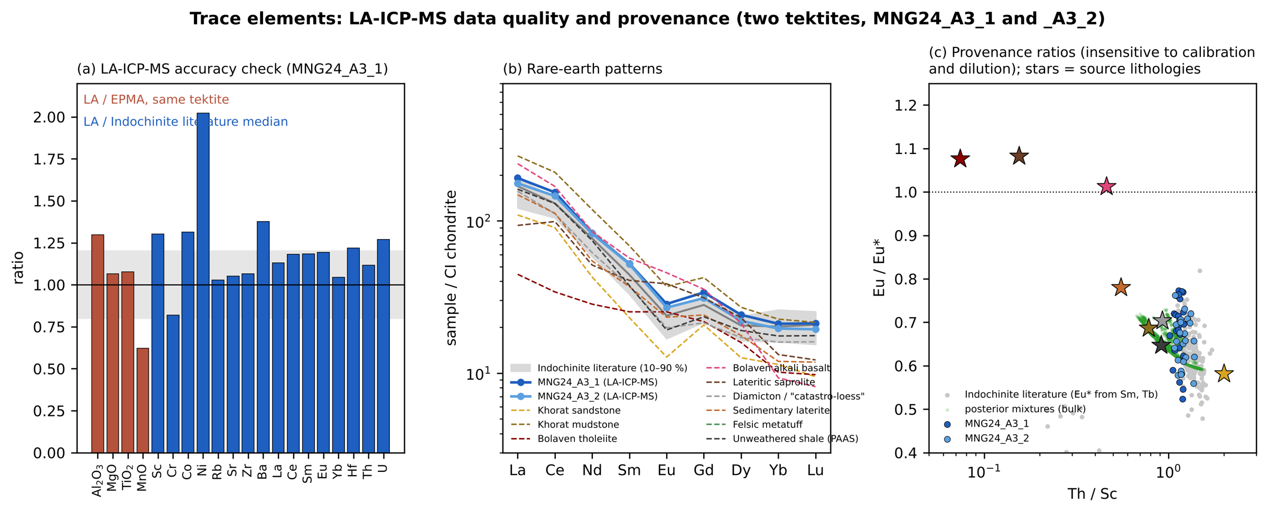
Figure S1. Trace elements of tektites MNG24_A3_1 and MNG24_A3_2 (LA-ICP-MS). (a) Accuracy check. Red bars: LA-ICP-MS/EPMA on the same tektite for four major elements. Blue bars: LA-ICP-MS relative to the median of published Indochinite and Muong Nong analyses. The shaded band is ±20 %. (b) CI-chondrite-normalised REE (Sun & McDonough, 1989) compared with the literature 10–90 % range and with source lithology medians. (c) Th/Sc versus Eu/Eu*, which are insensitive to the internal standard and to dilution, for the tektites, the literature (Eu* from Sm and Tb), source lithologies (stars; the felsic metatuff has no trace-element data) and the bulk posterior mixtures of Fig. 5 (green; metatuff omitted).
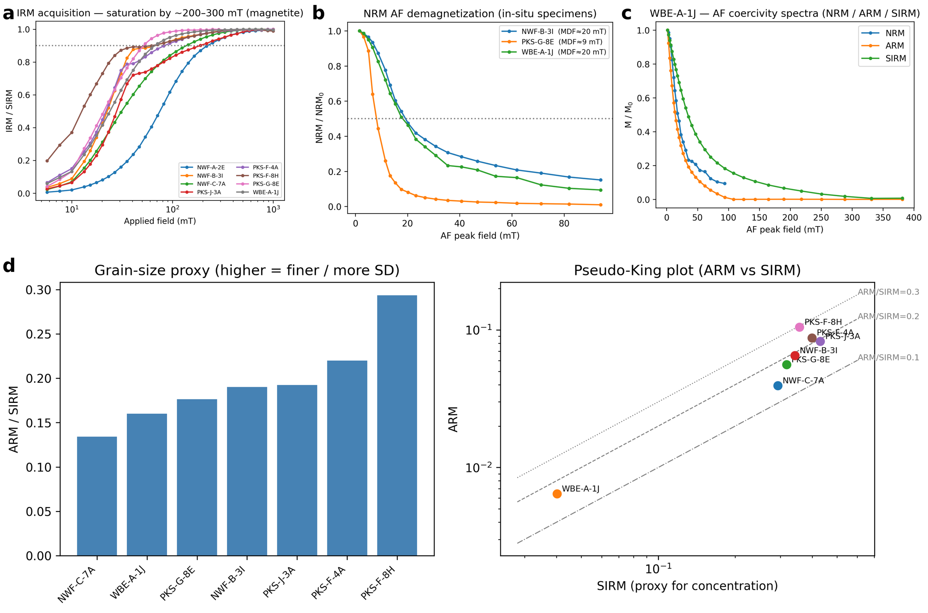
Figure S2. Additional rock magnetism of Bolaven basalts (MicroMag/2G AF and pulse-magnetizer measurements; plots from Code/AF_rockmag.ipynb). (a) Isothermal remanent magnetization (IRM) acquisition of eight specimens, normalised to the saturation IRM (SIRM); all reach 90 % of saturation by ~200–300 mT, as expected for magnetite-family carriers. (b) Alternating-field (AF) demagnetization of the NRM of three specimens, with median destructive fields (MDF) of ~9–20 mT. (c) AF demagnetization spectra of the NRM, an anhysteretic remanence (ARM) and the SIRM of WBE-A-1J. (d) ARM/SIRM, a magnetite grain-size proxy (higher values indicate finer, more single-domain-like grains), and ARM against SIRM.
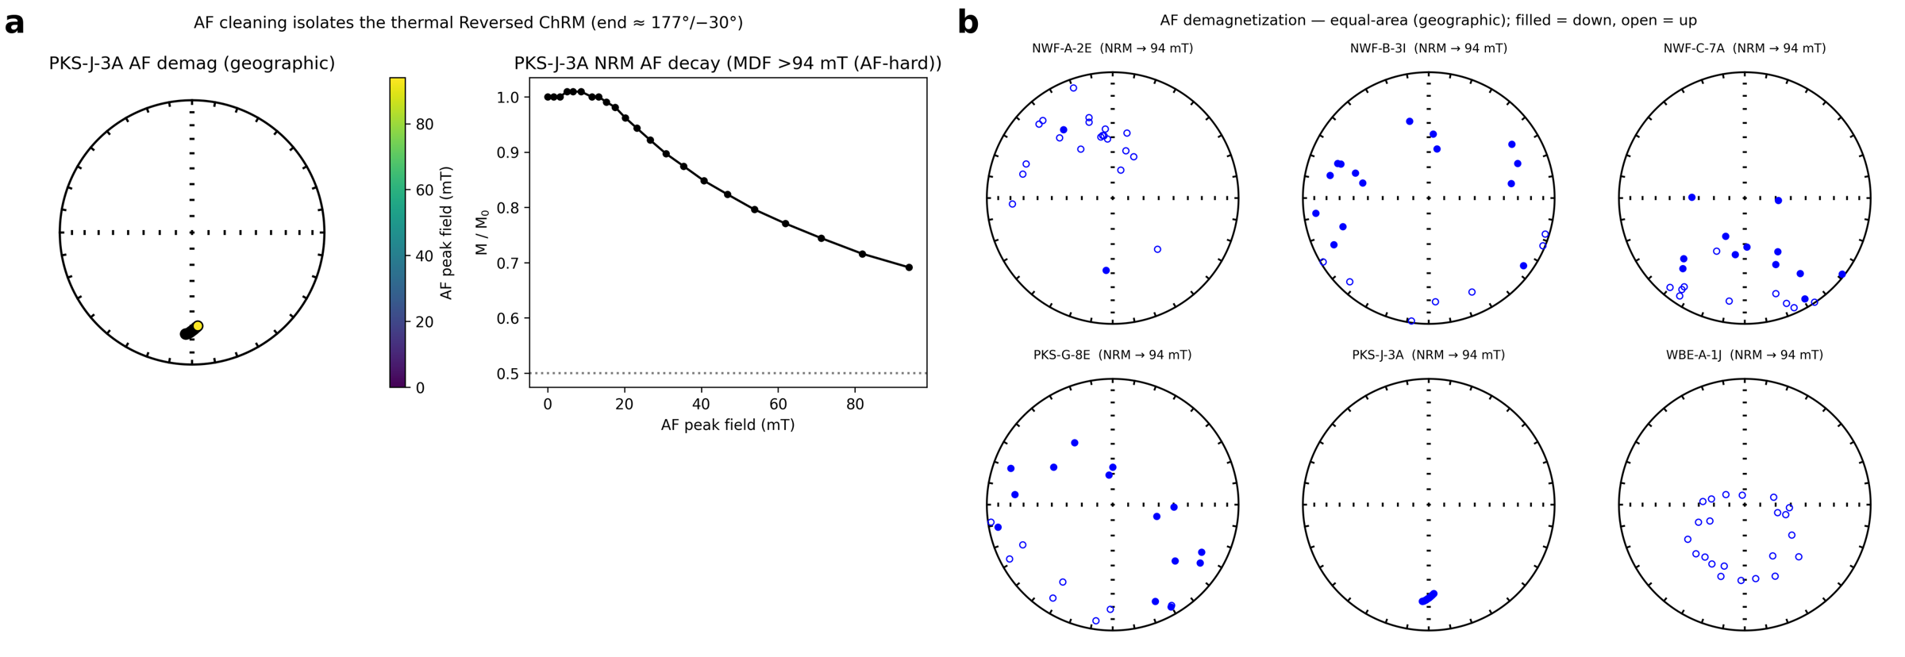
Figure S3. AF demagnetization of the NRM (geographic coordinates). (a) Specimen PKS-J-3A: equal-area path of the remanence with AF peak field (colour) and normalised intensity decay; AF cleaning isolates the same reversed ChRM (≈177°/−30°) as thermal demagnetization, and the remanence is AF-hard (MDF > 94 mT). (b) Equal-area projections of AF demagnetization paths to 94 mT for six specimens (filled = lower hemisphere, open = upper hemisphere).
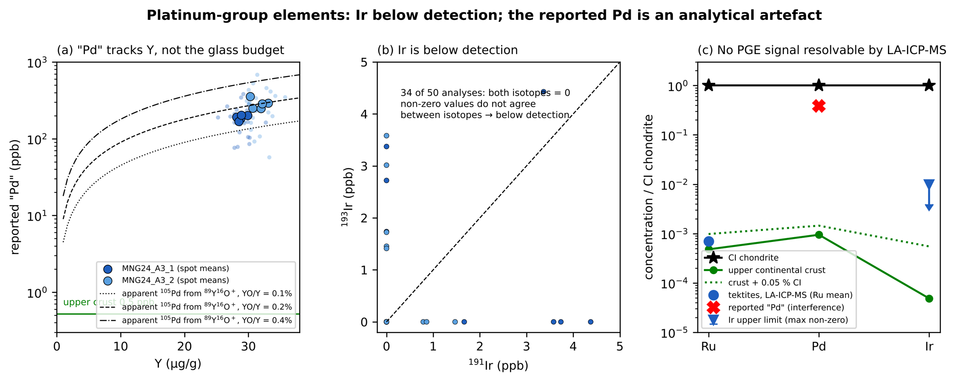
Figure S4. Platinum-group elements by LA-ICP-MS. (a) Reported “Pd” against Y. Small symbols are individual analyses; large symbols are ablation-site means. Lines show the apparent ¹⁰⁵Pd produced by ⁸⁹Y¹⁶O⁺ at oxide production rates of 0.1–0.4 %. (b) ¹⁹¹Ir against ¹⁹³Ir: most analyses are zero and the non-zero values do not agree between isotopes, so Ir is below detection. (c) CI-normalised Ru, Pd and Ir compared with CI chondrite, upper continental crust (Rudnick & Gao, 2003) and crust plus 0.05 % CI. Detecting a projectile component at the ≤ 0.005 % level inferred from Os isotopes (Ackerman et al., 2019) is beyond LA-ICP-MS.
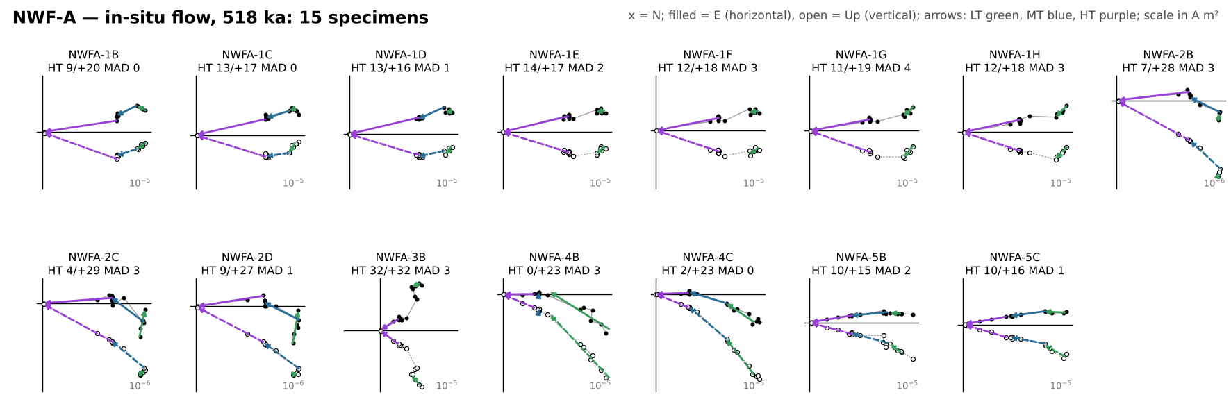
Figure S5. Orthogonal-vector (Zijderveld) diagrams of every thermally demagnetized specimen from NWF-A (in-situ flow, 518 ka), in geographic coordinates. x = north; filled symbols = horizontal plane (east), open = vertical plane (up); scale in A m². Arrows are the LT (green), MT (blue) and HT (purple) least-squares fits from the fitquest re-fits, drawn in the direction of demagnetization. Each label gives the HT direction (declination/inclination) and MAD; red labels mark HT fits with MAD > 15°, which are excluded from all site, boulder and conglomerate statistics.
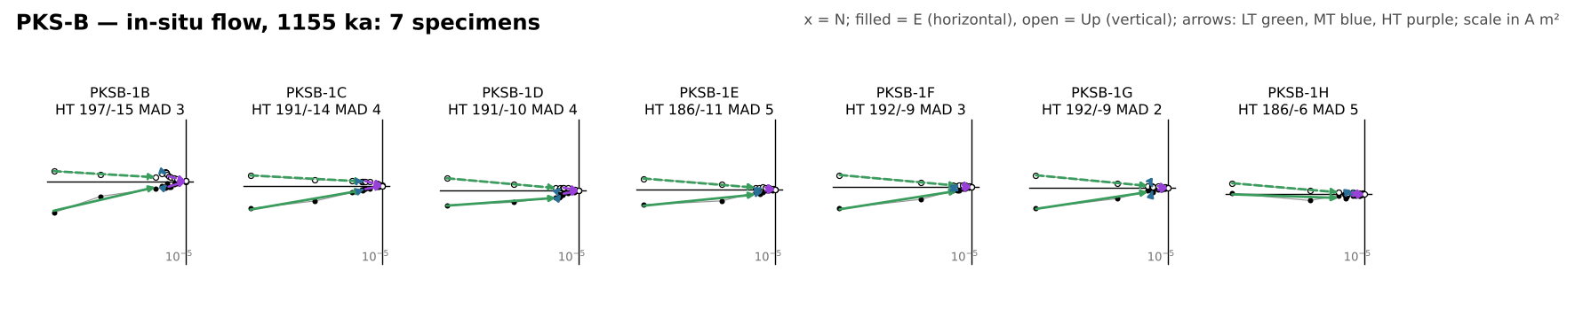
Figure S6. Orthogonal-vector (Zijderveld) diagrams of every thermally demagnetized specimen from PKS-B (in-situ flow, 1155 ka), in geographic coordinates. x = north; filled symbols = horizontal plane (east), open = vertical plane (up); scale in A m². Arrows are the LT (green), MT (blue) and HT (purple) least-squares fits from the fitquest re-fits, drawn in the direction of demagnetization. Each label gives the HT direction (declination/inclination) and MAD; red labels mark HT fits with MAD > 15°, which are excluded from all site, boulder and conglomerate statistics.
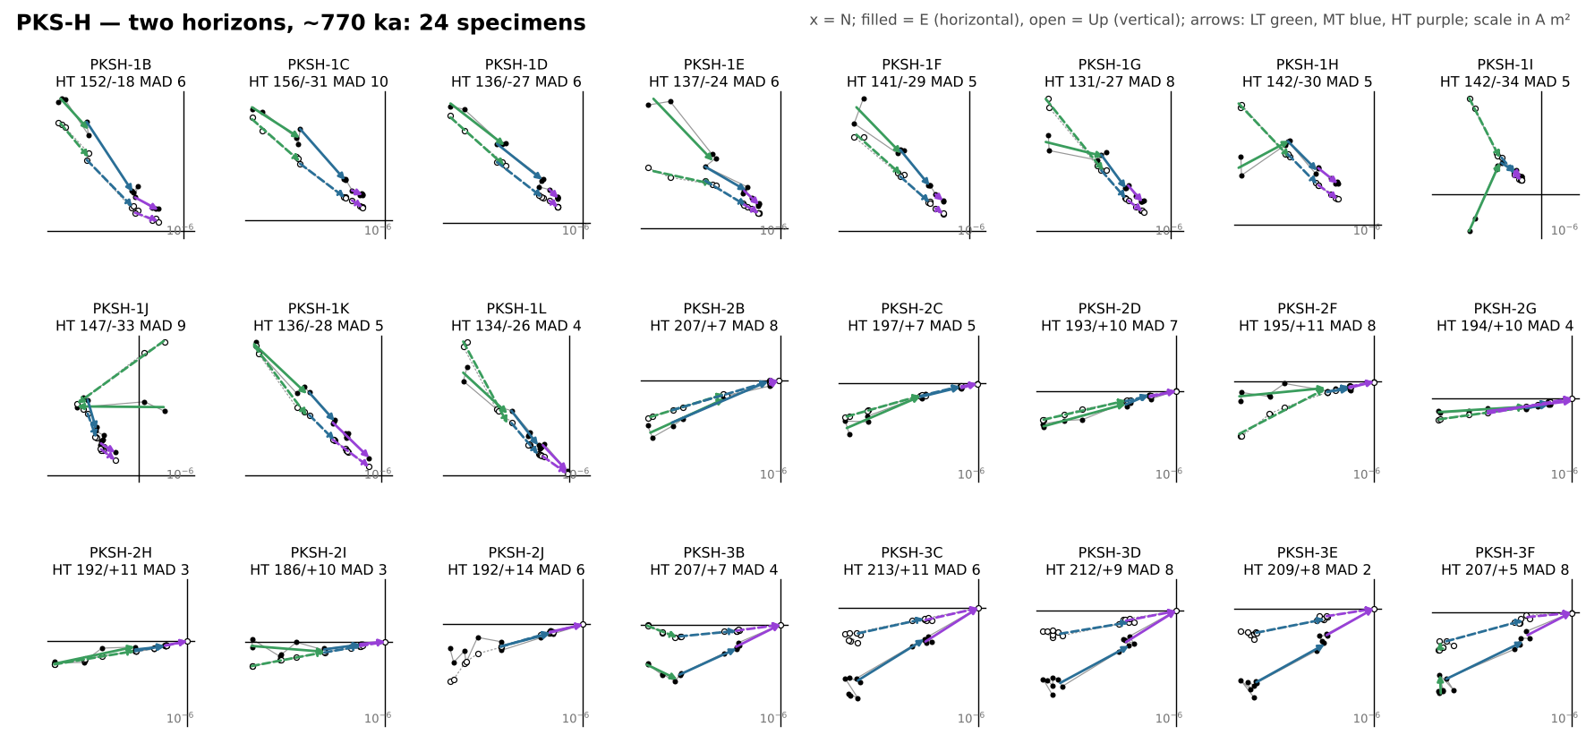
Figure S7. Orthogonal-vector (Zijderveld) diagrams of every thermally demagnetized specimen from PKS-H (upper horizon HA, cores 1–2; lower flow HB, core 3), in geographic coordinates. x = north; filled symbols = horizontal plane (east), open = vertical plane (up); scale in A m². Arrows are the LT (green), MT (blue) and HT (purple) least-squares fits from the fitquest re-fits, drawn in the direction of demagnetization. Each label gives the HT direction (declination/inclination) and MAD; red labels mark HT fits with MAD > 15°, which are excluded from all site, boulder and conglomerate statistics.
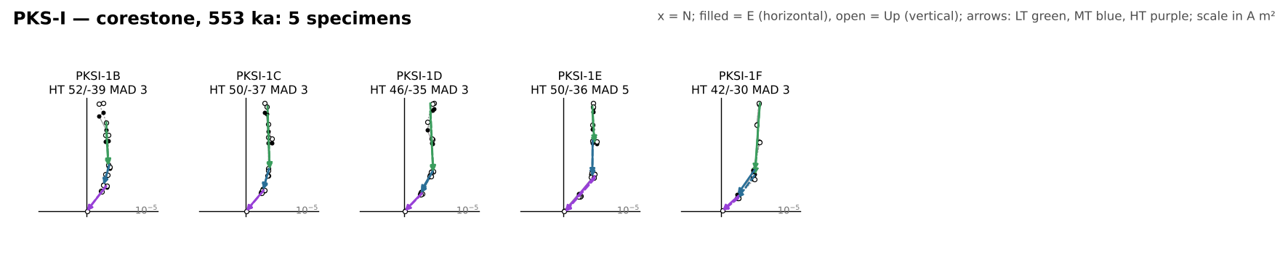
Figure S8. Orthogonal-vector (Zijderveld) diagrams of every thermally demagnetized specimen from PKS-I (corestone, 553 ka), in geographic coordinates. x = north; filled symbols = horizontal plane (east), open = vertical plane (up); scale in A m². Arrows are the LT (green), MT (blue) and HT (purple) least-squares fits from the fitquest re-fits, drawn in the direction of demagnetization. Each label gives the HT direction (declination/inclination) and MAD; red labels mark HT fits with MAD > 15°, which are excluded from all site, boulder and conglomerate statistics.
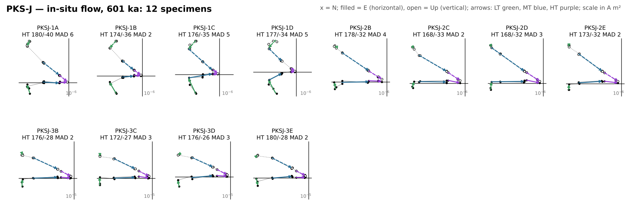
Figure S9. Orthogonal-vector (Zijderveld) diagrams of every thermally demagnetized specimen from PKS-J (in-situ flow, 601 ka), in geographic coordinates. x = north; filled symbols = horizontal plane (east), open = vertical plane (up); scale in A m². Arrows are the LT (green), MT (blue) and HT (purple) least-squares fits from the fitquest re-fits, drawn in the direction of demagnetization. Each label gives the HT direction (declination/inclination) and MAD; red labels mark HT fits with MAD > 15°, which are excluded from all site, boulder and conglomerate statistics.
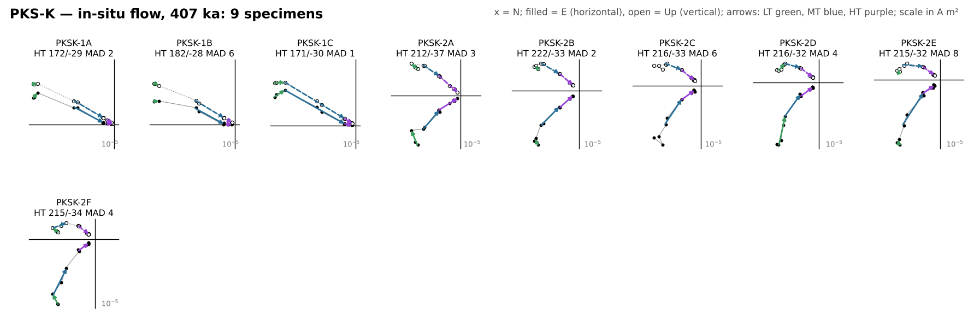
Figure S10. Orthogonal-vector (Zijderveld) diagrams of every thermally demagnetized specimen from PKS-K (in-situ flow, 407 ka), in geographic coordinates. x = north; filled symbols = horizontal plane (east), open = vertical plane (up); scale in A m². Arrows are the LT (green), MT (blue) and HT (purple) least-squares fits from the fitquest re-fits, drawn in the direction of demagnetization. Each label gives the HT direction (declination/inclination) and MAD; red labels mark HT fits with MAD > 15°, which are excluded from all site, boulder and conglomerate statistics.
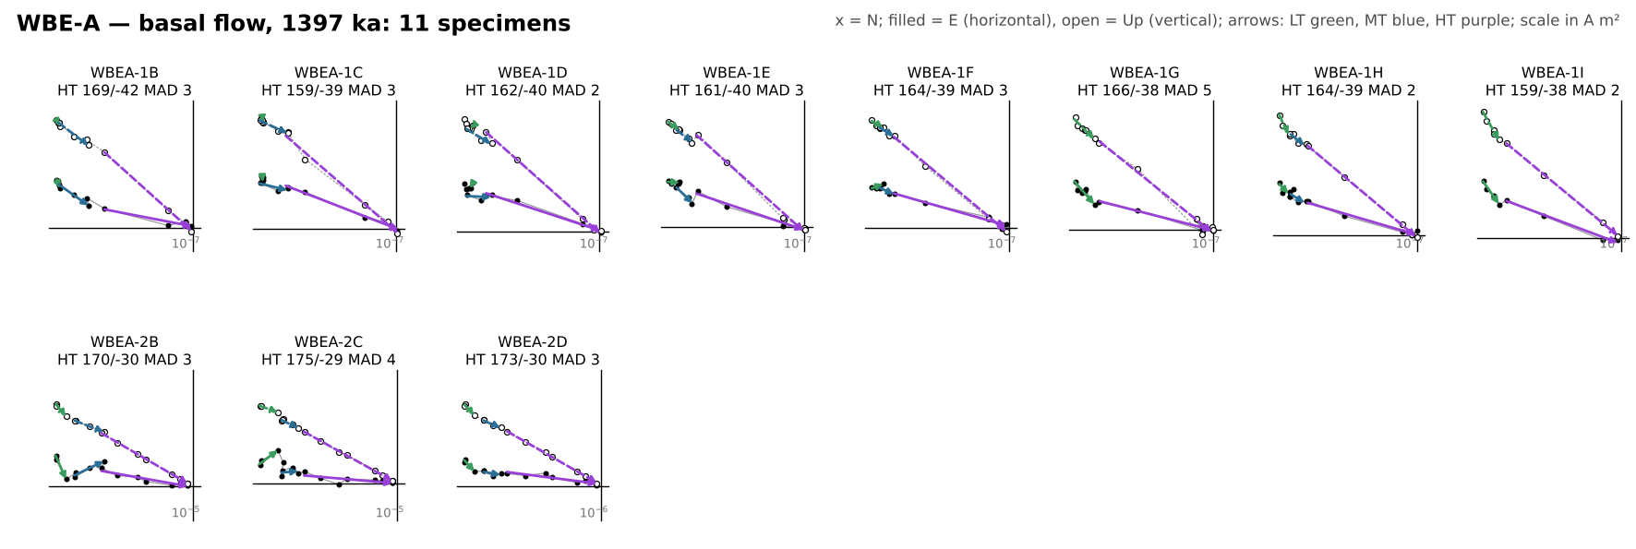
Figure S11. Orthogonal-vector (Zijderveld) diagrams of every thermally demagnetized specimen from WBE-A (basal flow, 1397 ka), in geographic coordinates. x = north; filled symbols = horizontal plane (east), open = vertical plane (up); scale in A m². Arrows are the LT (green), MT (blue) and HT (purple) least-squares fits from the fitquest re-fits, drawn in the direction of demagnetization. Each label gives the HT direction (declination/inclination) and MAD; red labels mark HT fits with MAD > 15°, which are excluded from all site, boulder and conglomerate statistics.
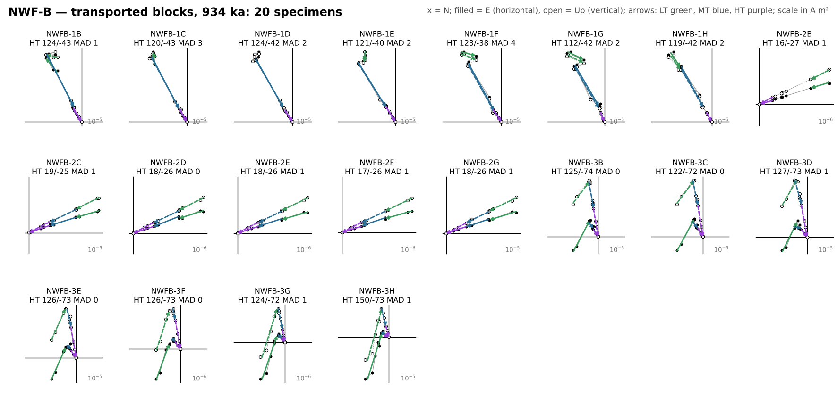
Figure S12. Orthogonal-vector (Zijderveld) diagrams of every thermally demagnetized specimen from NWF-B (transported blocks), in geographic coordinates. x = north; filled symbols = horizontal plane (east), open = vertical plane (up); scale in A m². Arrows are the LT (green), MT (blue) and HT (purple) least-squares fits from the fitquest re-fits, drawn in the direction of demagnetization. Each label gives the HT direction (declination/inclination) and MAD; red labels mark HT fits with MAD > 15°, which are excluded from all site, boulder and conglomerate statistics.
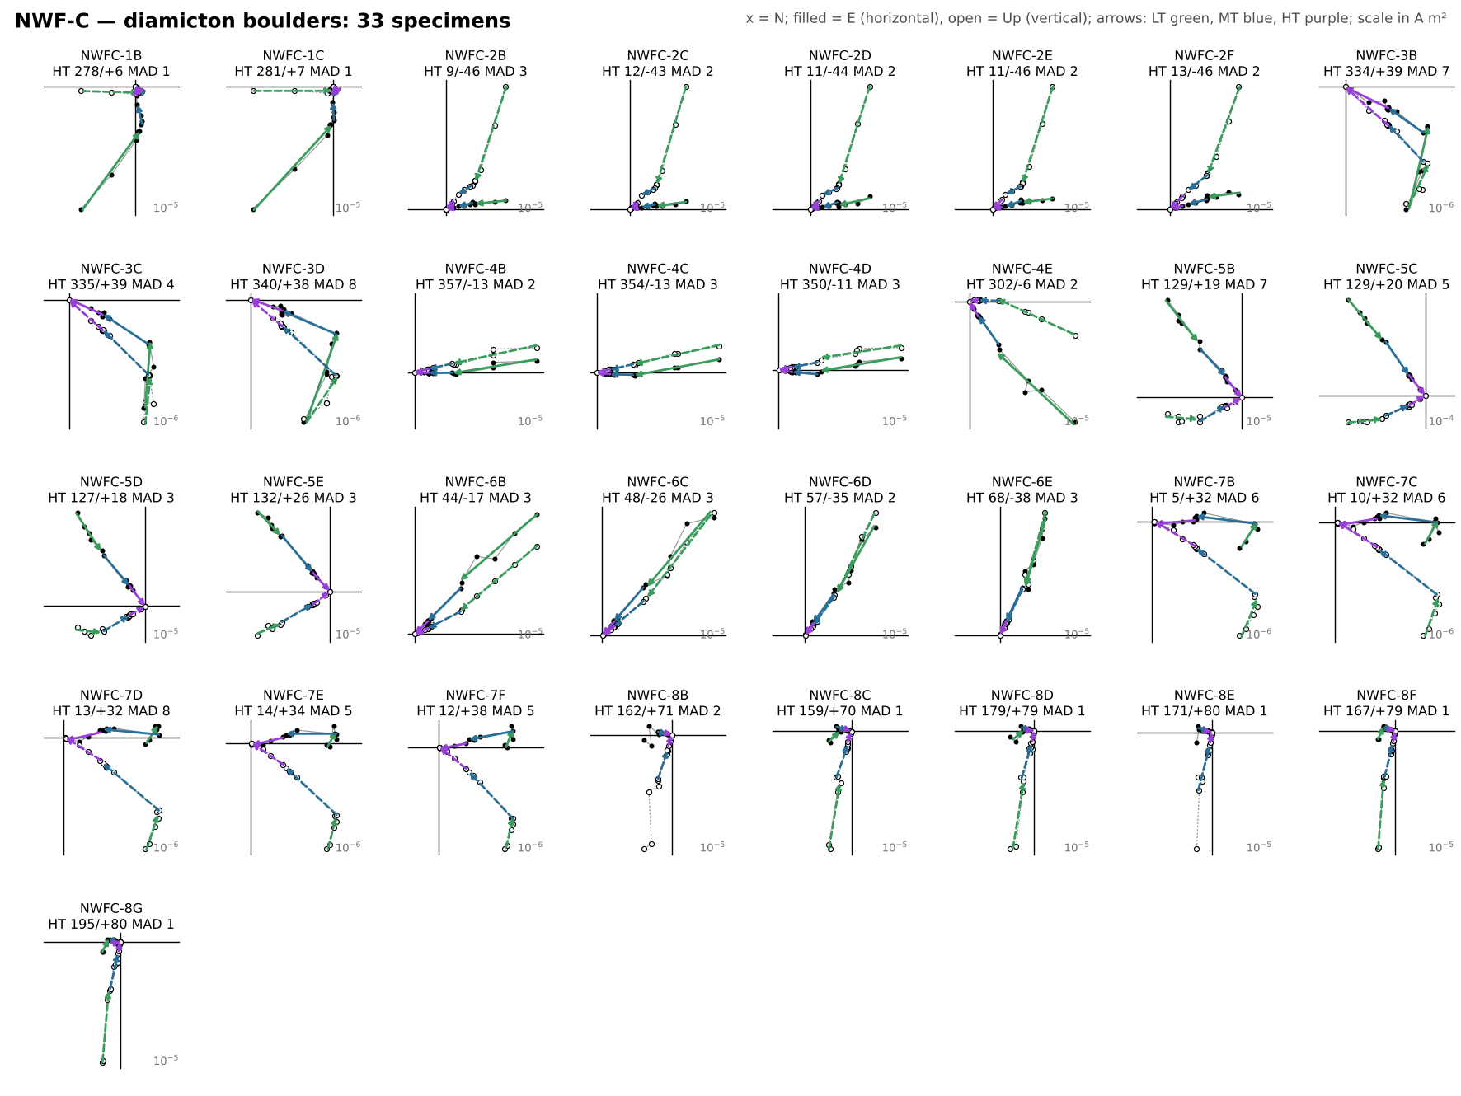
Figure S13. Orthogonal-vector (Zijderveld) diagrams of every thermally demagnetized specimen from NWF-C (diamicton boulders), in geographic coordinates. x = north; filled symbols = horizontal plane (east), open = vertical plane (up); scale in A m². Arrows are the LT (green), MT (blue) and HT (purple) least-squares fits from the fitquest re-fits, drawn in the direction of demagnetization. Each label gives the HT direction (declination/inclination) and MAD; red labels mark HT fits with MAD > 15°, which are excluded from all site, boulder and conglomerate statistics.
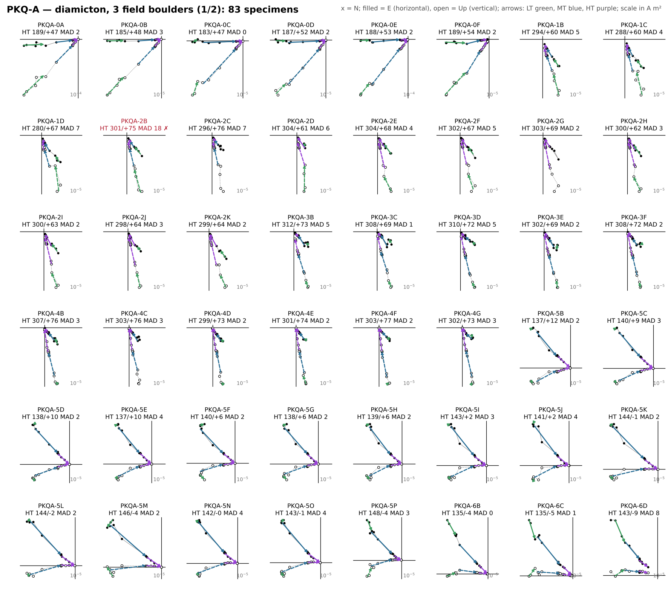
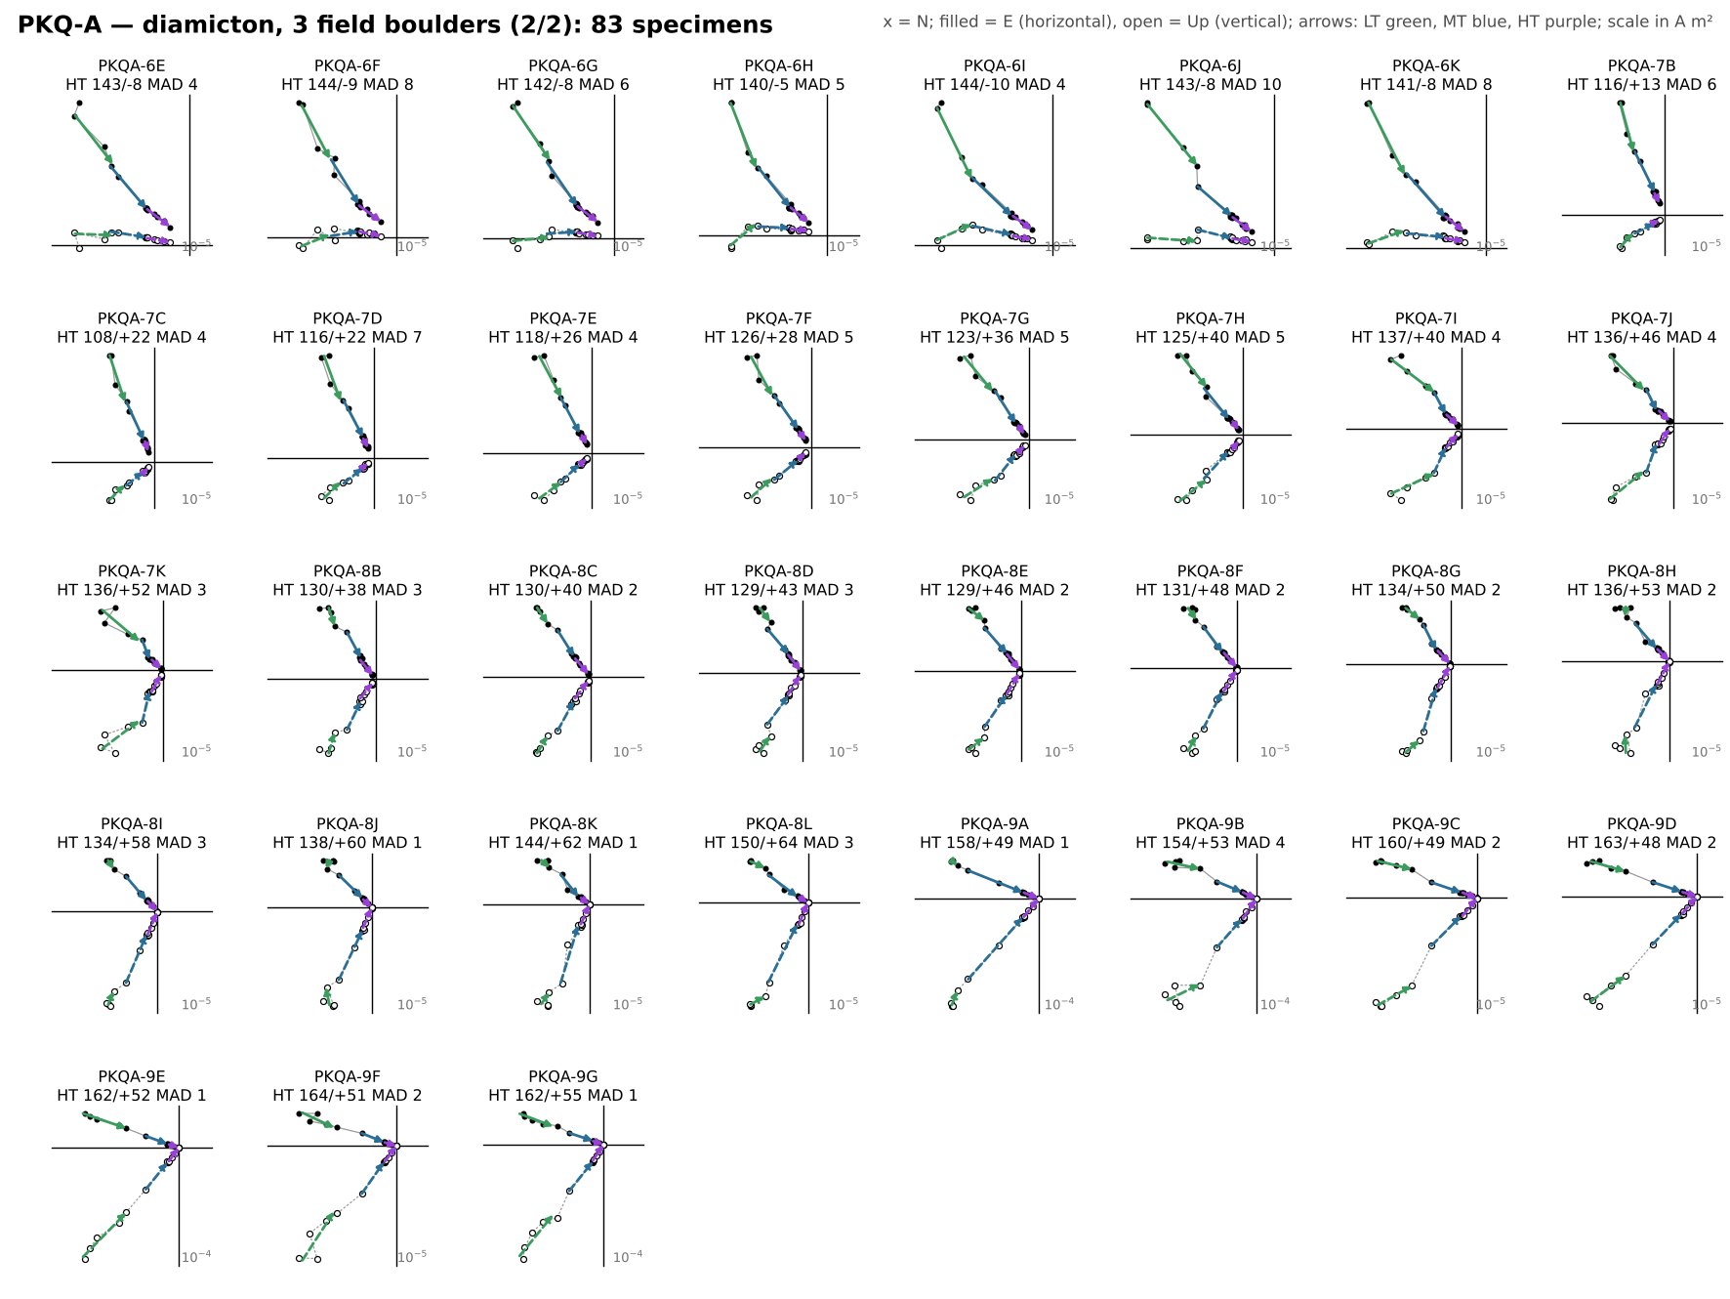
Figure S14. Orthogonal-vector (Zijderveld) diagrams of every thermally demagnetized specimen from PKQ-A (diamicton; field boulders B1 = cores 0–4, B2 = 5–6, B3 = 7–9), in geographic coordinates (2 parts). x = north; filled symbols = horizontal plane (east), open = vertical plane (up); scale in A m². Arrows are the LT (green), MT (blue) and HT (purple) least-squares fits from the fitquest re-fits, drawn in the direction of demagnetization. Each label gives the HT direction (declination/inclination) and MAD; red labels mark HT fits with MAD > 15°, which are excluded from all site, boulder and conglomerate statistics.
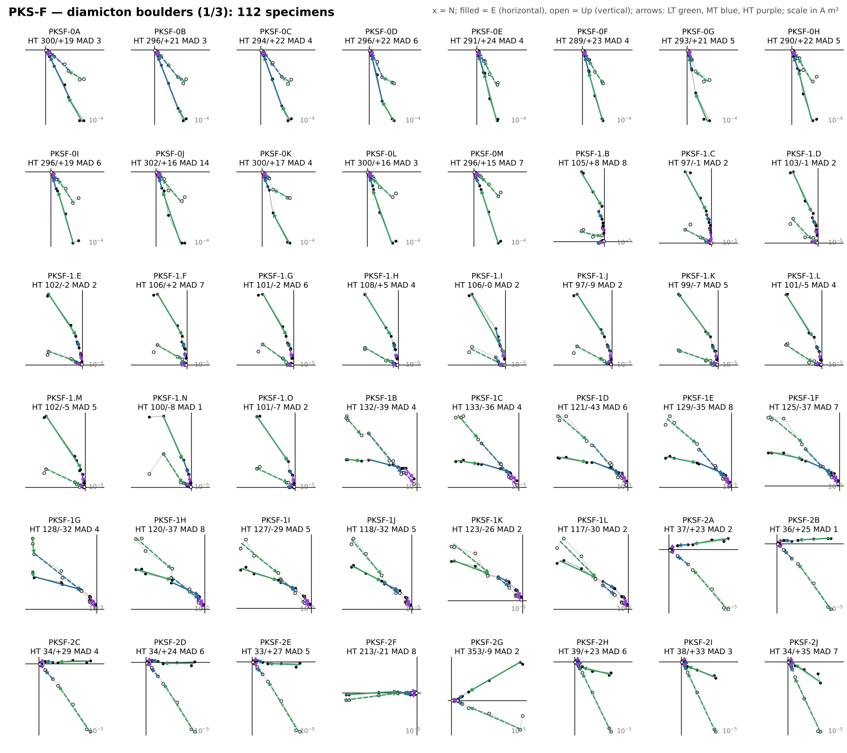
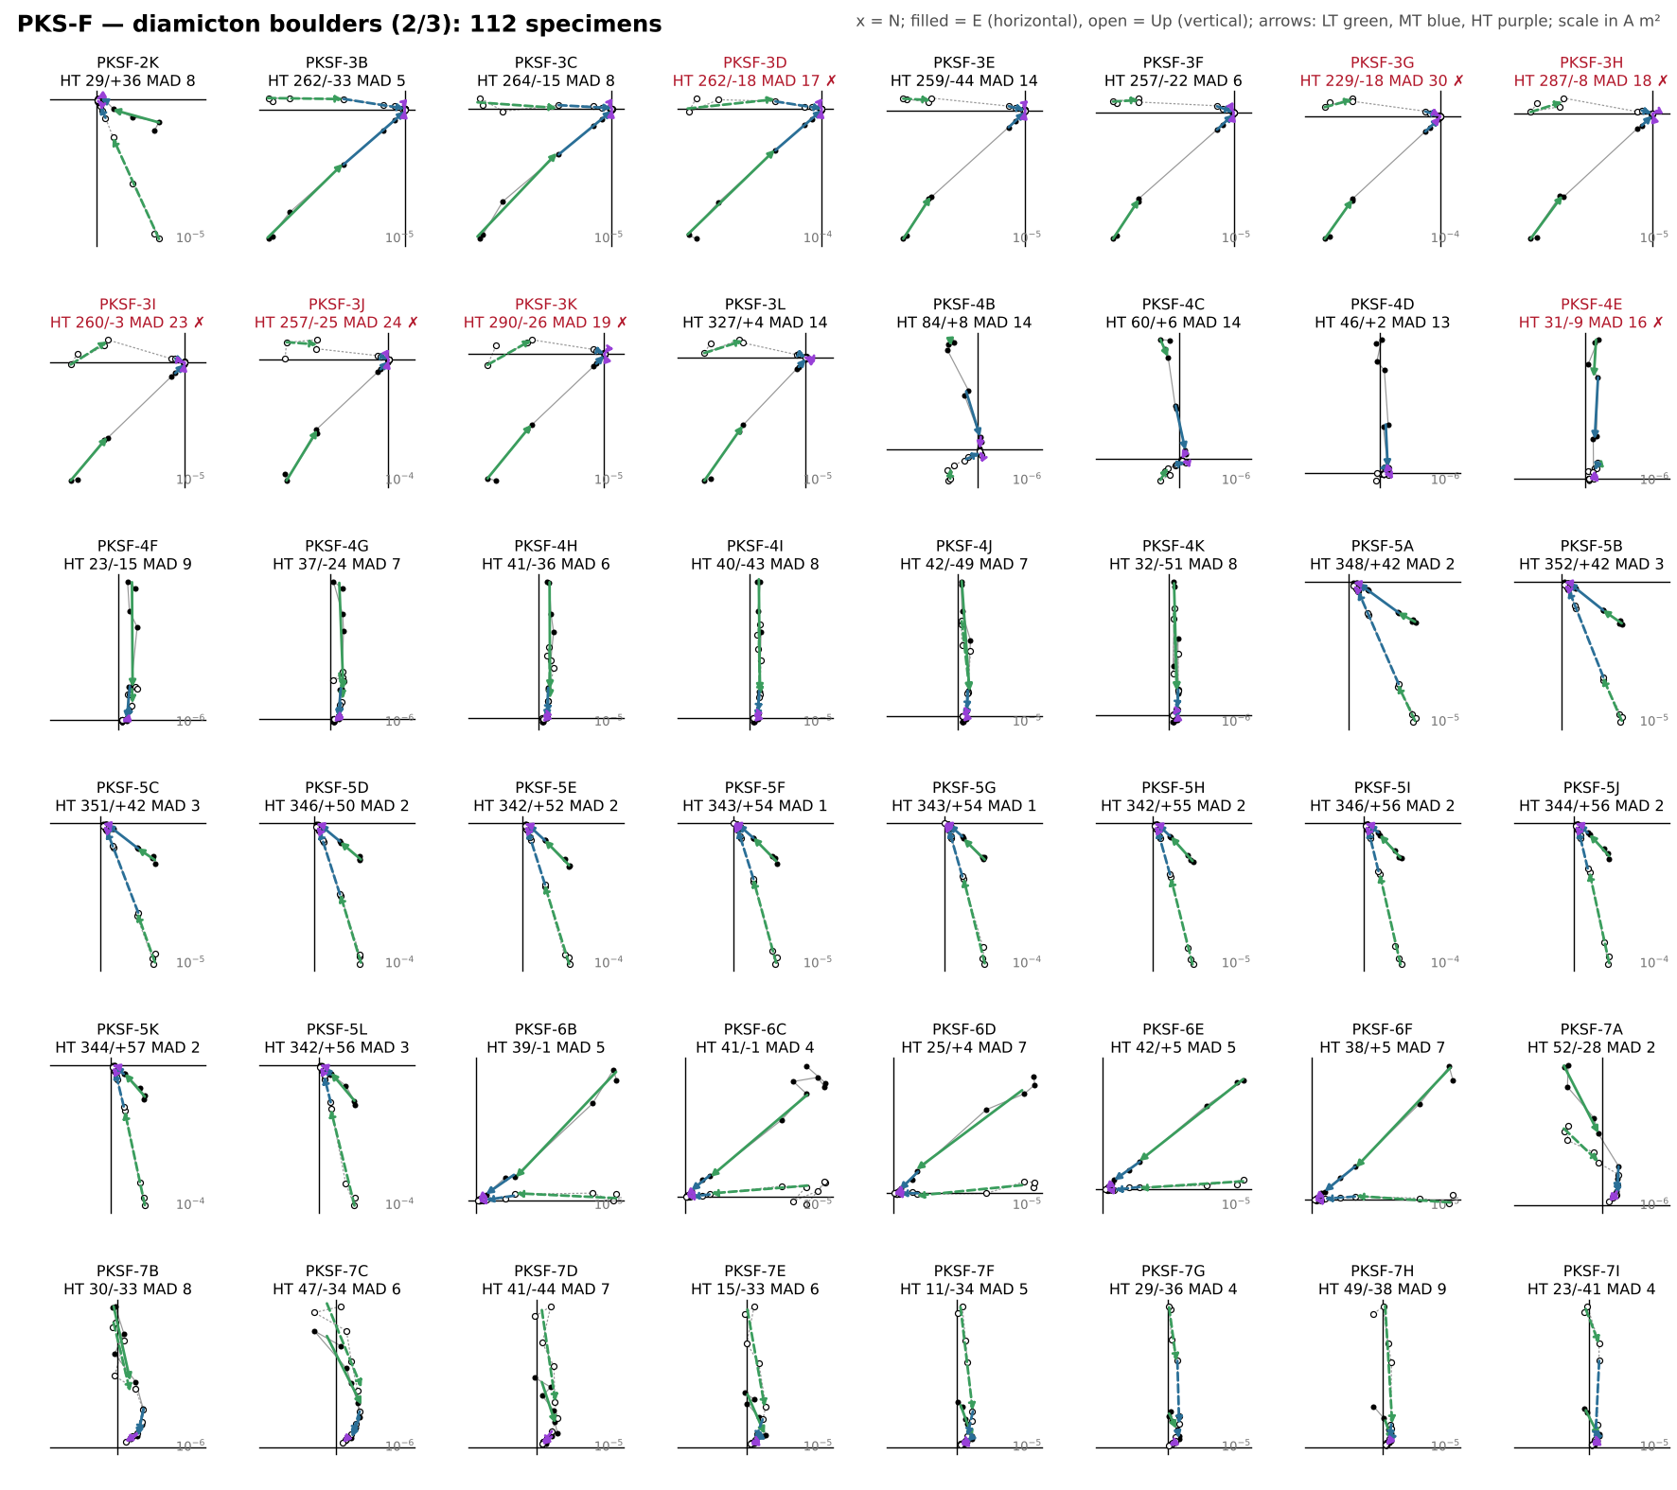
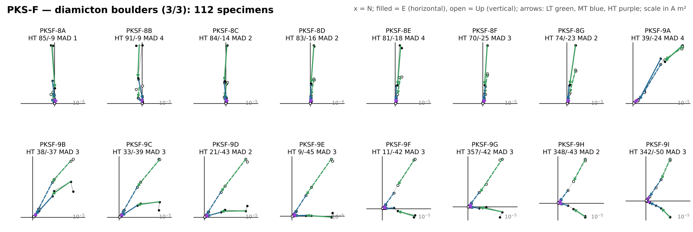
Figure S15. Orthogonal-vector (Zijderveld) diagrams of every thermally demagnetized specimen from PKS-F (diamicton boulders), in geographic coordinates (3 parts). x = north; filled symbols = horizontal plane (east), open = vertical plane (up); scale in A m². Arrows are the LT (green), MT (blue) and HT (purple) least-squares fits from the fitquest re-fits, drawn in the direction of demagnetization. Each label gives the HT direction (declination/inclination) and MAD; red labels mark HT fits with MAD > 15°, which are excluded from all site, boulder and conglomerate statistics.
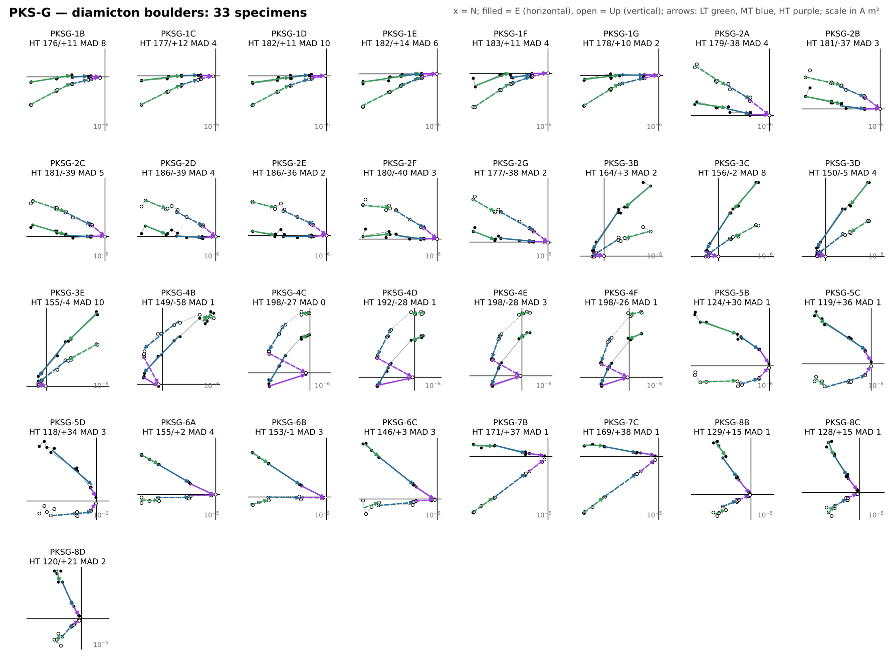
Figure S16. Orthogonal-vector (Zijderveld) diagrams of every thermally demagnetized specimen from PKS-G (diamicton boulders), in geographic coordinates. x = north; filled symbols = horizontal plane (east), open = vertical plane (up); scale in A m². Arrows are the LT (green), MT (blue) and HT (purple) least-squares fits from the fitquest re-fits, drawn in the direction of demagnetization. Each label gives the HT direction (declination/inclination) and MAD; red labels mark HT fits with MAD > 15°, which are excluded from all site, boulder and conglomerate statistics.

Supplementary Tables
Table S1. Paleomagnetic sample inventory. Coordinates are means of the 2024 GPS waypoints (WGS84). Orientation from the sample-header files: sun compass, or magnetic compass corrected to IGRF declination. Specimens: thermally demagnetized specimens with fitted components; HT accepted: specimens whose HT (ChRM) fit has MAD ≤ 15°; component fits: all LT, MT and HT fits.

Table S2. Tektites analysed in this study. EPMA spots with oxide totals below 97 wt% are rejected (shaded: no accepted analyses). LA-ICP-MS: five ablation sites with five replicates each.

Table S3. Hysteresis parameters of the seven fresh-interior / weathered-rind chip pairs plotted in Fig. 4c (MicroMag VSM; Hc and Mr/Ms from the slope-corrected loops, Hcr from backfield remanence). Shaded rows are weathered chips. PKS24-I and PKS24-HB were filed as PKQ24-… in the instrument files.

Table S4 lists the complete set of ten quantitative energy-dispersive X-ray (EDS) point analyses obtained from a fresh Bolaven basalt (specimen LS-H18, Area 1), extending the three oxide analyses shown in the main text (Fig. 4k,l). The analyses span every major phase identified in back-scattered-electron imaging: five Fe–Ti oxide grains (four titanomagnetite, one of them chromian, plus one secondary Fe–Mn oxide), two plagioclase (labradorite, An59–62), two olivine grains spanning Fo53–78, and one augite. No exotic, high-pressure, shock-diagnostic, or metallic (Ni-rich) phase was encountered – the assemblage is that of an ordinary, weathered intraplate basalt rather than an impact-shocked or impactor-contaminated lithology, corroborating the rock-magnetic and geochemical results in the main text.
Table S4. Complete EDS analyses of Bolaven basalt specimen LS-H18 (Area 1), acquired on an Oxford Instruments EDS system. All values in wt%, normalized to 100%; all iron reported as FeO. “–” denotes an oxide below detection. Anorthite (An) and forsterite (Fo) contents are computed from cation proportions. Analyses 1, 4 and 5 are the three oxide grains shown in Fig. 4k,l. The assemblage – titanomagnetite (one Cr-rich), a secondary Fe–Mn oxide, labradorite, olivine, and augite – is ordinary intraplate-basalt mineralogy with no high-pressure, shock, or metallic phases.

[tab:sem_eds]
Table S5. Posterior mixing weights (wt%, mean ± 1σ combining within- and between-chain variance) of each lithology type in the reversible-jump MCMC unmixing of the 82 accepted EPMA analyses (Fig. 5k, m). The number in parentheses is the percentage of posterior samples in which the type is present. Full model: 12 chains × 6 × 10⁴ iterations; sensitivity runs: 4 chains × 3 × 10⁴ iterations. "Excluded" marks types removed from the dictionary in that run.

Site | Lat (°N) | Lon (°E) | Setting | Sample type | Orientation | Cores / blocks | Specimens | HT accepted (MAD ≤ 15°) | Component fits
NWF-A | 15.6446 | 106.1427 | In-situ flow | Block | Sun | 5 | 15 | 15 | 40
NWF-B | 15.6236 | 105.9859 | Blocks (transported) | Block | Magnetic (IGRF-corr.) | 3 | 20 | 20 | 58
NWF-C | 15.4148 | 106.1433 | Diamicton boulders | Block | Sun | 8 | 33 | 33 | 97
PKQ-A | 15.1020 | 105.8536 | Diamicton boulders | Core | Sun (cores 0, 3 magnetic) | 10 | 83 | 82 | 238
PKS-B | 15.1543 | 106.1897 | In-situ flow | Block | Sun | 1 | 7 | 7 | 21
PKS-F | 15.1131 | 106.2282 | Diamicton boulders | Core | Sun | 11 | 112 | 105 | 334
PKS-G | 15.1558 | 106.1903 | Diamicton boulders | Block | Magnetic (IGRF-corr.) | 8 | 33 | 33 | 98
PKS-H | 15.1557 | 106.1918 | Two horizons (HA, HB) | Core | Sun | 3 | 24 | 24 | 68
PKS-I | 15.2328 | 106.1908 | Corestone | Core | Sun | 1 | 5 | 5 | 15
PKS-J | 15.2431 | 106.2581 | In-situ flow | Core | Magnetic (IGRF-corr.) | 3 | 12 | 12 | 36
PKS-K | 15.2419 | 106.2585 | In-situ flow | Core | Magnetic (IGRF-corr.) | 2 | 9 | 9 | 26
WBE-A | 15.2700 | 106.3472 | Basal flow | Block | Magnetic (IGRF-corr.) | 2 | 11 | 11 | 31
Tektite | Locality | EPMA spots | Accepted (≥ 97 wt%) | Total range (wt%) | LA-ICP-MS
KK24_T1 | Khon Kaen, NE Thailand | 30 | 30 | 97.7–99.7 | —
MG24_B1 | Muong Nong area, Savannakhet, Laos | 6 | 5 | 96.8–98.6 | —
MNG24_A3_1 | Muong Nong area, Savannakhet, Laos | 30 | 30 | 98.4–99.7 | yes (5 sites × 5)
MNG24_A3_2 | Muong Nong area, Savannakhet, Laos | 27 | 0 | 32.7–85.6 | yes (5 sites × 5)
MNG24_A3_3 | Muong Nong area, Savannakhet, Laos | 15 | 0 | 60.7–96.7 | —
MNG24_B1 | Muong Nong area, Savannakhet, Laos | 20 | 17 | 96.3–98.0 | —
MNG24_C2 | Muong Nong area, Savannakhet, Laos | 25 | 0 | 65.8–93.9 | —
Site | Setting | Sample | Chip | Mass (g) | Hc (mT) | Hcr (mT) | Mr (µA m²) | Ms (µA m²) | Mr/Ms | Hcr/Hc
PKS-B | In-situ flow | PKS24-BA-P1 | fresh | 0.299 | 16.8 | 24.5 | 33.6 | 96.7 | 0.348 | 1.46
 |  |  | weathered | 0.164 | 17.3 | 34.2 | 8.6 | 32.5 | 0.265 | 1.98
PKS-H (HB) | In-situ flow | PKS24-HB-P1 | fresh | 0.423 | 14.7 | 23.3 | 30.7 | 97.5 | 0.315 | 1.58
 |  |  | weathered | 0.023 | 10.7 | 18.7 | 2.1 | 8.3 | 0.258 | 1.75
PKS-I | Corestone | PKS24-I-P1 | fresh | 1.307 | 26.2 | 47.5 | 90.4 | 304.5 | 0.297 | 1.81
 |  |  | weathered | 0.108 | 22.2 | 42.1 | 23.3 | 86.5 | 0.270 | 1.90
NWF-C | Diamicton clast | NWF24-C-P8 | fresh | 0.307 | 21.1 | 38.3 | 25.5 | 78.0 | 0.327 | 1.82
 |  |  | weathered | 0.300 | 16.6 | 32.6 | 28.8 | 108.3 | 0.266 | 1.97
PKQ-A (2A) | Diamicton clast | PKQ24-A-P2A | fresh | 0.637 | 15.7 | 33.0 | 34.2 | 127.4 | 0.268 | 2.10
 |  |  | weathered | 0.359 | 10.6 | 19.9 | 32.2 | 173.4 | 0.186 | 1.88
PKQ-A (5A) | Diamicton clast | PKQ24-A-P5A | fresh | 0.790 | 13.9 | 30.3 | 34.1 | 132.0 | 0.258 | 2.17
 |  |  | weathered | 0.286 | 8.4 | 16.8 | 19.2 | 120.0 | 0.160 | 1.99
PKQ-A (5C) | Diamicton clast | PKQ24-A-P5C | fresh | 0.668 | 10.6 | 23.2 | 27.4 | 133.0 | 0.206 | 2.18
 |  |  | weathered | 0.245 | 8.7 | 17.1 | 15.6 | 90.8 | 0.171 | 1.97
# | Phase | SiO2 | TiO2 | Al2O3 | Cr2O3 | V2O5 | FeO | MnO | MgO | CaO | Na2O | K2O
1 | Titanomagnetite | 0.42 | 21.74 | 1.18 | – | 0.89 | 73.80 | 0.82 | 1.15 | – | – | –
2 | Plagioclase (An59) | 53.60 | – | 29.13 | – | – | 1.07 | – | 0.45 | 11.27 | 4.14 | 0.34
3 | Olivine (Fo53) | 32.99 | – | 0.77 | – | – | 40.26 | – | 25.30 | 0.68 | – | –
4 | Cr-titanomagnetite | 2.30 | 16.03 | 3.80 | 10.83 | 1.16 | 62.55 | 0.61 | 2.72 | – | – | –
5 | Titanomagnetite | 2.02 | 22.41 | 2.56 | 1.07 | 0.91 | 68.48 | 0.60 | 1.68 | 0.26 | – | –
6 | Plagioclase (An62) | 52.53 | – | 29.22 | – | – | 0.90 | – | – | 12.95 | 4.12 | 0.28
7 | Olivine (Fo78) | 39.73 | – | 1.32 | – | – | 19.37 | – | 38.88 | 0.70 | – | –
8 | Fe–Mn oxide (secondary) | 3.02 | – | – | – | – | 80.66 | 4.05 | 9.31 | 2.97 | – | –
9 | Augite (clinopyroxene) | 49.93 | 2.37 | 3.87 | – | – | 14.92 | – | 9.55 | 19.11 | – | 0.26
10 | Titanomagnetite | 7.00 | 20.15 | 3.37 | – | 0.73 | 65.33 | – | 2.28 | 0.39 | 0.28 | 0.48
Lithology type | Full model (12 chains) | No random (4) | Na₂O, K₂O excluded (4) | Regional only (4)
Khorat sandstone | 35.6 ± 15.4 (91) | 26.2 ± 13.3 (99) | 40.1 ± 11.9 (100) | 25.0 ± 11.2 (99)
Khorat mudstone | 3.3 ± 5.6 (37) | 32.2 ± 20.8 (100) | 3.8 ± 4.6 (48) | 25.5 ± 12.0 (100)
Unweathered shale (PAAS) | 26.8 ± 23.1 (91) | 7.2 ± 8.5 (50) | 28.2 ± 15.8 (100) | excluded
Felsic metatuff | 9.9 ± 5.7 (91) | 14.7 ± 11.1 (75) | 6.2 ± 6.3 (65) | 30.6 ± 12.9 (100)
Bolaven tholeiite | 3.7 ± 5.2 (53) | 10.2 ± 5.1 (100) | 7.3 ± 9.5 (50) | 6.3 ± 5.5 (71)
Bolaven alkali basalt | 1.1 ± 2.7 (19) | 8.6 ± 9.7 (75) | 0.0 ± 0.2 (1) | 11.9 ± 6.3 (86)
All basalt (sum) | 4.8 ± 5.4 (64) | 18.8 ± 9.4 (100) | 7.3 ± 9.5 (50) | 18.2 ± 2.3 (100)
Lateritic saprolite | 0.0 ± 0.0 (0) | 0.0 ± 0.0 (0) | 0.0 ± 0.0 (0) | 0.0 ± 0.0 (0)
Sedimentary laterite / bauxite | 1.6 ± 3.8 (17) | 0.0 ± 0.0 (0) | 0.0 ± 0.0 (0) | 0.0 ± 0.0 (0)
Diamicton / loess | 0.4 ± 1.6 (6) | 1.0 ± 3.0 (14) | 2.4 ± 3.5 (40) | 0.7 ± 2.1 (12)
Random (unconstrained) | 17.8 ± 13.2 (86) | excluded | 12.0 ± 8.7 (75) | excluded

