Middle Miocene magnetostratigraphy of the Pebas Formation, Peruvian Amazonia: u-channel records from Tamshiyacu (TAM) and site SC, with palynological and vertebrate (Purussaurus) age control
Nick Stephann
Working draft —
The middle Miocene Pebas Formation records the Pan-Amazonian mega-wetland, and its lignites and shell beds yield an abundant vertebrate fauna — including a hyperdiverse crocodylian community and the giant caiman Purussaurus — yet individual fossil horizons are typically dated only to within a million years or more, because the strata are seldom tied directly to the geomagnetic polarity time scale (GPTS). We present paleomagnetic u-channel records from two Pebas sections $∼$170 km apart near Iquitos, Peru — Tamshiyacu (TAM; 4.01° S, 73.15° W) and Santa Carina (SC; 3.36° S, 71.79° W) — each preserving a single, well-resolved polarity reversal. Characteristic remanent magnetization (ChRM) directions isolated from despiked, high-coercivity () demagnetization define the reversal in each section; field-based reconstruction of core azimuth recovers geographic declination, so that the reversal is expressed antipodally in both inclination and declination and the virtual geomagnetic poles concentrate toward the geographic poles. Tied by the reversal, the two sections share a normal-below-to-reversed transition — the C5ABn–C5AAr boundary — whereas their lignite flooding surfaces do not align and are demonstrably diachronous. Four independent constraints — the polarity pattern, a palynological zone floor (T-15/T-16, $>$12.7), a Purussaurus maximum-age ceiling ($<$13.8), and U-Pb detrital-zircon ages from the P. neivensis–bearing La Venta Honda Group (youngest zircon populations $∼$13.9; Mora-Rojas et al., 2023) — converge on chron C5AAr, $∼$. A Purussaurus cranial horizon discovered at Tamshiyacu in 2025 falls within C5AAr, dating it to a $∼$180 kyr window ($∼$13.2) — $∼$1 Myr older than the U-Pb-dated P. neivensis horizon at La Venta (the Monkey Beds, chron C5An.1n, $≤$12.17) — a sub-million-year calibration of value to evolutionary and biogeographic models of the proto-Amazonian fauna. Down-core X-ray fluorescence shows that iron is dominantly authigenic (pyrite and carbonate), recording reducing, episodically brackish bottom water consistent with a tidally-influenced bay margin; net accumulation is very low ($∼$3 m/Myr), marking a condensed, incomplete succession. These records provide the first direct GPTS calibration of the Pebas Formation at Iquitos and a chronologic bridge to the La Venta vertebrate fauna.

Geological setting
The Pebas Formation (~ Solimões Formation of Brazil) records the middle Miocene Pebas mega-wetland system of western Amazonia — a long-lived lacustrine-to-brackish system with episodic marine influence, deposited in the Andean foreland (Wesselingh & Salo, 2006; Hoorn et al., 2010a; Hoorn et al., 2010b). Near Iquitos the formation comprises blue-grey lignitic claystones with Pebasian molluscs and marine-influenced palynomorphs, capped by the fluvial Nauta Formation (Rebata et al., 2006). The two sections studied here, TAM and SC, expose this facies along the Amazon River.
The lignites and shell beds of the Iquitos Pebas yield an abundant vertebrate fauna — crocodylians, turtles, rodents, and the giant caiman Purussaurus — recovered almost yearly from the actively eroding cutbanks. The same region has produced a hyperdiverse crocodylian community (Salas-Gismondi et al., 2015), including the $∼$13 Ma gavialoid Gryposuchus pachakamue, whose skull records parallel evolution among proto-Amazonian longirostrine crocodylians (Salas-Gismondi et al., 2016). Yet these fossils are dated largely by molluscan and palynological biostratigraphy and only rarely tied to the GPTS, so individual horizons commonly carry age uncertainties of a million years or more — coarse control that limits their use in the evolutionary and biogeographic models the fauna is invoked to inform. A direct magnetostratigraphic calibration therefore adds resolution that the biostratigraphy alone cannot.

Sedimentology and stratigraphy
The sedimentological framework adopted here follows the classic accounts of the Pebas system (Hoorn, 1993; Hoorn, 1994; Wesselingh et al., 2002; Hoorn et al., 2010a), against which our sections and their downhole geochemistry are interpreted.

Stratigraphic framework
The Pebas Formation accumulated in the Andean foreland/back-arc basin of western Amazonia during the middle Miocene and is the westward, more fully lacustrine expression of a depositional system that extends across Peru, Colombia, Ecuador and Brazil (where its correlative is the Solimões Formation, and in Ecuador the Curaray Formation) (Hoorn, 1993; Hoorn et al., 2010a). In the Iquitos region it reaches several tens of metres in outcrop and is considerably thicker in the subsurface; it overlies older, dominantly fluvial pre-Pebas strata and passes upward, conformably and gradationally, into the fluvial Nauta Formation as the wetland gave way to a through-going fluvial system in the late Miocene (Rebata et al., 2006). The formation is subdivided biostratigraphically rather than by mappable members, using the palynological zonation of the Amazonian Neogene (Jaramillo et al., 2011; Hoorn, 1993); the sections studied here fall in zones T-15/T-16, in the upper part of the Pebas succession.

Lithofacies
Hoorn (1993); Hoorn (1994) recognised a small number of recurring lithofacies that together define the Pebas system. The volumetrically dominant facies is massive to finely laminated blue-grey mudstone and claystone, deposited by suspension settling in low-energy, commonly stratified and oxygen-poor lake waters; it is the facies sampled by the u-channels in this study. Interbedded with it are organic-rich mudstones, lignites and thin coals representing swamp and mire environments at the wetland margins, and laterally extensive mollusc shell beds and coquinas built almost entirely of the endemic Pebasian fauna (pachydontine and corbulid bivalves, cochliopid gastropods), which record shallow, productive, largely freshwater-to-oligohaline lake floors. A distinctive minor facies is heterolithic fine sandstone and siltstone bearing tidal sedimentary structures — flaser, wavy and lenticular bedding, paired mud drapes, tidal rhythmites, reactivation surfaces and locally bidirectional (herringbone) cross-bedding — which Hoorn (1994) and Rasanen et al. (1995) interpreted as the signature of tidal influence during marine ingressions. Authigenic siderite and pyrite occur through the mudstone and shell-bed facies, and bioturbation (including Teredolites in the lignitic beds) is common; these early-diagenetic and biogenic overprints are directly relevant to the rock-magnetic and XRF results below.

Depositional model and cyclicity
In the synthesis of Hoorn et al. (2010a) and Wesselingh et al. (2002) these facies represent a single, long-lived, low-gradient mosaic of shallow lakes, swamps and floodplains — “Lake Pebas” — occupying a subsiding foreland embayment that was predominantly freshwater to oligohaline but was repeatedly and briefly connected to the sea. The marine ingressions, reaching the basin most likely from the north (Caribbean/Llanos) and possibly at times from the south, are recorded by the tidal facies, by brackish and marine palynomorphs, foraminifera and dinoflagellate cysts, and by molluscan isotopic excursions (Hoorn, 1993; Hoorn, 1994; Wesselingh & Salo, 2006). The succession is not monotonous but cyclic: repeated flooding surfaces and metre-scale coarsening- and fining-upward parasequences record the alternation of lake expansion, shallowing and swamp development, an alternation some authors attribute to orbital forcing. This facies alternation is the depositional context for the elemental cycles resolved by XRF (Sec. 5.1) and for the polarity records, which sample the fine-grained lacustrine intervals between coarser or more organic beds.

The Tamshiyacu and Santa Carina sections
The two studied sections are the same cutbank exposures measured by Gingras et al. (2002) as their Tamshiyacu ($∼$4.01° S) and Santa Julia II ($∼$3.34° S) localities, and we adopt their facies scheme: laminated and massive blue-grey muds (F1A, F1B), heterolithic and bioturbated silty sands (F2A–F2D), rooted lignites (F3A), winnowed mollusc shell beds (F3B, dominated by the Pebasian endemics Pachydon and Dyris), and Glossifungites-demarcated discontinuities (F3C). Our columns, logged bed-by-bed and rendered with the pystrat package, are built almost entirely of the fine-grained F1A/F1B mud facies with subordinate F2 silts/sands, F3A lignites and F3B shell beds — the low-energy lacustrine-to-oligohaline core of the system. Bedding is planar and essentially horizontal (measured dips $∼$0–3$​^{∘}$; Sec. 4.3).
Read in the sequence-stratigraphic framework of Gingras et al. (2002), each section is a coarsening- to fining-upward parasequence bounded by rooted-lignite flooding surfaces (F3A), with a basal transgressive surface of erosion marked by a Glossifungites (Thalassinoides) firmground and an overlying winnowed shell bed. Tying the Gingras et al. (2002) logs to ours at the shared lignite-capped flooding surfaces, Tamshiyacu comprises their parasequence TmA — founded on a Thalassinoides firmground at the lower lignite ($∼$0.26 m), coarsening from laminated mud into sand–mud interbeds, and capped by a hummocky, storm-emplaced sand that fines upward into bioturbated silty sand and a laterally continuous ironstone-nodule horizon ($∼$2.06 m) — and the base of TmB, whose basal lignite ($∼$2.66–2.76 m) yields the Purussaurus cranial horizon beneath a winnowed shell bed. Santa Carina is their Santa Julia II section: it spans the top of SJA, the whole of the mud-dominated SJB between the basal lignite and the coaly top bed (starved ripples, shell lenses, a silty coarsening-upward top), and the base of SJC. These parasequences, their grading and the ichnological and physical structures are drawn in Fig. 9. These field thicknesses agree with the total lengths of the OSU u-channel composites (Tamshiyacu $∼$3.84 m, Santa Carina $∼$3.91 m), confirming that coring spanned essentially the whole of each measured parasequence. Not all cored material yielded usable polarity, however: at Tamshiyacu the uppermost core group (Group 1, the Purussaurus-bearing lignite and capping beds) is NRM-only with poor susceptibility and no interpretable characteristic direction, so the reliable polarity record is restricted to the lower $∼$2.5 m (Groups 2–3), and the Purussaurus horizon itself — being lignite — carries no polarity data. The u-channels sample the slowly-deposited, lowest-energy part of the system, where a primary detrital remanence is most faithfully recorded but which is also most susceptible to the reductive diagenesis (pyritisation) documented below.

Methods

Sampling and u-channels
Oriented-up (but azimuthally unoriented) u-channel samples were collected from the two sections and subdivided into sub-cores separated by foam spacers. Section TAM comprises 12 sub-cores (TAM 1–7, total measured length ~397 cm); section SC comprises 17 sub-cores (SC 1C–8, total ~400 cm). Sub-cores were assigned to seven measurement groups (TAM: Groups 1–3; SC: Groups 4–7). Foam-spacer intervals and the outermost $∼$5 cm of each sub-core end (u-channel edge effects) were tracked so that they could be excluded from the composite depth scale (“viable positions”); composite depths reported here are foam-corrected sediment depth.

Paleomagnetic measurements and ChRM isolation
Natural remanent magnetization (NRM) was measured continuously at 1 cm spacing on a 2G Enterprises cryogenic magnetometer at Oregon State University, with in-line alternating-field (AF) demagnetization. Most groups were demagnetized in steps to 100 mT. The characteristic remanent magnetization (ChRM) was isolated by principal component analysis (Kirschvink, 1980) over the high-coercivity interval (; “300–1000” in instrument units), which removes a soft, steep drilling/coring overprint (Sec. 4.1). Maximum angular deviation (MAD) was recorded for each fit. A u-channel spike (edge-response) removal was applied prior to fitting (“despiked” data). Fits with MAD $>{12}^{∘}$ were rejected.

Group 1 (TAM 1, 2, 3B) — excluded.
This group was measured at only two demagnetization steps (NRM and a single $∼$12.5 mT/ 125 Oe step); no high-coercivity series exists, so a ChRM line fit is not possible (the nominal PCA over the 30–100 mT window is degenerate, MAD $=0$). The two-step directions are steep and highly scattered (interquartile inclination $−52$ to $+5^{∘}$), dominated by the coring overprint. Group 1 is therefore excluded from the polarity record; its polarity is not recoverable without re-measurement with a full AF series. Because Group 1 occupies the base of TAM, the section’s uppermost normal interval is not preserved in the ChRM record.

Polarity determination
The sites lie at $∼$4° S paleolatitude, where a geocentric axial dipole (GAD) field gives a shallow, negative inclination for normal polarity; we therefore adopt the convention normal $=$ negative inclination (POLARITY_SIGN $=−1$). Inclination is the primary polarity criterion. Absolute declination in the raw core frame is uninformative because the cores are azimuthally unoriented; we recovered it by field-based azimuth reconstruction (Sec. 4.3), which provides a validated second discriminant. ChRM inclinations were smoothed with a 7 cm running median and merged into polarity zones of minimum thickness 12 cm (respecting the $∼$5 cm u-channel response function).

Rock magnetism and magnetic susceptibility
Volume magnetic susceptibility was measured downcore (point sensor, 5 s integration, one iteration per position) for each group. NRM intensity was compared with susceptibility to test whether downcore intensity minima reflect changes in magnetic-mineral concentration (lithology) rather than instrument or field effects.

X-ray fluorescence (XRF) core scanning
Split-core surfaces were scanned by energy-dispersive micro-XRF ([instrument model — to confirm]) with a Mo X-ray source at $∼$3 mm resolution. Element intensities (Al, Si, P, S, Cl, K, Ca, Ti, V, Cr, Mn, Fe, …, Rb, Sr, Y, Zr, Ba, Pb) are reported as spectral peak areas (semi-quantitative). We use Fe/Ti and related ratios as proxies for magnetic-mineral vs. detrital/clay input, and Ca as a carbonate/mollusc proxy, and compare these against NRM intensity and susceptibility.

Age model and correlation
Observed polarity zones were pattern-matched to the geomagnetic polarity time scale. We use the astronomically tuned ATNTS2012 (Hilgen et al., 2012), which is identical to GTS2020 (Raffi et al., 2020) in this interval, as the primary scale, and compare against Cande & Kent 1995 (Cande & Kent, 1995) and 1992 (Cande & Kent, 1992) to bound legacy calibration offsets. Independent age control is provided by (i) the western-Amazonian palynological zonation (zones T-15/T-16; Jaramillo et al., 2011; Jaramillo et al., 2017) and (ii) vertebrate biostratigraphy (Sec. 6). All processing was performed with an open Python pipeline (polarity_synthesis/, age_model_ assessment/; archived with this study).

Paleomagnetic results

Overprint and ChRM
A soft magnetization component removed below 30 mT is steep and of consistent sign, and shallows the direction when stripped (e.g. SC 1C inclination ${29}^{∘}​→​{20}^{∘}$): it is interpreted as a near-vertical drilling/coring overprint (a mechanical artifact). The high-coercivity ChRM () is shallow — per-group median inclinations range $−19$ to $+8^{∘}$ — consistent with the GAD expectation for $∼$4° S, and is multi-polarity within the section. Because a single post-depositional overprint cannot produce several reversals, the ChRM is interpreted as a primary (or early) depositional remanence recording the field through deposition.

Sub-core rotations vs. true reversals
Large declination jumps at sub-core boundaries (e.g. TAM 4$→$5E $∼$182°; TAM 5A$→$6 $∼$140°; TAM 6$→$7 $∼$188°; SC 7B) are accompanied by no change in inclination sign and are interpreted as accidental $∼$180° or irregular tray rotations of individual sub-cores, not polarity reversals. Genuine reversals require both inclination and relative declination to flip and to be near-antipodal; only TAM 3A$→$4 and SC 4C$→$4B satisfy this test. SC 4C$→$4B is the clearest reversal in the dataset: it occurs within a single measurement group (no possible tray change), with excellent MAD ($∼$4°–5°) on both sides, a $∼$157° (near-antipodal) declination offset, and a full inclination flip.

Core-azimuth reconstruction and VGPs
In the (azimuthally unoriented) core frame, computed VGPs scatter across all latitudes and longitudes rather than clustering near the geographic poles, because the declination is arbitrary and, at these shallow inclinations, VGP latitude is hypersensitive to declination: for a normal, shallow direction ($I=−8^{∘}$) at 4° S, sweeping the unknown declination from 0° to 180° swings the computed VGP latitude from $+{89}^{∘}$ to $−{83}^{∘}$.
We recovered azimuthal orientation from field measurements of each core’s outward (up-facing, in-magnetometer) face relative to the river-bank strike (229°), and rotated the core-frame declination to geographic coordinates ($D=D_{core}+azimuth+C$, with one global reference offset $C​≈​{35}^{∘}$ calibrated to a geocentric axial dipole field). Because the outcrop orientation was recorded but the magnetometer tray-loading was not, roughly half the sub-cores additionally required a binary ${180}^{∘}$ “lab-flip”; this is resolved by inclination (a ${180}^{∘}$ declination flip does not change inclination) and therefore does not alter the inclination-based polarity.
After reconstruction the directions collapse onto the geocentric-axial-dipole normal and reversed directions (Fig. 1) and the VGPs concentrate strongly toward the poles — the fraction within ${30}^{∘}$ of a pole rises from 24 % to 69 % (Fig. 2). Individual cores validate well (e.g. TAM 5E to within $5^{∘}$ with no lab-flip; TAM 4 to $9^{∘}$), confirming the field azimuths carry real signal. The reconstruction thus confirms the inclination polarity (TAM 4 reversed; TAM 5–6 normal; SC 4C$→$4B reversal now antipodal in oriented declination as well as inclination) and provides a validated second discriminant, though because of the residual flip ambiguity at this low paleolatitude inclination remains the primary polarity criterion.
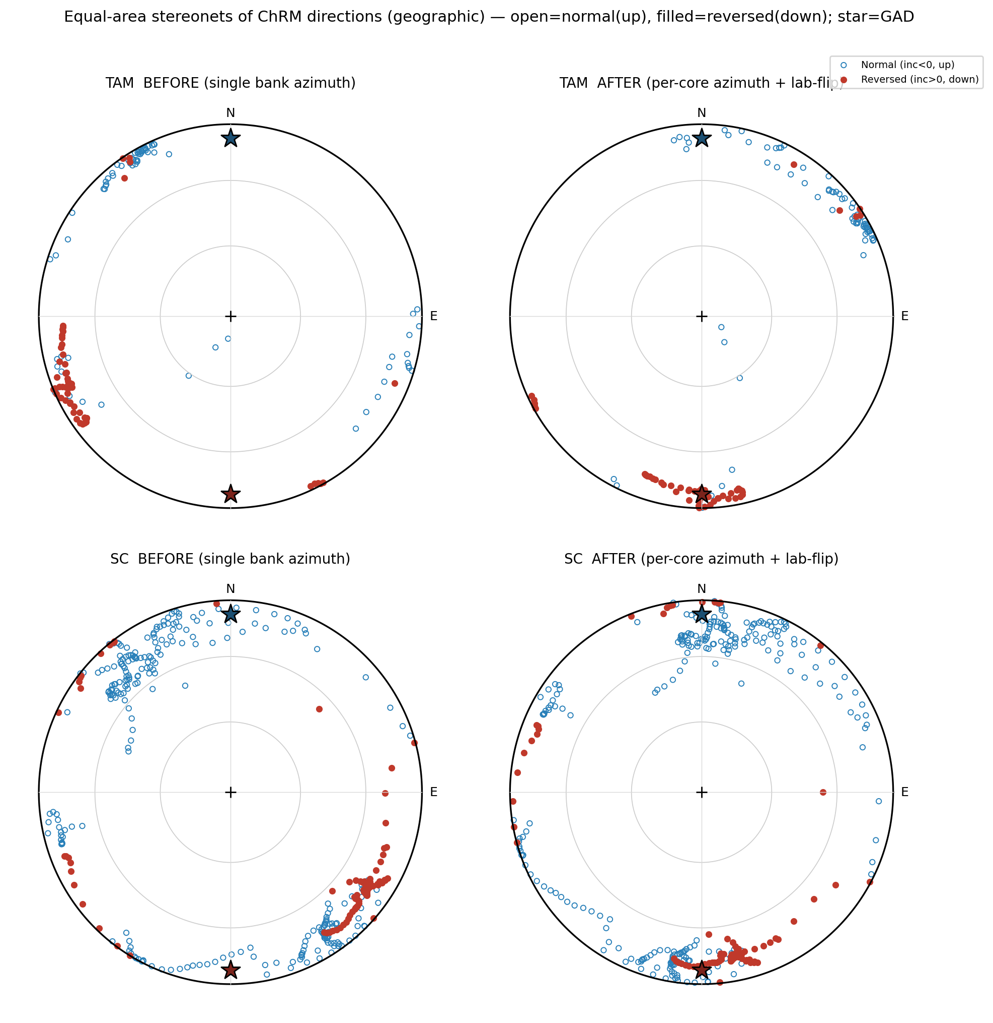
Equal-area stereonets of ChRM directions (geographic frame), before (single bank azimuth) and after per-core azimuth reconstruction (with the binary lab-flip resolved). Open $=$ normal (upward, $I<0$); filled $=$ reversed (downward, $I>0$); stars $=$ expected GAD normal/reversed directions. After reconstruction the directions collapse onto the N–S (declination $0/{180}^{∘}$) axis at the GAD directions.
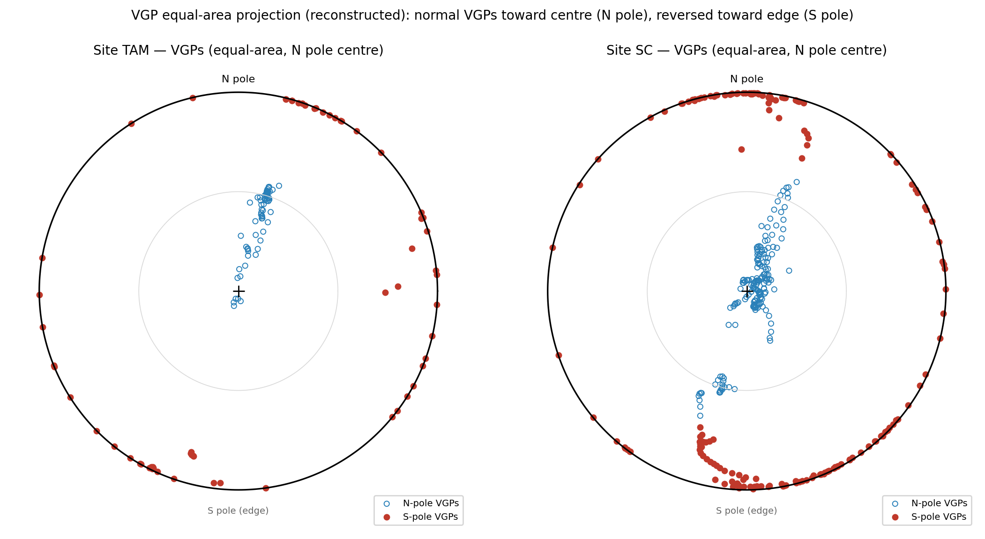
VGP equal-area projection (N pole at centre) of the reconstructed directions. Normal-polarity VGPs (open) fall toward the centre (north pole) and reversed VGPs (filled) toward the edge (south pole), for both sites.

Polarity records and internal correlation
Foam-corrected composite polarity is:
- TAM: (uppermost normal not preserved) $→$ Reversed $→$ Normal ($∼$99 cm of usable ChRM). The azimuth reconstruction additionally suggests the basal core TAM 7 is reversed (Sec. 4.3); if confirmed with better demagnetization this would make the base of TAM Reversed–Normal–Reversed (a second, low reversal), but TAM 7 is currently low-quality and this remains tentative.
- SC: Normal $→$ Reversed $→$ Normal ($∼$262 cm), with the reversal at composite depth.
Each section records (at least) one well-resolved reversal, now confirmed in both inclination and reconstructed declination; the most parsimonious interpretation is that TAM’s reversal (TAM-4) and SC’s reversal (SC-4C$→$4B) are the same event. SC’s Normal–Reversed–Normal thickness ratio ($103​:​43​:​88$ cm) is best matched by a short reversed chron between two long normals; a pattern-fit favours the C5AAr–C5ABr interval ($∼$13.2–13.7 Ma). TAM, having lost its uppermost normal, is under-constrained on its own and is consistent with the same tie.
Reversal reliability summary.
Boundary | Inc. flip | Rel. decl. flip / antipodal | Verdict
SC 4C$→$4B | yes | yes ($∼$157°) | true reversal (high)
TAM 3A$→$4 | yes (gradual) | partial | true transition (moderate)
TAM 4$→$5E | no | $∼$182° | rotation artifact
TAM 5A$→$6 | no | $∼$140° | rotation artifact
TAM 6$→$7 | possible | $∼$188°$​^{*}$ | possible N$→$R reversal (tentative)
SC 7B | no | $∼$180° | rotation artifact
$​^{*}$After azimuth reconstruction TAM 7 fits a reversed direction for any orientation consistent with its neighbours, so the TAM 6/7 declination jump may be a genuine N$→$R reversal rather than only a tray rotation; TAM 7 is low-quality, so this is tentative.
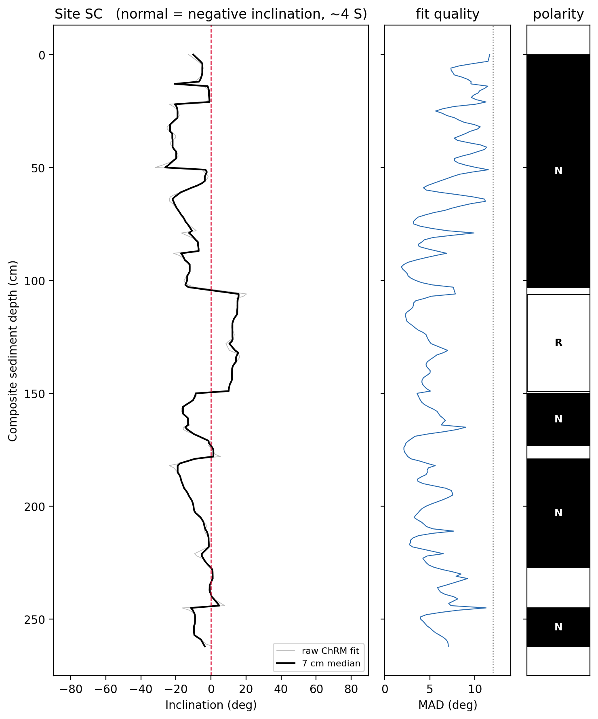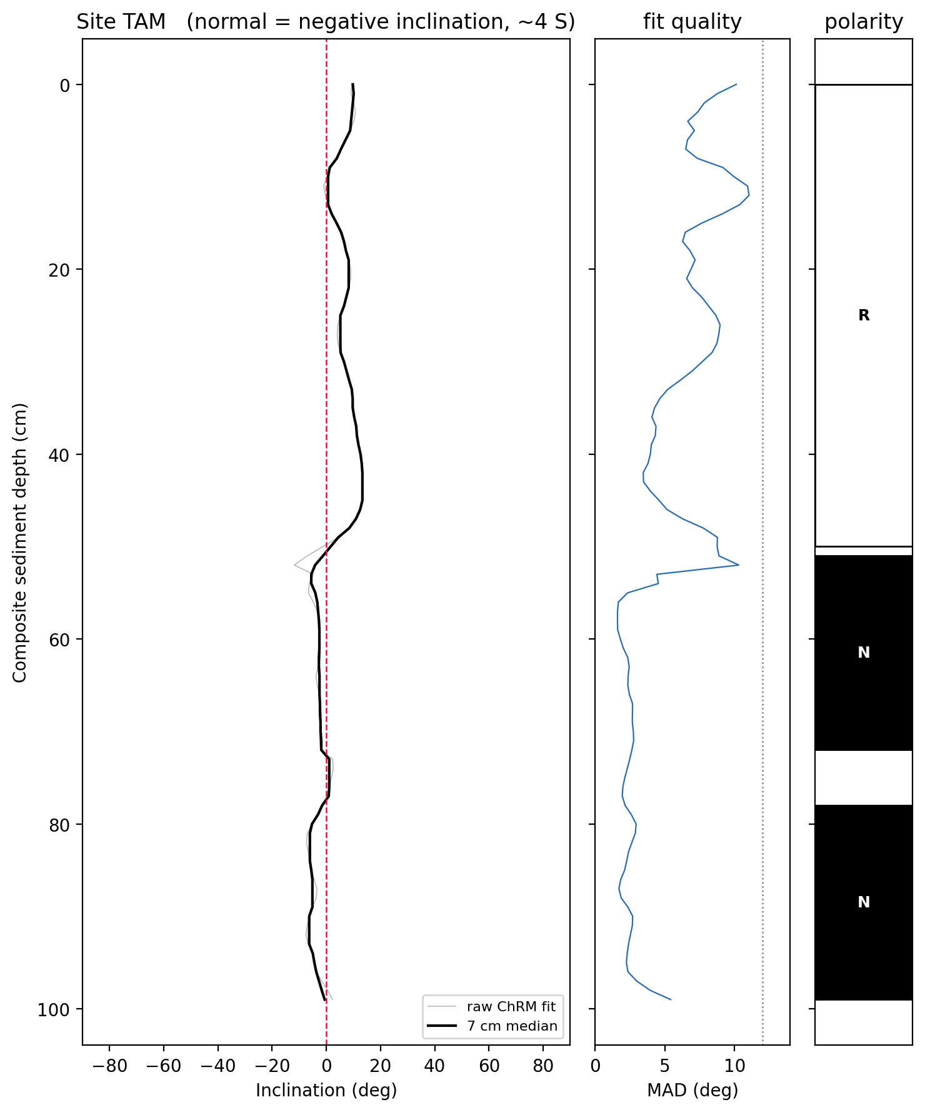

Rock-magnetic and XRF results
NRM intensity co-varies with magnetic susceptibility in three of four matched cores (log-intensity vs. susceptibility $r≈0.5$–$0.75$; TAM 3A weaker at $0.23$). Because susceptibility scales with magnetic-mineral concentration, downcore intensity minima are interpreted as real sediment-property changes (magnetite-poor, clay- or organic-rich intervals) rather than artifacts. Two intervals show anomalously low or negative susceptibility — SC 7C (susceptibility $∼$100$×$ lower than adjacent cores) and SC 2 (diamagnetic) — and carry correspondingly unreliable directions; these are masked in the polarity interpretation.
The 27 XRF scans (1906 validity-filtered points) were depth-registered to the paleomagnetic record per group (XRF position/10 $=$ measured u-channel position). Contrary to the initial expectation that magnetic-mineral (Fe) content would predict remanence intensity, total Fe is only weakly and inconsistently related to NRM intensity (per-group Pearson $r$ on log-log $−0.10$ to $+0.45$; pooled, within-group-standardized $r≈+0.16$; Fe/Ti $r≈+0.08$). This is not a registration artifact: a depth-lag scan peaks at zero offset and a coarse (5 cm-binned) comparison gives the same weak result ($r≈+0.18$).
Instead, Fe co-varies with S and Ca: log Fe vs. log S reaches $r=+0.5$–$0.7$ (pooled $+0.39$) and log Fe vs. log Ca reaches $r=+0.7$–$0.9$ (pooled $+0.56$). We interpret this to mean that in this organic-rich, reducing, lignitic facies most iron resides in authigenic phases — pyrite (Fe–S) and carbonate/shell-associated or Fe-carbonate intervals (Fe–Ca) — rather than in detrital magnetite. Total Fe measured by XRF is therefore a poor proxy for the remanence carrier here, which is why it fails to track NRM intensity even though susceptibility does ($r≈0.5$–$0.75$; above). The two groups with the strongest Fe–intensity coupling (TAM 5B–5A–6–7, $r≈0.45$; SC 3B–3A–4, $r≈0.27$) are also those with the strongest Fe–S/Fe–Ca signal, i.e. where a larger detrital component is preserved.
The implication is that reductive diagenesis (pyritisation) exerted a first-order control on the magnetic mineralogy: it both sequestered iron into pyrite and diluted or dissolved the detrital magnetite that carries the remanence, producing the low-intensity, low-susceptibility intervals. The lithological control on remanence intensity is thus real, but it is diagnosed by susceptibility, not by XRF Fe; XRF instead resolves the diagenetic (pyrite) and carbonate/detrital architecture of the section. Downcore profiles and cross-plots are given below (Figs 5, 6).
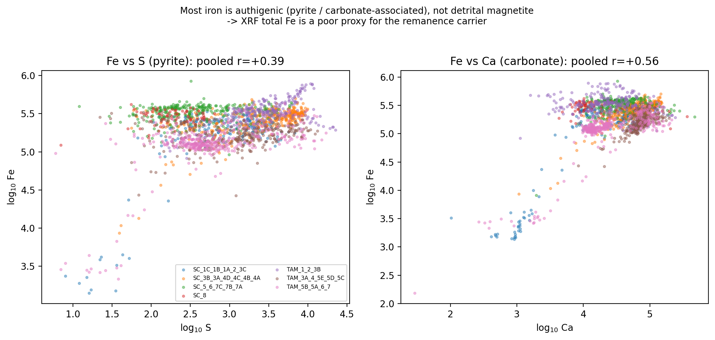
XRF total Fe co-varies with S (pyrite; pooled $r=+0.39$) and Ca (carbonate; pooled $r=+0.56$), indicating that most iron is authigenic rather than detrital magnetite. This is why total Fe does not predict the magnetite-controlled remanence intensity.
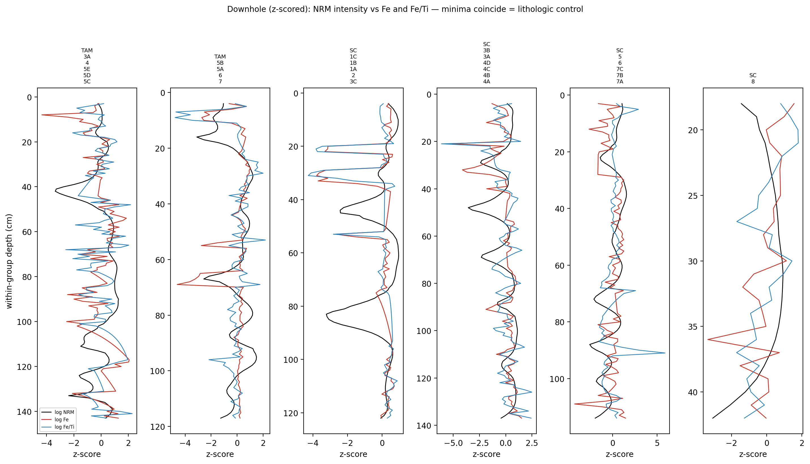
Downhole (within-group $z$-scored) NRM intensity vs. Fe and Fe/Ti. The lack of consistent coincidence between intensity and Fe minima confirms that XRF Fe is a poor proxy for the remanence carrier; susceptibility (not shown) remains the reliable magnetic-concentration proxy.

Elemental stratigraphy
Downcore, the elements most diagnostic of the depositional environment vary by one to two orders of magnitude and co-vary systematically (Fig. 7). Sulphur (pyrite) ranges over $∼$two orders of magnitude (10th–90th percentile $∼$110–6000 peak-area units) and is highest in discrete, decimetre-scale intervals; Fe and Ca track those same intervals (pooled log–log $r$: Fe–S $=+0.39$, Fe–Ca $=+0.56$, S–Ca $=+0.57$), and Ca in turn co-varies with Sr ($r=+0.62$), the expected signature of aragonitic mollusc carbonate. Fe/Ti (authigenic-Fe enrichment above the detrital baseline) rises in the same pyrite-and-carbonate-rich intervals, whereas K/Ti (a clay/detrital proxy) is comparatively flat, indicating the elemental variability is driven by authigenic mineral formation rather than changing detrital provenance. Manganese, mobile under reducing pore-waters, is low in the most pyritic intervals.
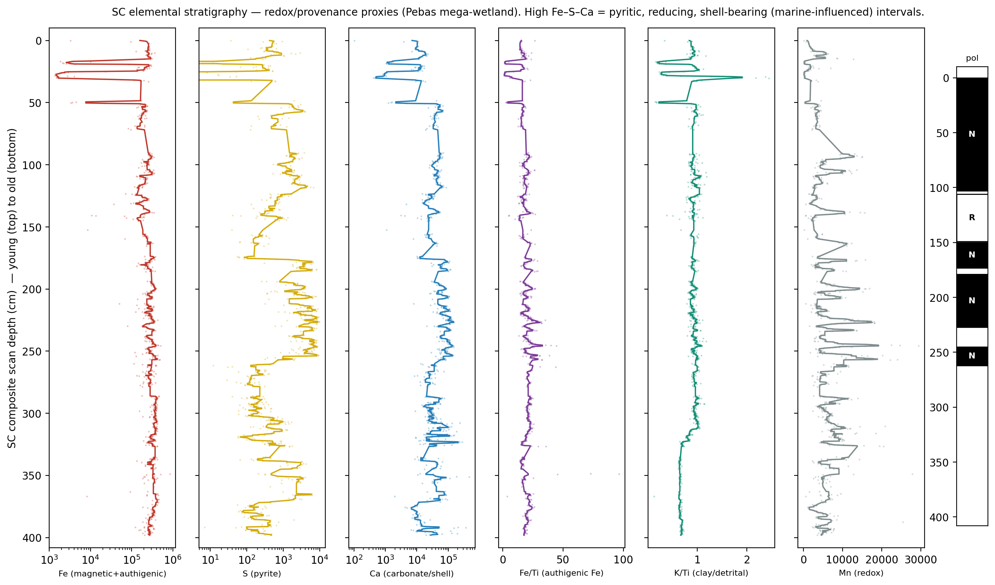
Elemental stratigraphy of the SC composite (valid XRF points; running median). Sulphur (pyrite), Fe and Ca (carbonate/shell, with Sr) are enriched together in discrete reducing intervals; Fe/Ti (authigenic Fe) tracks them while K/Ti (detrital) stays flat and Mn (redox) is depressed. Polarity column at right. Depth is approximate composite scan depth (young at top).

Fossil age control: Purussaurus
A cranial fossil of the giant caiman Purussaurus was recovered at TAM at 2.71 m in the measured section (Fig. 9), in the basal lignite of parasequence TmB and $∼$0.17 m above the top of the measured magnetic record (2.54 m), which ends within C5AAr. Purussaurus is a middle-to-late Miocene genus whose oldest records (P. neivensis) occur in the Pebas Formation near Iquitos, where it is the apex predator of a $∼$13 Ma crocodylian assemblage dated by palynology and mollusc/ostracod zonation (Salas-Gismondi et al., 2015; Pujos & Salas-Gismondi, 2020), and at La Venta (Colombia; the Monkey Beds, $∼$12.0–12.2 Ma; Mora-Rojas et al., 2023). The genus therefore imposes a maximum-age (older) bound of $∼$13.8 Ma on the fossil horizon — the complement of the palynological T-15/T-16 minimum-age bound of 12.7 Ma. Together these independent constraints bracket the section to $∼$12.7–13.8 Ma (and, using the $∼$13 Ma Iquitos-Pebas assemblage age, to $∼$12.7–13.0 Ma), consistent with the magnetostratigraphic correlation to C5AAr–C5ABr (Fig. 8). The independent, U-Pb-based refinement of this ceiling from La Venta is developed in Section 6.1.
Caveats: (i) genus-level identification alone permits only the broad mid–late Miocene ($∼$13–6.8 Ma) range; the tight bound requires species identification, as only P. neivensis is diagnostically middle Miocene (a late Miocene species — P. mirandai, P. brasiliensis — would falsify the $∼$13 Ma reading). (ii) Because Purussaurus in Amazonia is partly calibrated by the Pebas itself, the independent leg of the argument is La Venta, where P. neivensis is now dated by U-Pb zircon geochronology (Section 6.1; Mora-Rojas et al., 2023), not only mammal biostratigraphy. That dated occurrence (Monkey Beds, C5An.1n) is $∼$1 Myr younger than the Iquitos horizon, so it constrains the species’ range rather than the Iquitos age; the La Venta leg of our age argument is the U-Pb-calibrated age model at the level of La Venta’s C5AAr, not the fossil. (iii) The fossil lies in the (excluded) Group 1 interval, so it presently anchors the section as a whole rather than a specific polarity zone.
The Pebas facies (blue-grey lignitic clays, Pebasian fauna) together with this Pebas-fauna vertebrate exclude a younger fluvial-terrace or Nauta-Formation origin for the section; the terrace, Nauta, and Madre-de-Diós units of the region overlie, and are younger than, the sediments studied here.
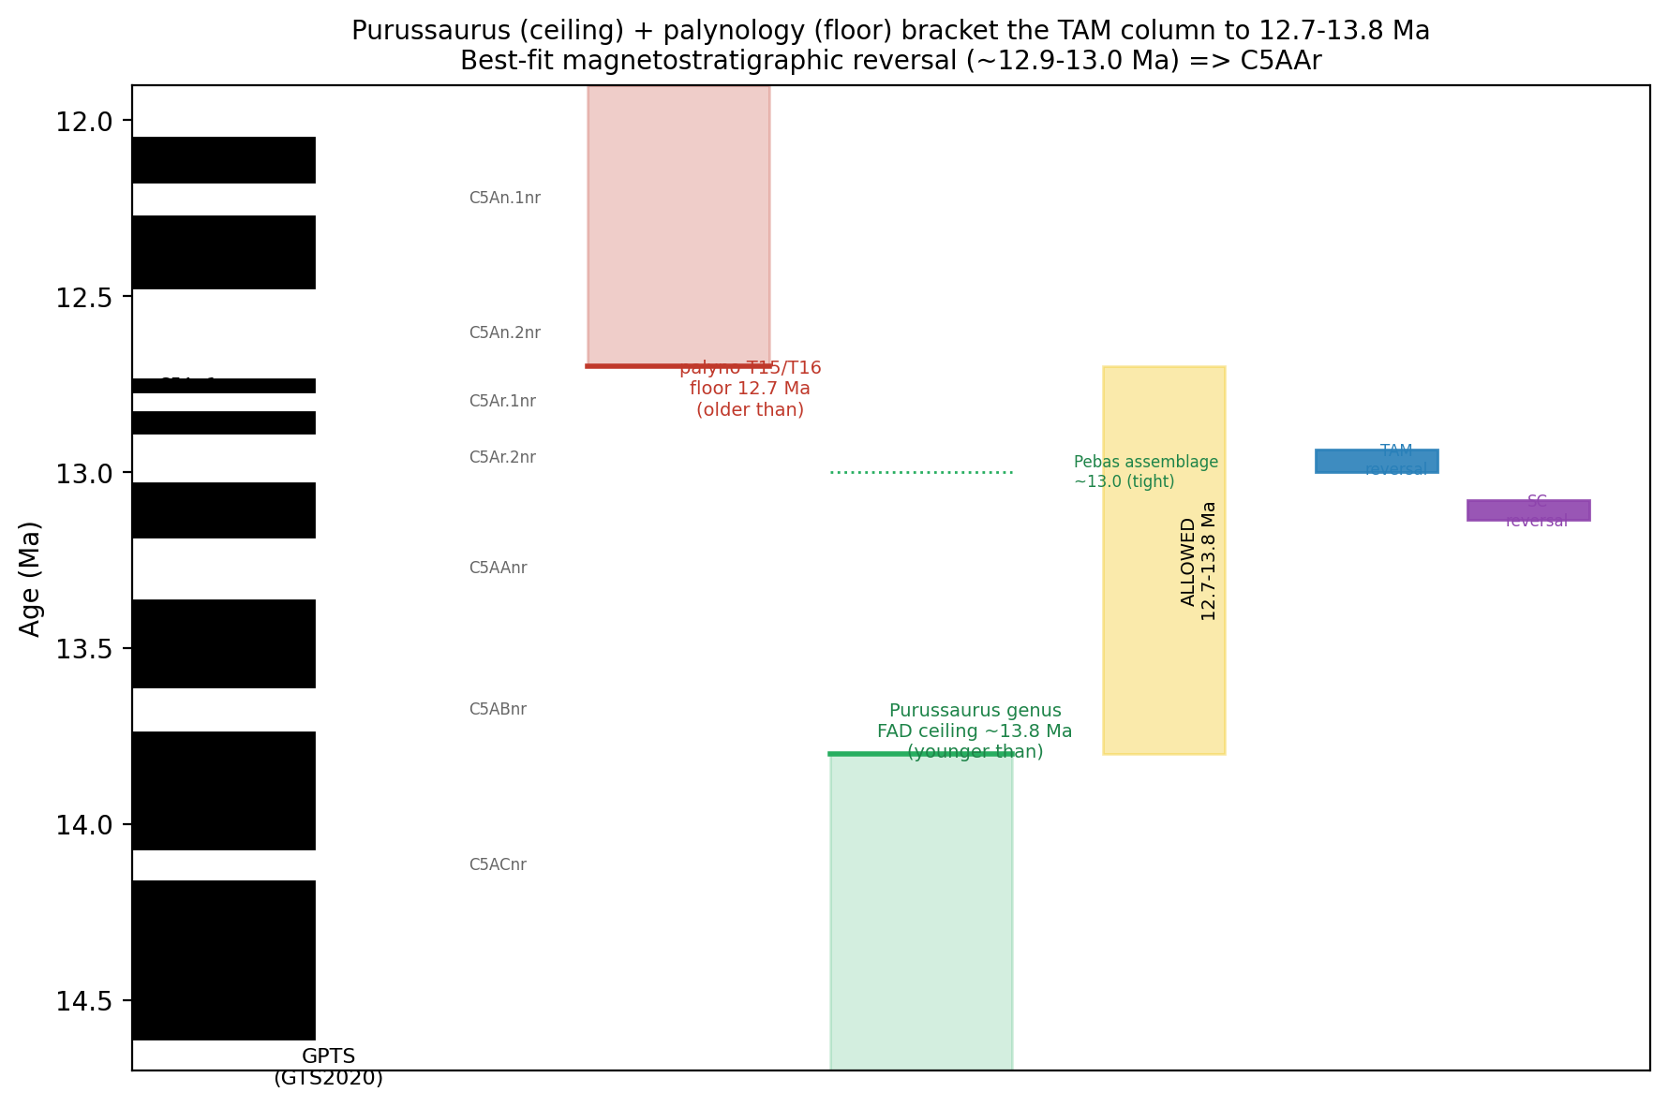
The Purussaurus genus ceiling ($<∼$13.8 Ma) and the palynological T-15/T-16 floor ($>$12.7 Ma) bracket the section to $∼$12.7–13.8 Ma; the tighter Iquitos-Pebas assemblage age ($∼$13 Ma) narrows it further. The best-fit magnetostratigraphic reversal falls at the young edge of this bracket.

Regional correlation to La Venta (Honda Group)
The strongest independent calibration of Purussaurus neivensis comes not from the Pebas (which would be circular) but from La Venta in the Tatacoa Desert, Colombia, whose Honda Group has recently been re-dated with new U-Pb zircon geochronology and a Bayesian age–depth model (Mora-Rojas et al., 2023; Carrillo et al., 2023). In that framework the La Victoria Formation spans $<$16 to 12.58 Ma and the Villavieja Formation 12.58 to 10.52 Ma (Table 1), and the magnetostratigraphy is reinterpreted as chrons C5ABn (base) through C5An.1n (top) on the ATNTS2012/GTS2020 scale, reinterpreting the Flynn et al. (1997) polarity sequence. In their composite standard section (Fig. 9), C5AAr occupies 153.5–176.6 m and the fossil-rich “Monkey Beds” that yield P. neivensis (stratigraphic level 9, $∼$557–566 m) lie $∼$13 m above the base of C5An.1n ($≤$12.17), at $∼$12.0–12.2 Ma in the U-Pb age model. (Their text groups stratigraphic levels 7–12 with C5Ar.2r–C5Ar.1r, but both their polarity column and age model place level 9 in C5An.1n, which we adopt.) The La Venta P. neivensis is therefore $∼$1 Myr younger than the Iquitos horizon.
The same framework dates the Tamshiyacu horizon itself. Because the fossil lies just above the top of the measured C5AAr record, it is bracketed by C5AAr–C5AAn (); its chron-equivalent position in La Venta is the C5AAr top, at 176.6 m in the composite section. We sample the La Venta U-Pb age model (Mora-Rojas et al., 2023, their table 4: ten samples, median and 95% CI interpolated in depth) uniformly over ($−20$/$+15$ m about that level, to span the no-polarity gap above the TAM record and the cross-basin mapping), and intersect the draws with the chron bracket (Monte Carlo, $3×{10}^{5}$ draws). The inferred age is 13.18 (95% CI ); the age model alone is broad at this level (13.13 Ma, 95% CI 12.75–13.51 Ma), so the precision comes from the magnetostratigraphic bracket rather than from the U-Pb dates in isolation. Independently, Carrillo et al. (2023) note that Laventan-equivalent beds are now recognised at Tamshiyacu itself (near Iquitos), sharing taxa with La Venta.
This lets us tie the Peru record to a regional, radiometrically calibrated reversal sequence rather than to the abstract GPTS alone (Fig. 9). The preferred correlation places the Peru reversal in C5AAr ($∼$13.2–13.4 Ma): it satisfies (i) the SC polarity-pattern fit, (ii) the palynological floor, (iii) the Purussaurus ceiling, and (iv) the U-Pb-calibrated La Venta age model at La Venta’s C5AAr (e.g. sample 44011 at 218.8 m, 13.1 Ma), which all overlap at $∼$13.2–13.4 Ma. This converts the earlier tentative $∼$13 Ma tie into one anchored on zircon dates.
U-Pb zircon ages for the Honda Group (La Venta), from Mora-Rojas et al. (2023). Median and 95% CI from the Bayesian age model; YSP $=$ youngest statistical population.
Sample | Strat. (m) | Age (Ma, 95% CI) | Type
TVV-01 | 932 | 11.5 (10.52–12.09) | detrital MDA
SEL-02 | 503 | 12.3 (11.79–12.74) | tuff, YSP 12.8$±$0.1
TVV-04 | 474 | 12.3 (11.80–12.77) | tuff, YSP 12.8$±$0.1
44011 | 218.8 | 13.1 (12.69–13.47) | tuff, YSP 13.9$±$0.3
44017 | 63.5 | 16.0 (15.94–16.00) | tuff, YSP 17.6$±$0.4
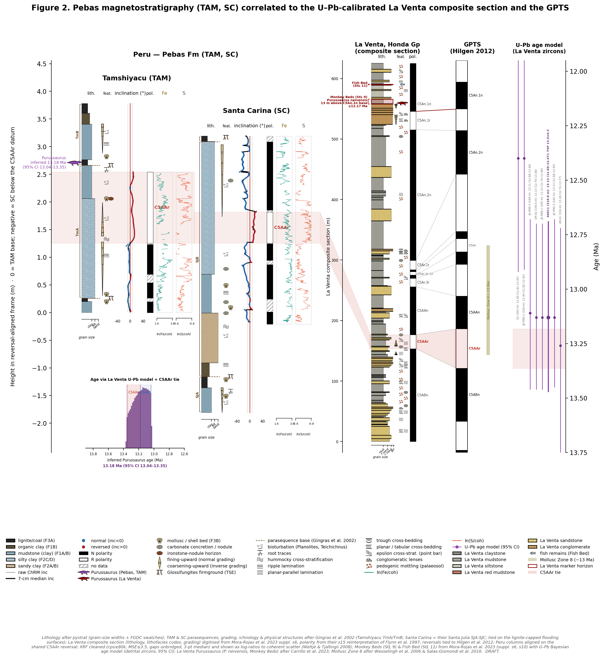
Master magnetostratigraphic correlation. Left — Tamshiyacu (TAM) and Santa Carina (SC): lithology (pystrat; facies after Gingras et al., 2002); a feature lane with grading (fining-/coarsening-upward), Glossifungites firmgrounds, bioturbation, root traces, hummocky cross-stratification, ripples, molluscs and concretions; parasequence brackets (TmA–TmB, SJA–SJC) with dashed basal surfaces; ChRM inclination; polarity (hatched $=$ no data, incl. the NRM-only upper TAM core); and log-ratio XRF over the full scanned interval, hung on the shared C5AAr reversal (red band over each site’s reversed interval). The Tamshiyacu Purussaurus (purple) carries its inferred age (posterior inset). Right — the La Venta composite section (0–625 m, digitised from Mora-Rojas et al., 2023) with the Monkey Beds (StL 9; La Venta P. neivensis, dark red) and Fish Bed (StL 11), its reinterpreted polarity column, the ATNTS2012 GPTS (Hilgen et al., 2012), and the La Venta U-Pb age model (95% CI). Ribbons tie C5AAr from Peru to La Venta to the GPTS; dashed lines tie each La Venta reversal to its GPTS boundary (solid dark red: base of C5An.1n, 12.17 Ma, 13 m below the Monkey Beds).

Discussion

Age of the Pebas Formation at Tamshiyacu
Four independent lines of evidence converge on a middle Miocene age of $∼$ (chron C5AAr) for the studied succession. (i) The polarity record: each site preserves a single robust reversal, now expressed antipodally in both inclination and reconstructed declination, and SC’s Normal–Reversed–Normal thickness ratio favours a short reversed chron between two long normals (C5AAr–C5ABr). (ii) Palynology places the section in zone T-15 / base T-16, a firm minimum-age (younger-than) bound of 12.7. (iii) The giant caiman Purussaurus supplies the complementary maximum-age (older-than) bound: the genus does not appear before $∼$13.8. (iv) Most decisively, the U-Pb-calibrated La Venta age model (Mora-Rojas et al., 2023) dates the La Venta C5AAr interval (153.5–176.6 m in the composite section) at 13.18–13.36 Ma, an anchor independent of the Pebas itself and therefore free of the circularity that weakens a Pebas-internal argument. (The La Venta P. neivensis, from the Monkey Beds in C5An.1n, is $∼$1 Myr younger and does not enter the age argument.) These four constraints overlap only around C5AAr, and the independent recognition of Laventan-equivalent beds at Tamshiyacu (Carrillo et al., 2023) corroborates the correlation. The tie is further consistent with molluscan biostratigraphy: the hyperdiverse Iquitos crocodylian assemblage, including Gryposuchus pachakamue, is placed in Mollusc Zone 8 ($∼$13 Ma) in the same district (Salas-Gismondi et al., 2016), in agreement with our C5AAr calibration but at coarser ($∼$1 Myr) resolution. The middle-Miocene calibration is robust to the choice of GTS2020/ATNTS2012 vs. CK95 (a shift), which is smaller than the current tie uncertainty.

Magnetic mineralogy and diagenetic overprinting
The ChRM is a shallow, dual-polarity, primary detrital remanence, but its intensity is strongly modulated by diagenesis rather than by the primary depositional flux of magnetic minerals. NRM intensity tracks susceptibility ($r≈0.5$–$0.75$) — both measuring magnetite concentration — yet is essentially uncorrelated with XRF total Fe, because in this facies most iron is locked in authigenic phases (pyrite and carbonate; Sec. 5.1) rather than in detrital magnetite. The most pyritic intervals are also the lowest in remanence intensity and susceptibility, implying that bacterial sulphate reduction consumed reactive iron and partly dissolved detrital (titano)magnetite, driving the low-intensity zones. This is the expected behaviour of an organic-rich, reducing sediment and it explains why polarity in those intervals is noise-prone and best read from the surviving high-coercivity ChRM. It also means XRF Fe cannot substitute for rock-magnetic measurements as a magnetic-concentration proxy here — a transferable caution for magnetostratigraphy in reducing tropical wetland deposits.

A freshwater mega-wetland with episodic marine influence
The elemental stratigraphy is best read within the framework of the Pebas mega-wetland (Hoorn et al., 2010a; Wesselingh & Salo, 2006): a vast, long-lived, low-gradient system of shallow lakes, swamps and floodplains that covered much of western Amazonia through the middle Miocene — in scale and dynamics the closest modern analogue is a greatly enlarged Everglades-type wetland rather than a coastal or deltaic setting. The system was dominantly freshwater to oligohaline, as shown by its hyperdiverse endemic mollusc fauna (cochliopid gastropods, pachydontine and corbulid bivalves), whose diversity and endemism themselves require a persistent, stable, largely freshwater water body (Wesselingh & Salo, 2006). Marine influence was real but episodic and subordinate — short brackish ingressions punctuating a freshwater background rather than a standing marine connection.
The XRF cycles record exactly this behaviour. Against a reducing, organic-rich freshwater substrate — the natural state of a peat/marl mega-wetland — discrete intervals enriched in S, Fe and Ca (with Sr) mark the episodic events. Authigenic pyrite (Fe–S) forms where bacterial sulphate reduction operates below the sediment–water interface, and in a freshwater system its abundance is limited chiefly by the scarce supply of dissolved sulphate; the strong, punctuated pyrite enrichments therefore most plausibly track brief pulses of enhanced sulphate availability, i.e. the brackish ingressions independently inferred from molluscan and geochemical proxies (Wesselingh & Salo, 2006). Slow net accumulation (below) reinforces this: prolonged residence below the redoxcline in a sediment-starved wetland favours pyritisation even where sulphate is only intermittently supplied. The co-enrichment of Ca and Sr in the same beds — aragonitic Pebasian mollusc coquinas — ties shell beds and pyritic muds to the same low-energy, reducing episodes, while flatter K/Ti and higher Mn between them indicate more oxygenated, detritally-diluted freshwater intervals. The section thus does not record a static environment, nor a marine-dominated one, but a persistent freshwater mega-wetland briefly and repeatedly perturbed by marginal-marine incursions during peak inundation.
This reading is strongly supported by the ichnology and sedimentology of the same two exposures. Gingras et al. (2002) document, at Tamshiyacu and Santa Julia, marginal-marine to brackish trace-fossil suites (Thalassinoides, Ophiomorpha, Teichichnus, Rhizocorallium, Scolicia), Glossifungites firmground discontinuities, and rhythmic tidal couplets — including semidiurnal (neap–spring) laminae sets preserved as burrow infills — indicating deposition in a tidally-influenced, sporadically dysaerobic, stratified brackish-water bay margin. Their evidence places our XRF pyrite signal in a concrete process context: the “sporadically dysaerobic, marine-to-brackish” bottom waters they infer are precisely the setting in which bacterial sulphate reduction pyritises the mud, and our F3B shell beds are the winnowed transgressive lags of their model. Our elemental record and their ichnological record thus converge on the same conclusion — genuine, repeated marine influence superimposed on a dominantly freshwater wetland — addressing the long-standing lacustrine (Wesselingh & Salo, 2006) versus tidal-brackish (Gingras et al., 2002) debate from a new (geochemical + magnetostratigraphic) angle.
The architecture also explains why the two sections correlate only loosely. Gingras et al. (2002) show that low accommodation space and repetitive, rapid relative-sea-level swings produced an “atypical” parasequence architecture in which lignite-capped flooding surfaces form repeatedly and are laterally variable. Such lignites are therefore diachronous facies boundaries, not time lines. Tying Tamshiyacu and Santa Carina on their lower lignites (a lithofacies correlation) places their magnetic reversals at different heights, forcing the polarity records out of agreement. When the sections are instead hung on the reversal, the magnetostratigraphy becomes horizontal: both record a normal-below-to-reversed transition at the datum — the shared C5ABn–C5AAr boundary — with Santa Carina continuing upward into the succeeding normal chron (C5AAn) and Tamshiyacu truncated within C5AAr. The two sections thus share the C5AAr reversal, and the Purussaurus cranial horizon at Tamshiyacu falls within C5AAr, $∼$1 Myr before the U-Pb-dated La Venta occurrence of P. neivensis in the Monkey Beds (C5An.1n; Mora-Rojas et al., 2023), extending the dated record of the genus back into the peak of the Pebas wetland. The lignite flooding surfaces do not align once the reversals are matched, confirming their diachroneity; we therefore correlate the sections in time by the reversal and treat the lignite/flooding-surface ties as facies markers, the offset between them quantifying the diachroneity expected in a low-accommodation bay-margin succession.
The two sites also differ systematically in facies, consistent with occupying different positions on that low-gradient margin. Tamshiyacu is mud- and silt-dominated (86% of the section; no clean sand facies, no carbonate concretions), the quieter, more basinward bay-centre setting; Santa Carina is coarser and more fossiliferous — a metre-scale sand body (18% F2 sand), additional mollusc/shell beds (F3B) and carbonate concretions — the more marginal, higher-energy bay-margin setting nearer the sediment and shell source. This lateral facies gradient is itself expected to make the parasequence-capping lignites diachronous between the two localities, reinforcing the correlation logic above.

Sedimentation rate, paleoclimate, and the road to the modern Amazon
The magnetostratigraphy indicates a strongly condensed succession. Taking the reversed chron C5AAr ($∼$180 kyr; GTS2020) against its $∼$0.5 m expression at Santa Carina gives an accumulation rate of only $∼$3 m/Myr (compacted; $∼$6–9 m/Myr decompacted). Even the most generous reading — in which the cored $∼$3.4 m at Santa Carina represents the full C5ABn–C5AAn interval — yields only $∼$10–20 m/Myr. This net rate is an order of magnitude lower than the short-term and regional estimates: Hoorn et al. (2022) infer $∼$4 m, 41-kyr obliquity cycles in the Pebas (implying $∼$100 m/Myr of intra-cycle accumulation), and the formation reaches $∼$350–1000 m over its $∼$8-Myr life ($∼$45–130 m/Myr regional average; Hoorn et al., 2010a). The discrepancy is itself diagnostic. It records incompleteness: at a sediment-starved, low-accommodation bay margin (Gingras et al., 2002) deposition was rapid within cycles but was repeatedly interrupted by non-deposition, transgressive erosion (the Glossifungites firmgrounds and TSEs) and winnowing (the shell lags), so that net accumulation is slow even where short-term rates are high. Our sections sample this condensed margin rather than the thick depocentre. The Tamshiyacu record is further truncated: usable polarity spans only the lower $∼$2.5 m (Groups 2–3), while the uppermost $∼$1.3 m (Group 1, the Purussaurus-bearing lignite and capping beds) yielded no reliable remanence and is left as a data gap. The record is thus condensed and incomplete rather than continuous — the expected signature of the repetitive, rapidly-shifting base level of a low-accommodation bay-margin wetland.
Two independent checks against ODP Site 1237 (Leg 202, Nazca Ridge; Mix et al., 2003) support both the rate and the age. First, the shipboard age-depth model of that continuous, GPTS-tied pelagic-carbonate section gives a corrected linear sedimentation rate of only $∼$6–9 m/Myr through 12–15 Ma ($∼$7.7 m/Myr at 13 Ma) — essentially our decompacted value — confirming that low net accumulation at a sediment-starved site is expected at this time and that our rate is not anomalous. Second, ChRM inclinations from the Site 1237 demagnetisation data, placed on that age model, record the C5AAn–C5AAr normal-to-reversed transition at $∼$13.2–13.3 Ma (Fig. 10), independently reproducing the age of the reversal we tie to. (The Site 1237 polarity reconstructed here is limited by the 1-Myr age-model ties and does not resolve the thin C5ABn normal, so it is a first-order age cross-check rather than a chron-by-chron match.)
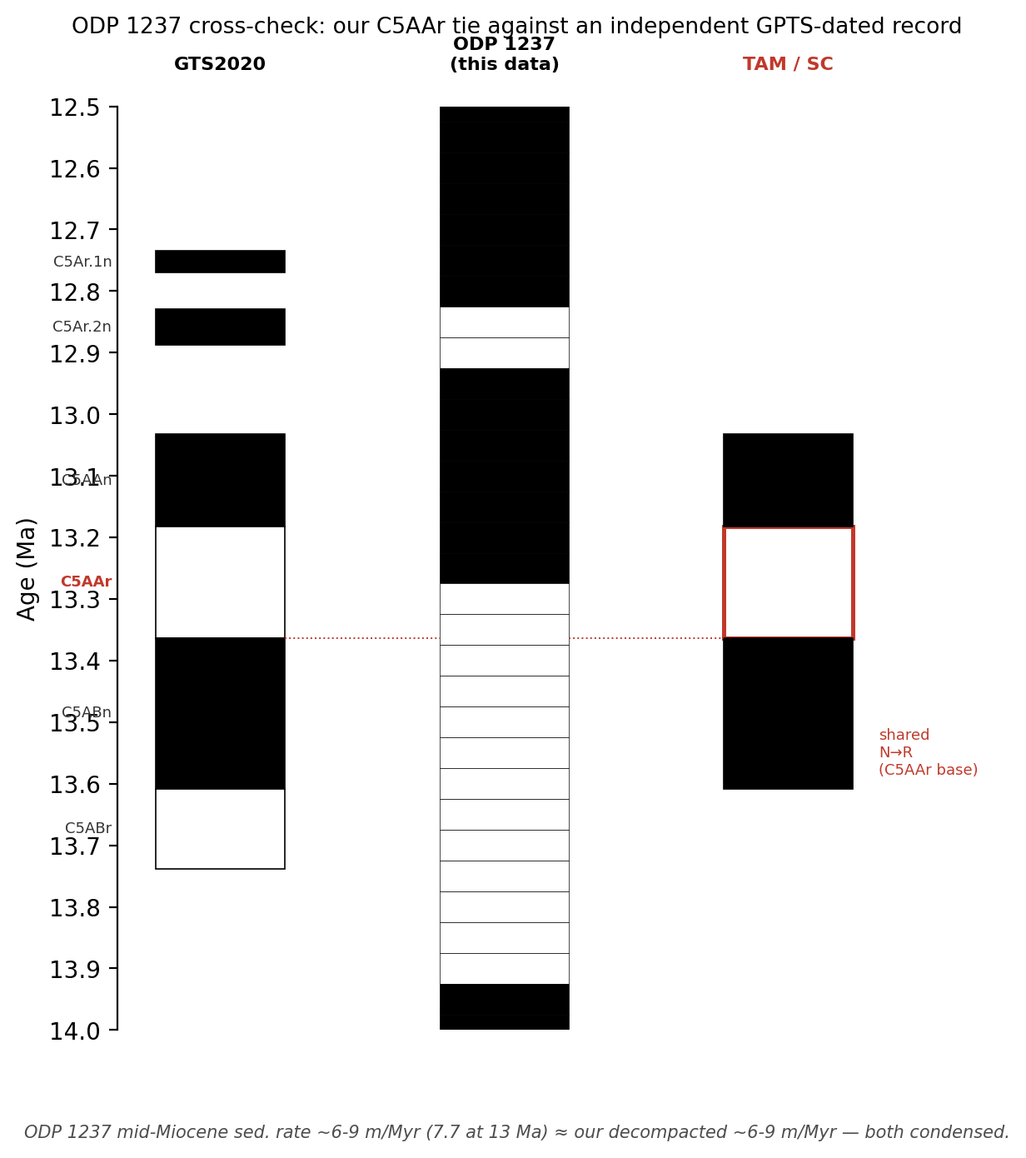
Cross-check against ODP Site 1237 (Leg 202, Nazca Ridge; Mix et al., 2003). GTS2020 chrons (left); polarity from the Site 1237 AF-demagnetisation data on the shipboard age-depth model (centre); and the interval calibrated here (right). Site 1237 independently records the C5AAn–C5AAr transition at $∼$13.2–13.3 Ma and gives a mid-Miocene rate ($∼$7.7 m/Myr at 13 Ma) matching our decompacted estimate.
Climatically, the $∼$13 Ma interval sits immediately after the Middle Miocene Climatic Transition (MMCT, $∼$14.2–13.8 Ma), the global cooling that ended the Middle Miocene Climatic Optimum; in western Amazonia this coincided with the maximum extent of the mega-wetland, sustained by Andean-foreland subsidence and a very low regional gradient. Our record captures the peak-wetland phase of a longer landscape trajectory: the Pebas system persisted through the middle Miocene before the late-Miocene reorganisation of Amazonian drainage, when the establishment of the modern transcontinental Amazon River and the growth of its deep-sea fan ($∼$11–9.4 Ma; Figueiredo et al., 2009; Hoorn et al., 2010a; Hoorn et al., 2017) drained and replaced the wetland with the fluvial system seen today. Placed on the magnetostratigraphic age model, the Tamshiyacu succession provides a polarity-calibrated tie-point within the Pan-Amazonian framework (La Venta, Contamana, the Marañón and Solimões basins) near the apex of the Pebas mega-wetland, against which the timing of individual incursions and the onset of drainage reorganisation can be tested. More broadly, by pinning a single fossil horizon to a $∼$180 kyr polarity chron and placing it against the U-Pb-dated La Venta section, the approach converts an abundant but coarsely dated fauna — the crocodylian radiations of the Pebas mega-wetland among them (Salas-Gismondi et al., 2015; Salas-Gismondi et al., 2016) — into a sub-million-year chronologic framework, the resolution required to test rates of diversification, dispersal, and morphological evolution and a template for dating the many other fossiliferous Pebas cutbanks that presently lack direct GPTS control.

Limitations and next steps
The GPTS tie rests on a single well-resolved reversal per site; recovering a second reversal in one continuous section (e.g. confirming the tentative TAM 7 reversal with fuller demagnetisation, or re-measuring the excluded TAM Group 1) would make the correlation unique rather than best-fit. Species-level confirmation of the Tamshiyacu Purussaurus would convert the vertebrate constraint from a genus-level ceiling into a tight ($∼$) tie. The azimuth reconstruction would tighten with a physically fixed reference offset (from confirming the x- vs y-face convention) and a re-check of the anomalous TAM 6 field azimuth. Finally, the XRF–environment interpretation is currently qualitative and depth-registered only approximately; quantitative sulphate/marine-influence inference would benefit from paired ⁸⁷Sr/⁸⁶Sr or S-isotope measurements on the pyritic and shell-bearing intervals identified here.

Data and code availability
Processing scripts and derived data (polarity zones, age-model scenarios, multi-timescale chron tables, fossil-bracket analysis) are archived in the project repository (polarity_synthesis/, age_model_ assessment/) and in Uchannel_notebook.ipynb.
99 Cande, S.C., Kent, D.V., 1992. A new geomagnetic polarity time scale for the Late Cretaceous and Cenozoic. J. Geophys. Res. 97, 13917–13951. Cande, S.C., Kent, D.V., 1995. Revised calibration of the geomagnetic polarity timescale for the Late Cretaceous and Cenozoic. J. Geophys. Res. 100, 6093–6095. Carrillo, J.D., Jaramillo, C., Abadía, F., et al., 2023. The Miocene La Venta Biome (Colombia): a century of research and future perspectives. Geodiversitas 45(26): 739–767. Figueiredo, J., Hoorn, C., van der Ven, P., Soares, E., 2009. Late Miocene onset of the Amazon River and the Amazon deep-sea fan: evidence from the Foz do Amazonas Basin. Geology 37, 619–622. Flynn, J.J., Guerrero, J., Swisher, C.C., III, 1997. Geochronology of the Honda Group. In: Kay, R.F., Madden, R.H., Cifelli, R.L., Flynn, J.J. (Eds.), Vertebrate Paleontology in the Neotropics: The Miocene Fauna of La Venta, Colombia. Smithsonian Institution Press, Washington, D.C., pp. 44–59.
Gingras, M.K., Räsänen, M.E., Pemberton, S.G., Romero, L.P., 2002. Ichnology and sedimentology reveal depositional characteristics of bay-margin parasequences in the Miocene Amazonian foreland basin. J. Sediment. Res. 72, 871–883. Hilgen, F.J., Lourens, L.J., Van Dam, J.A., et al., 2012. The Neogene Period. In: The Geologic Time Scale 2012, Elsevier, ch. 29. Hoorn, C., 1993. Marine incursions and the influence of Andean tectonics on the Miocene depositional history of northwestern Amazonia: results of a palynostratigraphic study. Palaeogeogr. Palaeoclimatol. Palaeoecol. 105, 267–309. Hoorn, C., 1994. An environmental reconstruction of the palaeo-Amazon River system (Middle–Late Miocene, NW Amazonia). Palaeogeogr. Palaeoclimatol. Palaeoecol. 112, 187–238. Hoorn, C., et al., 2010a. Amazonia through time: Andean uplift, climate change, landscape evolution, and biodiversity. Science 330, 927–931. Hoorn, C., Wesselingh, F.P., Hovikoski, J., Guerrero, J., 2010b. The development of the Amazonian mega-wetland (Miocene; Brazil, Colombia, Peru, Bolivia). In: Hoorn, C., Wesselingh, F.P. (Eds.), Amazonia: Landscape and Species Evolution: A Look into the Past. Wiley-Blackwell, Oxford, pp. 123–142. Hoorn, C., Bogotá-A, G.R., Romero-Baez, M., et al., 2017. The Amazon at sea: onset and stages of the Amazon River from a marine record, with special reference to Neogene plant turnover in the drainage basin. Global and Planetary Change 153, 51–65. Hoorn, C., Kukla, T., Bogotá-Angel, G., et al., 2022. Cyclic sediment deposition by orbital forcing in the Miocene wetland of western Amazonia? New insights from a multidisciplinary approach. Global and Planetary Change 210, 103717. Jaramillo, C., Rueda, M., Torres, V., 2011. A palynological zonation for the Cenozoic of the Llanos and Llanos Foothills of Colombia. Palynology 35, 46–84. Jaramillo, C., et al., 2017. Miocene flooding events of western Amazonia. Science Advances 3, e1601693. Kirschvink, J.L., 1980. The least-squares line and plane and the analysis of palaeomagnetic data. Geophys. J. R. Astron. Soc. 62, 699–718. Mix, A.C., Tiedemann, R., Blum, P., et al., 2003. Proceedings of the Ocean Drilling Program, Initial Reports, vol. 202. Ocean Drilling Program, College Station, Texas. Mora-Rojas, L., Cárdenas, A., Jaramillo, C., et al., 2023. Stratigraphy of a middle Miocene neotropical Lagerstätte (La Venta Site, Colombia). Geodiversitas 45(6): 197–221. Pujos, F., Salas-Gismondi, R., 2020. Predation of the giant Miocene caiman Purussaurus on a mylodontid ground sloth. Biology Letters 16, 20200239. Raffi, I., et al., 2020. The Neogene Period. In: Geologic Time Scale 2020, Elsevier. Räsänen, M.E., Linna, A.M., Santos, J.C.R., Negri, F.R., 1995. Late Miocene tidal deposits in the Amazonian foreland basin. Science 269, 386–390. Rebata-H., L.A., et al., 2006. Sedimentology and ichnology of tide-influenced Late Miocene successions in western Amazonia: the gradational transition between the Pebas and Nauta formations. J. South Am. Earth Sci. 21, 96–119. Salas-Gismondi, R., Flynn, J.J., Baby, P., Tejada-Lara, J.V., Wesselingh, F.P., Antoine, P.-O., 2015. A Miocene hyperdiverse crocodylian community reveals peculiar trophic dynamics in proto-Amazonian mega-wetlands. Proc. R. Soc. B 282, 20142490. Salas-Gismondi, R., Flynn, J.J., Baby, P., Tejada-Lara, J.V., Claude, J., Antoine, P.-O., 2016. A new 13 million year old gavialoid crocodylian from proto-Amazonian mega-wetlands reveals parallel evolutionary trends in skull shape linked to longirostry. PLoS ONE 11 (4), e0152453. Wesselingh, F.P., Räsänen, M.E., Irion, G., Vonhof, H.B., Kaandorp, R., Renema, W., Romero Pittman, L., Gingras, M., 2002. Lake Pebas: a palaeoecological reconstruction of a Miocene, long-lived lake complex in western Amazonia. Cainozoic Research 1, 35–81. Wesselingh, F.P., Salo, J.A., 2006. A Miocene perspective on the evolution of the Amazonian biota. Scripta Geologica 133, 439–458.

Corresponding author.

