**CST8215 (314) Database**

**International Sport Database Demo**

**Term: Summer 2020**

**Professor: Sarfraz Fayaz Khan**

**School: Algonquin College**



Yicong Zhang (040991538)

## **Abstract**

In this project, we designed a database for an International sport competition association who wants to manage the inventory of their registered athletes. Under this association, there are different sports, athletes and coaches from different countries, and stadiums for different sport matches. It is quite complicated to organize this information efficiently without a well-designed database.

The database we created focuses on maintaining all registered athletes from different countries well organized. In order to create this database, we identified the problems stated above and came up with a hand drawn solution of an ER diagram. The main table is the sport table which contains all sport competitions the association can host. The other tables are associated with the sport table. Later on, we will implement DDL, DML, and metadata with PostgreSQL.

The sample data represents record of registered athletes from different countries who have the right to participate in the competitions hosted by the association. There are eight types sport match included in the sport table and each sport match allows eight athletes to participate in. As we mentioned before, the main table in this database is the sport table which is unique. The sport is the basic factor for a competition association. Lastly, a stadium table related to the sport table, holds all the stadium options the association has.

## **Business Rules**

**Athlete and coach:**

1. An athlete and a coach are identified by an athlete ID and coach ID respectively, and they are both primary keys.

2. An athlete can participate only one sport and representing only one country.

3. A coach can serve only one sport team/athlete and representing only one country.

4. When adding an athlete or coach, it is mandatory to fill in all the information in the tables (e.g. Name, Gender, Nationality, Sport etc.)

**Sports:**

5. A sport must hold in only one stadium due to traffic convenient purpose.

6. Sport ID begins with the first letter of the sport following by five-digit number.

7. A sport can have zero or many athletes to participate in.

8. It is possible that the athletes/teams in the same sport are all from the same country.

**Country:**

9. A country has at zero or many athletes.

10. A country has at zero or many coaches.

**Stadium:**

11. A stadium can hold zero or many sports.

12. Stadium capacity data is maintained.

## **ERD design on paper**

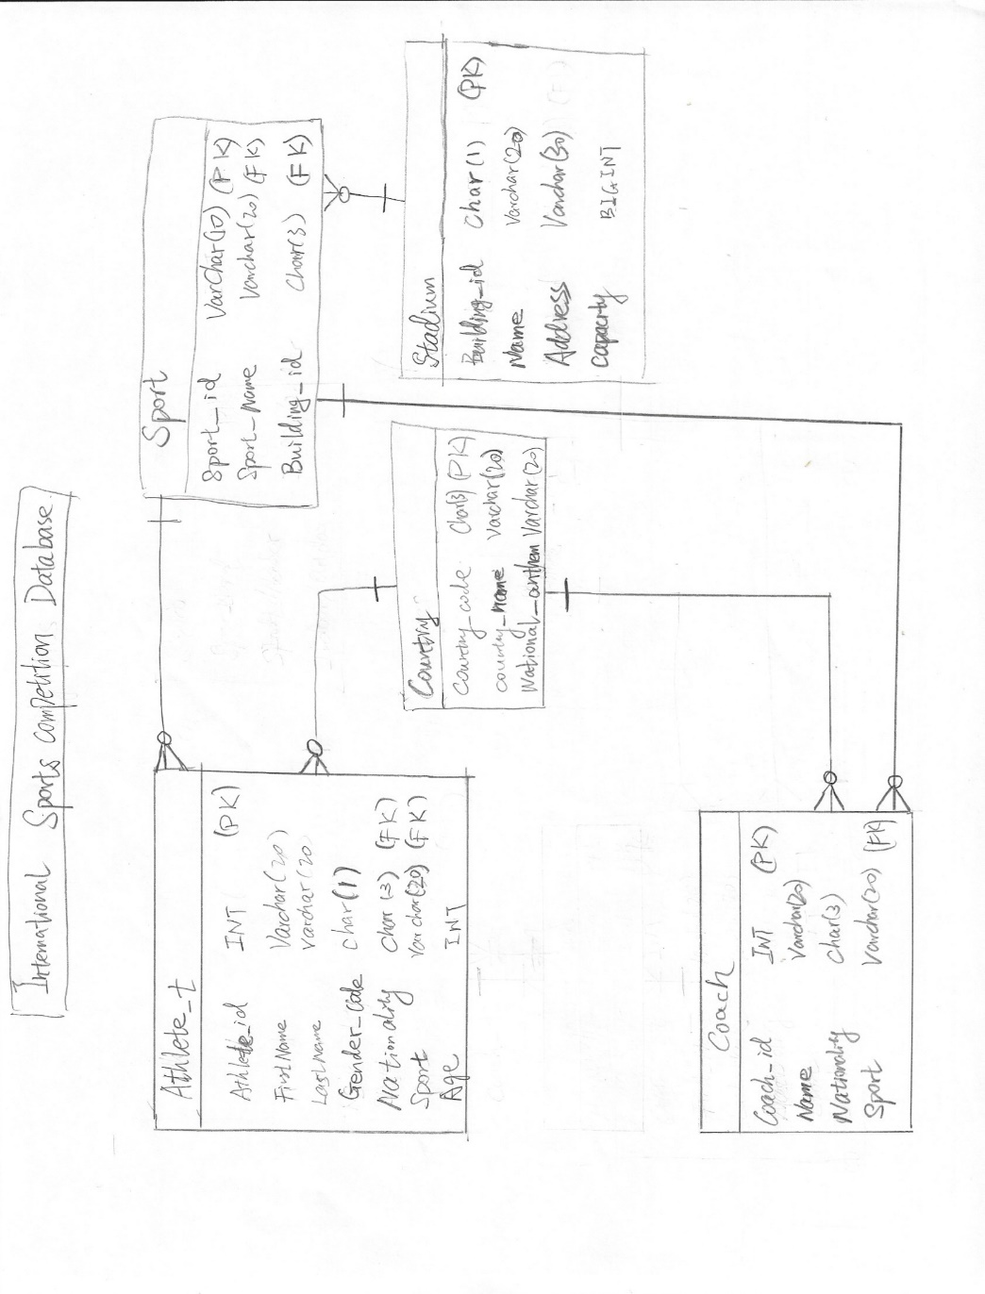

**Requirements**

1. DDL file (Assignment2_ddl.sql) to create tables is submitted as attachment. A screenshot after running the DDL file is also shown as follows.

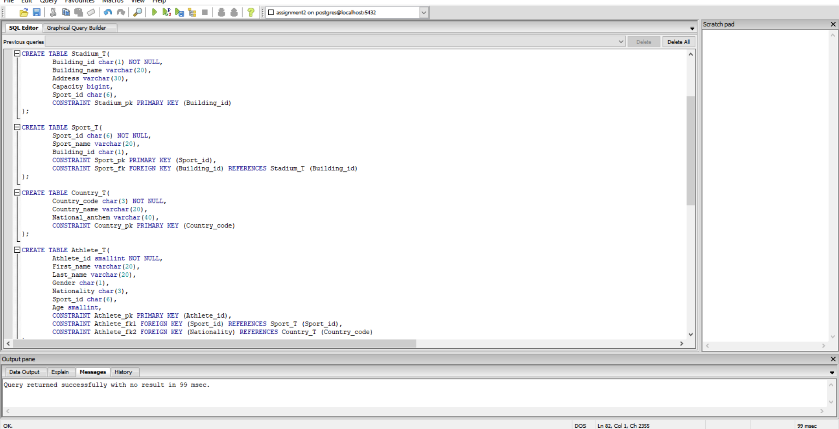

1. DML file (Assignment2_dml.sql) to insert five entities is submitted as attachment. A screenshot after running the DML file is also shown as follows.

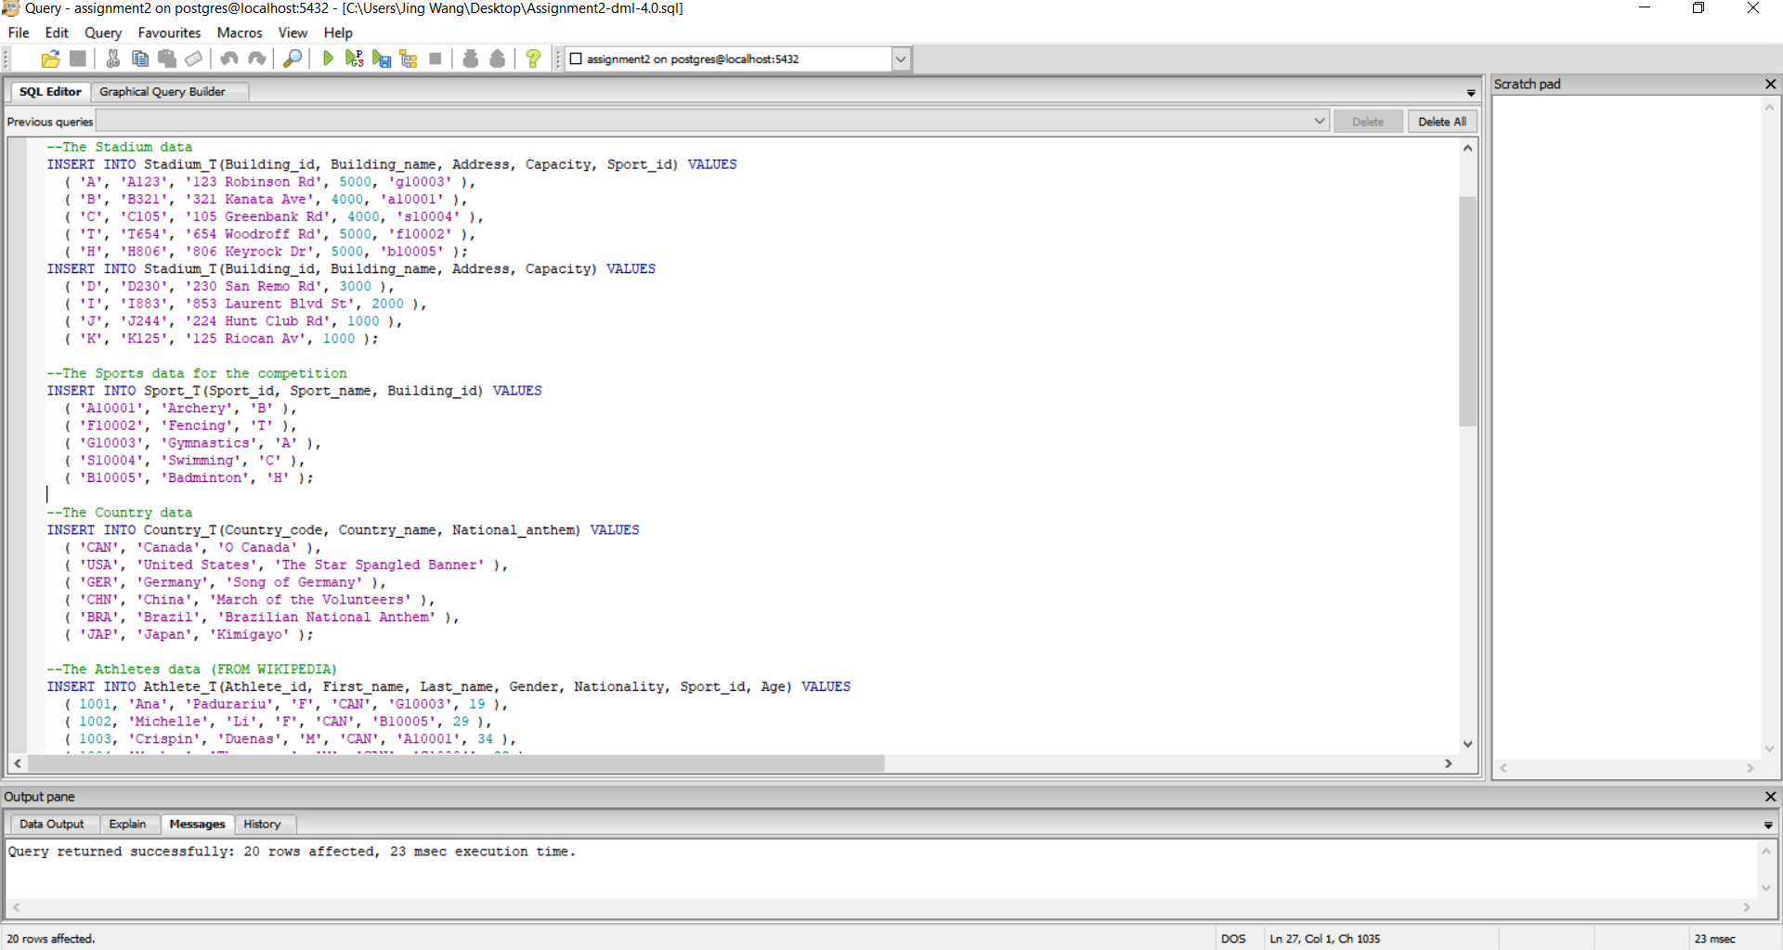

1. Three queries with their statements is submitted as attachment (Assignment2_query.sql). A screenshot after running each query is also shown as follows.

Query 1: Find buildings whose capacity is more than 4000

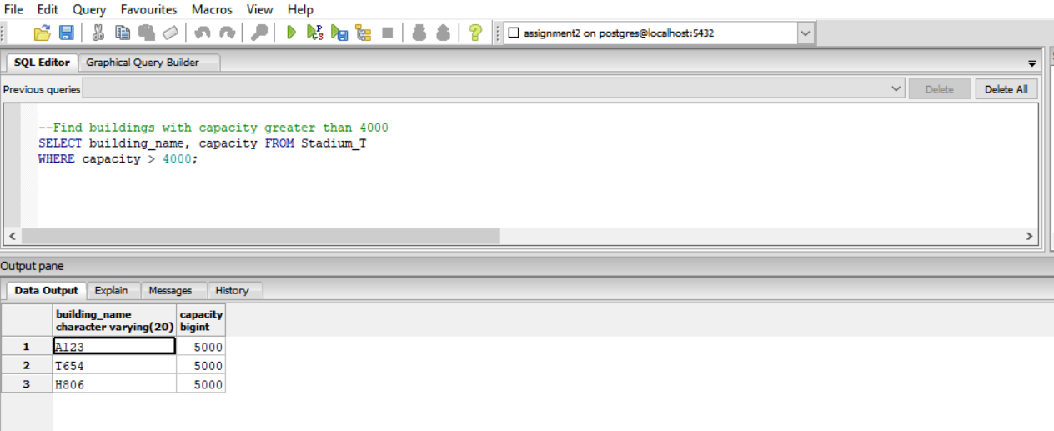

Query 2: Find female athletes who are older than 20 years old

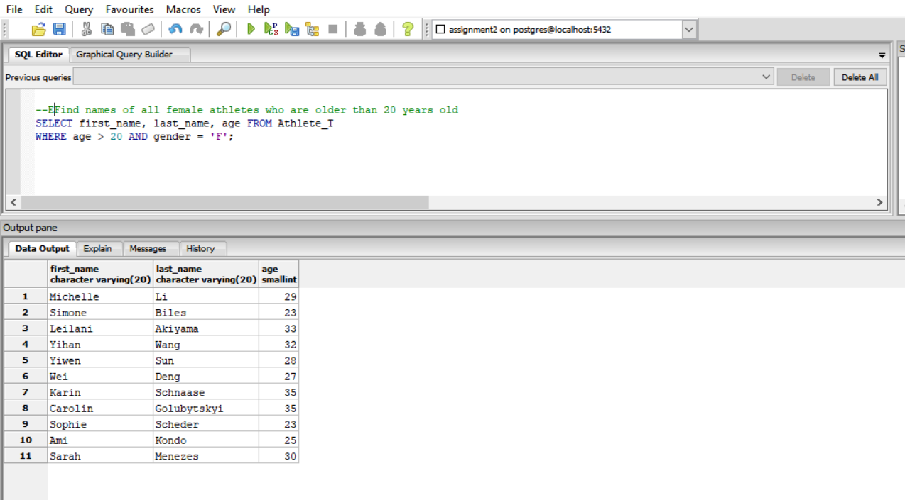

Query 3: Find all badminton coaches

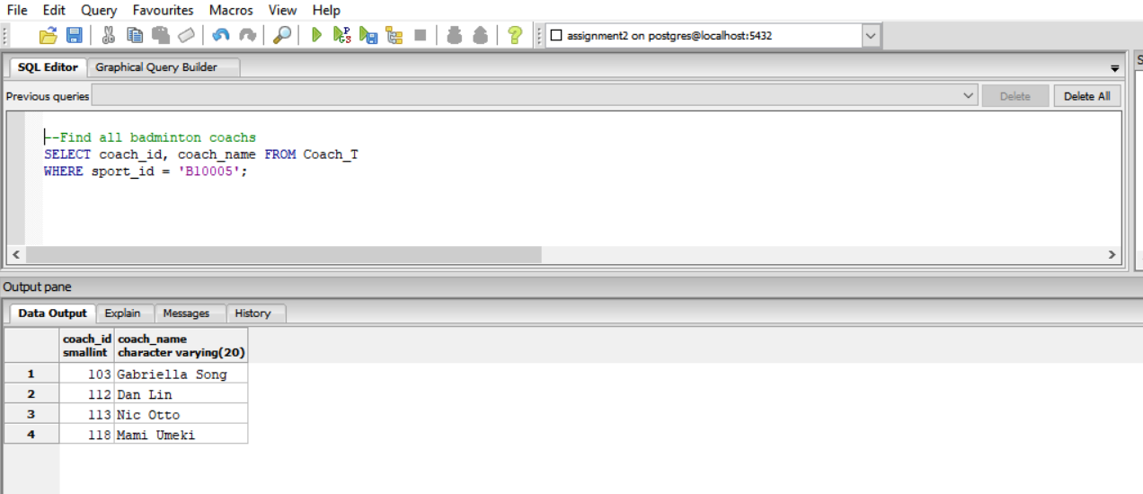

1. Two joins

Left Join: Find stadiums that do not hold any match from Stadium_T table left join Sport_T table

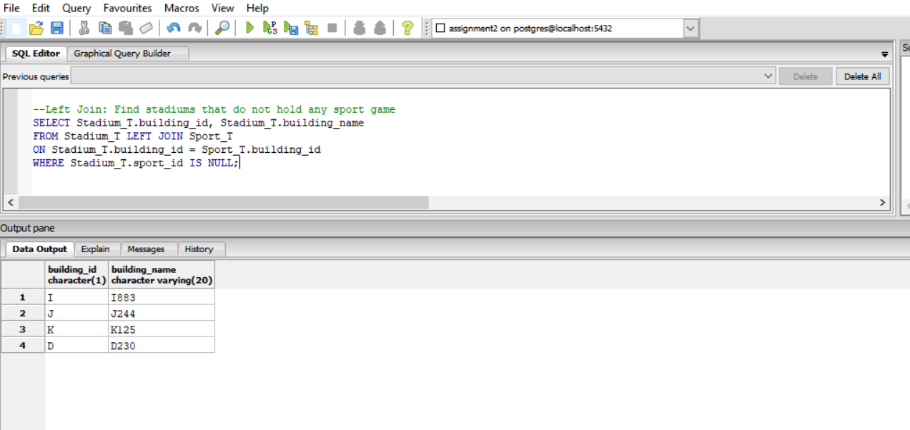

Right Join: Find athlete name and sport name for game hold in building H from Sport_T table right join Athlete_T table

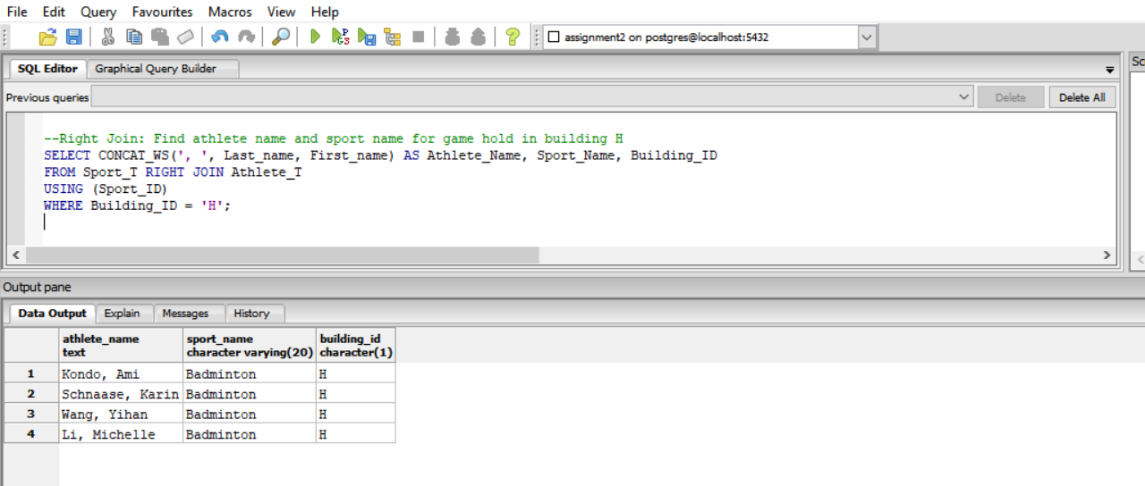

1. Sub-query

Subquery 1: Find the youngest athlete from Athlete_T table

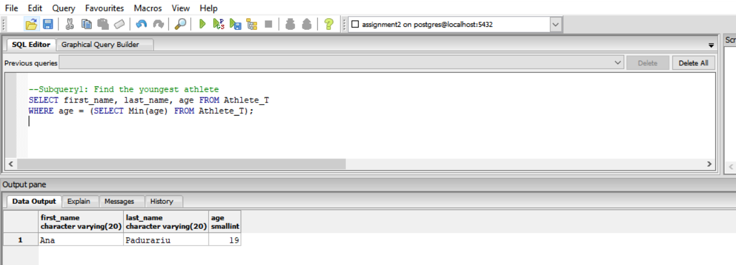

Subquery 2: Find information for all the athletes from China.

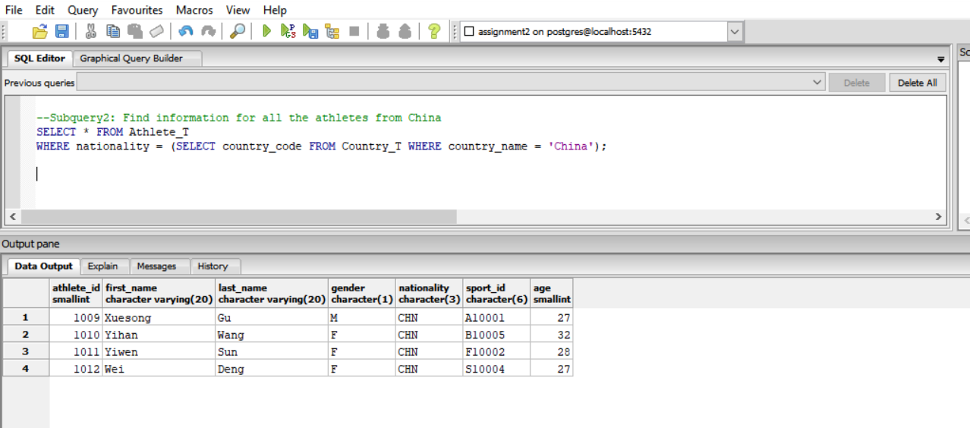

1. Two union queries

Union query 1: Find information of all athletes and coaches

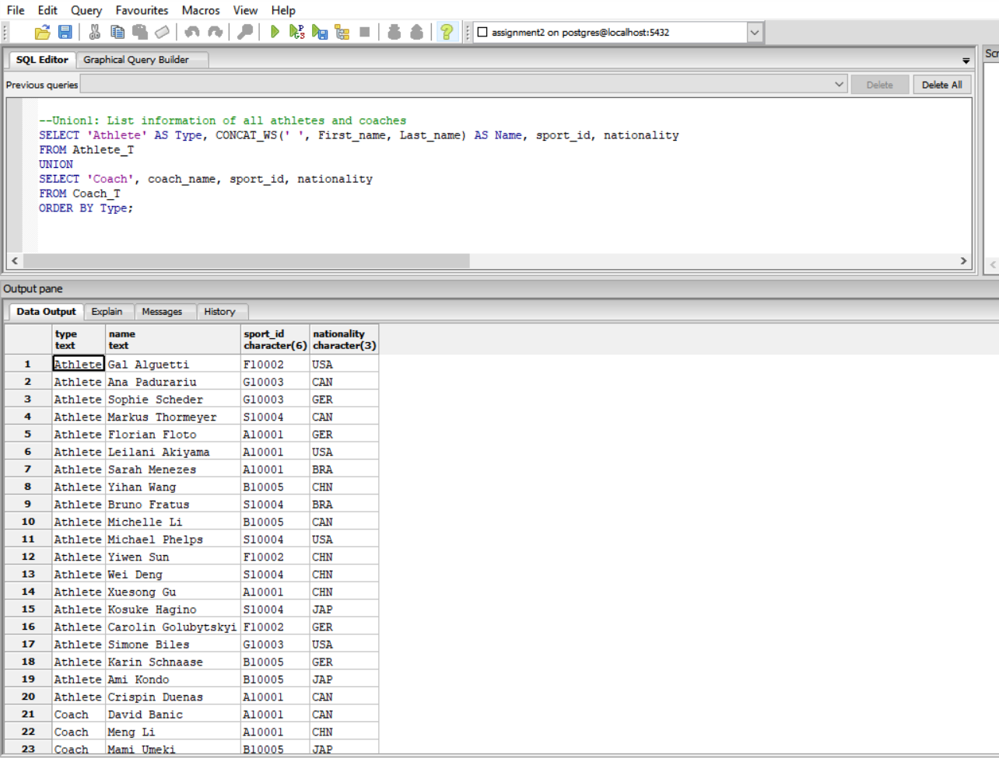

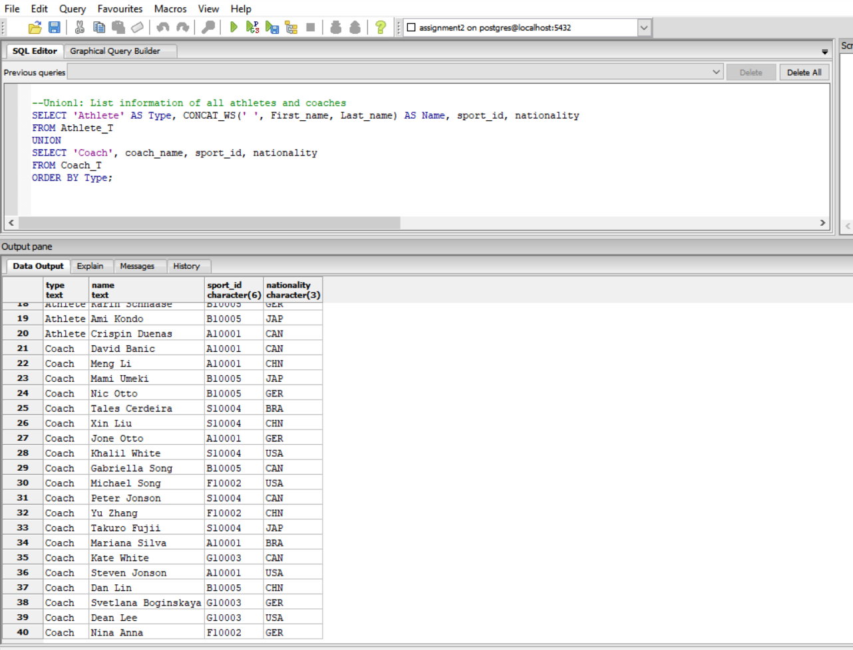

Union query 2: Find information of all athletes and coaches from Canada

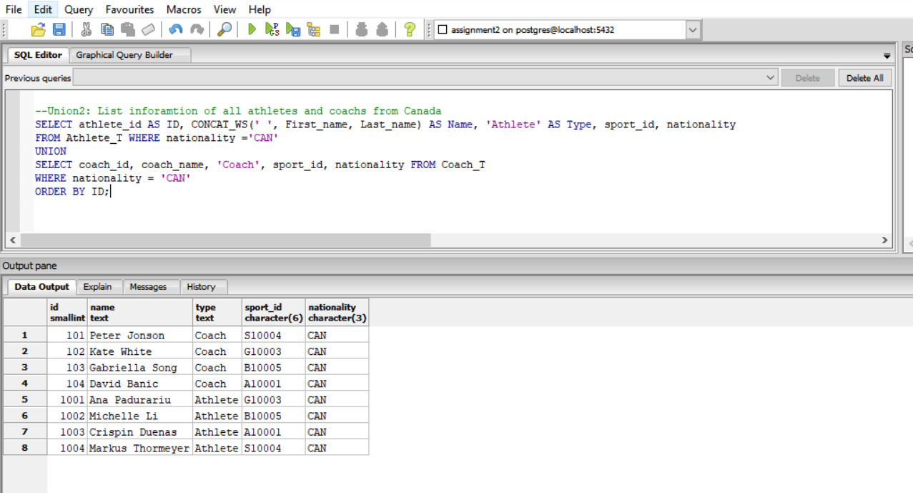

1. Index: Create one index for Athlete_T table and one for Coach_T table. The commands are presented in an attached file (Assignment2_idx.sql).

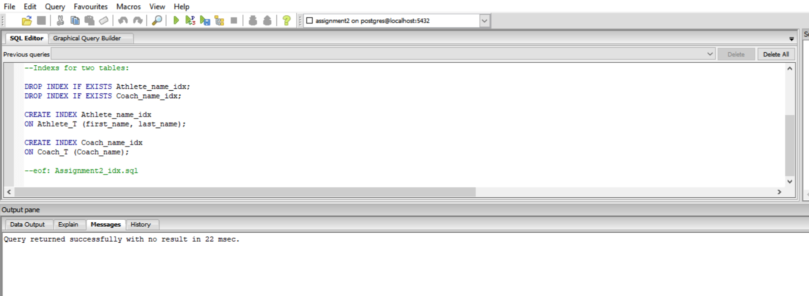

1. Two views

View1: All Canadian athletes who are younger than the average athlete age

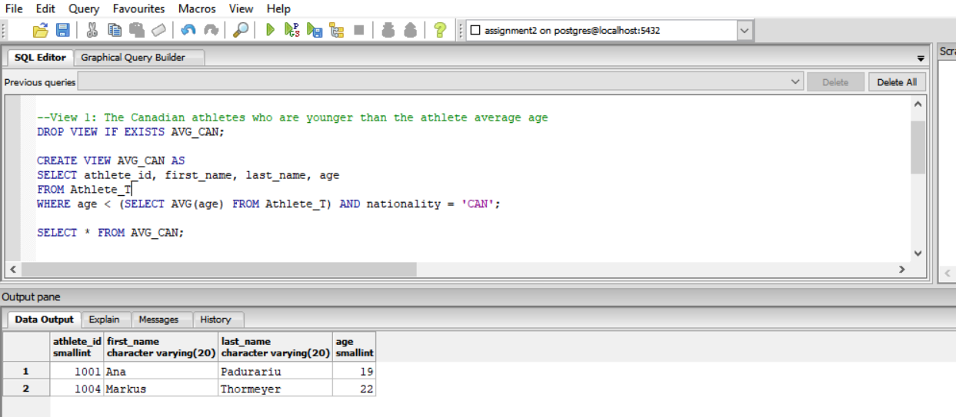

View 2: The information of all athletes who participate in swimming game

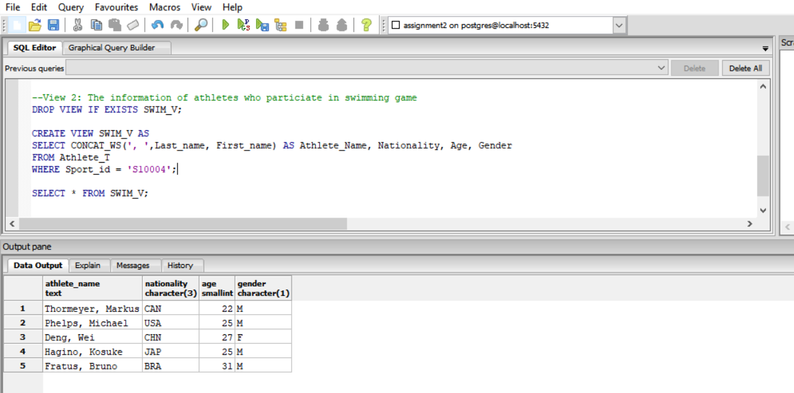

1. Reverse engineering: the ER Diagram obtained from reverse engineering is shown as follows

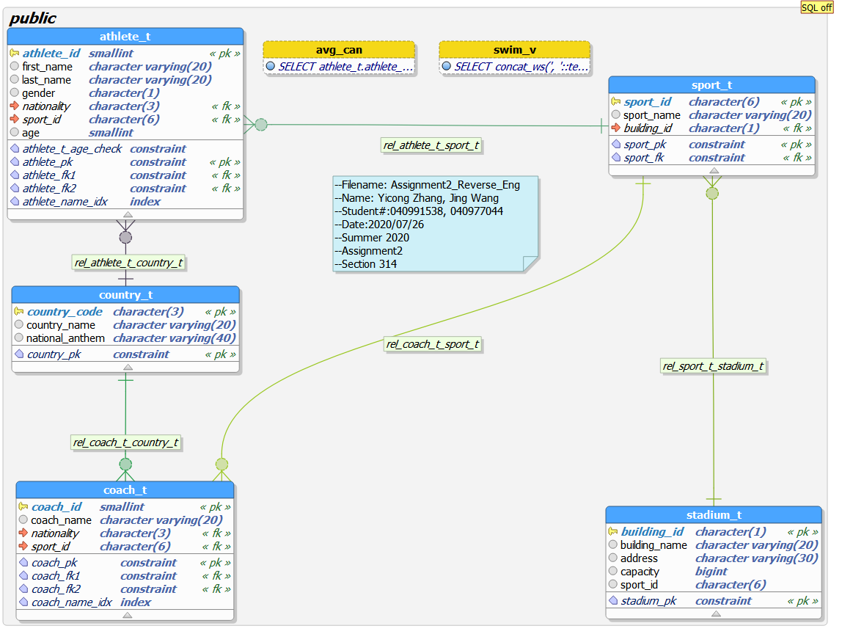

1. Metadata: the statements and result after running the statements are shown as follows. The metadata with additional information is submitted in a csv file (Assignment2_metadata.csv). The metadata query statements is also presented in an attached file (Assignment2_metadata.sql).

