# Docker 学习

## 基础

### 命令

#### docker version

查看当前docker的版本信息

$ docker version

Client:

Version: 1.11.2

API version: 1.23

Go version: go1.5.4

Git commit: b9f10c9

Built: Wed Jun 1 21:2

OS/Arch: windows/amd64

Server:

Version: 1.11.2

API version: 1.23

Go version: go1.5.4

Git commit: b9f10c9

Built: Wed Jun 1 21:2

OS/Arch: linux/amd64

#### docker search tutorial

搜寻镜像

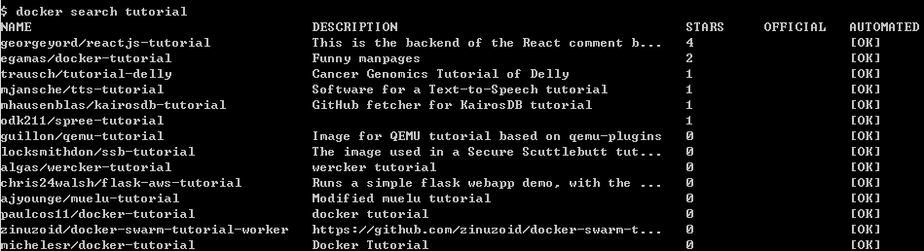

#### docker pull 全名

下载镜像

$ docker pull paulcos11/docker-tutorial

Using default tag: latest

latest: Pulling from paulcos11/docker-tutorial

fdd5d7827f33: Pulling fs layer

a3ed95caeb02: Pulling fs layer

0f35d0fe50cc: Downloading [=> ] 589.8 kB/18.53 MB

627b6479c8f7: Waiting

30b55b68365b: Waiting

aa7bdd0927d7: Waiting

adbe557703b3: Waiting

bd9cfd657b95: Waiting

ca124c0d17dc: Waiting