Collaborators: yc2454 (Yalu Cai)

To prove MAX-CUT is NP-complete, we need to prove it’s both NP and NP-hard. It’s NP because it’s easy to verify in polynomial time whether a potential solution is correct because we just need to see whether the cut goes through edges that have one endpoint in and the other in .

To prove it’s NP-hard, we will reduce from a -SAT problem as per the hint. This reduction is polynomial time because we’re constructing nodes and edges.

Claim: There is a cut of size on the transformed graph if and only if is -satisfiable.

Proof:

Claim: If ­ is -satisfiable, then there exists a cut of size on the transformed graph.

Proof: Given the assignment, visualize all literals that are set to true to be lined up horizontally on the upper side of the page and all their negation nodes to be lined up horizontally on the lower side of the page as such:

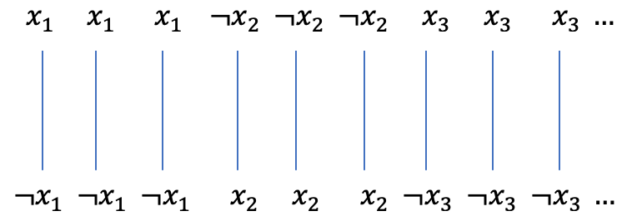

Put all top nodes in and all bottom nodes in . There are thus edges between all the ’s and ’s. The satisfying -assignment makes it so that one or more but less than three literals in each clause is true. The resulting triangle thus has nodes on both sides, as such:

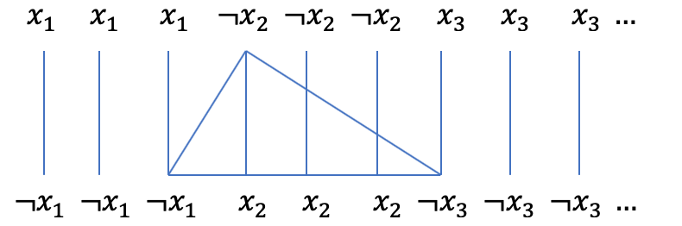

A cut for a satisfying -assignment thus has the size . The is because of the edges between ’s and ’s, and the is because each satisfied clause’s triangle would get cut twice.

Claim: If there exists a cut of size , then is -satisfiable.

Proof: Realize that the are all from the edges between and being cut. The remaining edges cut are from the edges of clause triangles. Assign all literal nodes in to true and all literal nodes in to false (or vice-versa; it doesn’t matter because we proved in Q2a that the negation of a valid -assignment is still a valid -assignment). A literal will not be both false and true under this construction because the edge between them will get cut, so they belong on different sides of the cut.