WAD Group project *ThinkNote*

**Overview:**

*ThinkNote* is a web application designed for students to upload, share, and edit course notes with peers taking the same courses. This platform serves as a centralized knowledge hub where users can easily access study materials from current and past students to enhance their learning experience.

Upon signing up, users will create a profile and enter details such as which university their from, their enrolled courses as well as current academic year, allowing the platform to display relevant study materials.

Uploaded course notes can be categorized by course name, the academic week and year this was made, making it easier for others to find useful materials.

Users can also copy notes into their personal repository, edit them by adding annotations or extra details

Specification: backend database, django, javascript, css,HTML, php

high-level system architecture diagram:

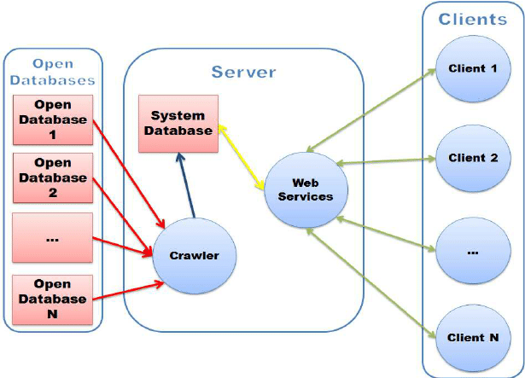

User persona 1:

**Name:**

Luca Rogers

**Details**:

* Year 2 Computer Science Student
* Commutes to University from home
* Works part time

**Goals**:

* Wants a third person perspective on the topics
* Looking for efficient ways to study, balancing his academic workload and part-time job responsibilities.

User Persona 2:

Name:

Ian miles

Details:

* 3rd year business student
* International student
* English is not his first language

Goals:

* Wants to be able to learn on his own time
* Looking for styles to create notes from

User Persona 3:

Name:

Alex Wang

Detalis:

* Postgraduate physics student
* Assistent reseracher in university

Goals:

* Looking for cross courses notes to learn
* Trying to help younger learner with more extensive materials beyond courses

Web Site URLs:

* Index: The home page

Site URLs

Home page/Major: ThinkNote

Major: ThinkNote/Major

Courses: ThinkNote/Major/Course

Notes: ThinkNote/Major/Course/NoteID

Upload: ThinkNote/Upload

Login: ThinkNote/Login

Register: ThinkNote/Register

Personal: ThinkNote/User

Search: ThinkNote/Search/SearchContent

Course

OOSE

Java/Python (sub cat)

