**HUMAN SCIENCES DEMOGRAPHY: PRELIMS 2022**–**2023**

**Introduction to Population Measures**

1. The table below gives data on deaths and population by age-group for two occupational groups and overall, for males aged 15–64 in England and Wales in 1959–1963.

|  |  |  |  |  |  |  |
| --- | --- | --- | --- | --- | --- | --- |
|  | Coal face miners | | Engine drivers | | England and Wales | |
| Age-group | deaths | population | deaths | population | deaths | population |
| 15–24 | 160 | 25,230 | 70 | 11,820 | 15,754 | 3,063,620 |
| 25–34 | 278 | 32,840 | 71 | 14,240 | 16,466 | 2,944,620 |
| 35–44 | 732 | 44,160 | 169 | 15,910 | 37,976 | 3,150,180 |
| 45–54 | 1,865 | 33,680 | 252 | 16,530 | 114,007 | 3,224,010 |
| 55–64 | 4,182 | 18,100 | 2,438 | 21,170 | 275,752 | 2,540,300 |

1. Compute the crude death rates for males aged 15–64 for three populations.
2. Calculate the age-specific mortality rates for two occupational groups and the overall population.
3. Explain the differences in the values that you obtain.
4. Discuss what might be the disadvantages of these measures of comparing mortality experience of different populations.
5. How have mortality risks in these groups and generally, developed in England and Wales since around 1960?
6. The data in the tables below are for UK and Taiwan in 1977 and 1991 and 2011.
7. **UK**

|  |  |  |  |  |  |  |
| --- | --- | --- | --- | --- | --- | --- |
|  | Number of births | | | Number of women | | |
|  | 1977 | 1991 | 2011 | 1977 | 1991 | 2011 |
| 12–14 | 245 | 264 | 178 | 1,378,305 | 986,001 | 1,094,706 |
| 15–19 | 63,292 | 59,446 | 40,817 | 2,136,119 | 1,813,821 | 1,935,671 |
| 20–24 | 202,547 | 196,219 | 149,688 | 1,929,861 | 2,204,982 | 2,124,051 |
| 25–29 | 237,852 | 282,106 | 223,639 | 2,004,320 | 2,347,928 | 2,159,449 |
| 30–34 | 115,572 | 182,660 | 231,686 | 1,933,440 | 2,108,221 | 2,074,311 |
| 35–39 | 30,251 | 60,546 | 129,164 | 1,604,278 | 1,897,848 | 2,091,808 |
| 40–44 | 6,753 | 10,450 | 30,606 | 1,557,029 | 2,059,599 | 2,337,446 |
| 45–49 | 517 | 526 | 1,869 | 1,620,499 | 1,768,420 | 2,352,582 |
| 50–54 | 9 | 51 | 128 | 1,698,277 | 1,544,472 | 2,077,603 |
| Total population |  |  |  | 46,639,000 | 47,875,000 | 53,107,000 |

1. **Taiwan**

|  |  |  |  |  |  |  |
| --- | --- | --- | --- | --- | --- | --- |
|  | Number of births | | | Number of women | | |
|  | 1977 | 1991 | 2011 | 1977 | 1991 | 2011 |
| 12–14 | 370 | 271 | 30 | 591,021 | 582,321 | 427,914 |
| 15–19 | 34,819 | 14,710 | 2,817 | 958,644 | 886,212 | 772,923 |
| 20–24 | 171,043 | 84,703 | 17,705 | 882,888 | 919,253 | 768,372 |
| 25–29 | 142,380 | 142,918 | 60,196 | 692,273 | 960,312 | 906,135 |
| 30–34 | 31,981 | 62,800 | 82,387 | 440,825 | 918,613 | 1,016,100 |
| 35–39 | 10,372 | 12,931 | 30,744 | 452,138 | 832,855 | 916,172 |
| 40–44 | 2,402 | 1,273 | 4,324 | 396,350 | 596,838 | 926,477 |
| 45–49 | 194 | 47 | 131 | 349,213 | 432,533 | 953,483 |
| 50–54 | 72 | 27 | 14 | 285,352 | 428,939 | 902,003 |
| Total population |  |  |  | 17,043,000 | 20,679,000 | 23,269,000 |

1. Calculate the crude birth rates for both countries in 1977, 1991 and 2011.
2. Calculate the age-specific fertility rates for all periods in UK and Taiwan
3. Calculate the Total Fertility Rate for women aged 15–49.
4. Using the data you have available and your own calculations, discuss how fertility has changed in UK and Taiwan. Compare the fertility change in two countries.
5. Figure 1 below provides the number of deaths by age, period and cohort in Lexis diagram for England and Wales, 1900–1905

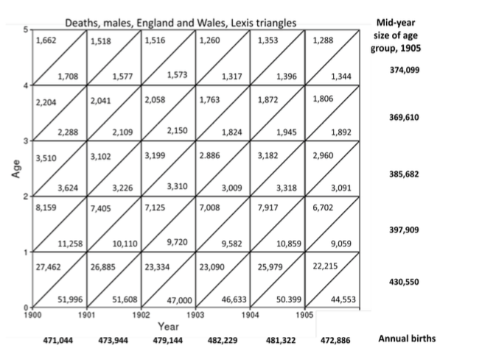

Figure 1: Deaths by age, period and cohort, depicted as Lexis triangles for England and Wales, 1900–1905

1. Using the data provided in Figure 1, compute the infant mortality rate (IMR) in 1900, 1902, and 1904.
2. Why do we use births, not the number of infants alive at mid-year, to calculate IMR?
3. Why are there more infant deaths in the lower triangle of each year than the upper?
4. How many 4-year olds died in 1902? How many 4-year olds died in 1905?
5. How many deaths occurred to the cohort born in 1900 between birth and age 3? How many deaths occurred between the same ages to the cohort born in 1902?
6. What was the age-specific mortality rate in 1905 for 1-year olds? What was the age-specific mortality rate for 3-year olds in 1905?
7. Why are age-specific rates preferable to crude rates for demographic measurement?