Progress of “Backpacking to Kaohsiung”

By Yi-Fan Chen

Step ONE -- a mind map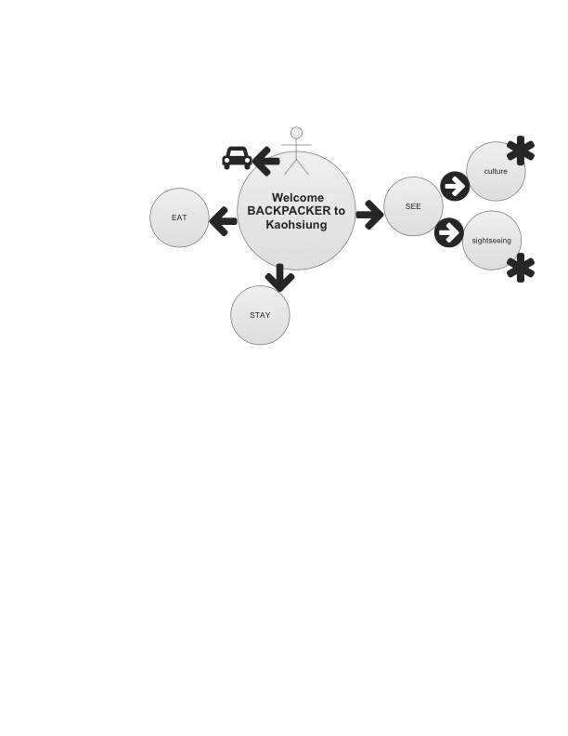

I like to have a page with many photos.

Step TWO – photo collection

GO FB to “borrow” photos from friend and family members.

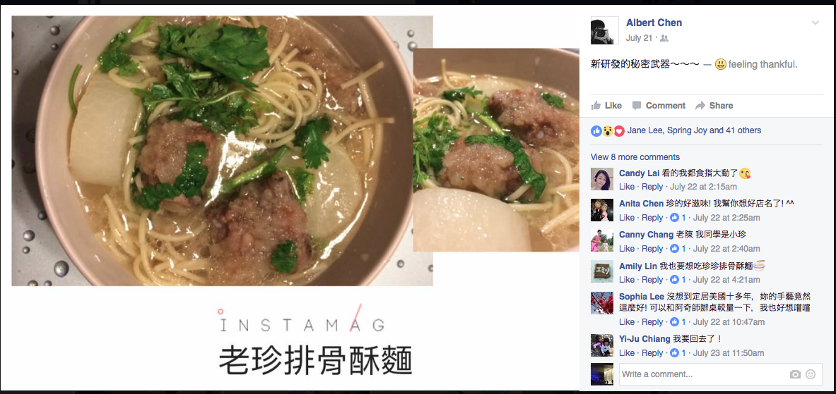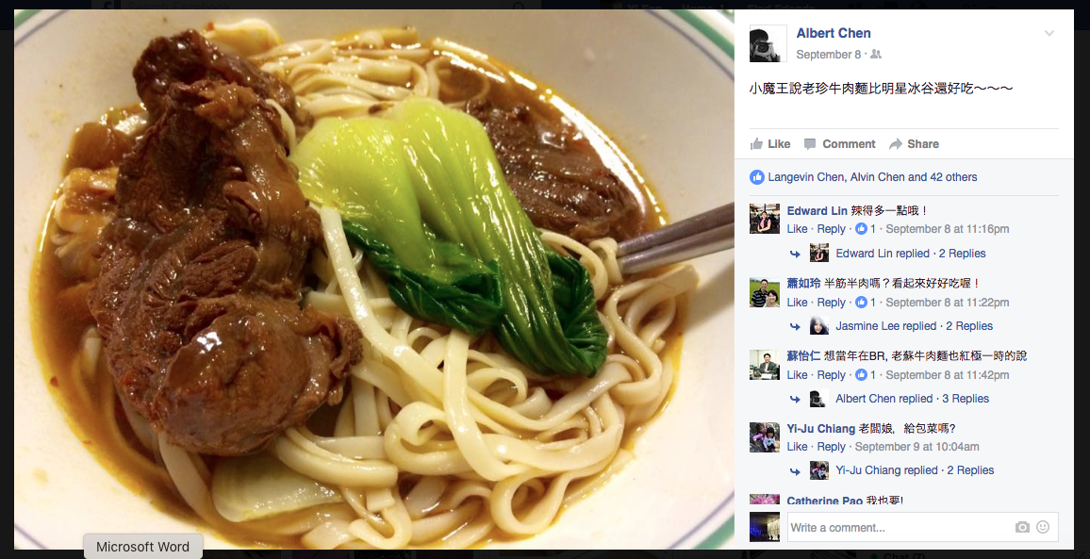

Step THREE – more photo collection

CALL a family member to ask more photos

Step FOUR – START work on a mobile first nav bar

Step FIVE – FIND a wikitravel about backpacking to Kaohsiung

Step SIX – COMPLETE the assignment