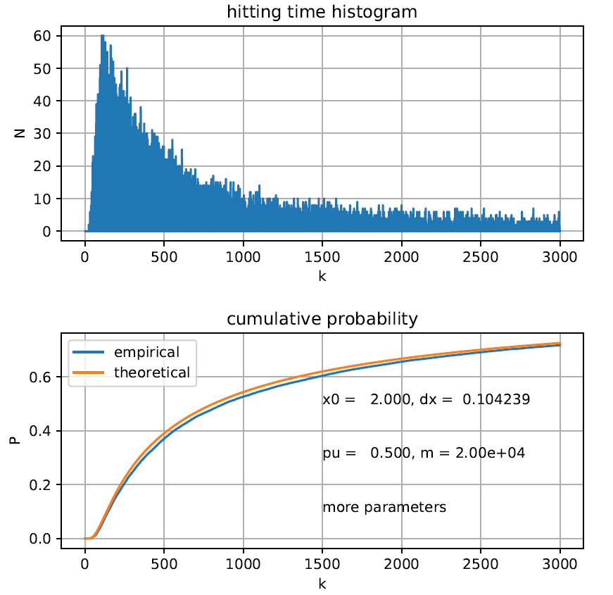

According to the result, I firstly notice that, in the first graph, the probability of absorption does not seem to decay to 0 when t is large. In fact, in these cases where k is larger than 2000, frequency N seems to be stable at a certain value about 3 to 6, which indicates the hitting probability density could have a fat tail.

In the second picture, both the empirical and theoretical cumulative curve are already showing the tendency of becoming flat when just crossing the line P=0.6, indicating some density gathering at where t is large, which implies the hitting probability density could have a fat tail.