To answer the influence of number of paths, we firstly fix delta_x=0.104239, then change the number of steps, we set n_max=1000, 3000 and 10000, the results are below:

n_max=1000:

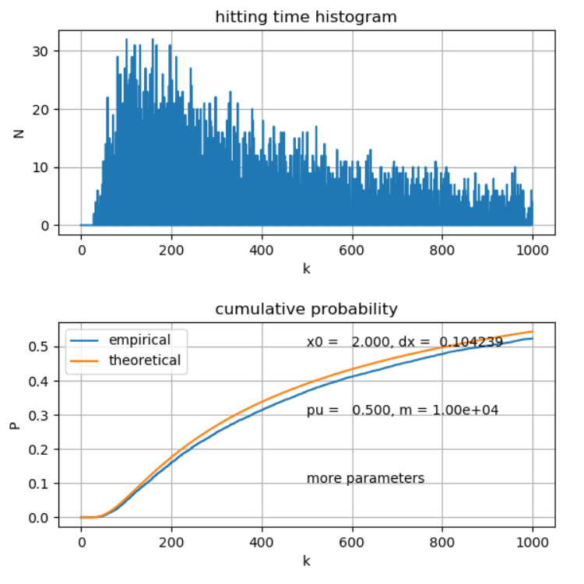

n_max=3000

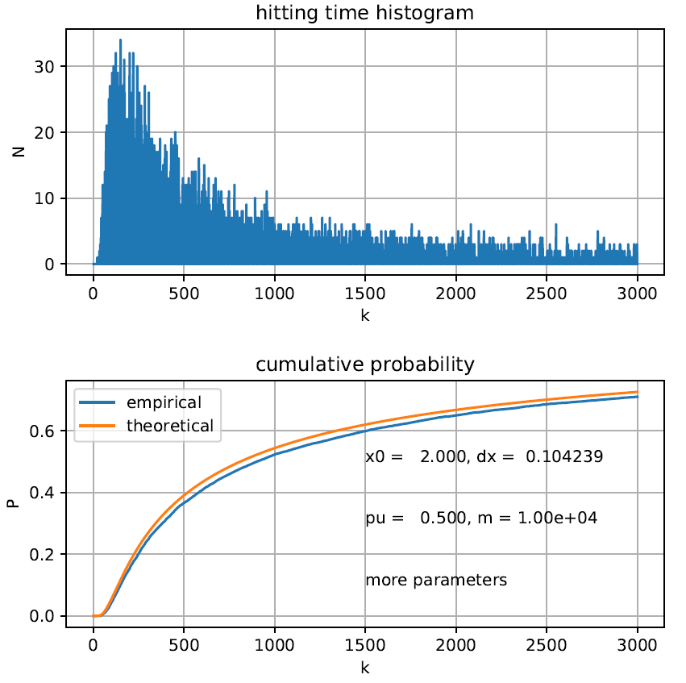

n_max=10000

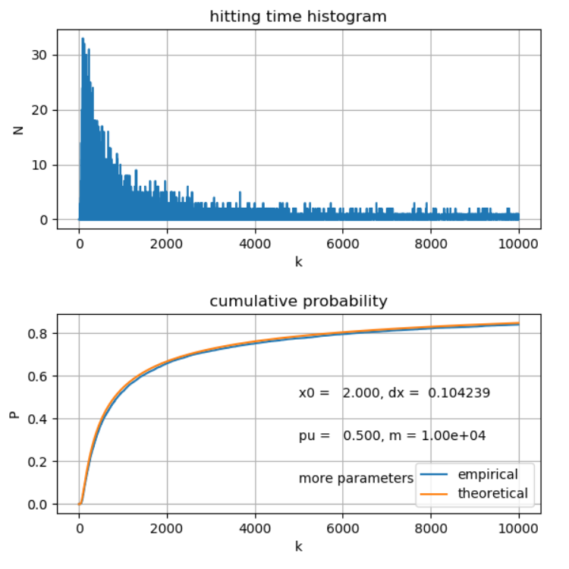

From these three graphs, I notice that, when the number of steps increase, the points have more chances to hit the absorption wall, which leads to the hitting cumulative probability is closer to 1 at the end of all steps

Then we concentrate on the change of delta_x, we fix n_max=3000, then set delta_x=0.024239, 0.104239, 0.204239, 0.404239, the results are below:

delta_x=0.024239

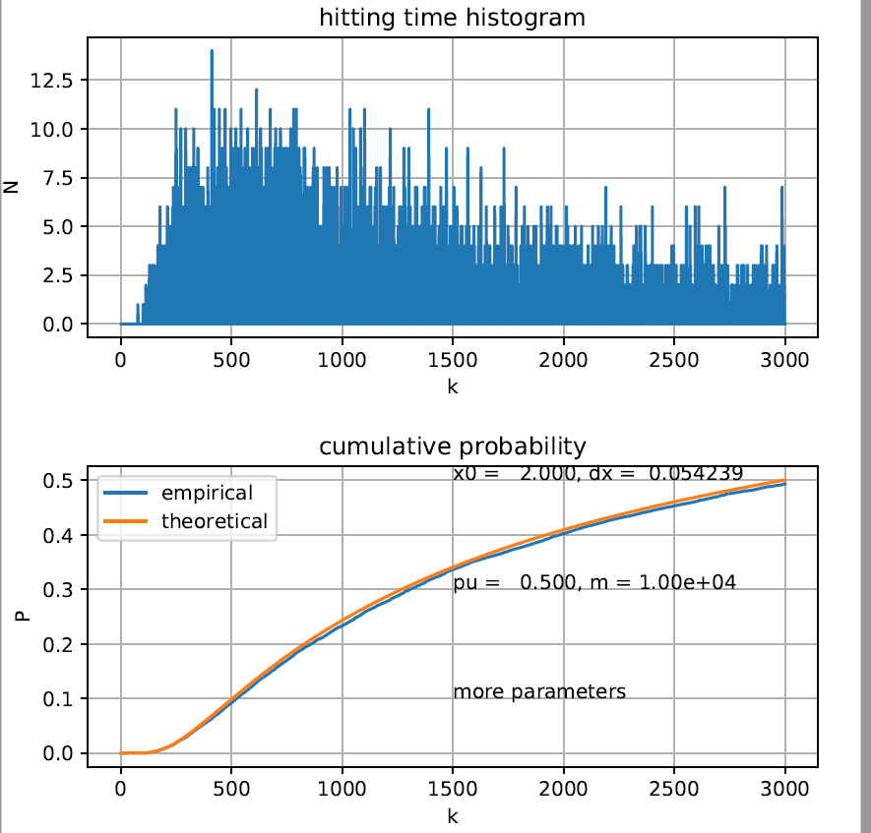

delta_x=0.104239

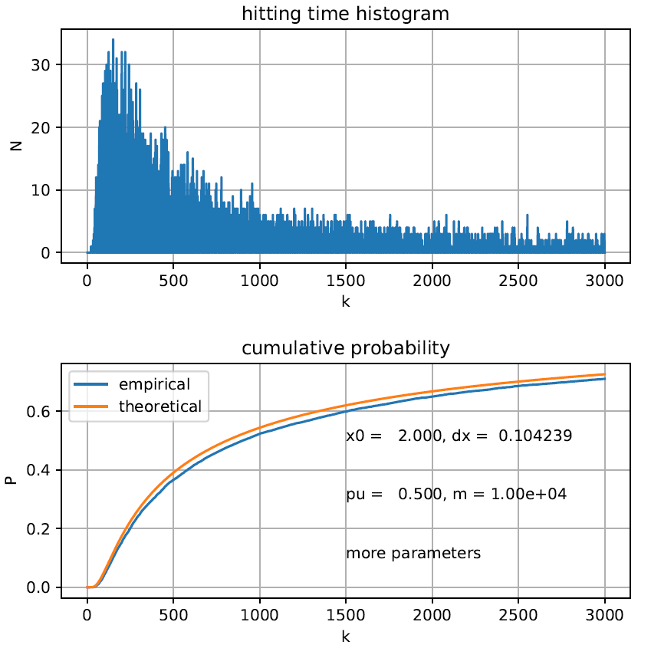

delta_x=0.204239

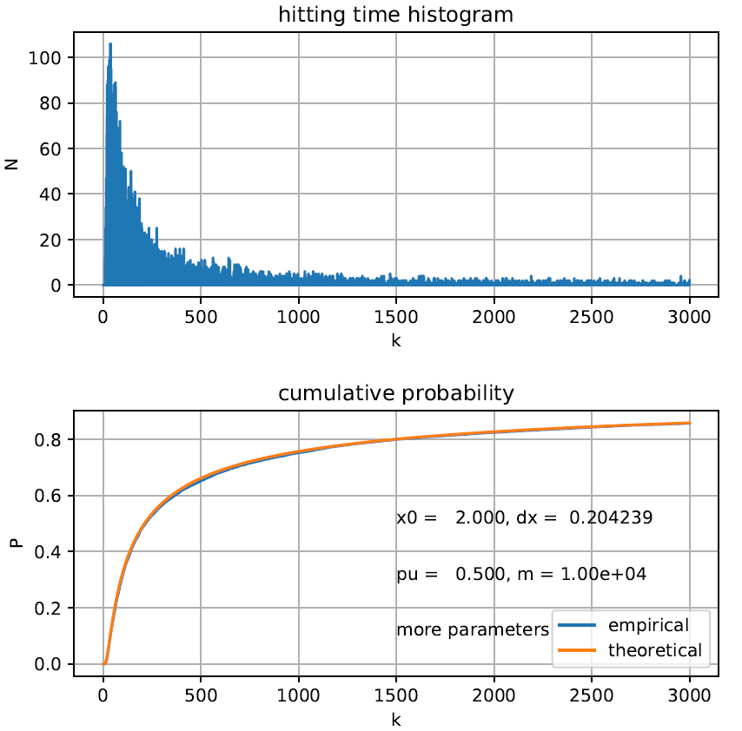

delta_x=0.404239

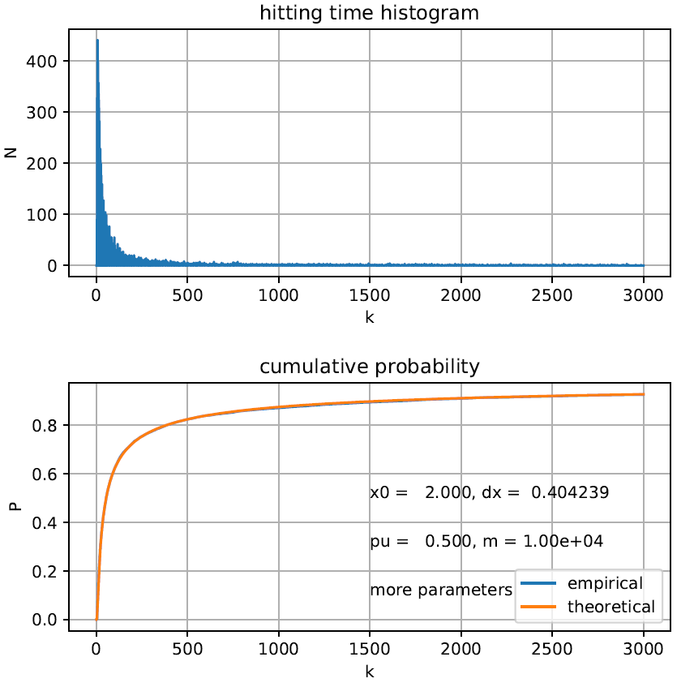

From these four pictures, we clearly find that when we make delta_x larger than the origin, the agreement of two curves becomes better. I think it is because when delta_x is large, more points hit the wall at an early time (small t), in the graph, the point concentrate at where k is small, which leads to a better agreement in the left part. In the right part, the theoretical cumulative probability increase slowly, at the same time, less hitting incidents happen at this condition, leading to the result of the gap between two curves is not obvious.