After we add a negative drift parameter a to the model, the result is showed below:

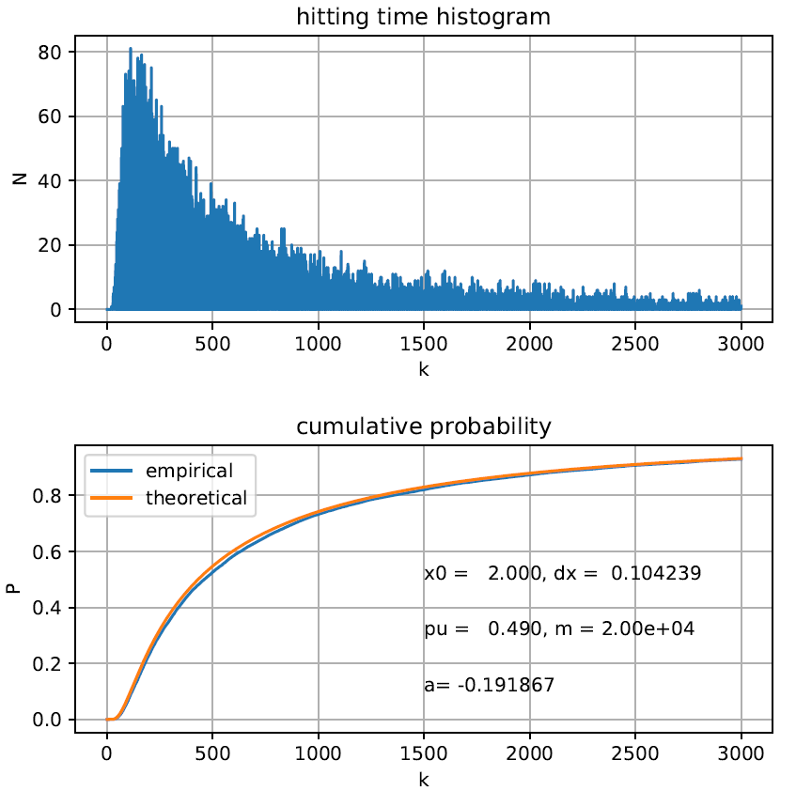

we make it compared with origin result which does not have drift:

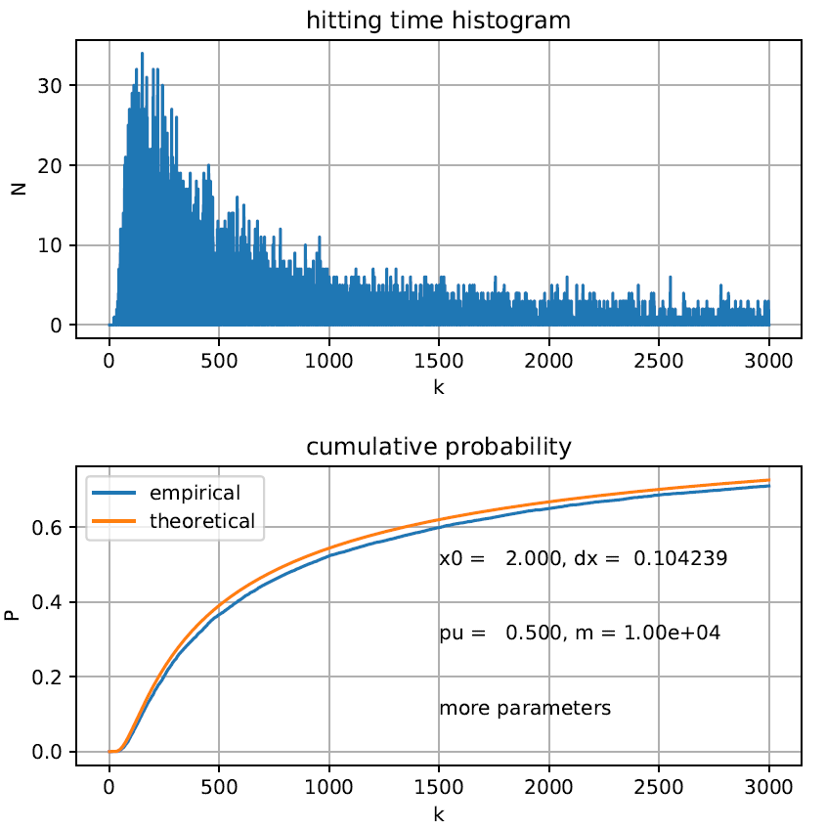

It is clear that, with a negative drift parameter, more hitting probability density cumulate within 3000 moving steps, which indicates the distribution has a thinner "fat tail".

Moreover, the formula for a in terms of pu, pd and delta_x is listed below:

$$a=\frac{{(p}_{u}-p_{d})×Δt}{Δt}≈\frac{p_{u}-p_{d}}{Δx}$$