To violate the CFL condition, we test the results at lambda=0.501,0.505 and 0,51.

When lambda=0.501, there is no apparent difference observed from the first part of the movement pattern. However, after t reduce to 0.5, the jagged pattern shows up more and more apparently in the movie, which indicated the calculate from fk to fk+1 becomes more unstable.

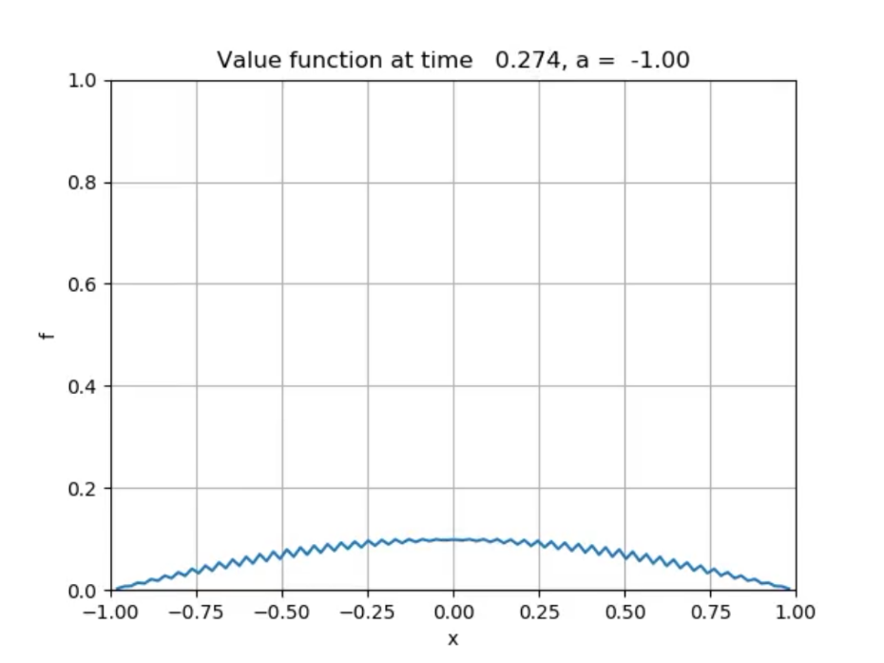

When lambda=0.505, the jagged patterns come earlier, when t reduce to 0.9-0.8, large jagged patterns fill half the canvas. After that, the curve become many vertical lines meaning the calculation from fk to fk+1 never converge.

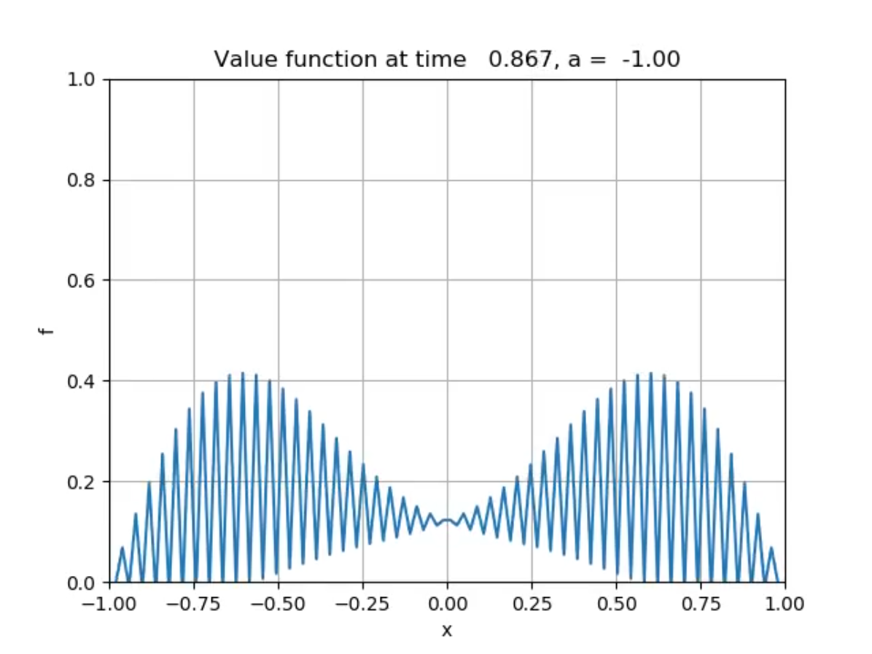

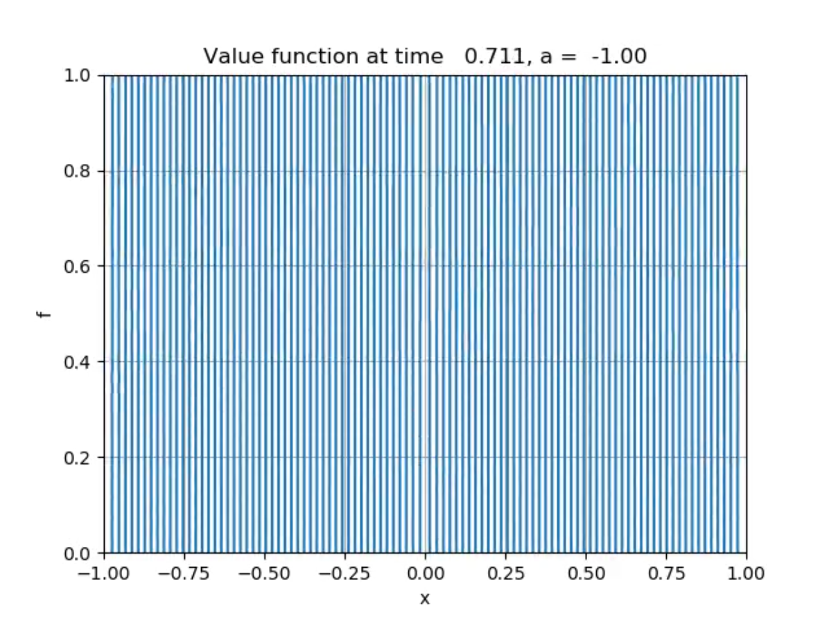

After changing lambda to 0.51, the pattern become vertical lines more quickly, meaning the instabilities of the algorithm is becoming more serious when lambda is larger.

