DSCI551 HW4
Name: Yi-Fan Tsai
USC ID: 4173878189

- db.countrylanguage.countDocuments({IsOfficial: "T", Percentage: {$gt: 0.5}})
- db.country.find({Continent: /America/, GNP: {$gt: 100000}},
{_id: 0, Name: 1, GNP: 1})
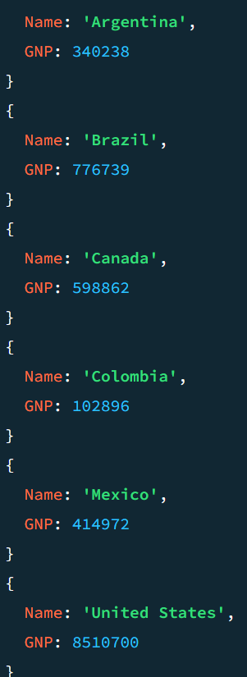
- db.country.aggregate([
{$match:{Continent: "North America", Population: {$gt: 100000}}},
{$group:{_id: null, avgGNP: {$avg: "$GNP"}}}])
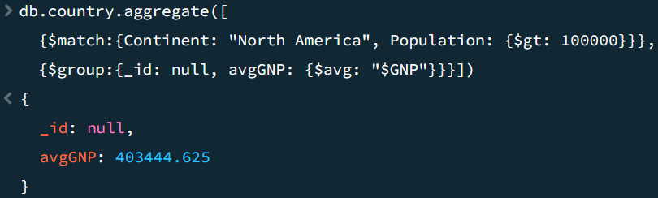
- db.country.aggregate([
{$lookup: {from: "city", localField: "Capital", foreignField: "_id.ID", as: "cap_city"}}, {$unwind: "$cap_city"}, {$sort: {Name: 1}}, {$limit: 5},
{$project: {_id: 0, countryName: "$Name", cityName: "$cap_city.Name"}}])
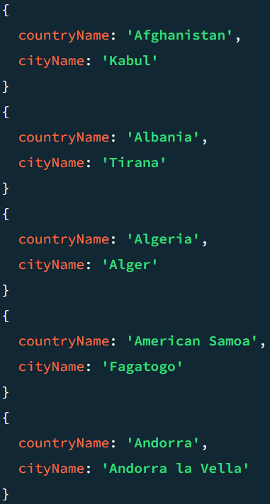
- db.countrylanguage.aggregate([
{$group: {_id: "$_id.Language", count: {$count: {}}}},
{$match: {count: {$gt: 20}}}, {$sort: {count: -1, _id: 1}}])
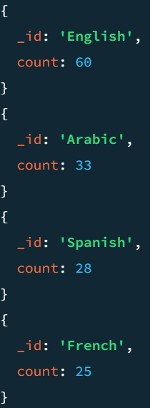
- db.city.aggregate([
{$match: {CountryCode: "USA"}},
{$group: {_id: "$District", avgPop: {$avg: "$Population"}, count: {$count: {}}}},
{$match: {count: {$gt: 10}}}, {$project: {avgPop: 1}}])
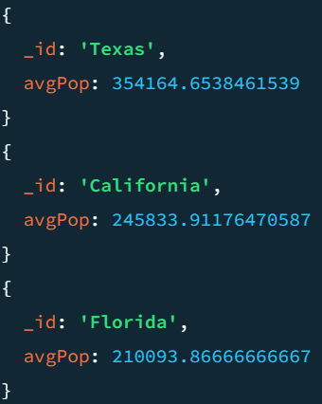
- db.city.insertMany([
{"_id": { "ID": 4080 }, "Name": "LA suburb", "CountryCode": "USA", "District": "California", "Population": 1000},
{"_id": { "ID": 4081 }, "Name": "LA dessert", "CountryCode": "USA", "District": "California", "Population": 2000}])
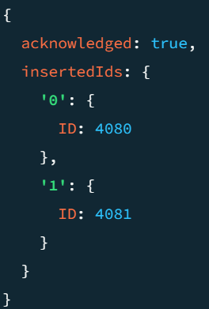
- db.city.updateOne(
{"_id.ID": 4081},
{$set: {Name: "LA orange", Population: 3000}})
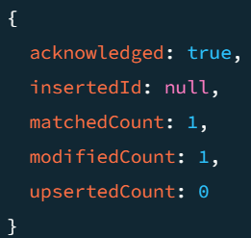
- db.city.deleteMany({"_id.ID": {$in: [4080, 4081]}})
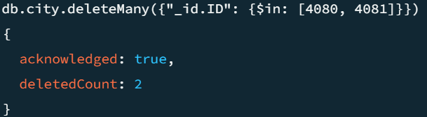

Appendix (Results in MySQL):
This Appendix includes the results run in MySQL server for double-check.
