完美替代stack

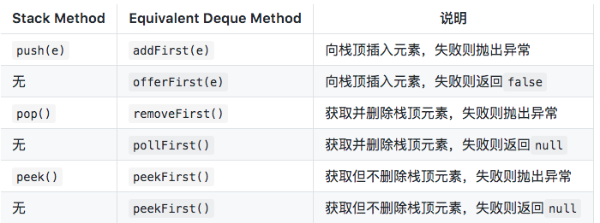

创建的时候

Deque<Character> myStack=**new** ArrayDeque<Character>();

注意了一定要是arrayDeque

1. [addFirst(Element e) :](https://www.geeksforgeeks.org/arraydeque-addfirst-method-in-java/) The method inserts particular element at the start of the deque.
2. [addLast(Element e) :](https://www.geeksforgeeks.org/arraydeque-addlast-method-in-java/) The method inserts particular element at the end of the deque. It is similiar to add() method
3. [removeFirst() :](https://www.geeksforgeeks.org/arraydeque-removefirst-method-in-java/) The method returns first element and also removes it
4. [removeLast() :](https://www.geeksforgeeks.org/arraydeque-removelast-method-in-java/) The method returns last element and also removes it

[size() :](https://www.geeksforgeeks.org/arraydeque-size-method-in-java/) The method returns the no. of elements in deque.