Dear all,  
      Here is a short description of **the theory for points of local maximum, points of local minimum, and saddle points for two-variable functions.**  
  
**Suppose that we are given a two variable function f(x,y).  
  
Points of local maximum.** Take a point (a,b) in the domain of this function. If for any point (x,y)  in a disk  centered at (a,b) of radius r>0: (x-a)^2+(y-b)^2 <= r^2 we have that f(x,y) <= f(a,b) then (a,b) is a point of local maximum for f(x,y). Note that the radius r>0 can be arbitrary small positive number. Example: For the function f**(x,y)= - (x^2+y^2)**; the point (0,0) is a  point of loc max (local maximum). The graph of the function**z= - x^2 - y^2** is inverted circular paraboloid (see quadric surfaces).

给你一个(f(x,y))，你通过xy能得到的f(x,y)最大值，这个point就是你的loc max， 例如这里，最大也就是00

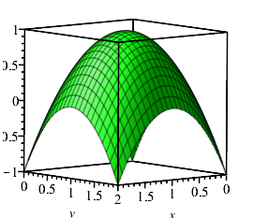

**Points of local minimum.**Take a point (a,b) in the domain of this function. If for any point (x,y)  in a disk  centered at (a,b) of radius r>0: (x-a)^2+(y-b)^2 <= r^2 we have that f(x,y) >= f(a,b) then (a,b) is a point of local minimum for f(x,y). Note that the radius r>0 can be arbitrary small positive number. Example: For the function**f(x,y)=x^2+y^2**; the point (0,0) is a  point of loc min (local minimum). The graph of the function **z=x^2+y^2** is  a circular paraboloid (see quadric surfaces).  
能渠道的最小，也就是00

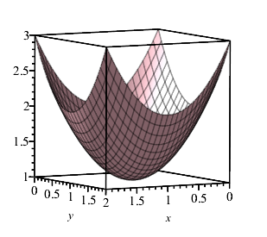

**Saddle points.** Take a point (a,b) in the domain of the function f(x,y). If  for each poistive number r>0  (does not matter how small)  in the disk  centered at (a,b) of radius r>0: (x-a)^2+(y-b)^2 <= r^2 we have that f(x,y) > f(a,b) for at least one point (x,y) in the disk and  f(x,y) < f(a,b) for at least one point (x,y) in the disk then (a,b) is called a  saddle point. Note that  at a saddle point f(x,y) does not have loc max or loc min.  Example: For the function f**(x,y)=x^2 - y^2;** the point (0,0) is a saddle  point. The graph of the function**z=x^2 - y^2**is  hyperbolic paraboloid (see quadric surfaces) that looks like a horse saddle around the point  (0,0).  
saddle point鞍点，

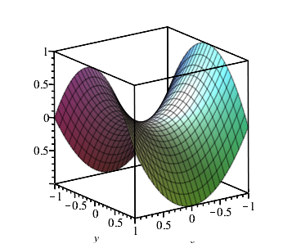

**Graphically if a point (a,b) is either a point of loc max, or a point of loc min, or a saddle point the tangent plane to the graph of  the surface z=f(x,y) (the graph of z=f(x,y)) at the point (a,b) is parallel to the xy-plane. For the tangent plane to  the surface z= f(x,y) at (a,b) we have first the standard equation:  
z=f(a,b) +f_x(a,b)(x-a)+f_y(a,b)(y-b) and  
also the equation z=f(a,b)  taking into account the tangent plane is parallel to the xy-plane.  From here f_x(a,b)(x-a)+f_y(a,b)(y-b)=0 for any point in the disk of radius r>0.  Now taking the partial derivative in x in the equation:  f_x(a,b)(x-a)+f_y(a,b)(y-b)=0 we obtain f_x(a,b)=0; and taking the partial derivative in y we obtain f_y(a,b)=0.**  
  
**Important conclusion.** Then we make the conclusion that in order a point (a,b) to be either a point of loc max or a point of loc min or a  saddle point for the function f(x,y) we must have: f_x(a,b)=0 and f_y(a,b)=0  that is: the first order partial derivatives of f(x,y) at (a,b) must be equal to zero.  
  
**Definition.** If for a point (a,b) in the doamin of f(x,y) we have that the first order partial derivatives of f(x,y) at (a,b) are equal to zero, i.e.,  f_x(a,b)=0 and f_y(a,b)=0 then the point (a,b) is called a critical point (called also a stationary point) for f(x,y).  
  
**Important Conclusion.** Then we make an important conclusion that all points (a,b) of loc max; all points (a,b) of loc min; and all saddle points (a,b)  for f(x,y) must be critical points for f(x,y). In other words: all points of loc max; all points of loc min; and all saddle points for a given function f(x,y) are in the set of the critical points of f(x,y), i.e., we must have f_x(a,b)=0 and f_y(a,b)=0.  
  
**Algorithm.** Then the algorithm to find all points of loc max; all points of loc min; and all saddle points for  a given two-variable function is the following:  
**(1) Find all critical points of f(x,y), in other words solve the system of equations f_x(x,y)=0 and f_y(x,y)=0 to find the critical points. We know that all points of loc max; all points of loc min; and all saddle points  are critical points.  
(2) Suppose that the point (a,b) is a critical point. Then we apply a specific test called a second derivative test for each of the critical points  in order to determine if a given critical point  is a point of loc max or a point of loc min or a saddle point:**

**First, we compute the second order derivatives of f(x,y) at (a,b):**

**(a) If f_xx(a,b)f_yy(a,b) -  f_xy(a,b)f_yx(a,b) < 0 then (a,b) is a saddle point;**

**(b) If  f_xx(a,b)f_yy(a,b) -  f_xy(a,b)f_yx(a,b) > 0  and f_xx(a,b) > 0 then (a,b) is a point of local minimum;**  
**(c)** **(b) If  f_xx(a,b)f_yy(a,b) -  f_xy(a,b)f_yx(a,b) > 0  and f_xx(a,b) < 0 then (a,b) is a point of local maximum.**

The teaching materials that will be posted on the present Moodle site (after this post, most probably tomorrow)  contain solved problems and the solutions that show how we apply the above algorithm. I would like to advice you first read the theory given above and then you can consider the teaching material that will be posted tomorrow on the present Moodle site.

 If any questions on the above important considerations please, let me know by e-mail.

Best wishes,

D. Dryanov, Instructor