14.7

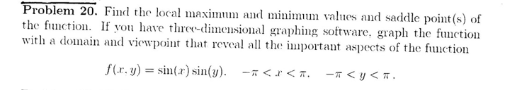

STEP1求关于xy一阶导，让他们分别=0，再联立

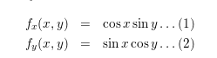



STEP2: 联立，得到critical point

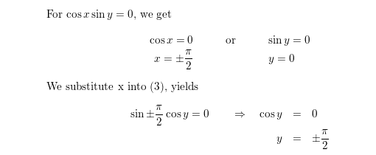

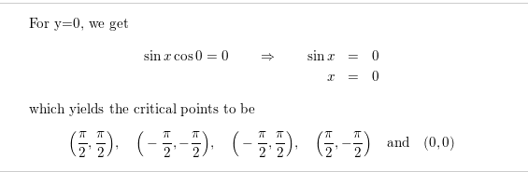

STEP3：对x求二阶导，对y求二阶导，在x基础上对y求导

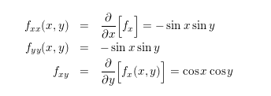

STEP4:求D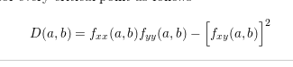

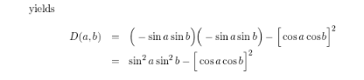

两个二阶导相乘减去dxy

如果两个二阶导数同一正负，且D<0 ,sapple point

如果两个二阶导数同一正负，且D>0

如果二阶导>0,minimum

如果<0,maximum

然后带入点

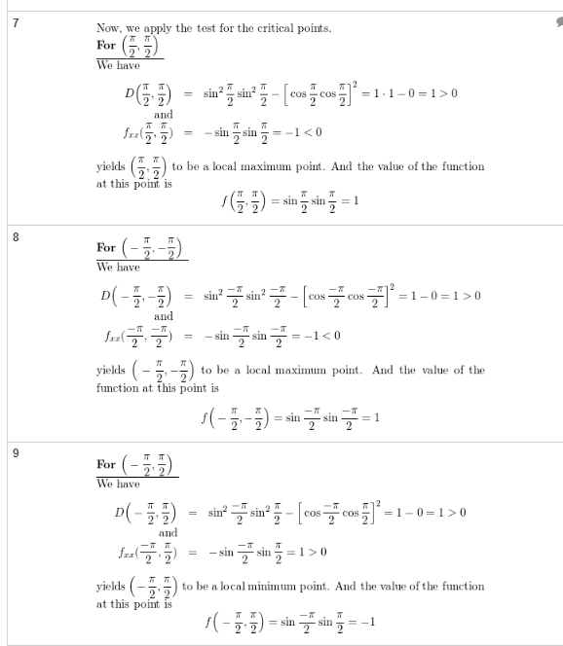

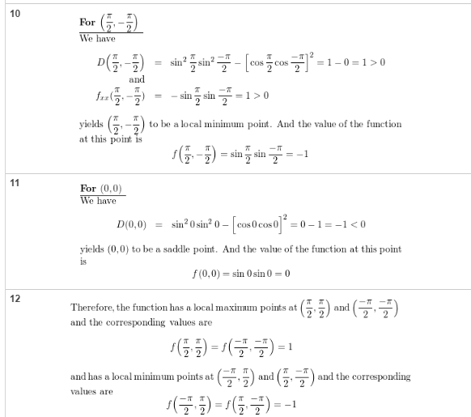

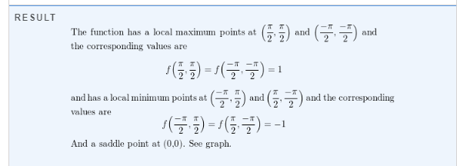

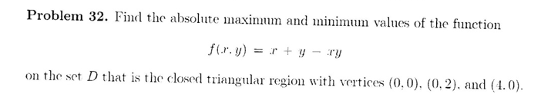

<https://www.slader.com/discussion/question/find-the-absolute-maximum-and-minimum-values-off-on-the-set-d-fx-y-x-y-xy-d-is-the-closed-triangular/>

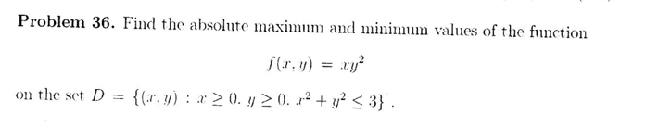

<https://www.slader.com/discussion/question/find-the-absolute-maximum-and-minimum-values-of-f-on-the-set-d/>

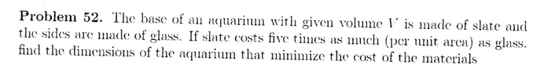

<https://www.slader.com/discussion/question/the-base-of-an-aquarium-with-given-volume-v-is-made-of-slate-and-the-sides-are-made-of-glass-if-slat/>

14.8

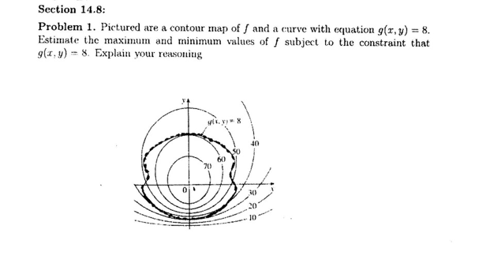

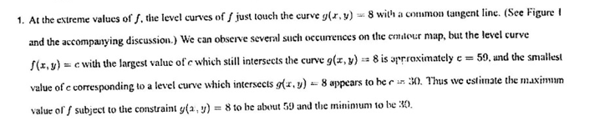

很简单，不会考应该，就是粗的是g，细的是f，交界处什么时候f最大，也就是50，什么时候f最小也就是30

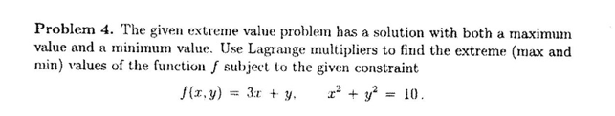

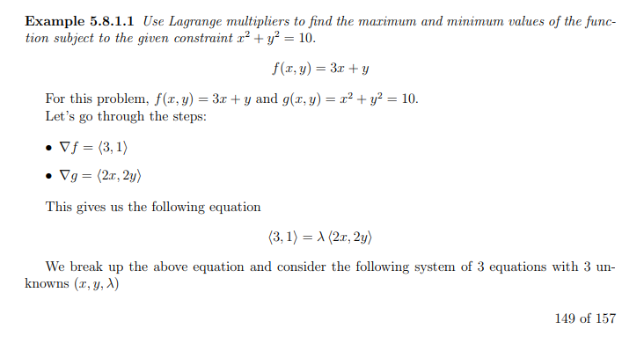

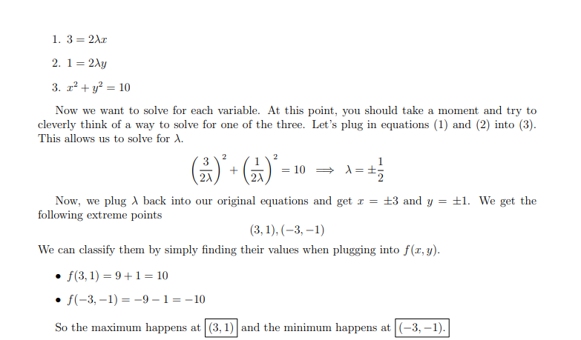

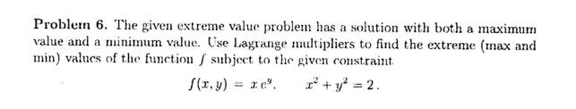

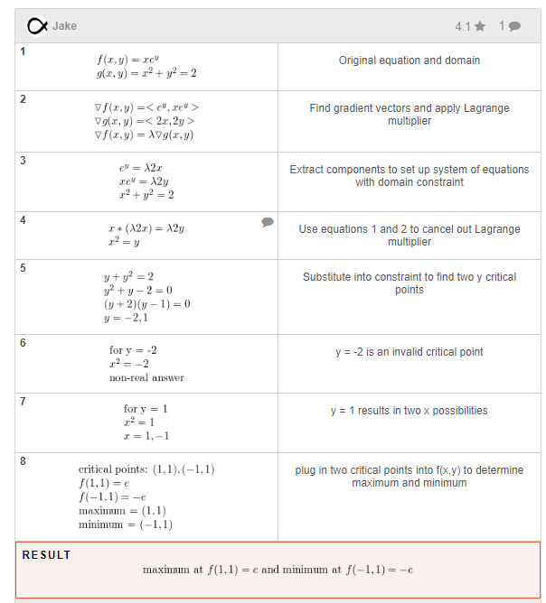

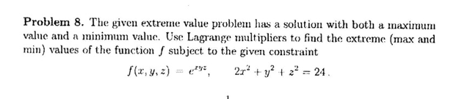

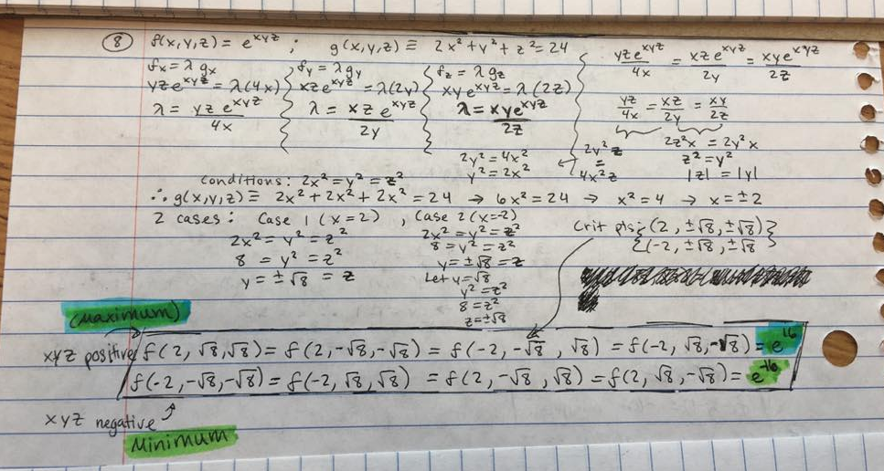

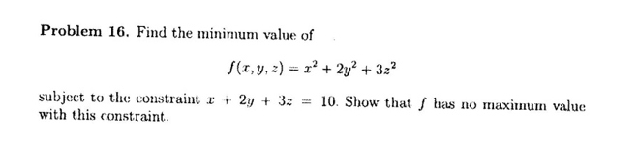

<https://www.slader.com/discussion/question/find-the-minimum-value-of-fx-y-z-x2-2y2-3z2-subject-to-the-constraint-x-2y-3z-10-show-that-f-has-no/>

Problem 18

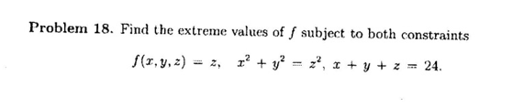

<https://math.stackexchange.com/questions/2048685/find-extreme-values-of-f-subject-to-both-constraints-f-z-g-x2y2-z2-h-x>

<https://www.slader.com/textbook/9781305482463-calculus-early-transcendentals-8th-edition/977/exercises/18/>

Problem 32

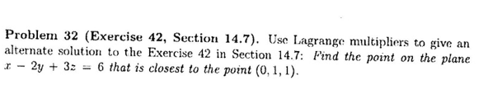

<https://www.slader.com/textbook/9781305482463-calculus-early-transcendentals-8th-edition/978/exercises/32/>

Problem 42

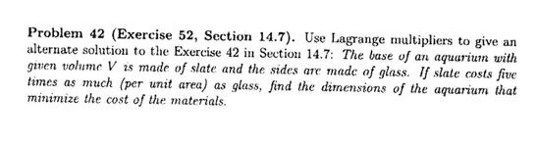

<https://www.slader.com/textbook/9781305482463-calculus-early-transcendentals-8th-edition/978/exercises/42/>