Sharing Agricultural Machinery Application

By

Yifan Yang

40038814

Professor: Bruno Grenier   
Tutor: Aaron Golish

The proposal followed Aaron Golish’s guideline

A report submitted in partial fulfilment of the requirements of ENCS-282

Concordia University

June 2018

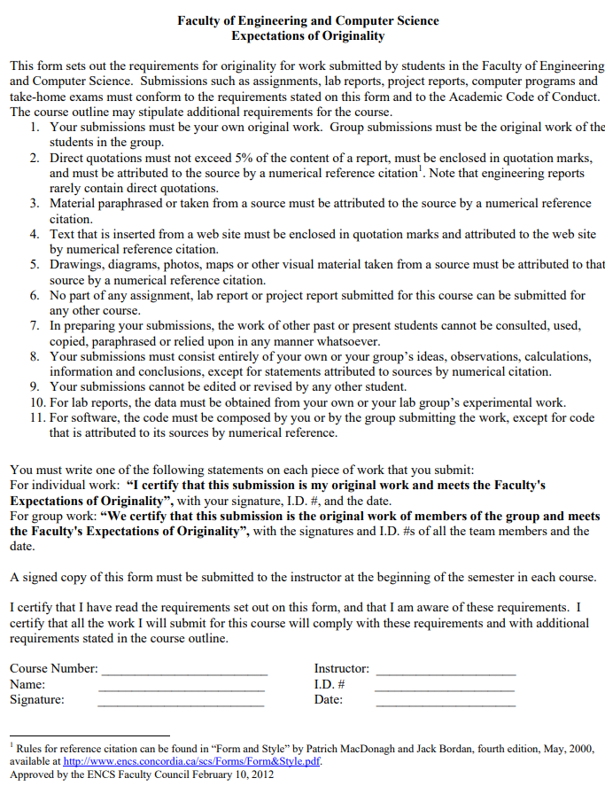

Abstract

With the development of science and technology, more and more farmers are using agricultural machinery instead of traditional agriculture. However, the production of agricultural machinery needs a lot of material and creates huge emissions. And the unqualified agricultural machinery in developing country will produce more emissions than qualified country. To solve these problems. The project will create an app to help farmers share agricultural machinery with others. For developing country where has not enough idle agricultural machinery, we can offer qualified and unified machine to rent. The application need 3 steps to create: draft, develop and test. The whole process will require 50000$ and 9 weeks to develop. The main way of this application to make profit is the service charge and the rent money of unified machine offered by company. This proposal below will show the details about this application.

**TABLE OF CONTENTS**

List of figures iii

List of tables iv

1.0 Introduction 1

1.1 Purpose 1

1.2 Background 1

1.2.1 Subsection 1 2

1.2.2 Subsection 2 3

1.3 Scope 3  
2.0 Solution 4

2.1 Business model in developed country 4

2.2 Business model in developing country 5

2.3 Applicant Eligibility 6

2.3 Results 7

3.0 Plan of action 8

3.1 Step 1: Draft 8

3.2 Step 2: Beta version 8

3.3 Step 3: Test 8

4.0 Schedule 9

5.0 Budget 10

5.1 Sharing station cost 10

5.2 Salary 10

5.3 Equipment/Material 11

5.4 Additional Cost 11

6.0 Qualifications 12

7.0 Conclusion 13

7.1 Contact Information 13

ii

**LIST OF FIGURES**

Business model in developed country 4

Business model in developing country 5

App screenshot 7

Gantt chart of Schedule 9

iii

**LIST OF TABLES**

Table 1 Life Cycle Assessment of a Tractor 2

Table 2 Canada Agricultural Machinery and Equipment Data 2

Table 3 Bharat emission limits for agricultural diesel tractors and implementation timeline 3

Table 4 Annual fee for one sharing station 10

Table 5 The Budget for developing application 11

iv

1. **INTRODUCTION**

There are many farmers using agricultural machinery instead of traditional agriculture nowadays. However, the production of agricultural machinery needs a lot of material and energy. In developing country, lots of farmers cannot afford to buy agriculture machinery or they can only buy unqualified machine. For developed countries, they still import and produce agricultural machinery when the market is saturated. As a software engineer, I think our company should design an app to help farmers share agricultural machinery.

**1.1Purpose**

Design an app to help farmers to share agricultural machinery. The app has 2 business modes. In developed country, this app will offer a platform for farmers to share their idle machine, then they don’t need to buy new machine when their old ones are scrapped. In developing country, farmers who cannot afford to buy qualified agricultural machinery can rent qualified and unified agricultural machinery offered by our company through this app. Both business modes have the same core: sharing agricultural machinery instead of buying.

**1.2 Background: the huge resources needed to make farm machinery**

We need a lot of material and energy to make agricultural machinery. Take tractor for example (Table 1). The table is the life cycle assessment of a tractor. Factory needs nearly 15 tons of input material and 600000MJ energy to produce one tractor, which also result in huge emissions including air emission and water emission. And the table only shows the direct emission. The indirect emission such as the water emission caused by process raw material are not counted.

Table 1 Life Cycle Assessment of a Tractor [1]

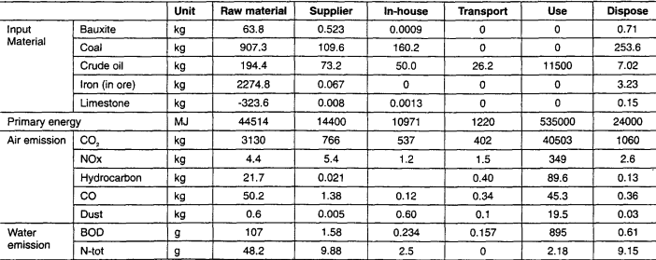

* + 1. **Saturated market in developed country**

The table shows the data of Canada Agricultural Machinery and Equipment (Table 2). From 2015 to 2018, the data of Canada agricultural machinery only fluctuate a little. In another word, the market is saturated. But Canada still import and produce agricultural machinery. Mainly because old ones are scrapped. And farmers still have the need to use agricultural machinery, so they produce and import new ones.

Table 2 Canada Agricultural Machinery and Equipment Data [2]

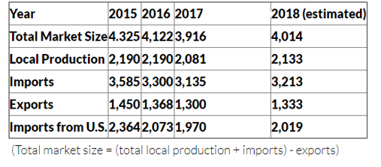

**1.2.2 Huge Emission of Old-typed Agricultural Machinery**

In developing countries, a lot of farmers cannot afford to buy qualified agricultural machinery, so they choose to farm in traditional way or use unqualified old-typed agricultural machinery. However, compared with new-typed machinery, old-typed ones not only have low engine power, but also produce more emissions.

Table 3. Bharat emission limits for agricultural diesel tractors and implementation timeline [3].

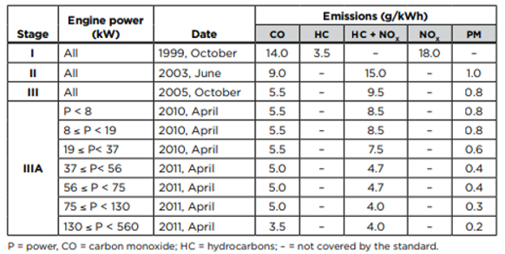

**1.3 Scope**

The application aimed at solving overplus agricultural machinery problem in developed countries, and lack of qualified machinery in developing countries. Its main purpose is reducing the amount of agricultural machinery in a whole area by sharing. Then ecological footprint of the farms in this area will be reduced.

**2 SOLUTION**

The app will have 2 different models for developed country and in developing country respectively to solve their different problems. And for the problem caused by this app: the agricultural machinery you rent out may be destroyed by others. We will have strict policies to make sure the possibilities are minimal

2.1 **Business model in developed country**

The market in developed country is saturated. Most farmers buy new machine because there old one is scrapped. If farmers can choose to rent usable idle agricultural machinery instead of buying new one, the huge resources needed to make new farm machinery will be saved a lot. This application will offer an intermediary platform for farmers to share agricultural machinery. For farmers who have idle agricultural machinery, they just need to publish information about their machine on our platform. Then the information about the agricultural machinery will be collected and be shown to farmers who need to rent (Figure 1). The main way of this business model to make profit is the service charge.

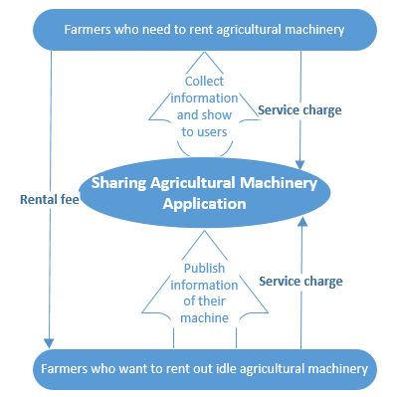

Figure 1 Business model in developed country

**2.2 Business model in developing country**

In developing countries, our company need to cooperate with other companies that can make qualified and unified agricultural machinery. They make agricultural machinery and we rent. Firstly, farmers reserve the type of agricultural machinery they want and our app will show the rental station where has this type. Secondly, they can take the reserved machine. Thirdly, after farmers return the agricultural machinery, they will get their cash pledge back. This business model not only help farmers share one machine, but also help qualified machine take the place of unqualified machine, which can reduce ecological footprint further. The main way of this business model to make profit is the service charge and parts of rental fee.

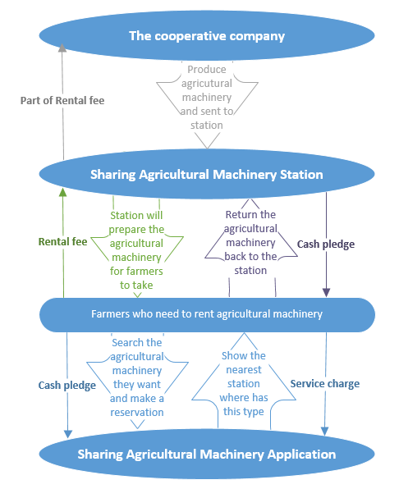

Figure 2 Business model in developing country

**2.3** **Applicant Eligibility**

Sharing agricultural machinery will produce new problem: The agricultural machinery you rent out is expensive, others may do damage to your agricultural machinery unintentionally. To solve the problem as much as possible, our app will have strict qualification examination for applicants. If farmers want to rent agricultural machinery, they will have to provide driver license for agricultural machinery, cash pledge and insurance fee. These three things can make sure that they are able to drive it and they will be careful enough, and even they do damage to others’ machine in case, they will have insurance at least.

**2.4 Results**

The figure below should be the final operation interface of the app. Firstly, choose you want to rent or rent out. Secondly, choose the type of agricultural machinery you want. Thirdly, search for a rent location (Figure 3). By using the app, less agricultural machinery will be produced worldwide. And in developing countries, the qualified machinery will produce less ecological footprint than unqualified machinery. The exact value depends the market size. If 2 people share 1 tractor. 15 tons of input material and 600000MJ energy will be saved. If 3 people share 1 tractor. 30 tons of input material and 1200000MJ energy will be saved. The more people share their agricultural machinery, the more ecological footprint of farms will be reduced.

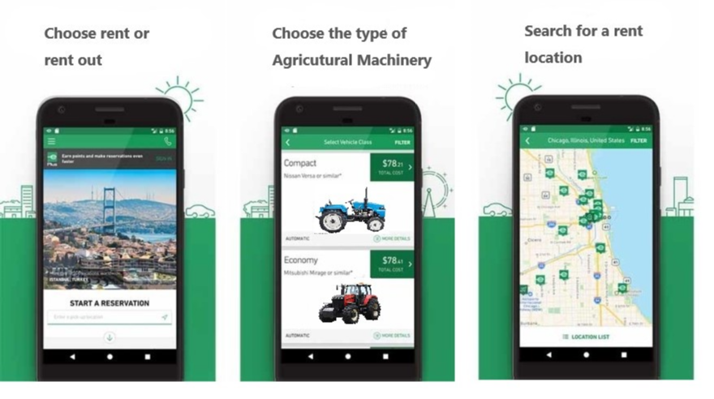

Figure 3 App screenshot [4-5]

**3** **PLAN OF ACTION**

There are 3 steps to develop the app: draft, develop beta version and test.

**3.1 Step1: Draft**

Draft has 2 parts: Basic draft and low-fidelity prototype. In basic draft, engineers just use pencil and paper to draw the draft by hand, which can help the group share their idea quickly. Based on the final basic draft, engineers will use simple wireframe and text to draw the low-fidelity prototype. Users can have some basic interaction with the low-fidelity prototype. By experiencing the design simply, engineers can find some basic problems and change it.

**3.2 Step2：Beta Version**

Software engineers will write code about different functional modules of sharing agricultural machinery application. Such as GPS module to help users find rent location, searching module to help users search which kind of agricultural machinery they want, payment module to take rental fee, cash pledge and service charge… After every functional module have been written, UI engineers will follow the low-fidelity prototype and write code about UI module to combine every functional module together. UI engineers will also beautify the interface. Then we will get the 0.9 version of our application: Beta version

**3.3 Step3: Test**

The finish of developing beta version means that we can start our close beta test. Software engineers will debug the app as careful as possible. Meanwhile testing engineers will pretend as a farmer to find the detailed requirements of farmers. Then software engineers will make a final patch to meet these detailed requirements.

**4 Schedule**

The Gantt chart below will show the schedule of developing the sharing agriculture machinery application (Figure 4). Our company need 2 weeks for draft, 4 weeks for develop beta version, 3 weeks for closed beta test and make the final patch. The schedule is only the schedule for develop app. It doesn’t contain the time for Appstore approval process (1 week -4 weeks).

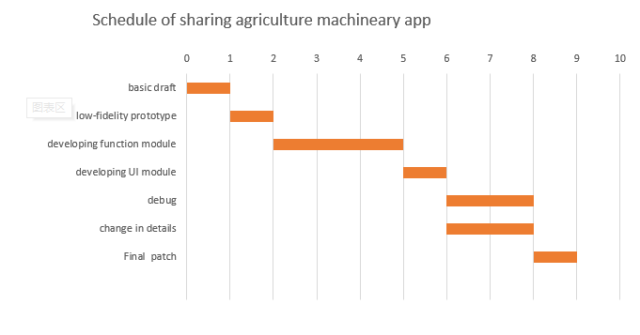

Figure 4 Gantt chart of Schedule

**5 Budget**

There are multiple types of cost in developing the application. We can divide these types of cost into 4 types: sharing station cost, salary, equipment cost, and additional cost. Total budget= the budget for developing application+ Annual fee for one sharing station*number of stations+ rental fee of cloud server =60800$ +1500$/year+269280$/year *number of stations

**5.1 Sharing station cost**

To build a sharing station in developing countries, we need employ 8 clerks, 2 maintenance workers and 1 manager to keep the sharing station running and maintain the agricultural machinery in the station. We also need to pay location rental for our station. Because our sharing station is in developing countries, hourly wage is very low.

Table 4. Annual fee for one sharing station

|  |  |  |
| --- | --- | --- |
| **Location rental/Employee** | **Price** | **Time** |
| Location rental | $80000.00 | 1 year |
| Manager | $15.00/hour | 2080 hours |
| Maintenance worker | $10.00/hour | 2080 hours |
| Clerk | $7.00/hour | 2080 hours |
| **Total** | $269280 | year |

**5.2 Salary of developing group**

The project need a group of 8 engineers to develop application and a project manager to manage the group. 4 software engineers who working all 9 weeks,2 UI engineers who working 4 weeks (basic draft, low-fidelity prototype, developing UI module, final patch), 2 testing engineers who working 2 weeks (change in details).

Table 5. The Budget for developing application

|  |  |  |
| --- | --- | --- |
| **Employee (number of people)** | **Price** | **Time** |
| Project Manager (1) | $65.00/hour | 360 hours |
| Software Engineer (4) | $32.00/hour | 360 hours |
| UI Engineer (2) | $32.00/hour | 160 hours |
| Testing Engineer (2) | $28.00/hour | 80 hours |
| **Total** | $84200.00 | 9 weeks |

**5.3 Equipment Cost**

If we choose to buy enough agricultural machinery for sharing station, then we will have very high equipment cost. However, we choose to cooperative with other companies that can offer the agricultural machinery in this proposal, then we don’t have any equipment cost because the project is about software.

**5.4 Additional Cost**

We need to rent a cloud server to process user instructions, store user data and store our backup of past versions. The annual rental fee of a cloud server is 1500$.

**6 QUALIFICATIONS**

Dr. Aiman Hanna holds a B.Sc. in Electrical Engineering from Assuit University, Egypt and a Diploma of Computer Science followed by a Master's in Computer Science from Concordia University. He has been a faculty member in the Department of Computer Science at Concordia University for more than six years, while working concurrently as a senior software engineer for one of the largest telecommunication firms in North America. Professor Hanna has valuable international industry experience and is an expert in more than six computer languages. His exceptional expertise in software engineering is what led me to choose him as my supervisor. [6]

My name is Yifan Yang, a software engineering student study in Concordia University. I studied in Concordia from fall 2016 and I am expected to graduate by fall 2021 (international students have to use a year for ESL and extended Credit Program). I have worked as a Junior Software Testing Engineer(internship) at Zhihu (China) for one year. I write the proposal to your company because of 2 reasons: the unqualified agricultural machinery has caused serious smog pollution in my hometown, and the sharing bike application is very popular in China. I believe this project will reduce ecological footprint and be promising.

**7 CONCLUSION**

To sum up, in developed country, this app will offer a platform for farmers to share agricultural machinery. The main way to make profit is service charge. In developing country, this app will have its own sharing station for farmers to rent agricultural machinery. The main way to make profit is service charge and rental fee, but a part of rental fee will be paid to our cooperative company who offer agricultural machinery. This application will reduce ecological footprint of farms by sharing agricultural machinery and using qualified agricultural machinery instead of old-typed and unqualified agricultural machinery.

**7.1 Contact Information**

pigooo1@hotmail.com

514-XXX-XXXX

Software engineering student in Concordia

**8 REFERENCES**

[1] J.Lee, H.Cho, *et al.* (2000). ”*Life cycle assessment of tractors”.*[online]. Available at:

https://link.springer.com/article/10.1007/BF02979361 [Accessed 5 June. 2018]

[2] V.Oujegov.(2017).”*Canada - Agricultural Machinery and Equipment*”[online].Available at:https://www.export.gov/article?id=Canada-Agricultural-Machinery-and-Equipment [Accessed 5 June. 2018]

[3] Z.Shao.(2016). *“An emissions inventory for agricultural tractors and construction equipment in India*”[online]. Available at:

https://www.theicct.org/sites/default/files/publications/India%20Nonroad%20Emissions%20Inventory%20Working%20Paper_vF.pdf [Accessed 5 June. 2018]

[4] J.Hindy.(2017).” *10 best car rental apps for Android*” [online]. Available at:

https://www.androidauthority.com/best-car-rental-apps-android-784387/ [Accessed 5 June. 2018]

[5] N.A.,” *BELARUS MTZ 82.1*” [online]. Available at: https://www.mojauto.rs/polovni-poljoprivredna/2562740_BELARUS_MTZ-82-1_2017_god/?cena=high [Accessed 5 June. 2018]

[6] N.A., *“Professor Aiman Hanna - Department of Computer Science, Concordia University, Montreal, Canada.”* [online] Available at:

http://aimanhanna.com/concordia/teachingexcellenceaward.htm [Accessed 5 Jun. 2018].