（to do list: technical definition, recommendation,查询，memo, analysis , instruction）

**要带把尺子**

**1.**

**Letter**

* Often on exam*

Sender

Date

Destination

Subject

Opening salutation

Introduction

Body

Conclusion

Closing remark

Signature

Name

INITIAL

ENCLOSURE

CC

2.

**Mechanism description**

**Overall description**

**Overall function**

**Overall appearance(shape, material, size，colour, weight, texture)**

**Pillar 柱子**

不锈钢：stainless steel

木头：wooden

塑料plastic

石头stone

棉质 cotton  
正方形 square

圆柱cylinder

五边形pentagon

六边形Hexagon

8边形 octagon

10边形 decagon

**List of parts**

**Description**

**Function**

**Appearance**

**Link to next part**

**要有图片**

3.

**Persuasion guidelines**

* Ethos, Logos, Pathos
* Ethos: Appeal to our good character 用我们的社会地位，知名度来说服你  
  Logos: Appeal to our reason 用逻辑说服你  
  Pathos: Appeal to our emotion 用感情说服你  
  **4.**

**Abstract**

* Informative abstract only
* Usually couple 100 words
  + Example of exam question:
    - Cover each part of the article (structure)
    - Given article from newspaper

5.

**Toulmin logic**

* + Example of exam question:
    - Given Press release and must find: Grounds, warrant, backing

Claim: Major proposition or conclusion of the argument

主张：论点的主要命题或结论

Claim:你想让他人承认的观点或你想让他人做的事

*You should use a hearing aid.*

Grounds: Evidence upon which the claim rest

理由：论点所依赖的证据，具体的数据或者是一种事实

*Over 70% of all people over 65 years have a hearing difficulty.*

Warrant: Justification for the grounds and what makes them relevant to the claim

证明：解释grounds，以及他和claim之间的联系

*A hearing aid helps most people to hear better.*

他回答的是一个潜在的问题'*Why*does that data mean your claim is true?

Backing: Further evidence for accepting the warrant

支持：进一步证明接受warrant的证据通过回答一个不同的问题，这一句话要支撑warrant，会显然的用ethos logos pathos

*Hearing aids are available locally.*

Rebuttal: Counterarguments or exception to the claim, warrant or backing  
反驳：claim warrant backing的反驳或例外情况

你的辩证无论多严格，总会有例外，rebuttal就是承认这一部分里外的过程  
*There is a support desk that deals with technical problems.*

**Other likely questions and their formats:**

* Sometimes proposal question combined with memo.
* Given 5 words, define
  + Examples:
    - “write a technical definition of a bridge”
    - “write a technical definition of a key”

1) Technical definition (5*2 = 10 points) (18 min) (kitchen blender...)

Short report memo (20 points) (36 min) (you have to write about complaining situation)

**6.**

**Format [Memo]**

**To:** Readers Name/Job Title

**From:** Your Name/Job Title

**Date:** Complete Current Date

**Subject:** What Is Memo About

**Body**

* Action Opening [Engage Reader]
* Background Context
* Relevant Details
* Action Closing

**Remember**

* Most Important Info First, Details Follow
* Non-Emotional Content, Passive Voice
* Not A Letter, First Person Acceptable
* **TAPSS:** Topic, Audience, Purpose, Structure & Style

**Topics**

Project Completion, Incident/Accident Report, Inspection, Compliance, Field/Laboratory Trip, Feasibility, Casual Analysis, Assessment, and Problems Analysis/Recommendation

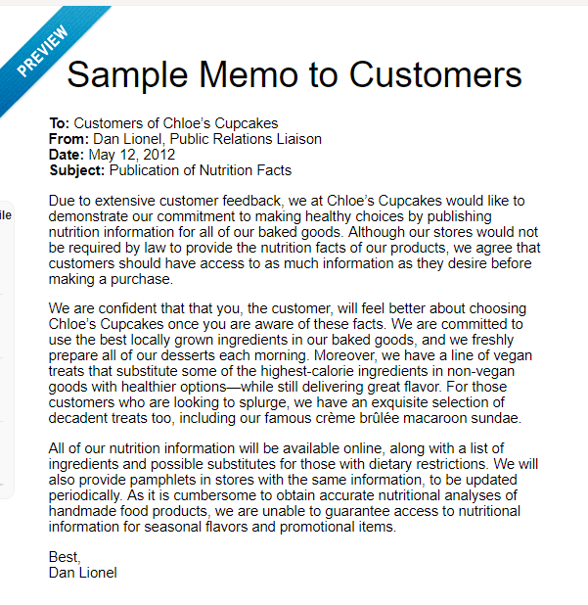

7.question is about writing instructions (write instructions about the following process, just as

done in class)

**Instructions**

Introduction  
  
 1. Definition of the overall process  
 2. Purpose  
 3. Theory or principles, if necessary  
 4. list of steps  
  
Steps

1. Definition, introduction
2. Description of what happens
3. Cautions
4. List of required equipment
5. Specific directions (number the directions in sequence)
6. Result
7. Conclusion

* Summary of the steps
* Additional information

***Do not forget visuals***

2) question about writing technical descriptions (just as practiced in the assignment, will be

shown a picture of something and the question will be to write a description about this object,

if things are inside the object, ignore what&#39;s inside. Focus on the outside, what we can see. The

parts will be parts that we can SEE) + BRING a ruler to get measurement to scale (1 to 3, etc).

8.

6) Library power point (20 points) (36 min) (slide 8 + slide 18) on the link: <http://library.concordia.ca/research/subjects/techwriting/ENCS282.pdf>

question on the library workshop (slides on moodle), it’s going to be on something very

specific (very straightforward).

1. Technical definition

Technical definition: names the mechanism, gives its class,  
appearance, and prinicipal characteristic or function

Name/class/appearance/function

XX是一个由什么组成的XX

PI ywood is a building material composed of thin sheets of wood  
glued together.  
A hypodermic needle is a slender, hollow, steel instrument used to  
introduce medication into the body.  
Anaesthetics are drugs causing unconsciousness or insensibility to  
pain.  
A periodic report is a technical paper wri tten to record tasks  
accomplished during a specified period of time.  
A rectangl e is a foursided figure having all its angl es right  
angles and, thus, its oppostie sides equal and parallel.  
A mouse is an electronic device that looks like a small box and  
pI ugs into the computer operating system to allow the user to  
interact with the information on the screen.

Class : building material

Medical equipment

Electronic device

办公用具： office equipment

药：drugs

文具 stationery

厨房用具 kitchen equipment

Techinical paper

Xx figure

a slender, hollow, steel instrument

XX IS A XX that looks like a xx used to do sth