LECTURE 1  
Memorandum   
  
Company (From)  
Destination (To)  
Date  
Topic  
Memo itself

LECTURE 2

Letters:  
  
Sender  
Date  
Destination  
Subject  
Opening salutations  
Introduction  
Body  
Conclusion  
Closing remarks  
Signature  
Enclosure  
Carbon copy 抄送人  
Initials

怎么写信

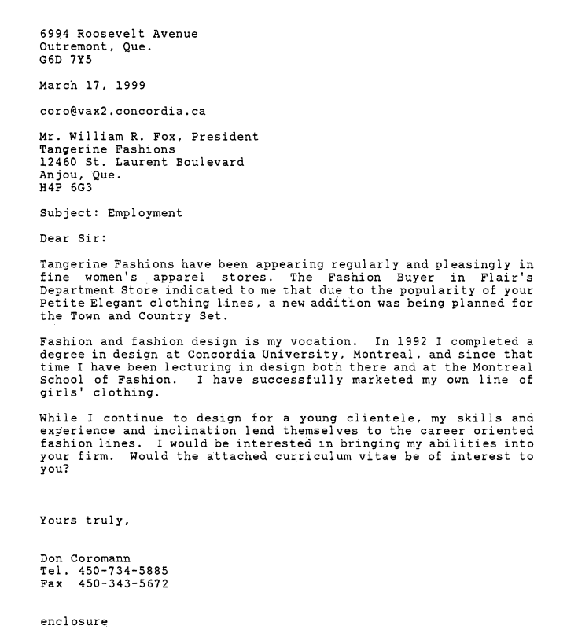

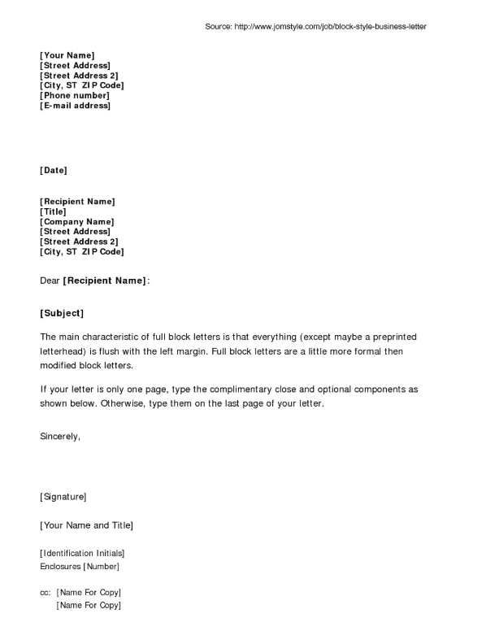

LECTURE 3

Mechanism Description  
  
◆       Introduction  
  
•       Definition

XXXX is a xxclass to do sth  
•       Overall function  
•       Overall appearance (colour, shape, size, texture质地, finish, material)  
•       List of parts  
不锈钢：stainless steel

木头：wooden

塑料plastic

石头stone

棉质 cotton  
正方形 square

圆柱cylinder

五边形pentagon

六边形Hexagon

8边形 octagon

10边形 decagon

柱子pillar  
◆       Parts’ description  
  
•       Definition  
•       Function  
•       Appearance  
•       Link to the next part  
  
  
◆       Conclusion  
•       Summary of the mechanism function (relist the parts)  
•       Sense of finality  
  
Proposals  
  
◆       Introduction  
  
•       Purpose  
•       Background (statement of the problem) 2 subheadings  
•       Scope  
  
◆       Solution criteria  
  
•       Approach (2 subheadings)  
•       Result  
  
◆       Plan of action (3 steps)  
  
◆       Schedule  
  
◆       Budget ( 3 positions)  
  
◆       Qualifications (2 people)  
  
◆       Conclusion  
  
•       Summary  
        Contact

LECTURE 5

Instructions  
  
Introduction  
  
Definition of the overall process  
Purpose  
Theory or principles, if necessary  
List of steps  
  
Steps  
  
Definition 描述  
Description of what happens 描述发生了什么  
Cautions 警告  
List of required equipment  
Specific directions (number the directions in sequence)  
Result  
  
Conclusion  
  
Summary of the steps  
Additional information

LECTURE 7

Abstract  
  
Informative abstract  Summarize each section of a paper, 150 to 200 words

每段2句话，150字

LECTURE 9

Toulmin logic  
  
Toulmin logic provides a way of checking your own arguments for overlooked flaws.  It can also help you arrange your argument.  
检查您自己的参数的方法，以发现被忽略的缺陷。它还可以帮助你安排你的论点。  
Claim: Major proposition or conclusion of the argument

主张：论点的主要命题或结论

Claim:你想让他人承认的观点或你想让他人做的事

*You should use a hearing aid.*

Grounds: Evidence upon which the claim rest

理由：论点所依赖的证据，具体的数据或者是一种事实

*Over 70% of all people over 65 years have a hearing difficulty.*

Warrant: Justification for the grounds and what makes them relevant to the claim

证明：解释grounds，以及他和claim之间的联系

*A hearing aid helps most people to hear better.*

他回答的是一个潜在的问题'*Why*does that data mean your claim is true?

Backing: Further evidence for accepting the warrant

支持：进一步证明接受warrant的证据通过回答一个不同的问题，这一句话要支撑warrant，会显然的用ethos logos pathos

*Hearing aids are available locally.*

Rebuttal: Counterarguments or exception to the claim, warrant or backing  
反驳：claim warrant backing的反驳或例外情况

你的辩证无论多严格，总会有例外，rebuttal就是承认这一部分里外的过程  
*There is a support desk that deals with technical problems.*

Aristotle  
  
Ethos: Appeal to our good character 用我们的社会地位，知名度来说服你  
Logos: Appeal to our reason 用逻辑说服你  
Pathos: Appeal to our emotion 用感情说服你