GFM Inverter
circular limiter:
voltage drop: 0.078
0.082
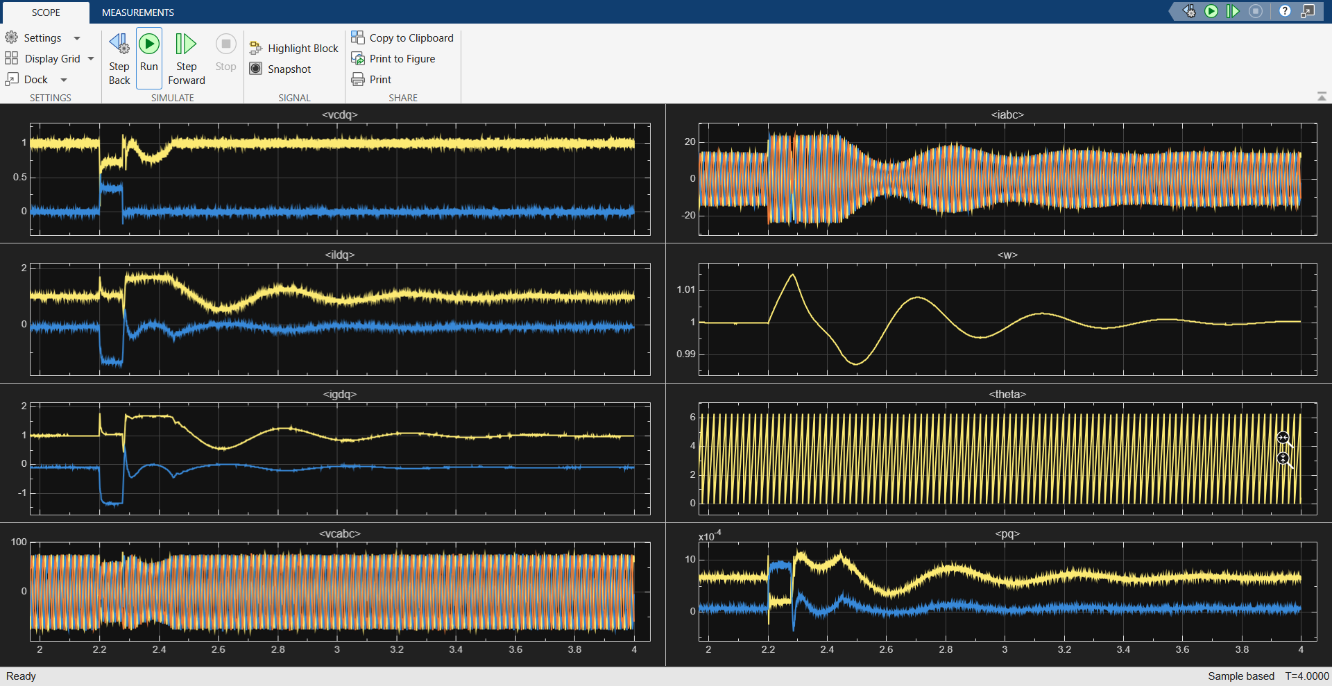
EVA:
Xg = 0.307; %0.431
Rg = 0.0338;%0.05

voltage drop
t_c = 0.118

