**Examining the Potential for Nigeria's Quota Deviation on 2024**

2024S ECO254 Final Paper Cao Yifei

**Introduction**

Nigeria, a prominent member of the Organization of the Petroleum Exporting Countries (OPEC), has long relied on oil as a cornerstone of its economy. The country's oil production and adherence to OPEC quotas significantly impact its economic stability and growth. This paper aims to analyze the relationship between Nigeria's deviation from OPEC production quotas and key economic indicators, including GDP per capita, fiscal deficit as a percentage of GDP, and OPEC oil prices. By employing Ordinary Least Squares (OLS) regression analysis utilizing data from the World Bank and OEPC, this study seeks to quantify how domestic fiscal balance and global oil market will influence Nigeria’s decision on Deviation.

**Structure of Oil Industry**

The oil industry is divided into three sectors: upstream, midstream, and downstream. The upstream sector involves exploration, drilling, and production of crude oil and natural gas, significantly influencing oil prices through supply control (BP, 2021). The midstream sector covers transportation and storage, while the downstream sector includes refining and distribution of petroleum products.

The history of the oil industry dates back to the mid-19th century, with the first commercial oil well drilled by Edwin Drake in Pennsylvania in 1859 (Yergin, D., 2006). The industry evolved significantly in the 20th century, with the Organization of the Petroleum Exporting Countries (OPEC) formation in 1960, which marked a pivotal development. OPEC, founded by Iran, Iraq, Kuwait, Saudi Arabia, and Venezuela, aimed to coordinate and unify petroleum policies among member countries to secure fair and stable prices for petroleum producers (OPEC, 2021).

Upstream activities, led by companies like ExxonMobil and BP, determine production levels and are influenced by geopolitical events, technological advancements, and regulatory changes, all of which directly impact global oil prices (OPEC, 2021). OPEC's production decisions, particularly during events like the 1973 oil embargo, have historically caused substantial fluctuations in the oil market, highlighting the critical role of the upstream sector (Yergin, D., 2011).

**Economic Models Supporting OPEC's Strategies**

Since there are multiple countries that have sufficient oil reserves, most customers are indifferent between different brands or versions of the oil product because the products are functionally identical (Tirole, J., 1988). In Industrial Organization, this kind of product can be seen as homogeneous products, which will be perfect substitutes for each other. Bertrand Competition is highly possible for the market of this kind of product. Bertrand competition is a model of competition in which firms set prices for homogeneous products, and consumers buy from the firm with the lowest price (Tirole, J.,1988). Therefore, these companies might be stuck in the Bertrand Trap, which is a situation in which firms in an oligopoly compete solely on price, leading to a downward spiral of prices and diminishing profits for all firms involved (Fudenberg, D., & Tirole, J., 1984). To compete in this trap, theoretically, with the same production cost, companies will keep decreasing their prices until it equals their cost. Cartel or price differentiation will be the solution to get out of the trap.

Before 1960, when OPEC was founded, the oil market was dominated by the major oil companies, known as the Seven Sisters. These companies operated in an oligopolistic market, where firms compete on price, often leading to price wars and reduced profits, a scenario akin to the Bertrand trap. In response to their price strategy, they decided to collude and form a Cartel Organization, OPEC. OPEC's objective was to unify the petroleum policies of its member countries to counteract this competitive pressure and assert control over oil pricing and production in order to maximize their collective profits. By forming OPEC, oil-producing countries sought to collectively negotiate prices and reduce the risk of undercutting each other, thereby avoiding the Bertrand trap and ensuring fair and stable prices for oil producers (Yergin, D., 2006).

OPEC's control over oil supply is a central element of its economic strategy. By setting production quotas, OPEC members aim to balance the market, avoiding both oversupply (which would lower prices) and undersupply (which could lead to price spikes). The organization monitors global oil demand and adjusts its quotas accordingly. With this strategy, OPEC already commands approximately 50% of the world's market share and accounts for about 40% of global oil production (EIA, 2022). This strong market power enables OPEC to exert significant influence on global oil prices. Analyzing their performance over the past 20 years, OPEC has demonstrated a positive oil price elasticity of 0.003618061 (Fig. 1), reflecting their ability to maintain stable prices even with adjustments in production levels.

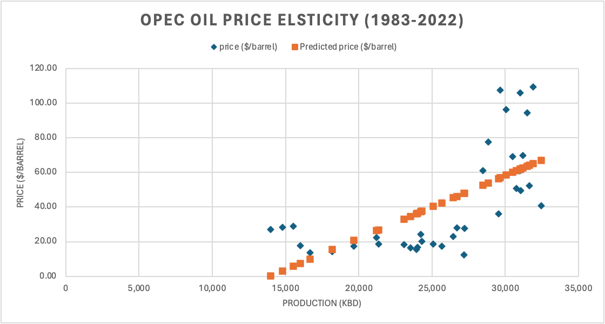

|  |  |  |  |  |  |  |  |  |
| --- | --- | --- | --- | --- | --- | --- | --- | --- |
|  | *Coefficients* | *Standard Error* | *t Stat* | *P-value* | *Lower 95%* | *Upper 95%* | *Lower 95.0%* | *Upper 95.0%* |
| Intercept | -50.414992 | 18.6088138 | -2.7091996 | 0.01048622 | -88.232652 | -12.597332 | -88.232652 | -12.597332 |
| production (kbd) | 0.00361806 | 0.00071311 | 5.07366828 | 1.3786E-05 | 0.00216886 | 0.00506727 | 0.00216886 | 0.00506727 |

**Fig. 1. OPEC oil price elasticity (1983-2022)**

OPEC Oil Price = -50.41499 + 0.003618 * OPEC oil Production

Analyzed and plotted by “Regression” in Excel’s “Data Analysis Toolpak”.

Data Source: OPEC Secretariat’s Annual Statistical Bulletin. (2024). “OPEC Members' crude oil production allocations 2023”. See Appendix 1.

However, individual OPEC member countries sometimes deviate from agreed-upon production quotas to maximize their own benefits. For instance, some countries might overproduce oil to take advantage of high prices, thereby increasing their revenue at the expense of overall market stability (Smith, 2005). This behavior can undermine OPEC's collective efforts to control supply and stabilize prices, leading to a breakdown in cooperation. Conversely, other countries might choose to underproduce to create an artificial scarcity, driving up prices and benefiting from higher market prices for their limited output (Fattouh, 2011). Both strategies disrupt the delicate balance OPEC strives to maintain and parallel the Bertrand trap, where firms lower prices to attract more customers, ultimately harming industry profits through competitive actions (Fudenberg & Tirole, 1984).

**Nigeria’s Historical Deviation**

Nigeria has the largest GDP and the greatest oil export amount in Africa, making it a significant player in the global oil market. As of 2022, Nigeria's GDP stood at approximately $514 billion, the highest in Africa (World Bank, 2022). Additionally, Nigeria is the largest oil exporter on the continent, with crude oil exports amounting to about 1.6 million barrels per day (OPEC Annual Statistical Bulletin, 2023). This significant contribution to the oil market underscores Nigeria's pivotal role in influencing global oil prices and supplies.

However, the country's macroeconomic situation is becoming increasingly precarious due to several factors. The insecurity in the Niger Delta, often referred to as the "Niger Delta Triangle," has led to frequent disruptions in oil production and pipeline vandalism (Udegbunam et al., 2015). Additionally, Nigeria's large and growing population, projected to reach over 400 million by 2050, places immense pressure on its economy (World Bank, 2021). High unemployment rates, inflation, and a heavy reliance on oil exports for government revenue exacerbate these issues, creating a volatile economic environment. Despite its vast natural resources, Nigeria struggles with economic instability, driven by both internal conflicts and external market fluctuations (Okonjo-Iweala, 2018).

Nigeria's oil production costs have recently become some of the highest in the world, reaching approximately $48 per barrel (Punch, 2024). These high production costs pose significant challenges for the country in maintaining its production quotas. By analyzing Nigeria's deviation from OPEC quotas, calculated from OPEC's published data archives (Table 1), it becomes evident that Nigeria has consistently underproduced relative to its quotas since 2021 (Fig. 2). Several reasons contribute to this underproduction. The ongoing security challenges in the Niger Delta, including militant activities and oil theft, have severely impacted Nigeria's ability to meet its production targets (Obi, 2010). Additionally, maintenance issues and aging infrastructure have led to frequent shutdowns of production facilities. By underproducing, Nigeria aims to create artificial scarcity in the oil market, which can drive up global oil prices. This strategy allows Nigeria to benefit from higher oil prices, even if its production volumes are lower, thereby maximizing revenue from its exports. Despite the potential short-term financial gains, this approach undermines OPEC's collective efforts to stabilize the oil market and can lead to long-term economic challenges for Nigeria (Nwosu et al., 2022).

|  |  |  |  |
| --- | --- | --- | --- |
| **Year** | **Quota (kbd*)** | **Actual production (kbd*)** | **Deviation (kbd*)** |
| 2017 | 1685 | 1536 | -149 |
| 2018 | 1685 | 1602 | -83 |
| 2019 | 1774 | 1737 | -37 |
| 2020 | 1412 | 1493 | 81 |
| 2021 | 1683 | 1323 | -360 |
| 2022 | 1742 | 1138 | -604 |

**Table 1. Deviation in Nigeria from 2017 to 2022**

*“kbd” stands for a kilo barrel per day.

Data Source: OPEC Secretariat’s Annual Statistical Bulletin. (2024). “OPEC Members' crude oil production allocations 2023”.

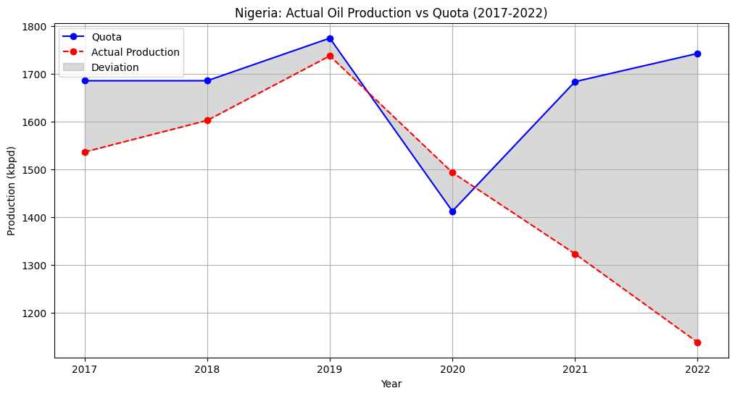

**Fig. 2. Nigeria: Actual Oil Production vs Quota (2017-2022)**

Plotted by Python utilizing Data in Table 1.

**Nigeria’s gaining from future possible Deviation in 2024**

Given Nigeria's challenging economic circumstances, the country has a strong incentive to maximize its income, especially with the current relatively high oil prices. To assess Nigeria's potential profits from its ongoing deviation in 2024, it is essential to calculate its price elasticity for oil exports. Utilizing OPEC's historical dataset of Nigeria's monthly oil prices and production levels, we can determine that Nigeria's oil price elasticity from 2020 to 2022, has been -0.0928 (Fig. 3). This elasticity measure indicates the responsiveness of Nigeria's oil revenue to changes in oil prices, providing valuable insights into the economic implications of its production decisions.

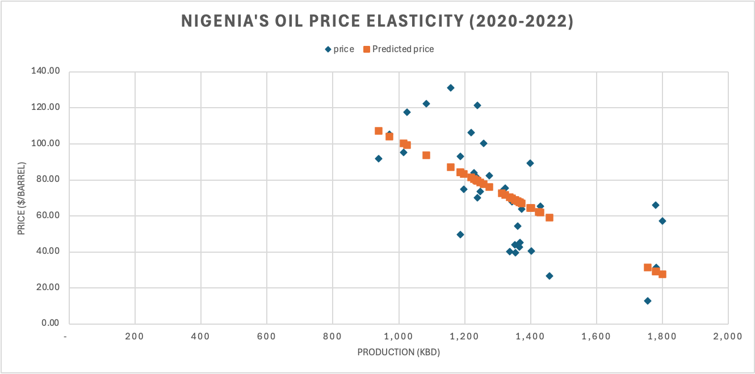

|  |  |  |  |  |  |  |  |  |
| --- | --- | --- | --- | --- | --- | --- | --- | --- |
|  | *Coefficients* | *Standard Error* | *t Stat* | *P-value* | *Lower 95%* | *Upper 95%* | *Lower 95.0%* | *Upper 95.0%* |
| Intercept | 194.363748 | 23.5521643 | 8.25247931 | 1.249E-09 | 146.499992 | 242.227505 | 146.499992 | 242.227505 |
| production | -0.0927689 | 0.0176675 | -5.2508245 | 8.1164E-06 | -0.1286736 | -0.0568643 | -0.1286736 | -0.0568643 |

**Fig. 3. Nigeria’s Oil Elasity (2020-2022)**

Nigeria Oil Price = 194.3637 - 0.09277 * Nigeria oil Production

Analyzed and plotted by “Regression” in Excel’s “Data Analysis Toolpak”.

Data Source: OPEC Secretariat’s Annual Statistical Bulletin. (2024). “OPEC Members' crude oil production allocations 2023”. See Appendix 2.

Using the linear expression between Nigeria's oil price and its oil production, we can compare the profits of following and deviating from OPEC's quotas. Both profit calculations are based on the quantity of oil produced multiplied by the profit per barrel, with a production cost of $48 per barrel. The specific data used for these calculations can be found in Table 2. If Nigeria adheres to OPEC's quota for 2024, set at 1,380 thousand barrels per day (kbd) (OPEC, 2024), and with recent oil prices around $80 per barrel, the country stands to profit approximately $44.160 million per day.

In contrast, if Nigeria deviates from OPEC by underproducing, operating within the range of 407 kbd to 1171 kbd, it can potentially earn more profit than by adhering to OPEC's quota (Fig. 4). Nigeria's maximum profit, totaling $57.737 million, is achievable at a production level of 789 kbd. This maximum profit represents an increase of approximately $13 million per day compared to following OPEC's quota, highlighting the potential short-term financial benefits of deviating from the quota.

|  | **OPEC** | **Deviation** |
| --- | --- | --- |
| **Quantity** | 1,380 kbd (Quota, 2024) | [0,2000] kbd |
| **Cost** | $48 per barrel | $48 per barrel |
| **Price** | $80 (Recent Oil price) | $194.3637 -$0.0928 * Production |

**Table 2. Data for Calculating Profit on Occasions Nigeria Follow OPEC and Deviate from OPEC.**

Data Source of Cost: Punch. (2024). "Nigeria’s $48 per barrel oil production cost, global highest- Faleke”. Accessed June 21, 2024.

Date Source of Quota: OPEC. (2024). Production table - 35th ONOMM.

Data Source of Recent Oil Price: Crude Oil Price Today. “WTI Crude Price”. https://oilprice.com/. Accessed June 10, 2024.

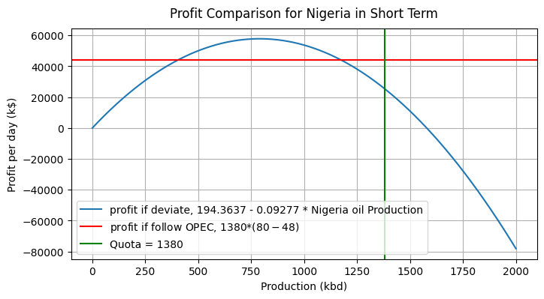

**Fig. 4. Profit Comparison on Occasions Nigeria Follow OPEC and Deviate from OPEC.**

Calculated and Plotted by Python, utilizing data in Table 2.

Code see Appendix 3.

**Concerns Over Deviation and Economic Determinants for Nigeria's Production Decisions**

Despite the potential short-term financial gains from deviating from OPEC quotas, Nigeria faces significant long-term concerns that may outweigh these benefits. Continued deviation could strain Nigeria's relationships with other OPEC members and international oil markets, leading to reputational damage and potential market backlash. Furthermore, prioritizing immediate profits over sustainable production practices risks depleting Nigeria's oil reserves faster than planned, jeopardizing its long-term economic stability. Additionally, the volatility caused by erratic production levels could undermine investor confidence in Nigeria's oil industry, hindering future investment and development opportunities.

To understand the economic conditions under which Nigeria might ignore the long-term concerns and consider continuing its deviation from OPEC quotas, it is crucial to analyze the relationship between deviation and key macroeconomic indicators: GDP per capita, fiscal deficit as a percentage of GDP, and OPEC oil prices. These indicators were selected due to their comprehensive representation of the economic pressures and incentives influencing Nigeria's production decisions.

Firstly, GDP per capita is an essential measure reflecting the average economic output per person and serves as a general indicator of economic health and living standards. A higher GDP per capita suggests a more robust economy, potentially reducing the need for immediate revenue boosts from increased oil production. Conversely, a lower GDP per capita might pressure the government to seek additional revenues through overproduction. Secondly, the fiscal deficit as a percentage of GDP indicates the gap between government revenues and expenditures. A larger fiscal deficit, expressed in negative values, signifies greater financial stress, possibly compelling Nigeria to deviate from OPEC quotas to generate more revenue. Understanding this relationship helps gauge the extent to which fiscal pressures influence production decisions. Lastly, OPEC oil prices represent the average oil prices in the global oil market, which directly impact the revenue Nigeria can earn from its oil exports. Higher oil prices might reduce the incentive to overproduce, as adequate revenue can be generated even with lower production levels. Conversely, lower oil prices could drive Nigeria to exceed its production quota to compensate for reduced per-barrel income.

To quantify these relationships, an Ordinary Least Squares (OLS) regression analysis was conducted using historical data obtained from the World Bank and OPEC from 2017 to 2022 (Table 3). The regression analysis demonstrates a strong positive correlation between the fiscal deficit and deviation (Fig. 6). Given that the fiscal deficit is expressed in negative values, this result implies that the more severe the fiscal deficit, the greater Nigeria’s deviation through underproduction might be. This finding underscores the significant influence of fiscal stress on Nigeria's decision to deviate from OPEC quotas. Additionally, there is a strong negative correlation between OPEC oil prices and deviation (Fig. 7). This suggests that higher oil prices reduce the likelihood of deviation, as Nigeria can achieve sufficient revenue without increasing production. In contrast, lower oil prices may prompt overproduction to maintain revenue levels. Furthermore, the regression indicates a weak positive correlation between GDP per capita and deviation (Fig. 5). This implies that higher GDP per capita slightly increases the likelihood of overproduction, as a stronger economy might support more aggressive production strategies to capitalize on higher revenues. However, it is important to note that the accuracy of these correlations may be limited by the available data. Specifically, there is a 10-year period during which no quota was assigned to Nigeria. This limitation may affect the precision of the regression results and the strength of the observed correlations.

According to these results, Nigeria’s fiscal deficit emerges as the most significant factor influencing its decision to deviate from OPEC quotas. In times of severe fiscal deficits, the financial pressures may compel Nigeria to underproduce, even at the risk of long-term economic and relational consequences within OPEC. Conversely, higher oil prices and a stronger economy (as indicated by GDP per capita) may reduce the likelihood of deviation, aligning Nigeria’s production levels more closely with OPEC’s quotas. Integrating these insights with the potential short-term financial benefits of deviation elucidates that Nigeria’s production decisions are heavily influenced by its macroeconomic environment. Balancing immediate revenue needs with long-term sustainability and market relationships will be crucial for Nigeria as it navigates its economic challenges.

|  |  |  |  |  |
| --- | --- | --- | --- | --- |
| Year | Deviation | GDP per Capita | Fiscal Deficit in GDP | OPEC oil price |
| 2017 | -149 | 1941.9 | -3.1 | 52.43 |
| 2018 | -83 | 2125.8 | -2.8 | 69.78 |
| 2019 | -37 | 2334.0 | -3.3 | 64.04 |
| 2020 | 81 | 2074.6 | -5.6 | 41.47 |
| 2021 | -360 | 2065.8 | -5.6 | 41.47 |
| 2022 | -604 | 2162.6 | -5.0 | 100.08 |

**Table 3. Deviation, GDP per Capita, Fiscal Deficit in GDP, OPEC Oil Price in Nigeria from 2017-2022.**

Data Source of Deviation: Calculated Deviation in Table 1.

Data Source of GDP per Capita: World Bank. (2022). “GDP per capita (current US$) - Nigeria”. World Bank Group.

Data Source of Fiscal Deficit in GDP: Trading Economics (2022). “Nigeria Government Budget”. Central Bank of Nigeria.

Data Source of OPEC Oil Price: “OPEC Members' crude oil production allocations 2023” from OPEC Secretariat’s Annual Statistical Bulletin.

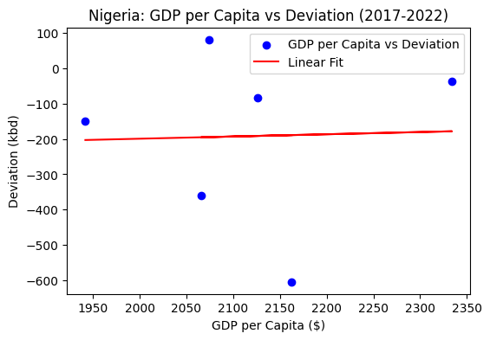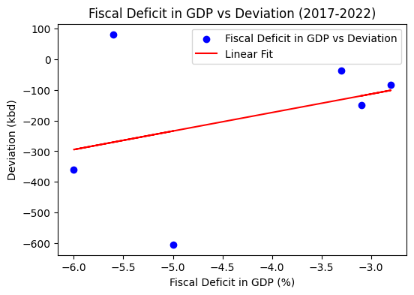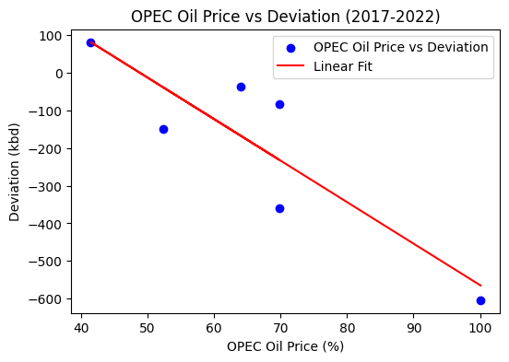

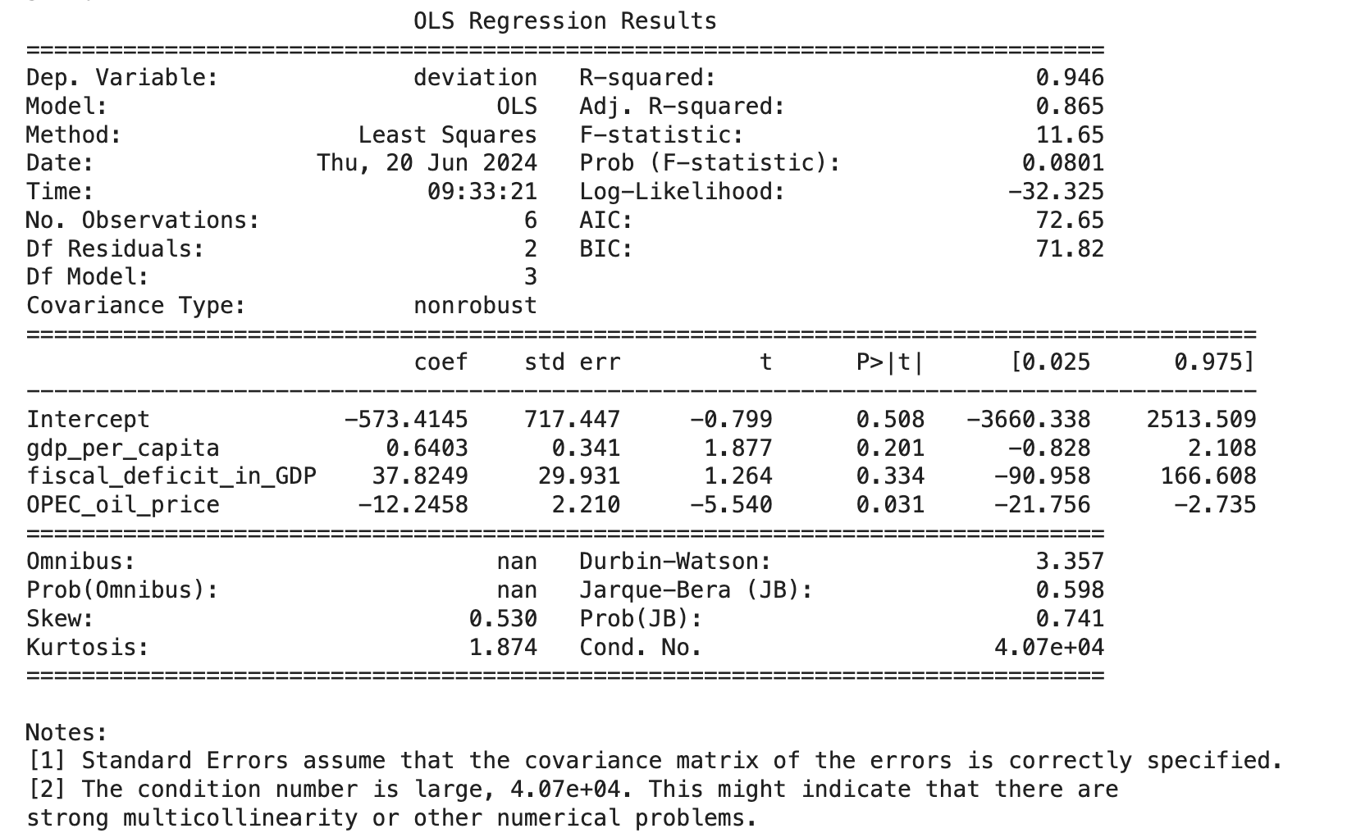

**Fig. 5.6.7. OLS Regression between Deviation and GDP per Capita, Fiscal Deficit in GDP, OPEC Oil Price.**

Analyzed and Plotted by OLS Regression model from Python’s “statsmodels.formula.api” interface, utilizing Data in Table 3.

**Conclusion**

In conclusion, the analysis of Nigeria's deviation from OPEC quotas and its economic repercussions reveals a complex interplay between oil production, fiscal stability, and economic growth. The regression results indicate that Nigeria’s deviations from OPEC quotas have significant correlation with its fiscal deficit and global market oil prices, highlighting the critical role of oil revenue in Nigeria's economic framework. This study underscores the importance of consistent and strategic management of oil production to mitigate adverse economic effects and enhance fiscal sustainability. As global oil markets continue to evolve, Nigeria must navigate these challenges by balancing its production commitments with domestic economic priorities. Future research should further investigate the long-term effects of oil production policies and explore alternative strategies to diversify Nigeria's economic base, reducing its vulnerability to fluctuations in the oil market.

**Works Cited**

BP. (2021). Statistical Review of World Energy 2021.

Energy Information Administration (EIA). (2022). "International Energy Statistics."

Fattouh, B. (2011). "OPEC Oil Pricing Power: The Need for a New Perspective." Oxford   
 Institute for Energy Studies.

Fudenberg, D., & Tirole, J. (1984). The Fat-Cat Effect, the Puppy-Dog Ploy, and the Lean and   
 Hungry Look. The American Economic Review.

Griffin, J. M. (1985). "OPEC Behavior: A Test of Alternative Hypotheses." American Economic   
 Review.

Nwosu, C. O., & Okafor, C. E. (2022). "Oil Price Shocks and Macroeconomic Performance in   
 Nigeria: An OPEC Member's Perspective." Energy Policy.

Obi, C. (2010). "Oil Extraction, Dispossession, Resistance, and Conflict in Nigeria's Oil-Rich   
 Niger Delta." Canadian Journal of Development Studies.

Okonjo-Iweala, N. (2018). "Fighting Corruption Is Dangerous: The Story Behind the Headlines."   
 MIT Press.

OPEC. (2021). Annual Statistical Bulletin.

OPEC. (2024). Production table - 35th ONOMM.

OPEC Annual Statistical Bulletin. (2023). "Crude Oil Production and Exports." Organization of   
 the Petroleum Exporting Countries.

OPEC Secretariat’s Annual Statistical Bulletin. (2024). “OPEC Members' crude oil production   
 allocations 2023”.

Punch. (2024). "Nigeria’s $48 per barrel oil production cost, global highest- Faleke”. Accessed   
 June 21, 2024.

Smith, J. L. (2005). "Inscrutable OPEC? Behavioral Tests of the Cartel Hypothesis." The Energy   
 Journal.

Tirole, J. (1988). The Theory of Industrial Organization. MIT Press.

Udegbunam, R. I., & Eboh, E. C. (2015). "Insecurity in the Niger Delta and Its Impact on Oil   
 Production in Nigeria." African Journal of Economic Review.

World Bank. (2021). "Population, total - Nigeria." World Bank Group.

World Bank. (2022). "GDP (current US$) - Nigeria." World Bank Group.

Yergin, D. (2006). The Prize: The Epic Quest for Oil, Money, and Power. Free Press.

Yergin, D. (2011). The Quest: Energy, Security, and the Remaking of the Modern World. Penguin   
 Press.

**Appendix 1. Data Used for OPEC Oil Price Elasticity Calculation.**

|  |  |  |
| --- | --- | --- |
| **Date (Annual)** | **OPEC Production (kbd)** | **OPEC Oil Price ($/barrel)** |
| 1983 | 15,521 | 29.04 |
| 1984 | 14,809 | 28.20 |
| 1985 | 13,966 | 27.01 |
| 1986 | 16,661 | 13.53 |
| 1987 | 16,000 | 17.73 |
| 1988 | 18,198 | 14.24 |
| 1989 | 19,667 | 17.31 |
| 1990 | 21,220 | 22.26 |
| 1991 | 21,357 | 18.62 |
| 1992 | 23,092 | 18.44 |
| 1993 | 23,520 | 16.33 |
| 1994 | 23,928 | 15.53 |
| 1995 | 24,022 | 16.86 |
| 1996 | 24,313 | 20.29 |
| 1997 | 25,075 | 18.68 |
| 1998 | 27,194 | 12.28 |
| 1999 | 25,662 | 17.48 |
| 2000 | 27,227 | 27.60 |
| 2001 | 26,459 | 23.12 |
| 2002 | 24,224 | 24.36 |
| 2003 | 26,691 | 28.10 |
| 2004 | 29,534 | 36.05 |
| 2005 | 30,772 | 50.64 |
| 2006 | 31,014 | 61.08 |
| 2007 | 30,515 | 69.08 |
| 2008 | 31,506 | 94.45 |
| 2009 | 28,492 | 61.06 |
| 2010 | 28,830 | 77.45 |
| 2011 | 29,647 | 107.46 |
| 2012 | 31,925 | 109.45 |
| 2013 | 31,025 | 105.87 |
| 2014 | 30,075 | 96.29 |
| 2015 | 31,062 | 49.49 |
| 2016 | 32,467 | 40.76 |
| 2017 | 31,636 | 52.43 |
| 2018 | 31,217 | 69.78 |
| 2019 | 29,376 | 64.04 |
| 2020 | 25,659 | 41.47 |
| 2021 | 26,363 | 69.89 |
| 2022 | 28,895 | 100.08 |

**Appendix 2. Data Used for Nigeria’s Oil Price Elasticity Calculation.**

|  |  |  |
| --- | --- | --- |
| **Date (Monthly)** | **Nigeria Oil Production (kbd)** | **Nigeria Oil Price (($/barrel))** |
| Jan-2020 | 1,779 | 66.11 |
| Feb-2020 | 1,799 | 57.17 |
| Mar-2020 | 1,781 | 31.27 |
| Apr-2020 | 1,755 | 12.92 |
| May-2020 | 1,457 | 26.60 |
| June-2020 | 1,401 | 40.48 |
| Jul-2020 | 1,352 | 44.02 |
| Aug-2020 | 1,368 | 45.09 |
| Sep-2020 | 1,336 | 40.33 |
| Oct-2020 | 1,354 | 39.59 |
| Nov-2020 | 1,365 | 42.80 |
| Dec-2020 | 1,186 | 49.78 |
| Jan-2021 | 1,361 | 54.51 |
| Feb-2021 | 1,424 | 62.16 |
| Mar-2021 | 1,429 | 65.23 |
| Apr-2021 | 1,372 | 63.89 |
| May-2021 | 1,344 | 68.05 |
| June-2021 | 1,313 | 73.55 |
| Jul-2021 | 1,323 | 75.37 |
| Aug-2021 | 1,239 | 70.23 |
| Sep-2021 | 1,247 | 73.61 |
| Oct-2021 | 1,228 | 83.81 |
| Nov-2021 | 1,275 | 82.25 |
| Dec-2021 | 1,197 | 74.73 |
| Jan-2022 | 1,399 | 89.24 |
| Feb-2022 | 1,258 | 100.27 |
| Mar-2022 | 1,238 | 121.50 |
| Apr-2022 | 1,219 | 106.31 |
| May-2022 | 1,024 | 117.73 |
| June-2022 | 1,158 | 131.23 |
| Jul-2022 | 1,084 | 122.20 |
| Aug-2022 | 972 | 105.35 |
| Sep-2022 | 938 | 91.76 |
| Oct-2022 | 1,014 | 95.18 |
| Nov-2022 | 1,186 | 93.00 |
| Dec-2022 | 1,235 | 81.60 |

**Appendix 3. Code for Profit Comparison on Occasions Nigeria Follow OPEC and Deviate from OPEC.**

#N oil elasticity

elasticity_N = -0.09277

intercept_N = 194.3738

import numpy as np

import matplotlib.pyplot as plt

# follow OPEC

Quota_N = 1380 # unit kbd

price = 80 #per barrel

cost_N = 48 # unit $/barrel

profit_N_OPEC = Quota_N * (price - cost_N)

print(profit_N_OPEC)

-> 44160

# Deviate from OPEC

quantity_N = np.arange(0, 2000,1)

price_deviate_N = elasticity_N *quantity_N + intercept_N

profit_deviate_N = quantity_N*(price_deviate_N -cost_N)

plt.figure(figsize=(8,4))

plt.plot(quantity_N, profit_deviate_N, label = "profit if deviate, 194.3637 - 0.09277 * Nigeria oil Production")

plt.axhline(y = profit_N_OPEC, color = "r", label = "profit if follow OPEC, 1380*($80-$48)")

plt.axvline (x = Quota_N, color = "g", label = "Quota = 1380")

plt.title("Profit Comparison for Nigeria in Short Term", y = 1.02)

plt.xlabel("Production (kbd)")

plt.ylabel("Profit per day (k$)")

plt.grid()

plt.legend()

plt.show()

-> Fig. 4

# check profit level where deviation greater than following

for i in profit_deviate_N:

if i >= profit_N_OPEC:

print(quantity_N[np.where(profit_deviate_N == i)],i)

-> [407] 44206.878869999986

…

-> [1171] 44193.69222999998

# check maximum profit in deviation and its production level

print(max(profit_deviate_N))

print(np.argmax(profit_deviate_N))

-> 57737.65502999999

-> 789