Yifei Jin

11/7/16

**Analysis of Baroness**

**Model of Entities and Boundaries**

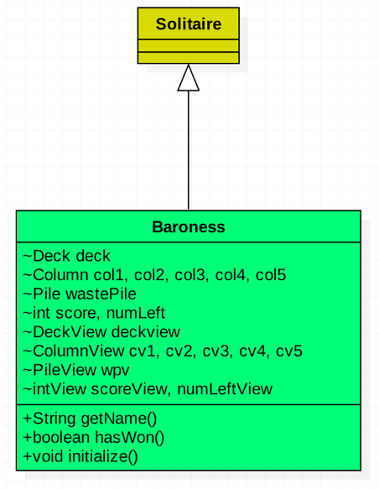

**View**

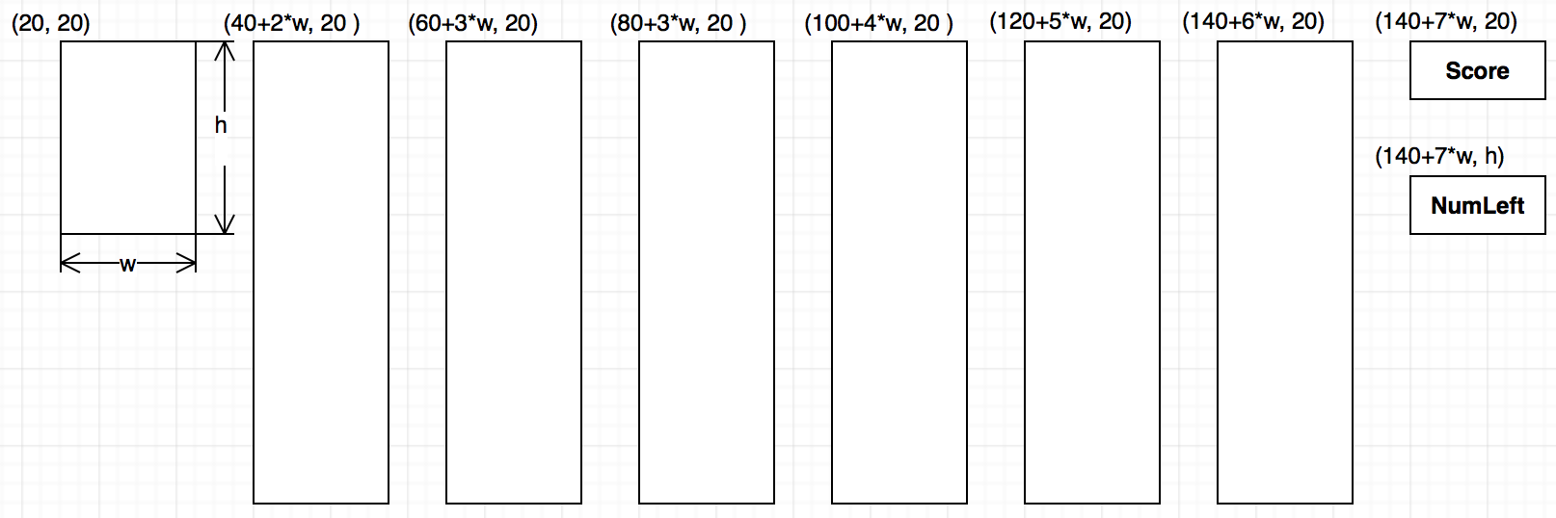

**Move Classes**

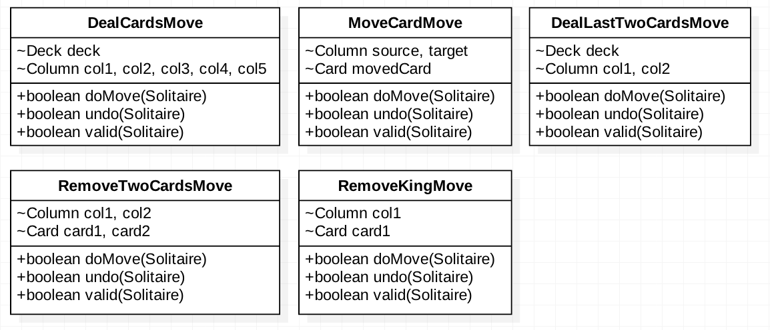

* DealCardsMove – five cards are being removed from the deck and dealt face up, one to each column. The number of cards is reduced by five and the score is untouched.
* DealLastTwoCardsMove – last two left cards are being removed from the deck and dealt face up to the first two columns. The number of cards is reduced by two and score is untouched. The number of cards remaining now should be zero.
* MoveCardMove – one card from a column is dragged from one column to another empty column. The number of cards and the score keep untouched.
* RemoveTwoCardsMove – drag one card from one column to another column. If the sum of the two cards is 13, remove these two cards. Number of cards left is untouched. score increases by one and the number of cards in the waste pile increases by two. If the sum is not 13, do nothing.
* RemoveKingMove – press the king card and remove it. Score increases by one and the number of cards left is untouched. The number of the cards in the watet pile increase by one.

**User Interaction**

* DealCardsMove – mousePress on the deckView when it is not empty
* DealLastTwoCardsMove – mousePress on the deckView when it is not empty and only has two cards left.
* MoveCardMove -- mousePress on a source columnView to initiate the move by extracting the top card from the column; mouseDragged to cover the card being moved to the new columnView; and mouseReleased on the target columnView to complete the move.
* RemoveTwoCardsMove – mousePress on a source columnView to initiate the move by extracting the top card from the column; mouseDragged to cover the card being moved to the new columnView; and mouseReased on the target columnView to complete the move.
* RemoveKingMove – mousePress on the columnView which has a king on the top.