# A1.Analysis

Heineman/Sample RedBlack A1.Model then followed by A1.Analysis

# Variation

Red Black consists of a Deck of cards and a waste pile into which you can deal a single card at a time. There are two Foundation piles, one of which will contain cards that have a red suit (i.e., hearts or diamonds) and the other will contain cards that have a black suit (i.e., clubs or spades). Game play consists of dealing cards to the waste pile. The player can at any time move cards from the waste pile onto one of the foundation piles

## Use Cases

Name: Deal card

Participating actor: player

Entry Condition: Deck has cards

Exit Condition: Top card from deck added to waste pile and numberCards left decremented

Flow of Events:

1. Player requests to deal top card from deck
2. RedBlack responds by updating wastepile and number cards left

Name: Move card

Participating actor: player

Entry Condition: Waste pile has at least one card and foundation pile has at least one card of same color

Exit Condition: Top card from waste pile added to foundation pile and score incremented

Flow of events

1. Player request to move top card from waste pile to foundation pile
2. RedBlack responds by updating waste pile and foundation pile and score

Name: Move card to empty foundation

Participating actor: player

Entry Condition: Waste pile has at least one card, foundation pile is empty, and other foundation pile doesn’t have card with same color

Exit Condition: Top card from waste pile moved to foundation pile and score incremented

Flow of events

1. Player requests to move top card from waste pile to foundation pile
2. RedBlack responds by updating waste pile and foundation pile and score

## Class Diagram

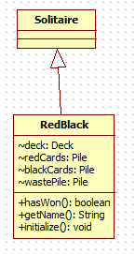

# Now Modify to make your A1.Analysis

You need four parts in this document. Review these from the A1.Narcotic Examples folder in my.wpi.edu

## Model of Entities and Boundaries



In the original, I had used by mistake “WastePileView” as a class. This is fixed now.

## View

This format demonstrates the layout of your game. Be as precise as you can when specifying the coordinates.

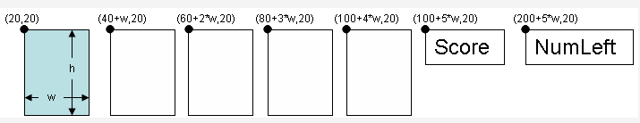

## Move Classes

Based on your analysis, you need to identify the specific Move classes that form the logic of the game. Here you have two kinds of moves – the dealing move for placing a card on the waste pile from the deck, and the move of a card from the waste pile to one of the foundation piles. The diagrams for these move classes are shown below, together with logic that explains exactly what effect occurs.



In the original diagram, I omitted the “cardBeingMoved” attribute from FoundationMove class. The reason why I want to include it will best be explained in class on Monday

Use the above format to represent the class diagram of these move classes

## User Interactions

Finally you need to identify what sequence of operations will be used to trigger the execution of moves

**DealCardMove** -- mouse press on DeckView

**FoundationMove** -- mousePress on a source pileView (wastepileView) to initiate the move by extracting the top card from the pile; mouseDragged to cover the card being moved to the new pileView (some Foundation); and mouseReleased on the target PileView to complete the move.