Data Visualization
For the sample, I did data visualization for all touches mainly included the features below:

ID:
Hip adduction moment
Hip flexion moment
Hip rotation moment

IK:
Hip adduction angle
Hip flexion angle
Hip rotation angle

Force:
Calculated from above: but didn’t do visualization for this time yet

The data will also be splited to dominant leg vs non-dominant
Dominant-leg is depended on the touches of the side, the more touches side will be the dominant side.

Player number | Injury side | Left # of touch | Right # of touch | Preferred foot | Dominant side=injury side
P02 | R | 13 | 11 | R | yes
P32 | R | 15 | 17 | R | yes
P34 | L | 9 | 25 | R | no
P53 | L | 3 | 17 | R | no
P64 | R | 2 | 10 | R | yes
P74 | L | 19 | 9 | L | yes
P88 | L | 26 | 5 | L | yes

I have done the drawing in the following format:
An Example for player 02:
Left passes done by 02:
Left Hip Data:
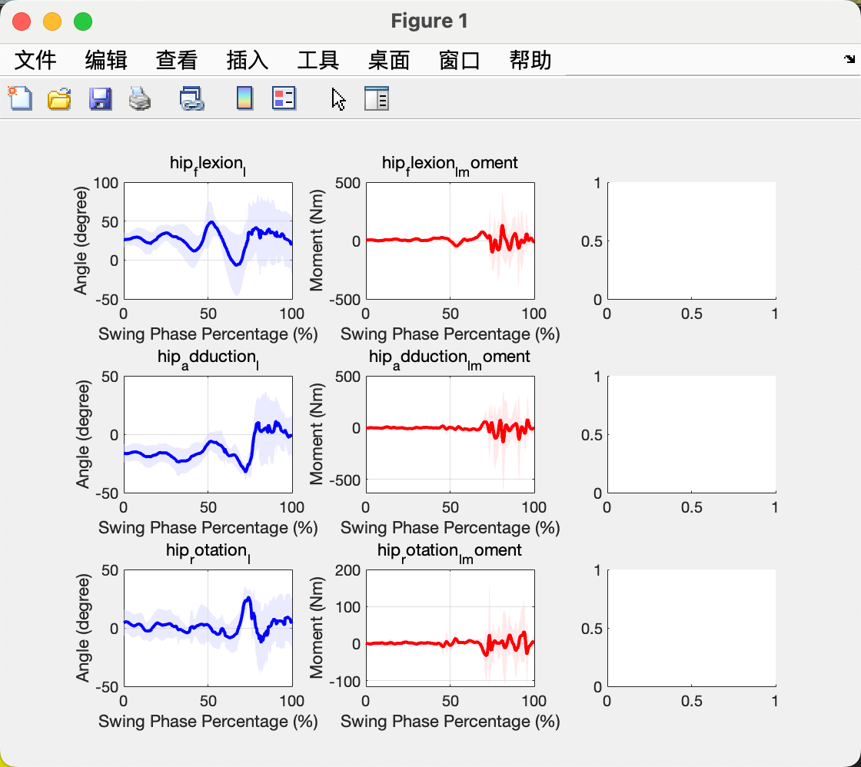
Right Hip Data:
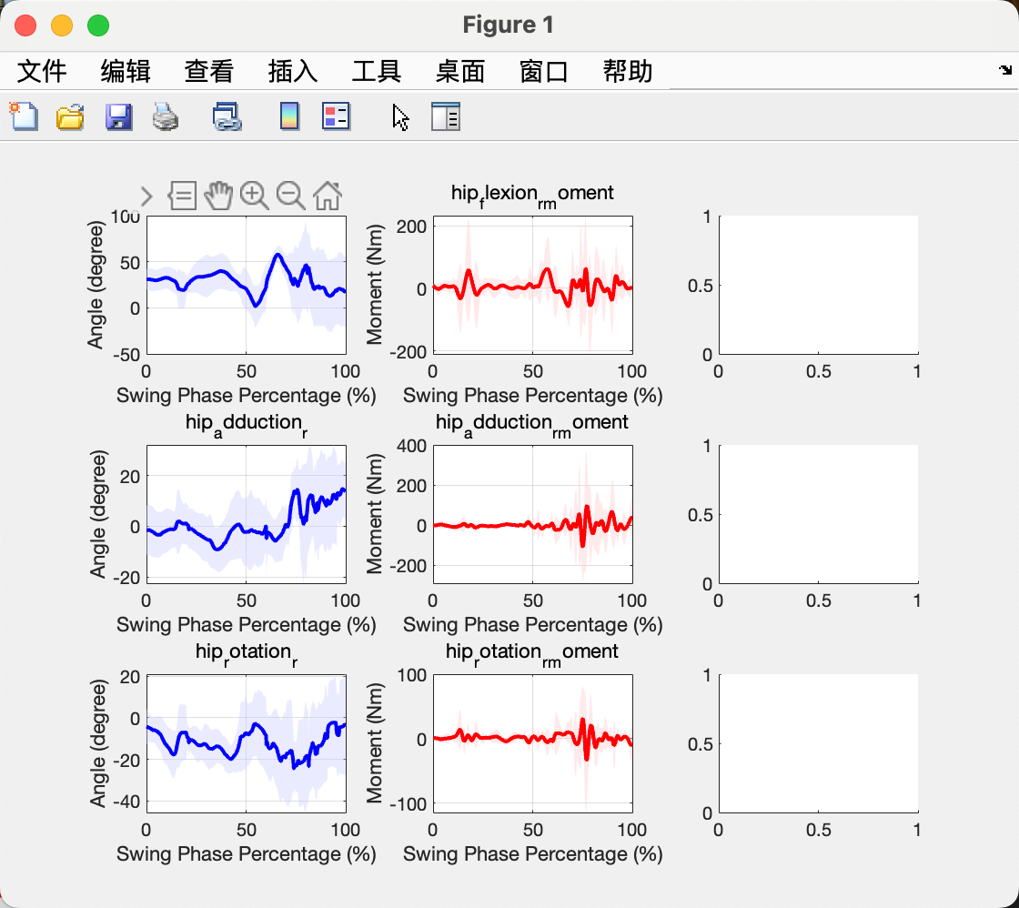
Right passes done by 02:
Left Hip data:
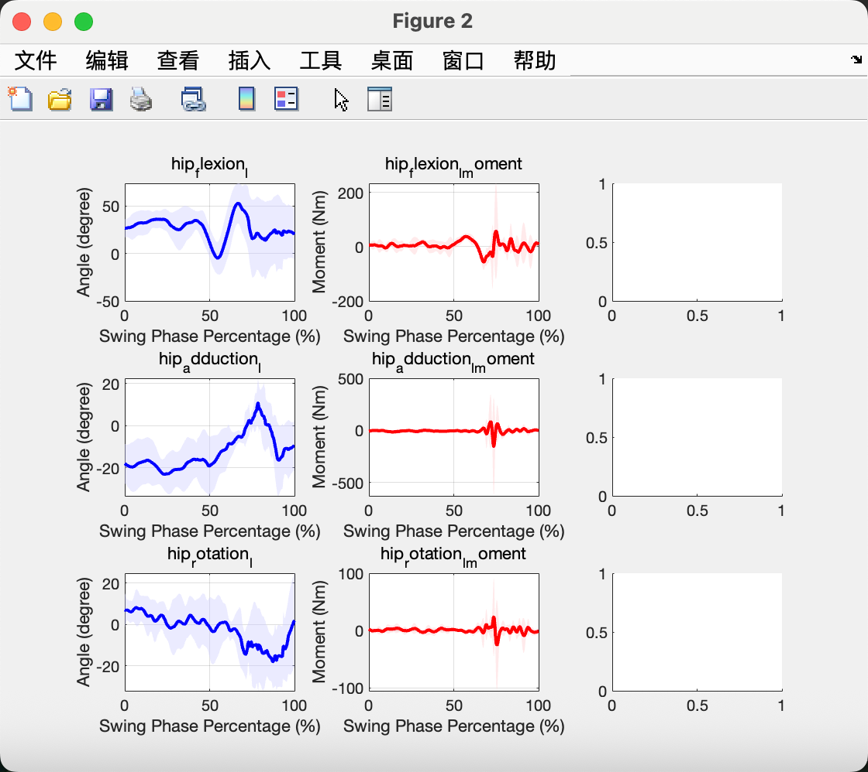
Right Hip data:
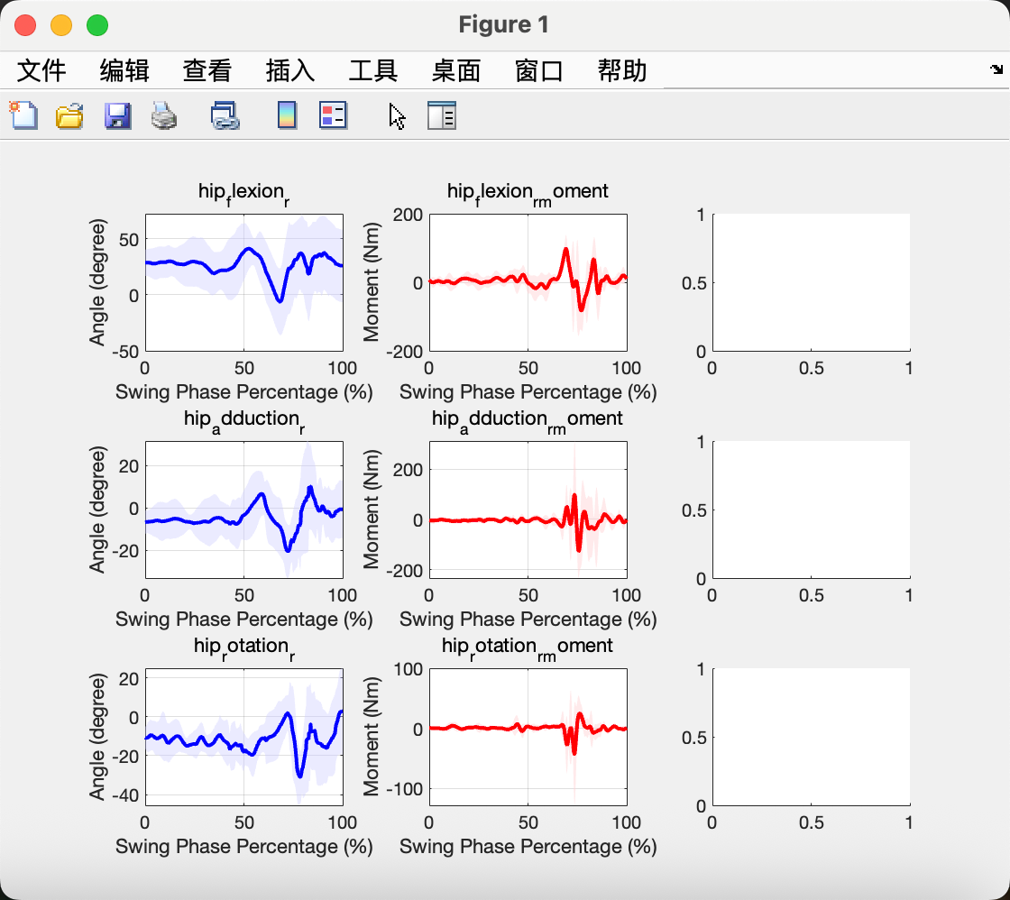
I will add the force data to the third column and add some comparison examples and analysis in the next session.

