Results
My results find that
Hip flexion angle: 0-50% dominant side slightly higher degree angle, after 70% the gap is getting larger
Hip adduction angle: dominant side has more adduction angle from beginning to the end（O型腿）
Hip rotation angle: non dominant side has larger rotation than dominant side (外八字)

ID kneeFlexion moment: after 80% phase the non dominant side has more moment, increasing faster than knee flexion moment

Repetitive injuried
Further injured caused by leg length discrepency (normal people LLD data)
关键点和平时训练需要注意什么
Disscusion

How much people asymmetric? genu varum
The first term reminds by symmetric for me is the leg length. With diff leg length there is a term called leg length Inequalty or leg length discrepancy. Here are some stats to define them..
The stats of LLD, discrepancy, 多少人的左右腿长短不一样

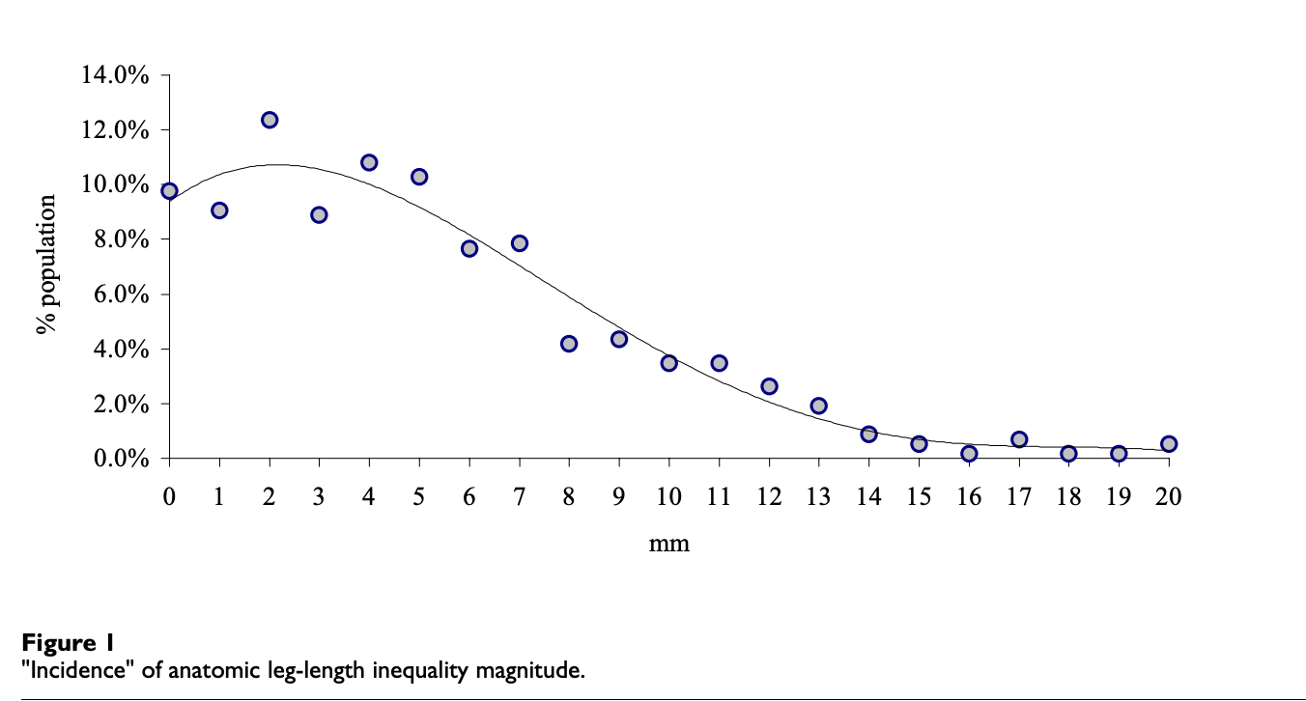
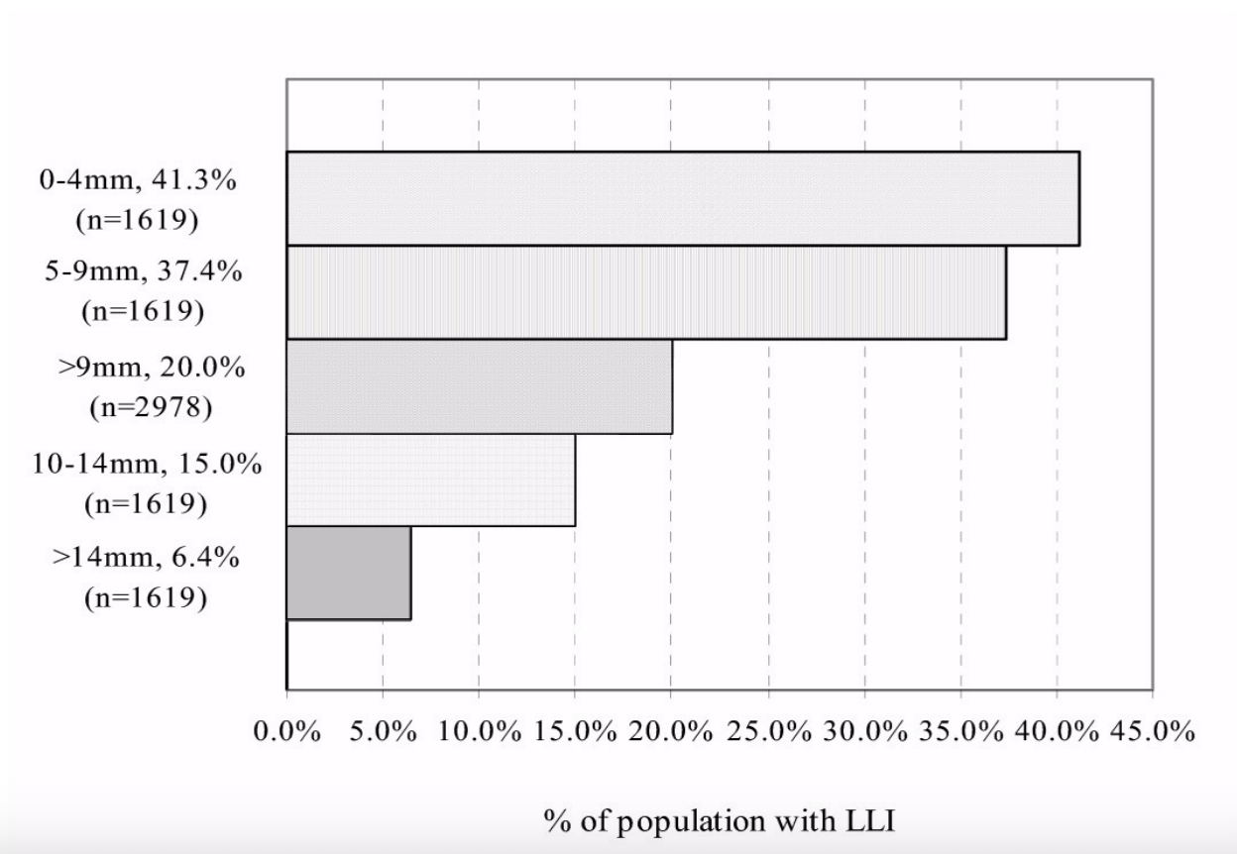

How about football Dominant leg shorter?
In amateur soccer players, around three‑quarters have some degree of lower limb length discrepancy, and in many cohorts about half to two‑thirds have the right leg shorter; in a large proportion of cases, the shorter leg is also the dominant kicking leg.

Some studies indicate that starting intense soccer training early in life is associated with true anatomical shortening of the dominant leg, with reported side‑to‑side differences up to around 17 mm in extreme cases.

Among players who started high‑level training before roughly age 13, almost all showed a pattern of “shorter dominant (kicking) leg”, whereas this pattern is less consistent in those who began intensive training later.

Sources:
Limb length discrepancy and gait parameters of amateur football players in Lagos State, Nigeria.
Journal: South African Journal of Physiotherapy, 2022（在线发表于 2019–2020 年间）
结论中给出：89 名业余球员中，真实 LLD 的患病率为 75%，其中 59–60% 为右腿较短，讨论部分指出“the shorter limb is often the kicking leg”。

这个研究支持：“约 3/4 有 LLD；右腿更短占约 60%；短腿往往是踢球腿”

Why injuried easier? 腿型图片 对比 左右不同区别 o型腿

The dominant leg is the main kicking leg, undergoing large‑amplitude swings, high angular velocities, and powerful eccentric contractions, which increase shear forces at the hip, knee, and hamstrings.

If the dominant leg is also slightly shorter, landing and cutting may load that side with higher impact peaks, while the longer leg may experience prolonged stance time and different compensations; both patterns can increase joint and soft‑tissue stress.

The dominant leg often accumulates more exposure time (shots, long passes, set pieces), so even with only modest per‑movement risk, the cumulative injury probability over a season is higher.

影响是什么
Football effect – no effect
Mild LLD and mild genu varum do not necessarily impair performance; many high‑level athletes—including sprinters and footballers—compete successfully despite measurable asymmetries because neuromuscular control and strength compensate.

From a biomechanical standpoint, some structural asymmetries might even be associated with specific performance profiles (for example, a slightly shorter dominant leg combined with strong hip and knee musculature may subtly alter swing mechanics), but current evidence for direct performance advantages is limited and largely speculative.

Injuried risk effect

Marked LLD (often defined as >20 mm) or pronounced genu varum is associated with an increased prevalence of low back pain, pelvic obliquity, and compensatory spinal curvature in both general and athletic populations.

Medial‑compartment knee loading increases with varus alignment and LLD‑related pelvic tilt, which is linked to a higher risk of knee osteoarthritis, especially in the medial compartment.

In soccer players, LLD has been related to abnormal gait parameters such as asymmetrical step length and stance/swing time, which can overload specific muscle groups (hamstrings, quadriceps, calf) and joint structures during sprinting, cutting, and landing.

Sources：
Adegoke BOA, Akinbo SRA, Balogun MO, Adeyinka AA. Limb length discrepancy and gait parameters of amateur football players in Lagos State, Nigeria. S Afr J Physiother. 2022;78(1):1490.

Guer JL, Menu P, Messina C, et al. Does intensive soccer playing during the growth period lead to leg length discrepancies? Sports Med Int Open. 2017;1(5):E183-E187.

减少位数

Your kinematic and kinetic asymmetries are consistent with a pattern that can increase repetitive loading and injury risk, especially when combined with leg length discrepancy and football-specific demands. 下面我用你的结果帮你梳理关键风险点和训练建议。pmc.ncbi.nlm.nih+3

1. How to interpret your findings
- Hip flexion: 优势侧前 0–50% 屈曲更大，后 70% 差异增大，说明这条腿在支撑后期承担更多减速和推进控制，长期可能出现屈髋、股四、臀肌的过度使用和疲劳性损伤。orthopedicshoelift+1
- Hip adduction (O 型腿): 优势侧全程内收更多，结合 genu varum 会增加内侧膝关节负荷、半月板和内侧结构的长期磨损风险，尤其是在足球的变向、急停中。pmc.ncbi.nlm.nih+2
- Hip rotation: 劣势侧旋转更大（外八），可能是为补偿下肢力线和 LLD，导致胫骨外旋、足外翻/外旋，增加踝和膝外侧结构的剪切力和过用风险。pmc.ncbi.nlm.nih+1
- Knee flexion moment: 80% 之后劣势侧屈曲矩更大、上升更快，说明后期制动主要“吃”在这条腿的膝关节上，易出现髌股疼、髌腱/腘绳肌疲劳性损伤，甚至应力性损伤。pmc.ncbi.nlm.nih+2
结合你提到的 “repetitive injured”，这些运动学/动力学特点说明你在双下肢之间形成了固定的“分工”：一条腿多负责髋控制和方向，另一条腿多负责膝的制动和旋转补偿。

2. Leg length discrepancy & “normal” data
- 70–90% 普通人存在一定程度解剖性 LLD，平均约 5–7 mm，多数文献认为 ≤10 mm–20 mm 通常可被身体代偿，不一定有症状。motushp+2
- 但在跑跳较多的运动员中，即使是大约 6–10 mm 的轻度 LLD，也被认为可能增加慢性过用损伤风险，如应力性骨折、髌软骨软化、腰痛等，尤其是在短腿侧。orthopedicshoelift+2
- 对足球运动员，反复变向、冲刺、单脚支撑，会把这种小差异“放大”为长期的负荷不对称，叠加 genu varum、外八、髋内收/旋转差异，就更容易出现同一部位的重复性损伤。pmc.ncbi.nlm.nih+2
所以：即使你的 LLD 在“正常范围”，对你这种高运动量、已有多次受伤史的人来说，也需要重视功能性影响，而不是只看毫米数。

3. 关键风险点总结（你身上的“易伤模式”）
- O 型腿 + 优势侧更多髋内收：
  - 增加内侧膝室负荷、内侧半月板和内侧副韧带长期压力。pmc.ncbi.nlm.nih+1
  - 在变向、铲球、单脚落地时，若伴随膝内翻，会提高膝关节退变和内侧疼痛的风险。pmc.ncbi.nlm.nih+1
- 劣势侧外八 + 髋外旋大 + 膝屈矩高：
  - 膝关节在屈曲制动时承受较大的旋转和剪切力，易出现髌股疼、腘绳肌和腓肠肌过用、腓骨头周围不适等。pmc.ncbi.nlm.nih+2
  - 踝关节可能存在过度外翻/外旋，增加外侧韧带、腓骨肌腱的慢性拉扯。pmc.ncbi.nlm.nih+1
- LLD（哪侧长哪侧短要结合你的测量）：
  - 短腿侧：冲击和地面反作用力相对更大，易出现应力性损伤、足底筋膜炎、胫骨应力综合征等。orthopedicshoelift+2
  - 长腿侧：骨盆相对下沉，容易出现腰骶不适、对侧腰肌紧张等。pmc.ncbi.nlm.nih+2

4. 关键点：平时训练要注意什么？
下面重点回答你问的“关键点和平时训练需要注意什么”，偏实用向。你可以结合自己的侧别情况进行调整。

4.1 对齐与矫正（姿势 & 鞋垫）
- 明确真实 LLD（X 光或 CT 站立测量），区分解剖性 vs 功能性（骨盆歪斜、足弓塌陷等）。physio-pedia+2
- 若 LLD ≥ 6–10 mm 且已有重复损伤，可在专业医生/运动医学团队指导下尝试渐进式鞋垫或鞋跟垫（先矫正 50–70%，再视症状和表现调整），避免一次性全补偿导致新问题。physio-pedia+2
- 选择合适球鞋：足弓支撑（尤其是短腿侧）、足跟稳定性和中底缓冲，对降低非对称冲击有帮助。pmc.ncbi.nlm.nih+1

4.2 肌力与控制训练重点
- 髋外展/外旋与骨盆控制
  - 目标：减少优势侧过度内收（减轻 O 型腿下内侧膝压力），改善单脚支撑稳定性。
  - 练习建议：
    - 側卧/站立髋外展、站立抗阻带侧步、单脚桥式、侧向滑步带阻力。
    - 单脚深蹲（箱式）、下台阶时注意膝盖对准第二趾，防止“膝内扣”或过度内收。
  - 强调慢速控制，尤其是离心控制和动作末端（类似你数据中 70–100% 的相位）。pmc.ncbi.nlm.nih+1
- 髋屈伸力量平衡
  - 目标：缓解优势侧髋屈肌、股四的过用，增强臀大肌与腘绳肌的参与，让髋伸而不是膝来承担更多推进与减速。
  - 练习建议：臀桥、硬拉（罗马尼亚式更加友好）、反向弓箭步、俯卧/坐姿屈膝抗阻。
  - 训练过程中关注左右力量是否对称，必要时做等速或等长对比测试。pmc.ncbi.nlm.nih+1
- 劣势侧膝关节减速与旋转控制
  - 目标：降低 80% 之后过高的屈曲矩和旋转负荷，优化落地和变向技术。
  - 练习建议：
    - 多方向的落地训练（垂直、前后、侧向），重点是“安静落地”：膝不过度前冲、髋同时屈、足跟—中足协同缓冲。
    - 低速开始的变向训练：预先降低重心，增加髋屈和膝屈，避免膝在接触瞬间非常直且同时承担很大旋转。
  - 可录像从正面和侧面观察膝与髋角度变化，模仿 ACL 预防项目（如 FIFA 11+ 的进阶版）。pmc.ncbi.nlm.nih+2

4.3 柔韧性与组织平衡
- 短腿侧通常更紧张，尤其是腓肠肌、比目鱼肌、髂胫束、腰方肌；长腿侧反而可能过度拉长或反应性紧张。可针对性拉伸和筋膜放松，避免“一刀切”式两侧完全一样的拉伸配方。pmc.ncbi.nlm.nih+1
- O 型腿 + 髂胫束紧张的人，外侧结构经常代偿，记得增加股外侧、臀中肌、臀小肌的放松与轻微拉伸，同时通过力量训练提高对内侧结构的使用效率，而不是纯被动拉伸内侧韧带。pmc.ncbi.nlm.nih+1

4.4 训练量与恢复管理
- 你已有“repetitive injured”，说明组织耐受已经接近上限，建议：
  - 每周安排 1–2 次专门的“身体维护日”：低强度跑 + 核心/髋控制训练 + 拉伸 + 手法/泡沫轴。
  - 高冲击训练（高强度对抗、小场比赛、频繁急停变向）之间至少间隔 48 小时，并观察是否总是在同一侧/同一结构反复酸痛或紧绷。
- 若连续 2–3 周同一部位负荷后症状越来越快出现，而不是越来越耐受，应视为“红灯信号”，考虑减量或改变训练内容，而不是硬扛。orthopedicshoelift+1

4.5 比赛/训练技术细节
- Change of direction：刻意练习用双侧都做变向，而不是总用习惯那一条腿去做支撑/切入，让负荷更平均。pmc.ncbi.nlm.nih+1
- 射门与传球：适当增加“弱侧”发力与支撑练习，不只是技术，而是关注支撑腿落地姿势、重心控制和离心控制。
- 起跳与落地：跳起可以不管哪腿主导，但落地尽量双腿均衡、膝髋同时屈曲，而不是某一侧几乎直膝落地。

如果你愿意把具体：哪条腿长、哪条腿是 dominant、最近 1–2 年最常受伤的具体部位（例如内侧膝、胫骨、踝外侧、腰等）告诉我，我可以帮你画一个更细的“伤病风险地图”，再给你一个更针对性的每周训练/预防计划模板。

