**MATLAB Homework 02**

Yifu Huang

**Codes location:** [**https://github.com/yifuhhh/EE385J_Biomed_Image/tree/master/HW03/Submission**](https://github.com/yifuhhh/EE385J_Biomed_Image/tree/master/HW03/Submission)

1. **Compared to the other images we have looked at so far (MRI, PET, CT), what are some differences between this US image and those other images?**

Ultrasound images are acquired by collecting the echo of ultrasound transmitted into tissues and organs. The data acquired by ultrasound image will be 2D. However, the images get from MRI/PET/CT are 3D images. Also, due to the limitation of ultrasound wavelength, the spatial resolution of US image is worse than MRI/PET/CT.

1. **Create a “for” loop to loop through each image in time (MATLAB Monday 00), as you watch the playback, what do you notice happening? What could be the potential cause of this? Can you think of anyways we could address this? Are you able to see the contrast enhancement?**

I notice that there are some movements of tumor. The muscle and tissues attached to the tumor are contracting at the beginning and the amplitude gets down during the period of imaging.

The potential cause of this could be some drugs gets effective which decreases the activity of muscle.

I can see the contrast enhancement brought by the microbubbles along the interface between tumor and muscle, as is shown below.

1. **Using the imresize function, resize the image to 15% of its original value. (Since this is a 3D image, you will have to loop through time to resize each time point)**
2. For each voxel, we want to calculate the baseline signal intensity. To calculate the baseline signal intensity, we will simply average the first 5 time points at each voxel. Display the baseline signal intensity (on one plot) and the standard deviation (on a second plot). What could the standard deviation tell us about the image?

The standard deviation tells us about the variation of the value in each voxel during the period of imaging time. It shows the range of signal density distributing around the baseline of each voxel.

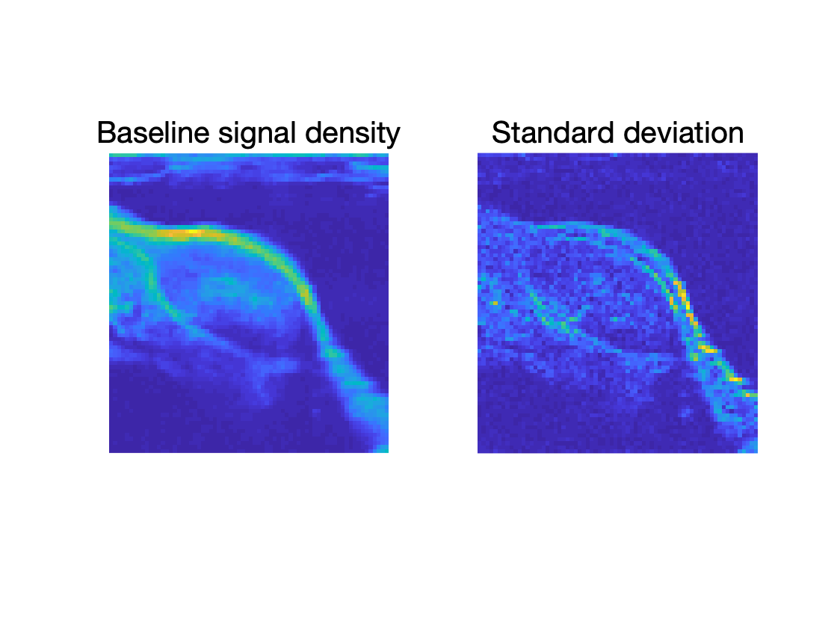

Figure 1. Baseline and standard deviation of the image

1. Segment the tumor tissue. Display your segmentation on top of one of the images.

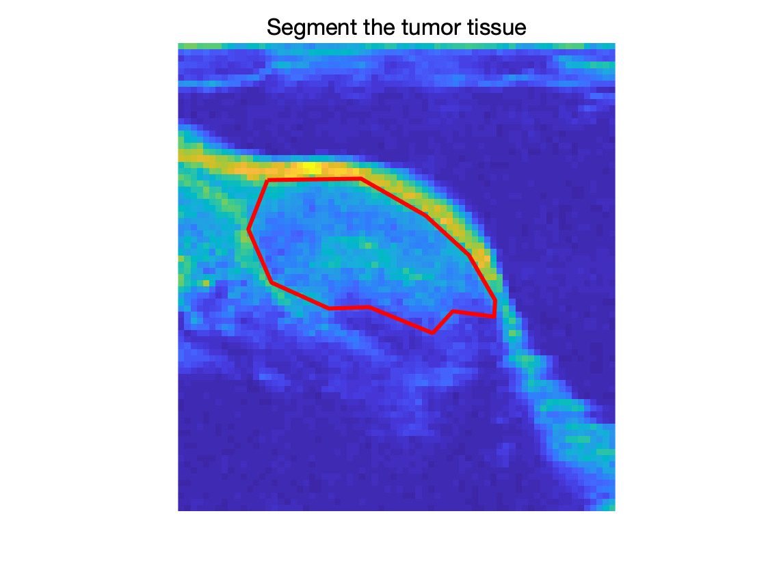

Figure 2. Segmentation on top of one of the tumor images

1. Within the segmented tumor: Find the maximum value at each voxel within the tumor. Then divide 2D array of maximum values by the baseline signal intensity. Use the colormap ‘hot’ to display your results. Set the display range in imagesc to be from 1 to 1.3. Add a colorbar. What does this image tell us?

As is shown in Fig. 3, the image shows the maximum value at each voxel within the tumor. It gives the idea of the effectiveness of the contrast enhancement agent on the tumor imaging. Most part of the tumor would be enhanced by 10% – 20% with the help of contrast enhancement agent.

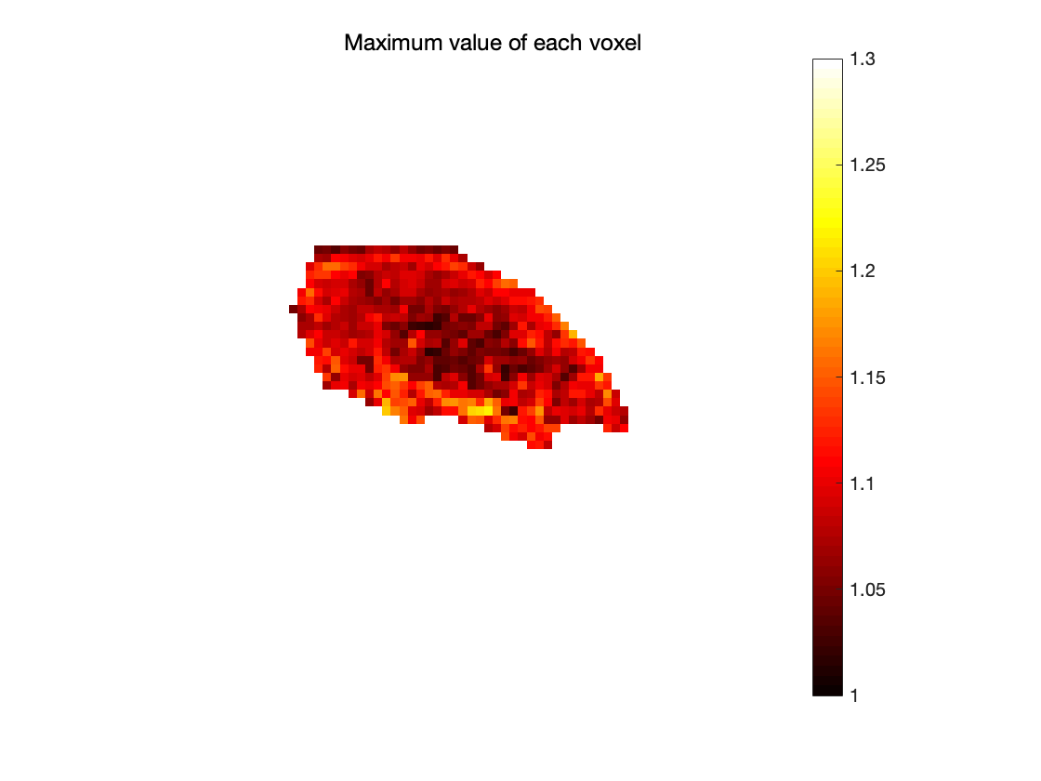

Figure 3. Heat map for the maximum value of each voxel

1. Within the segmented tumor: Create 4 plots showing which voxels are greater than baseline + 1*SD, +2*SD, + 4*SD, and +8*SD (Where SD = baseline standard deviation). What do these images tell us?

As is shown in Fig. 4, these images tell us the amount of time points in each voxel that have an intensity offset to the baseline at certain values. As we can see, the points have value more than 1*SD larger than baseline is more that those have value more than 8*SD larger than baseline.

Figure 4. Heat map for value in each voxel comparing with baseline + N*SD

1. Within the segmented tumor: Find at what time point the maximum value occurs in each voxel within the tumor. Display with a colorbar. Comment on what this map might tell us.

This map tells us when will the contrast enhancement agent take effect in the tumor. We can also tell the differences of effective time in different sections of the tumor.

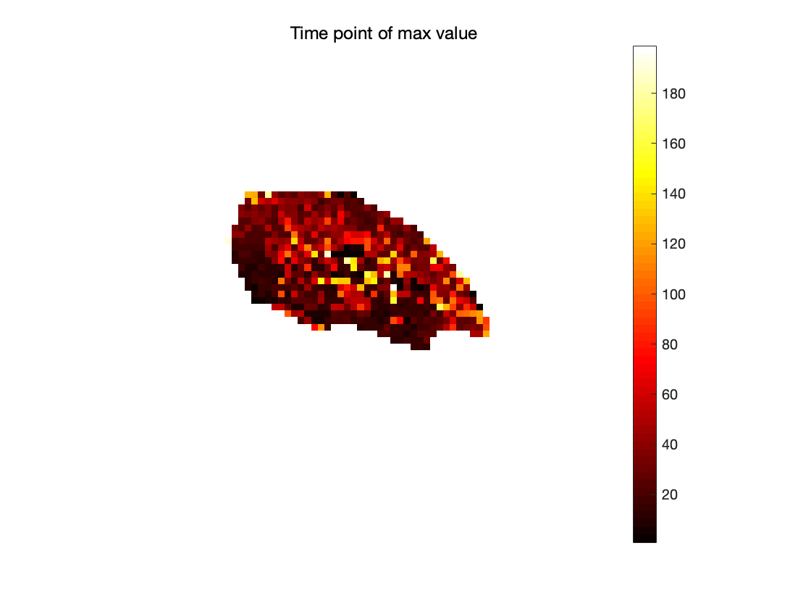

Figure 5. Time point of max value in the tumor

1. **Using lsqcurvefit and a scripted function to fit each voxel’s timecourse using the logistic growth model consisting of parameters P1 and P2. Before fitting, normalize the signal to the baseline signal intensity. Assume the parameters have a lower bound of 0, and no upper bound.**
$$S(t, P) = P1 (1- exp(-P2 ⋅t))$$

2. What does P1 and P2 represent in terms of the tumor biology?

P1 is the original energy of the ultrasound wave the tumor reflected back. P2 is the attenuation factor of time.

1. Create a plot of P1 and P2 within the tumor.

Figure 6. Plot for P1 and P2.

1. **Using the results of (3) and (4) what are the best and worst perfused regions? What could the impact of this be on tumor growth? What could the impact of this be on a tumor’s response to treatment?**

The best perfused region is near the surface of the tumor. The worst perfused region is near the center. I really don’t know about this part because I’m ECE student and lack of such background. So sorry about that!